JFreeChart Statistical Analysis Documentation

JFreeChart is a powerful Java library used for creating interactive and customizable charts in the application. It provides a comprehensive set of tools for data visualization, allowing developers to create various types of charts, such as line charts, bar charts, and scatter plots. In this codebase, JFreeChart is utilized to visualize the quadratic function, salted data, and smoothed data. The library's ChartFactory class is used to create line charts, while XYSeries and XYSeriesCollection classes manage the data points for plotting. The ChartPanel component integrates these charts into the Swing-based graphical user interface, enabling users to interact with the charts through features like zooming, panning, and tooltips. JFreeChart's flexibility and ease of use make it an ideal choice for displaying statistical data and trends in a user-friendly manner.
1. FunctionPlotter.java
Purpose:The FunctionPlotter.java file is responsible for generating and visualizing a quadratic function. It creates a range of x-values from -10 to 10 in steps of 0.5 and calculates the corresponding y-values using the formula The data is stored in an ArrayList and an XYSeries for plotting. The file then exports this data to a CSV file named function_data.csv, which includes a header row for clarity. Using JFreeChart, the FunctionPlotter creates an interactive line chart that displays the quadratic function. The chart is titled "Quadratic Function Plot" and includes axis labels, a legend, and tooltips for better user interaction. The plot is displayed in a Swing window, allowing users to visualize the function and understand its behavior.
This file is the starting point of the application, responsible for generating and visualizing a quadratic function.

1. **Data Generation Process:**
ArrayList<Double[]> data = new ArrayList<>();
XYSeries series = new XYSeries("y = x² + 2");

- Creates two data structures:
- `ArrayList<Double[]>` for raw data storage
- `XYSeries` for JFreeChart plotting
- Each point is stored as [x, y] coordinates

2. **Function Calculation:**
for (double x = -10; x <= 10; x += 1.0) {
double y = Math.pow(x, 2) + 2;
data.add(new Double[]{x, y});
series.add(x, y);
}

- Generates 21 points (from -10 to 10)
- Calculates y = x² + 2 for each x
- Stores in both data structures

3. CSV File Creation
try (FileWriter writer = new FileWriter("function_data.csv")) {
writer.append("x,y\n");
for (Double[] point : data) {
writer.append(point[0] + "," + point[1] + "\n");
}
}

- Creates CSV file with header
- Uses try-with-resources for automatic file closing
- Format: x,y on each line

4. Plot Creation and Display
JFreeChart chart = ChartFactory.createXYLineChart(
"Quadratic Function Plot",
"X",
"Y",
dataset,
PlotOrientation.VERTICAL,
true,
true,
false
);

- Creates interactive line chart
- Features:
- Title: "Quadratic Function Plot"
- X-axis label: "X"
- Y-axis label: "Y"
- Legend: enabled
- Tooltips: enabled
- URLs: disabled

2.DataProcessor.java
The DataProcessor.java file handles data processing, including salting and smoothing operations. It loads data from CSV files, adds random noise to the y-values (salting), and applies a moving average to smooth the data. The file includes methods for loading data, salting data, smoothing data, saving data to CSV files, and plotting the data using JFreeChart. The DataProcessor class is designed to be flexible, allowing users to specify different parameters for salting and smoothing, and to visualize the results in an interactive chart.

This class handles all data manipulation operations.

1. Data Loading
public void loadData(String inputFile) throws IOException {
data.clear();
Scanner fileScanner = new Scanner(new File(inputFile));
if (fileScanner.hasNextLine()) fileScanner.nextLine();
while (fileScanner.hasNextLine()) {
String[] line = fileScanner.nextLine().split(",");
data.add(new Double[]{Double.parseDouble(line[0]), Double.parseDouble(line[1])});
}
}

- Clears existing data
- Skips CSV header
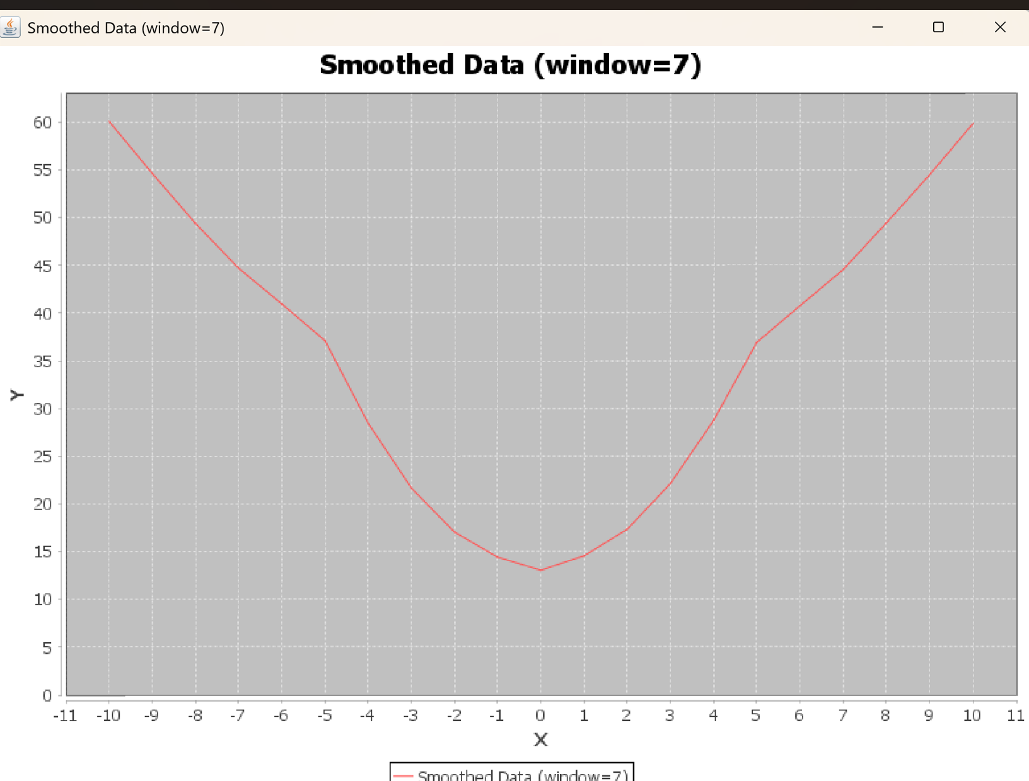 - Parses each line into x,y coordinates
- Handles file I/O exceptions

2. Data Salting (Adding Noise)
public void saltData(double range) {
for (Double[] point : data) {
double salt = (random.nextDouble() * 2 - 1) * range;
point[1] += salt;
}
}
- Adds random noise to y-values
- Noise range: [-range, +range]
- Uses uniform distribution
- Preserves x-values

3. Data Smoothing (Moving Average)
public void smoothData() {
ArrayList<Double[]> smoothedData = new ArrayList<>();
for (int i = 0; i < data.size(); i++) {
double sum = 0;
int count = 0;
for (int j = Math.max(0, i - windowValue); j <= Math.min(data.size() - 1, i + windowValue); j++) {
sum += data.get(j)[1];
count++;
}
smoothedData.add(new Double[]{data.get(i)[0], sum / count});
}
data = smoothedData;
}

- Applies moving average filter
- Window size: 2*windowValue + 1
- Handles edge cases
- Preserves x-values

4. Data Saving
public void saveData(String outputFile) throws IOException {
FileWriter writer = new FileWriter(outputFile);
writer.append("x,y\n");
for (Double[] point : data) {
writer.append(point[0] + "," + point[1] + "\n");
}
writer.close();
}

- Saves data to CSV
- Includes header
- Proper file closing

5. **Data Visualization:**
public void plotData(String title) {
XYSeriesCollection dataset = new XYSeriesCollection();
XYSeries series = new XYSeries(title);
// ... plotting code ...
}

- Creates interactive plots
- Customizable titles
- Multiple series support
- Interactive features:
- Zoom
- Pan
- Tooltips
- Legend

3. DataProcessorTester.java
This class tests the functionality of DataProcessor.
import java.io.IOException;

public class DataProcessorTester {
public static void main(String[] args) throws IOException {
DataProcessor processor = new DataProcessor();

// Test Case 1: Original Data
System.out.println("Plotting original data...");
processor.loadData("function_data.csv");
processor.plotData("Original Quadratic Function");

// Test Case 2: Different Salt Ranges
System.out.println("Testing different salt ranges...");
double[] saltRanges = {2.0, 5.0, 8.0};
for (double range : saltRanges) {
processor.loadData("function_data.csv");
processor.saltData(range);
processor.saveData("salted_range_" + range + ".csv");
processor.plotData("Salted Data (range=" + range + ")");
}

// Test Case 3: Smoothing with Different Window Sizes
System.out.println("Testing different smoothing windows...");
int[] windowSizes = {3, 5, 7};
for (int window : windowSizes) {
processor.loadData("salted_range_5.0.csv"); // Use moderately salted data
processor.smoothData();
processor.saveData("smoothed_window_" + window + ".csv");
processor.plotData("Smoothed Data (window=" + window + ")");
}

System.out.println("All tests completed!");
}
}

1. Test Cases:
- Original data visualization
- Multiple salt ranges:
- 2.0 (light noise)
- 5.0 (medium noise)
- 8.0 (heavy noise)
- Multiple smoothing windows:
- 3 (light smoothing)
- 5 (medium smoothing)
- 7 (heavy smoothing)

2. Output Files:
- Original: function_data.csv
- Salted: salted_data1.csv, salted_data2.csv, salted_data3.csv
- Smoothed: smoothed_data1.csv, smoothed_data2.csv, smoothed_data3.csv

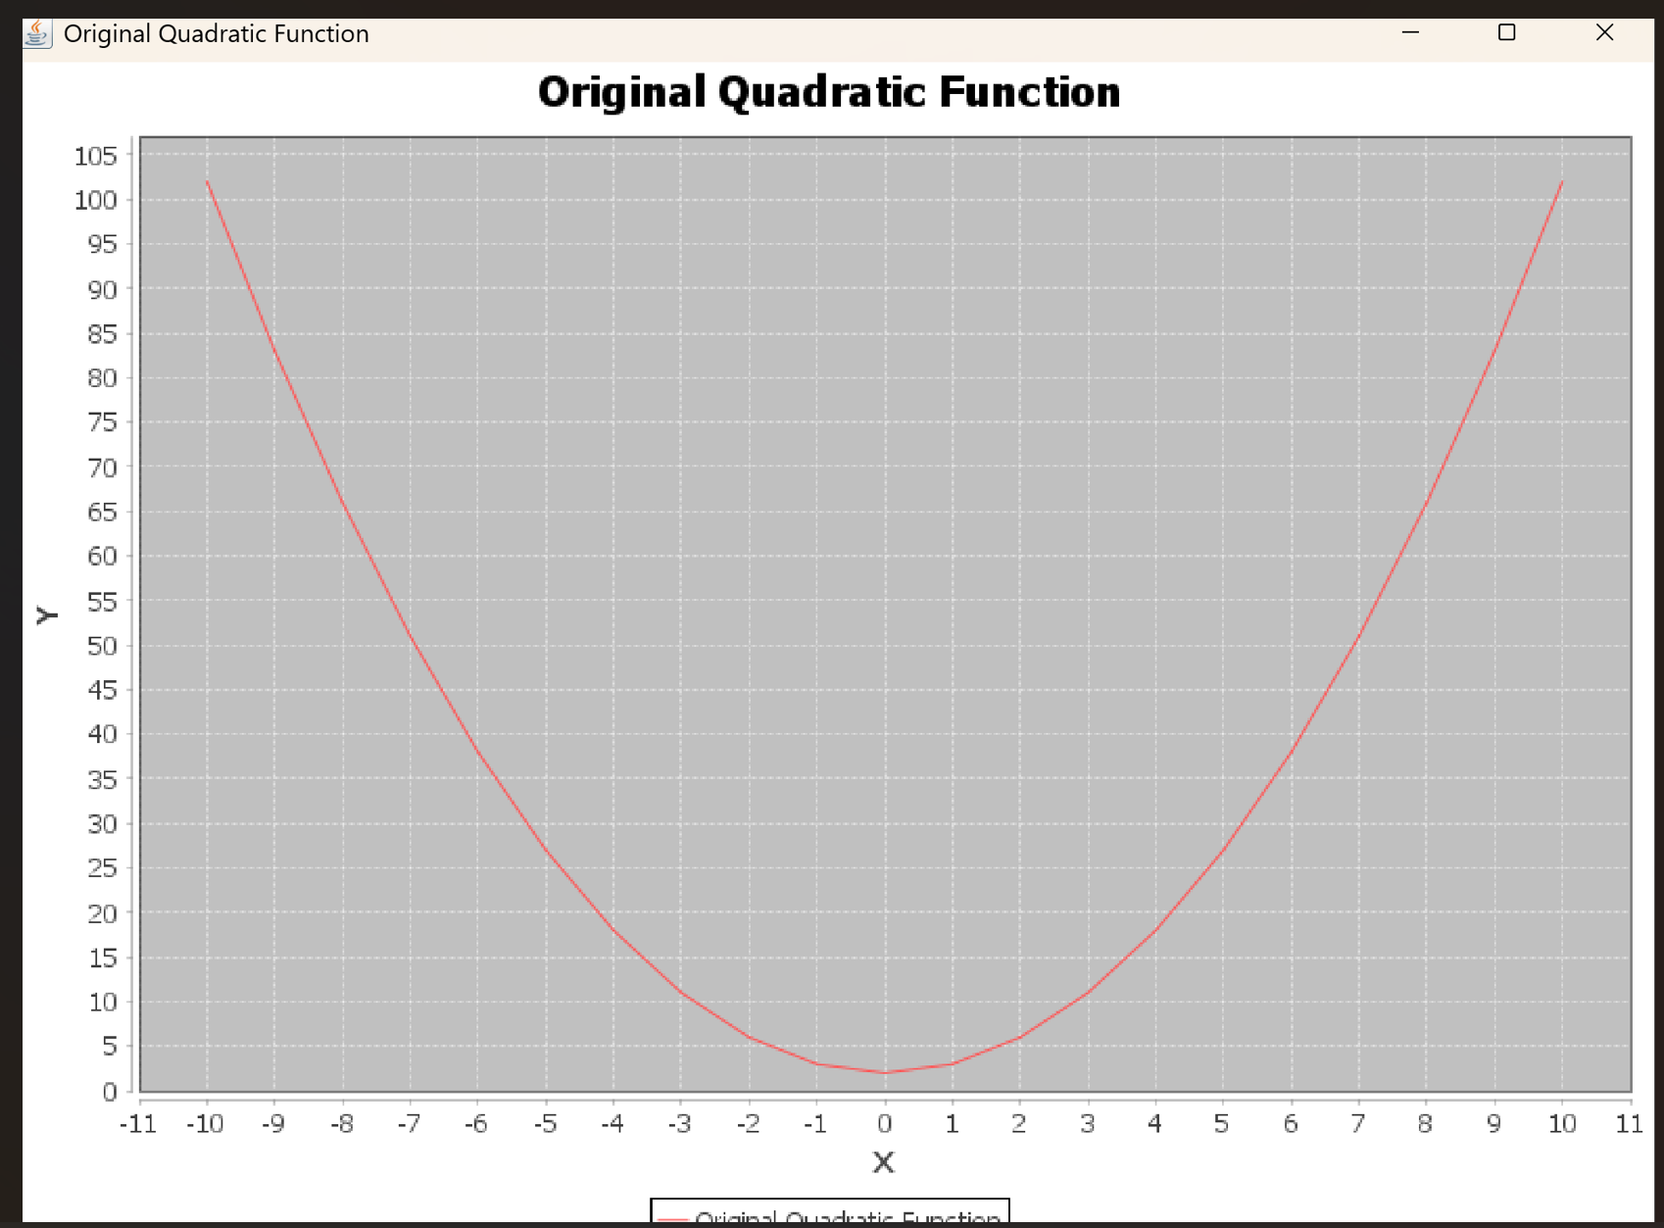
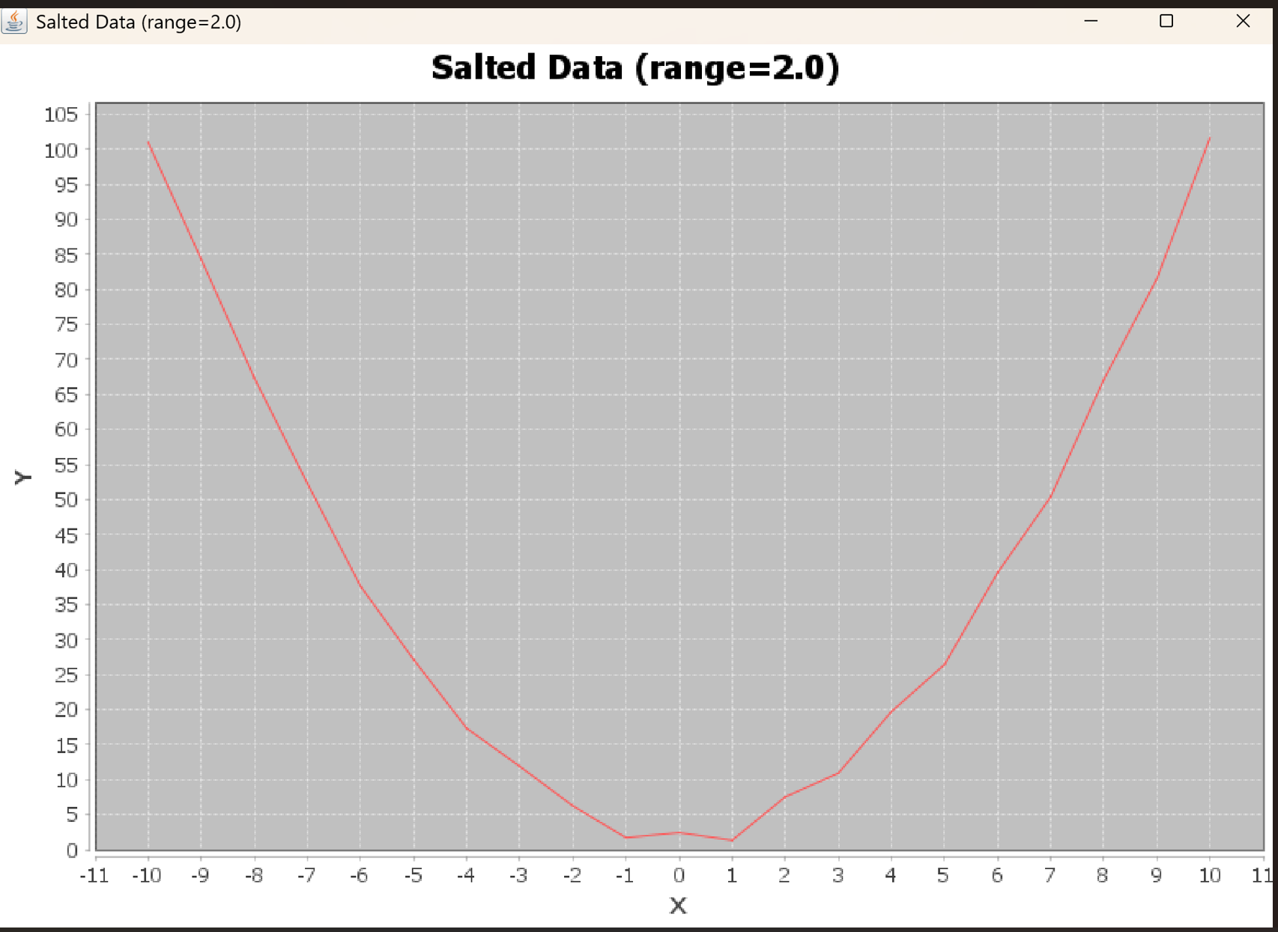

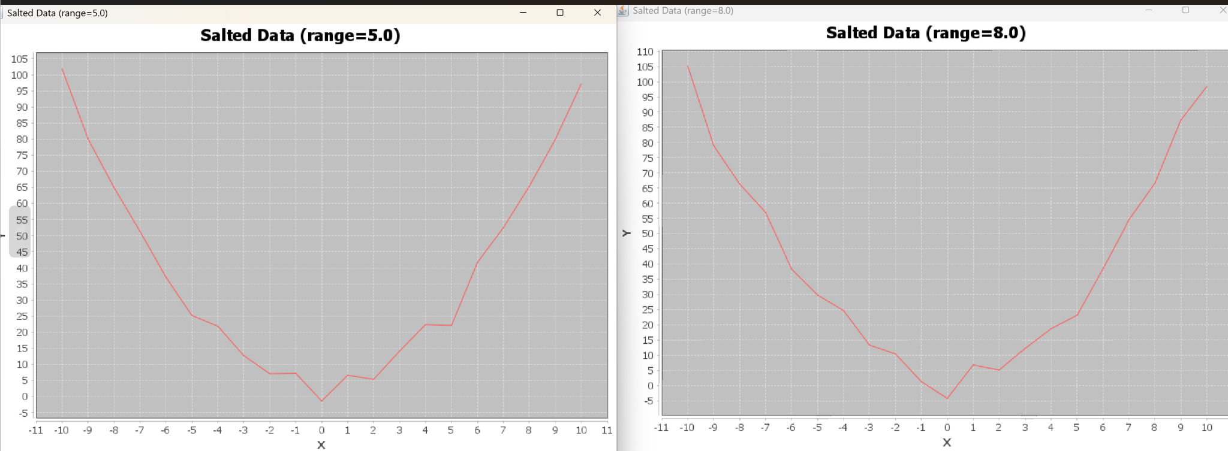
Smooth
