OCTAVE

GNU Octave is a free and open-source numerical computational environment that uses a high-level language, replacing MATLAB. Octave is a high-level computer language used to perform numerical calculations, matrices, and statistical computing. It excels at math calculations and features complex number support, matrix support, and support for a vast array of mathematical functions built-in. The software is especially valuable in education, scientific research, and engineering practice, available to students, researchers, and practitioners who need an efficient platform for numerical calculation and scientific simulation without the costs of licensing.

Octave's capabilities extend beyond mere calculations to include comprehensive data visualization through 2D/3D plotting, efficient file I/O for data import/export, and a vast package system (Forge) for users to extend its capabilities.

The users can perform signal processing, image analysis, and statistical analysis through built-in functions or packages. Octave is one of its kind as it is open-source and developed and maintained by a community of users with high compatibility with MATLAB syntax. The software permits structured programming through functions, loops, and conditionals and can be utilized for both simple calculations and complex numerical experiments. Using Octave, one is able to carry out a vast number of tasks such as: matrix manipulation and linear algebra operations; data analysis and visualization, statistical analysis; signal processing and Fourier analysis; image processing and computer vision operations; solving differential equations; polynomial operations, curve fitting; file I/O, data import/export in different formats (CSV, TXT, MAT); generating publication-quality graphs and plots; building graphical user interfaces (GUI); numerical optimization, root finding; and machine learning algorithm implementation.
The software also supports script automation, parallel processing, and interoperability with other programming languages, making it a comprehensive scientific computing and numerical analysis solution.
Tutorial
Learn GNU Octave under 10 Minutes
Control statements
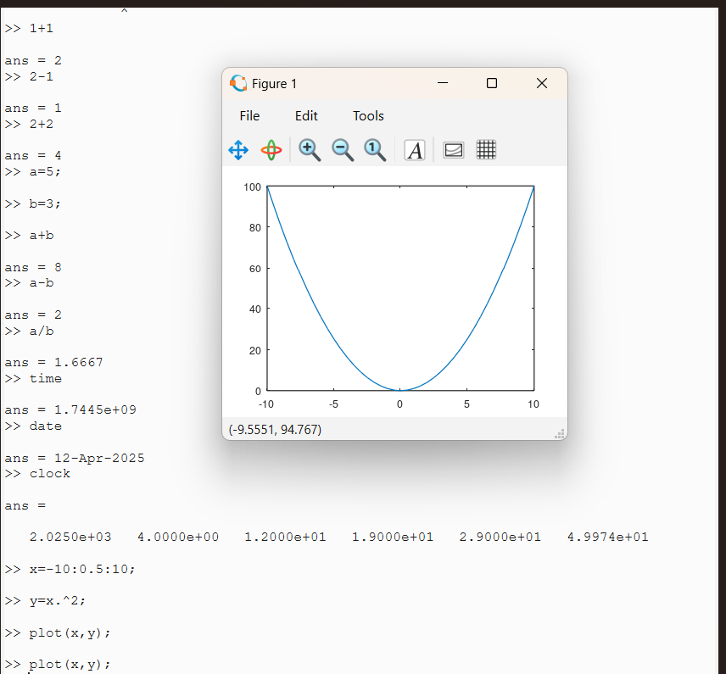
Octave Tutorial #5 - Control Statements
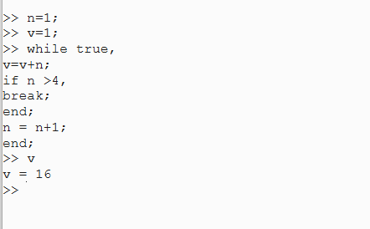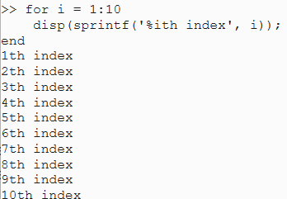
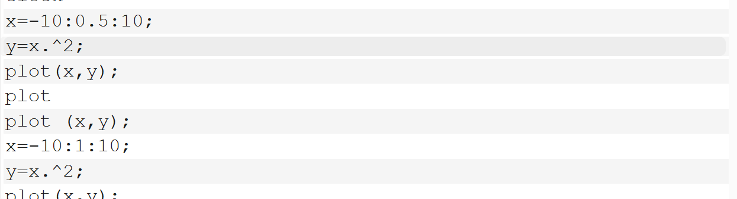

Overview
This set of files is designed to perform statistical analysis on a quadratic function. The process involves plotting the function, adding random noise (salting), and then smoothing the data. Each file has a specific role in this workflow, making it easy to understand and modify for different functions or parameters.

Files and Their Functions

1. plotter.m
Purpose:The plotter.m file is responsible for generating a quadratic function and saving the data to a CSV file. It creates a range of x-values from -10 to 10 in steps of 0.5 and calculates the corresponding y-values using the formula
$y=x^{2}$
. The data is then saved to a file named function_data.csv. This file is essential for setting up the initial data that will be used in subsequent steps of the analysis.
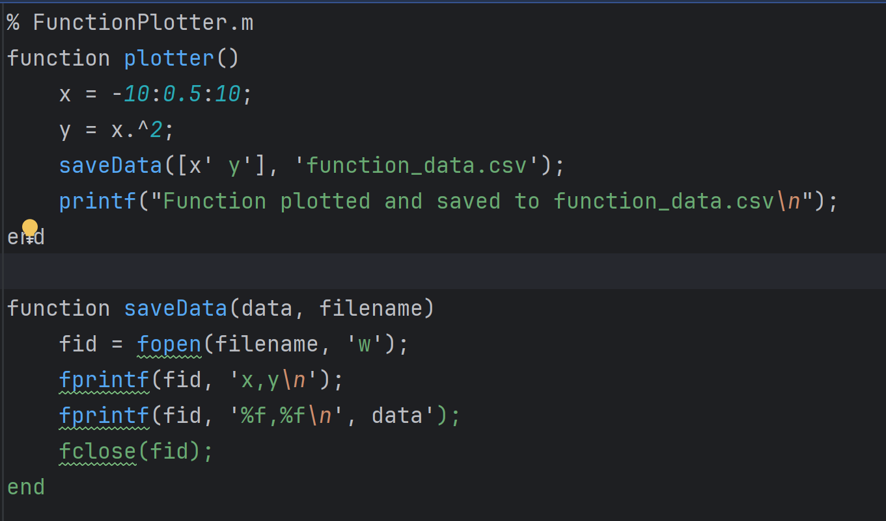

2. Salter.m
The Salter.m file adds random noise to the function data to simulate real-world data variability. It loads the original function data from function_data.csv and adds random noise to the y-values using different ranges (1.0, 2.0, and 3.0). The salted data is saved to three different CSV files: salted_data1.csv, salted_data2.csv, and salted_data3.csv. This step is crucial for understanding how noise affects the data and how it can be managed in statistical analysis.Example Usage:
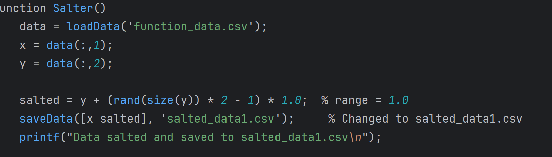

3. Smoother.m
The Smoother.m file smooths the salted data to reduce noise and highlight trends. It loads the salted data from the three CSV files and applies a moving average to the y-values to smooth the data. The smoothed data is saved to three different CSV files: smoothed_data1.csv, smoothed_data2.csv, and smoothed_data3.csv. This step is important for making the data more interpretable and for identifying underlying patterns.
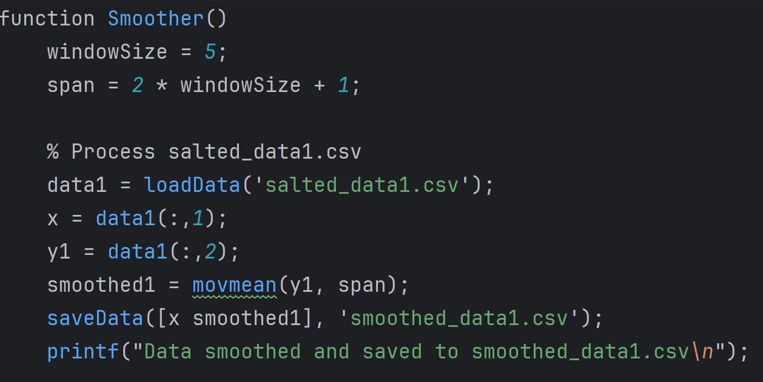
4. Tester.m
The Tester.m file executes the entire process, calling the other functions and plotting the results. It calls the plotter, Salter, and Smoother functions in sequence, loads all the data files (original, salted, and smoothed), and creates a plot to visualize the original function, the salted data, and the smoothed data.
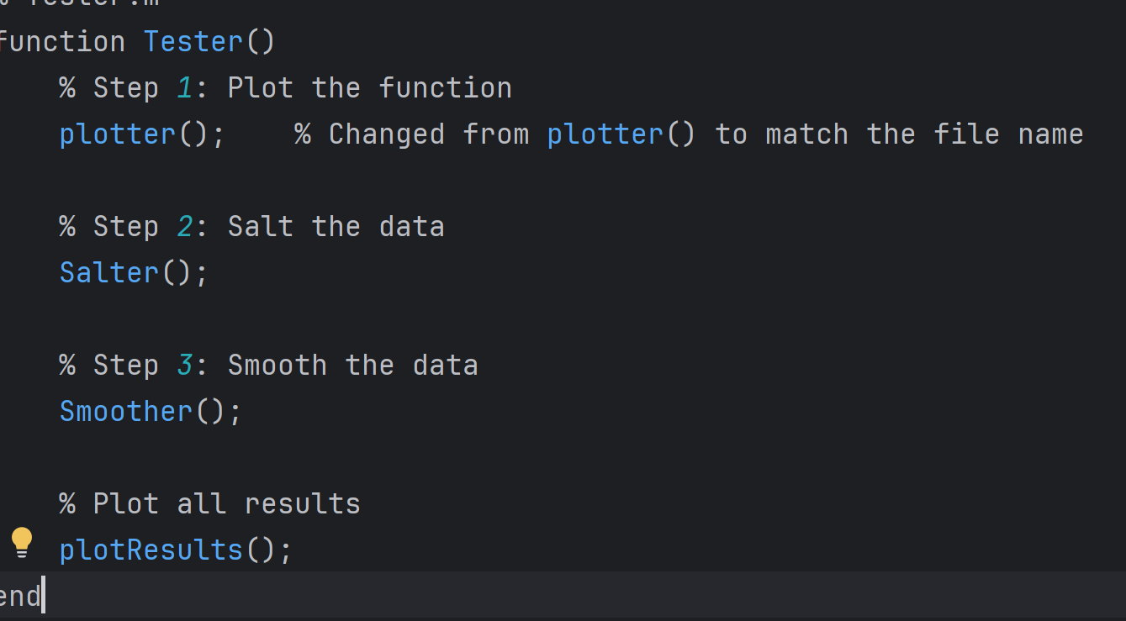
Plot results
The plotResults function is designed to visualize the results of a statistical analysis performed on a quadratic function. It starts by loading the original function data from function_data.csv, along with the salted data from salted_data1.csv, salted_data2.csv, and salted_data3.csv, and the smoothed data from smoothed_data1.csv, smoothed_data2.csv, and smoothed_data3.csv. The function then creates a new figure and plots the original function in blue with a solid line, the salted data in red, green, and magenta with dots, and the smoothed data in the same colors with solid lines. It enhances the plot by adding a legend to identify each line, enabling a grid for better readability, and setting a title and axis labels. This visualization helps users to easily interpret the results and understand the effects of adding noise (salting) and smoothing on the original function, making it clear how the different steps of the analysis affect the data.
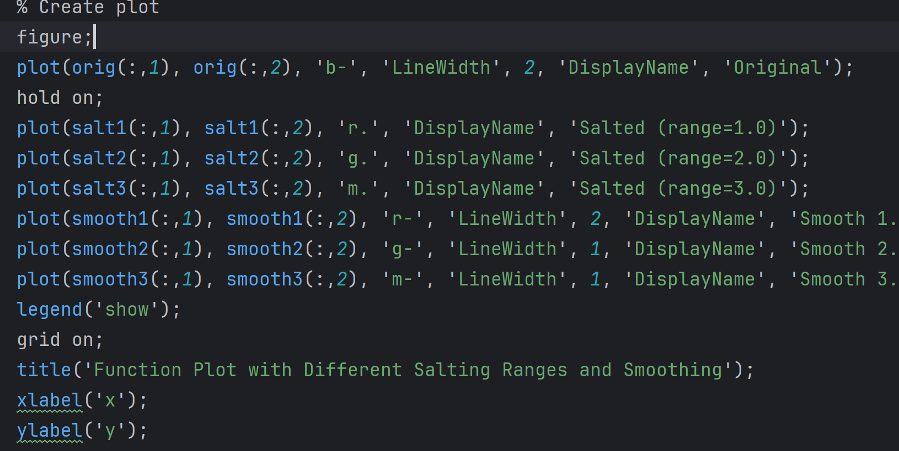
Results
