PSS1

DataHandler.java
The DataHandler class serves as the core data management component of the application, handling all data operations including loading, saving, and manipulating numerical data. It maintains data in an ArrayList of Double arrays, where each array contains x and y coordinates. The class provides functionality for loading data from CSV files, saving data to CSV files, generating function plots (specifically $y=x^{2}$), adding random noise to data points (salting), and smoothing data using a moving average window. The class implements error handling for file operations and includes methods for data transformation. It acts as the central data processing unit that other classes utilize for their specific operations.public void loadData(String inputFile) throws IOException {
data.clear();
Scanner fileScanner = new Scanner(new File(inputFile));
if (fileScanner.hasNextLine()) {
fileScanner.nextLine(); // Skip header
}
while (fileScanner.hasNextLine()) {
String[] line = fileScanner.nextLine().split(",");
double x = Double.parseDouble(line[0]);
double y = Double.parseDouble(line[1]);
data.add(new Double[]{x, y});
}
fileScanner.close();
}

public void plotter() throws IOException {
for (double x = -10; x <= 10; x += 0.5) {
double y = Math.pow(x, 2);
data.add(new Double[]{x, y});
}
saveData("function_data.csv");
}

public void salter(double range) throws IOException {
for (Double[] point : data) {
double salt = (random.nextDouble() * 2 - 1) * range;
point[1] += salt;
}

}

public void smoother(int windowValue) throws IOException {
ArrayList<Double[]> smoothedData = new ArrayList<>();
for (int i = 0; i < data.size(); i++) {
double sum = 0;
int count = 0;
for (int j = Math.max(0, i - windowValue); j <= Math.min(data.size() - 1, i + windowValue); j++) {
sum += data.get(j)[1];
count++;
}
smoothedData.add(new Double[]{data.get(i)[0], sum / count});
}
data = smoothedData;

}

public void saveData(String outputFile) throws IOException {
FileWriter writer = new FileWriter(outputFile);
writer.append("x,y\n");
for (Double[] point : data) {
writer.append(point[0] + "," + point[1] + "\n");
}
writer.close();
}

FunctionPlotter.java
The FunctionPlotter class is responsible for generating the initial mathematical function data, specifically plotting y = x² over the range from -10 to 10 with steps of 0.5. This class creates the baseline data that will be used for subsequent operations. It utilizes the DataHandler class to generate and save the function data to a CSV file named "function_data.csv". The class represents the first step in the data processing pipeline, establishing the original, unmodified function data that will later be subjected to salting and smoothing operations.
ublic class FunctionPlotter {
public void plot() throws IOException {
DataHandler handler = new DataHandler();
handler.plotter();
System.out.println("Function plotted and saved to function_data.csv");
}
}

Salter.java
The Salter class implements data perturbation functionality by adding random noise to the original function data. It reads the function data created by FunctionPlotter, applies random variations (salt) to the y-values using different ranges of noise (1.0, 2.0, and 3.0), and saves the results to separate CSV files. This class demonstrates how to introduce controlled randomness to a dataset, which is useful for testing data smoothing algorithms or simulating real-world data noise. The salting process creates three different versions of the data with increasing levels of noise, allowing for comparison of different noise impacts.
public void salt() throws IOException {
DataHandler handler = new DataHandler();
handler.loadData("function_data.csv");
handler.salter(1.0);
handler.saveData("salted_dat.csv");
System.out.println("Data salted and saved to salted_data.csv");
}

Smoother.java
The Smoother class implements data smoothing functionality using a moving average algorithm to reduce noise in the salted data. It reads the salted data files and applies a smoothing window to reduce the random variations introduced by the Salter class. The smoothing process helps to recover the original trend of the data by averaging out the noise. This class represents the final step in the data processing pipeline, demonstrating how to clean up noisy data and save the results to new CSV files. The smoothing window size can be adjusted to control the level of smoothing applied to the data.
public void smooth() throws IOException {
DataHandler handler = new DataHandler();
handler.loadData("salted_data.csv");
handler.smoother(5);
handler.saveData("smoothed_dat.csv");
System.out.println("Data smoothed and saved to smoothed_data.csv");
}
}

1. FunctionPlotter generates the original data
2. Salter adds noise to the data
3. Smoother reduces the noise
4. DataHandler provides the underlying data management functionality

Tester
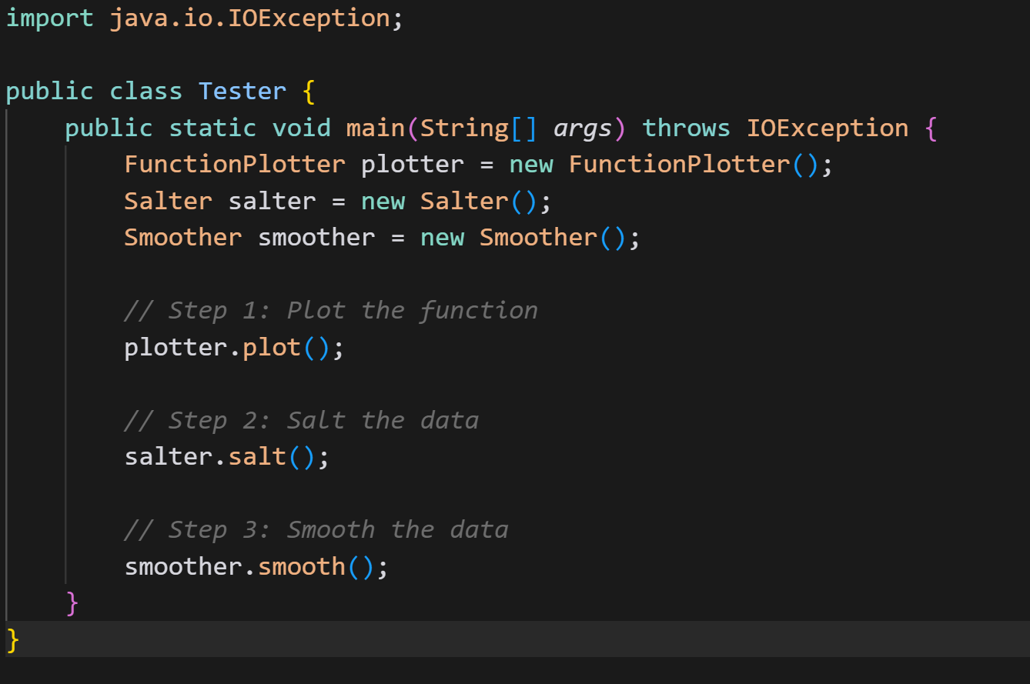
THis results in creation of the csv files .

