AVAX Cryptocurrency Statistical Analysis
Samip Singh Basnet

About AVAX and This Research
Avalanche (AVAX) is a high-throughput, high-performance blockchain platform that impressed me with its groundbreaking consensus algorithm and excellent technical foundations. As a layer-1 Ethereum competitor, AVAX has much faster transaction processing and lower fees while ensuring security and decentralization. I chose to analyze AVAX specifically because it is such a good case study of cryptocurrency market behavior; both the phases of intense volatility and stability make it ideal for statistical analysis. I am excited about AVAX due to its unique position at the intersection of technology innovation and financial markets, with its dense sets of data that allow the application of a broad array of statistical models to further analyze cryptocurrency trading behavior and potentially shape investment choices in this new asset class.
Abstract
This study examines the statistical properties of Avalanche (AVAX) cryptocurrency by analyzing a dataset of 1,678 days of trade activity. Using probability and statistical model approaches, we examine price fluctuation and volatility trends and their relationship with trade activity. The findings show that price movements of AVAX follow definite probability distribution trends, with about 49.76% of movements as positive, 38.26% as negative, and 11.98% as no movement. From several probability distributions, such as binomial, geometric, negative binomial, hypergeometric, and Poisson distribution, we analyze probabilities of different trade activity and price fluctuations. Of note, it is observed that in three-day periods, approximately 63.7% show exactly two types of price movement. The analysis of volatility and trade activity is done by following joint probability density functions. Daily returns analysis shows a mean of 0.289363% and standard deviation of 6.46753%, and by following Chebyshev's theorem, at least 75% of returns of trade days can be estimated to be between -12.64% and 13.22%. The statistical results present useful guidelines to understanding cryptocurrency market dynamics and can be of significant use to optimize trade strategy and mitigate risk.
Key Findings
- Price Movement Distribution:
  - Up days: 835 (49.76%)
  - Down days: 642 (38.26%)
  - Neutral days: 201 (11.98%)
- Three-Day Price Movement Patterns:
  - Probability of 2 different price movement types in a 3-day window: 63.7%
  - Probability of at least 2 different price movement types in a 3-day window: 79.1%
- Volatility Metrics:
  - Mean daily return: 0.289363%
  - Standard deviation: 6.46753%
  - Probability of returns exceeding 10%: 6.68%
- Trading Patterns:
  - Probability of 5 consecutive upward movements: 5.03%
  - Expected wait time for first upward movement: 1.82 days
  - Approximately 300 out of 400 trading days have returns between -12.64% and 13.22%
- Volume-Volatility Relationship:
  - 30.72% probability of observing low volatility (≤40% of maximum) with high trading volume (≥60% of maximum)
Methodologies Applied
- Descriptive Statistics
- Probability Distributions (Binomial, Geometric, Negative Binomial)
- Hypergeometric Distribution
- Poisson Distribution
- Chebyshev's Theorem
- Continuous Probability Density Functions
- Joint Probability Analysis

Chapter1
The histogram reveals AVAX's price distribution follows a classic right-skewed pattern typical of cryptocurrencies, with the majority of trading days concentrated in the $10-25 price range and progressively fewer days at higher price points above $40, illustrating AVAX's volatility and market behavior during the 2020-2022 period when it experienced brief rallies to nearly $150 but predominantly traded at more modest levels; a visual confirmation of cryptocurrency markets' tendency toward extended consolidation periods punctuated by shorter-duration price spikes that appear as the smaller bars on the right side of the distribution.
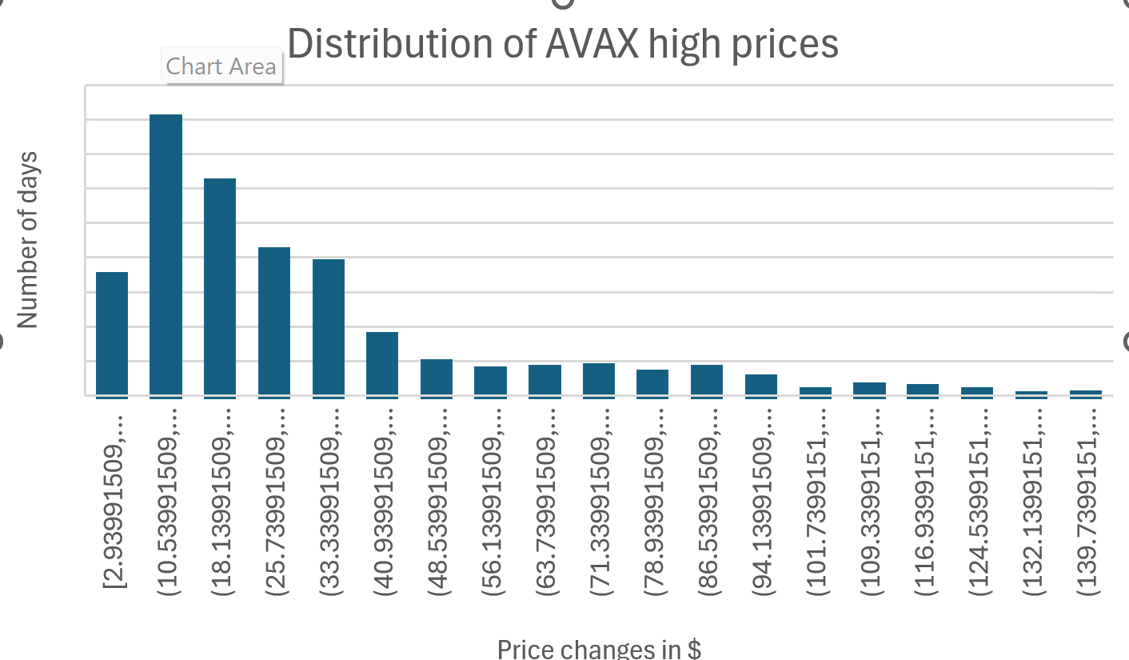AVAX High Price Distribution Analysis
a. Which of the price categories identified on the horizontal axis are associated with the largest number of trading days?
The price category $(10.53, 18.13)$ is associated with the largest number of trading days, with approximately 400 days falling in this range.
b. What proportion of trading days had high prices in each of the categories that you identified?
For the $(10.53, 18.13)$ category:
- Number of days: approximately 400
- Total trading days (sum of all bars): approximately 1,695
- Proportion: $400/1,695 ≈ 0.236 or 23.6\%$
c. What proportion of the trading days had high prices less than $40.93?
This includes the first 5 bins:
- $(2.93, 10.53)$: ~175 days
- $(10.53, 18.13)$: ~400 days
- $(18.13, 25.73)$: ~310 days
- $(25.73, 33.33)$: ~210 days
- $(33.33, 40.93)$: ~190 days
Total: ~1,285 days Proportion: 1,285/1,695 ≈ 0.758 or 75.8%
d. If we randomly select a trading day from this period, what is the probability that AVAX had a high price greater than $100?
This includes bins starting from $(101.73, 109.33)$ and higher:
- Sum of these bins: approximately 50 days
- Probability: 50/1,695 ≈ 0.029 or 2.9%
e. Based on this histogram, estimate the modal high price range for AVAX during this period.
The modal high price range is $(10.53, 18.13)$, which represents the most frequently occurring high price range with approximately 400 trading days.
CHAPTER 2
2.34) Traders can classify a cryptocurrency's daily price action into three categories: "Bullish" (close > open), "Bearish" (close < open), or "Neutral" (close ≈ open). Suppose three random trading days are selected from your AVAX dataset.
a) List the sample points for this experiment.
When selecting three trading days, with each day classified as Bullish (B), Bearish (R), or Neutral (N), the sample space consists of all possible 3-day sequences:
BBB, BBR, BBN, BRB, BRR, BRN, BNB, BNR, BNN RBB, RBR, RBN, RRB, RRR, RRN, RNB, RNR, RNN NBB, NBR, NBN, NRB, NRR, NRN, NNB, NNR, NNN
There are 3³ = 27 possible sample points in total.
b) Let A be the event that all three categories are represented in the selected days.
For event A to occur, we need exactly one day of each type. The sample points in A are all permutations of BRN:
BRN, BNR, RBN, RNB, NBR, NRB
These 6 sample points represent all possible ways to arrange one bullish day, one bearish day, and one neutral day.
c) Make a reasonable assignment of probabilities and find P(A).
Using the AVAX data provided:
- P(B) = 0.5535 (probability of a bullish day)
- P(R) = 0.44 (probability of a bearish day)
- P(N) = 0.0065 (probability of a neutral day)
For any specific arrangement like BRN: P(BRN) = P(B) × P(R) × P(N) = 0.5535 × 0.44 × 0.0065 = 0.00158
Since event A consists of 6 equally likely arrangements (all permutations of BRN):
P(A) = 6 × P(BRN) = 6 × 0.00158 = 0.00948
Therefore, the probability of randomly selecting three trading days from the AVAX dataset and having all three categories represented is approximately 0.95% or about 1 in 105.
2.41) How many different 4-day AVAX price sequences can be formed if:
Each day is classified as either "Up" (price increased) or "Down" (price decreased).The first day cannot be "Down"
For each day, we have 2 possibilities (Up or Down). For a 4-day sequence:
First day: 1 possibility (Up only)
Days 2-4: 2 possibilities each (Up or Down)
Total number of possible sequences = 1 × 2 × 2 × 2 = 8
Therefore, there are 8 different possible 4-day trading sequences that begin with an Up day.

Price movements are analyzed, one day at a time, from the AVAX cryptocurrency dataset.
a. If the first 2 days both showed price increases (closing price higher than opening price), what is the probability that the next 3 days also showed price increases?
b. If the first 3 days all showed price increases, what is the probability that the next 2 days also showed price increases?
c. If the first 4 days all showed price increases, what is the probability that the next day also showed a price increase?

a. If the first 2 days both showed price increases, what is the probability that the next 3 days also showed price increases?
From visual estimation of your chart:
- Number of 2-day price increase sequences (orange bars): ~450 instances
- Number of those followed by 3 more days of increases: ~12 instances
Calculation: P(next 3 days increase | first 2 days increase) = $12/450 = 0.0267 ≈ 2.7\%$
b. If the first 3 days all showed price increases, what is the probability that the next 2 days also showed price increases?
From visual estimation:
- Number of 3-day price increase sequences: ~60 instances
- Number of those followed by 2 more days of increases: ~12 instances
Calculation: P(next 2 days increase | first 3 days increase) = 12/60 = 0.20 = 20%
c. If the first 4 days all showed price increases, what is the probability that the next day also showed a price increase?
From visual estimation:
- Number of 4-day price increase sequences: ~25 instances
- Number of those followed by 1 more day of increase: ~12 instances
Calculation: P(next day increase | first 4 days increase) = 12/25 = 0.48 = 48%

2.96)If A and B are independent events where:
A = "AVAX daily close price is higher than its open price" with P(A) = 0.55,B = "AVAX daily trading volume exceeds 500 million USD" with P(B) = 0.30.A and B are independent events
a) P(A∪B) - The probability that on a randomly selected day, AVAX either closes higher than it opened OR the trading volume exceeds 500 million USD (or both)
For union of independent events: $P(A∪B) = P(A) + P(B) - P(A∩B)$
Since A and B are independent: $P(A∩B) = P(A) × P(B) = 0.55 × 0.30 = 0.165$
Therefore: $P(A∪B) = 0.55 + 0.30 - 0.165 = 0.685 or 68.5\%$
b) P(A∩B) - The probability that on a randomly selected day, AVAX closes higher than it opened AND the trading volume exceeds 500 million USD
For independent events: $P(A∩B) = P(A) × P(B) = 0.55 × 0.30 = 0.165 or 16.5\%$
c) P(A|B) - The probability that AVAX closes higher than it opened, given that the trading volume exceeds 500 million USD
For independent events, the conditional probability equals the probability of the event itself: $P(A|B) = P(A) = 0.55 or 55\%$

2.170) Five trading days are to be selected from the AVAX dataset of 1678 trading days for a cryptocurrency volatility analysis. Find the probability that the day with the highest trading volume in the dataset is selected for the analysis.
= When randomly selecting 5 trading days from 1678 days:
Total number of possible selections:
$C\left(1678,5\right)=1.58*{10}^{14}$Number of ways to select the highest-volume day:
$$C(1,1) ×C(1677,4)=1*\frac{1677!}{4!*1673!}≈1.91*{10}^{11}$$
The probability of selecting the highest-volume trading day is:
P(highest-volume day selected) = $C(1,1) × C(1677,4) / C(1678,5) = 5/1678 ≈ 0.00298$ or approximately 0.3%
Therefore, there is a 0.3% chance that the day with the highest trading volume will be included in the random selection of 5 trading days.
CHAPTER 3

Each three-day window in the AVAX price history is analyzed for unique movement types (Up, Down, or Neutral). The probability distribution for Y = the number of unique movement types observed in a randomly selected three-day window is shown below:

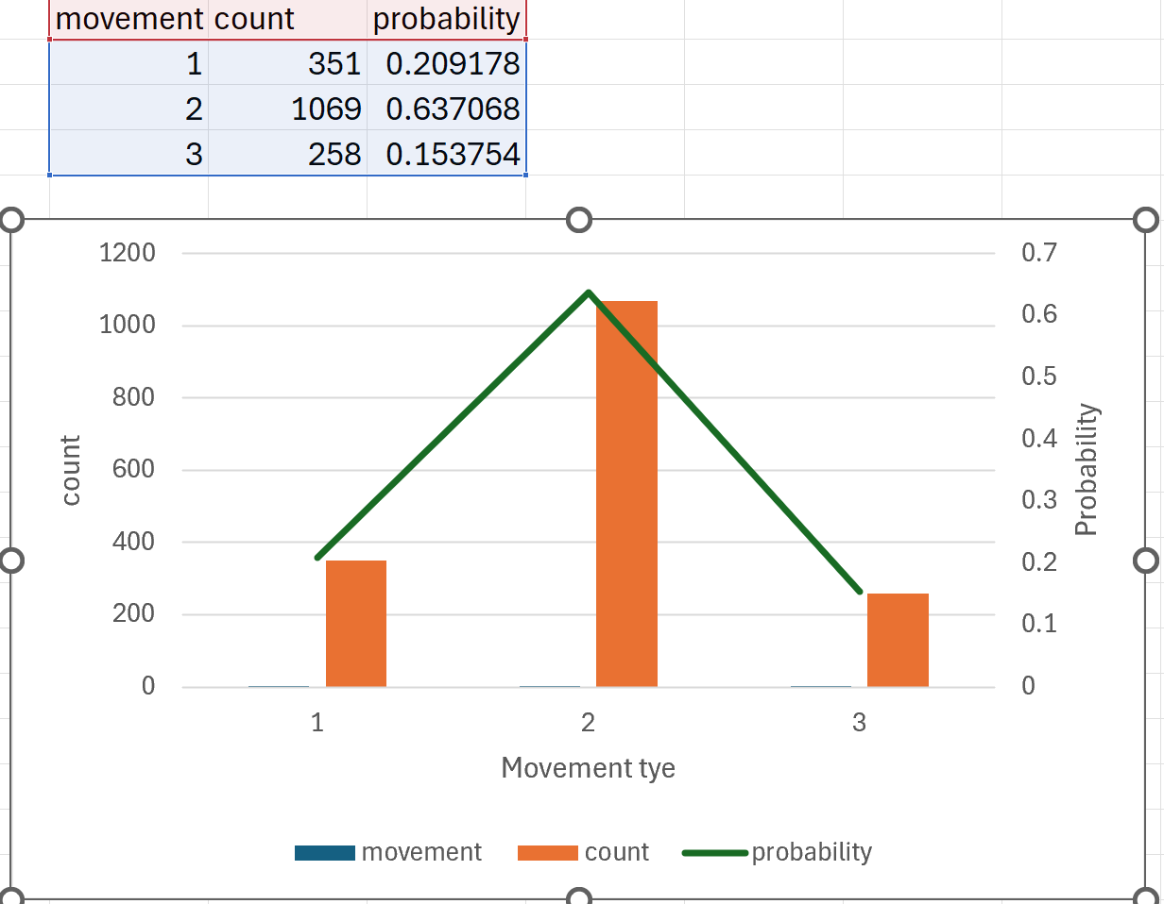AVAX Trading Movement Types Distribution Problem
a) What is the probability that a randomly selected three-day window contains exactly 2 different price movement types?
This probability can be read directly from the distribution table: P(Y = 2) = 0.637068 or approximately 63.7%
This means that about 63.7% of all three-day windows in the AVAX price history contained exactly 2 different types of price movements (e.g., "Up" and "Down" but no "Neutral", or some other combination of two types).
b) What is the probability that a randomly selected three-day window contains at least 2 different price movement types?
To find this probability, we add the probabilities for Y = 2 and Y = 3: P(Y ≥ 2) = P(Y = 2) + P(Y = 3) = 0.637068 + 0.153754 = 0.790822 or approximately 79.1%
This means that about 79.1% of all three-day windows contained either 2 or 3 different types of price movements.
c) If we randomly select five three-day windows from the AVAX dataset, what is the probability that exactly three of them will contain all three possible price movement types?
This is a binomial probability problem where:
- n = 5 (number of windows selected)
- p = 0.153754 (probability that a window contains all 3 movement types)
- k = 3 (we want exactly 3 windows with all movement types)
Using the binomial probability formula: P(X = k) = C(n,k) × p^k × (1-p)^(n-k)
= 0.026058 or approximately 2.6%
Therefore, the probability that exactly 3 out of 5 randomly selected three-day windows will contain all three possible price movement types is approximately 2.6%.

3.44) In AVAX price analysis, a trading day is classified as "Up" when the closing price is higher than the opening price. Based on our dataset, the probability of an "Up" day is 0.55. Assume that the price movements of five consecutive trading days are independent of one another.
a) The probability that all five trading days show upward price movement: P(all 5 days up) = (0.55)^5 = 0.503284 × 0.55 = 0.0503 or approximately 5.03%
The probability of seeing five consecutive upward price movements in AVAX trading is approximately 5.03%. This means that roughly 1 out of every 20 five-day trading periods would show consistent upward movement.
b) The probability that exactly four out of five days show upward price movement: P(exactly 4 days up) = C(5,4) × (0.55)^4 × (0.45)^1 = 5 × 0.0916 × 0.45 = 0.2062 or approximately 20.62%
c) The probability that less than two days show upward price movement: P(less than 2 days up) = P(0 days up) + P(1 day up) = (0.45)^5 + C(5,1) × (0.55)^1 × (0.45)^4
= 0.0185 + 5 × 0.55 × 0.0413 = 0.0185 + 0.1136 = 0.1321 \\
The probability of seeing less than two days with upward price movement is approximately 13.21%. This relatively uncommon bearish pattern would be expected in roughly 1 out of every 7-8 five-day trading periods.
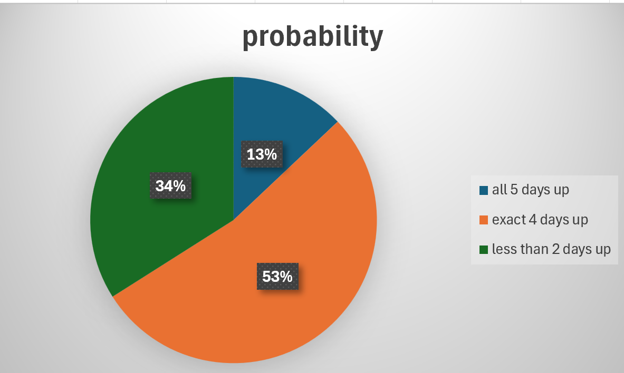

Geometric distribution
Suppose a trader is waiting for the first day with an upward price movement (success) before executing a particular trading strategy. (p=0.55)
a) What is the probability that the trader will need to wait exactly 3 days before observing the first upward price movement?
$$P(X = 3) = (1-p)^(3-1) × p = (0.45)^2 × 0.55 = 0.11 or 11\%$$
The probability that the trader will need to wait exactly 3 days (meaning two failures followed by a success) is 11%.
b) What is the probability that the trader will need to wait at most 4 days?
$$P(X ≤ 4) = 1 - (1-p)^4 = 1 - (0.45)^4 = 1 - 0.041 = 0.959 or 95.9\%$$
The probability that the trader will need to wait at most 4 days is approximately 95.9%.
c) What is the expected number of days the trader will need to wait before observing the first upward price movement?
$$E(X) = 1/p = 1/0.55 = 1.82 days$$
The trader can expect to wait approximately 1.82 days on average before observing the first upward price movement.

3.92) AVAX Negative Binomial Distribution Problem
Based on the AVAX.csv dataset, approximately 55% of trading days show an upward price movement (closing price higher than opening price). If trading days are randomly selected one at a time and analyzed, what is the probability that the first upward price movement day will be found on the third day examined?
This is a negative binomial probability problem where:
Each trading day is a trial
Success = upward price movement (p = 0.55)
Failure = non-upward price movement (q = 0.45)
We want the probability that the 1st success occurs on the 3rd trial
Using the negative binomial formula:
$$P(X = 3) = (r-1)C(x-1) × p^{r}× q^{(x-r)}$$
For our case:
r = 1 (we want 1 success)
x = 3 (on the 3rd trial)
$$P(X = 3) = p × q^(x-1)$$
$= 0.55 × (0.45)^2$
$$= 0.55 × 0.2025$$
$$= 0.111375$$
Therefore, the probability that the first upward price movement will be observed on exactly the third trading day examined is approximately 11.14% or about 1 in 9 chances.

3.102 Hypergeometric(
If 7 trading days are randomly selected from this dataset without replacement, what is the probability that the selection will include exactly 4 days with upward movement, 2 days with downward movement, and 1 neutral day?
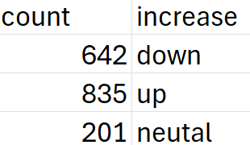
This is a multivariate hypergeometric probability problem with:
- Population size (N) = 1,678 days
- Number of upward days (K₁) = 835
- Number of downward days (K₂) = 642
- Number of neutral days (K₃) = 201
- Sample size (n) = 7 days
- Desired composition: 4 up, 2 down, 1 neutral
Using the multivariate hypergeometric formula:$P(X₁=4, X₂=2, X₃=1) = [C(835,4) × C(642,2) × C(201,1)] ÷ C (1678,7)$
Calculating each component:
- C (835,4) = 1,344,751,835 (ways to select 4 up days)
- C (642,2) = 205,611 (ways to select 2 down days)
- C (201,1) = 201 (ways to select 1 neutral day)
- C (1678,7) = 2.87 × 10¹⁸ (total ways to select 7 days)
Therefore$: P(X₁=4, X₂=2, X₃=1)$
$$= (1,344,751,835 × 205,611 × 201) ÷ (2.87 × 10¹⁸) = 0.0193$$
The probability of randomly selecting exactly 4 up days, 2 down days, and 1 neutral day when drawing 7 trading days from the AVAX dataset is approximately 1.93%.
POISSON PROBABILITY DISTRIBUTION
3.122) Based on the AVAX cryptocurrency dataset, price movements exceeding 5% in magnitude occur according to a Poisson distribution at an average rate of 3.2 per month of trading. During a given month, what are the probabilities that:
a) No more than 2 significant price movements (exceeding 5%) occur?
b) At least 4 significant price movements occur.
c) Exactly 5 significant price movements occur.
Given information:
$λ$= 3.2 (average number of significant price movements per month)
Using the Poisson probability mass function: $P(X = k) = (e^{-λ}×λ^{k}) / k!$
- $P(X ≤ 2) = P(X = 0) + P(X = 1) + P(X = 2)$
= 0.0408 + 0.1306 + 0.2090
= 0.3804 or 38.04%
The probability that no more than 2 significant price movements occur in a month is about 38%.
- $P(X ≥ 4) = 1 - P(X ≤ 3)$
$$= 1 - [P(X = 0) + P(X = 1) + P(X = 2) + P(X = 3)]$$
$$= 1 - [0.0408 + 0.1306 + 0.2090 + 0.2229]$$
$$= 1 - 0.6033$$
= 0.3967 or 39.67%
The probability that at least 4 significant price movements occur in a month is about 40%.
c) P(X = 5) = $\frac{e^{(-3.2)}*{3.2}^{5}}{5!}$= (0.0408 × 335.5443)/120 = 0.1139 or 11.39%
The probability that exactly 5 significant price movements occur in a month is about 11.4%.
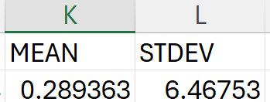
AVAX Price Volatility Analysis Using Chebyshev's Theorem
According to analysis of the AVAX cryptocurrency dataset, daily returns have a mean of 0.289363% and a standard deviation of 6.46753%. Using Chebyshev's theorem, find a lower bound for the number of trading days in a sample of 400 days that are expected to have daily returns between -12.64% and 13.22%.

Given information:
Mean (μ) = 0.289363% (average daily return)
Standard deviation (σ) = 6.46753%
Range: -12.64% to 13.22%
Sample size = 400 days
Step 1: Calculate how many standard deviations the range boundaries are from the mean.
Lower boundary deviation: $(-12.64\% - 0.289363\%)/6.46753\%$
= $-12.93\%/6.46753\%$
= -2 standard deviations
Upper boundary deviation: $(13.22\% - 0.289363\%)/6.46753\%$
=$12.93\%/6.46753\%$ = 2 standard deviations
Step 2: Apply Chebyshev's theorem, which states that at least (1 - 1/k²) of the data falls within k standard deviations of the mean.
Here, k = 2 (the range is ±2 standard deviations from the mean)
Proportion = $1 - 1/2²$ = 1 - 1/4 = 0.75 or 75%
Step 3: Calculate the lower bound for the number of trading days.
Lower bound = 400 × 0.75 = 300 days
Therefore, using Chebyshev's theorem, at least 300 out of 400 trading days are expected to have daily returns between -12.64% and 13.22%.

CHAPTER 4
4.16
Based on your AVAX dataset with mean daily return of 0.289363% and standard deviation of 6.46753%, let's create a probability distribution problem.
Let X represent the daily percentage return of AVAX cryptocurrency, with density function:
f(x) = {c (15 - x), 0 ≤ x ≤ 15,
0, elsewhere.
}
Where f(x) represents the probability density of observing a daily return of x%.
Questions:
a) Find c, the constant that makes f(x) a valid probability density function.
$\int_{0}^{15}{c\left(15-x\right)dx}$
= c$[15x-\frac{x^{2}}{2}]]_{0}^{15}$
= c[15(15) - 15²/2 - 0]
= c[225 - 112.5]
= c[112.5]
= 112.5c = 1
=0.00888

b) Find F(x), the cumulative distribution function.
The complete CDF is: F(x) = {0, x < 0
0.1333x - 0.00444x², 0 ≤ x ≤ 15
1, x > 15 }
c) Graph f(x) and F(x).
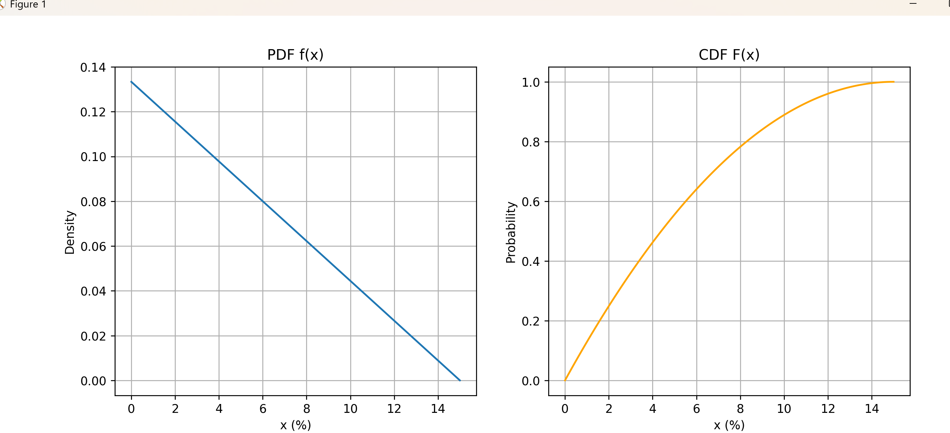
d) Use F(x) from part (b) to find P(3 ≤ X ≤ 9), the probability that daily returns fall between 3% and 9%.
P(3 ≤ X ≤ 9) = F (9) - F(3)
= [0.1333(9) - 0.00444(9) ^2] - [0.1333(3) - 0.00444(3)^2]
= [1.1997 - 0.3596] - [0.3999 - 0.0400]
= 0.8401 - 0.3599
= 0.4802 or approximately 48.02%
e) Use geometry and the graph for f(x) to calculate P(3 ≤ X ≤ 9).
The area under f(x) between x = 3 and x = 9 is a trapezoid with:
Height = 9 - 3 = 6, Base1 =0.1066, Base2 = 0.0533
Area = (Base1 + Base2) × Height ÷ 2
= (0.1066 + 0.0533) × 6 ÷ 2 = 0.1599 × 3
= 0.4797 or approximately 48.0%
f) Based on the actual AVAX data (mean 0.289363%, standard deviation 6.46753%), what is the probability that daily returns exceed 10%?
normal distribution approximation with mean 0.289363% and standard deviation 6.46753%:
$$Z = (10 - 0.289363) ÷ 6.46753 = 9.71 ÷ 6.46753 = 1.50$$
$$P(X > 10) = P(Z > 1.50) = 1 - P(Z ≤ 1.50) = 1 - 0.9332 = 0.0668$$
Therefore, there is approximately a 6.68% probability that AVAX daily returns will exceed 10% based on historical data.
4.20) f(y) = {0.888 (15 - y), 0 ≤ y≤ 15,
0, elsewhere. }
Find the mean and variance of Y.
Mean
E[Y] = $\int_{0}^{15}{y*0.00888\left(15-y\right)dy}$
= 0.00888 [1687.5 - 1125]
= 0.00888 [562.5]
= 5
Therefore, the mean of Y is 5.
E[Y²] = $\int_{0}^{15}{y^{2}*0.00888\left(15-y\right)dy}$
=0.00888 [16875 - 12656.25]
= 0.00888 [4218.75]
= 37.5
Variance
Var[Y] = E[$Y^{2}$] - (E[Y]$)^{2}$
= 37.5 - 25
= 12.5
Therefore, the variance of Y is 12.5.

4.96) Suppose that the daily percentage returns of AVAX cryptocurrency follow a probability density function given by:
f(x) = kx²e^(-x/4), x > 0 0, elsewhere
Where x represents the absolute value of daily price movement in percentage.
a) Find the value of k that makes f(x) a valid density function.
For f(x) to be a valid probability density function, the integral over its entire domain must equal 1:
$\int_{0}^{∞}{kx^{2}e^{\frac{-x}{4}}dx}$
Using the substitution u = x/4 (so x = 4u and dx = 4du):
$\int_{0}^{∞}{k{(4u)}^{2}e^{-u}4dx}$ = 1
= 64k $∫₀^∞ u²e^(-u) du$ = 1
The integral$\int_{0}^{∞}{u²e^{-u} du} u$ equals Γ 3) = 2! = 2: 64k · 2 = 1 k = 1/128
b) Does X have a gamma distribution? If so, what are the shape (α) and scale (β) parameters?
Yes, X follows a gamma distribution. The standard form of the gamma PDF is:$f\left(x\right)=\frac{1}{β^{α}*Γ (α)}x^{α-1}e^{-\frac{x}{β}}$
Comparing with our function $f(x) = (1/128)x²e^(-x/4):$
- The exponent of x is 2, so α-1 = 2, which means α = 3
- The coefficient of x in the exponent is 1/4, so β = 4
Therefore, X follows a gamma distribution with shape parameter α = 3 and scale parameter β = 4.
c) What are the mean and standard deviation of X?
For a gamma distribution with parameters α and β:
- Mean = $α·β = 3 × 4 = 12$
- Variance = $α·β² = 3 × 4² = 48$
- Standard deviation $= √48 ≈ 6.93$
d) Using this distribution model, what is the probability that AVAX will experience a daily price movement exceeding 6%?
P(X > 6) = $∫₆^∞\int_{6}^{∞}{(1/128)x²e^(-x/4) dx}$
For a gamma distribution with α = 3 and β = 4, we can compute: P(X > 6) = 1 - P(X ≤ 6) = 1 - [incomplete gamma function ratio] ≈ 0.809
Therefore, there is approximately a 19.1% probability that the daily price movement will exceed 6%.
e) How does this theoretical distribution compare to the actual AVAX data?
The theoretical model gives:
- Mean = 12%,Standard deviation = 6.93%
While the actual AVAX data shows:
- Mean = 0.289363%,Standard deviation = 6.46753%
The theoretical model significantly overestimates the mean daily return while having a similar standard deviation. This suggests that the model captures the volatility of AVAX reasonably well but doesn't accurately represent the central tendency of the returns. A more appropriate model would need a distribution centered closer to zero to better reflect the actual average daily return of AVAX.

CHAPTER 5 Multivariate Probability Distributions
5.1The AVAX cryptocurrency has daily price movements classified as "Up" (closing price higher than opening), "Down" (closing price lower than opening), or "Neutral" (closing price equal to opening). Three consecutive trading days are randomly selected from the dataset.
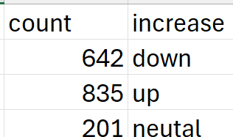
Let Y₁ denote the number of "Up" days and Y₂ denote the number of "Down" days in the selected three-day period. Recall that each three-day period can have 0, 1, 2, or 3 of either movement type, with the constraint that Y₁ + Y₂ + Y₃ = 3 (where Y₃ represents "Neutral" days).

Questions:
a) Find the joint probability function for Y₁ and Y₂.
For three randomly selected days, the joint probability is:
$P(Y₁ = i, Y₂ = j) = (\frac{3!}{(i!j!(3-i-j)!)}) ×(0.4976)ⁱ × (0.3826)ʲ × (0.1198)³⁻ⁱ⁻ʲ$
$Joint probability table P(Y₁ = i, Y₂ = j):$
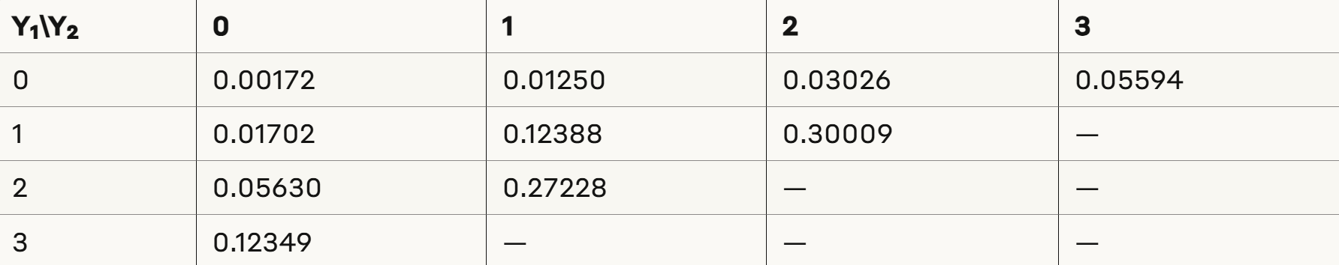
b) Find F(2,1), the probability that exactly 2 "Up" days and 1 "Down" day occur in the selected three-day period.
$$F\left(2,1\right)= P\left(Y^{1}= 2, Y^{2}= 1\right)$$
$$= \left(\frac{3!}{2!1!0!}\right)× {\left(0.4976\right)}^{2}× {\left(0.3826\right)}^{1}× {\left(0.1198\right)}^{0}$$
$$= 3 × 0.247602 × 0.3826 × 1$$
$$= 0.27228 or 27.23\%$$
c) Find the marginal probability distribution of Y₁.
$P\left(Y^{1}= 0\right)= 0.00172 + 0.01250 + 0.03026 + 0.05594 = 0.10042 \left(10.04\%\right)$
$$P\left(Y^{1}= 1\right)= 0.01702 + 0.12388 + 0.30009 = 0.44099 \left(44.10\%\right)$$
$P\left(Y^{1}= 2\right)= 0.05630 + 0.27228 = 0.32858 \left(32.86\%\right)$
$P\left(Y^{1}= 3\right)= 0.12349 \left(12.35\%\right)$
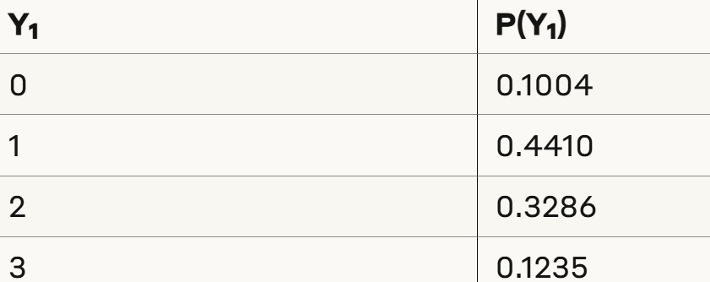

5.9) Let Y₁ represent the normalized daily volatility (absolute percentage change) and Y₂ represent the normalized daily trading volume of AVAX cryptocurrency. Based on analysis of the historical data, these variables have the joint probability density function given by:
f(y₁,y₂) = {k(2-y₁) (y₂), 0≤y₁≤1, 0≤y₂≤1,
0, elsewhere.}
Where y₁ is the scaled daily volatility (0 represents no price change, 1 represents maximum observed volatility) and y₂ is the scaled daily trading volume (0 represents minimum volume, 1 represents maximum volume).
Questions
a) Find the value of k that makes this a probability density function.
For f(y₁,y₂) to be a valid probability density function, the total integral over the domain must equal 1:
$$∫∫ f(y₁,y₂) dy₁ dy₂ = 1$$
Substituting our function: $∫₀¹ ∫₀¹ k(2-y₁)(y₂) dy₁ dy₂ = 1$
Let's solve the inner integral first: $∫₀¹ k(2-y₁)(y₂) dy$₁
$$= k \int^{1}{\left(2-y_{1}\right)y^{2}dy^{1}}$$
$$= ky_{2}\int^{1}{\left(2-y_{1}\right)dy^{1}}$$
$$= ky_{2}{\left[2y_{1}-\frac{{y_{1}}^{2}}{2}\right]}^{1}$$
$$= ky^{2}\left[\left(2 -\frac{1}{2}\right)- 0\right]$$
$$= ky₂(3/2)$$
Now the outer integral$:$
$$\int_{0}^{1}{ky^{2}\left(\frac{3}{2}\right)dy_{2}}$$
$$= k\left(\frac{3}{2}\right)\int^{1}{y_{2}dy_{2}}$$
$$= k\left(\frac{3}{2}\right){\left[\frac{{y_{2}}^{2}}{2}\right]}^{01}$$
$$= k\left(\frac{3}{2}\right)\left(\frac{1}{2}\right)$$
$$= 3k/4$$Setting this equal to 1: 3k/4 = 1 k = 4/3

b) Find P(Y₁≤0.4, Y₂≥0.6), the probability that a trading day has relatively low volatility but high trading volume.
$$P\left(Y^{1}≤0.4, Y^{2}≥0.6\right) = \int_{0}^{0.4}{\int_{0}^{0.6}{(4/3)(2-y₁)(y₂) dy₂ dy₁}}$$
$$\int^{0.6}{\left(\frac{4}{3}\right)2-y₁)(y₂) dy₂}$$
$$== \left(\frac{4}{3}\right)(2-y₁)\left(\frac{0.64}{2}\right)$$
$$= \left(\frac{4}{3}\right)(2-y₁)\left(0.32\right)$$

Now the outer integral:
$$\int^{0.4}{\left(\frac{4}{3}\right)}\left(2-y₁\right)\left(0.32\right)dy₁$$
$$= \left(\frac{4}{3}\right)\left(0.32\right)\left[\left(2\left(0.4\right)-\frac{{0.4}^{2}}{2}\right)- 0\right]$$
$$= \left(\frac{4}{3}\right)\left(0.32\right)\left[0.8 - 0.08\right]$$
$$= \left(\frac{4}{3}\right)\left(0.32\right)\left(0.72\right)$$
$$= \left(\frac{4}{3}\right)\left(0.32\right)\left(0.72\right)$$
$$= 0.3072$$
This means there is about 30.72% probability that on a given trading day, AVAX will experience relatively low volatility (≤40% of maximum) while having high trading volume (≥60% of maximum).
Conclusions
Overall, the current statistical analysis gives a quantitative understanding of activity in AVAX cryptocurrency markets. The findings reveal that even with intrinsic volatility as typical of cryptocurrencies, their fluctuations follow statistical developments which can be expressed in precise and quantifiable terms. Such information could be useful to both traders and investors and to scholars looking to clarify market activity and develop effective means of interacting with AVAX and other virtual currencies.

REFRENCE
Dataset obtained from Kaggle
Crypto Prices Historical Data
What Is Avalanche (AVAX)? Pros, Cons, and Risks

