Predicting the FIFA World Cup 2026 Winner Using Machine Learning and Monte Carlo Simulation
Author: Samip Singh Basnet
Stockton University
1/4/2026

Abstract
This document presents a machine learning–based approach for predicting the outcome of the FIFA World Cup 2026. Historical World Cup match data from 1930 to 2022, FIFA rankings, Elo ratings, and group-stage information are combined to engineer team-level features. Multiple classification models are trained and ensembled, and a Monte Carlo tournament simulation is used to capture uncertainty in match outcomes. The results identify Argentina, Spain, and Brazil as the strongest contenders for the 2026 World Cup.
1. Introduction
Predicting the winner of an international football tournament is challenging due to the randomness of individual matches, differences in team quality, and the structure of the competition itself. Traditional approaches rely on expert opinion or rankings, which may not fully capture complex performance patterns. This project applies machine learning techniques combined with probabilistic simulation to provide a data-driven and interpretable prediction framework for the FIFA World Cup 2026.

2. Data Sources and Feature Engineering
Multiple datasets were used, including all historical FIFA World Cup matches (1930–2022), FIFA rankings, detailed match statistics from the 2022 World Cup, Elo ratings, and official group-stage assignments for 2026. From these data, features such as historical win rate, goals per match, goal difference, points per match, defensive stability, and long-term team strength were computed. A normalized group difficulty index was also introduced to reflect the competitive environment faced by each team.

3. Modeling Approach
Three supervised learning models were trained: Random Forest, Logistic Regression, and XGBoost. Logistic Regression provides a linear baseline, Random Forest offers robust performance and interpretability, and XGBoost captures complex non-linear relationships. The final prediction is obtained using an ensemble of these models to improve stability and reduce bias.

Figure 1: Random Forest Feature Importance
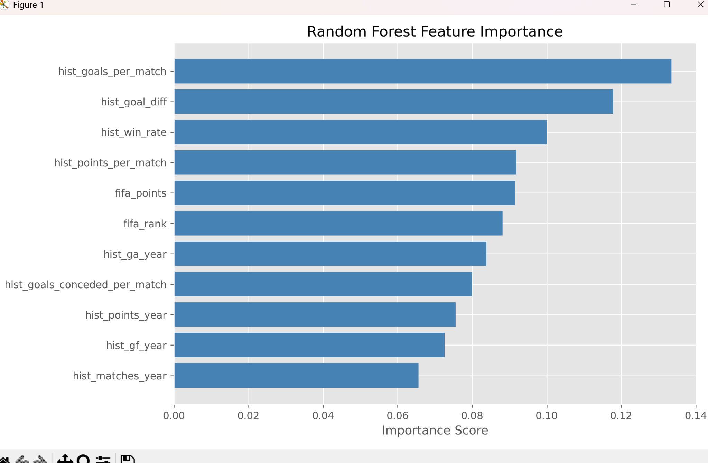
This figure shows the relative importance of each feature used by the Random Forest model. Historical goals per match, goal difference, and win rate are the most influential, indicating that long-term consistency is a key determinant of World Cup success.

Figure 2: Top 15 Teams by Machine Learning Championship Probability
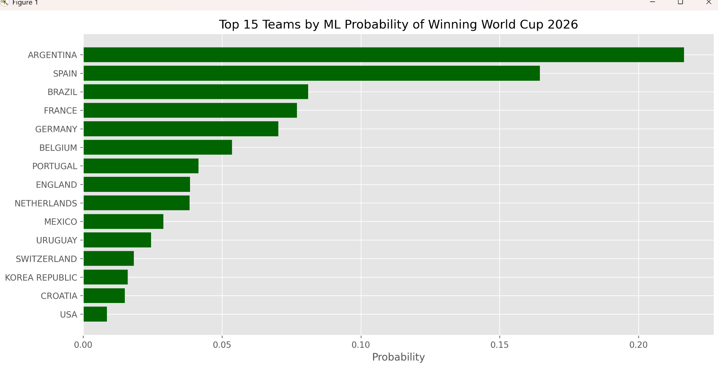
This bar chart presents the top 15 teams ranked by their ensemble machine learning probability of winning the 2026 World Cup. Argentina, Spain, and Brazil emerge as the leading contenders based on historical performance and ranking-based features.

Figure 3: Top 10 Teams by Monte Carlo Win Probability
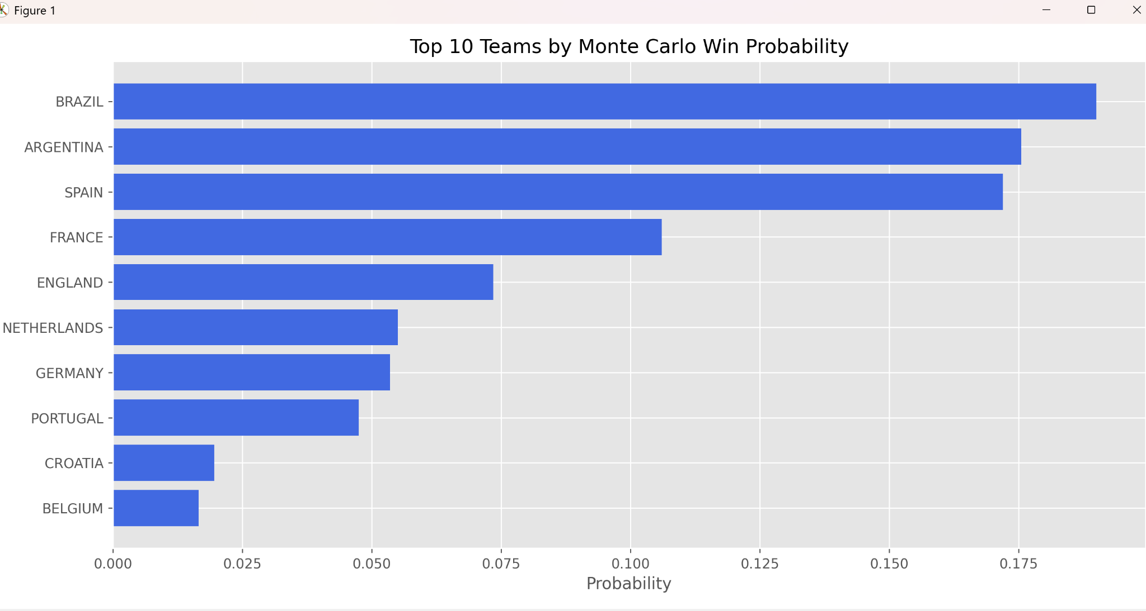
Monte Carlo simulation results are shown here, representing the probability of each team winning the tournament across thousands of simulated runs. Brazil ranks slightly higher due to consistent simulated knockout performance.

Figure 4: Team Strength vs Group Difficulty (2026 World Cup)
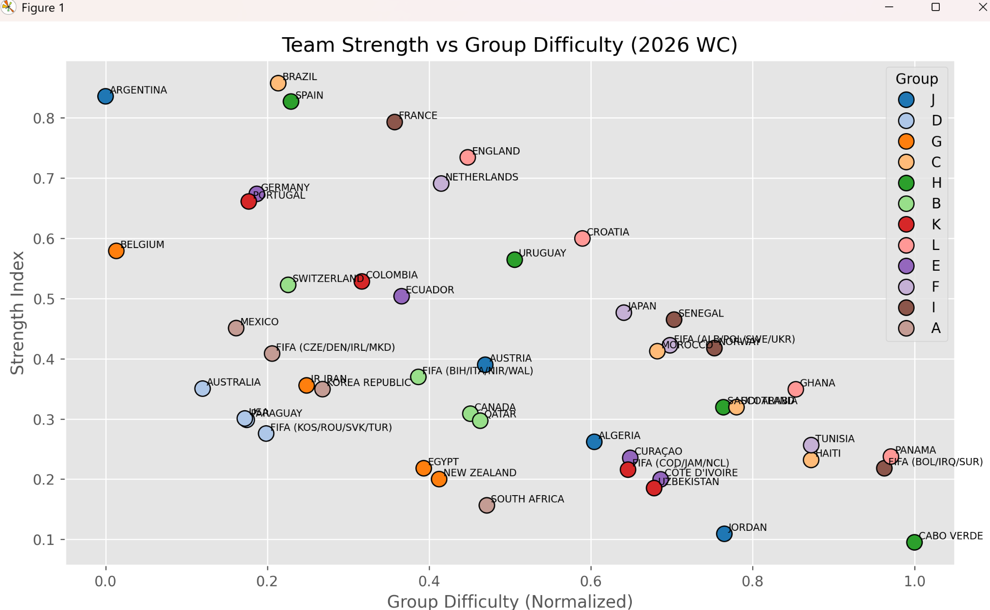
This scatter plot illustrates the relationship between team strength and group difficulty. Strong teams placed in easier groups gain a measurable advantage, while competitive groups reduce advancement probability even for high-strength teams.
Figure 5: Correlation Heatmap of Model Features and Probabilities
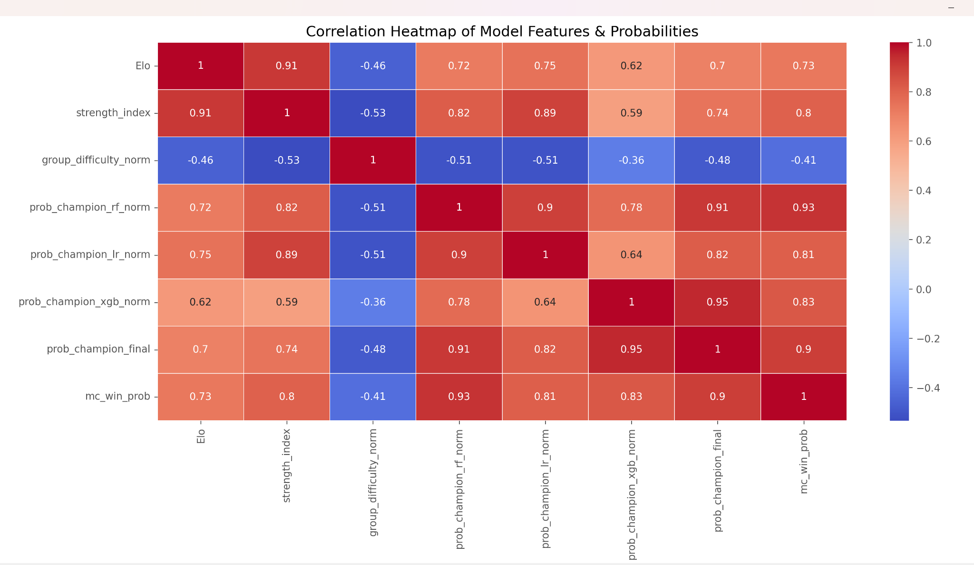
The correlation heatmap highlights relationships between features and predicted probabilities. Elo rating and strength index show strong positive correlation with championship probability, while group difficulty exhibits a negative correlation.

4. Results and Discussion
Both the ensemble machine learning model and the Monte Carlo simulation independently identify Argentina, Spain, and Brazil as the top contenders for the FIFA World Cup 2026. The agreement between these approaches increases confidence in the robustness of the results. Differences in ranking order reflect the impact of tournament structure and matchup uncertainty.

5. Conclusion and Future Work
This project demonstrates the effectiveness of combining ensemble machine learning models with Monte Carlo tournament simulation for sports outcome prediction. Future improvements may include player-level statistics, expected-goals (xG) modeling, and time-aware validation strategies to further enhance predictive accuracy.

