

Concepts and Technologies of AI

(5CS037)

Project Report

Ethics on AI

Student Id : 2066031

Student Name : Samir Chaulagain

Group : L5CG15

Module Leader : Siman Giri

Asst. Module Leader : Anmol Adhikari

Instructor : Anmol Adhikari

Cohort : 7

Submitted on : 1/20/2023

**Abstract**

This report summarizes the widespread use of artificial intelligence technology in everyday life today. AI is This report covers all about AI, AI ethics, and AI ethics dilemmas with solutions. This study analyzes these moral and ethical consequences and offers several solutions that can be used to deal with them. Consider how to balance the potential benefits of AI, such as improved health and safety. It is crucial to create artificial intelligence that is moral. AI is a technology with enormous potential that can benefit and help humanity in both positive and negative ways.

This report also summarizes the importance of Artificial Intelligence, Machine Learning and Deep Learning in upcoming future.

**Table of figure**

Figure i Ethics 2

Figure ii Social dilemma 3

Figure iii AI intelligence 4

Figure iv AI Soilders 5

## **Table of Contents**

1. Introduction 1

2. Review of Major ethical dilemmas and moral questions associated with AI 3

3. Initiatives in the field of Ethical AI 5

4. Generic Framework/Principle for the development and use of AI 7

5. Discussion 8

6. References 9

# Introduction

The concept of ethics is a set of moral principles that guide us in determining what is right and wrong. Many data and social scientists, philosophers, lawyers, human rights activists, regulators, and policymakers are concerned about ethical issues surrounding AI and its applications in different contexts. "AI ethics" are simply a subset of computer ethics. The study of AI's ethical implications is known as "AI ethics" in a variety of academic fields. By providing fundamental guidance and limitations, AI ethics can and should guide more practical endeavors. Moral principles are especially important in this situation. The goal of ethical guidelines is to ensure an ethical process or outcome in the area of application in question. Ethical guidelines are documents that provide principles for action. We must create experiments and algorithms with this in mind because all AI and machine learning algorithms are built on data. Artificial intelligence has the potential to scale and amplify these human decisions, so this must be taken into consideration when designing algorithms and experiments.

Human rights, social issues, and ethical issues related to computing technologies have been discussed since the inception of these AI technologies. The opportunities and threats created by AI and provides a human-centered perspective on the topic. AI has already demonstrated its potential in a number of industries, including business, healthcare, transportation, and many more when integrated with other intelligent technology like robotics. Furthermore, AI applications are already having an effect on society and humanity.

Unfortunately, developing ethical artificial intelligence is a difficult and complex task. These guidelines should be built on the societal values of the society where AI will be used. Create algorithms that will allow the AI to follow these moral guidelines. This entails developing algorithms that can recognize moral conundrums.

(Anon., n.d.)

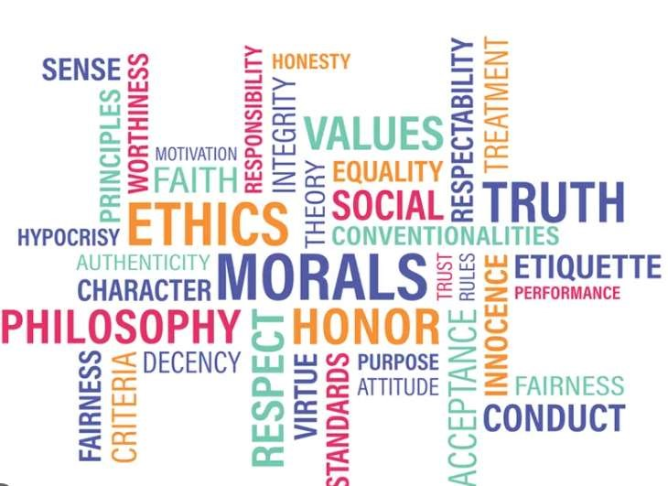

Figure i Ethics

# Review of Major ethical dilemmas and moral questions associated with AI

Artificial intelligence has presented us with a variety of moral dilemmas that force us to prioritize certain values in our designs. Artificial intelligence will have an impact on the future of work and humanity, so strategies must be developed and implemented. But if used unethically – e.g., for purposes such as disinformation, deception, human abuse, or political suppression – AI can cause severe deleterious effects for individuals, the environment, and society. Below some of the dilemmas and moral question associated with AI are pointed: -

## Social dilemma:-

The automation of tasks traditionally done by humans has the potential to lead to widespread job displacement, particularly in industries that rely heavily on manual labor and routine tasks. This could have a significant impact on the economy, as people who lose their jobs may struggle to find new employment, leading to increased poverty and social inequality. A significant number of employment could be eliminated by autonomous vehicles, which would also drastically change the transportation sector and its related industries.

* What happens after the end of jobs?
* How do we distribute the wealth created by machine?
* What to prioritize machine i.e. faster, stronger, efficient or human that needs job to survive?



Figure ii Social dilemma

## Automated decision/AI bias:

AI recruiters are recognized to contain human biases due to the fact that our prejudices are transmitted through the training data. Since the emergence of big data, businesses have expanded their attention on implementing automation and data-driven decision-making throughout their operations. Businesses are encountering unintended effects in some of their AI applications, which is due to inadequate upfront study design and biased datasets, even if the objective is often, if not always, to improve business outcomes.

* How do machines affect our behavior and interaction?

- How do we keep AI safe from adversaries?



Figure iii AI intelligence

## Ethical harms:-

In general, laws and regulations do not adequately protect the ethical use of AI. The creators and providers of AI tools and technologies, as well as those who use AI, must act ethically. Ethical use of AI requires proactive action by users and providers. In addition to making statements, this obligation entails actively applying specific policies. The military now prioritizes self-reliance, both in dynamic responses as well as in research and advancement. One concern is that future self-propelled weapons systems may not be safely controlled.

* How do we protect against unintended consequences? (Anon., n.d.) (Anon., n.d.)



Figure iv AI Soilders

# Initiatives in the field of Ethical AI

Its goal is to generate and disseminate knowledge, conduct high-level research, and train human resources in order to assist in finding solutions to local, regional, and global issues. We should take the following actions when creating AI's guiding ethical principles:-

* The first step in developing ethical AI is to identify the ethical standards to which the AI should adhere. When AI is used in the medical field, for example, ethical standards should be based on healthcare system values such as patient autonomy, altruism, and harmlessness. The next step is to develop algorithms that will enable the AI to adhere to these ethical principles. This involves creating algorithms that can identify ethical dilemmas and make decisions based on the ethical principles. Finally, it is important to ensure that the AI is tested and monitored to ensure that it is adhering to the ethical principles. Additionally, the AI should be tested in a variety of scenarios to ensure that it is making ethical decisions in all situations. Creating ethical AI is a difficult and complex task, but it is necessary to ensure that AI is used responsibly and ethically. By defining ethical principles, developing algorithms to adhere to those principles, and testing and monitoring the AI, it is possible to create ethical AI that meets the expectations and questions of society.

Some of the initiatives in the field of Ethical AI are:

* The Open Robo Ethics Institute (ORI) was founded in 2012 as a non-profit organization dedicated to understanding the ethical and social implications of advances in artificial intelligence. Its primary goal is to educate technology professionals, executives, and government officials about the ethics of artificial intelligence. In 2017, ORI launched Generation R, a consulting firm that assists leaders in holistically implementing ethical AI development.

* A global research center based in the UK, the Institute for Ethical AI & Machine Learning carries out cutting-edge studies on the moral advancement of artificial intelligence. The creation of ethical practices, structures, operations, and implementation is among its research interests. The Institute is made up of volunteer teams of data science and machine learning specialists who work on research projects with academics, business leaders, and policymakers.

# Generic Framework/Principle for the development and use of AI

Frameworks and policies can help reduce the risks of AI and ensure that technology is used to make the world a safer and more equitable place for all. Many countries, companies, and universities are developing AI systems, but most regions lack legal frameworks that are responsive to recent AI developments. Modernizing legal frameworks at all levels, including the United Nations, opens the way for ethical AI development. Pioneers should take the lead in bringing clarity to the industry.

1. Accountability:

The concept of accountability refers to one`s duty to take responsibility for one's actions, decisions, and any unfavorable effects they may have on others and on the organization. This entails making certain that safeguards are in place to reduce negative effects, internal and external governance frameworks are in place, that compensation is offered to those impacted by negative effects, includes proof of human oversight to guarantee ethical decision-making.

## Technical durability and security:

It refers to a set of actions taken to make sure a system is safe, dependable, and assault-resistant. This includes defenses like security procedures, backup plans, and general security procedures. Additionally, it consists of steps to guarantee precision, dependability, and reproducibility.

## Privacy and data governance:

Data use is made safe and responsible by a set of policies, procedures, and practices known as privacy and governance. This entails creating policies for data security, following protocols for using and accessing data, and putting data protection measures into place. In the end, this entails creating data security policies and practices to guarantee that data is gathered, stored, and used in a responsible and secure manner.

## Environmental security:

AI systems and big data can be used to improve environmental health by improving access to information and services and assisting in the identification and resolution of environmental problems. Artificial intelligence and big data can also be used to create sustainable and environmentally friendly systems by improving access to information and services and assisting in the identification and resolution of environmental issues. (Anon., n.d.)

# Discussion

AI is a powerful tool when used properly, but it can have a significant impact on morality when not used properly. We have encountered several ethical quandaries in real life as a result of AI misuse or improper AI innovation. Artificial intelligence-powered systems are changing the way businesses and governments operate around the world, raising concerns about the risk of serious violations of human rights. However, as AI technology grows increasingly complex and expands to other areas, more work will be required to protect all those on the right. Privacy laws, transparency safeguards, and accountability safeguards, such as those mentioned in this article, can mitigate few of today's worst known uses. Artificial intelligence has the power to transform every organization. The process by which this conversion occurs varies, but the steps generally follow the paths documented throughout this book. By following all the steps outlined in the previous chapter, your business can leverage AI technology to gain an edge. AI is the key to a brighter future where we all make better informed decisions, guided by the data and computers that make sense of our world.

AI has the ability to fundamentally alter how you conduct business, even though it won't be able to solve all of your company's problems. It will change how we trade, get medical diagnoses, have surgeries, and drive cars. As a result, financial modeling, computer vision, industrial processes, and medical imaging have all changed. We are close to recognizing this enormous potential, which could lead to better and more rapid decision making in the future.

# References

Anon., n.d. *Dialogue on AI.* [Online]

Available at: https://aiethics.princeton.edu/case-studies/case-study-pdfs/

Anon., n.d. *IBM.* [Online]

Available at: https://www.ibm.com/topics/ai-ethics [Accessed 2019].

Anon., n.d. *Link springer.* [Online]

Available at: https://link.springer.com/article/10.1007/s43681-022-002447#Sec2

Anon., n.d. *OECD.* [Online]

Available at: https://www.oecd.org/digital/artificial-intelligence/

Anon., n.d. *Research Ai.* [Online]

Available at: https://research.aimultiple.com/ai-ethics/ Anon., n.d. *Sage journals.* [Online] Available at:

https://journals.sagepub.com/doi/full/10.1177/1781685818764821