## 1- Data structure and distribution

in this section, the data statistical summary and the distribution of the data was evaluated

### A. Data summary

## Group pre post   
## Control :27 Min. :42.00 Min. :44.00   
## Experiment:27 1st Qu.:52.00 1st Qu.:56.25   
## Median :56.00 Median :70.50   
## Mean :57.19 Mean :68.89   
## 3rd Qu.:61.75 3rd Qu.:83.00   
## Max. :79.00 Max. :90.00

## Group pre post   
## Control :27 Min. :13.00 Min. :17.0   
## Experiment:27 1st Qu.:28.25 1st Qu.:37.0   
## Median :35.50 Median :44.5   
## Mean :38.09 Mean :47.5   
## 3rd Qu.:44.75 3rd Qu.:59.5   
## Max. :70.00 Max. :81.0

## Group pre post   
## Control :27 Min. :4.00 Min. : 4.00   
## Experiment:27 1st Qu.:5.00 1st Qu.: 5.25   
## Median :5.00 Median : 7.00   
## Mean :5.37 Mean : 6.87   
## 3rd Qu.:6.00 3rd Qu.: 8.00   
## Max. :7.00 Max. :10.00

### B. Data Distribution:

Here the data distribution was checked using Boxplot

1-For Reading Accuracy

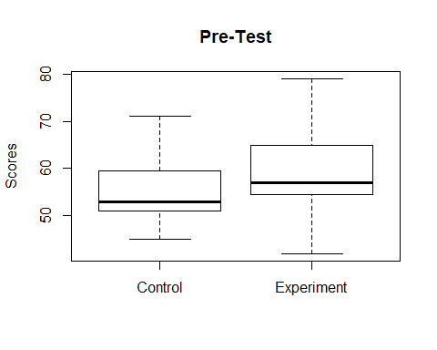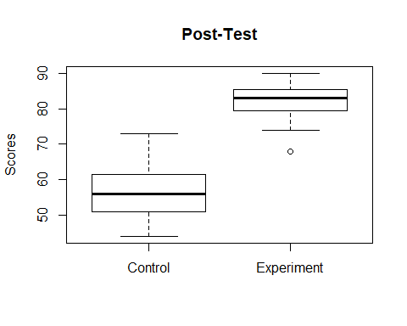

the boxplot figuers shows that, for the pre-test data, the median for both the control scores and the experimental scores are close indicating that the two populations are close. where for the post-test results, there is a difference in the median between the two populations. also the the post-test of the experiment group showed a narrower range compared with the post-test cosres of the control group.

2- For Reading Automaticity

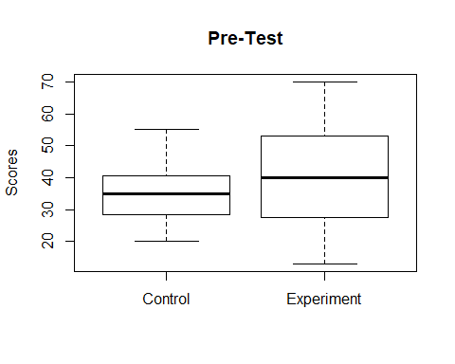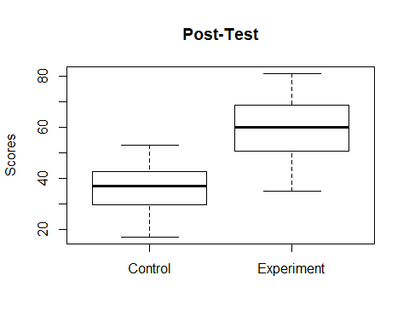

for the pre-test scores, althougth the experiment group has a wider score ranges - engulfing the control group range -, but, the medians are still close. however, for the post-est, an observable differece in the median can be observed.

3- For Reading Prosody

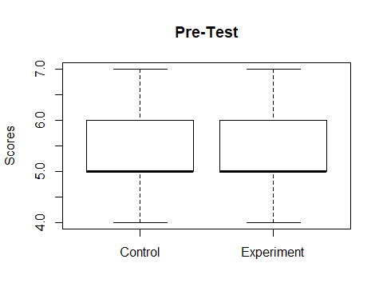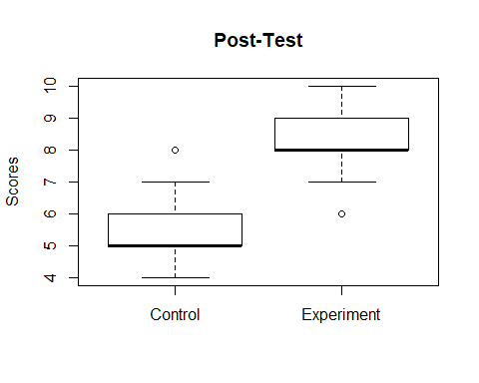

the boxplotfor the Prosody variable shows that, median for the pre-test scores are alost equal for both the control group and expeiment group. where a remarkable shif for the expeiment group scores was observed in the post-test results.

## 2- Normaility Tests

the normality test were applied to check whether the data are normaly distributed or not. The normaility test was conducted through: * 1. Q-Q plot * 2. shapiro test * 2. Levene’s test _ for variance homogeneity_ (for independet variables) * 3. difference between score normality test (for repeated variables)

### A. Q-Q plot

#### I. For Reading Accuracy

##### a. *Control*

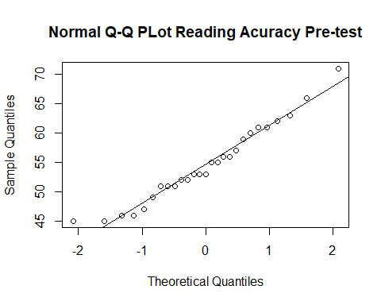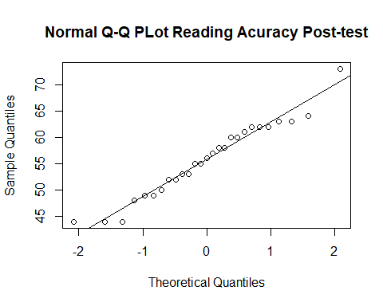

the Q-Q plots for pre- and post-test for the reatding accuracy data shows that the data are normaly distributed

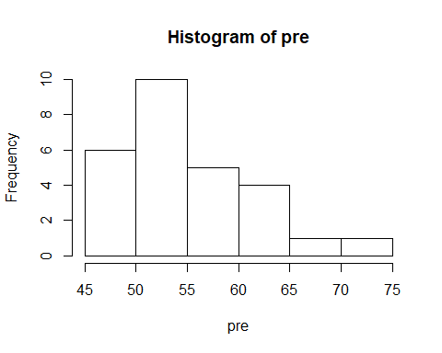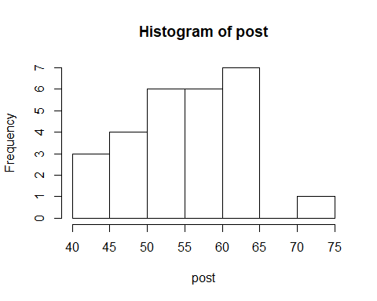

However, from the histograms, the data are skwed.

##### b. *Experiment*

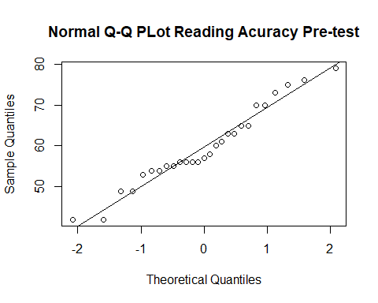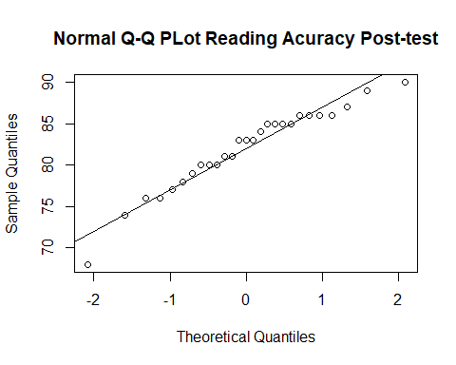

Q-Q plot for the pre- and post-test for the expperimental data shows that are quite alined and not normaly distributed

#### II. For Reading Automaticity

##### a. *Control*

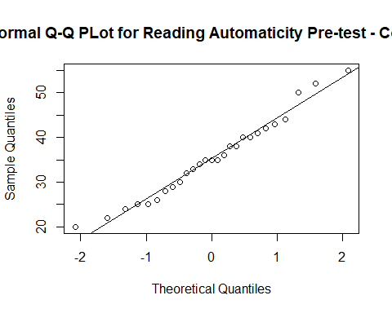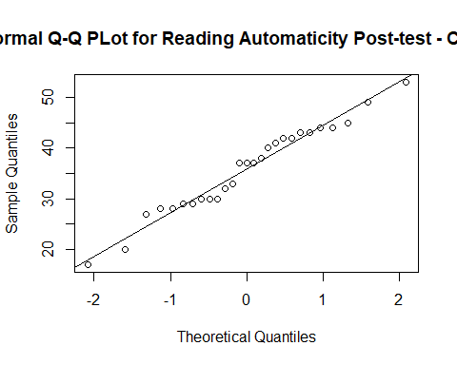

Q-Q plot for pre- and post-test for the Automaticity test of the control group would indicate that, for the pre- test, the data are normally distributed where for the post-test data it is not.

##### b. *Experiment*

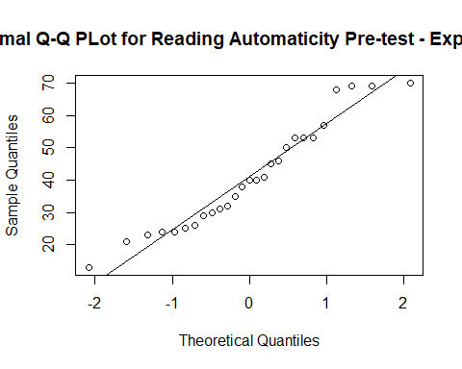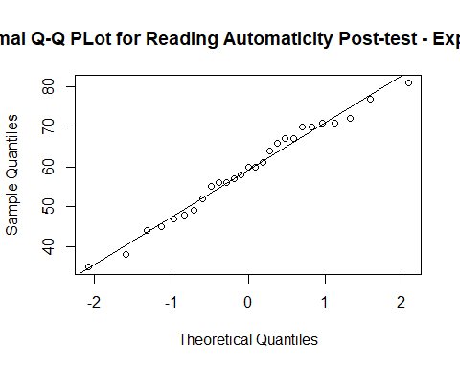

Q-Q plot for reading Automaticity for the experiment group shows that, for pre- and post-test that data are not normaly distributed

#### III. For Reading Prosody

##### a. *Control*

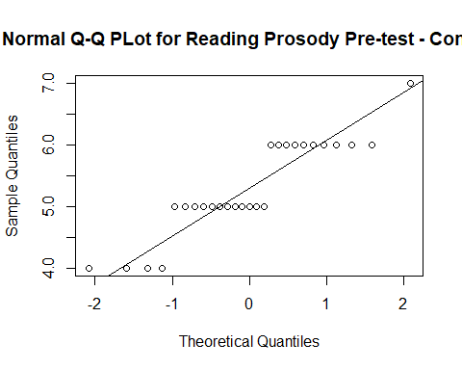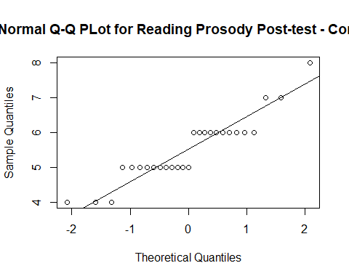

Q-Q plot shows that both pre and post-test are not normaly distributed

##### b. *Experiment*

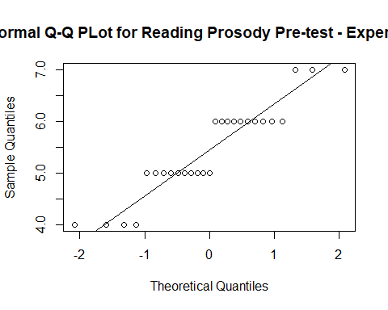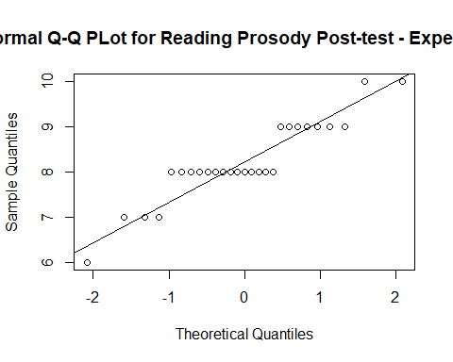

Q-Q plot shows that both pre and post-test are not normaly distributed

### B. Shapiro Test

The Shapiro–Wilk test is a test of normality in statistics.It is comparable in power to the other normality tests. The test rejects the hypothesis of normality when the p-value is less than or equal to 0.05.

#### I. Reading Accuracy

##### a. *Control*

Testing the normality of the pre- and post data of the control group

##   
## Shapiro-Wilk normality test  
##   
## data: Acc2pCont$pre  
## W = 0.96252, p-value = 0.421

##   
## Shapiro-Wilk normality test  
##   
## data: Acc2pCont$post  
## W = 0.96367, p-value = 0.4462

According to the test, both pre and post-test scores of the control are noramly distributed since the p-values are > 0.05

##### b. *Experiment*

Testing the normality of the pre- and post data of the experiment group.

##   
## Shapiro-Wilk normality test  
##   
## data: Acc2pExp$pre  
## W = 0.96046, p-value = 0.3786

##   
## Shapiro-Wilk normality test  
##   
## data: Acc2pExp$post  
## W = 0.94714, p-value = 0.1826

According to the test, both pre and post-test scores of the control are noramly distributed since the p-values are > 0.05

#### II. Reading Automaticity

##### a *Control*

Testing the normality of the pre- and post data of the control group.

##   
## Shapiro-Wilk normality test  
##   
## data: Auto2pCont$pre  
## W = 0.97453, p-value = 0.7237

##   
## Shapiro-Wilk normality test  
##   
## data: Auto2pCont$post  
## W = 0.97047, p-value = 0.6143

According to the test, both pre and post-test scores of the control are noramly distributed since the p-values are > 0.05

##### b. *Experiment*

Testing the normality of the pre- and post data of the control group.

##   
## Shapiro-Wilk normality test  
##   
## data: Auto2pExp$pre  
## W = 0.94318, p-value = 0.146

##   
## Shapiro-Wilk normality test  
##   
## data: Auto2pExp$post  
## W = 0.98013, p-value = 0.8652

According to the test, both pre and post-test scores of the control are noramly distributed since the p-values are > 0.05

#### III. Reading Prosody

#### a. *Control*

Testing the normality of the pre- and post data of the control group.

##   
## Shapiro-Wilk normality test  
##   
## data: Pros2pCont$pre  
## W = 0.85629, p-value = 0.001538

##   
## Shapiro-Wilk normality test  
##   
## data: Pros2pCont$post  
## W = 0.88528, p-value = 0.006258

According to the test, both pre and post-test scores of the control are NOT noramly distributed since the p-values are < 0.05

#### II. *Experiment*

Testing the normality of the pre- and post data of the control group.

##   
## Shapiro-Wilk normality test  
##   
## data: Pros2pExp$pre  
## W = 0.88299, p-value = 0.005578

##   
## Shapiro-Wilk normality test  
##   
## data: Pros2pExp$post  
## W = 0.88162, p-value = 0.005207

According to the test, both pre and post-test scores of the control are NOT noramly distributed since the p-values are < 0.05

### c. Levene’s Test for variance homogeneity

Levene’s test is used to test if two or more samples have equal variances. Equal variances across samples is called homogeneity of variance. this homogeneity is a pre-requisit for some statistical tests, for example the analysis of variance, which assume that variances are equal across groups or samples. therefor, before deciding whether to go for t-test or other normality based- hypothesis test, The Levene test can be used to verify the normality assumption.

## Loading required package: carData

#### I. Reading Accuracy

##### a. *Pre-test*

test homogeneity of variance of the control and experiment groups to decide whether they have equal variance

## Warning in leveneTest.default(pre[Group == "Control"], pre[Group ==  
## "Experiment"]): pre[Group == "Experiment"] coerced to factor.

## Levene's Test for Homogeneity of Variance (center = median)  
## Df F value Pr(>F)  
## group 16 1.3867 0.3051  
## 10

since p-value > 0.05, data are homogenouse

##### b. *post-test*

## Warning in leveneTest.default(post[Group == "Control"], post[Group ==  
## "Experiment"]): post[Group == "Experiment"] coerced to factor.

## Levene's Test for Homogeneity of Variance (center = median)  
## Df F value Pr(>F)  
## group 14 1.1628 0.4009  
## 12

since p-value > 0.05, data are homogenouse

#### II. Reading Automaticity

##### a. *pre-test*

## Warning in leveneTest.default(pre[Group == "Control"], pre[Group ==  
## "Experiment"]): pre[Group == "Experiment"] coerced to factor.

## Levene's Test for Homogeneity of Variance (center = median)  
## Df F value Pr(>F)  
## group 21 0.6616 0.7713  
## 5

since p-value > 0.05, data are homogenouse

##### b. *post-test*

## Warning in leveneTest.default(post[Group == "Control"], post[Group ==  
## "Experiment"]): post[Group == "Experiment"] coerced to factor.

## Warning in anova.lm(lm(resp ~ group)): ANOVA F-tests on an essentially  
## perfect fit are unreliable

## Levene's Test for Homogeneity of Variance (center = median)  
## Df F value Pr(>F)   
## group 21 8.7258e+29 < 2.2e-16 ***  
## 5   
## ---  
## Signif. codes: 0 '***' 0.001 '**' 0.01 '*' 0.05 '.' 0.1 ' ' 1

since p-value < 0.05, data are NOT homogenouse

#### III. Reading Prosody

##### a. *pre-test*

## Warning in leveneTest.default(pre[Group == "Control"], pre[Group ==  
## "Experiment"]): pre[Group == "Experiment"] coerced to factor.

## Levene's Test for Homogeneity of Variance (center = median)  
## Df F value Pr(>F)  
## group 3 0.1168 0.9494  
## 23

since p-value > 0.05, data are homogenouse

##### b.. *post-test*

## Warning in leveneTest.default(post[Group == "Control"], post[Group ==  
## "Experiment"]): post[Group == "Experiment"] coerced to factor.

## Levene's Test for Homogeneity of Variance (center = median)  
## Df F value Pr(>F)  
## group 4 1.6464 0.1983  
## 22

since p-value > 0.05, data are homogenouse

### C. Difference between scores normality test

this test is used to assess the normailty distribution of repeated variables and used as a pre-normality test before selecting Wilcoxson’s singled rank test

#### I. Reading Accuracy

##### a. *Control*

## 'data.frame': 27 obs. of 4 variables:  
## $ Group: Factor w/ 2 levels "Control","Experiment": 1 1 1 1 1 1 1 1 1 1 ...  
## $ pre : int 61 63 52 46 51 56 56 61 62 59 ...  
## $ post : int 60 62 44 55 52 62 64 49 52 63 ...  
## $ Diff : int -1 -1 -8 9 1 6 8 -12 -10 4 ...

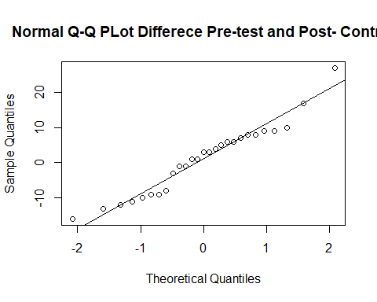

from the Q-Q plot, the data are NOT equally distributed

##### b. *Experiment*

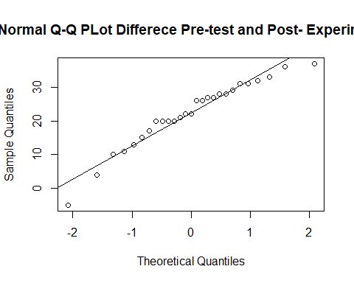 from the Q-Q plot, the data are NOT equally distributed, therefore, Wilcoxon signed sum test can be used for the hypthesis testing.

#### II. Reading Automaticity

##### a. *Control*

## 'data.frame': 27 obs. of 4 variables:  
## $ Group: Factor w/ 2 levels "Control","Experiment": 1 1 1 1 1 1 1 1 1 1 ...  
## $ pre : int 24 32 29 36 25 42 35 43 35 41 ...  
## $ post : int 33 37 28 41 44 43 45 28 30 37 ...  
## $ Diff : int 9 5 -1 5 19 1 10 -15 -5 -4 ...

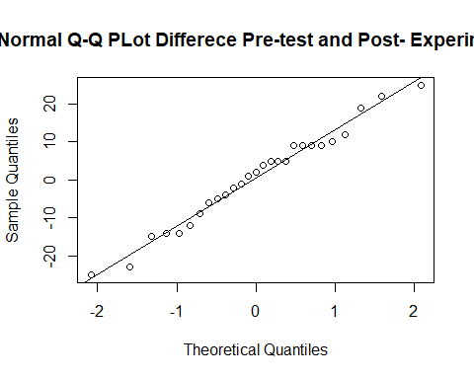 from the Q-Q plot, the data are NOT equally distributed

##### b. *Experiment*

## 'data.frame': 27 obs. of 4 variables:  
## $ Group: Factor w/ 2 levels "Control","Experiment": 2 2 2 2 2 2 2 2 2 2 ...  
## $ pre : int 30 32 24 13 53 35 57 46 69 45 ...  
## $ post : int 66 56 56 64 70 67 71 35 45 47 ...  
## $ Diff : int 36 24 32 51 17 32 14 -11 -24 2 ...

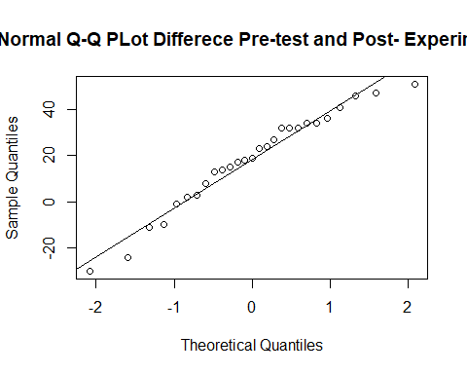 from the Q-Q plot, the data are NOT equally distributed

#### II. Reading Prosody

##### b. *Control*

## 'data.frame': 27 obs. of 4 variables:  
## $ Group: Factor w/ 2 levels "Control","Experiment": 1 1 1 1 1 1 1 1 1 1 ...  
## $ pre : int 6 6 5 4 5 5 6 6 6 6 ...  
## $ post : int 6 7 5 6 5 6 5 5 5 6 ...  
## $ Diff : int 0 1 0 2 0 1 -1 -1 -1 0 ...

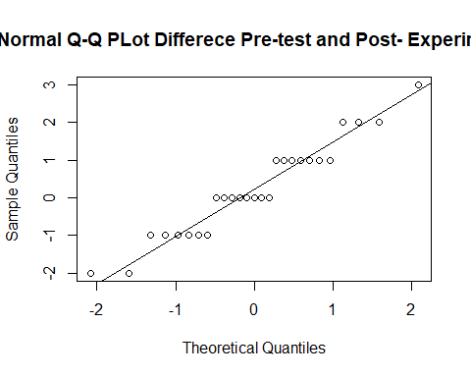 from the Q-Q plot, the data are NOT equally distributed

##### b. *Experiment*

## 'data.frame': 27 obs. of 4 variables:  
## $ Group: Factor w/ 2 levels "Control","Experiment": 2 2 2 2 2 2 2 2 2 2 ...  
## $ pre : int 5 6 6 6 7 6 6 5 7 6 ...  
## $ post : int 8 9 8 9 8 8 8 7 9 6 ...  
## $ Diff : int 3 3 2 3 1 2 2 2 2 0 ...

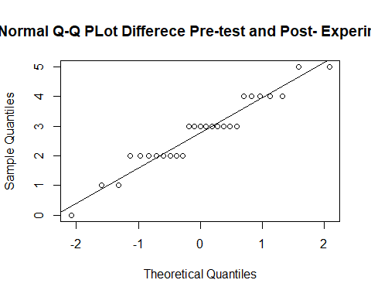

from the Q-Q plot, the data are NOT equally distributed

ACCORDING THE NORMALITY TESTS, SOME DATA SHOWED NON-NORMALITY BEHAVIOUR. ACCORDINGLY, NON-PARAMETERIC HYPOTHESIS TESTS WILL BE USED AS FOLLOW: * 1. MANN WHITNEY TEST: U- TEST TO TEST WHETHER THERE IS A DIFFERENCE BETWEEN THE CONTROL AND EXPERIMENT GROUPS REGARDING PRE- AND POST-TESTS SCORES (TWO INDEPENDENT POPUALTIONS) *2. WILCOXON SIGNED SUM RANKS TEST TO TEST WHETHER THERE IS A DIFFERNECE THE PRE- AND POST-TEST WITH EACH GROUP (REPEATED TEST)

NOTES: FOR WILCOXSON SIGNED SUM OF RANKS, THE SAME METHOD FOR QUANTIFY THE EFFECT SIZE IS USED, HOWEVER Z-SCORE IS DIVIDED BY THE 2 SINCE IT IS A PAIRED “REPEATED” ANALYSIS.

## 3- Hypothesis tests:

### A. Mann Whitney U test

the H0: is that there is no significant difference between the control and Experimental groups for pre and post test.

#### I. Hypothesis testing for the *Pre-Test* (control Vs experiment)

H0: no difference in the pre-test scores between the control and the Experiment groups (this is the required result)

##### a.Reading Accuracy

## Warning in wilcox.test.default(x = c(61L, 63L, 52L, 46L, 51L, 56L, 56L, :  
## cannot compute exact p-value with ties

## Warning in wilcox.test.default(x = c(61L, 63L, 52L, 46L, 51L, 56L, 56L, :  
## cannot compute exact confidence intervals with ties

according to test, there is a SIGNIFICANT DIFFERENCE (p-vale = 0.0323) in scores between the control and experiment group in the pre-test for the reading accuracy. although this is not what was expected, but it is still needed to quantify th effect “effect size”, to decide whether this difference is large or small

###### The effect size:

Since there is a significant difference between the control and the experiment for the pre-test,

## [1] -1.84705

## [1] 0.2513517

from the effect size results, it was found that The effect is SAMLL (25.1% of the variations might be related to unknow variable)…………NEED EXPLINATION HERE

##### b. Reading Automaticity (control Vs experiment)

## Warning in wilcox.test.default(x = c(24L, 32L, 29L, 36L, 25L, 42L, 35L, :  
## cannot compute exact p-value with ties

## Warning in wilcox.test.default(x = c(24L, 32L, 29L, 36L, 25L, 42L, 35L, :  
## cannot compute exact confidence intervals with ties

##   
## Wilcoxon rank sum test with continuity correction  
##   
## data: pre by Group  
## W = 302.5, p-value = 0.287  
## alternative hypothesis: true location shift is not equal to 0  
## 95 percent confidence interval:  
## -12.999929 3.000046  
## sample estimates:  
## difference in location   
## -4

the results showed that for reading Aotumaticity, the results are is NO SIGNIFICANT DIFFERERNCE between the control and the experiment groupd in the pre-tests.

##### c. Reading Prosody (control Vs experiment)

## Warning in wilcox.test.default(x = c(6L, 6L, 5L, 4L, 5L, 5L, 6L, 6L, 6L, :  
## cannot compute exact p-value with ties

## Warning in wilcox.test.default(x = c(6L, 6L, 5L, 4L, 5L, 5L, 6L, 6L, 6L, :  
## cannot compute exact confidence intervals with ties

##   
## Wilcoxon rank sum test with continuity correction  
##   
## data: pre by Group  
## W = 331.5, p-value = 0.5485  
## alternative hypothesis: true location shift is not equal to 0  
## 95 percent confidence interval:  
## -0.9999971781 0.0000438064  
## sample estimates:  
## difference in location   
## -6.182401e-05

the results showed that for reading Prosody, the results are is NO SIGNIFICANT DIFFERERNCE between the control and the experiment groupd in the pre-tests.

#### II. Hypothesis testing for the *Post-Test* (control Vs Experiment)

H0: no difference in the pre-test scores between the control and the Experiment group (this is not the required result).if H0 was true, this will indicate that the intervention had no effect

##### a. Reading Accuracy

## Warning in wilcox.test.default(x = c(60L, 62L, 44L, 55L, 52L, 62L, 64L, :  
## cannot compute exact p-value with ties

## Warning in wilcox.test.default(x = c(60L, 62L, 44L, 55L, 52L, 62L, 64L, :  
## cannot compute exact confidence intervals with ties

p-value=3.27e-10

###### The effect size:

Since there is a significant difference between the control and the experiment in the pre-test scores, the effect size was calculated.

## [1] -6.176711

## [1] 0.8405439

From the effect size results, the effect was found to be HIGH (84% of the variation is resulting from the intervention)…………EXPLIAN MORE

##### b. Reading Automaticity

## Warning in wilcox.test.default(x = c(33L, 37L, 28L, 41L, 44L, 43L, 45L, :  
## cannot compute exact p-value with ties

## Warning in wilcox.test.default(x = c(33L, 37L, 28L, 41L, 44L, 43L, 45L, :  
## cannot compute exact confidence intervals with ties

p-value= 1.95e-08

##### The effect size:

Since there is a significant difference between the control and the experiment in the pre-test scores.

## [1] -5.495354

## [1] 0.747823

The effect is HIGH (74.7% of the variation is resulting from the intervention)…………EXPLAIN MORE

##### c. Reading Prosody

## Warning in wilcox.test.default(x = c(6L, 7L, 5L, 6L, 5L, 6L, 5L, 5L, 5L, :  
## cannot compute exact p-value with ties

## Warning in wilcox.test.default(x = c(6L, 7L, 5L, 6L, 5L, 6L, 5L, 5L, 5L, :  
## cannot compute exact confidence intervals with ties

p-value = 1.36e-09

##### The effect size:

Since there is a significant difference between the control and the experiment in the pre-test.scores.

## [1] -5.947572

## [1] 0.8093621

The effect is HIGH (80.9% of the variation is resulting from the intervention)…………EXPLAIN MORE

### B. Wilcoxson’s single Rank Test

the test was used to test whether there is a significant difference in scores within groups before and after intervention. the test hypothesis was: the H0: is that ther is no difference between the pre and post test within the control or Experiments

#### I.Reading Accuracy

##### a. *Control*

## Warning in wilcox.test.default(pre, post, mu = 0, alt = "two.sided",  
## conf.int = T, : cannot compute exact p-value with ties

## Warning in wilcox.test.default(pre, post, mu = 0, alt = "two.sided",  
## conf.int = T, : cannot compute exact confidence interval with ties

##   
## Wilcoxon signed rank test with continuity correction  
##   
## data: pre and post  
## V = 174.5, p-value = 0.7363  
## alternative hypothesis: true location shift is not equal to 0  
## 95 percent confidence interval:  
## -5.499973 3.000013  
## sample estimates:  
## (pseudo)median   
## -0.9999788

the results revealed that there is No SIGNIFICANT DIFFERENCE between scores before of after intervetion for the control group

##### b. *Experiment*

## Warning in wilcox.test.default(pre, post, mu = 0, alt = "two.sided",  
## conf.int = T, : cannot compute exact p-value with ties

## Warning in wilcox.test.default(pre, post, mu = 0, alt = "two.sided",  
## conf.int = T, : cannot compute exact confidence interval with ties

the results showed that there a SIGNIFICANT DIFFERENCE (7.36e-06) in scores before and after the intervention. to quatify the effect, effect size was calculated

###### The effect size:

Since there is a significant difference between the pre-test scores of the experiment

## [1] -2.166463

## [1] 0.2948183

The effect is LOW (29.5% of the variation is resulting from the intervention). Although the Wilcoxon test showed that the difference between pre and post test are highly significant, the effect size of the intervention was small. this is because the significance test is dependent on: *1- sample size* 2- effect size accordingly, word ‘significance’ is often used to mean ’statistical significance which is the likelihood that the difference between the two groups could just be an accident of sampling. afterall, effect size is an estimate for the true effect size!!!

#### II. Reading Automaticity

##### a. *Control*

## Warning in wilcox.test.default(pre, post, mu = 0, alt = "two.sided",  
## conf.int = T, : cannot compute exact p-value with ties

## Warning in wilcox.test.default(pre, post, mu = 0, alt = "two.sided",  
## conf.int = T, : cannot compute exact confidence interval with ties

##   
## Wilcoxon signed rank test with continuity correction  
##   
## data: pre and post  
## V = 177, p-value = 0.7821  
## alternative hypothesis: true location shift is not equal to 0  
## 95 percent confidence interval:  
## -6.499943 4.500063  
## sample estimates:  
## (pseudo)median   
## -0.9999746

there was no SIGNIFICANT DIFFERENCE between pre- and post test for the control group regarding the Automaticity test

##### b. *Experiment*

## Warning in wilcox.test.default(pre, post, mu = 0, alt = "two.sided",  
## conf.int = T, : cannot compute exact p-value with ties

## Warning in wilcox.test.default(pre, post, mu = 0, alt = "two.sided",  
## conf.int = T, : cannot compute exact confidence interval with ties

p-value = 0.00049

##### The effect size:

Since there is a significant difference between the pre-test scores of the experiment

## [1] -1.647166

## [1] 0.2241509

The effect is LOW (22.4% of the variation is resulting from the intervention)…………

#### III. Reading Prosody

##### a. *Control*

## Warning in wilcox.test.default(pre, post, mu = 0, alt = "two.sided",  
## conf.int = T, : cannot compute exact p-value with ties

## Warning in wilcox.test.default(pre, post, mu = 0, alt = "two.sided",  
## conf.int = T, : cannot compute exact confidence interval with ties

## Warning in wilcox.test.default(pre, post, mu = 0, alt = "two.sided",  
## conf.int = T, : cannot compute exact p-value with zeroes

## Warning in wilcox.test.default(pre, post, mu = 0, alt = "two.sided",  
## conf.int = T, : cannot compute exact confidence interval with zeroes

##   
## Wilcoxon signed rank test with continuity correction  
##   
## data: pre and post  
## V = 74, p-value = 0.3903  
## alternative hypothesis: true location shift is not equal to 0  
## 95 percent confidence interval:  
## -1.0000553 0.4999784  
## sample estimates:  
## (pseudo)median   
## -7.419546e-05

there was no SIGNIFICANT DIFFERENCE between pre- and post test for the control group regarding the Automaticity test

##### b. *Experiment*

## Warning in wilcox.test.default(pre, post, mu = 0, alt = "two.sided",  
## conf.int = T, : cannot compute exact p-value with ties

## Warning in wilcox.test.default(pre, post, mu = 0, alt = "two.sided",  
## conf.int = T, : cannot compute exact confidence interval with ties

## Warning in wilcox.test.default(pre, post, mu = 0, alt = "two.sided",  
## conf.int = T, : cannot compute exact p-value with zeroes

## Warning in wilcox.test.default(pre, post, mu = 0, alt = "two.sided",  
## conf.int = T, : cannot compute exact confidence interval with zeroes

p-value = 7.27e-06

#### The effect size:

Since there is a significant difference between the pre-test scores of the experiment

## [1] -2.167813

## [1] 0.2950019

The effect is LOW (29.5% of the variation is resulting from the intervention)…………