# Importing data

data will be imported:

1- Reading accurecy data

2-Reading Automaticity

3-Reading Prosody

# Chack variables type/class

now all “Group” has been converted into categorical data

# 

1-For Reading Accuracy

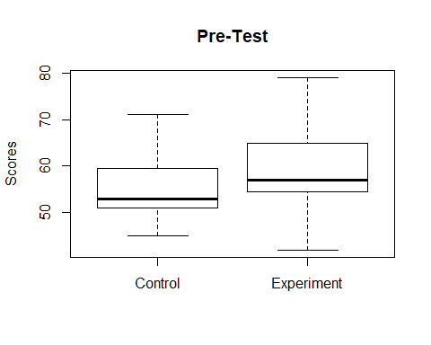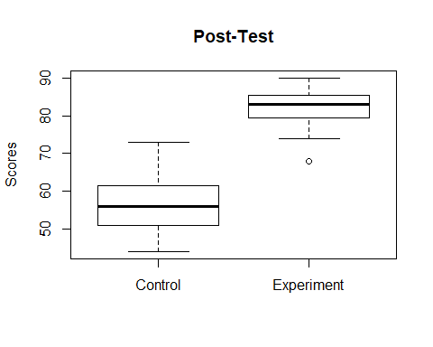

2- For Reading Automaticity

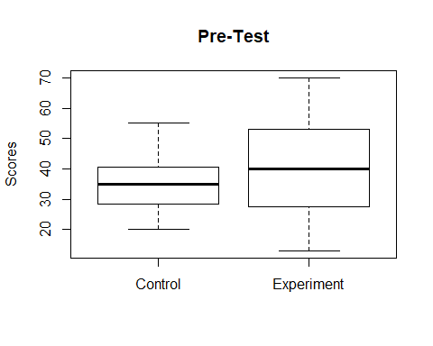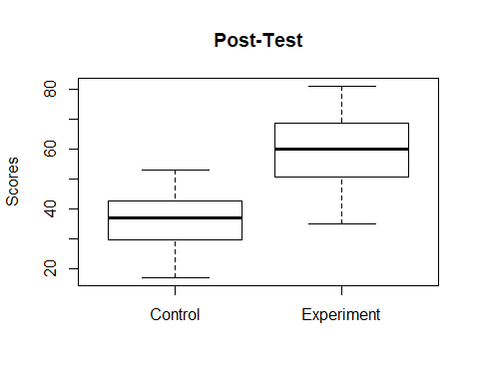

3- For Reading Prosody

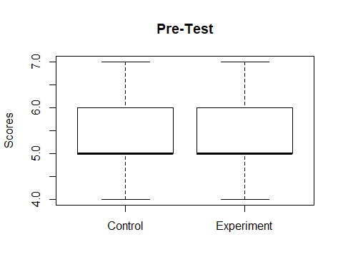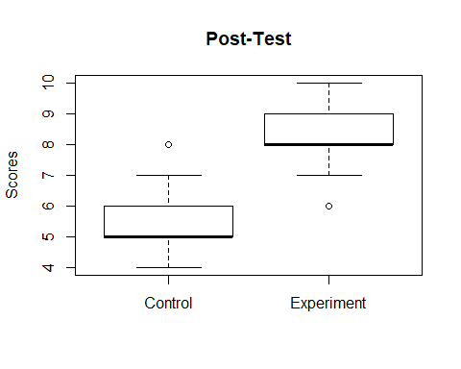

## 2. Subsetting the data

First subsetting the data according to the following Groups * 1. *Control / Experiment*. and this subset will be used to answer whether there is a difference within the groups * 2. *Control compared with Experiment* for pre and post test, to deciede whether there is a difference between the groups

### A. Control / Experiment Susbsetting (difference within Groups)

#### I. for the Accuracy test

for the control

for the experiment

#### II. for the Automaticity test

for the control

for the experiment

#### III. for the Prosopy test

for the control

for the experiment

### B. Control Vs Experiment Susbsetting (difference Between Groups)

#### I. for Accuracy

#### II. For Automaticity

#### III. For Prosody

# Normaility Tests

the normality test were applied to check whether the data are normaly distributed or not. The normaility test was conducted through: * 1. Q-Q plot * 2. shapiro test * 2. Levene’s test _ for variance homogeneity_ (for independet variables) * 3. difference between score normality test (for repeated variables)

## 1. Q-Q plot

#### A. For Reading Accuracy

##### I. *Control*

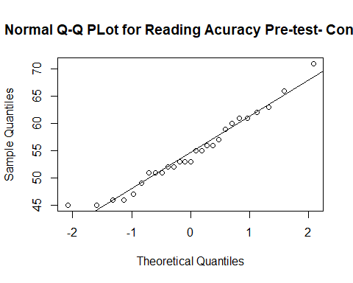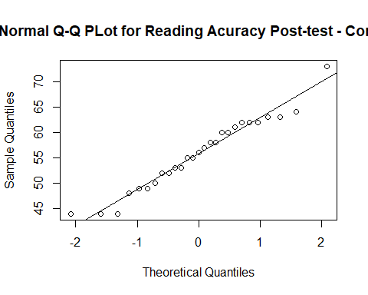

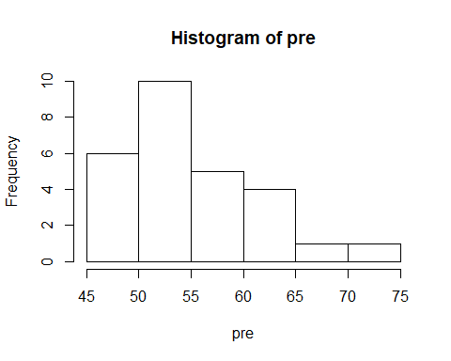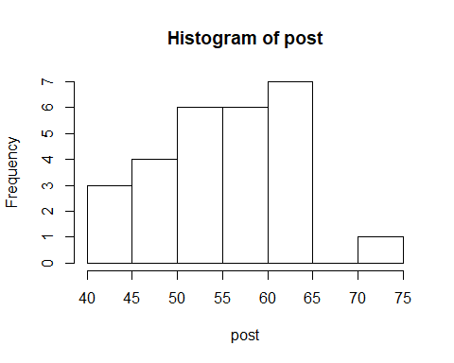

##### II. *Experiment*

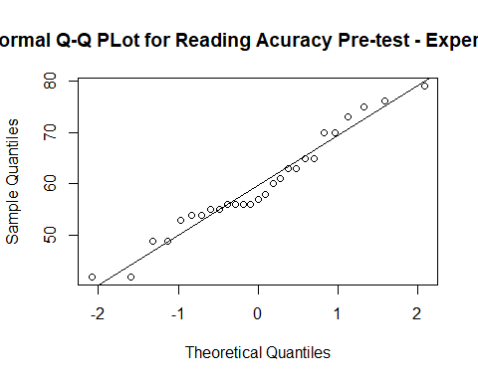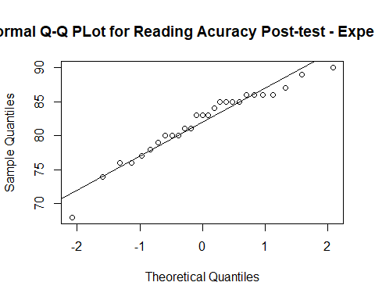

#### B. For Reading Automaticity

##### I. *Control*

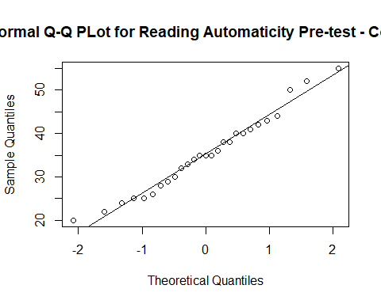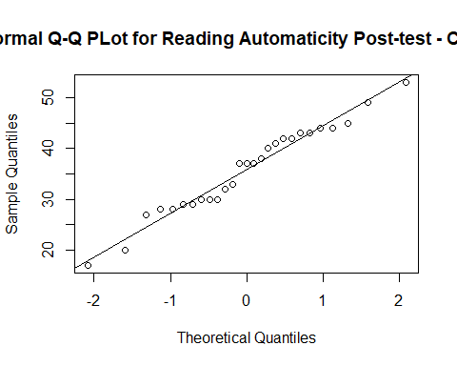

##### II. *Experiment*

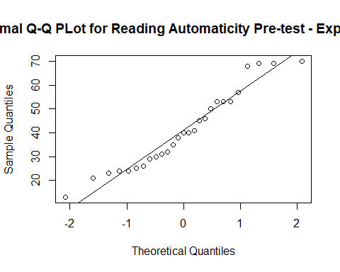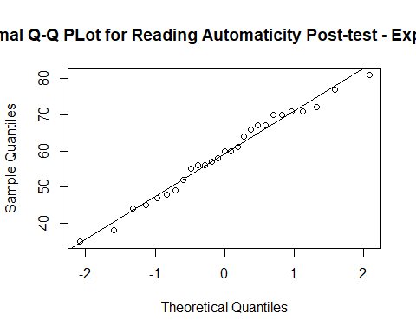

#### C. For Reading Prosody

##### I. *Control*

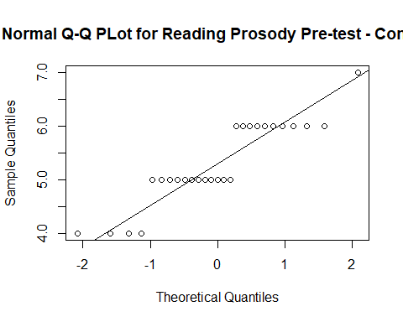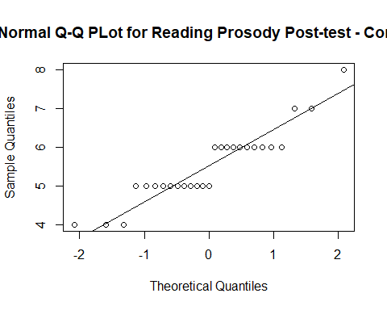

##### II. *Experiment*

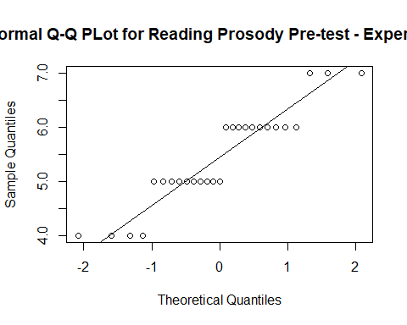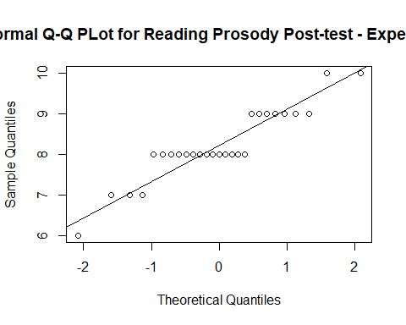

## 2. Shapiro Test

### A. Reading Accuracy

#### I. *Control*

##   
## Shapiro-Wilk normality test  
##   
## data: Acc2pCont$pre  
## W = 0.96252, p-value = 0.421

##   
## Shapiro-Wilk normality test  
##   
## data: Acc2pCont$post  
## W = 0.96367, p-value = 0.4462

#### II. *Experiment*

##   
## Shapiro-Wilk normality test  
##   
## data: Acc2pExp$pre  
## W = 0.96046, p-value = 0.3786

##   
## Shapiro-Wilk normality test  
##   
## data: Acc2pExp$post  
## W = 0.94714, p-value = 0.1826

### B. Reading Automaticity

#### I. *Control*

##   
## Shapiro-Wilk normality test  
##   
## data: Auto2pCont$pre  
## W = 0.97453, p-value = 0.7237

##   
## Shapiro-Wilk normality test  
##   
## data: Auto2pCont$post  
## W = 0.97047, p-value = 0.6143

#### II. *Experiment*

##   
## Shapiro-Wilk normality test  
##   
## data: Auto2pExp$pre  
## W = 0.94318, p-value = 0.146

##   
## Shapiro-Wilk normality test  
##   
## data: Auto2pExp$post  
## W = 0.98013, p-value = 0.8652

### B. Reading Prosody

#### I. *Control*

##   
## Shapiro-Wilk normality test  
##   
## data: Pros2pCont$pre  
## W = 0.85629, p-value = 0.001538

##   
## Shapiro-Wilk normality test  
##   
## data: Pros2pCont$post  
## W = 0.88528, p-value = 0.006258

#### II. *Experiment*

##   
## Shapiro-Wilk normality test  
##   
## data: Pros2pExp$pre  
## W = 0.88299, p-value = 0.005578

##   
## Shapiro-Wilk normality test  
##   
## data: Pros2pExp$post  
## W = 0.88162, p-value = 0.005207

## 3. Levene’s Test for variance homogeneity

Levene’s test is used to evaluate the normality of distribution between two independent variables *e.g. Control Vs Experiment* , and not repeated variable.

## Loading required package: carData

### A. Reading Accuracy

#### I. *Pre-test*

## Warning in leveneTest.default(pre[Group == "Control"], pre[Group ==  
## "Experiment"]): pre[Group == "Experiment"] coerced to factor.

## Levene's Test for Homogeneity of Variance (center = median)  
## Df F value Pr(>F)  
## group 16 1.3867 0.3051  
## 10

#### II. *post-test*

## Warning in leveneTest.default(post[Group == "Control"], post[Group ==  
## "Experiment"]): post[Group == "Experiment"] coerced to factor.

## Levene's Test for Homogeneity of Variance (center = median)  
## Df F value Pr(>F)  
## group 14 1.1628 0.4009  
## 12

### B. Reading Automaticity

#### I. *pre-test*

## Warning in leveneTest.default(pre[Group == "Control"], pre[Group ==  
## "Experiment"]): pre[Group == "Experiment"] coerced to factor.

## Levene's Test for Homogeneity of Variance (center = median)  
## Df F value Pr(>F)  
## group 21 0.6616 0.7713  
## 5

#### II. *post-test*

## Warning in leveneTest.default(post[Group == "Control"], post[Group ==  
## "Experiment"]): post[Group == "Experiment"] coerced to factor.

## Warning in anova.lm(lm(resp ~ group)): ANOVA F-tests on an essentially  
## perfect fit are unreliable

## Levene's Test for Homogeneity of Variance (center = median)  
## Df F value Pr(>F)   
## group 21 8.7258e+29 < 2.2e-16 ***  
## 5   
## ---  
## Signif. codes: 0 '***' 0.001 '**' 0.01 '*' 0.05 '.' 0.1 ' ' 1

### C. Reading Prosody

#### I. *pre-test*

## Warning in leveneTest.default(pre[Group == "Control"], pre[Group ==  
## "Experiment"]): pre[Group == "Experiment"] coerced to factor.

## Levene's Test for Homogeneity of Variance (center = median)  
## Df F value Pr(>F)  
## group 3 0.1168 0.9494  
## 23

#### II. *post-test*

## Warning in leveneTest.default(post[Group == "Control"], post[Group ==  
## "Experiment"]): post[Group == "Experiment"] coerced to factor.

## Levene's Test for Homogeneity of Variance (center = median)  
## Df F value Pr(>F)  
## group 4 1.6464 0.1983  
## 22

## 4. Difference between scores normality test

this test is used to assess the normailty distribution of repeated variables and used as a pre-normality test before selecting Wilcoxson’s singled rank test

### A. Reading Accuracy

#### I. *Control*

## 'data.frame': 27 obs. of 4 variables:  
## $ Group: Factor w/ 2 levels "Control","Experiment": 1 1 1 1 1 1 1 1 1 1 ...  
## $ pre : int 61 63 52 46 51 56 56 61 62 59 ...  
## $ post : int 60 62 44 55 52 62 64 49 52 63 ...  
## $ Diff : int -1 -1 -8 9 1 6 8 -12 -10 4 ...

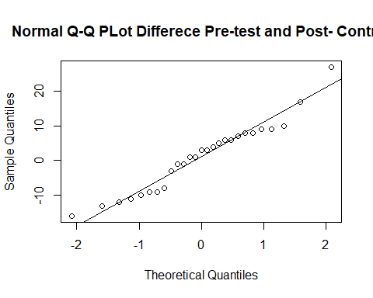

#### II. *Experiment*

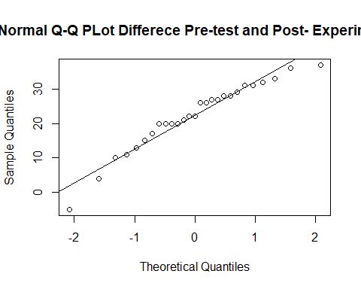

### B. Reading Automaticity

#### I. *Control*

## 'data.frame': 27 obs. of 4 variables:  
## $ Group: Factor w/ 2 levels "Control","Experiment": 1 1 1 1 1 1 1 1 1 1 ...  
## $ pre : int 24 32 29 36 25 42 35 43 35 41 ...  
## $ post : int 33 37 28 41 44 43 45 28 30 37 ...  
## $ Diff : int 9 5 -1 5 19 1 10 -15 -5 -4 ...

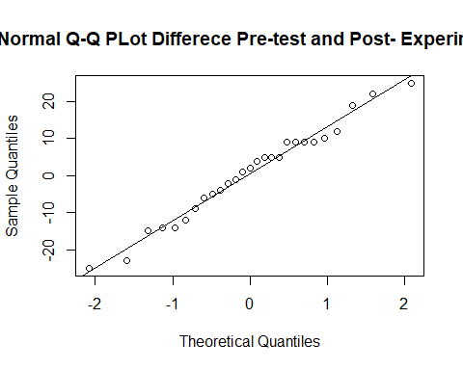

#### II. *Experiment*

## 'data.frame': 27 obs. of 4 variables:  
## $ Group: Factor w/ 2 levels "Control","Experiment": 2 2 2 2 2 2 2 2 2 2 ...  
## $ pre : int 30 32 24 13 53 35 57 46 69 45 ...  
## $ post : int 66 56 56 64 70 67 71 35 45 47 ...  
## $ Diff : int 36 24 32 51 17 32 14 -11 -24 2 ...

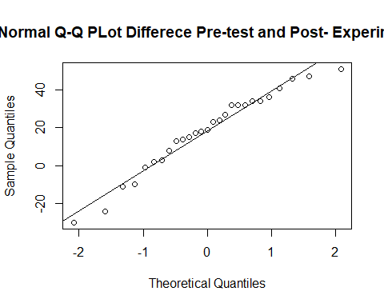

### C. Reading Prosody

#### I. *Control*

## 'data.frame': 27 obs. of 4 variables:  
## $ Group: Factor w/ 2 levels "Control","Experiment": 1 1 1 1 1 1 1 1 1 1 ...  
## $ pre : int 6 6 5 4 5 5 6 6 6 6 ...  
## $ post : int 6 7 5 6 5 6 5 5 5 6 ...  
## $ Diff : int 0 1 0 2 0 1 -1 -1 -1 0 ...

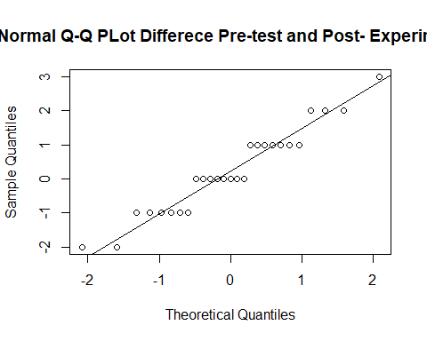

#### II. *Experiment*

## 'data.frame': 27 obs. of 4 variables:  
## $ Group: Factor w/ 2 levels "Control","Experiment": 2 2 2 2 2 2 2 2 2 2 ...  
## $ pre : int 5 6 6 6 7 6 6 5 7 6 ...  
## $ post : int 8 9 8 9 8 8 8 7 9 6 ...  
## $ Diff : int 3 3 2 3 1 2 2 2 2 0 ...

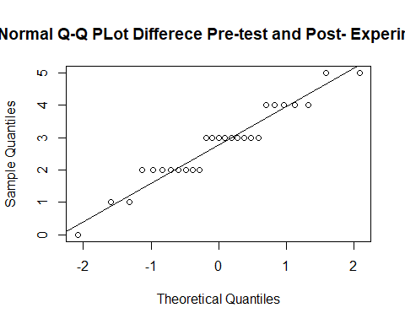

## Hypothesis tests:

### 1. Mann Whitney U test

the H0: is that there is no significant difference between the control or the Experimental groups

#### A. Hypothesis testing for the *Pre-Test*

H0: no difference in the pre-test scores between the control and the Experiment group (this is the required result)

##### I.Reading Accuracy

## Warning in wilcox.test.default(x = c(61L, 63L, 52L, 46L, 51L, 56L, 56L, :  
## cannot compute exact p-value with ties

## Warning in wilcox.test.default(x = c(61L, 63L, 52L, 46L, 51L, 56L, 56L, :  
## cannot compute exact confidence intervals with ties

##   
## Wilcoxon rank sum test with continuity correction  
##   
## data: pre by Group  
## W = 240.5, p-value = 0.03237  
## alternative hypothesis: true location shift is not equal to 0  
## 95 percent confidence interval:  
## -9.000003e+00 -1.163105e-06  
## sample estimates:  
## difference in location   
## -4.000065

Effect Size:………………

#### II. Reading Automaticity

## Warning in wilcox.test.default(x = c(24L, 32L, 29L, 36L, 25L, 42L, 35L, :  
## cannot compute exact p-value with ties

## Warning in wilcox.test.default(x = c(24L, 32L, 29L, 36L, 25L, 42L, 35L, :  
## cannot compute exact confidence intervals with ties

##   
## Wilcoxon rank sum test with continuity correction  
##   
## data: pre by Group  
## W = 302.5, p-value = 0.287  
## alternative hypothesis: true location shift is not equal to 0  
## 95 percent confidence interval:  
## -12.999929 3.000046  
## sample estimates:  
## difference in location   
## -4

#### III. Reading Prosody

## Warning in wilcox.test.default(x = c(6L, 6L, 5L, 4L, 5L, 5L, 6L, 6L, 6L, :  
## cannot compute exact p-value with ties

## Warning in wilcox.test.default(x = c(6L, 6L, 5L, 4L, 5L, 5L, 6L, 6L, 6L, :  
## cannot compute exact confidence intervals with ties

##   
## Wilcoxon rank sum test with continuity correction  
##   
## data: pre by Group  
## W = 331.5, p-value = 0.5485  
## alternative hypothesis: true location shift is not equal to 0  
## 95 percent confidence interval:  
## -0.9999971781 0.0000438064  
## sample estimates:  
## difference in location   
## -6.182401e-05

#### B. Hypothesis testing for the *Post-Test*

H0: no difference in the pre-test scores between the control and the Experiment group (this is not the required result).if H0 was true, this will indicate that the intervention had no effect

###### I. Reading Accuracy

## Warning in wilcox.test.default(x = c(60L, 62L, 44L, 55L, 52L, 62L, 64L, :  
## cannot compute exact p-value with ties

## Warning in wilcox.test.default(x = c(60L, 62L, 44L, 55L, 52L, 62L, 64L, :  
## cannot compute exact confidence intervals with ties

##   
## Wilcoxon rank sum test with continuity correction  
##   
## data: post by Group  
## W = 1, p-value = 3.273e-10  
## alternative hypothesis: true location shift is not equal to 0  
## 95 percent confidence interval:  
## -29.99996 -22.99993  
## sample estimates:  
## difference in location   
## -26.00006

Effect Size:………………….

#### II. Reading Automaticity

## Warning in wilcox.test.default(x = c(33L, 37L, 28L, 41L, 44L, 43L, 45L, :  
## cannot compute exact p-value with ties

## Warning in wilcox.test.default(x = c(33L, 37L, 28L, 41L, 44L, 43L, 45L, :  
## cannot compute exact confidence intervals with ties

##   
## Wilcoxon rank sum test with continuity correction  
##   
## data: post by Group  
## W = 39.5, p-value = 1.95e-08  
## alternative hypothesis: true location shift is not equal to 0  
## 95 percent confidence interval:  
## -29.00003 -17.00001  
## sample estimates:  
## difference in location   
## -23.99992

Effect Size:………………….

#### III. Reading Prosody

## Warning in wilcox.test.default(x = c(6L, 7L, 5L, 6L, 5L, 6L, 5L, 5L, 5L, :  
## cannot compute exact p-value with ties

## Warning in wilcox.test.default(x = c(6L, 7L, 5L, 6L, 5L, 6L, 5L, 5L, 5L, :  
## cannot compute exact confidence intervals with ties

##   
## Wilcoxon rank sum test with continuity correction  
##   
## data: post by Group  
## W = 21, p-value = 1.361e-09  
## alternative hypothesis: true location shift is not equal to 0  
## 95 percent confidence interval:  
## -3.000045 -2.000012  
## sample estimates:  
## difference in location   
## -2.999975

Effect Size:………………….

### 2. Wilcoxson’s single Rank Test

the H0: is that ther is no difference between the pre and post test for control or Experiments

I.Reading Accuracy ##### A. *Control*

## Warning in wilcox.test.default(pre, post, mu = 0, alt = "two.sided",  
## conf.int = T, : cannot compute exact p-value with ties

## Warning in wilcox.test.default(pre, post, mu = 0, alt = "two.sided",  
## conf.int = T, : cannot compute exact confidence interval with ties

##   
## Wilcoxon signed rank test with continuity correction  
##   
## data: pre and post  
## V = 174.5, p-value = 0.7363  
## alternative hypothesis: true location shift is not equal to 0  
## 99 percent confidence interval:  
## -6.500037 4.499953  
## sample estimates:  
## (pseudo)median   
## -0.9999788

###### B. *Experiment*

## Warning in wilcox.test.default(pre, post, mu = 0, alt = "two.sided",  
## conf.int = T, : cannot compute exact p-value with ties

## Warning in wilcox.test.default(pre, post, mu = 0, alt = "two.sided",  
## conf.int = T, : cannot compute exact confidence interval with ties

##   
## Wilcoxon signed rank test with continuity correction  
##   
## data: pre and post  
## V = 2, p-value = 7.357e-06  
## alternative hypothesis: true location shift is not equal to 0  
## 99 percent confidence interval:  
## -27.99999 -17.49999  
## sample estimates:  
## (pseudo)median   
## -23.07433

Effect Size:………………….

#### II. Reading Automaticity

###### *Control*

## Warning in wilcox.test.default(pre, post, mu = 0, alt = "two.sided",  
## conf.int = T, : cannot compute exact p-value with ties

## Warning in wilcox.test.default(pre, post, mu = 0, alt = "two.sided",  
## conf.int = T, : cannot compute exact confidence interval with ties

##   
## Wilcoxon signed rank test with continuity correction  
##   
## data: pre and post  
## V = 177, p-value = 0.7821  
## alternative hypothesis: true location shift is not equal to 0  
## 99 percent confidence interval:  
## -7.500034 6.500014  
## sample estimates:  
## (pseudo)median   
## -0.9999746

###### B. *Experiment*

## Warning in wilcox.test.default(pre, post, mu = 0, alt = "two.sided",  
## conf.int = T, : cannot compute exact p-value with ties

## Warning in wilcox.test.default(pre, post, mu = 0, alt = "two.sided",  
## conf.int = T, : cannot compute exact confidence interval with ties

##   
## Wilcoxon signed rank test with continuity correction  
##   
## data: pre and post  
## V = 43.5, p-value = 0.0004933  
## alternative hypothesis: true location shift is not equal to 0  
## 99 percent confidence interval:  
## -30.500044 -6.499961  
## sample estimates:  
## (pseudo)median   
## -19.27148

Effect Size:………………….

#### III. Reading Prosody

###### A. *Control*

## Warning in wilcox.test.default(pre, post, mu = 0, alt = "two.sided",  
## conf.int = T, : cannot compute exact p-value with ties

## Warning in wilcox.test.default(pre, post, mu = 0, alt = "two.sided",  
## conf.int = T, : cannot compute exact confidence interval with ties

## Warning in wilcox.test.default(pre, post, mu = 0, alt = "two.sided",  
## conf.int = T, : cannot compute exact p-value with zeroes

## Warning in wilcox.test.default(pre, post, mu = 0, alt = "two.sided",  
## conf.int = T, : cannot compute exact confidence interval with zeroes

##   
## Wilcoxon signed rank test with continuity correction  
##   
## data: pre and post  
## V = 74, p-value = 0.3903  
## alternative hypothesis: true location shift is not equal to 0  
## 99 percent confidence interval:  
## -1.4999553 0.9999688  
## sample estimates:  
## (pseudo)median   
## -7.419546e-05

###### B. *Experiment*

## Warning in wilcox.test.default(pre, post, mu = 0, alt = "two.sided",  
## conf.int = T, : cannot compute exact p-value with ties

## Warning in wilcox.test.default(pre, post, mu = 0, alt = "two.sided",  
## conf.int = T, : cannot compute exact confidence interval with ties

## Warning in wilcox.test.default(pre, post, mu = 0, alt = "two.sided",  
## conf.int = T, : cannot compute exact p-value with zeroes

## Warning in wilcox.test.default(pre, post, mu = 0, alt = "two.sided",  
## conf.int = T, : cannot compute exact confidence interval with zeroes

##   
## Wilcoxon signed rank test with continuity correction  
##   
## data: pre and post  
## V = 0, p-value = 7.267e-06  
## alternative hypothesis: true location shift is not equal to 0  
## 99 percent confidence interval:  
## -3.500013 -2.499971  
## sample estimates:  
## (pseudo)median   
## -3

Effect Size:………………….