useContext is used to share data between components without passing props in each level
there are three steps to create useContext
- Create the context
- Provide the context with the value using provider
- Consume the context value

App.js
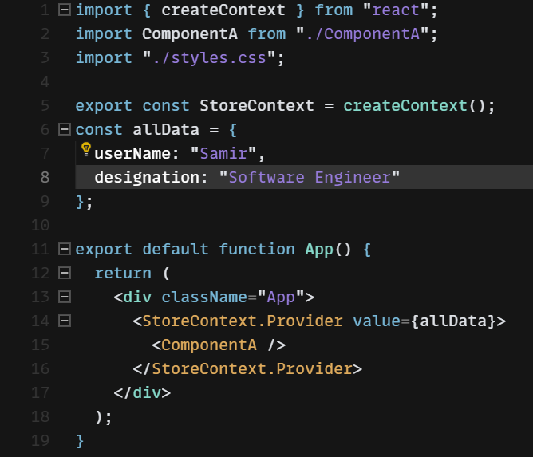

ComponentA.js
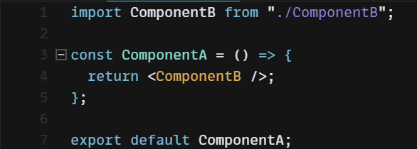

ComponentB.js
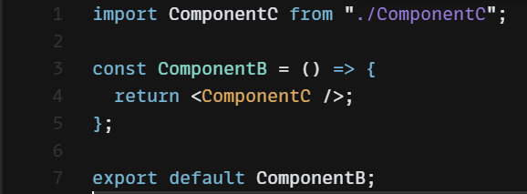

ComponentC.js
