ShareLM data analysis and insights
By: Samer Attrah
Introduction
The ShareLM dataset consists of Human-model conversations, that took place between users from all around the world and the mainstream commercial models, that can be easily found on the internet today, these conversations are collected using different tools, one of the is the ShareLM browser extension, in addition of including parts of other datasets previously made available online by other companies.

Currently the data set features are as follows:
- conversation_id: autonomously generated encrypted phrase, unique for every conversation.
- Conversation: the contents of the textual human-model conversation.
- model_name: the display name of the model (ChatGPT, Claude, Gemini).
- user_id: autonomously generated encrypted phrase, unique for every user.
- Timestamp: the time when the conversation took place
- source: the source of the conversation, from which dataset it was taken (for a subgroup)
- user_metadata:
  - location: geographical location of the user
  - age: a number for the user age
  - gender: the sex/gender of the user
- conversation_metadata:
  - rate: zero(s) or one(s) numerically representing a like or a dislike, respectively, assigned by the user to the conversation.
  - Language: the language used in the conversation.
  - Redacted: (no definition provided)
  - toxic: the value measured for the toxicity of the conversation.
  - Title: the title of the conversation.
  - custom_instruction: (no definition provided)
  - status: (no definition provided)
  - topic: describe the topic of the conversation, and ideally takes, one of:
    - assisting/creative writing.
    - analysis/decision.
    - explanation/coding.
    - factual info.
    - math reason.

The user
The human user does not get identified by their name or any other personal information but by a user_id generated by an algorithm that will generate the same ID when provided the same name, while the other data provided for the user and it get manually and optionally inputted by the user, are location, age, and gender which can get better attention with a minor change to the user interface design, previously discussed in the discord community server, can be highlighted as moving the metadata collection to the same window of the terms of use, instead of the plugin window and possibly make filling them required from the user and not optional.

The model
For the information about the model, all that is provided is the model_name which is also not optimized and accurate at the time writing this document, where having an accurate name for the model will enable deriving many insights, such as:
- user retention for a single model.
- if a wide user base provided a time for use can be found for each model
- improved accuracy in topic-to-model relatedness
- rate-to-model ratio (user engagement)
- toxicity-per-model
- language-to-model
- the regional favorite model
- finding the most popular age group and gender can also be useful.
in other words all the conversation_metadata can be used to find insights about the model and the users when all the information is accurate, so it has big potential and it will improve the study and insight found greatly.
Further work that can be done to improve the dataset such as, using the source feature for the conversation collected from other datasets can fill the model_name feature manually, since it does not have any values currently.

The conversation

Each conversation is provided with a conversation_id, and it is fully recorded as prompt-response pairs between the user and the model, which can be regarding any topic or in any type of language, and in any length, in addition to the conversation and it’s unique id, a list of metadata is recorded manually or autonomously, where the rate is manual by the user, while the topic has been autonomously created, and most of the other metadata are not provided in the dataset currently.

Further improvement for the dataset can also be achieved by filling the language feature as part of the conversation_metadata which can be done using an automated pipeline with an LLM that response for each conversation with the correct language. Where the languages are currently as in the plot, has empty values.
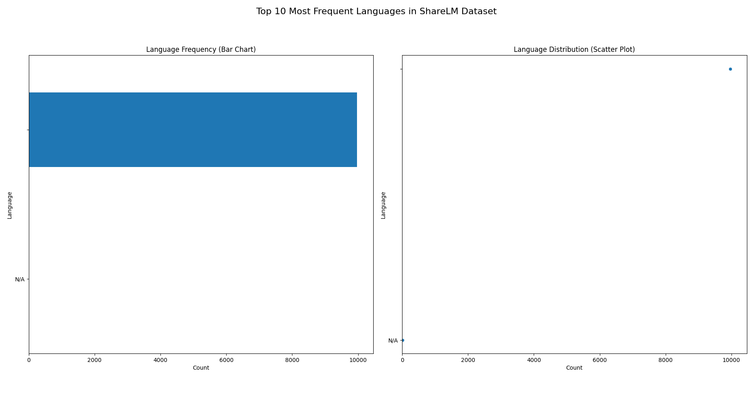
Adding the Topic to the conversation_metadata was done using an LLM (gemma-3n-e2b-it) which is not the best and most accurate in the market today in this task, but it was used to fit the resources available, and it delivered a reasonable performance, this feature (topic) is to be used in further understanding the users, the models and the other conversation properties and improve the models and all that is related to it based on the findings.
Current possible insight
Based on the current data provided which can be found on HuggingFace, in addition to the conversation topic added feature, several insights and visualizations can by driven and facts can be found and be useful in planning and driving further improvement to the models used, the browser extension, or included in marketing studies and social studies about the users.

Considering the importance of the model_name the data used for analysis was a subgroup from the full dataset, were extracted and used in creating a new dataset only with elements that has a defined model_name, and the insights found from the data are listed below:

- Contributions per user:
shows the number of contribution made by each user, by counting the conversations submitted by each user_id, which can show that only nine users has a significant number of contribution with the highest reaching above 800, and as mentioned earlier we can not find who the person is since the user name is not provided but the user_is is what included in the dataset.

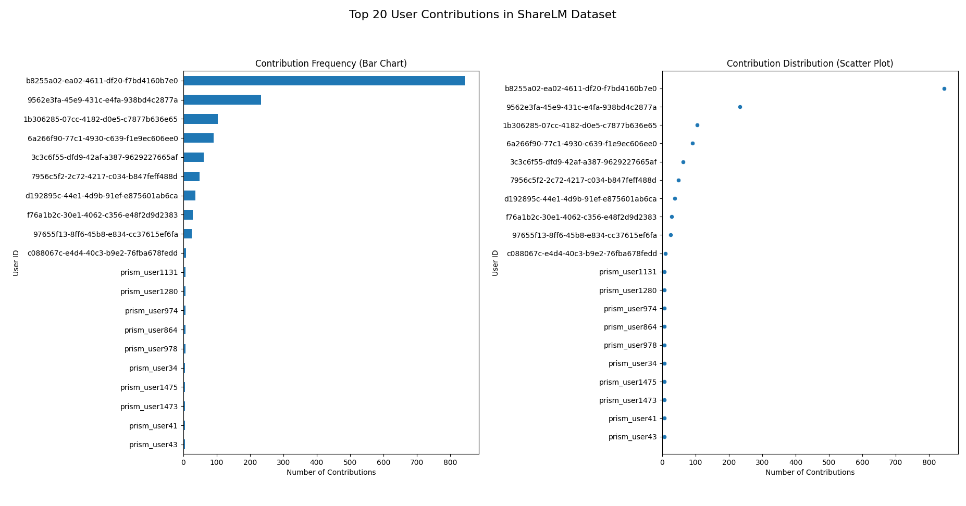
This plot indicate that the retention of the users is so limited today, and only a few of them are significantly contributing, which can also result in having a limited number of topics and models with high frequency and usage while all the others are less active. And this finding can be used in conducting further improvements to the dataset and the browser extension.

- Conversation length:
one insight that mostly matters for model training engineers is the knowing of the lengths of the conversations included in the dataset, which get measured by the number of turns i.e. pairs of prompt-response between the user and the model, and there are other methods of measurements such as the number of characters, number of tokens, and possibly the number of words.

The plot shown below for the conversation length analysis, can indicate the following facts about the data analyzed:
- the longest conversation is a single one with around a hundred turns and the shortest has a turn only.
- The majority of the conversations are below 20 turns.
- The turn count with highest occurrences is the 2 turns conversation reaching around 3000 in frequency.

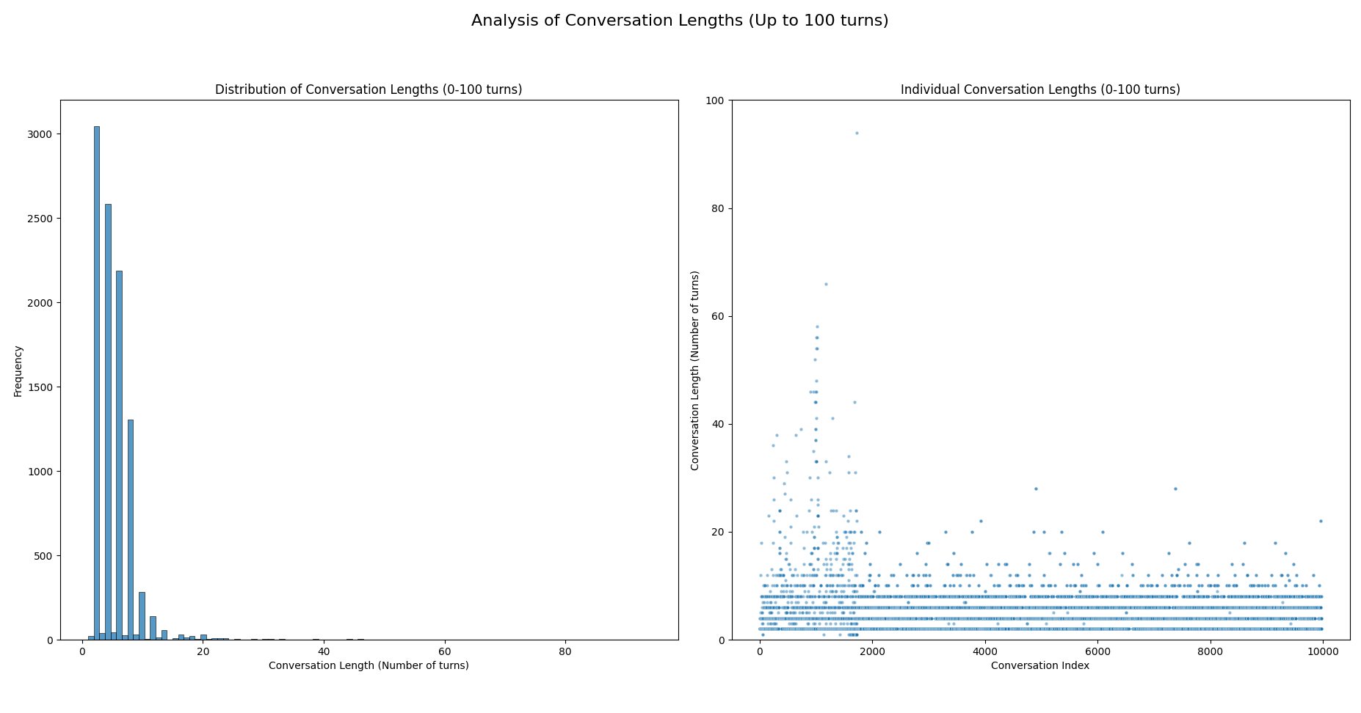
- The longer the conversation the less frequent it is.

- model counts
The model counts can help in understanding the users of the plugin and which model they prefer, and currently the model names are not so accurate and as mentioned in a previous section.

The plot shows the following:
- One model which is GPT4 is dominating the use with around 250 conversations.
- The more frequently used models are only 12 and 6 of them are GPT models by OpenAI.
- Lmarena.ai is heavily used being in the second place, although tens of models on the website all of them are under the same model_name.
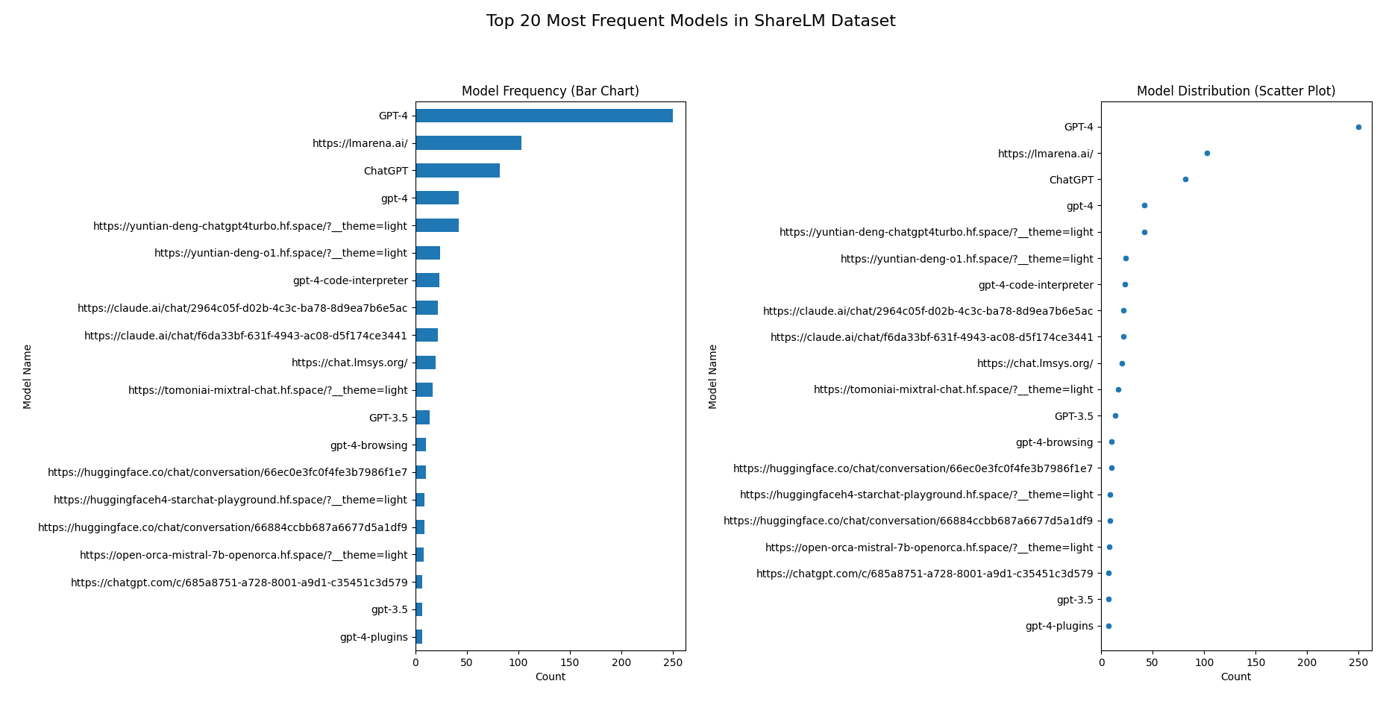

- topic counts
For the topic counting and visualization the classes were used are the same as in the “WildChat” dataset and they are as specified above, applying the classification on the conversations of the dataset can show the following:

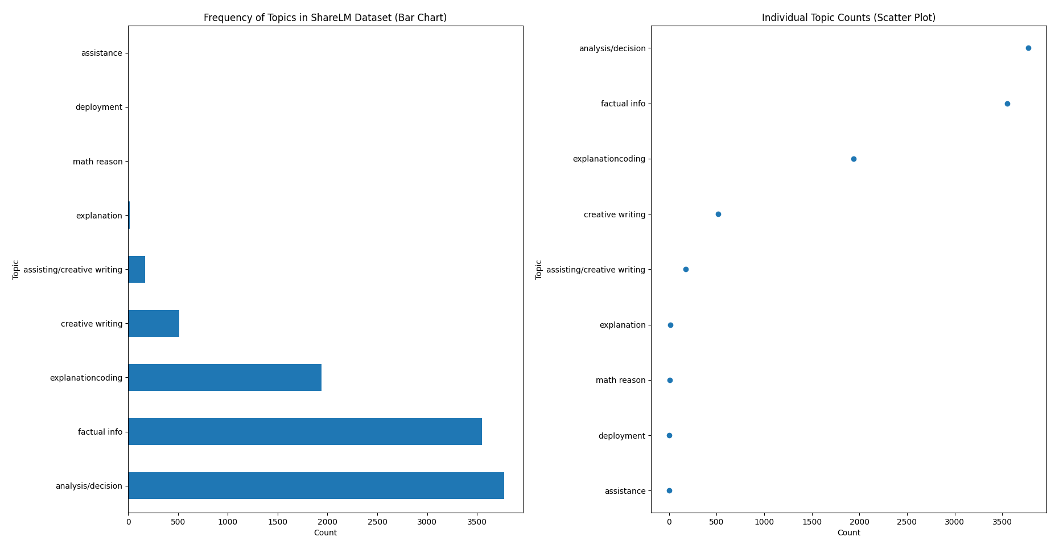
- Analysis/decision and factual info classes are the most common in the dataset with more than 7000 conversations in these classes.
- Assistance and deployment classes are not part of the criteria but can be found in one occurrence each in the dataset.
- Math reason is almost not existing in the dataset.
- “explanation” and “creative writing” have separate frequencies and get summed with the main classes.

- topic per model
To better understand the user patterns and how each model is related to a conversation topic or a use case, conducted an analysis of the topic vs. model_name and found the following:

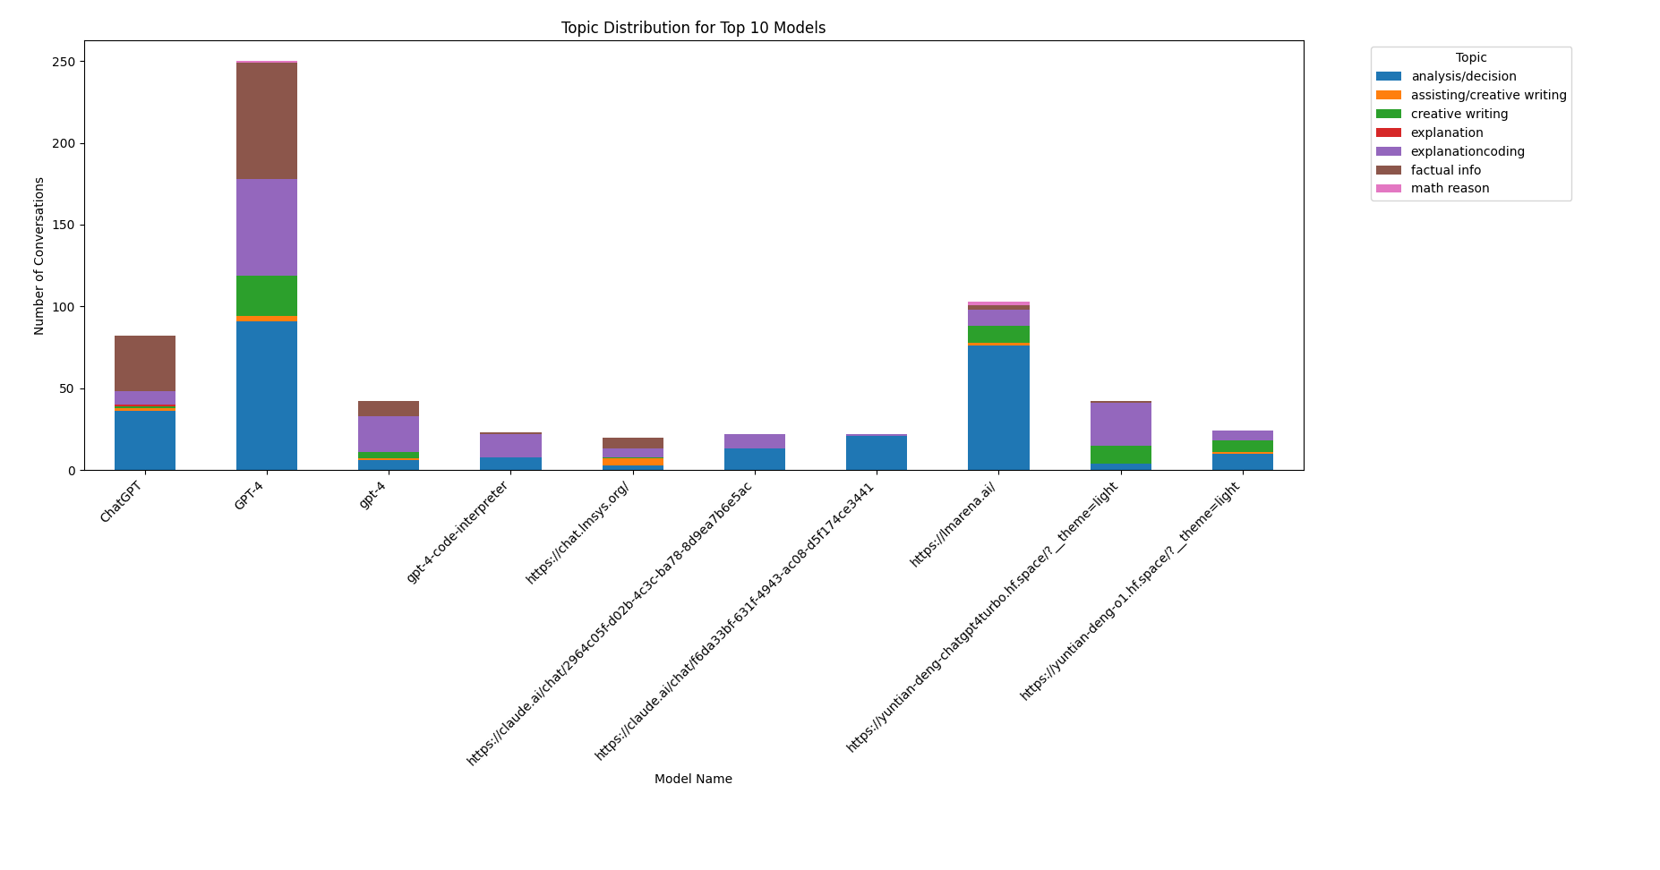
- GPT4 which has the highest number in usage frequency is used for finding factual info, analysis/decision and explanation/coding.
- Lmarena is mostly used for analysis/decision, which has the second highest usage frequency.
- ChatGPT comes third with a topic pattern similar to the GPT4 model which indicates the similar user type are the ones interested in GPT models.

Further analysis and conclusions to be driven from the data if a bigger sample is used and further literature survey is conducted.

References:
- Don-Yehiya S, Choshen L, Abend O. The ShareLM collection and plugin: contributing human-model chats for the benefit of the community. arXiv preprint arXiv:2408.08291. 2024 Aug 15.
- Zhao W, Ren X, Hessel J, Cardie C, Choi Y, Deng Y. Wildchat: 1m chatgpt interaction logs in the wild. arXiv preprint arXiv:2405.01470. 2024 May 2.

