**HIMALAYAN WHITEHOUSE INTERNATIONAL COLLEGE**

(Affiliated to Purbanchal University)

Putalisadak, Kathmandu



**Proposal on**

“Restaurant Menu”

**Submitted to**:

Ram Chandra Poudel

DEPARTMENT OF “IT”

**Submitted by**:

Samip Kc

Bibek Singh Bist

Samir Balami

# ACCEPTANCE LETTER

This is to certify that Mr.Samip kc,Samir Balami,Bibek Bist has prepared this project/presentation entitled “Resturant menu ” for the partial fulfillment of bachelor of information technology second semester ,under my supervision.

I recommended this project for the approval and acceptance.

February 20, 2023

…………………………………………………

Mr. UTSAB POKHAREL

BIT, HOD

HIMALAYAN WHITEHOUSE INTERNATIONAL COLLEGE,

PUTALISADAK, KATHMANDU

# APPROVAL SHEET

This project/presentation submitted by Samip Kc,Samir Balami,Bibek Bist has been accepted as partial fulfillment of the Bachelor of Information Technology (BIT).

Expert Committee

External:

Supervisor:

Mr. RC Poudel

Exam Head:

Date

# Table of Contents

ACCEPTANCE LETTER i

APPROVAL SHEET ii

Table of Contents iii

INTRODUCTION 1

PROBLEM STATEMENT 2

OBJECTIVE 3

FEATURE 4

FLOWCHART 5

ALGORITHM 6

PSEUDO CODE 7

EXCEPTED OUTPUT 14

GANTT CHART 15

BIBLIOGRAPHY 17

# INTRODUCTION

There is various factor which helps to run restaurant with profitability, smoothly and in perfect way. But among them restaurant menu is most important thing. Because in restaurant, profit can be generated by selling foods and it is very important to manage the restaurant menu system.

It is very uneasy and hard physical presence and it is very time on that process. Restaurant menu system is designed with the help of this system customer can order anything without any obligation.

The main aim to design this project is to make systematic order system, manage the flow of increasing customer in peak time and facilitate customer with user friendly system where customer can order anything they want in any quantity and get instant bill.

# **PROBLEM STATEMENT**

The traditional method to accept the restaurant order is to provide menu first and then customer will give their order and human resource is required to collect order and to serve the order. This process will take lots of time to place and get the order. And there are high chances of human errors in ordering and billing, to overcome this problem and to run restaurant smoothly this system was developed.

# **OBJECTIVE**

* To develop a system for better user experience with interactivity.
* To tailor the smooth operation with less delay and reduction in operational confusion.
* To integrate proper methods and methodologies which are used for designing and  
  developing the system in systematic approach.
* To integrate technology and automation in food service industry for efficiency.

# Methodology

# **FEATURE**

* Multiple orders can be received and processed simultaneously.
* Digital Menu can be easily updated and configured as per the requirement.
* Quick billing and item ordering.
* Detail description of the dish including price list serving size etc.

# **FLOWCHART**

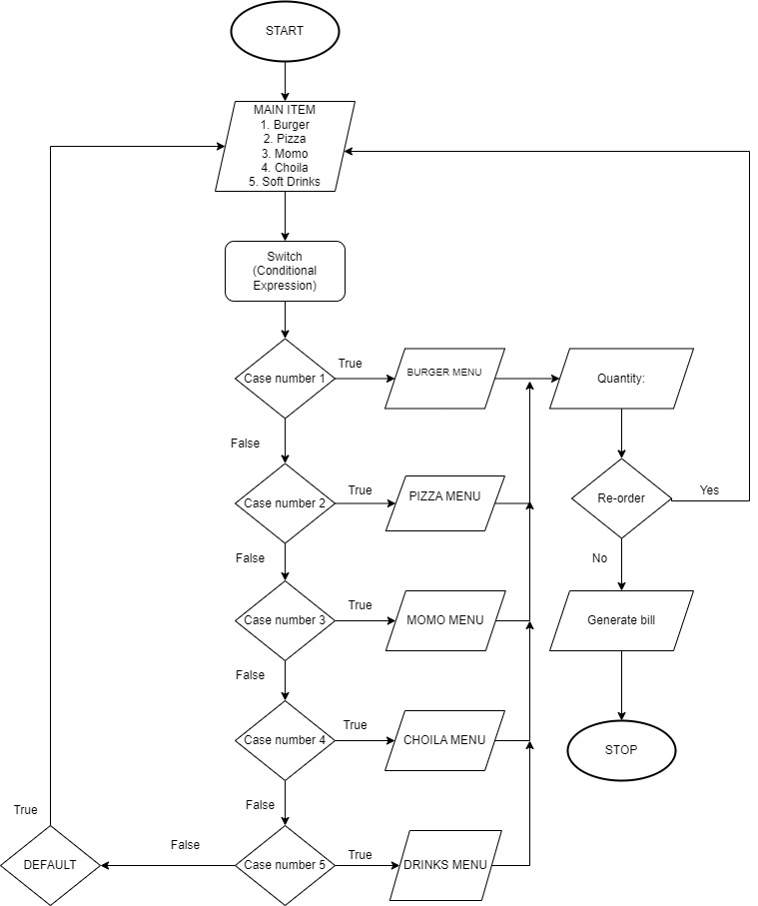

# **ALGORITHM**

Step 1: Start

Step 2: Main item 1. Burger 2. Pizza 3. Momo 4. Choila 5. Soft Drinks.

Step 3: Enter choice.

Step 4: case 1 goes to Burger Menu with ordering quantity facility.

Step 5: Click re-order for the food that goes to main item menu otherwise generate bill.

Step 6: case 2 goes to pizza menu with ordering quantity facility.

Step 7: repeat step 5.

Step 8: case 3 goes to Momo menu with ordering quantity facility.

Step 9: repeat step 5 process.

Step 10: case 4 goes to choila menu with ordering quantity facility.

Step 11: repeat step 5 process.

Step 12: case 5 goes to soft drinks menu with ordering quantity facility.

Step 13: Default goes to the main menu.

Step 14: stop

# **PSEUDO CODE**

Approach to counter

Line 1. Output ‘MAIN MENU’

Output ‘1. Burger’

Output ‘2. Pizza’

Output ‘3. Momo’

Output ‘4. Choila’

Output ‘5. Soft Drinks’

Input option here:

Line 2. If option = Burger

Output ‘BURGER MENU’

Output ‘1. Veg. Burger 100’

Output ‘2. Chicken. Burger 140’

Output ‘3. Buff. Burger 120’

Input option here:

Input Quantity:

Output “Do you like to re-order:”

If option = yes

Then go to line 1

If option = no

Then go to next line

Line 2. If option = Pizza

Output ‘PIZZA MENU’

Output ‘1. Veg. Pizza 250’

Output ‘2. Chicken. Pizza 350’

Output ‘3. Mix. Pizza 450’

Input option here:

Input Quantity:

Output “Do you like to re-order:”

If option = yes

Then go to line 1

If option = no

Then go to next line

Line 2. If option = Momo

Output ‘MOMO MENU’

Output ‘1. Veg. Momo 110’

Output ‘2. Chicken. Momo 180’

Output ‘3. Buff. Momo 150’

Input option here:

Input Quantity:

Output “Do you like to re-order:”

If option = yes

Then go to line 1

If option = no

Then go to next line

Line 2. If option = Choila

Output ‘CHOILA MENU’

Output ‘1. Buff. Choila 180’

Output ‘2. Chicken Choila 160’

Input option here:

Input Quantity:

Output “Do you like to re-order:”

If option = yes

Then go to line 1

If option = no

Then go to next line

Line 2. If option = Soft Drinks

Output ‘DRINKS MENU’

Output ‘1. Coca-Cola 60’

Output ‘2. Fanta 60’

Output ‘3. Sprite 60‘

Output ‘3. Pepsi 60‘

Output ‘3. Water 30‘

Input option here:

Input Quantity:

Output “Do you like to re-order:”

If option = yes

Then go to line 1

If option = no

Then go to next line

Line 3. Output ‘Billing with VAT’

Output ‘Buff Choila 180’

Output ’13% vat 23.4’

Output ’Total price 203.4’

# **GANTT CHART**



# **EXCEPTED OUTPUT**

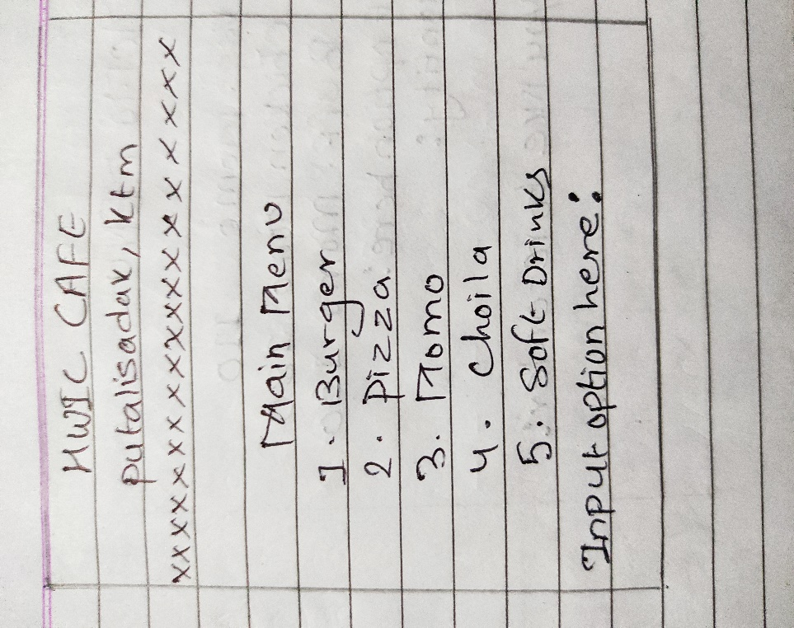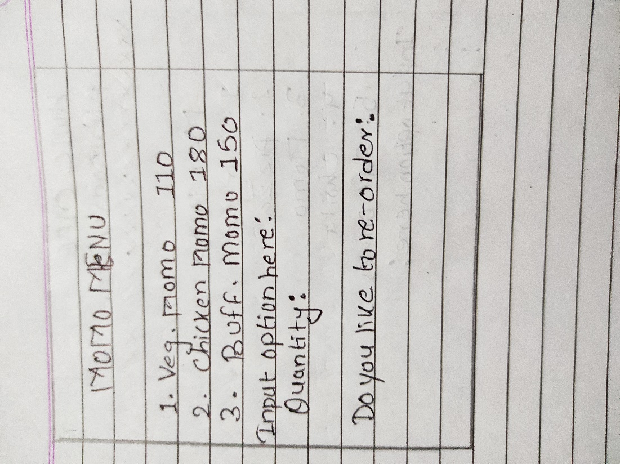

# **BIBLIOGRAPHY**

Torres, Arnelyn. (2016). Electronic Menu and ordering Application system: A strategic tool for customer satisfaction and profit enhancement. International journal of u- and e- service, science and technology.9.401-410. 10,14257//ijunesst.2016.9.4.39.