Week 2 – Exploratory Data Analysis (EDA)
and Visualization Framework Design
AI-Based Student Performance Prediction & Early Academic Risk Detection System
Prepared by: Shaikh Samir Yasin
B.Tech – Artificial Intelligence and Data Science
Internship Week 2

1. Executive Summary
This Week 2 project defines a comprehensive Exploratory Data Analysis (EDA) and visualization framework for the hypothetical student-performance project introduced in Week 1. No real dataset is provided, so the deliverable focuses on a reusable analytical process rather than actual findings. The framework explains how a future dataset would be inspected, validated, cleaned for analysis, summarized, visualized, and interpreted before machine-learning modeling.
The proposed EDA process covers data understanding, data-quality checks, univariate analysis, bivariate analysis, multivariate analysis, missing-value and outlier assessment, relationship analysis, visualization selection, interpretation, and reporting. Python libraries including Pandas, NumPy, Matplotlib, Seaborn, and Plotly are proposed. The framework is designed to be adaptable to other tabular datasets as well.

2. Introduction to EDA
Exploratory Data Analysis is the systematic process of examining a dataset to understand its structure, quality, distributions, relationships, unusual observations, and potential patterns. EDA is performed before or alongside formal statistical and machine-learning analysis because it can reveal data-quality issues and guide the choice of features, transformations, visualizations, and modeling strategies.
For the student-performance use case, EDA would help answer questions such as: How is attendance distributed? Are marks highly skewed? Are there missing values? Is study time associated with marks? Do assignment scores differ across risk groups? Are some variables strongly correlated? Are there outliers that require investigation?

3. Potential Data Types and Dataset Structure
Data type | Example variables | EDA approach
Numerical – continuous | Study hours, average marks, assignment score | Distribution, summary statistics, histogram, box plot
Numerical – discrete | Number of assignments, absence count | Frequency, histogram/bar chart
Categorical – nominal | Department, learning mode | Counts, bar/count plot
Categorical – ordinal | Performance band, risk level | Ordered frequency plots
Binary | At-risk flag, attendance warning | Class balance, proportion plot
Date/time | Assessment date, semester | Time trend, seasonality

4. EDA Workflow
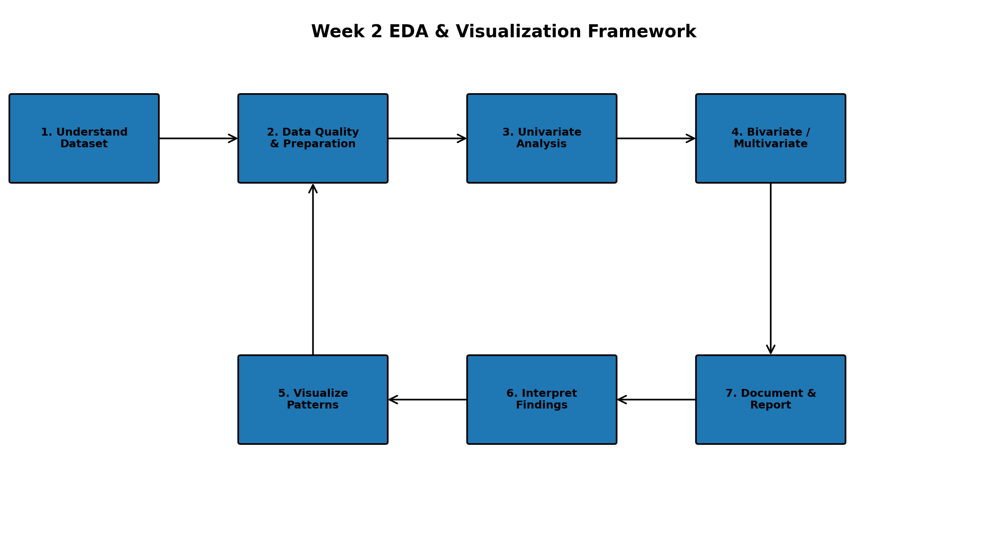
Figure 1. Proposed EDA and visualization workflow.

5. Data Understanding and Initial Inspection
- Load the dataset with Pandas and preserve the raw source separately from analysis copies.
- Inspect dimensions using shape and review columns using head(), tail(), sample(), and info().
- Identify data types and convert columns to appropriate numeric, categorical, or datetime formats.
- Generate descriptive statistics with describe() and frequency tables for categorical variables.
- Check duplicate rows, unique-value counts, constant columns, and suspicious values.
- Document assumptions and create a data dictionary describing each variable.

6. Data Quality Assessment
The analysis should assess quality before interpreting patterns.
- Missing values: calculate counts and percentages by column; determine whether missingness appears random or systematic.
- Duplicates: identify exact duplicate records and investigate whether they represent repeated observations.
- Invalid values: check domain rules such as marks outside the permitted range or negative study hours.
- Inconsistent categories: standardize spelling, capitalization, whitespace, and category labels.
- Outliers: use IQR-based rules, box plots, z-score screening where appropriate, and domain review.
- Data leakage risks: flag variables that would only become available after the outcome being predicted.

7. Univariate Analysis
Univariate analysis studies one variable at a time. Numerical variables would be examined using mean, median, standard deviation, minimum, maximum, quartiles, skewness, and distribution plots. Categorical variables would be examined using counts and percentages.
- Histogram/KDE: understand numerical distribution, skewness, and concentration.
- Box plot: compare spread and identify potential outliers.
- Bar/count plot: inspect categorical frequencies and class imbalance.
- Summary tables: report central tendency and variability.

8. Bivariate and Multivariate Analysis
Analysis | Example question | Visualization
Numerical vs numerical | Does study time relate to marks? | Scatter plot + trend line
Category vs numerical | Do marks differ by department? | Box plot / violin plot
Category vs category | Is risk level associated with learning mode? | Grouped/stacked bar chart
Many numerical variables | Which features move together? | Correlation heatmap
Three or more variables | Does the study-hours/marks relationship differ by risk group? | Faceted scatter plots / pair plot
Multivariate analysis should be used carefully: correlation does not establish causation, and patterns must be checked against domain knowledge and data quality.

9. Visualization Strategy
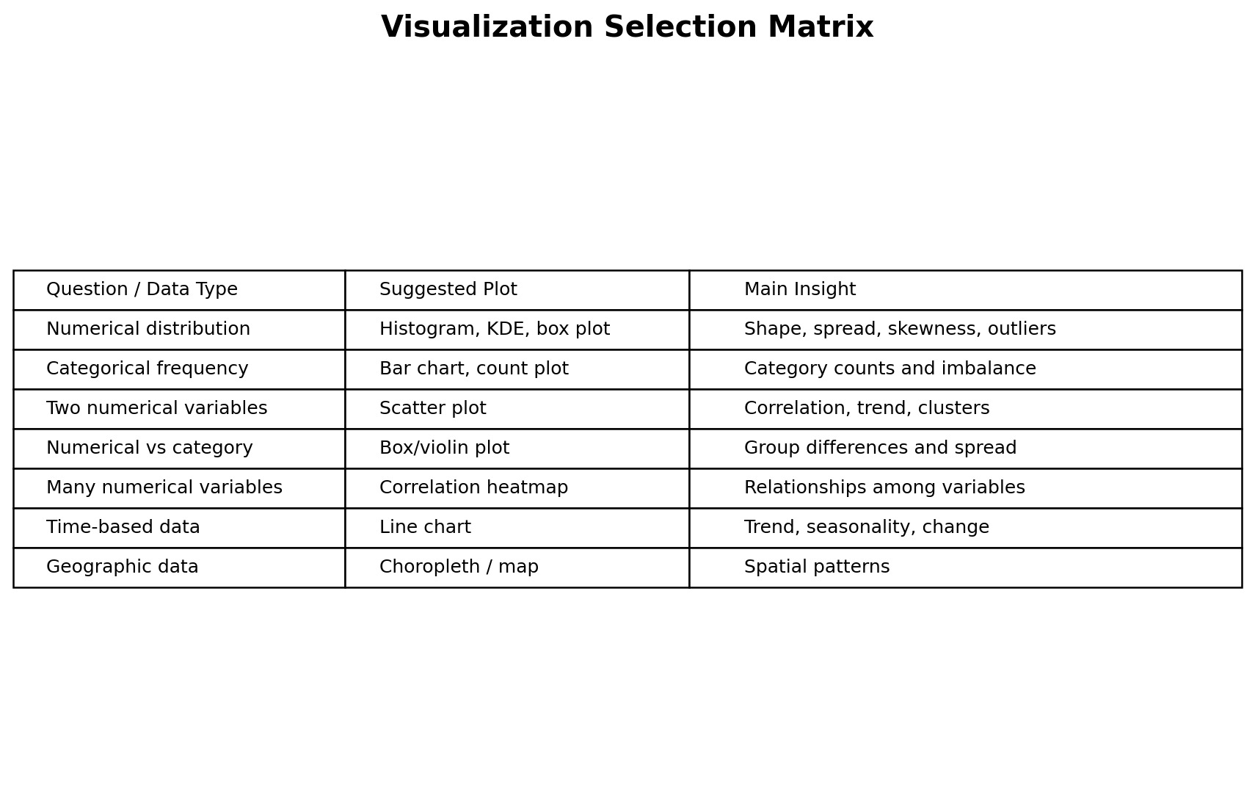
Figure 2. Visualization selection matrix.
- Use clear titles, axis labels, units, legends, and readable annotations.
- Avoid unnecessary 3D effects and excessive decoration.
- Use consistent formatting across related charts.
- Prefer plots that directly answer a question rather than creating charts without an analytical purpose.
- Include appropriate notes when values are normalized, filtered, transformed, or aggregated.

10. Proposed Visualization Examples
Plot | Purpose | Potential student-performance use
Histogram | Distribution | Distribution of average marks or study hours
Box plot | Spread/outliers/group comparison | Marks by attendance band
Bar/count plot | Category frequency | Students by risk category
Scatter plot | Relationship | Study hours vs average marks
Heatmap | Correlation matrix | Relationships among numeric features
Line chart | Time trend | Average performance across assessment dates
Violin plot | Distribution by group | Marks distribution across departments
Pair plot | Multiple pairwise relationships | Initial screening of selected numeric variables

11. Python Libraries and Tools
Tool / Library | Role
Python | Core programming language
Pandas | Data loading, cleaning, transformation, aggregation
NumPy | Numerical operations and array-based calculations
Matplotlib | Flexible foundational plotting
Seaborn | Statistical visualizations and attractive defaults
Plotly | Interactive charts when interactivity is useful
Jupyter Notebook / Google Colab | Exploration, documentation, and reproducible analysis
VS Code | Project development and organization
Git / GitHub | Version control and submission

12. Missing Data and Outlier Handling Framework
- Quantify missingness before deciding on an action.
- For low missingness, consider appropriate imputation based on variable type and domain context.
- For substantial missingness, investigate why values are missing before dropping or imputing.
- For outliers, distinguish data-entry errors from legitimate extreme observations.
- Avoid automatically deleting outliers; compare robust statistics and domain rules.
- Record every transformation so the final analysis is reproducible.

13. Reporting and Documentation Plan
The final EDA report should follow a consistent structure:
- Executive summary and analytical questions
- Dataset description and data dictionary
- Data-quality assessment
- Univariate findings
- Bivariate and multivariate findings
- Visualization gallery with interpretations
- Important anomalies, limitations, and assumptions
- Feature recommendations for modeling
- Conclusions and next steps
Each important chart should be accompanied by a short interpretation explaining what the visualization shows, why it matters, and what action or follow-up analysis it suggests.

14. 34-Hour Week 2 Timeline
Activity | Hours | Output
Understand EDA requirements and analytical questions | 3 | EDA objectives and question list
Dataset structure and data-quality framework | 4 | Data inspection/checklist plan
Univariate analysis framework | 4 | Distribution and frequency analysis plan
Bivariate and multivariate analysis | 5 | Relationship-analysis plan
Visualization strategy and chart selection | 5 | Visualization matrix/examples
Missing data and outlier framework | 3 | Quality-handling strategy
Python tools and reproducibility plan | 3 | Tool/library workflow
Reporting/documentation structure | 3 | Report template
Review, formatting, diagrams, final submission | 4 | Final DOC and submission package
Total: 34 hours

15. Expected Outcomes
- A reusable EDA workflow that can be applied when the actual dataset becomes available.
- A clear method for detecting missing values, duplicates, invalid values, outliers, and potential leakage.
- A visualization framework that maps analytical questions to appropriate chart types.
- A structured approach for discovering distributions, relationships, trends, and potential feature interactions.
- A documented process that prepares the project for feature engineering and machine-learning modeling in later weeks.

16. Anticipated Challenges and Mitigation
Challenge | Mitigation
Missing or incomplete data | Quantify missingness and choose domain-appropriate treatment.
Outliers | Investigate context before removing; use robust statistics.
Class imbalance | Report class proportions and consider appropriate evaluation methods later.
Misleading correlations | Use domain knowledge and avoid causal interpretation.
Too many visualizations | Prioritize charts tied to explicit analytical questions.
Inconsistent data types | Validate and standardize types during initial inspection.
Reproducibility | Record code, transformations, assumptions, and library versions.

17. Evaluation Criteria Alignment
- Depth and clarity of the EDA process.
- Well-organized explanation of visualization methodologies.
- Appropriate use and explanation of Python libraries.
- Clear, logical process adaptable to different datasets.
- Effective document formatting and visual structure.
- Detailed reporting and documentation plan.
- Approximately 30–35 hours of planned work.

18. Conclusion
This Week 2 framework establishes a systematic approach to exploratory data analysis and visualization for the proposed student-performance project. It begins with understanding the dataset and its quality, progresses through univariate, bivariate, and multivariate exploration, and finishes with documented visual insights and recommendations for subsequent modeling. Because the assignment does not provide a dataset, the focus remains on methodology rather than fabricated results. When a real dataset is available, the same framework can be implemented in Python using Pandas, NumPy, Matplotlib, Seaborn, and Plotly.

19. Final Submission Checklist
- ☐ Week 2 DOCX saved with your name.
- ☐ Introduction to EDA included.
- ☐ Data types and exploration techniques explained.
- ☐ Missing data and outlier handling included.
- ☐ Visualization strategies and examples included.
- ☐ Python libraries/tools explained.
- ☐ Reporting/documentation plan included.
- ☐ Professional flowchart and visualization matrix included.
- ☐ 30–35 hour timeline included (34 hours planned).
- ☐ GitHub repository updated with the Week 2 document and diagrams.
- ☐ Internship portal description prepared (minimum 200 words if required).

