WEEK 1 PROJECT PLAN

Data Science Project Planning
and Strategy Design
Hypothetical Project: AI-Based Student Performance Prediction and Early Academic Risk Detection

Item | Details
Prepared by | Shaikh Samir Yasin
Technology | Python & Machine Learning
Project Type | Hypothetical Data Science Project
Planned Effort | 34 Hours
Document | Week 1 Internship Deliverable

This document presents the complete project strategy, methodology, timeline, tools, expected outcomes, risks, and evaluation approach required for Week 1.

1. Executive Summary
This project proposes a data science solution that uses historical and current student-related information to estimate academic performance and identify students who may benefit from early academic support. The project is hypothetical and is designed to demonstrate the complete data science lifecycle using Python without requiring a real dataset during Week 1.
The planned workflow starts with problem definition and data-source planning, followed by data collection, cleaning, exploratory analysis, feature engineering, model development, validation, interpretation, and reporting. The proposed system is intended as a decision-support tool rather than a replacement for teachers or academic decision makers.

1.1 Project at a Glance
Aspect | Planned Approach
Business/academic problem | Identify factors associated with student performance and detect potential academic risk early.
Primary output | Predicted performance category or score plus an interpretable risk indicator.
Data | Attendance, previous marks, assignment/test performance, study time, participation and other appropriate academic variables.
Core techniques | EDA, preprocessing, feature engineering, classification/regression, cross-validation and model comparison.
Primary tools | Python, Pandas, NumPy, Matplotlib, Seaborn, Scikit-learn, Jupyter/Colab, Git/GitHub.
Success measures | Data quality, appropriate validation, useful predictive performance, interpretability and reproducibility.
Planned effort | 34 hours.

1.2 Guiding Principles
- Start with a clearly defined problem and measurable objectives.
- Treat data quality as a core project requirement, not an afterthought.
- Use an iterative workflow: findings from EDA and evaluation can change later steps.
- Avoid data leakage by keeping training, validation and test procedures separated.
- Prefer interpretable and reproducible analysis before adding unnecessary complexity.
- Use student data responsibly, minimize sensitive information, and restrict the system to academic support purposes.

2. Introduction and Project Background

2.1 Problem Statement
Educational institutions may collect many indicators of student engagement and academic progress, but these indicators are not always combined into a structured analytical process. A hypothetical data science system can analyze historical records to understand which measurable factors are associated with academic outcomes and to flag patterns that may justify timely support.
The project will investigate whether a machine-learning model can predict a student's academic performance category or continuous score from information available before the final outcome is known.

2.2 Motivation
- Early identification of students who may need additional academic support.
- Better understanding of relationships between attendance, assessment performance, engagement and final results.
- Demonstration of an end-to-end Python data science workflow.
- Creation of a reusable project architecture that could later support a dashboard or academic analytics application.

2.3 Intended Users and Stakeholders
Stakeholder | Potential Need
Students | Understand learning patterns and receive appropriate support recommendations.
Faculty/mentors | Identify patterns requiring academic attention and monitor progress.
Academic administrators | Understand aggregate performance trends and resource needs.
Data science team | Build, validate, document and maintain the analytical pipeline.

2.4 Assumptions
- A sufficiently representative historical dataset can be obtained from an authorized source.
- Relevant variables are recorded consistently enough to support analysis.
- The target outcome can be defined clearly, such as final score or performance category.
- Data use will follow applicable institutional privacy, access-control and governance requirements.
- The Week 1 project is a planning exercise; model performance is not claimed until experiments are actually performed.

3. Project Objectives and Scope

3.1 SMART-Oriented Objectives
- Define a measurable target variable for academic performance prediction.
- Design a data pipeline capable of handling missing values, duplicate records, inconsistent formats and categorical variables.
- Perform systematic EDA to identify distributions, relationships, outliers and potential data-quality issues.
- Engineer meaningful predictive features without introducing target leakage.
- Develop and compare suitable baseline and machine-learning models.
- Evaluate the selected model using metrics appropriate to the target type and class distribution.
- Produce interpretable findings and document the complete workflow so another analyst can reproduce it.

3.2 In-Scope
- Data-source definition and data dictionary planning.
- Data validation, cleaning and preprocessing.
- Exploratory analysis and visualization.
- Feature engineering and feature selection.
- Baseline model and one or more machine-learning models.
- Model evaluation, comparison and error analysis.
- Documentation and recommendations for a possible future prototype.

3.3 Out-of-Scope
- Making high-stakes academic decisions automatically.
- Replacing teachers, counselors or institutional judgment.
- Collecting unnecessary personal or sensitive information.
- Production deployment, live integration with institutional systems, or mobile-app development during Week 1.
- Guaranteeing student outcomes based on model predictions.
- Using the model to penalize students or make disciplinary decisions.

3.4 Proposed Target
Two modeling formulations may be considered during planning. The primary formulation is classification, where students are grouped into performance categories such as Low, Medium and High. A secondary formulation is regression, where the model predicts a continuous final score. The final choice should be made after inspecting the available target variable and data quality.

4. Methodology and Strategy
The methodology follows a structured data science lifecycle. Each stage has an explicit input, activity, quality check and expected output.
Stage | Key Activities | Expected Output
1. Problem Definition | Clarify the decision problem, target, users, constraints and success criteria. | Project charter and target definition
2. Data Collection | Identify authorized data sources and collect only variables needed for the project. | Raw dataset and source log
3. Data Understanding | Review schema, data types, missingness, class distribution and basic statistics. | Data-quality profile
4. Data Cleaning | Handle duplicates, missing values, inconsistent categories, invalid values and outliers. | Clean analytical dataset
5. EDA | Analyze distributions, relationships, correlations and subgroup patterns. | EDA notebook and visualizations
6. Feature Engineering | Encode categorical data, scale where appropriate and create justified derived features. | Model-ready feature matrix
7. Modeling | Create a baseline and train candidate models using suitable validation. | Trained candidate models
8. Evaluation | Compare models using relevant metrics and inspect errors and stability. | Evaluation report
9. Interpretation | Explain important factors and limitations without overstating causality. | Insights and recommendations
10. Reporting | Package methods, results, limitations and future work into reproducible documentation. | Final project report

4.1 Data Collection Strategy
- Prefer authorized institutional records or a suitable public/synthetic dataset for experimentation.
- Create a data dictionary listing each variable, data type, unit, meaning, source and allowed values.
- Record the date/source of each data extract and maintain version information.
- Exclude fields that are not required for the analytical objective.
- Check whether the target is available only after the prediction point; if so, prevent it from entering model features.

4.2 Data Cleaning Strategy
- Check duplicate rows and duplicate student-event records.
- Standardize column names, categorical labels, date formats and numeric units.
- Profile missing values by column and by relevant subgroup.
- Use appropriate imputation strategies based on variable type and missingness pattern.
- Detect impossible values, such as attendance above the valid range or negative study hours.
- Investigate outliers before deciding whether to retain, transform or exclude them.
- Document every cleaning rule for reproducibility.

4.3 EDA Strategy
- Univariate analysis: distributions of marks, attendance, study time and other numerical variables.
- Categorical analysis: frequency counts and target distribution across categories.
- Bivariate analysis: relationships between predictors and the target.
- Correlation analysis for numerical variables, while avoiding interpretation of correlation as causation.
- Outlier and missingness visualization.
- Check class imbalance before choosing classification metrics and resampling methods.

5. Modeling, Validation and Evaluation Strategy

5.1 Feature Engineering
- Encode categorical variables using methods such as one-hot encoding where appropriate.
- Scale numerical features when required by the chosen algorithm.
- Create domain-reasonable aggregates such as assessment average or recent-performance trend if the data supports them.
- Avoid features that directly or indirectly reveal the final target.
- Use a reproducible preprocessing pipeline so the same transformations are applied consistently.

5.2 Candidate Models
Model | Purpose | Key Consideration
Dummy / majority baseline | Minimum reference performance. | Shows whether ML adds value over a simple baseline.
Logistic Regression | Interpretable classification baseline. | Useful for understanding directional feature relationships.
Decision Tree | Simple nonlinear model. | Easy to interpret but can overfit.
Random Forest | Robust nonlinear candidate. | Can capture interactions and is often useful for tabular data.
Gradient Boosting | Higher-capacity candidate. | Can perform strongly but requires careful validation and tuning.

5.3 Validation Plan
- Separate the target variable from predictors.
- Split the data into training and held-out test sets before model selection where the dataset size permits.
- Use stratified splitting for classification when class proportions need to be preserved.
- Build preprocessing and modeling inside a pipeline to prevent leakage.
- Use cross-validation on the training data for model comparison and hyperparameter selection.
- Evaluate the final selected pipeline once on the held-out test set.
- Record random seeds, versions and key configuration settings for reproducibility.

5.4 Evaluation Metrics
Problem Type | Primary Metrics | Why
Classification | Accuracy, Precision, Recall, F1-score | Provides multiple views of correct predictions and error types.
Imbalanced classification | F1, Recall, Precision, ROC-AUC / PR-AUC where appropriate | Accuracy alone can be misleading when classes are uneven.
Regression | MAE, RMSE, R² | Measures absolute error, larger-error sensitivity and explained variance.

5.5 Interpretation and Error Analysis
- Review false positives and false negatives rather than relying only on one aggregate metric.
- Inspect whether performance changes across meaningful groups, where such analysis is appropriate and privacy-safe.
- Use feature importance or model-interpretation methods carefully and distinguish association from causation.
- Document uncertainty, data limitations and situations where predictions should not be used.

6. Professional Project Flowchart
The following flowchart represents the planned end-to-end workflow. The process is intentionally iterative: model evaluation can reveal data-quality or feature issues that require returning to earlier stages.
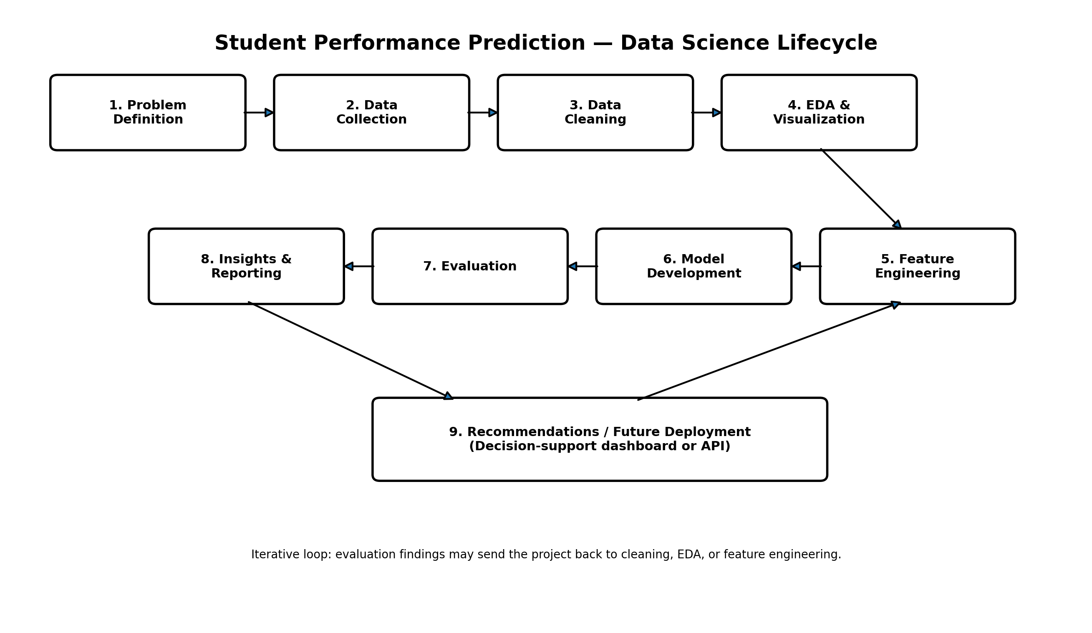
Figure 1. Proposed data science lifecycle for the Student Performance Prediction project.

6.1 Decision Gates
Gate | Question | Action if Not Met
Data readiness | Is the dataset complete, valid and sufficiently documented? | Return to data collection/cleaning.
EDA readiness | Are distributions, target balance and major data-quality issues understood? | Extend profiling and EDA.
Model readiness | Is there a leakage-safe feature pipeline and suitable validation design? | Revise preprocessing/feature design.
Model usefulness | Does the model outperform the baseline under appropriate metrics? | Revisit features, target definition or model choice.
Reporting readiness | Are results reproducible and limitations clearly documented? | Complete documentation and review.

7. 34-Hour Project Timeline
The assignment requests roughly 30–35 hours of work. This plan allocates exactly 34 hours across the major stages, with more time assigned to data preparation and EDA because these stages typically determine the quality of downstream modeling.
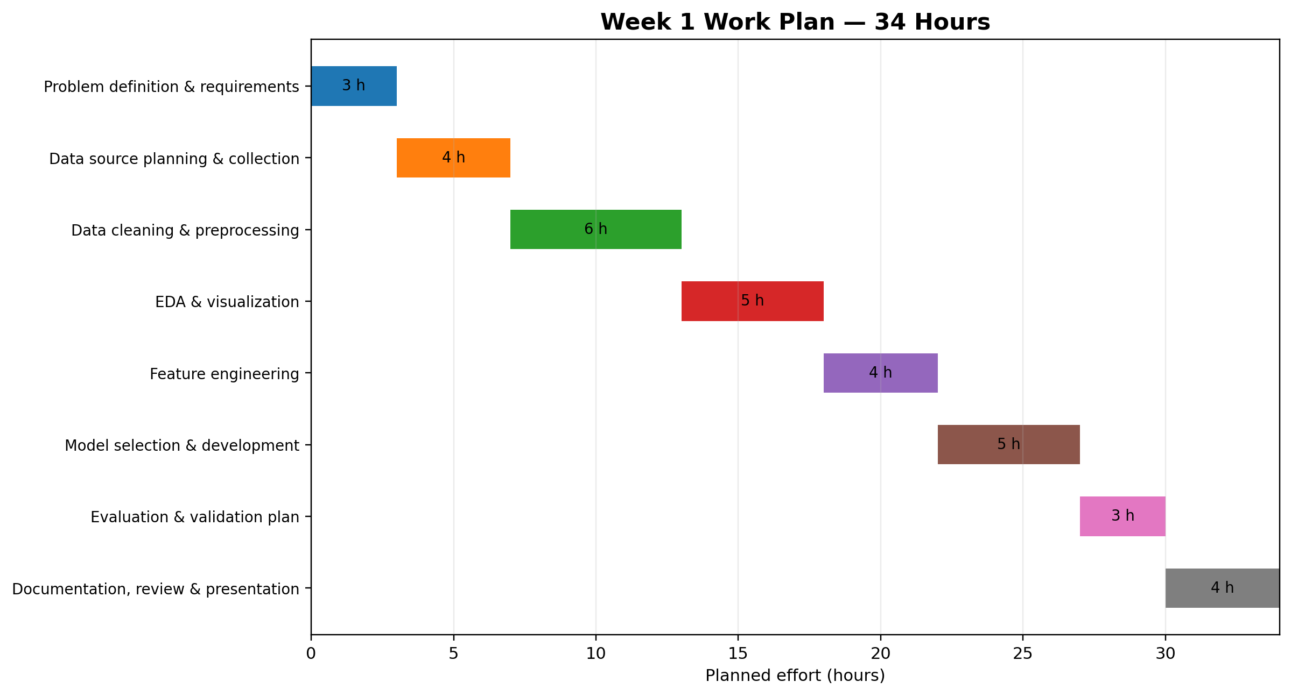
Figure 2. Planned 34-hour effort allocation.
Phase | Activity | Hours | Deliverable / Focus
1 | Problem definition & requirements | 3 | Define problem, target, stakeholders, assumptions and success criteria.
2 | Data source planning & collection | 4 | Identify sources, define schema, data dictionary and access requirements.
3 | Cleaning & preprocessing | 6 | Missing values, duplicates, types, outliers, validation and preprocessing pipeline.
4 | EDA & visualization | 5 | Univariate/bivariate analysis, target distribution, relationships and data-quality visuals.
5 | Feature engineering | 4 | Encoding, transformations, justified derived variables and leakage checks.
6 | Model development | 5 | Baseline plus candidate models, pipelines and cross-validation setup.
7 | Evaluation & validation plan | 3 | Metrics, error analysis, model comparison and interpretation strategy.
8 | Documentation & review | 4 | Report writing, diagrams, reproducibility checks and final review.

7.1 Suggested Working Schedule
Session | Hours | Focus
Session 1 | 4 | Problem definition, project charter and data-source planning.
Session 2 | 5 | Data understanding, schema design and cleaning strategy.
Session 3 | 5 | Cleaning plan and EDA design.
Session 4 | 5 | EDA visualizations and feature engineering strategy.
Session 5 | 5 | Model selection, baseline and validation architecture.
Session 6 | 4 | Evaluation plan, risks and interpretation.
Session 7 | 6 | Documentation, diagrams, quality review and final submission.

8. Python Libraries and Project Tools
Tool / Library | Role in Project | Planned Use
Python | Primary programming language | Data processing, analysis, modeling and automation.
Pandas | Tabular data processing | Loading, cleaning, transforming and summarizing datasets.
NumPy | Numerical computing | Arrays, mathematical operations and numerical preprocessing.
Matplotlib | Visualization | Custom plots and publication-ready basic charts.
Seaborn | Statistical visualization | EDA plots such as distributions, boxplots and heatmaps.
Scikit-learn | Machine learning | Preprocessing, pipelines, models, cross-validation and metrics.
Jupyter Notebook / Google Colab | Interactive development | Document analysis steps and results.
Git & GitHub | Version control | Track code, documentation and project versions.
VS Code | Development environment | Organize scripts, notebooks and project files.
python-docx | Documentation automation | Generate or maintain structured project documentation if required.

8.1 Proposed Project Folder Structure
student-performance-project/
├── data/
│ ├── raw/
│ ├── processed/
│ └── external/
├── notebooks/
│ ├── 01_data_understanding.ipynb
│ ├── 02_eda.ipynb
│ └── 03_modeling.ipynb
├── src/
│ ├── data_cleaning.py
│ ├── features.py
│ ├── train.py
│ └── evaluate.py
├── reports/
│ ├── figures/
│ └── week1_project_plan.docx
├── requirements.txt
└── README.md
This structure separates raw data, processed data, analysis notebooks, reusable source code and reports. It also supports reproducibility and cleaner version control.

8.2 Reproducibility Practices
- Use a fixed random seed where appropriate.
- Record Python and major package versions.
- Keep data-processing steps deterministic where possible.
- Store configuration and preprocessing rules with the project.
- Do not manually edit the raw dataset; create processed outputs through documented code.
- Maintain a README explaining setup, inputs, outputs and execution order.

9. Expected Outcomes and Benefits

9.1 Expected Deliverables
- A clearly defined project problem, target and scope.
- A documented data dictionary and data-quality checklist.
- A repeatable cleaning and preprocessing strategy.
- An EDA notebook containing meaningful visualizations.
- A feature-engineering plan.
- A baseline and candidate model strategy.
- A validation and evaluation framework.
- A documented list of insights, limitations and future improvements.
- A professional project report with diagrams and timeline.

9.2 Potential Benefits
- Earlier visibility into patterns associated with academic difficulty.
- Better understanding of which measurable variables are associated with outcomes.
- A reusable architecture for future academic analytics projects.
- Practical demonstration of Python, statistics, visualization and machine learning skills.
- A foundation for a future dashboard or API prototype, subject to appropriate governance.

10. Anticipated Challenges and Mitigation Strategies
Challenge | Risk | Mitigation
Missing data | Important variables may contain gaps. | Profile missingness; use justified imputation; document assumptions; consider whether variables should be excluded.
Data leakage | A feature may contain information only available after the prediction point. | Define the prediction time clearly and use leakage checks plus pipeline-based preprocessing.
Class imbalance | One performance group may dominate. | Use stratified validation and appropriate metrics; consider class weights or resampling when justified.
Small dataset | Limited observations can make results unstable. | Prefer simpler models, cross-validation and uncertainty-aware interpretation.
Noisy/inconsistent records | Different formats or labels can reduce data quality. | Standardize categories and create automated validation checks.
Overfitting | A complex model may memorize training patterns. | Use cross-validation, regularization, simpler baselines and a held-out test set.
Interpretability | Predictions may be difficult to explain. | Compare interpretable baselines and use feature-importance/interpretation techniques.
Privacy and governance | Student records may contain sensitive information. | Minimize collected data, restrict access, anonymize where possible and follow institutional rules.
Changing behavior | Patterns may shift across semesters or cohorts. | Monitor model performance over time and plan periodic revalidation.
Misuse of predictions | Predictions could be treated as definitive judgments. | Position outputs as decision support, include limitations, and require human review.

11. Data Governance, Ethics and Responsible Use
Because the hypothetical project involves student-related information, responsible data use is part of the technical strategy. The system should support academic assistance rather than automatically label or penalize students.
- Collect only variables necessary for the defined analytical objective.
- Use authorized data sources and appropriate access controls.
- Remove or protect direct identifiers where they are not needed for analysis.
- Document the intended prediction point and prevent post-outcome information from entering the features.
- Evaluate whether model errors could disproportionately affect particular groups.
- Communicate uncertainty and limitations clearly.
- Require qualified human review before any consequential intervention.
- Treat model output as an indicator for further investigation, not proof of a student's ability, effort or future.

11.1 Quality Assurance Checklist
☐ Problem statement and target are unambiguous.
☐ Scope and out-of-scope items are documented.
☐ Data dictionary is prepared.
☐ Missing values and duplicates are profiled.
☐ Invalid values and outliers are investigated.
☐ EDA covers numerical and categorical variables.
☐ Target leakage has been considered and checked.
☐ Baseline model is defined.
☐ Validation strategy is appropriate for the target.
☐ Evaluation metrics are justified.
☐ Reproducibility requirements are documented.
☐ Risks, limitations and responsible-use requirements are included.
☐ Final report contains the required diagrams and timeline.

12. Evaluation Criteria Alignment
Assignment Requirement | Where Addressed in This Plan
Project background and motivation | Sections 1–2
Objectives and scope | Section 3
Detailed methodology and strategy | Section 4
Flowchart / diagram | Section 6
30–35 hour timeline | Section 7 — 34 hours
Python libraries and tools | Section 8
Expected outcomes and benefits | Section 9
Challenges and mitigation | Section 10
Clear strategic thinking and data science process | Sections 4–8
Visual clarity | Figures 1 and 2 plus structured tables
Responsible project planning | Section 11

13. Conclusion
This Week 1 project plan establishes a complete and structured strategy for a hypothetical AI-based Student Performance Prediction and Early Academic Risk Detection project. The plan covers the problem definition, objectives, scope, data strategy, cleaning, EDA, feature engineering, modeling, evaluation, tools, timeline, expected outcomes, risks and responsible-use considerations.
The proposed 34-hour schedule prioritizes the stages that have the greatest effect on analytical quality: understanding the problem, preparing reliable data and performing meaningful exploratory analysis. The modeling stage is deliberately positioned after these foundations so that algorithm selection is driven by the data and project objective rather than by model complexity alone.
If the project progresses beyond planning, the next step would be to obtain an authorized dataset, create the data dictionary, implement the cleaning pipeline, perform EDA, and then test the proposed modeling approaches using leakage-safe validation. Any future deployment should retain human oversight, privacy controls and clear communication of model limitations.

14. Final Submission Checklist
- ☐ Save the document with a clear filename.
- ☐ Review spelling, formatting and section numbering.
- ☐ Ensure the flowchart is visible and readable.
- ☐ Ensure the timeline totals 34 hours.
- ☐ Confirm all assignment-required sections are present.
- ☐ Add your name, internship details and submission date if required.
- ☐ If a GitHub repository is required, create it and add the project README.
- ☐ Submit the DOC/DOCX file through the internship portal.

END OF WEEK 1 PROJECT PLAN

