Week 3 – Python-Based Machine Learning Model
Development and Evaluation Plan
AI-Based Student Performance Prediction & Early Academic Risk Detection System
Prepared by: Shaikh Samir Yasin
B.Tech – Artificial Intelligence and Data Science
Internship Week 3

1. Executive Summary
This Week 3 plan defines how a machine-learning system would be developed, validated, evaluated, and eventually deployed for the hypothetical student-performance problem introduced in Weeks 1 and 2. The proposed system predicts whether a student may be at academic risk using attendance, previous marks, study hours, assignment performance, participation, and related academic indicators. No real dataset or code execution is required, so the document focuses on a realistic implementation plan.

2. Problem Definition and Relevance
The task is framed as binary classification: predict an at-risk versus not-at-risk label from information available before an intervention decision. The goal is to help academic advisors prioritize support, not to replace human judgment.
- Target: binary at-risk / not-at-risk classification.
- Inputs: attendance, previous marks, study hours, assignment scores, participation and assessment trends.
- Primary users: academic advisors, faculty and student-support teams.
- Success principle: detect as many genuinely at-risk students as possible while keeping false alarms manageable.

3. Machine Learning Workflow
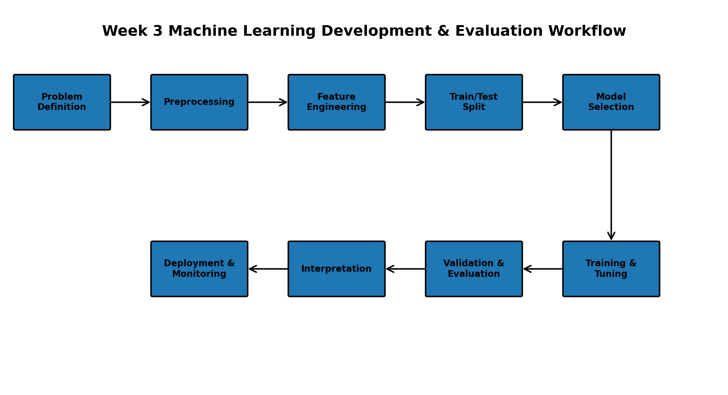
Figure 1. Proposed end-to-end machine-learning workflow.

4. Data Preprocessing
- Inspect schema, types, missingness, duplicates, invalid ranges and inconsistent categories.
- Separate predictors from the target before transformations.
- Use justified imputation for missing numerical and categorical values.
- Encode categorical variables using appropriate methods such as one-hot encoding.
- Scale numerical features for models that are sensitive to feature magnitude.
- Handle outliers using domain rules rather than automatically deleting extremes.
- Use Scikit-learn Pipeline/ColumnTransformer so transformations are fitted only on training data.
- Document every transformation for reproducibility.

5. Feature Engineering and Selection
- Create justified features such as recent-average score, attendance band, assignment completion rate or performance change.
- Avoid variables unavailable at prediction time.
- Remove identifiers and irrelevant columns.
- Inspect redundancy and correlations among predictors.
- Use model-based or permutation importance only after a sound baseline.
- Prefer a compact and interpretable feature set when performance is comparable.

6. Train/Test Split and Validation
Use a stratified 80/20 train/test split for the initial binary-classification plan. The test set remains untouched until final evaluation.
- Use stratification to preserve class proportions.
- Use cross-validation on the training set for model comparison and tuning.
- Use time-aware splitting if observations are time ordered.
- Do not repeatedly tune against the final test set.

7. Candidate Model Selection
Model | Purpose | Advantages | Considerations
Dummy baseline | Reference | Shows whether ML adds value | Not a predictive solution
Logistic Regression | Interpretable baseline | Fast and explainable | May miss nonlinear patterns
Decision Tree | Nonlinear baseline | Easy to explain | Can overfit
Random Forest | Primary candidate | Robust nonlinear performance | Less transparent
Gradient Boosting | Alternative ensemble | Often strong performance | Needs careful tuning
Recommended comparison: Logistic Regression for interpretability, plus Random Forest and Gradient Boosting for nonlinear patterns. Select the final model using validation results, operational needs, interpretability and stability—not accuracy alone.

8. Training and Hyperparameter Tuning
- Establish a baseline first.
- Use consistent cross-validation folds for candidate comparison.
- Use GridSearchCV or RandomizedSearchCV.
- Tune relevant parameters such as tree depth, number of estimators, minimum samples and regularization.
- Select configurations using a metric aligned with the objective, such as recall or F1.
- Record parameters, splits, random seed, library versions and evaluation results.

9. Evaluation Metrics
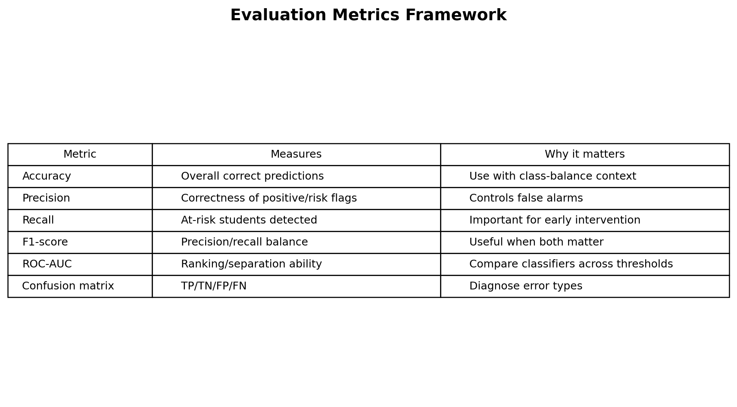
Figure 2. Evaluation metrics framework.
Recall is especially important because missing a genuinely at-risk student can be more costly than reviewing an additional student. Precision, F1-score, ROC-AUC, accuracy and the confusion matrix should also be reported.
Metric | Use in this project
Accuracy | Overall correctness, interpreted with class balance.
Precision | How many students flagged as at risk are actually at risk.
Recall | How many genuinely at-risk students are detected.
F1-score | Balances precision and recall.
ROC-AUC | Measures ranking/separation across thresholds.
Confusion matrix | Shows false positives and false negatives.

10. Cross-Validation Strategy
Use stratified k-fold cross-validation, such as 5 folds, on the training data. All preprocessing must occur inside the pipeline so validation data does not leak into training. Report average performance and variability across folds where appropriate.

11. Model Interpretation and Responsible Use
- Review coefficients for Logistic Regression and feature/permutation importance for tree ensembles.
- Use explanations to support, not replace, academic judgment.
- Avoid inappropriate sensitive attributes unless explicitly governed and justified.
- Provide human review before consequential intervention.
- Monitor whether errors disproportionately affect student groups.
- Communicate that the model is a decision-support tool, not a definitive judgment.

12. Deployment and Maintenance Concept
After validation, the selected model could be packaged as a controlled Python service or scheduled batch process. A possible flow is validated data → preprocessing pipeline → trained model → risk score → advisor dashboard → human action.
- Version the model and preprocessing pipeline together.
- Restrict access to authorized users.
- Record prediction timestamps and model versions.
- Monitor input drift, missing-input rates and outcome performance when labels become available.
- Compare a new model against the existing model before replacement and keep rollback capability.

13. Challenges and Solutions
Challenge | Solution
Class imbalance | Stratified validation, class weights when justified, and precision/recall/F1.
Overfitting | Cross-validation, regularization, model constraints and locked test set.
Data leakage | Strict train/validation/test separation and pipelines.
Missing values | Training-fitted imputation with documented assumptions.
Unstable results | Fixed seeds where appropriate and cross-validation variability.
Low interpretability | Compare interpretable baselines and provide feature explanations.
Data drift | Monitor feature distributions and outcomes after deployment.
False negatives | Prioritize recall and tune the decision threshold based on intervention capacity.

14. Python Tools
Tool | Use
Python | Core implementation
Pandas / NumPy | Data and numerical operations
Scikit-learn | Preprocessing, models, tuning, metrics and validation
Matplotlib / Seaborn | Evaluation plots
Jupyter / Google Colab | Experimentation and documentation
VS Code | Development
Git / GitHub | Version control and submission

15. 34-Hour Week 3 Timeline
Activity | Hours | Output
Problem definition and target design | 3 | Objective and success criteria
Preprocessing and leakage strategy | 5 | Preprocessing workflow
Feature engineering and selection | 4 | Feature plan
Model selection and baseline | 4 | Candidate comparison
Training and hyperparameter tuning | 5 | Tuning strategy
Validation and evaluation | 4 | Metrics and CV plan
Deployment and monitoring concept | 2 | Maintenance strategy
Documentation, diagrams, review and submission | 7 | Final DOC
Total: 34 hours

16. Expected Outcomes
- Complete step-by-step Python ML development plan.
- Justified candidate models and selection strategy.
- Robust preprocessing and validation approach.
- Evaluation framework using accuracy, precision, recall, F1, ROC-AUC and confusion matrix.
- Conceptual deployment and monitoring strategy.
- Documented workflow ready for implementation when data becomes available.

17. Evaluation Criteria Alignment
- Thorough coverage of model-development phases.
- Clear explanation of preprocessing, training, validation and evaluation.
- Professional workflow diagrams.
- Understanding of metrics and cross-validation.
- Realistic model-selection and tuning strategy.
- Deployment and maintenance considerations.
- Approximately 30–35 hours of planned work.

18. Conclusion
This Week 3 plan provides a structured machine-learning development and evaluation strategy for the student academic-risk problem. It emphasizes sound preprocessing, leakage prevention, model comparison, cross-validation, appropriate metrics, interpretability and responsible deployment. Because no dataset or execution is required, the document does not fabricate results. The workflow can be implemented in Python and Scikit-learn when actual data becomes available.

19. Final Submission Checklist
- ☐ Week 3 DOCX saved with your name.
- ☐ Problem definition and relevance included.
- ☐ Preprocessing and feature engineering included.
- ☐ Candidate models and choice justified.
- ☐ Training and hyperparameter tuning included.
- ☐ Accuracy, precision, recall, F1 and ROC-AUC included.
- ☐ Cross-validation included.
- ☐ Deployment and maintenance concept included.
- ☐ Workflow and metrics diagrams included.
- ☐ 34-hour timeline included.
- ☐ GitHub updated with Week 3 files; README does not need to be changed.

