WEEK 4 PROJECT REPORT
Comprehensive Data Science Report and Insights Presentation Plan
AI-Based Student Performance Prediction and Early Academic Risk Detection System
Prepared by: Shaikh Samir Yasin
Week 4 • Data Science Internship
Hypothetical project — no real dataset or actual model results are claimed.

1. Executive Summary
This report presents a complete plan for communicating the results of a hypothetical data science project focused on predicting student performance and identifying students who may benefit from early academic support. It combines data analysis, visualization, machine-learning evidence, stakeholder-focused communication, and actionable recommendations. Because no dataset is supplied, all findings are framed as expected or illustrative insights rather than measured results.
The communication sequence moves from the problem and methodology to evidence, insights, recommendations, limitations, and future work. Each visual is selected to answer a specific analytical question and the presentation is designed for non-technical stakeholders.

2. Project Background and Purpose
Student performance can be influenced by attendance, previous academic results, study habits, assignment completion, participation, and other measurable factors. A data science approach can help identify patterns and risk indicators early enough for institutions to provide targeted support.
- Purpose: create a professional reporting and presentation framework for the hypothetical project.
- Decision need: identify patterns associated with academic risk and translate them into practical interventions.
- Audience: faculty, academic coordinators, student-support teams, and decision makers.
- Constraint: no real dataset is supplied; therefore findings are hypotheses, not actual results.

3. Objectives
- Create a clear end-to-end reporting structure.
- Define how analytical findings become understandable insights.
- Plan visualizations for distributions, comparisons, relationships, trends, and model performance.
- Develop recommendations linked to evidence.
- Design a presentation strategy for a non-technical audience.
- Document limitations, responsible use, and future improvements.

4. Scope
In Scope | Out of Scope
Hypothetical student-performance analysis | Collecting real student personal data
EDA and visualization planning | Claiming real statistical results
Expected insight categories | Production deployment
Model-performance communication | Actual model training on supplied data
Recommendations and future work | High-stakes decisions about individual students

5. Methodology Overview
The reporting methodology follows a decision-oriented sequence: define the question, understand the planned data, analyze patterns, validate evidence, communicate findings, and recommend actions.
Phase | Purpose | Output
Problem framing | Define decision and audience | Research questions and success criteria
Data understanding | Identify variables and quality issues | Data dictionary and quality checklist
EDA | Explore distributions and relationships | Statistics and visual evidence
Model evidence | Explain predictive performance conceptually | Metrics and validation approach
Insight synthesis | Convert evidence into findings | Prioritized insights
Recommendation design | Connect findings to actions | Action plan
Communication | Present results clearly | Report and presentation narrative

6. Insights and Analysis Framework
The analysis will be organized around questions rather than around individual charts. Example questions include: Which factors appear associated with academic risk? Are there meaningful differences between attendance groups? Are multiple risk indicators occurring together? Which findings are strong enough to support a recommendation?
- Attendance: lower attendance may be associated with higher risk; this must be verified with real data.
- Assessment: previous marks and assignment performance may provide useful signals.
- Engagement: study hours or participation may reveal differences between groups.
- Combined risk: several moderate indicators may together be more informative than one variable.
- Model evidence: evaluation metrics should indicate whether predictions are sufficiently reliable.
These are planning hypotheses only and are not claims about actual students or actual model performance.

7. Visualization Strategy
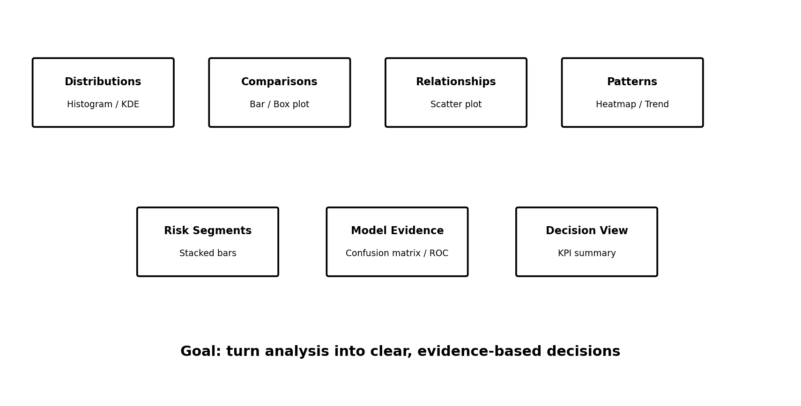
Figure 1. Visualization framework for turning analytical questions into evidence.
Question | Visual | Purpose
How are variables distributed? | Histogram / KDE / box plot | Spread, skewness, unusual values
How do groups differ? | Bar / box plot | Compare categories
Are two variables related? | Scatter plot | Assess relationships
Which variables move together? | Correlation heatmap | Identify relationships
How does risk vary by group? | Stacked bar | Compare proportions
How well does the model classify? | Confusion matrix / ROC | Communicate model performance
What should decision makers remember? | KPI summary | Concise evidence

8. Mock-Up Visualization Plan
- Attendance versus academic-risk visualization.
- Previous marks by risk category.
- Risk-category distribution bar chart.
- Correlation heatmap for numeric variables.
- Confusion matrix for classification outcomes.
- ROC curve and AUC summary.
- Feature-importance chart, with a warning that importance does not imply causation.

9. Presentation Strategy for Non-Technical Stakeholders
The presentation should follow a simple narrative: What is the problem? What did we plan to analyze? What evidence matters? What does the evidence mean? What action should be considered? Technical terms should be translated into plain language and every chart should have a clear takeaway.
Section | Message
Opening | Why early identification of academic risk matters
Approach | How data science addresses the question
Evidence | What patterns and metrics would be examined
Key insights | Most important evidence-based observations
Recommendations | Practical actions
Limitations | What cannot be concluded without real data
Closing | Next steps and future validation

10. Recommendations
- Use multiple indicators rather than a single variable when assessing academic risk.
- Provide supportive interventions rather than punitive labels.
- Validate patterns on representative real-world data before operational use.
- Monitor model performance and fairness after deployment.
- Give faculty concise explanations rather than opaque scores alone.
- Keep human review in the decision loop for important academic-support decisions.

11. Risks, Limitations and Mitigation
Risk | Mitigation
No real dataset | Label findings as hypothetical and validate later
Missing/inconsistent data | Define quality checks and preprocessing rules
Class imbalance | Use appropriate metrics and resampling/weighting
Overfitting | Use train/validation/test separation and cross-validation
Data leakage | Apply preprocessing within the training pipeline
Bias/unfair impact | Subgroup checks and human review
Correlation misinterpretation | Avoid causal language without causal evidence
Model drift | Monitoring and periodic retraining review

12. Responsible Data Use
- Use only necessary variables and protect student privacy.
- Restrict access to authorized users.
- Explain predictions in understandable terms.
- Do not treat a model score as a definitive judgment.
- Assess fairness before operational use.
- Maintain auditability of data, preprocessing, model versions, and decisions.

13. Python Tools and Technologies
Tool | Planned Use
Python | Core analysis
Pandas | Data manipulation
NumPy | Numerical operations
Matplotlib | Visualization
Seaborn | Statistical visualization
Scikit-learn | Model evaluation and validation
Jupyter/Colab | Exploration
Git/GitHub | Version control
python-docx | DOCX generation

14. 34-Hour Timeline
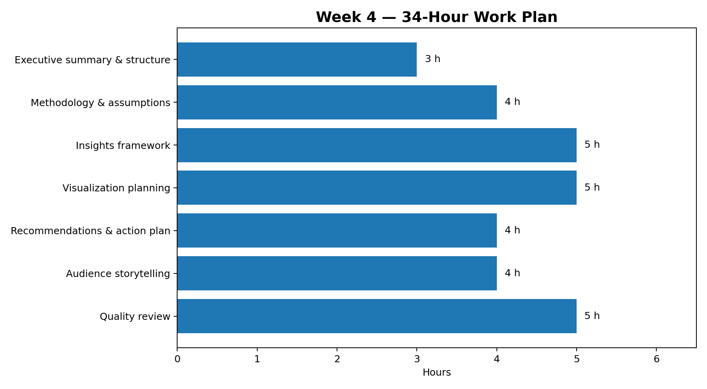
Task | Hours
Executive summary & structure | 3
Methodology & assumptions | 4
Insights framework | 5
Visualization planning | 5
Recommendations & action plan | 4
Audience storytelling | 4
Quality review & finalization | 5
TOTAL | 34

15. Expected Outcomes
- Polished report suitable for executive-level review.
- Clear connection between analysis, visual evidence, insights, and recommendations.
- Reusable visualization framework for a real dataset.
- Accessible communication strategy for non-technical stakeholders.
- Documented limitations and responsible-use safeguards.

16. Professional Report Flow
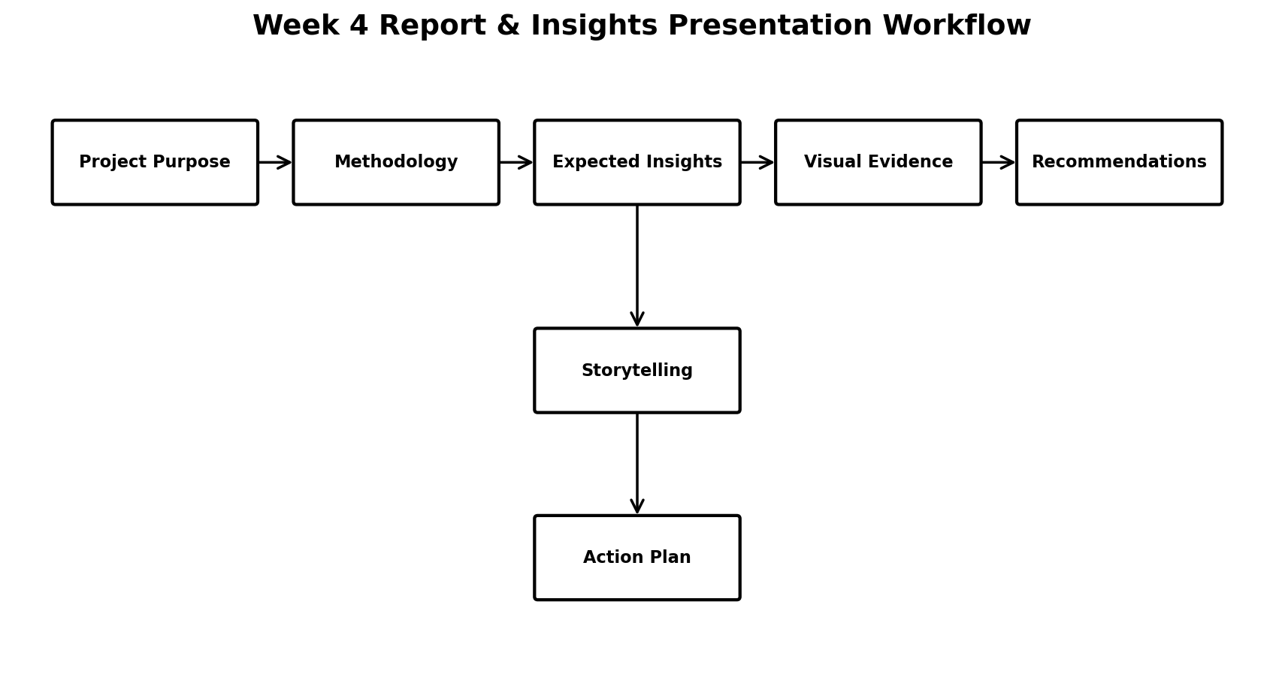
Figure 2. End-to-end reporting and presentation workflow.

17. Quality Assurance Checklist
- All requested sections are present.
- Hypothetical findings are clearly labeled.
- Every visualization has a stated purpose.
- Recommendations are linked to evidence or labeled as proposed.
- Technical terminology is explained.
- Limitations and responsible-use issues are documented.
- Formatting, tables, figures, and page flow are reviewed.
- Final DOCX opens correctly and includes all required diagrams.

18. Conclusion
This Week 4 plan consolidates the data science project into a professional reporting and communication framework. It connects methodology with expected analytical evidence, visualization choices, actionable recommendations, and stakeholder communication. Since no dataset is provided, the document deliberately avoids invented numerical results. The framework can be applied to a real dataset later, where the proposed hypotheses, visualizations, metrics, and recommendations can be tested and refined.
The final outcome is a clear, decision-oriented report demonstrating analytical thinking, strategic communication, visualization planning, and responsible interpretation of machine-learning results.

