# Journal Title

# Concise and Informative Article Title

Firstname M. I. Lastname,1 Firstname A. Lastname,2 and Firstname B. Lastname1,2

1 Department, Institute, City ZIP/Post code, Country.  
2 Department, Institute, City ZIP/Post code, Country.

Correspondence should be addressed to Firstname B. Lastname; lastname@institution.edu

## Abstract

The abstract should be a single, self-contained paragraph which summarises the manuscript. Ideally it will provide a brief context for the study, before describing the scientific approach and some key results in a qualitative manner. It should finish with a sentence to describe the implications for the field. The abstract must not include references, figures or tables.

## Introduction

The introduction should be succinct, with no subheadings. Limited figures may be included only if they are truly introductory, and contain no new results.

## Materials and Methods

The materials and methods section should contain sufficient detail so that all procedures can be repeated. It may be divided into headed subsections if several methods are described.

## Results and Discussion

### Subheadings

The results and discussion may be presented separately, or in one combined section, and may optionally be divided into headed subsections.

### Advice on Equations

Equations should be provided in a text format, rather than as an image. Microsoft Word’s equation tool is acceptable. Equations should be numbered consecutively, in round brackets, on the right-hand side of the page. They should be referred to as Equation 1, etc. in the main text.

$x=\frac{-b±\sqrt{b^{2}-4ac}}{2a}$ (1)

### Advice on Figures

At the point of submission, authors may provide all figures embedded within the manuscript at a convenient break near to where they are first referenced or, alternatively, they may be provided as separate files. All figures should be cited in the paper in a consecutive order. Where possible, figures should be displayed on a white background. When preparing figures, consider that they can occupy either a single column (half page width) or two columns (full page width), and should be sized accordingly. All figures must have an accompanying caption which includes a title and, preferably, a brief description (see Figure 1).



Figure : Basic rocket ship design. The rocket ship is propelled with three thrusters and features a single viewing window. The nose cone is detachable upon impact.

The caption can also be used to explain any acronyms used in the figure, as well as providing information on scale bar sizes or other information that cannot be included in the figure itself. Plots that show error bars should include in the caption a description of how the error was calculated and the sample size (see Figure 2).

../Desktop/wtageinf.pdf

Figure : Plot of nanoparticle size with respect to time, recorded over a 90 s period. The error bars represent the standard deviation of measurements for 20 particles in five separate sample runs (n = 100).

If a figure consists of multiple panels, they should be ordered logically and labelled with lower case roman letters (i.e., a, b, c, etc.). If it is necessary to mark individual features within a panel (e.g., in Figure 3a), this may be done with lowercase Roman numerals, i, ii, iii, iv, etc. All labels should be explained in the caption. Panels should not be contained within boxes unless strictly necessary.

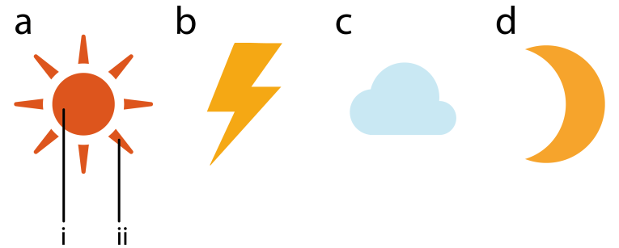

Figure : Representations of some common weather symbols. (a) The sun with (i) core, and (ii) rays. (b) Thunder bolt. (c) Cloud. (d) Moon.

Upon acceptance, authors will be asked to provide the figures as separate electronic files. At that stage, figures should be supplied in either vector art formats (Illustrator, EPS, WMF, FreeHand, CorelDraw, PowerPoint, Excel, etc.) or bitmap formats (Photoshop, TIFF, GIF, JPEG, etc.). Bitmap images should be of at least 300 dpi resolution, unless due to the limited resolution of a scientific instrument. If a bitmap image has labels, the image and labels should be embedded in separate layers.

### Advice on Tables

Every table must have a descriptive title and, if numerical measurements are given, the units should be included in the column heading. Vertical rules should not be used (see Table 1). Tables should be cited consecutively in the text.

Table 1: Temperature and wildlife count in the three areas covered by the study.

|  |  |  |  |  |  |
| --- | --- | --- | --- | --- | --- |
| Location | T [° C] | Turtles | Sharks | Octopuses | Starfish |
| Blue Lagoon | 21.2 | 5 | 3 | 4 | 543 |
| Regent’s Canal | 5.2 | 8 | 0 | 24 | 312 |
| Shark Bay | 12.8 | 4 | 7 | 9 | 122 |

## Conclusions

The Conclusions section should clearly explain the main findings and implications of the work, highlighting its importance and relevance.

## Data Availability

A data availability statement is compulsory for research articles and clinical trials. Here, authors must describe how readers can access the data underlying the findings of the study, giving links to online repositories and providing deposition codes where applicable. For more information on how to compose a data availability statement, including template examples, please visit: <https://www.hindawi.com/research.data/#statement>.

## Conflicts of Interest

This section is compulsory. A competing interest exists when professional judgment concerning the validity of research is influenced by a secondary interest, such as financial gain. We require that our authors reveal any possible conflict of interest in their submitted manuscripts. If there is no conflict of interest, authors should state that “The author(s) declare(s) that there is no conflict of interest regarding the publication of this paper.”  
  
Some of the information you choose to provide here may constitute your “sensitive personal data”. Please read our [Privacy Policy](https://www.hindawi.com/privacy/) for further information on how we handle your personal data.

## Funding Statement

Authors should state how the research and publication of their article was funded, by naming financially supporting bodies followed by any associated grant numbers in square brackets.

## Acknowledgments

An Acknowledgements section is optional and may recognise those individuals who provided help during the research and preparation of the manuscript.

## Supplementary Materials

If Supplementary Materials are provided (e.g., audio files, video clips or datasets) they should be described here. Note that authors are responsible for providing the final Supplementary Materials files that will be published along with the article, which are not modified by our production team. You should remember to reference the Supplementary Materials’ contents at appropriate points within the manuscript. We recommend citing specific items, rather than referring to the Supplementary Materials in general, for example: “See Figures S1-S10 in the Supplementary Material for comprehensive image analysis.”

## References

References will be reformatted in house, there is no need to adhere to a specific style at the point of submission. Authors are responsible for ensuring that the information in each reference is complete and accurate. All citations in the text must be numbered consecutively in square brackets, before any punctuation, for example, “as discussed by Smith [1],” and “as discussed elsewhere [2,3].” All uncited references will be automatically removed. The references should not contain footnotes. For your information, our citation style is:

[x] Author initials and surname, “Title in sentence style,” Journal title, vol. (volume number), no. (issue number), pp. (page numbers separated by an en-dash), Year.

For example:

[1] J. D. Watson and F. H. C. Crick, “A structure for deoxyribose nucleic acid,” *Nature*, vol. 171, no. 4356, pp. 737–738, 1953.

For articles with six or more authors, the first three authors are listed followed by ‘et al.’. When journals use only article numbers, no page numbers are necessary. For example:

[2] B. P. Abbott, R. Abbott, T. D. Abbott et al., “Observation of Gravitational Waves from a Binary Black Hole Merger,” *Physical Review Letters*, vol. 116, no. 6, Article ID 061102, 2016.