Check WebApiConfig.cs for MapHttpRoute

* Build the CSAPIChalenge.sln
* Application is pointing to Local Instance of SQL Server. DB Name is: CSApiTest

Please Change Web.config if needed:

add name="CSApiTest" connectionString="Data Source=LocalHost;Initial Catalog=CSApiTest;Integrated Security=True; MultipleActiveResultSets=true" providerName="System.Data.SqlClient" />

Note that every time application is run initial 3 users are recreated see DropCreateDatabaseAlways in Infrastructure/Initializer.cs, Infrastructure/InitializationData.cs and classes in Repository folder . This can be changed to: DropCreateDatabaseIfModelChanges (See commented code)

1. **TESTING WebApi RUNNING Tools\F12 Developer tools:**
2. Get all users

<http://localhost:50297/api/ApiCSUser/GetAllCSUsers>

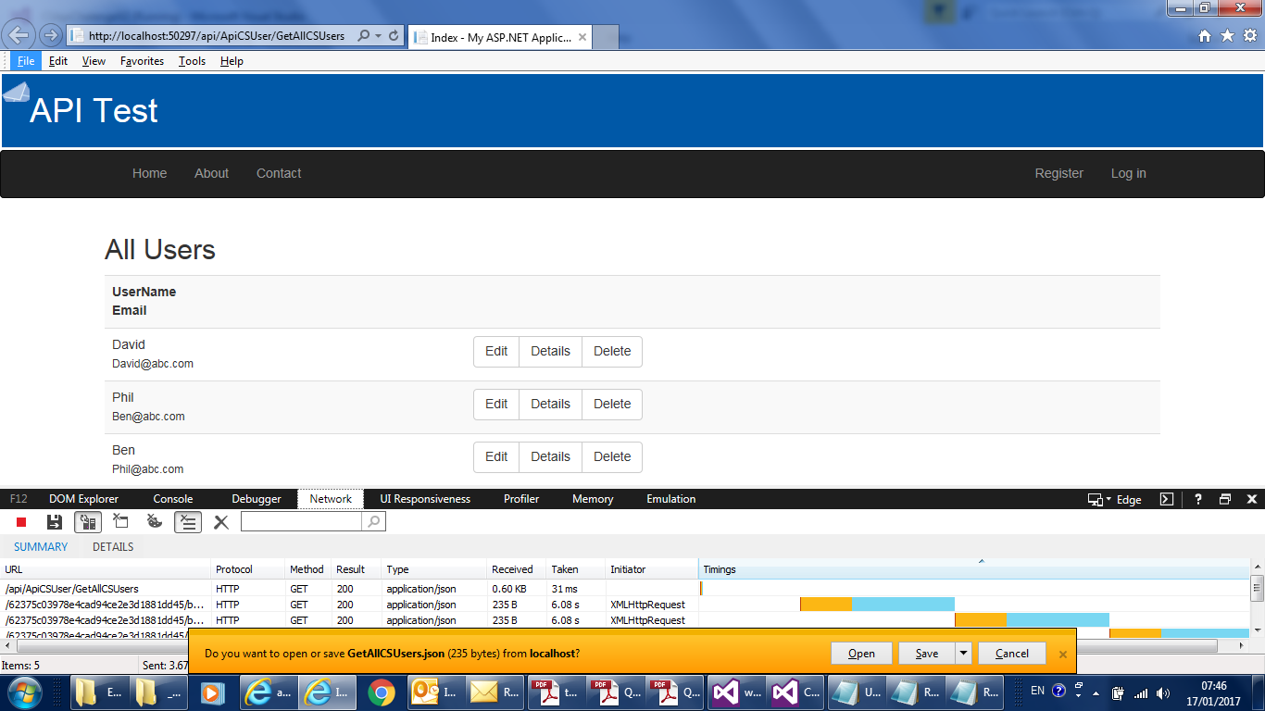

Picture 1.1 – Current users are displayed in Home page

Output:

[{"CSUserID":1,"Email":"David@abc.com","UserName":"David","Password":"Pa$$w0rd"},{"CSUserID":2,"Email":"Ben@abc.com","UserName":"Phil","Password":"Pa$$w0rd"},{"CSUserID":3,"Email":"Phil@abc.com","UserName":"Ben","Password":"Pa$$w0rd"}]

2. **GET**  <http://localhost:50297/api/ApiCSUser/GetCSUser/1>

JSON Output: {"CSUserID":1,"Email":"David@abc.com","UserName":"David","Password":"Pa$$w0rd"}

1. **TESTING POST AND DELETE USING FIDDLER 4**
2. **POST** <http://localhost:50297/api/ApiCSUser>

Header:

Accept: text/html, application/xhtml+xml, */*

Accept-Language: en-GB

User-Agent: Mozilla/5.0 (Windows NT 6.1; WOW64; Trident/7.0; rv:11.0) like Gecko

Accept-Encoding: gzip, deflate, peerdist

Connection: Keep-Alive

Content-Type: application/json; charset=utf-8

Host: localhost:50297

Pragma: no-cache

X-P2P-PeerDist: Version=1.0

Body

{"UseName" : "Tom", "Email": "Tom@abc.com", "Password": "TomPassword"}

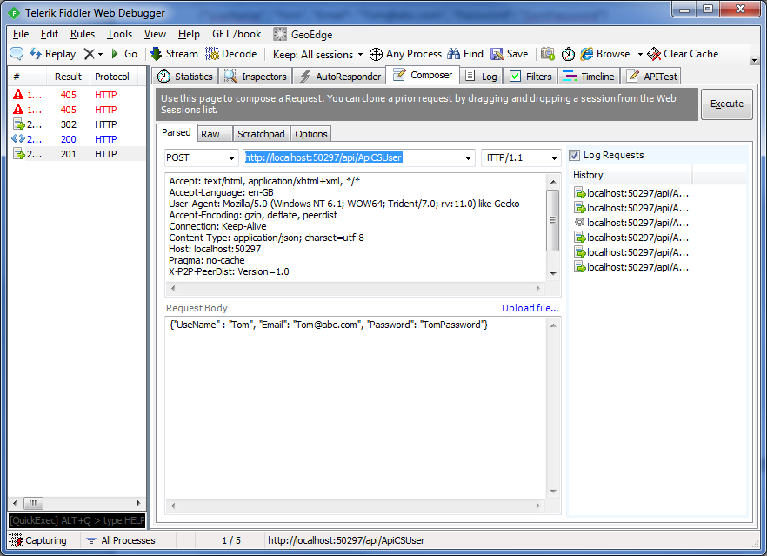

Pic 3.1 Post of new user succeeded (Composer Tab)

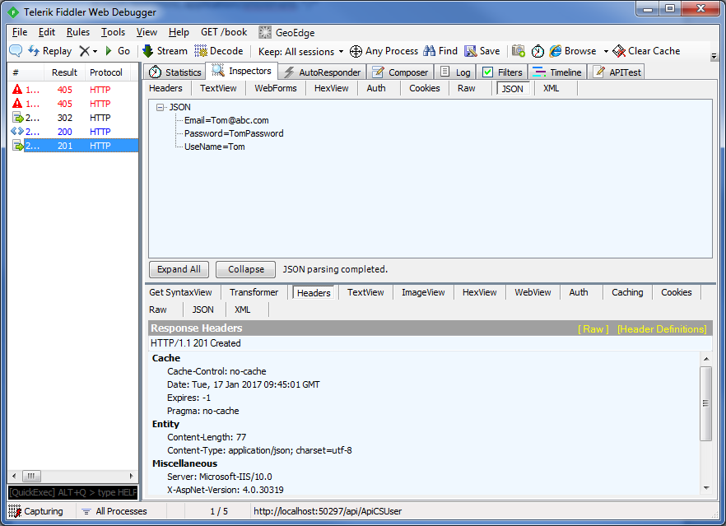

Pic 3.2 Post of new user succeeded (Inspectors Tab)

1. DELETE <http://localhost:50297/api/ApiCSUser/DeleteCSUser/4>

We will get Bad Request error if secret key is not in header.

With this header Deletion will succeed:

Header:

Accept: text/html, application/xhtml+xml, */*

Accept-Language: en-GB

User-Agent: Mozilla/5.0 (Windows NT 6.1; WOW64; Trident/7.0; rv:11.0) like Gecko

Accept-Encoding: gzip, deflate, peerdist

Connection: Keep-Alive

Content-Type: application/json; charset=utf-8  
secretkey: secret

Host: localhost:50297

Pragma: no-cache

X-P2P-PeerDist: Version=1.0

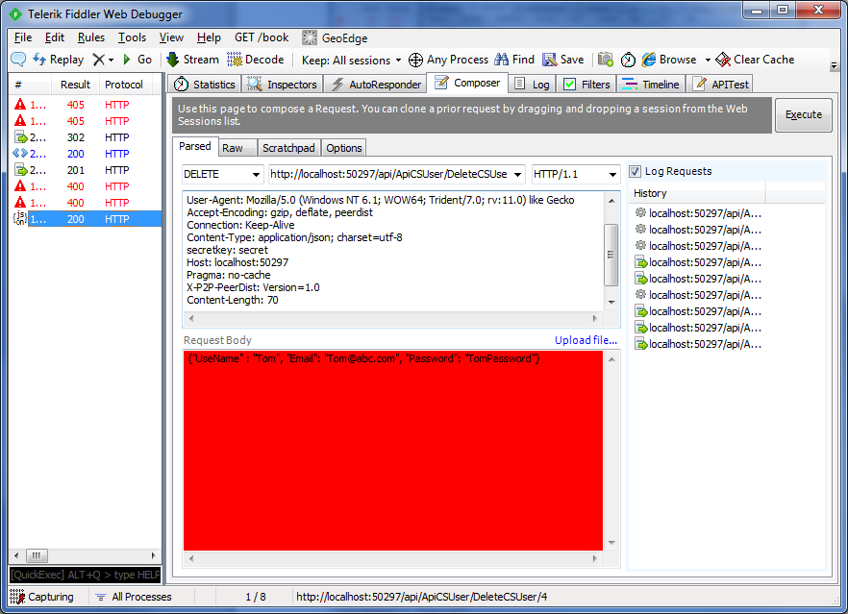

Pic 4.1 Delete succeeded as header has secret key

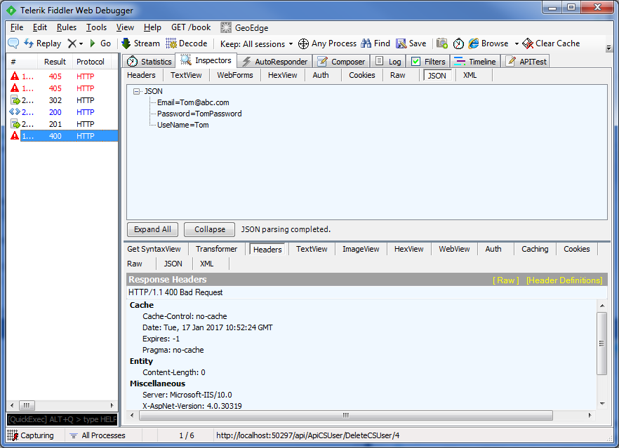

Pic 4.2 Delete Failed as secretkey was removed from header

1. **Testing using supplied CSApiChalenge Web application and webClient Console Appication**
2. Build and run supplied web application and note port number e.g. 50297

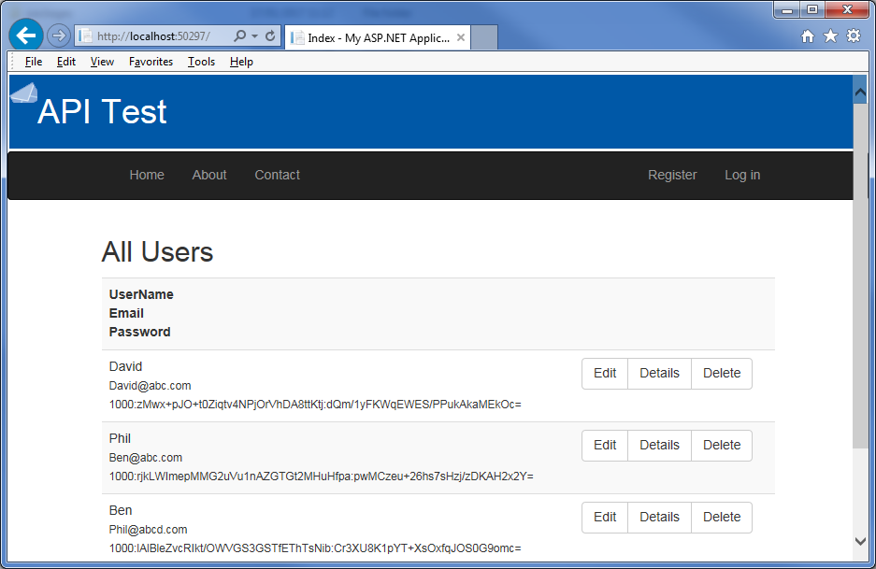

1. Build and run supplied webClient console application and follow the prompts:

2 a) Console test application when secretkey is added (See Program.cs line 35)

client.DefaultRequestHeaders.Add("secretkey", "secret");

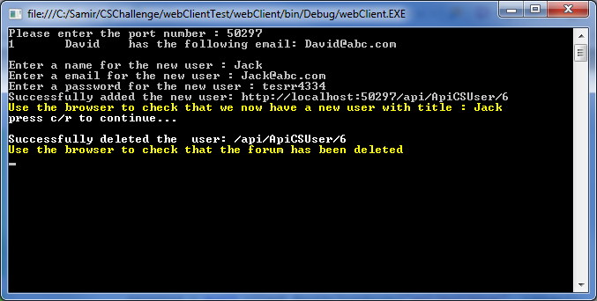

2 b) Comment line 35 and Build solution. Wen secretkey is not set in header deletion fails:

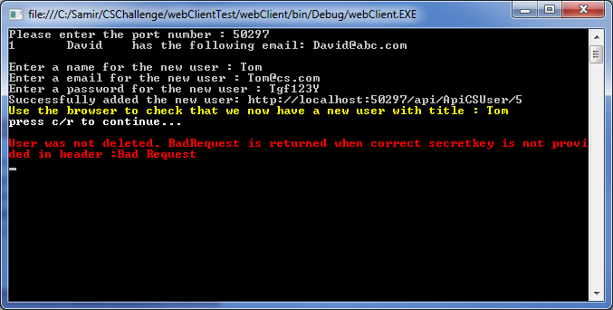

Hash and validation of password implemented in PasswordHash class and called in InitialisationData and SQLSiteRepository.cs : AddCSUser method