Training Statistics

Samir Rehmtulla

February 26, 2018

## Training Plan for Sub-19 Minute 5K

Special Thanks to Tanner Geary, UBC Thunderbirds Track and Field, for putting together the training plan!

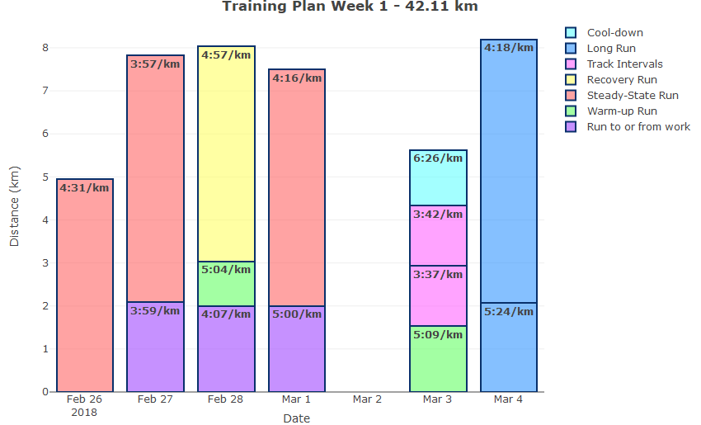

## Week 1 Route Plots

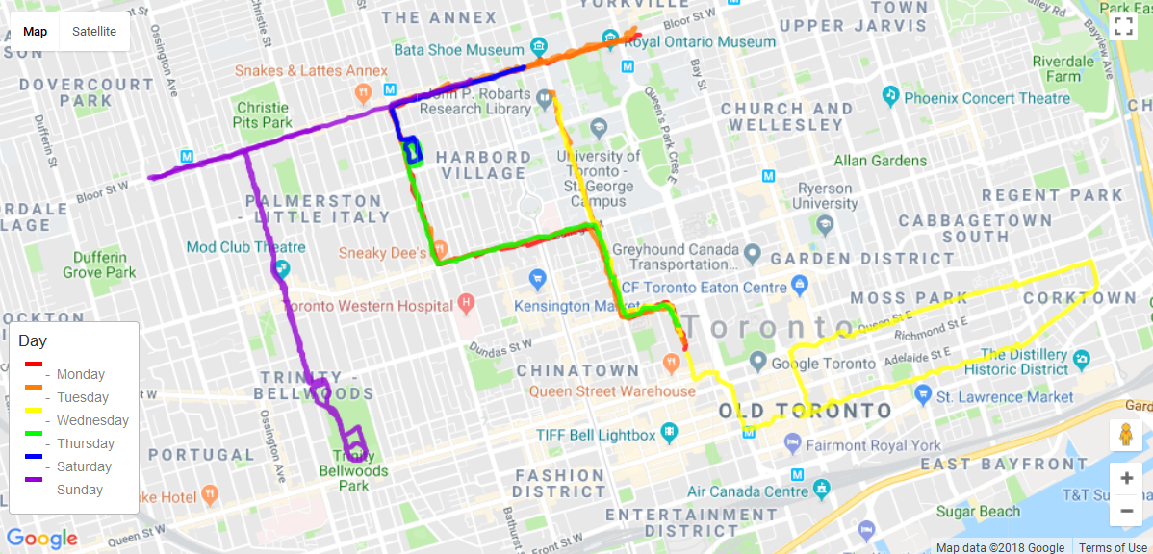

Note - Track Intervals are excluded as they were tracked manually