
Tribhuvan University
Faculty of Humanities and Social Sciences
An Internship Report on
Backend Development
At
E-Prabidhi Pvt. Ltd.
Submitted to
Department of Computer Application
Divya Gyan College
Putalisadak, Kathmandu, Nepal
In partial fulfillment of the requirements of Internship (CAIN403), Seventh Semester, for the degree of Bachelor in Computer Application
Submitted by
Samir Shrestha
T.U. Roll No.: 75102168
T.U. Reg. No.: 6-2-751-23-2022
Under the Supervision of
Mr. Sujit Shrestha

Tribhuvan University
Faculty of Humanities and Social Sciences
Divya Gyan College

Mentor's Recommendation
I hereby recommend that this internship report prepared under my mentorship by Mr. Samir Shrestha (T.U. Roll No.: 75102168) on Backend Development at E-Prabidhi Pvt. Ltd. in partial fulfillment of the requirements of 7th Semester for the degree of Bachelor in Computer Application is recommended for the final evaluation.
............................
SIGNATURE
Mr. Shirish Timalsina
MENTOR
Senior Backend Developer
E-Prabidhi Pvt. Ltd.
Putalisadak, Kathmandu, Nepal
Tribhuvan University
Faculty of Humanities and Social Sciences

Supervisor's Recommendation
I hereby recommend that this internship report prepared under my supervision by Mr. Samir Shrestha (T.U. Roll No.: 75102168) on Backend Development at E-Prabidhi Pvt. Ltd. in partial fulfillment of the requirements of Seventh Semester for the degree of Bachelor in Computer Application is recommended for the final evaluation.
............................
SIGNATURE
Mr. Sujit Shrestha
SUPERVISOR
Department of Computer Application
Divya Gyan College
Putalisadak, Kathmandu, Nepal
Tribhuvan University
Faculty of Humanities and Social Sciences
Divya Gyan College

Letter of Approval
This is to certify that this internship report prepared by Mr. Samir Shrestha (T.U. Roll No.: 75102168) on Backend Development at E-Prabidhi Pvt. Ltd. in partial fulfillment of requirements for the degree of Bachelor in Computer Application has been evaluated. In our opinion it is satisfactory in terms of scope and quality as a project for the required degree.
______________________________  SIGNATURE of Supervisor  Mr. Sujit Shrestha  Department of Computer Application  Divya Gyan College  Putalisadak, Kathmandu, Nepal | ______________________________  SIGNATURE of Coordinator  Mr. Sujit Shrestha  Department of Computer Application  Divya Gyan College  Putalisadak, Kathmandu, Nepal
______________________________  SIGNATURE of Internship Mentor  Mr. Shirish Timalsina  Senior Backend Developer  E-Prabidhi Pvt. Ltd. | _______________________________  SIGNATURE of External Examiner

Acknowledgement
I would like to extend my sincere gratitude to everyone who supported me throughout my internship and the preparation of this report. The internship at E-Prabidhi Pvt. Ltd. has been an invaluable experience that helped me bridge the gap between classroom learning and the way professional software teams design, build, test and maintain backend systems.
I am deeply thankful to Mr. Sujit Shrestha Coordinator of the Department of Computer Application, Divya Gyan College, for the continuous coordination and encouragement throughout the internship process. I am equally grateful to my supervisor, Mr. Sujit Shrestha, Lecturer at Divya Gyan College, for his guidance, constructive suggestions and regular follow-ups, which helped me stay on track from the proposal to the final report.
My heartfelt appreciation goes to my mentor at E-Prabidhi Pvt. Ltd., Mr. Shirish Timalsina, Senior Backend Developer, for patiently guiding me through the codebase, reviewing every pull request I submitted, and teaching me how to write clean, secure and maintainable Python and Django code. I would also like to thank the management and the entire development team of E-Prabidhi Pvt. Ltd. for welcoming me, answering my questions, and giving me the opportunity to contribute to a real project.
I also thank Tribhuvan University, the Faculty of Humanities and Social Sciences, and the faculty members of Divya Gyan College for the academic foundation in programming, databases and software engineering that made this internship possible.
Finally, I express my deepest thanks to my family and friends for their unwavering patience, motivation and belief in me throughout this internship.
Samir Shrestha
T.U. Roll No.: 75102168
T.U. Reg. No.: 6-2-751-23-2022

Abstract
This report presents my experience as a Backend Developer Intern at E-Prabidhi Pvt. Ltd., a Kathmandu-based software and web development company, from 9 July 2026 to 8 September 2026. The internship was carried out as part of the course CAIN403: Internship in the seventh semester of the Bachelor in Computer Application program of Tribhuvan University. Throughout the internship I worked in the backend team under the mentorship of Mr. Shirish Timalsina, Senior Backend Developer.
The main assignment was the design and development of an Inventory Management System for warehouse operations. The system manages categories, products, suppliers, warehouses, stock balances, audited stock movements and purchase orders. It provides a server-rendered Django web interface for day-to-day work and a Django REST Framework API for authenticated integrations. The project uses Python, Django, Django REST Framework, PostgreSQL and Bootstrap-based templates. Authentication is available through Django sessions for the web application and JSON Web Tokens for the API.
My key contributions included understanding the existing domain model, configuring and validating the relational schema, implementing authentication and role-based authorization, building catalog, inventory and purchasing functionality, and improving the shared web interface. The project records receipt, issue, transfer and adjustment movements inside database transactions, prevents negative balances, supports warehouse assignment for staff users, and exposes filtered, searchable and paginated API resources. Automated Django tests, database migrations, a seed-data command and OpenAPI documentation support the project.
Through this internship, practical experience was gained in backend architecture, REST API design, relational database design, transaction handling, query optimization, API testing, version control and professional team communication. This report outlines the organization, the theoretical background and related literature, the weekly activities, the technical contributions, and the professional skills acquired.
Keywords: Backend Development, Python, Django, Django REST Framework, PostgreSQL, REST API, Inventory Management System

Chapter 1: Introduction

1.1. Introduction
Internships allow students to apply classroom knowledge to problems that real users depend on. In a final year program, they also reveal how production software is planned, reviewed, tested and maintained, which is rarely visible in academic projects. This report documents the internship carried out at E-Prabidhi Pvt. Ltd., a software and web development company based in Putalisadak, Kathmandu, from 9th July 2026 to 8th September 2026 in the role of Backend Developer Intern.
During the internship I worked on a complete Django Inventory Manager rather than an API-only backend. The system manages categories, products, suppliers, warehouses, stock balances, stock movements and purchase orders. Users can review the dashboard, search and filter records, receive or issue stock, transfer stock between warehouses, make reasoned adjustments, and submit, receive or cancel purchase orders. The same project includes server-rendered HTML templates for the browser and a protected REST API for programmatic access.
The project was built with Python and Django. Django REST Framework provides the API layer, while Django templates, Bootstrap 5 and vanilla JavaScript provide the web interface. PostgreSQL stores the data through the Django ORM and psycopg driver. SimpleJWT, django-filter and drf-spectacular provide JWT authentication, filtering and OpenAPI documentation. The project is run locally with Django's development server and includes migrations, a README, a seed_demo management command and automated tests.
The internship strengthened technical skills in backend development and database design, and professional skills such as working to a schedule, communicating progress, accepting code review feedback and documenting work for other developers.

1.2. Problem Statement
In many small and medium-sized businesses, stock is still recorded in paper registers or scattered spreadsheets. Such manual methods make it difficult to know, at any moment, how many units of a product are available and in which warehouse. Typical consequences include stock-outs that lose sales, over-stocking that locks up capital, delayed re-ordering because nobody notices that a product is running low, arithmetic errors in stock valuation, and the absence of an audit trail that explains why the recorded quantity differs from the physical count.
Replacing manual records with software introduces its own technical challenges, and these were the problems the backend had to solve. First, stock quantities are shared, mutable data: if two staff members issue the last remaining units of the same product at the same time, a naive implementation can sell stock that does not exist. Second, every change in quantity must be traceable to a user, a time and a reason, so that the history can be audited. Third, different users such as administrators, managers and store staff should be allowed to perform different operations. Fourth, as products and transactions accumulate, list and report endpoints must remain fast. A backend that is consistent, auditable, secure and efficient was therefore required.

1.3. Objectives
The primary objectives of this internship were:
- To design and implement the backend of an Inventory Management System using Python, Django and PostgreSQL.
- To design a normalized relational schema and expose it through a consistent, versioned REST API.
- To implement secure token-based authentication and role-based authorization for different types of users.
- To gain hands-on experience of professional software development practices such as code review, task planning and team communication.

1.4. Scope and Limitation

1.4.1. Scope
- Application Architecture: A Django project organized into the config package and focused applications for users, catalog, inventory, purchasing and shared core functionality.
- Web and REST API: Server-rendered HTML pages and authenticated DRF endpoints with serializers, validation, filtering, searching, ordering, pagination and OpenAPI documentation.
- Authentication and Authorization: Django session authentication for the web interface and JSON Web Token authentication for the API, with three roles: Admin, Staff and Viewer.
- Stock Management: Receipt, issue, transfer and adjustment operations recorded through stock movement lines, with current StockBalance quantities maintained per product and warehouse. Purchase orders support draft, submitted, partially received, received and cancelled states.
- Operational Views: Dashboard metrics, low-stock filtering, movement history, product and supplier lists, warehouse views and purchase-order screens. A separate stock-valuation report, CSV export and sales-order workflow are not implemented in the current project.
- Quality Work: Django migrations, model and application tests, a reusable service layer, database indexes, a seed_demo command, README documentation and an OpenAPI schema/Swagger UI.

1.4.2. Limitations
- Confidentiality: The system was developed for the needs of the company's client. Detailed source code, client data and internal configuration cannot be reproduced in full in this report, so only selected excerpts are given in the appendices.
- Full-Stack Scope: The project includes both the Django web interface and the REST API. It is not an API-only backend; the browser screens use Django templates and session authentication, while external clients can use the JWT-protected API.
- Feature Boundaries: Sales orders, barcode scanning, stock valuation, CSV reporting, multi-currency accounting, payment processing, batch/expiry tracking and third-party accounting integrations are not part of the current implementation.
- Environment: The system was developed and tested in local and staging environments. Production hosting and long-term maintenance were handled by the company.

1.5. Report Organization
The report is structured into five main chapters covering the following topics:
1. Introduction
This chapter provides information about the internship and the project worked on. It describes the problem addressed by the project, the objectives, and the scope and limitations of the project and of this report.
2. Introduction to Organization
This chapter introduces the host organization. It describes the company, its hierarchy, its working domains and the department in which the internship was carried out.
3. Background Study and Literature Review
This chapter presents the background study of the technologies and concepts used in the project, followed by a literature review of the theory, standards and similar systems that informed the design decisions.
4. Internship Activities
This chapter presents the roles and responsibilities, a detailed weekly log, a description of the project and the tasks performed during the internship.
5. Conclusion and Learning Outcomes
This chapter summarizes the internship experience and the skills gained. The report ends with the references, the bibliography and the appendices.

Chapter 2: Introduction to Organization

2.1. Organization Details
E-Prabidhi Pvt. Ltd. is a software development company based in Nepal that has been in operation since 2010. The company describes its core proficiency as designing, developing and deploying software solutions and integrated mobile solutions for small, medium and large enterprises (E-Prabidhi Pvt. Ltd.). It serves both national and international clients, with customers in countries such as the United Kingdom, the United States, Canada, Australia and Ireland, and corporate clients in Nepal.
The services offered by the company include web design, web development, software development, e-commerce solutions, mobile application development, graphic design, multimedia and animation, and web hosting and domain services. Its software development work covers custom systems such as accounting software, management systems and department store systems. The company emphasizes open-source technology, content management systems and e-commerce, and follows a process of meeting the client, planning, design and development, testing and launch. This project-based, client-driven way of working made the company a suitable place to experience the complete life cycle of a backend system.
Table 2.1. Organizational Details of E-Prabidhi Pvt. Ltd.
Name | E-Prabidhi Pvt. Ltd.
Logo | 
Website | https://www.eprabidhi.com/
Email | info@eprabidhi.com
Phone | +977-1-4240005
Location | Putalisadak, Kathmandu, Nepal
Established | 2010
Working Hours | 10:00 AM to 6:00 PM
Working Days | Sunday to Friday

2.2. Organizational Hierarchy
The organizational structure of E-Prabidhi Pvt. Ltd. is shown in Figure 2.1. The company was co-founded by a team of young entrepreneurs, and the Board of Directors and management are at the top of the structure. The Project Manager, who is responsible for meeting deadlines for individual tasks and for the project as a whole, coordinates the project teams. A separate digital marketing team, supported by SEO content writers, handles online marketing for the company and its clients.
Under the Project Manager, the project work is divided among business and system analysts, UI/UX designers, the development team and the quality assurance (QA) team. Business analysts and system analysts gather and document the requirements, the UI/UX designers prepare the interfaces, the programmers implement the system, and the QA team verifies that the software is bug-free and ready for the end users. The development team is organized by technology and project type into backend developers, frontend and web developers, CMS and e-commerce developers, and mobile application developers.
The internship was carried out in the backend development group. I worked under the guidance of Mr. Shirish Timalsina, Senior Backend Developer, who acted as my mentor, and I reported through him to the Project Manager.

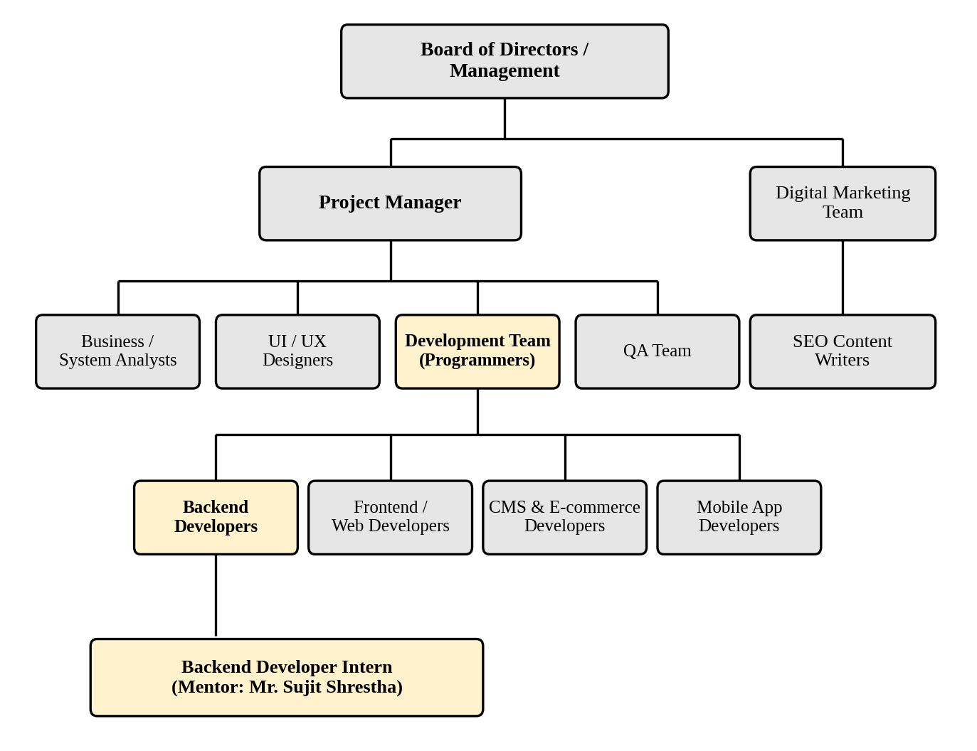
Figure 2.1. Organizational Hierarchy of E-Prabidhi Pvt. Ltd.

2.3. Working Domains of Organization
E-Prabidhi works across the following domains, several of which meet in the Inventory Management System developed during the internship:
- Web Design and Development: Responsive, search-engine-friendly websites and custom web applications, including customization of open-source platforms.
- Software Development: Custom software for business purposes such as accounting software, management systems and department store systems. The IMS belongs to this domain.
- E-commerce Solutions: Secure e-commerce systems with built-in content management features, where inventory and stock data are central.
- Mobile Application Development: Applications for iPhone, iPad and Android devices that allow businesses to interact with customers anytime and anywhere. These applications typically consume backend REST APIs.
- Graphic Design, Multimedia and Animation: Brand identity, print material, video editing, motion graphics and photography.
- Web Hosting and Domain Services: Hosting packages and domain registration to help businesses get online.

2.4. Description of Intern Department/Unit
The intern was placed in the backend development unit of the development team. The unit is responsible for server-side logic, databases and APIs for the web and mobile products of the company. Table 2.2 summarizes the internship details.
Table 2.2. Description of Intern Department
Internship | Backend Developer Intern
Organization | E-Prabidhi Pvt. Ltd.
Department/Unit | Development Team, Backend Unit
Mentor | Mr. Shirish Timalsina
Designation of Mentor | Senior Backend Developer
College Supervisor | Mr. Sujit Shrestha
Internship Duration | 9 Weeks (2 Months)
Working Hours | 10:00 AM to 6:00 PM
Working Days | Sunday to Friday
Work Mode | On-Site
Start Date | 9th July, 2026
End Date | 8th September, 2026

The backend unit follows the company's general process of meeting, planning, design and development, testing and launch. Requirements are discussed with the project manager and the analysts, the mentor breaks them into tasks, and each developer implements the tasks on a separate Git branch. A pull request is raised when a task is complete, and the mentor reviews the code before it is merged into the development branch. This cycle of assignment, development, review and merge was followed throughout the internship.
Interns work on real projects rather than isolated exercises. The mentor provided a learning roadmap in the early weeks covering Python, Django, DRF and PostgreSQL, and from the third week I was assigned to the Inventory Management System. Daily progress was shared with the mentor in short stand-up discussions, and a weekly review was held to check completed work and plan the next week.

Chapter 3: Background Study and Literature Review

3.1. Background Study
The Inventory Management System (IMS) developed during the internship is a data-intensive transactional application. This section describes the concepts and technologies that shaped the backend, and relates each of them to the work done at E-Prabidhi Pvt. Ltd. rather than defining them in general terms.

3.1.1. Nature of the Inventory Domain
Inventory data has two properties that influenced the design. First, stock on hand is shared and constantly changing: receipts, issues, adjustments and transfers modify it. Second, the business needs to explain how a quantity reached its current value. The project therefore stores current quantity per product and warehouse in the StockBalance table, while StockMovement and StockMovementLine preserve the history of each change. The balance answers how much is available now; the movement records explain why.
The backend enforces rules that must hold regardless of whether a change comes from a web form, an API request, a management command or a test. Quantities cannot become negative, transfer source and destination warehouses must differ, adjustment movements require a reason, inactive products cannot be used in new movements, and each movement line must have a positive quantity. Purchase-order receiving is linked to stock movements so receipt operations are recorded consistently.

3.1.2. Decoupled Architecture and REST
The project uses a Django application architecture rather than a fully decoupled frontend. Browser requests are handled by Django views and templates, with session authentication and CSRF protection. In parallel, authenticated API clients send HTTP requests to Django REST Framework, which validates input, applies permissions and business services, reads or writes PostgreSQL and returns JSON. This arrangement keeps the web workflow simple while allowing integrations through the API.
The API resources include /api/products/, /api/categories/, /api/suppliers/, /api/warehouses/, /api/stock/, /api/movements/ and /api/purchase-orders/. Authentication endpoints are available under /api/auth/, and the interactive API documentation is available under /api/docs/. Standard HTTP methods are used for resource operations, while stock-changing actions are represented by validated movement or purchase-order operations.
Table 3.1. HTTP Methods and Their Use in the IMS API
Method | Semantics | Example in the IMS
GET | Safe and idempotent; reads a resource or collection | GET /api/products/?search=notebook lists matching products
POST | Creates a resource or triggers a validated operation | POST /api/movements/ records a receipt, issue, transfer or adjustment
PUT | Idempotent; replaces a resource when supported | PUT /api/products/1/ replaces the product representation
PATCH | Partially updates a resource | PATCH /api/products/1/ changes selected product fields
DELETE | Removes a resource when permissions and relationships allow it | DELETE /api/categories/3/ is subject to application permissions and related records

JSON was selected as the data interchange format for requests and responses because it is a lightweight, language-independent text format defined by a stable standard (Bray, 2017) and is natively understood by browsers and mobile clients.

3.1.3. Django, Django REST Framework and the Request Lifecycle
Django is a high-level Python web framework that supplies the ORM, migration system, authentication framework, template engine and administration site. In this project Django templates render the browser interface, while Django REST Framework serializers and viewsets validate and expose JSON resources. DRF permissions, filtering, pagination and schema generation are configured in the project settings and reused across the API modules.
A web request is routed through Django URL configuration to a view, where authentication and authorization are applied before a form or serializer validates input. For API requests, the authentication class verifies the session or JWT, the permission class checks the user's role, and a service function performs stock or purchasing operations inside a database transaction. Keeping stock rules in apps.inventory.services allows the same rules to be reused by web views, API views, the seed command and tests.
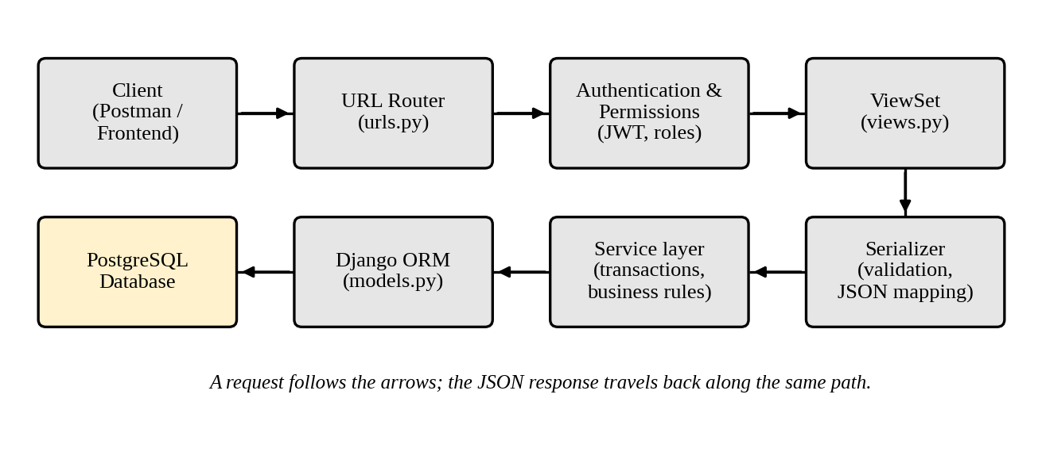
Figure 3.1. Request Lifecycle in the IMS Backend

3.1.4. PostgreSQL and Relational Design for Inventory
The schema is normalized so that product, category, supplier and warehouse data are stored once and referenced by foreign keys. The SKU is unique, the product-warehouse pair is unique in StockBalance, and stock quantities are decimal values constrained by application validation and transactional service logic. Database indexes support common lookups such as warehouse/product balances, movement type/date and supplier or product codes.
For stock updates, the service layer uses transaction.atomic() and select_for_update() when retrieving or creating the relevant StockBalance row. The new quantity is calculated before saving, and an InsufficientStockError is raised when an issue or transfer would make the balance negative. The balance update and movement-line creation occur as one transaction, so a failed operation does not leave a partial stock change.

3.1.5. Development Tools: Git, GitHub and Postman
[ Suggested screenshot: API documentation at /api/docs/ ]

3.2. Literature Review
The literature reviewed for this project can be grouped into six areas: inventory management theory and existing inventory software, REST and API design, backend web frameworks, relational databases and transaction processing, authentication and security, and software engineering practice. For each area, this section summarizes what the literature says and how it was applied in the IMS. A summary of the reviewed sources is given in Table 3.3 at the end of the section.

3.2.1. Inventory Management Theory and Existing Inventory Systems
Inventory control has a long research history. Harris (1913) formulated one of the earliest quantitative models, the economic order quantity, which balances ordering cost against holding cost to find the lot size that minimizes total cost. Modern textbooks extend this idea with safety stock, reorder points and service levels under uncertain demand (Silver et al., 2017), and place inventory decisions inside the wider context of supply chain strategy, where holding too much stock ties up capital while holding too little causes shortages and lost sales (Chopra & Meindl, 2016). These works explain why the IMS stores a reorder level for every product and why a low-stock report is a first-class feature. The IMS does not compute optimal order quantities, which require demand data that was not available, but it records the data (movement history, purchase and sales quantities) from which such analysis could later be built.
Several open source enterprise systems implement inventory management and were studied as related work. Odoo and ERPNext demonstrate multi-warehouse records, stock ledgers and replenishment concepts. These references helped distinguish the current project from a full ERP: Inventory Manager focuses on catalog, warehouses, stock movements, purchase orders, role-based access and operational dashboard views. It does not attempt to reproduce accounting, manufacturing, sales or stock-valuation modules.

3.2.2. REST and API Design
Fielding (2000) defined REST as a set of architectural constraints, namely client-server separation, statelessness, cacheability, a uniform interface, a layered system and optional code on demand, and argued that they give web-scale systems their scalability and evolvability. Richardson and Ruby (2007) turned these ideas into practical guidance for resource-oriented web services, and Masse (2011) collected concrete design rules such as using plural nouns for collections, using HTTP status codes meaningfully, and supporting filtering, sorting and pagination through query parameters instead of new endpoints.
These recommendations were adapted to the actual API. Collections use plural nouns under /api/, validation failures return structured 400 responses, missing resources return 404, and permission failures are protected by authentication and role checks. Filtering, searching, ordering and pagination are implemented through query parameters such as ?category=3 or ?search=notebook. Purchase-order receiving is handled by a validated action endpoint in the purchasing viewset and creates stock through the purchasing service rather than asking a client to update several tables directly.

3.2.3. Backend Web Frameworks
The choice of framework was dictated by the company's technology stack, but it was useful to compare Django with the other leading Python options in order to understand the trade-offs. Django is a "batteries-included" framework that provides an ORM, migrations, authentication, an administration interface and security protections out of the box (Django Software Foundation, n.d.; Holovaty & Kaplan-Moss, 2009). Flask is a microframework whose core is deliberately small, leaving database access, validation and authentication to extensions chosen by the developer (Pallets, n.d.). FastAPI focuses on building APIs, uses Python type hints for validation and generates interactive OpenAPI documentation automatically, but, like Flask, it does not include an ORM or an administration site (Ramírez, n.d.). Table 3.2 compares the three.
Table 3.2. Comparison of Python Backend Frameworks
Aspect | Django (with DRF) | Flask | FastAPI
Design philosophy | Full-stack, batteries included | Microframework with a minimal core | API-focused, built on type hints
Database access | Built-in ORM and migrations | No ORM built in; commonly SQLAlchemy through an extension | No ORM built in; commonly SQLAlchemy or SQLModel
Admin and authentication | Built-in admin site and auth system | Provided through extensions | Security utilities for OAuth2 and JWT; no admin site
API documentation | Through DRF browsable API or schema tools | Through extensions | Automatic OpenAPI and Swagger UI
Asynchronous support | ASGI and async views supported | Async views supported with limitations | Asynchronous by design
Fit for the IMS | High: relational data, admin screens, auth, permissions needed | Possible, but many components must be assembled | Possible, but ORM, admin and migrations must be added

For the IMS the deciding factors were the relational, transaction-heavy nature of the data and the need for authentication, permissions and an administration site for back-office users. Django covers these needs with a single, consistently documented framework. Greenfeld and Roy Greenfeld (2020) recommend, among other practices, keeping business logic out of views, using environment-specific settings, and keeping each Django app focused on one concern. These recommendations shaped the project layout of six small apps (accounts, catalog, partners, inventory, orders and reports) and the service layer described earlier.

3.2.4. Relational Databases, Transactions and Concurrency
Codd (1970) introduced the relational model, in which data is organized into relations related through keys and queried independently of its physical storage. This model underlies the normalized IMS schema. The POSTGRES project, described by Stonebraker and Rowe (1986), is the ancestor of PostgreSQL and introduced ideas such as extensible types and rules that are still visible in the system today. The core guarantee that matters for an inventory ledger comes from transaction theory: Haerder and Reuter (1983) formalized atomicity, consistency, isolation and durability, the properties that ensure either all the changes of a stock operation, the new quantity and the ledger row, are stored or none of them are.
Concurrency is the more subtle issue. Berenson et al. (1995) showed that weaker isolation behavior can allow anomalies such as lost updates. PostgreSQL uses multiversion concurrency control and runs at the Read Committed level by default, so a plain read-modify-write sequence remains vulnerable. The project uses explicit row-level locking through select_for_update() on StockBalance inside a transaction before checking and updating stock. This makes the sufficiency check and the update part of the same protected operation.
The database documentation also guided performance work. The project defines indexes for common lookups, including product SKU, warehouse code, the warehouse/product balance pair, movement type/date and purchase-order status. On the Django side, select_related() and prefetch_related() are used where related objects are displayed together, reducing unnecessary database queries in list and dashboard views.

3.2.5. Authentication, Authorization and API Security
A stateless REST backend needs a way to identify the caller on every request. JSON Web Token (JWT) is a compact, URL-safe format for representing claims that can be digitally signed, so that the server can verify a token without looking it up in a session store (Jones et al., 2015). The OAuth 2.0 framework, specified by Hardt (2012), defines a broader model for delegated authorization between separate parties. For the IMS, where the client and the API belong to the same system, a short-lived JWT access token with a longer-lived refresh token was sufficient and avoided the complexity of a full authorization server.
Authentication only establishes identity, whereas authorization decides what each identity may do. The IMS therefore defines three roles: administrators manage users and configuration, managers approve orders and view reports, and staff record stock movements. The roles are enforced through DRF permission classes so that the check happens before any business logic runs. The OWASP Top Ten, a widely used awareness document for web application risks, lists broken access control and injection among the most critical categories (OWASP Foundation, 2021). These risks were addressed in the project by default-deny permissions, object-level checks, the ORM's parameterized queries instead of string-built SQL, strict serializer validation, and keeping secrets such as the secret key and database credentials in environment variables instead of in the repository.

3.2.6. Software Engineering Practice: Testing and Version Control
Sommerville (2016) describes testing at several levels and stresses that defects found early are cheaper to fix. This guided the project tests for user models, registration and login, protected dashboard access, JWT registration/token behavior and inventory workflows. The repository does not claim a dedicated simultaneous-thread concurrency test; its concurrency protection is implemented in the transactional service layer. Git provides the source-control foundation for focused changes and repeatable verification.

3.2.7. Summary of the Review and Its Relevance
The reviewed literature supports the main design choices of the project. Inventory theory explains reorder levels and low-stock views, existing systems motivate multi-warehouse records and movement history, REST literature shapes API conventions, relational and transaction theory informs the schema and locking strategy, security literature supports authentication and authorization, and software engineering literature informs testing and documentation. Table 3.3 summarizes the sources and their relevance to the project.
Table 3.3. Summary of the Reviewed Literature and Its Relevance
Source | Focus | Relevance to the IMS
Harris (1913); Silver et al. (2017); Chopra & Meindl (2016) | Inventory control, reorder points and supply chain context | Reorder level per product, low-stock report, purchase and sales data kept for future analysis
Odoo S.A. (n.d.); Frappe Technologies (n.d.) | Open source inventory modules with ledger-based stock | Movement ledger design; multi-warehouse stock; lessons on keeping scope focused
Fielding (2000); Fielding & Reschke (2014); Richardson & Ruby (2007); Masse (2011) | REST constraints, HTTP semantics and API design rules | Resource naming, status codes, versioning, pagination and filtering conventions
Django Software Foundation (n.d.); Christie (n.d.); Holovaty & Kaplan-Moss (2009); Greenfeld & Roy Greenfeld (2020) | Django, DRF and best practices | Project layout, serializers, viewsets, service layer, permissions
Pallets (n.d.); Ramírez (n.d.) | Alternative Python frameworks | Framework comparison in Table 3.2
Codd (1970); Stonebraker & Rowe (1986) | Relational model and the POSTGRES system | Normalized schema; PostgreSQL features
Haerder & Reuter (1983); Berenson et al. (1995); PostgreSQL Global Development Group (n.d.) | Transactions, isolation and concurrency | Atomic stock operations, row-level locking, prevention of lost updates, index and query plan tuning
Jones et al. (2015); Hardt (2012); OWASP Foundation (2021) | JWT, OAuth 2.0 and web security risks | JWT authentication, role-based access, default-deny permissions, input validation
Sommerville (2016); Chacon & Straub (2014); Postman, Inc. (n.d.) | Testing, Git and API testing tools | Unit and integration tests, feature-branch workflow, Postman collections

Chapter 4: Internship Activities

4.1. Roles and Responsibilities
As a Backend Developer Intern at E-Prabidhi Pvt. Ltd., I worked under the guidance of Mr. Shirish Timalsina on the Inventory Manager project. The key responsibilities were:
- Analyzing requirements with the mentor and the analysts and converting them into user stories, entities and API endpoints.
- Designing and maintaining the PostgreSQL database schema through Django models and migrations.
- Developing REST APIs with Django and Django REST Framework, including validation, filtering, searching, sorting and pagination.
- Implementing session and JWT authentication with role-based permissions for Admin, Staff and Viewer users.
- Implementing transaction-safe receipt, issue, transfer and adjustment operations, together with purchase-order workflows.
- Building the dashboard, search/filtering behavior, OpenAPI documentation and efficient database queries using Django ORM techniques and indexes.
- Writing and running automated Django tests and validating the browser and API workflows.
- Using Git and GitHub for branching, pull requests and responding to code review comments.
- Reporting daily progress to the mentor and demonstrating completed work to the team.

4.2. Weekly Log
The log below records the activities carried out in each of the 9 weeks of the internship, with technical details. The first two weeks were used for onboarding and learning the technology stack. Week 3 was used for understanding the existing requirements and database design, and Week 4 for authentication and catalog functionality. Weeks 5 to 7 covered suppliers, warehouses, stock movements and purchase orders, Week 8 covered the dashboard, API documentation, testing and UI refinement, and the last week focused on documentation, seed data and final verification.
Table 4.1. Weekly Log
Week | Duration | Activities
Week 1 | 9th July to 15th July | Completed orientation and reviewed the project purpose, repository structure, Django settings, URL routing and the local PostgreSQL development environment.
Week 2 | 16th July to 22nd July | Studied Django models, migrations, QuerySets, forms, templates and Django REST Framework serializers, viewsets, routers and permissions.
Week 3 | 23rd July to 29th July | Mapped the warehouse domain: users and profiles, categories, products, suppliers, warehouses, stock balances, movements and purchase orders.
Week 4 | 30th July to 5th August | Reviewed the custom User model, Admin/Staff/Viewer roles, profile signals, web login/registration and JWT registration, token and current-user API endpoints.
Week 5 | 6th August to 12th August | Implemented and verified catalog, supplier and warehouse screens and API resources, including validation, search, filters, ordering and pagination.
Week 6 | 13th August to 19th August | Worked with StockBalance, StockMovement and StockMovementLine. Verified receipt, issue, transfer and adjustment rules, transactional updates and insufficient-stock handling.
Week 7 | 20th August to 26th August | Implemented and tested purchase-order workflows for draft, submitted, partially received, received and cancelled orders, including receiving into warehouse stock.
Week 8 | 27th August to 2nd September | Refined the dashboard, low-stock views, movement history, API schema/Swagger documentation, database indexes and related-object query loading.
Week 9 | 3rd September to 8th September | Ran migrations and automated tests, loaded repeatable demo data with seed_demo, verified browser workflows and API responses, updated the README and prepared the final demonstration.

Across the 9 weeks the work followed a consistent rhythm. Each module was studied through its models, forms, views, services, serializers and URLs. Changes were checked with Django's system checks, migrations, automated tests and local browser/API verification. The service layer kept business rules separate from presentation code, while the README and seed_demo command made the project easier to run and demonstrate.

4.3. Description of the Project(s) Involved During Internship
The project assigned during the internship was a warehouse-focused Inventory Management System. Admin users manage the whole system, Staff users can perform permitted warehouse operations, and Viewers can inspect records without mutating them. The system maintains products and categories, suppliers and warehouses, stock balances, receipt/issue/transfer/adjustment movements and purchase orders. The dashboard highlights active products, warehouses, open purchase orders and movements recorded today, while list screens provide search, filters and pagination.
The project is a Django application that combines server-rendered templates with a REST API. All data is stored in PostgreSQL. The Django project is divided into the config package and five installed applications: users, catalog, inventory, purchasing and core. Django REST Framework provides serializers, viewsets, permissions, pagination, filtering and OpenAPI schema generation for the API.
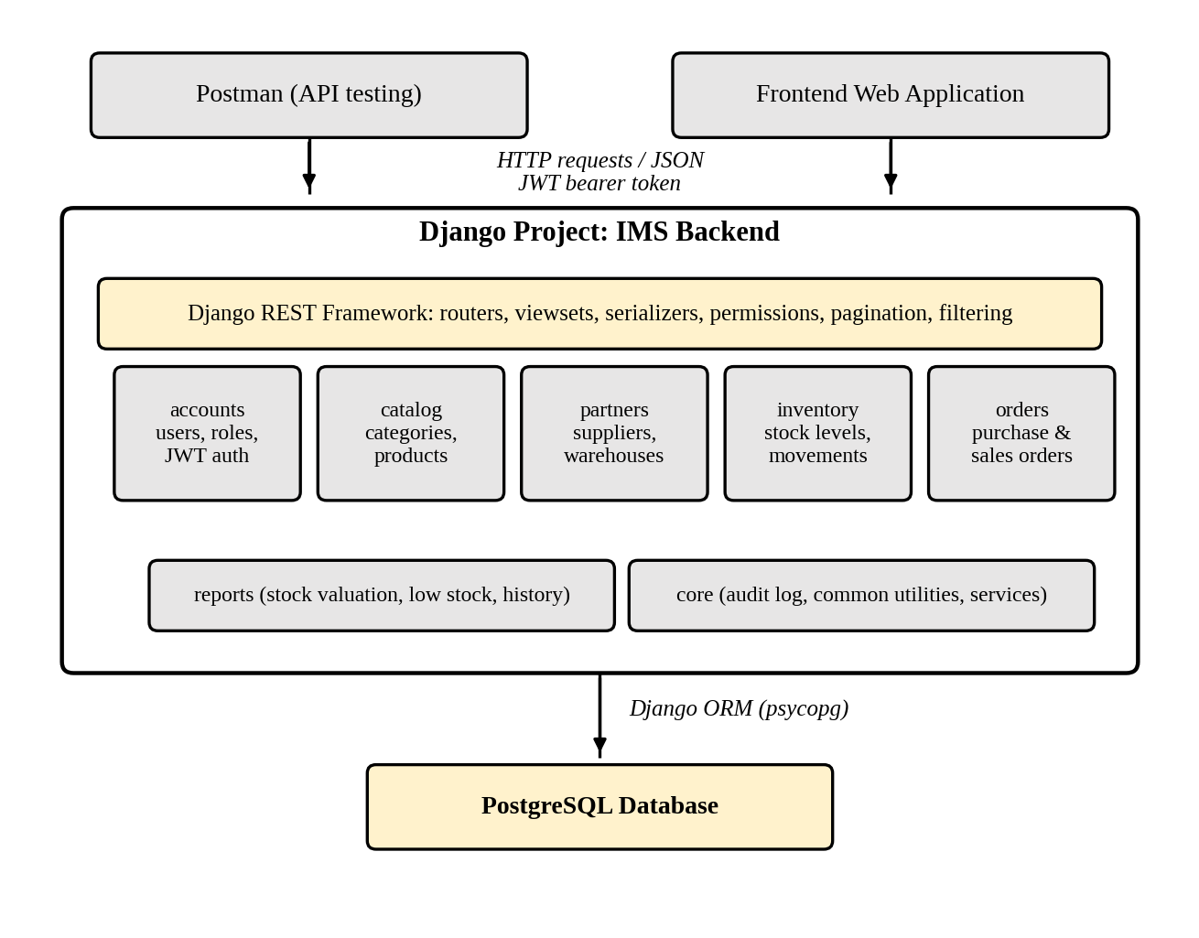
Figure 4.1. Architecture of the IMS Backend
The technologies used in the project are summarized in Table 4.2.
Table 4.2. Technology Stack and Tools
Programming Language | Python 3
Web Framework | Django 5.2
API Framework | Django REST Framework
Authentication | Django sessions and JWT through SimpleJWT
Filtering | django-filter
Database | PostgreSQL through psycopg
Database Tools | Django migrations and PostgreSQL tools
API Style | REST with JSON under /api/
API Testing | Not specified in the repository
Automated Testing | Django test framework and DRF APIClient
Version Control | Git repository
Staging Deployment | Not specified in the repository
Code Editor | Not specified in the repository

The data model contains User and Profile, Category and Product, Supplier, Warehouse, StockBalance, StockMovement and StockMovementLine, PurchaseOrder and PurchaseOrderLine, with foreign keys connecting the records. StockBalance stores the current quantity of each product in each warehouse. StockMovement and its lines record the immutable operational history. PurchaseOrder records procurement activity and can be linked to the movement created when stock is received. There is no SalesOrder model in the current project.
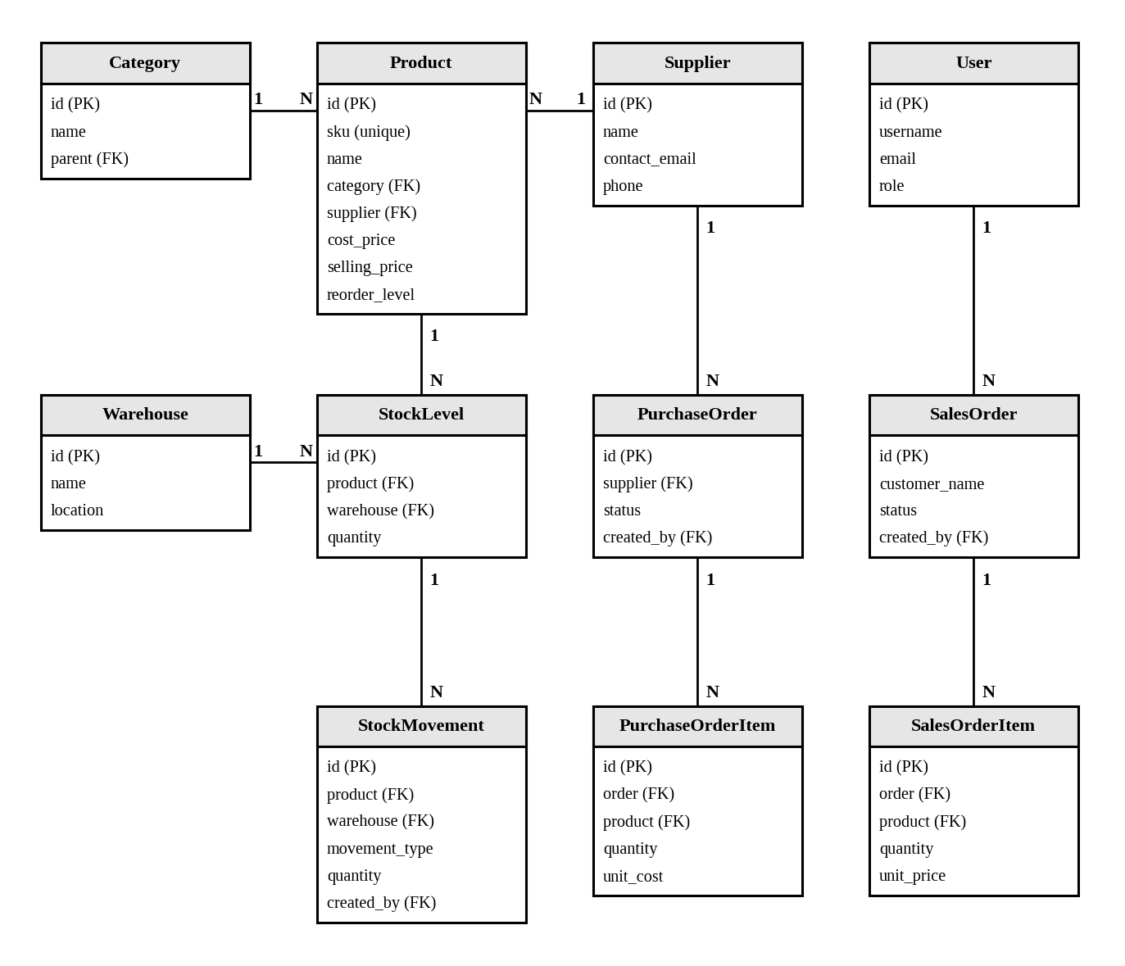
Figure 4.2. Entity-Relationship Diagram of the IMS
The functionality is organized into users, catalog, inventory, purchasing and core modules. API endpoints are prefixed with /api/ rather than /api/v1/.
Table 4.3. Modules and Main Endpoints of the IMS Backend
Module | Responsibility | Main Endpoints | Access
users | Users, profiles, roles and authentication | /api/auth/register/ /api/auth/token/ /api/auth/me/ /api/users/ | Registration: public; protected user operations: authenticated/admin
catalog | Categories and products | /api/categories/ /api/products/ | Authenticated users; mutation permissions apply
inventory | Warehouses, balances and stock movements | /api/warehouses/ /api/stock/ /api/movements/ | Authenticated users; warehouse mutation rules apply
purchasing | Suppliers and purchase orders | /api/suppliers/ /api/purchase-orders/ | Authenticated users; role and workflow rules apply
core | Dashboard, shared permissions and API support | /dashboard/ /api/docs/ /api/schema/ | Web users and authenticated API clients

Purchase-order status workflows are driven by Draft, Submitted, Partially received, Received and Cancelled states. Stock is increased when an order is received through the purchasing service, while cancellation does not add stock. Direct stock changes use the movement types Receipt, Issue, Transfer and Adjustment.
Table 4.4. Order Status Workflows and Their Effect on Stock
Order Type | Status Flow | Effect on Stock
Purchase order | Draft -> Submitted -> Partially received -> Received | Receiving creates stock movement lines and increases StockBalance; cancellation does not add stock
Purchase order | Draft or Submitted -> Cancelled | No stock increase; further receiving is prevented

My contribution comprised understanding the requirements and database design, authentication and permission behavior, catalog, inventory and purchasing functionality, dashboard presentation, API documentation, seed data and automated tests. Unlike the generic description in the original report, the current repository contains the frontend templates as well as the API, so the work was verified through browser pages and API requests rather than only through an external frontend.

4.4. Tasks/Activities Performed

4.4.1. Onboarding and Learning the Technology Stack
During the first two weeks the main task was to prepare for working on a real system. After setting up Python, PostgreSQL, Git and Postman, I followed the mentor's roadmap through Django models, the ORM, migrations, DRF serializers and viewsets, and PostgreSQL basics. Practice applications, such as a library app and a notes API, ensured that the conventions used by the team were learned and followed before touching the project repository. The internship proposal was also prepared and presented during this period.

4.4.2. Requirement Analysis and Database Design
The first assigned task was to understand the warehouse workflow and translate it into the existing Django model structure. The design uses User/Profile, Category/Product, Supplier, Warehouse, StockBalance, StockMovement/StockMovementLine and PurchaseOrder/PurchaseOrderLine records. A key design decision is to keep current balances for fast reads while preserving movement history for traceability. The design is implemented through migrations and protected foreign-key relationships.

4.4.3. Authentication and Role-Based Access Control
The users application provides a custom User model with Admin, Staff and Viewer roles, Profile records, registration, login, logout, password change and profile screens. API clients can register, obtain and refresh JWT tokens, retrieve the current user and change the password. Permission classes and view-level checks protect both web pages and API resources, and anonymous access is denied for protected operations.

4.4.4. Catalog, Supplier and Warehouse APIs
The catalog, purchasing and inventory applications provide web pages and API resources for categories, products, suppliers and warehouses. List screens support search, filtering and pagination. Product, supplier and warehouse records use validation and protected relationships; products with historical stock activity are not casually deleted. API filtering uses django-filter, while select_related() and prefetch_related() are used in relevant querysets.

4.4.5. Stock Ledger and Concurrency-Safe Stock Operations
The inventory service layer implements receipt, issue, adjustment and transfer operations inside transaction.atomic(). StockBalance rows are retrieved or created with select_for_update(), quantities are validated before saving, and StockMovementLine records are created in the same transaction. InsufficientStockError prevents a balance from becoming negative. Adjustments require a direction and a reason, while transfers require distinct source and destination warehouses. The current repository does not claim a dedicated simultaneous-thread concurrency test or a custom database-level non-negative constraint; those claims have therefore been removed.

4.4.6. Purchase Order Workflow
The purchasing application implements purchase orders with Draft, Submitted, Partially received, Received and Cancelled statuses. Orders contain supplier, warehouse and line-item information. Submitting an order changes its workflow state, receiving creates the related stock movement and updates received quantities, and cancelling prevents further receiving. There is no sales-order workflow or separate audit-log model in the current project.

4.4.7. Dashboard, API Documentation and Query Optimization
The core dashboard aggregates active product, warehouse, open purchase-order and daily movement counts, and displays low-stock products, recent movements and pending purchase orders. The API exposes filtering, search, ordering and pagination, with schema generation and Swagger UI through drf-spectacular. The project includes indexes and related-object loading for common queries. It does not include a separate reports module, stock-valuation endpoint or CSV export.

4.4.8. Testing, Documentation and Version Control
[ Suggested screenshot: API documentation at /api/docs/ ]

4.4.9. Deployment Support and Demonstration
In the final stage I verified migrations, loaded the idempotent demo data, ran Django's system checks and tests, started the local development server and checked the browser pages and API documentation. The project README provides handover instructions. Possible future enhancements include sales orders, stock valuation, CSV exports, barcode support, notifications and production deployment configuration.

Chapter 5: Conclusion and Learning Outcomes

5.1. Conclusion
The 9-week internship at E-Prabidhi Pvt. Ltd. provided meaningful exposure to a complete Django inventory application. The objectives were achieved: the project includes a PostgreSQL-backed schema, server-rendered browser workflows, a JWT-protected REST API, role-based access, transaction-safe stock movements, purchase-order workflows, dashboard summaries, seed data and automated tests. The final implementation is narrower than the generic inventory system described in the original report: it does not include sales orders, a separate reports module, stock valuation or CSV exports.
The most important technical lesson was that correctness in a data-intensive system comes from design decisions made close to the data: constraints in the database, transactions around multi-step operations, and locks where concurrent updates compete. The literature on REST, relational databases and transaction processing reviewed in Chapter 3 proved directly applicable to the work and made it possible to explain each design decision instead of simply copying a pattern.
Beyond the technical achievements, the internship showed how a feature is understood, implemented, tested and demonstrated in a working codebase. The experience increased my confidence in reading an unfamiliar Django project, tracing a request through URLs, views, serializers and services, and keeping browser behavior and API behavior consistent. Possible future enhancements include sales orders, stock valuation, CSV export, barcode scanning, email notifications, batch and expiry tracking, and production deployment support.

5.2. Learning Outcome
The key learning outcomes of this internship include:
- Practical proficiency in Python and Django, including models, migrations, the ORM, templates, forms, authentication, the admin site and focused application structure.
- Experience in building REST APIs with Django REST Framework, including serializers, viewsets, permissions, filtering, search, ordering, pagination and OpenAPI documentation.
- Ability to design a normalized PostgreSQL schema and use protected relationships, indexes, transactions and row-level locking to protect inventory data.
- Skill in improving database access with select_related(), prefetch_related(), queryset filtering and indexes while preserving readable service-layer code.
- Understanding of session authentication, JWT authentication, role-based authorization, CSRF protection and common web security considerations.
- Experience in writing Django and DRF tests, validating stock and purchase-order workflows, running migrations and using the seed_demo command to prepare repeatable sample data.
- Understanding of collaborative development practices using Git, GitHub, feature branches, pull requests and code review.
- Improved communication and time management through daily progress updates, weekly reviews and the final demonstration.

References
Berenson, H., Bernstein, P., Gray, J., Melton, J., O'Neil, E., & O'Neil, P. (1995). A critique of ANSI SQL isolation levels. ACM SIGMOD Record, 24(2), 1–10. https://doi.org/10.1145/568271.223785
Bray, T. (Ed.). (2017). The JavaScript Object Notation (JSON) data interchange format (RFC 8259). Internet Engineering Task Force. https://doi.org/10.17487/RFC8259
Chacon, S., & Straub, B. (2014). Pro Git (2nd ed.). Apress.
Chopra, S., & Meindl, P. (2016). Supply chain management: Strategy, planning, and operation (6th ed.). Pearson.
Christie, T. (n.d.). Django REST framework. https://www.django-rest-framework.org/
Codd, E. F. (1970). A relational model of data for large shared data banks. Communications of the ACM, 13(6), 377–387. https://doi.org/10.1145/362384.362685
Django Software Foundation. (n.d.). Django documentation. https://docs.djangoproject.com/
E-Prabidhi Pvt. Ltd. (n.d.). About us. https://www.eprabidhi.com/about_us.html
Fielding, R. T. (2000). Architectural styles and the design of network-based software architectures [Doctoral dissertation, University of California, Irvine]. https://ics.uci.edu/~fielding/pubs/dissertation/top.htm
Fielding, R., & Reschke, J. (Eds.). (2014). Hypertext Transfer Protocol (HTTP/1.1): Semantics and content (RFC 7231). Internet Engineering Task Force. https://doi.org/10.17487/RFC7231
Frappe Technologies. (n.d.). ERPNext documentation. https://docs.erpnext.com/
Greenfeld, D. R., & Roy Greenfeld, A. (2020). Two scoops of Django 3.x: Best practices for the Django web framework. Feldroy.
Haerder, T., & Reuter, A. (1983). Principles of transaction-oriented database recovery. ACM Computing Surveys, 15(4), 287–317. https://doi.org/10.1145/289.291
Hardt, D. (Ed.). (2012). The OAuth 2.0 authorization framework (RFC 6749). Internet Engineering Task Force. https://doi.org/10.17487/RFC6749
Harris, F. W. (1913). How many parts to make at once. Factory, The Magazine of Management, 10(2), 135–136, 152.
Holovaty, A., & Kaplan-Moss, J. (2009). The definitive guide to Django: Web development done right (2nd ed.). Apress.
Jones, M., Bradley, J., & Sakimura, N. (2015). JSON Web Token (JWT) (RFC 7519). Internet Engineering Task Force. https://doi.org/10.17487/RFC7519
Masse, M. (2011). REST API design rulebook. O'Reilly Media.
Odoo S.A. (n.d.). Odoo documentation. https://www.odoo.com/documentation/
OWASP Foundation. (2021). OWASP top ten. https://owasp.org/www-project-top-ten/
Pallets. (n.d.). Flask documentation. https://flask.palletsprojects.com/
PostgreSQL Global Development Group. (n.d.). PostgreSQL documentation. https://www.postgresql.org/docs/
Postman, Inc. (n.d.). Postman documentation. https://learning.postman.com/docs/
Ramírez, S. (n.d.). FastAPI. https://fastapi.tiangolo.com/
Richardson, L., & Ruby, S. (2007). RESTful web services. O'Reilly Media.
Silver, E. A., Pyke, D. F., & Thomas, D. J. (2017). Inventory and production management in supply chains (4th ed.). CRC Press.
Sommerville, I. (2016). Software engineering (10th ed.). Pearson.
Stonebraker, M., & Rowe, L. A. (1986). The design of POSTGRES. ACM SIGMOD Record, 15(2), 340–355. https://doi.org/10.1145/16894.16888

Bibliography
The following books were studied during the internship but are not cited in the text of this report.
Bass, L., Clements, P., & Kazman, R. (2012). Software architecture in practice (3rd ed.). Addison-Wesley.
Obe, R., & Hsu, L. (2017). PostgreSQL: Up and running (3rd ed.). O'Reilly Media.
Percival, H., & Gregory, B. (2020). Architecture patterns with Python. O'Reilly Media.
Siriwardena, P. (2020). Advanced API security: OAuth 2.0 and beyond (2nd ed.). Apress.

Appendices

Appendix A: Selected Source Code
The following excerpts illustrate the main techniques used in the IMS backend. They are shortened for readability and contain no client data.

A.1. StockBalance Model with Product-Warehouse Uniqueness
class StockBalance(models.Model):
product = models.ForeignKey("catalog.Product", on_delete=models.PROTECT, related_name="balances")
warehouse = models.ForeignKey(Warehouse, on_delete=models.PROTECT, related_name="balances")
quantity = models.DecimalField(max_digits=14, decimal_places=3, default=Decimal("0"))
updated_at = models.DateTimeField(auto_now=True)

class Meta:
unique_together = ("product", "warehouse")
indexes = [models.Index(fields=["warehouse", "product"])]
Code Listing A.1. StockBalance model
A.2. Transaction-Safe Stock Service
@transaction.atomic
def apply_delta(product, warehouse, delta):
balance, _ = StockBalance.objects.select_for_update().get_or_create(
product=product, warehouse=warehouse, defaults={"quantity": Decimal("0")}
)
new_quantity = balance.quantity + delta
if new_quantity < 0:
raise InsufficientStockError("Insufficient stock")
balance.quantity = new_quantity
balance.save(update_fields=["quantity", "updated_at"])
Code Listing A.2. apply_delta service function
A.3. Product API ViewSet
class ProductViewSet(viewsets.ModelViewSet):
queryset = Product.objects.select_related("category")

serializer_class = ProductSerializer
filterset_fields = ["category", "is_active"]
search_fields = ["name", "sku"]
Code Listing A.3. ProductViewSet
A.4. REST Framework Settings
REST_FRAMEWORK = {
"DEFAULT_AUTHENTICATION_CLASSES": [
"rest_framework_simplejwt.authentication.JWTAuthentication",
"rest_framework.authentication.SessionAuthentication",
],
"DEFAULT_PERMISSION_CLASSES": [
"rest_framework.permissions.IsAuthenticated"
],
"DEFAULT_PAGINATION_CLASS": "apps.core.pagination.StandardPagination",
"DEFAULT_FILTER_BACKENDS": [
"django_filters.rest_framework.DjangoFilterBackend",
"rest_framework.filters.SearchFilter",
"rest_framework.filters.OrderingFilter",
],
}
Code Listing A.4. REST framework configuration
A.5. Current Project Commands
python manage.py migrate
python manage.py seed_demo
python manage.py test
python manage.py runserver
Code Listing A.5. Local setup and verification commands
raise InsufficientStock(product=product, available=level.quantity)
level.quantity -= quantity
level.save(update_fields=["quantity", "updated_at"])
return StockMovement.objects.create(
product=product, warehouse=warehouse,
movement_type=StockMovement.OUT, quantity=quantity,
reference=reference, created_by=user,
)
Code Listing A.2. issue_stock service function

A.3. Product ViewSet with Query Optimization
class ProductViewSet(viewsets.ModelViewSet):
serializer_class = ProductSerializer
permission_classes = [IsManagerOrAdminOrReadOnly]
filterset_fields = ["category", "supplier", "is_active"]
search_fields = ["name", "sku"]
ordering_fields = ["name", "selling_price", "created_at"]

def get_queryset(self):
return Product.objects.select_related("category", "supplier")
Code Listing A.3. ProductViewSet

A.4. DRF Settings
REST_FRAMEWORK = {
"DEFAULT_AUTHENTICATION_CLASSES": (
"rest_framework_simplejwt.authentication.JWTAuthentication",),
"DEFAULT_PERMISSION_CLASSES": (
"rest_framework.permissions.IsAuthenticated",),
"DEFAULT_PAGINATION_CLASS": "core.pagination.StandardPagination",
"DEFAULT_FILTER_BACKENDS": (
"django_filters.rest_framework.DjangoFilterBackend",
"rest_framework.filters.SearchFilter",
"rest_framework.filters.OrderingFilter",),
"EXCEPTION_HANDLER": "core.exceptions.api_exception_handler",
}
Code Listing A.4. REST framework configuration

Appendix B: Screenshots
Replace each placeholder below with a screenshot from your own work, keeping the caption.
[ Suggested screenshot: API documentation at /api/docs/ ]
Figure B.1. Postman Collection of the IMS API
[ Suggested screenshot: Stock movement form or POST /api/movements/ response ]
Figure B.2. Stock-Out Request and Response in Postman
[ Suggested screenshot: validation response when an issue exceeds available StockBalance ]
Figure B.3. Insufficient Stock Error Response
[ Insert screenshot: pgAdmin showing the IMS tables ]
Figure B.4. Database Tables in pgAdmin
[ Suggested screenshot: Django dashboard or product list from the running project ]
Figure B.5. Pull Request Review on GitHub

