In northern city as the temperature decrease , the latitude increase

---------------------------------------------------------------------------------------------------------------------

In southern city as the temperature decrease , the latitude increase

---------------------------------------------------------------------------------------------------------------------

In southern city as the humidity increase , the latitude increase

---------------------------------------------------------------------------------------------------------------------

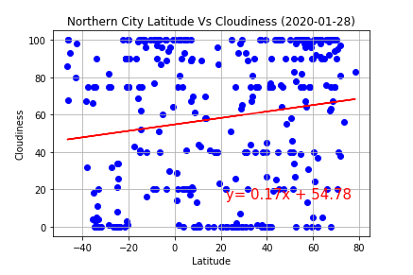

In northern city as the cloudiness increase , the latitude increase

---------------------------------------------------------------------------------------------------------------------

In southern city as the cloudiness increase , the latitude increase

---------------------------------------------------------------------------------------------------------------------

In northern city the wind speed is depend on latitude

---------------------------------------------------------------------------------------------------------------------

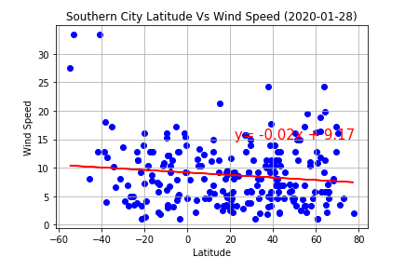

In southern city as the wind speed decrease , the latitude increase

---------------------------------------------------------------------------------------------------------------------