**KIST COLLEGE OF INFORMATION AND TECHNOLOGY KAMALPOKHARI, KATHMANDU NEPAL**



**PROPOSAL**

**FOR**

**“ELECTORAL PROCESS MANAGEMENT”**

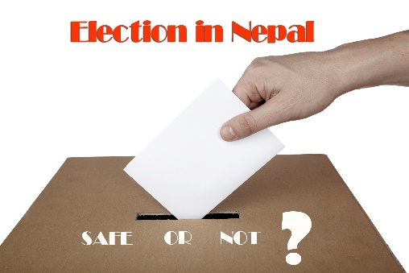

|  |  |  |
| --- | --- | --- |
| **Name** | **Registration No.** | **Exam Roll No.** |
| **1.Priya Kushawaha** | **058-3-2-04730-2020** | **324627** |
| **2. Samira Shahi** | **058-3-2-04737-2020** | **324634** |

**Submitted by:**

**Submitted to: BIT DEPARTMENT**

**Table of Contents**

1.Motivation………………………………………………………………………………….. 3

2.Software Overview………………………………………………………………………… 3

3.Development Methodology………………………………………………………………... 3

I. Requirement Analysis 3

II. Software Design Phase 3

III. Development and Integration 4

IV. Testing 4

V. Deployment 4

VI. Maintenance 4

4.Modules…………………………………………………………………………………….. 4

5.Objectives…………………………………………………………………………………... 4

6.Scope………………………………………………………………………………………... 5

7.Project Planning…………………………………………………………………………… 5

8.Tools and Technology Used……………………………………………………………….. 5

I. Tools 5

II. Technology 5

9.Use Case Diagram………………………………………………………………………… 6

10.Time Frame Required for Various Stages of Project Implementation……………….. 6

# **1.Motivation**

This project is made as our second semester final project. This project can be taken as the reference to build a better election management system. Several problems with current Election management have been identified. Hence this project is made for smooth elections.

# 

# **2.Software Overview**

Elections are something, that happens all over the world. This coded project easily depicts the management that is required to handle such a big program conducted all over the country. C++ language is used to develop this project. Users will have all options and features in the application like registration, vote, and also there will be an additional option for the Electoral manager to access the final results. The project has a set format as to how the voter registers, how he /she casts his vote and how the party with maximum votes wins the elections by fair chance. It is an electronic world and hence this program helps in demising the use of paper ballot. And minimizes the labor required while counting the votes.

**3.Development Methodology**

For this project, our team propose to follow our standard development model for software development.

A brief overview of the Waterfall model SDLC phases is as follows below:

1. **Requirement Analysis:** Our Team, in the consultation with our project teacher have studied the complete system in depth. The existing system is evaluated and the deficiencies are identified. All the relevant information is collected and analysis is done to check the feasibility of the development of the system.
2. **Software Design Phase:** In this phase, Based on the software requirements and operation concepts, detailed design solutions are worked out depending upon performance, availability of reusable components. The requirement gathered is used as an input and software architecture that is used for implementing system development is derived.
3. **Development and Integration:** Coding is started after design. The software design is then translated in source code.
4. **Testing:** Testing starts once the coding is complete and the modules are released for testing. In this phase, the developed software is tested thoroughly and any defects found are fixed.
5. **Deployment:** Once the system is tested, it is deployed. The system will be released to the client after the testing.
6. **Maintenance:** Post production and support is provided on the project. After the deployment of a product on the production environment, maintenance of the product i.e. if any issue comes up and needs to be fixed or any enhancement is to be done is taken care by the developers.

**4.Modules:**

• Admin Login

• Voters Login

• Voters can view Candidate’s data.

• Appropriate data processing and handling

• System generated ID and Password Voters.

• Result Calculation module

**5.Objectives:**

• Know about the candidate

• Caste the vote

• Display leading candidate

**6.Scope:**

This project has a large scope as it has the following features which help in making it easy to use, understand and modify it:

* The demise of ballot paper.
* The rise of electronic voting methods
* Electronic identities.
* To increment the precision and productivity of the arrangement technique.

**7.Project Planning:**

The project will be completed and presented to you as per the deadline. Team members and our project teacher is actively working for building this project. The project will be properly demonstrated to you with documentation and presentation by our team members after its completion.

# 

# **8.Tools and Technology Used:**

1. **Tools:** Dev C++ is a full-featured C and C++ Integrated Development Environment (IDE) for Windows platforms. Millions of developers, students and researchers use Dev-C++ since the first version was released in 1998. It has been featured in dozens of C++ and scientific books and remains one of the favorite learning tool among universities & school worldwide
2. **Technology:** C++ is a general-purpose programming language created by Danish computer scientist Bjarne Stroustrup as an extension of the C++ programming language, or "C++ with Classes". The language has expanded significantly over time, and modern C++ now has object-oriented, generic, and functional features in addition to facilities for low-level memory manipulation.

# **9.Use Case Diagram:**

**System**

**Register**

**System User**

**Administrator**

**10.Time Frame Required for Various Stages of Project Implementation:**

|  |  |  |
| --- | --- | --- |
| **S.N.** | **PHASES** | **TIME DURATION** |
| 1. | Software Requirement Specification | 1 weeks |
| 2. | System Design | 1 weeks |
| 3. | Coding | 1 weeks |
| 4. | Implementation | 1 weeks |
| 5. | Testing | 1 week |