Project

On

**Online railway reservation system**

B-Tech in information technology



*Submitted To:* -Shabnam

*Submitted by:-*

**Chris Varghese Pattasseril: 11902993**

**Shubham Kumar Singh: 11903512**

**Samir Barman: 11913872**

**Section: K19PB; Group:- 1**

**Online railway reservation system**

**Introduction:**

Railway transport as one of the most important mean of transport, has played an important role in the transport industry in India. With Indian rapid economic development, the railway lines and passengers are increasing day by day in this country. With such a huge customer base, buying train tickets problems has been very prominent. To solve these problems introduced a new online tickets reservation system. Passengers can access the website for book the trains for their journey from anywhere and anytime.

**Overview:**

The main aim of this project Online Railway Reservation system project is to book any train. Basically, this system helps the Railway workers to make all records and easy billing of passengers. This system work 24×7 because of it is online existence. Passengers can use this system from anywhere and anytime. Passengers can book trains from anywhere in the world and get the service of the transportation system.

**System Description**

**Home:**

In this section passengers can log in or sign up their account and after that they can search trains and will be able to book the tickets as they wish.

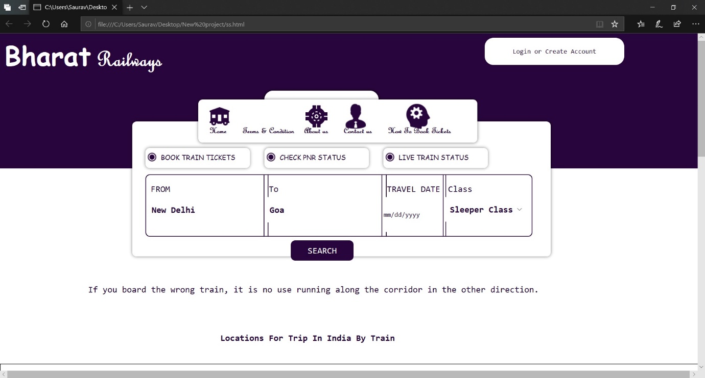

**About:**

In this section user can know all about this website and its working.

**Services:**

This system work 24×7 because of it is online existence. Passengers can use this system from anywhere and anytime for their journey.

**Gallery:**

You can see the photos of the railway service and the achievement.

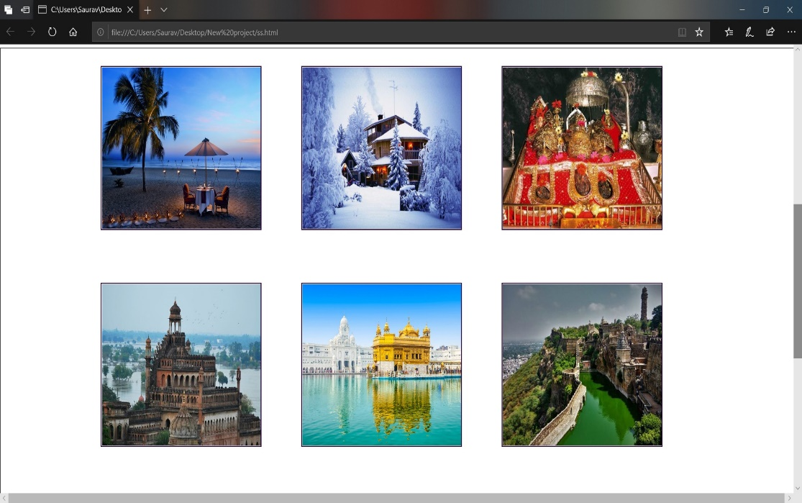

**Contact Us:**

This page provides Facility to passengers to contact us through mail or by mobile number.

**Conclusion:**

This website will help the passengers to operate from anywhere and anytime. This project will help us learn various elements of web development and to a step forward in building a responsive website.