**Cooperwind**

**PHASE 1– 04.07.2023**

1. They have system Sigma MRP → from that system, u QR will be generated, which consists of Part No’s.
2. In their system Sigma MRP, they only have Part No’s list. **(Not Mother, Child).**
3. In our system Pro-Biz, we should consider it has **Mother Part No, Child Part No.**
4. Around 5 different kinds of Mother Part No’s **(Groups),**each consisting of 80-100 Child Part No’s.

Item → **Group** → change it to **Mother Part No**

1. Add a New Module → **Kitting**→ Under Item → in this module → we will select Group (Mother Part No) → assign QTY’s for Child Part No’s. (Before sale or Purchase Order).
2. After assigning Qty s in Kitting Module → user go to Sale/ Purchase Order → and enter the Particular (Mother Part No (Group)). And enter the total QTYs of a Particular Kitting. After the sale / Purchase Order Proceeded automatically the inventory should change based on Kitting QTY.
3. During the Purchase Order → we will Scan the QR and then → create/ assign Child Part No Quantities. And will bring it to the system as stock.
4. During Sale Order → enter Mother Part no (Group) which we created in kitting.
5. After the sale order is created, the packing person will collect the packing slip and go for packing. At that time, he used to scan the same QR in which we **INWARD** the quantity during the **Purchase Order**. The same QR will be scanned for **Sale Order** **OUTWARD** also.   
     
   For e.g.: for a particular child Part No if a quantity is 10,

* then the packing person should scan 10 times only, if he scans after the 10th time, there should be a beep sound.
* If he scans 1-9 times only for a 10-quantity Part No, then it should move to the next Part No, until it scans 10 times.
* Likewise, there should be a manual entry also, with approval from a manager.
* If Packing Person wants to ente­r manually, then he should request to Manager's approval, if the manager approves, then only be able to enter manually and submit.
* ­­but the Packing person should enter only the exact quantity. no excess or shortage qty should allow.
* During the scan, inventory should change Automatically.
* During the Purchase order, → when Scanning the QR inventory should add automatically.

**I am attaching meeting link in this document: for your reference. Kindly refer the meeting link in case of any assistance.**

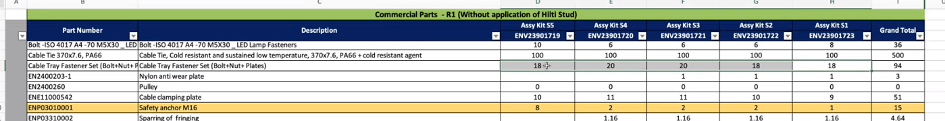

[Cooperwind Discussion-20230407_120203-Meeting Recording.mp4](https://iproat-my.sharepoint.com/:v:/p/basker/EQL-lvhW7rlFnHdiViF5fZAB2INvfYKKuyhVYY9bGqoOYg?e=kBFmcW)

**PHASE 2: - After Phase 1**

During delivery 🡪

While creating delivery challan at that time, there should be an option to generate QR.

That QR will be pasted in the Parcel.

When the sale order received to customer 🡪 at that time customer will scan the QR.

In that QR it should contains Part No and QTY’s.

By scanning this QR customer can able to check the Parcel with this QR.

After scan customer will update the status to **delivered.**

If there Is any Shortage, damage, Excess in the quantity. Customer will report it.

And those Qty’s with Part Nos will reflect in Return module.