PROJECT REPORT

On

Roomify for Room Provider and Room Seeker

From

ANALYZE INFOTECH

Towards partial fulfillment of the requirements
for the award of degree of

Bachelor of Computer Applications

From

Shri Ramswaroop Memorial University
Lucknow

Academic Session 2024 - 25

School of Computer Applications

PROJECT REPORT

On
Roomify for Room Provider and Room Seeker

From

ANALYZE INFOTECH

Towards partial fulfillment of the requirements
for the award of degree of

Bachelor of Computer Applications

From

Shri Ramswaroop Memorial University

Lucknow

Developed and Submitted by Under Guidance of
< Name of the Student> <Name of the Guide>
< University Roll No> <Designation>

Academic Session 2024 - 25

School of Computer Applications

Under taking

This is to certify that Project Report entitled

Roomify for Room Provider and Room Seeker
being submitted by

<Name of the Student>

Towards the partial fulfillment of the requirements
for the award of the degree of

Bachelor of Computer Applications
From
Shri Ramswaroop Memorial University
Lucknow
Academic Year 2024-25

is a record of the student’s own work carried out at

ANALYZE INFOTECH

and to the best of our knowledge the work reported herein does not form a part of any other thesis or work based on which degree or award was conferred on an earlier occasion to this or any other candidate.
Authorized Signatory Students’ Signature
Organization Name Name:
Roll No:

CERTIFICATE

DECLARATION

I, hereby declare that the report entitled “Roomify for Room Provider and Room Seeker” submitted to the School of Computer Applications, Shri Ramswaroop Memorial University, SSRM Tindora, Uttar Pradesh, 225003, is submitted in partial fulfilment of the requirements for the award of the degree of Bachelor of Computer Applications in specialization with Data Science & Artificial Intelligence.
This report is the outcome of my own effort and has been completed under the guidance and supervision of K.K PANDEY SIR. I also declare that the contents of this report have not been submitted, either in full or in part, to any other university or institution for the award of any degree or diploma.

Place: Lucknow
Date: 17/06/2025

Signature of the Student
Students’ Name:
University Roll No.:

Acknowledgment

It gives us immense pleasure to express our sincere gratitude to all those who extended their support and guidance throughout the course of this project. The successful completion of this work would not have been possible without the encouragement and assistance of many individuals.
First and foremost, we would like to extend our profound gratitude to Dr. Reena Srivastava, Honourable Dean, School of Computer Applications, Shri Ramswaroop Memorial University, for her continued support, motivation, and encouragement. Her visionary leadership and guidance have always been a source of inspiration for us. We are also deeply thankful to Dr. Prabhas Chandra Pathak, Head of the Department, School of Computer Applications, for his constant support and valuable insights, which played a vital role in shaping our project and helping us stay focused on our objectives.
We extend our deep appreciation to our project guide, K.K Pandey Sir, for his unwavering support, expert guidance, and timely feedback throughout the duration of the project. His willingness to assist us at every step and address our queries with patience greatly contributed to the successful completion of this work. We would also like to express our gratitude to the Training and Placement Coordinators for their support, cooperation, and guidance during this project.
Last but not the least, we sincerely thank our families and friends for their constant support, understanding, and motivation. Their encouragement has been a strong pillar behind our consistent efforts.

Index
S.No. | Title | Page no.
I | Certificate | IV
II | Declaration | V
III | Acknowledgement | VI
IV | Index | VII-VIII
1 | Introduction | 1
2 | Problem Definition | 2
2.1 | Purpose | 2
2.2 | Scope | 2
3 | Objective | 3
3.1 | Functional requirements | 3
3.2 | Non-Functional requirements | 3-4
4 | Requirement Specifications | 5
4.1 | Hardware requirements | 5
4.2 | Software requirements | 5
5 | Module Description | 6-7
6 | Problem Formulation | 7
7 | Feasibility Study | 8-9
8 | Problem Specifications | 10-15
9 | System Architecture Design | 16-17
10 | System Analysis | 18
11 | E-R Diagram | 19-22
12 | Data Flow Diagram | 23-26
13 | Project Planning & Scheduling | 27-28
14 | Coding | 29-50
15 | Screenshot | 51
16 | Testing | 52-59
17 | Conclusion | 60
18 | Future Scope | 61
19 | Bibliography | 62

INTRODUCTION
Roomify is a smart, digital room rental platform designed to connect room seekers (students, working professionals, travelers) with room providers (landlords, property managers, PG/hostel owners) in a simple, secure, and efficient way. The platform removes the hassle of traditional rental searches by offering a modern, online solution for listing, discovering, and booking accommodations.
For room seekers, Roomify provides a user-friendly interface to browse available rooms by location, budget, room type, and amenities. Users can view verified listings, schedule visits, communicate directly with providers, and even book rooms online—all from their mobile or desktop.
For room providers, Roomify offers a dedicated portal to list rooms with photos, rent details, rules, and availability status. It also allows them to manage inquiries, bookings, and track engagement metrics, helping reduce vacancy and reach a larger audience effortlessly.
By digitizing the room rental process, Roomify ensures transparency, convenience, and trust for both parties, making it the go-to platform for finding or offering accommodation quickly and confidently.

PROBLEM DEFINITION
In many cities, finding or offering a room for rent remains a manual, frustrating, and unorganized process. Room seekers—especially students, working professionals, or newcomers—often struggle to locate rooms that match their budget, location, and preferences due to lack of verified information or standard listings. They rely heavily on brokers, local ads, or word-of-mouth, which leads to high costs and wasted time.
On the other hand, room providers (house owners, PGs, hostel managers) face difficulties in advertising vacant rooms to the right audience. They often deal with frequent inquiries, no-shows, and poor tenant screening, leading to inefficiencies and lost revenue.
Thus, there is a need for a digital platform that seamlessly connects room seekers and providers, facilitates reliable communication, and simplifies the room booking process.
Purpose:
The main purpose of Roomify is to:
- Provide a centralized digital platform for listing and discovering rooms for rent.
- Help seekers find verified and affordable accommodations based on personalized filters such as budget, location, amenities, and stay duration.
- Assist providers in showcasing their available rooms, managing leads, and reducing room vacancy periods.
- Improve transparency in the room rental process by including ratings, reviews, photos, and verified listings.
- Reduce dependency on brokers, saving time and money for both parties.

Scope:
Roomify offers tailored features for both room seekers and room providers:
Room Seeker Scope:
- Easy sign-up and profile creation
- Advanced room search with filters (location, budget, room type, amenities)
- View detailed room listings with photos and reviews
- Chat with providers and schedule visits
- Online room booking or request for hold
- Save favourites and get alerts for new listings
Room Provider Scope:
- Property/room listing with availability calendar
- Upload photos, rent details, house rules, and amenities
- Dashboard to manage listings, inquiries, and bookings
- Receive seeker messages and respond quickly
- Mark rooms as booked or vacant
- View seeker interest metrics and feedback

.
OBJECTIVE
- To create a centralized and digital solution for room renting and booking.
- To provide room seekers with access to verified and filtered accommodation listings.
- To help room providers easily manage and showcase their available rooms.
- To reduce dependence on brokers by allowing direct interaction between seekers and providers.
- To ensure a transparent and secure room rental process with reviews, photos, and verified listings.
- To save time, cost, and effort for both parties by simplifying search, communication, and booking workflows.
Functional Requirements:
For Room Seekers:
- User Registration/Login
  - Sign up/login via email, phone number, or social platforms.
- Profile Creation
  - Add personal details, location preferences, budget, and accommodation type.
- Search Rooms
  - Filter rooms by location, rent, amenities, sharing type, and availability.
- Room Details View
  - See full listing details: images, rent, facilities, provider contact, rules, reviews.
- Favorites & Alerts
  - Save listings, get notifications for matching new rooms.
- Booking or Contact Provider
  - Chat with providers or request bookings directly.
- Ratings & Reviews
  - Rate rooms and share feedback after stay.
For Room Providers:
- Provider Registration/Login
  - Register as an individual, PG owner, or property manager.
- Room Listing Creation
  - Upload room photos, rent, room type, availability, and amenities.
- Inquiry Management
  - View and respond to seeker queries/messages.
- Booking Management
  - Accept, reject, or schedule bookings; mark rooms as occupied.
- Review Management
  - View feedback from seekers and respond to ratings.
- Dashboard
  - Monitor listing performance, views, and responses.
Non-Functional Requirements
- Performance
  - Fast loading time (<3 seconds), even with multiple users.
- Scalability
  - Should support thousands of listings and concurrent users across cities.
- Security
  - Secure login, encrypted data transmission, and privacy control.
- Usability
  - Simple, intuitive interface suitable for tech and non-tech users.
- Reliability
  - Minimal downtime, data backups, and consistent uptime.
REQUIREMENTS SEPECIFICATIONS

HARDWARE SPECIFICATION

Component | Minimum Requirement | Recommended Requirement
Processor | Quad-Core (e.g., Intel Xeon / Ryzen) | 8-Core Server Grade CPU
RAM | 8 GB | 16–32 GB
Storage |  | 512 GB SSD or NVMe
  256 GB SSD
Network | 10 Mbps or above | 100 Mbps or above

SOFTWARE SPECIFICATION

Software | Description
OS
  Windows 10+, Linux, or macOS
Browser | Google Chrome, Firefox, Safari
Framework | React.js
Libraries | Axios, React Router, Tailwind CSS, Mongoose, Cors, Multer, ExpressJs
Run Time Environment | NodeJS
Database | MongoDB Community Server

PROBLEM FORMULATION
In urban and semi-urban areas, the process of finding or offering a room for rent remains outdated, inefficient, and often untrustworthy. Room seekers frequently face challenges such as fake listings, high broker fees, lack of verified room details, and unclear communication with landlords. This leads to a frustrating and time-consuming experience, especially for students and working professionals relocating to new cities.
On the other hand, room providers (such as house owners, hostel managers, and PG operators) struggle to reach genuine tenants, manage multiple inquiries manually, and reduce the vacancy period of rooms. They lack a digital solution that provides visibility, lead management, and tenant screening in one place.
This unorganized system leads to:
- Wasted time and money on both ends
- Mismatched expectations due to lack of transparency
- Dependency on brokers and unreliable platforms
- Difficulty in trust-building and documentation
FEASIBILITY STUDY

1. Technical Feasibility
- Technology Stack: MERN (MongoDB, Express.js, React.js, Node.js) is suitable for building a responsive, full-stack application.
  - Listing rooms with images, pricing, and location
  - Search/filter by area, price, amenities
  - Booking management system
  - Real-time chat/contact
  - User authentication and dashboard
- Integration: Map APIs (e.g., Google Maps), payment gateways (Razorpay, Stripe), and review systems.
2. Economic Feasibility
- Development Cost: Medium; team of 2–4 developers needed.
- Operational Cost: Hosting, database management, and API usage (moderate and scalable).
- Revenue Model:
  - Subscription for premium listings
  - Featured ad placements
  - Commission on bookings
- ROI: High potential in cities with high rental activity (colleges, IT hubs).
3. Operational Feasibility
- Target Users:
  - Room Seekers: Students, employees, bachelors.
  - Room Providers: Landlords, PG/hostel owners.
- User Benefits:
  - For seekers: Easy discovery and booking of rooms.
  - For providers: Quick listing, visibility, and booking management.
- Ease of Use: Intuitive UI/UX planned for both mobile and desktop users.
4. Schedule Feasibility
- Estimated Timeline:
  - Basic MVP: 6–8 weeks
  - Full-featured version: 10–14 weeks
- Team Required: 1 frontend developer, 1 backend developer, 1 UI/UX designer, 1 tester.
5. Legal Feasibility
- Compliance:
  - Terms & conditions, privacy policy for users.
  - Verification of listings to avoid fraud.
  - Secure payment and data protection standards (e.g., GDPR compliance if international).
PROBLEM SPECIFICATION
The Roomify platform aims to solve key problems in the room rental market by providing a reliable, digital alternative to the traditionally manual and broker-dependent process. To build this platform effectively, the problem must be specified in terms of the exact features and challenges it must address for both users — room seekers and room providers.
Problems Faced by Room Seekers:
- Lack of Verified Listings
  - Many online listings are outdated, fake, or misleading, leading to wasted time and trust issues.
- High Broker Dependency
  - Users often rely on middlemen who charge excessive fees without guaranteeing results.
- No Centralized Search System
  - Seekers have to check multiple platforms or physical locations to find suitable rooms.
- Lack of Transparency
  - Important information like house rules, amenities, and real-time availability is often missing.
- Inconvenient Communication
  - Reaching out to room providers is often done through inconsistent or delayed channels.

Problems Faced by Room Providers:
- Limited Reach and Visibility
  - Providers find it hard to promote available rooms to the right audience without expensive ads or agents.
- Manual Inquiry Handling
  - Managing inquiries through calls or messages is unorganized and time-consuming.
- Long Vacancy Periods
  - Rooms often remain empty due to poor outreach or delayed responses.
- No Screening Tools
  - Providers lack any system to pre-qualify or understand potential tenants

COMPONENT DIAGRAM
The component diagram contains components and dependencies. Components represent the physical packaging of a module of code. The dependencies between the components show how changes made to one component may affect the other components in the system. Dependence in a component diagram are represented by a dashed line between two or more components. Component diagrams can also show the interfaces used by the components to communicate to each other.

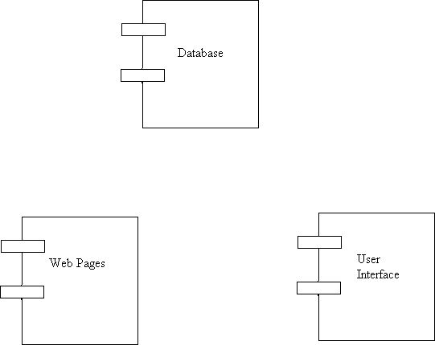

Figure of Component Diagram

Deployment Diagram:
Deployment and component diagram combines the features of both diagrams into one diagram.
The deployment diagram contains nodes and connections. A node usually represents a piece of hardware in the system. A connection depicts the communication path used by the hardware to communicate and usually indicates a method such as TCP/IP.

DB
UI
Web Server

Web pages

Figure of Deployment Diagram

SYSTEM ARCHETECTURE DESIGN
Defining System:
Collection of components, which are interconnected, and work together to realize some objective, from a system. There are three components in every system, namely input, processing and output

Input Output
Processing

System Development of Life Cycle:
The System development life cycle (SDLC), or Software development process in systems engineering, information systems and software engineering, is a process of creating or altering information systems, and the models and methodologies that people use to develop these systems. In software engineering, the SDLC concept underpins many kinds of software methodologies. Broadly, following are the different activities to be considered while defining the system development life cycle for the said project:
- Problem
- Definition
- System Analysis
- Study of existing system
- Drawback of the existing system
- Proposed system
- System Requirement study
- Data flow analysis
- Feasibility study
- System design
- Input Design (Database & Forms) Updating
- Query /Report
- Design
- Administration
- Testing
- Implementation
- Maintenance
SYSTEM ANALYSIS
Systems analysis is the study of sets of interacting entities, including computer systems analysis. This field is closely related to requirements analysis or operations research. It is also "an explicit formal inquiry carried out to help someone (referred to as the decision maker) identify a better course of action and make a better decision than he might otherwise have made.
System development can generally be thought of having two major components: systems analysis and systems design. In System Analysis more emphasis is given to understanding the details of an existing system or a proposed one and then deciding whether the proposed system is desirable or not and whether the existing system needs improvement.
Systems design is the process of defining the architecture, components, modules, interfaces, and data for a system to satisfy specified requirements. If the broader topic of product development "blends the perspective of marketing, design, and manufacturing into a single approach to product development," then design is the act of taking the marketing information and creating the design of the product to be manufactured. Systems design is therefore the process of defining and developing systems to satisfy specified requirements of the user. Until the 1990s systems design had a crucial and respected role in the data processing industry. In the 1990s standardization of hardware and software resulted in the ability to build modular systems. The increasing importance of software running on generic platforms has enhanced the discipline of software
ENTITY RELATION DIAGRAMS
The Entity Relation Model or Entity Relation Diagram (ERD) is a data model or diagram for high-level description of conceptual data model, and it provides a graphical notation for representing such data models in the form of entity relationship diagrams. Such models are typically used in the first stage of Management information management system design; they are used for example, to describe information needs and/ or the type of information that is to be stored in the Database during the requirement analysis. The data modeling technique, however, can be used to describe any ontology (i.e. an overview and classification of used terms and their relationships) for a certain universe of discourse (i.e. area of interest).
ER DIAGRAMS:
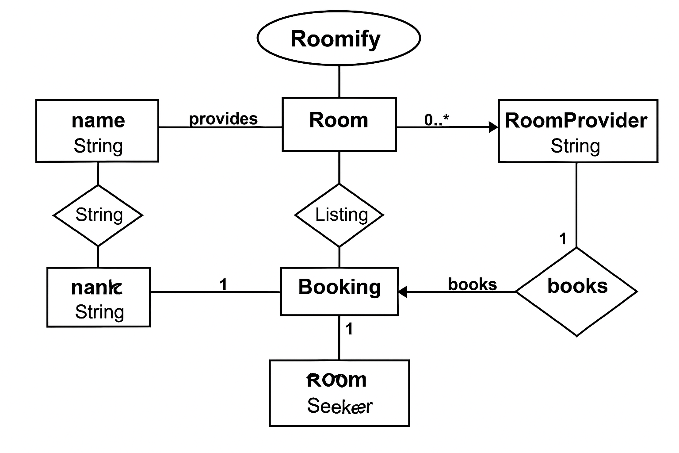
Activity Diagram:
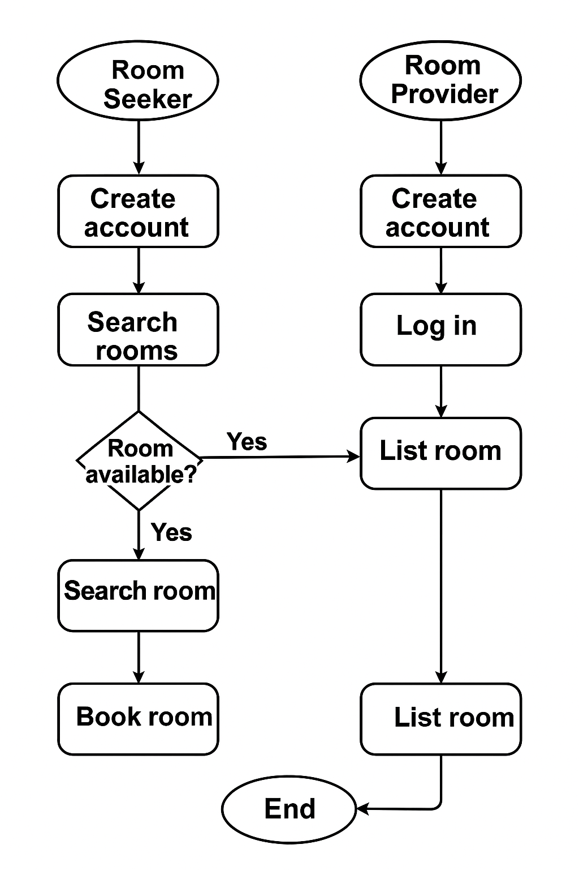

Event Diagram
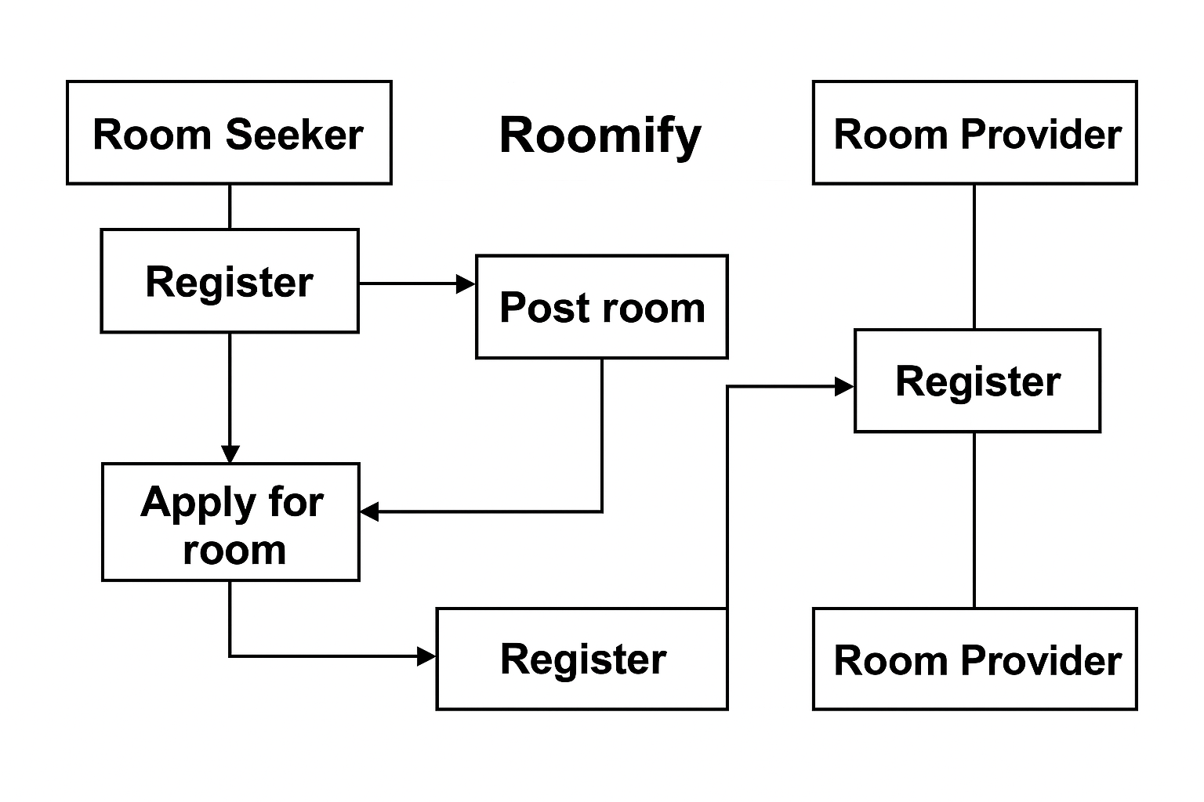
DATA FLOW DIAGRAM
The data flow diagram shows the flow of data within any system. It is an important tool for designing phase of software engineering. Larry Constantine first developed it. It represents graphical view of flow of data. It’s also known as BUBBLE CHART. The purpose of DFD is major transformation that will become in system design symbols used in DFD.
In the DFD, four symbols are used and they are as follows.
- A square defines a source (originator) or destination of system data.

- An arrow identifies data flow-data in motion. It is 2a pipeline through which information flows.

- An open rectangle is a data store-data at rest, or a temporary Repository of data.

- A circle or a “bubble “(Some people use an oval bubble) represents a process that transfers informing data flows into outgoing data flows.

Context Level Data Flow Diagram:
This level shows the overall context of the system and its operating environment and shows the whole system as just one process. Online book store is shown as one process in the context diagram; which is also known as zero level DFD, shown below. The context diagram plays important role in understanding the system and determining the boundaries. The main process can be broken into sub-processes and system can be studied with more detail; this is where 1st level

DFD comes into play.
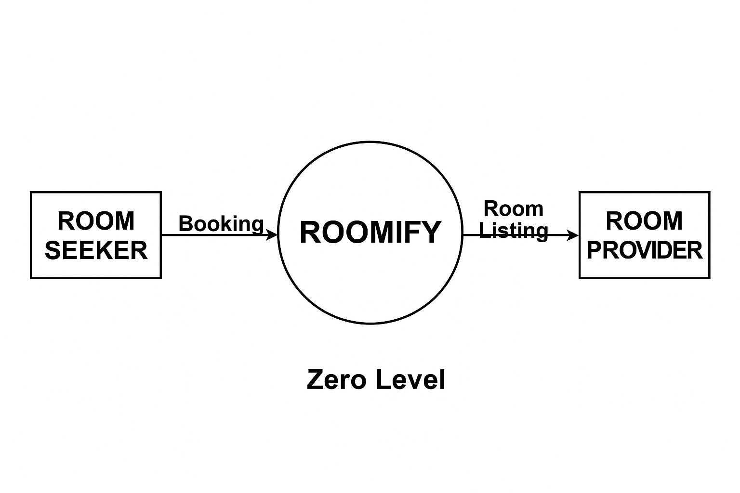

Zero Level Data Flow Diagram
First Level DFD:
This level (level 1) shows all processes at the first level of numbering, data stores, external entities and the data flows between them. The purpose of this level is to show the major high- level processes of the system and their interrelation. A process model will have one, and only one, level-1 diagram. A level-1 diagram must be balanced with its parent context level diagram,
i.e. there must be the same external entities and the same data flows, these can be broken down to more detail in the level 1.
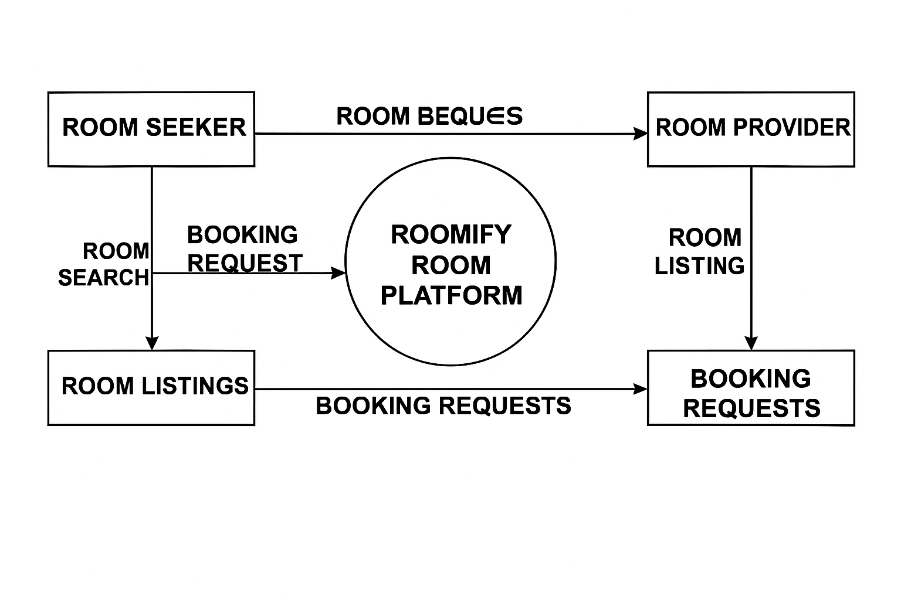

First Level Data Flow Diagram

Class Diagram
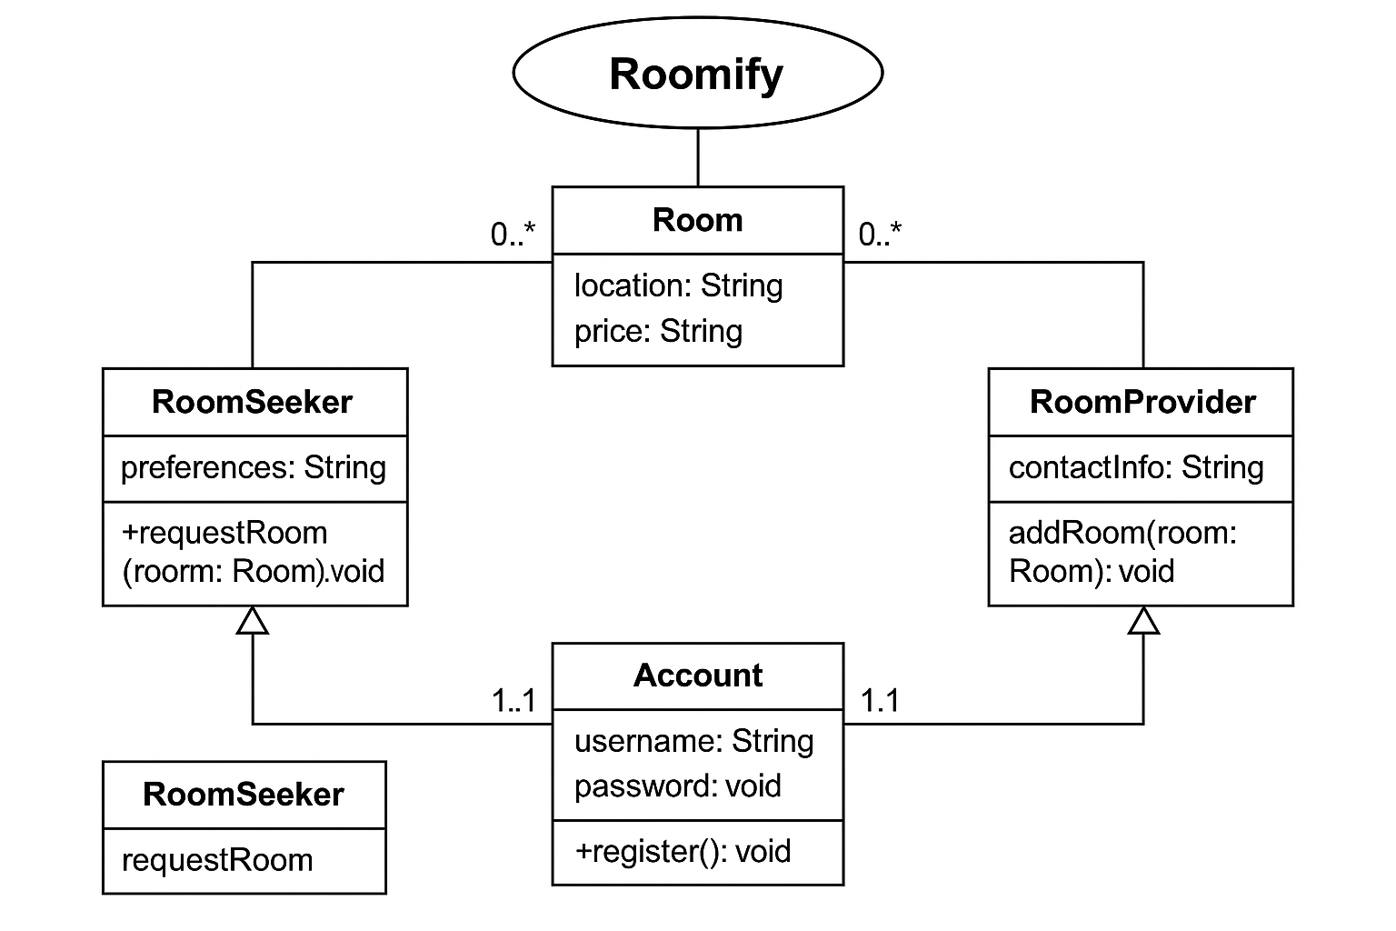

PROJECT PLANNING & SCHEDULING

Pert Chart:
A project plan needs to be created to ensure the timely completion of the project. As part of project analysis, we break the project down to a number of stages and use a Gantt chart and PERT chart to describe specific tasks and status.
The Work Breakdown Structure of our proposed system “E-Commerce” is shown below:

ID | Task Name | Duration | Start | Finish
1 | Project Initiation | 03 days | Tue  18/02/2025 | Fri  21/02/2025
2 | Draft Project Plan | 02 days | Sat  22/02/2025 | Mon  24/02/2025
3 | Analysis Phase | 09 days | Wed  26/02/2025 | Fri  07/03/2025
4 | Plan User Interviews | 02 days | Sat  08/03/2025 | Mon  10/03/2025
5 | Schedule users Interviews | 04 days | Tue  11/03/2025 | Sat  15/03/2025
6 | Conducting users Interviews | 03 days | Mon  17/03/2025 | Thu  20/03/2025
7 | System Design | 10 days | Fri  21/03/2025 | Mon  31/03/2025
8 | Modules Design | 09 days | Tue  01/04/2025 | Thu  10/04/2025
9 | Data Structure Design | 03 days | Fri  11/04/2025 | Mon  14/04/2025
10 | User Interface Design | 02 days | Tue  15/04/2025 | Thu  17/04/2025
11 | Coding Phase | 07 days | Fri  18/04/2025 | Fri  25/04/2025
12 | Testing Phase | 05 days | Fri  25/04/2025 | Wed  30/04/2025
13 | Integration Testing | 03 days | Wed  30/04/2025 | Fri  02/05/2025
14 | System Level Testing | 03 days | Fri  02/05/2025 | Mon  05/05/2025
15 | Implementation | 02 days | Tue  06/05/2025 | Wed  07/05/2025
16 | Post-Implementation Review | 04 days | Thu  08/05/2025 | Mon  12/05/2025

CODING OF PROJECT
App.jsx
import React from 'react'

import Home from './pages/Home';
import { Route, Routes } from 'react-router-dom';
import Adminogin from './pages/Adminlogin';
import Usersignin from './pages/Usersignin';
import Adminhome from './pages/Adminhome';
import Addroom from './pages/Addroom';
import Viewroom from './pages/Viewroom';
import Editroom from './pages/Editroom';
import Signup from './pages/Signup';
import Userhome from './pages/Userhome';
import Feedback from './pages/Feedback';
import Viewfeedback from './pages/Viewfeedback';
import Users from './pages/Users';
import Viewbooking from './pages/Viewbooking';
import Rooms from './pages/Rooms';
import Mybooking from './pages/Mybooking';
import Booknow from './pages/Booknow';
import Editbooking from './pages/Editbooking';
import PrivateRout from "./pages/PrivateRoute";
import PrivateRout2 from "./pages/PrivateRoute2";

function App() {
return (
<>
<Routes>

<Route element={<PrivateRout/>}>

<Route path="/userhome" element={ <Userhome/>} />
<Route path="/room" element={<Rooms/>}/>
<Route path={"/mybooking"} element={<Mybooking/>}/>
<Route path="/feedback" element={ <Feedback/>} />
<Route path="/booknow/:id" element={<Booknow/>}/>
</Route>

<Route element={<PrivateRout2/>}>

<Route path="/adminhome" element={<Adminhome/>}/>
<Route path="/users" element={<Users/>}/>
<Route path="/addroom" element={<Addroom/>}/>
<Route path="/viewroom" element={<Viewroom/>}/>
<Route path="/editroom/:id" element={<Editroom/>}/>
<Route path={"/viewbooking"} element={<Viewbooking/>}/>
<Route path={"/editbooking/:id"} element={<Editbooking/>}/>
<Route path="/viewfeedback" element={<Viewfeedback/>}/>
</Route>

<Route path='/' element={<Home/>}/>
<Route path='/adminlogin' element={<Adminogin/>}/>
<Route path='/usersignin' element={<Usersignin/>}/>
<Route path='/Signup' element={<Signup/>}/>
</Routes>

</>
)
}

export default App
backend/index.js
const mongoose = require('mongoose');
const express = require('express');
const bodyparser = require('body-parser');
const cors = require('cors');

const app = express();
mongoose.connect('mongodb://127.0.0.1:27017/Roomify');

app.use(cors());

app.use(bodyparser.json({limit:'50mb'}));
app.use(bodyparser.urlencoded({limit:'50mb',extended:true}));
app.use(express.json());

let admin = require('./admin');
let room = require('./rooms');
let feedback = require('./feedback');
let user = require('./user');
let booking = require('./booking');

app.post('/signup',async(req,res)=>{
console.log("called");
let result = new user(req.body);
let data = await result.save();
res.send(data);
});

app.post('/login',async (req,res)=>{
if(req.body.email && req.body.password)
{
let data = await user.findOne(req.body).select('-password');
if (data){
res.send(data);
}
else{
res.send("Email and Password no matched");
}
}
else{
res.send("provide both email and password");
}
});

app.get('/getusers',async(req,res)=>{
let data = await user.find();
res.send(data);
});

app.delete('/deleteuser/:id',async (req,res)=>{
let data = await user.deleteOne({_id:req.params.id});
res.send(data);
});

app.post('/adminlogin',async (req,res)=>{
if(req.body.username && req.body.password)
{
let data = await admin.findOne(req.body).select('-password');
if (data){
res.send(data);
}
else{
res.send("username and Password no matched");
}
}
else{
res.send("provide both email and password");
}
});

app.post('/addroom',async(req,res)=>{
let result = new room(req.body);
let data = await result.save();
res.send(data);
});

app.get('/getroom',async(req,res)=>{
let data = await room.find();
res.send(data);
});

app.delete('/deleteroom/:id',async (req,res)=>{
let data = await room.deleteOne({_id:req.params.id});
res.send(data);
});

app.get('/editroom/:id',async (req,res)=>{

let data = await room.findOne({_id:req.params.id});
res.send(data);
});

app.put('/updateroom/:id',async(req,res)=>{
let data = await room.updateOne(
{_id: req.params.id},
{$set: req.body}
);
res.send(data);
});

app.post('/feedback',async(req,res)=>{
let result = new feedback(req.body);
let data = await result.save();
res.send(data);
});

app.get('/viewfeedback',async (req,res)=>{
let data = await feedback.find();
res.send(data);
});

app.get('/getusers',async(req,res)=>{
let data = await user.find();
res.send(data);
});

app.delete('/deleteuser/:id',async (req,res)=>{
let data = await user.deleteOne({_id:req.params.id});
res.send(data);
});

app.post('/booking',async(req,res)=>{
let result = new booking(req.body);
let data = await result.save();
res.send(data);
});

app.get('/userbooking/:email',async(req,res)=>{
let data = await booking.find({email:req.params.email});
res.send(data);
});

app.get('/bookings',async(req,res)=>{
let data = await booking.find();
res.send(data);
});

app.delete('/deletebooking/:id',async (req,res)=>{
let data = await booking.deleteOne({_id:req.params.id});
res.send(data);
});

app.get('/editbooking/:id',async (req,res)=>{

let data = await booking.findOne({_id:req.params.id});
res.send(data);
});

app.put('/updatebooking/:id',async(req,res)=>{
let data = await booking.updateOne(
{_id: req.params.id},
{$set: req.body}
);
res.send(data);
});

app.get('/searchbooking/:key',async (req,res)=>{
let result = await booking.find({
"$or":[
{ email:{$regex:req.params.key,$options: 'i'} },{contact:{$regex:req.params.key,$options: 'i'} }
]
});
res.send(result);
});

app.get('/searchroom/:key',async (req,res)=>{
let result = await room.find({
"$or":[
{ type:{$regex:req.params.key,$options: 'i'} }
]
});
res.send(result);
});

app.listen(4500);

user.js
let mongoose = require('mongoose');

const userSchema = new mongoose.Schema({
name:String,
contact:String,
email:String,
address:String,
gender:String,
password:String

});

module.exports = mongoose.model('registration',userSchema);

rooms.js
let mongoose = require('mongoose');

const roomSchema = new mongoose.Schema({
rno:String,
price:Number,
image:String,
type:String,
status:String

});

module.exports = mongoose.model('room',roomSchema);

Booking.js
let mongoose = require('mongoose');

const roomSchema = new mongoose.Schema({
rno:String,
price:Number,
image:String,
type:String,
status:String

});

module.exports = mongoose.model('room',roomSchema);

DATABASE TABLES

Admin

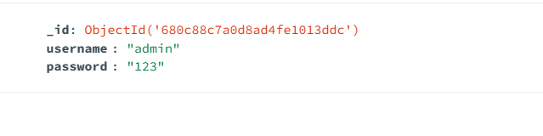

Bookings

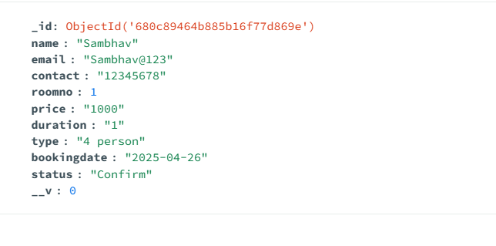

Feedbacks

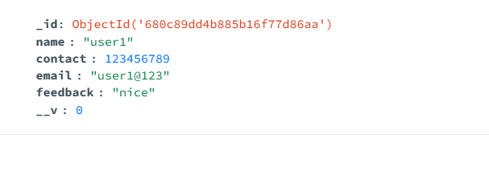

Registration

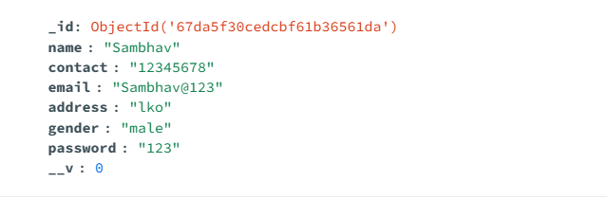

Rooms

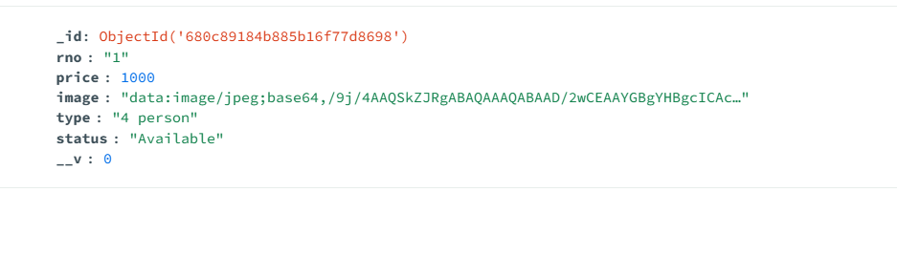

Project Screenshot

Home

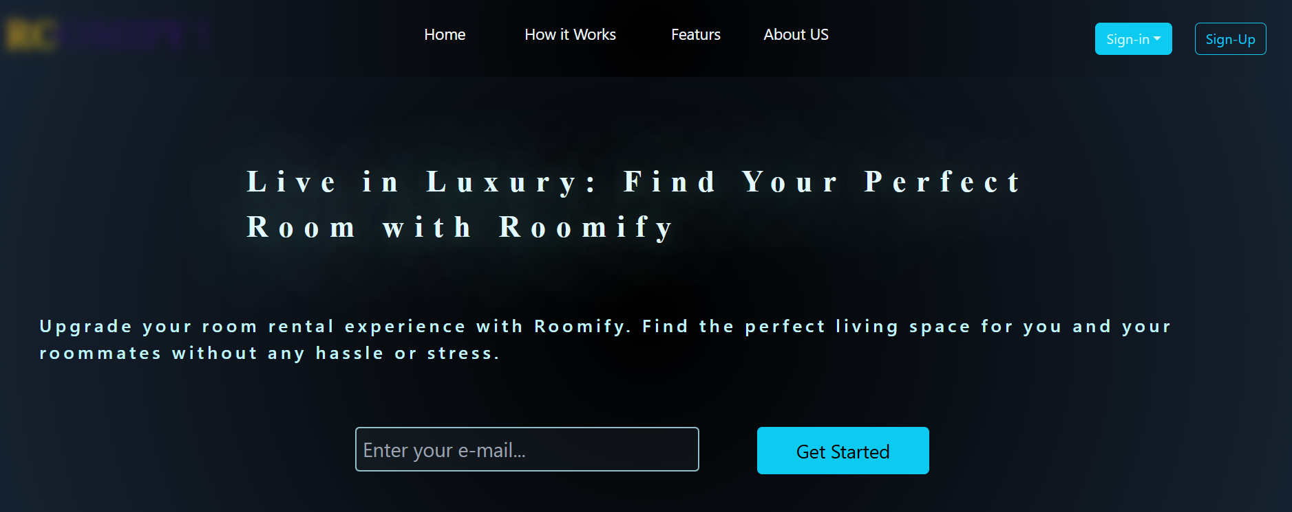

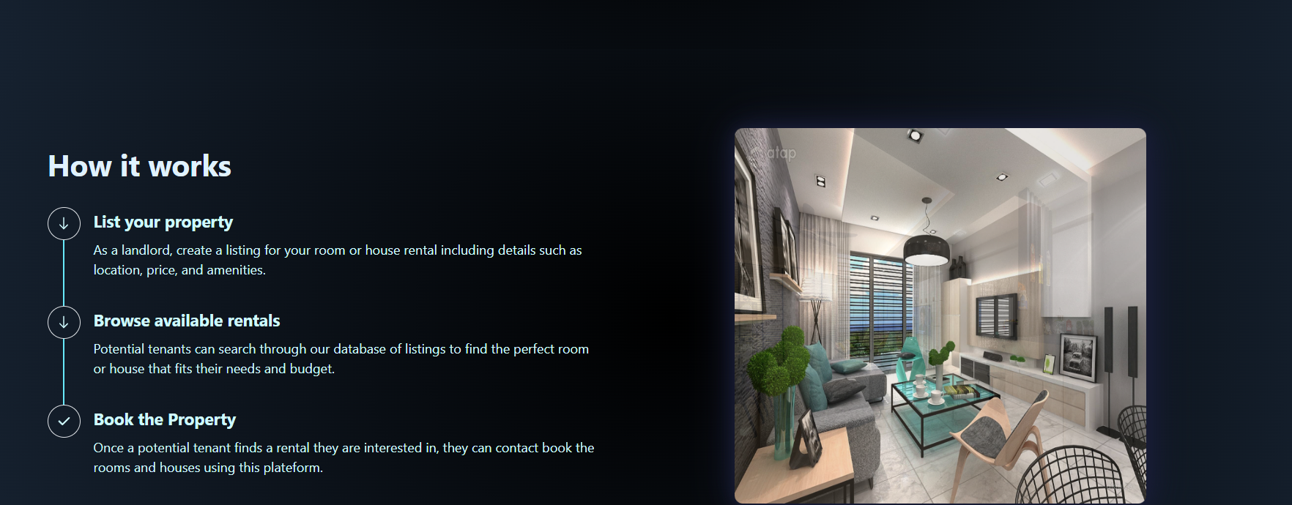

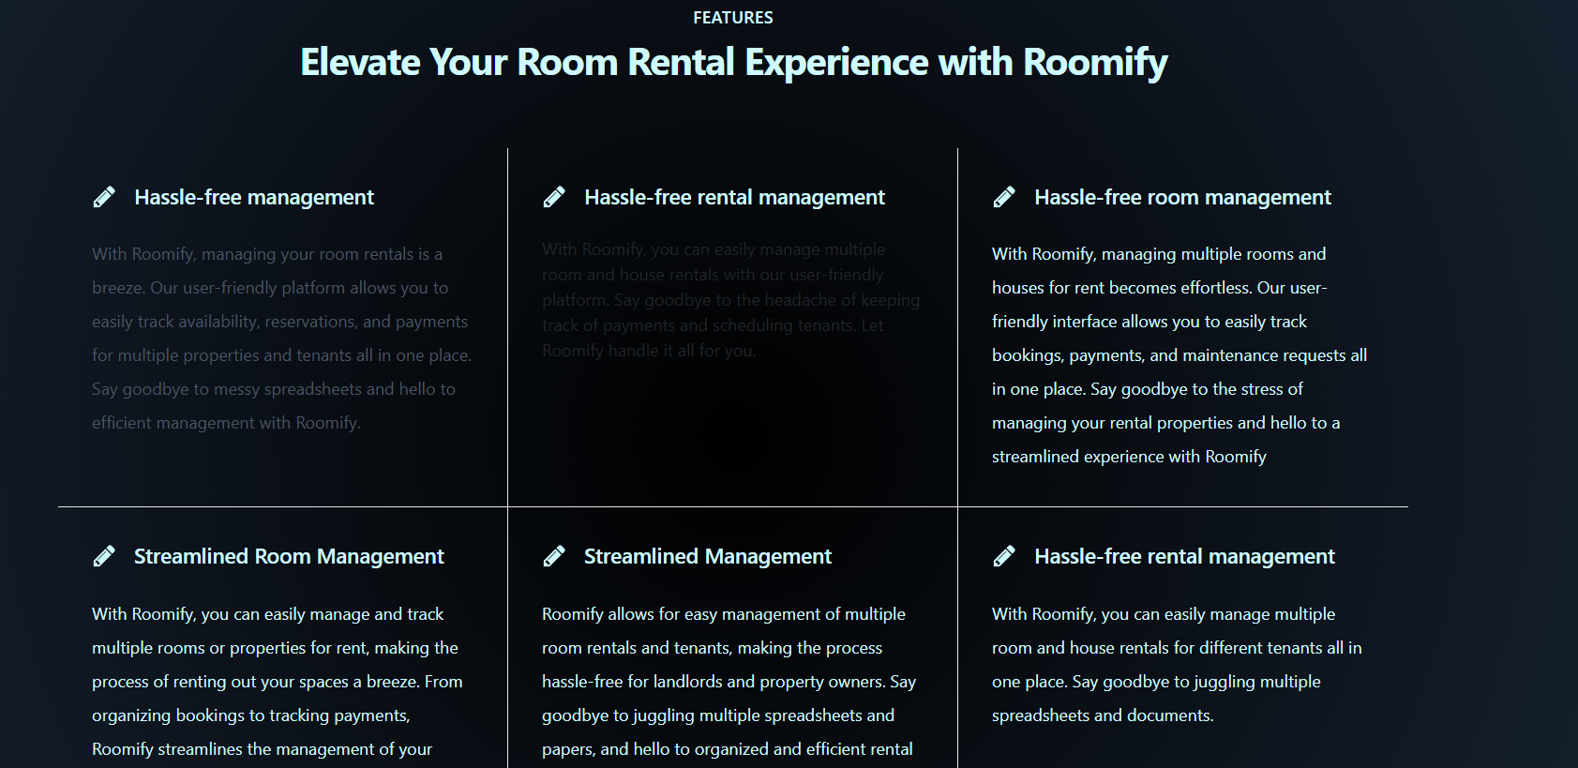

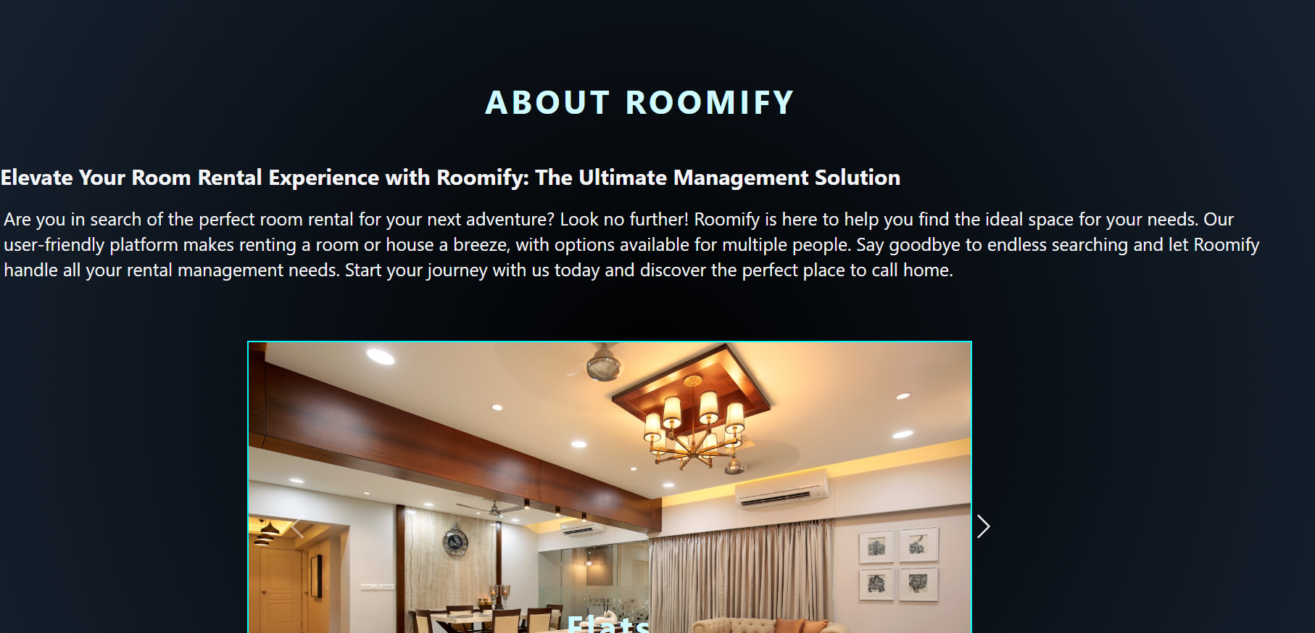

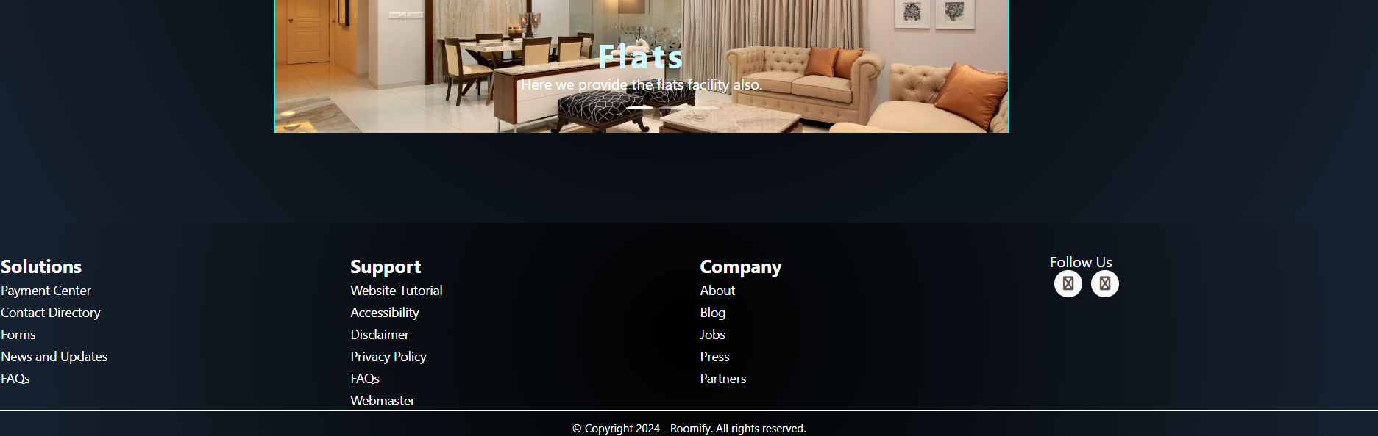

User Login

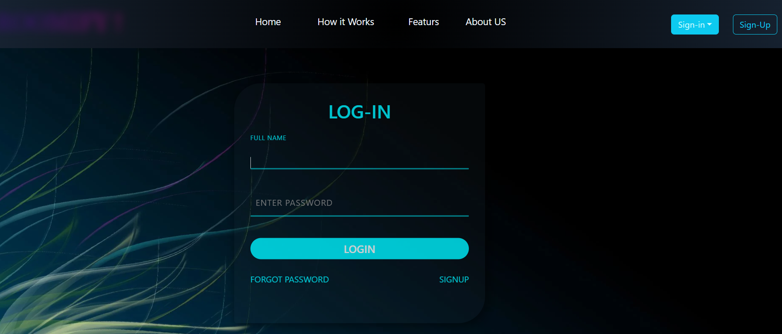

User Signup

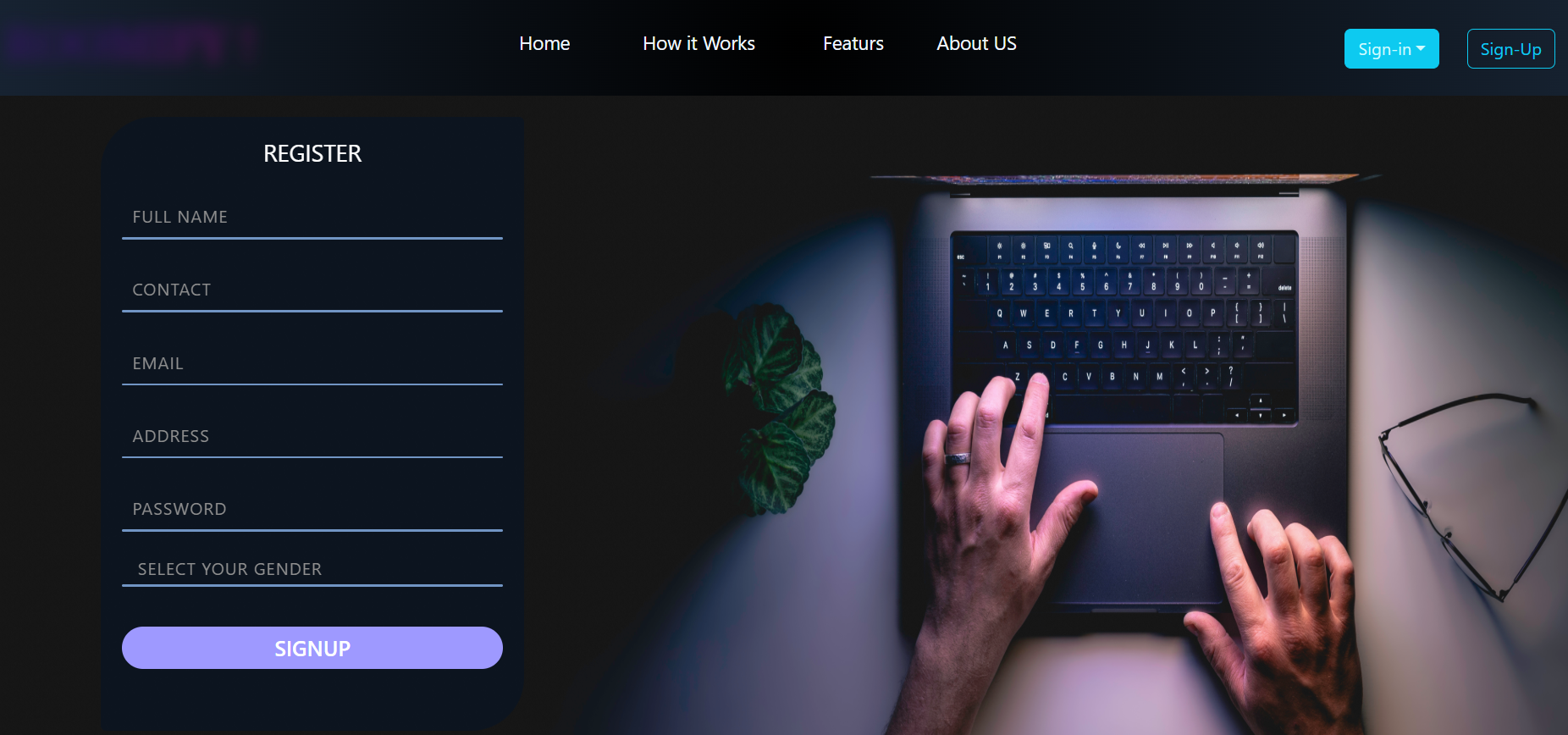

After Login Page

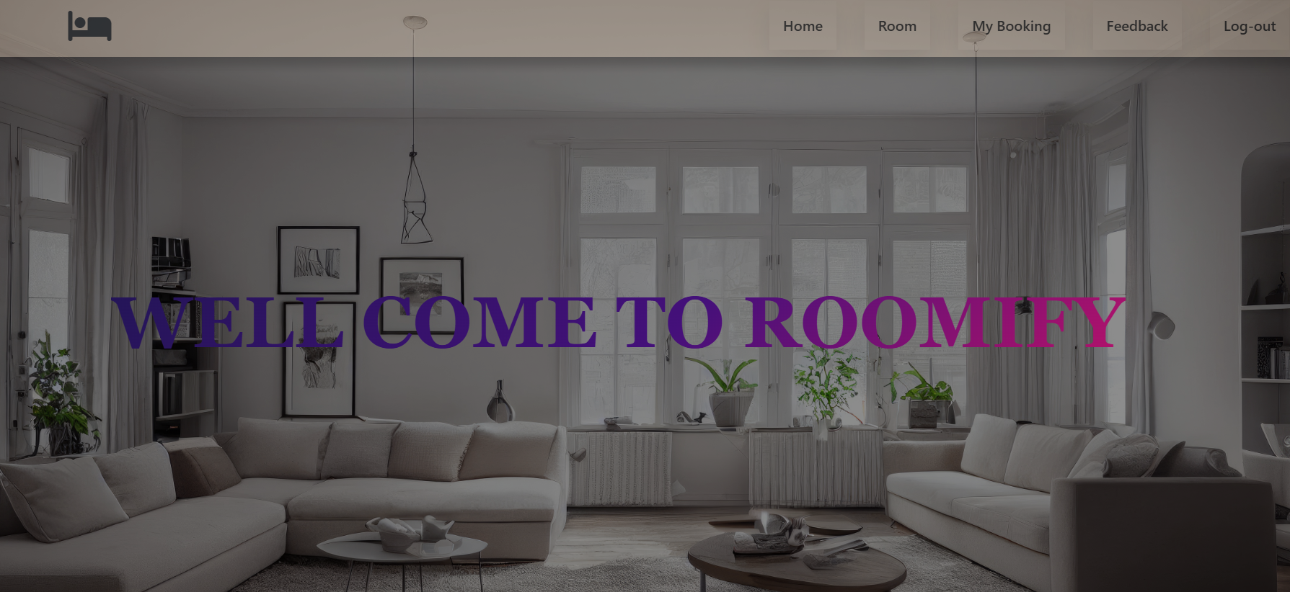

User Rooms Page

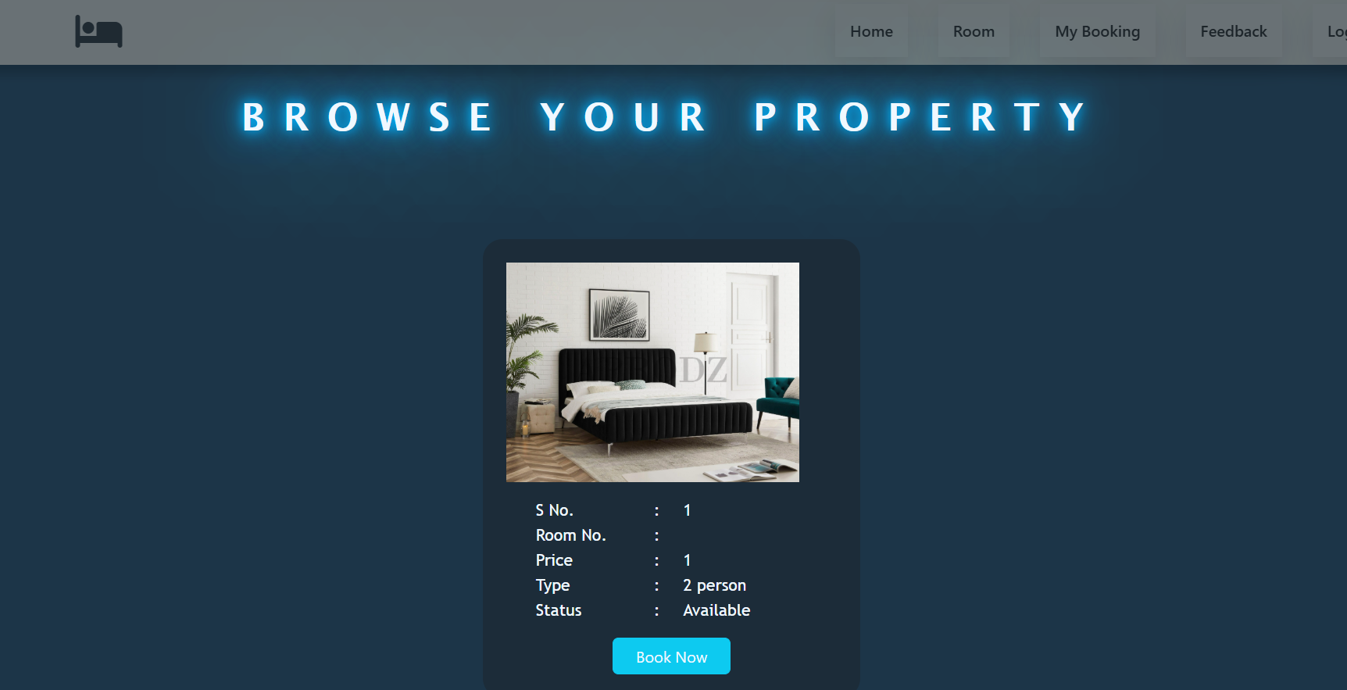

My Bookings

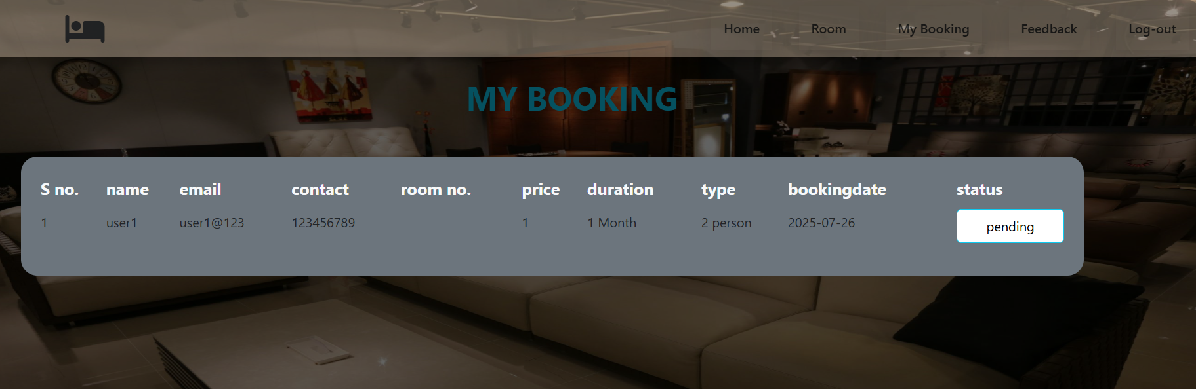

Feedback Page

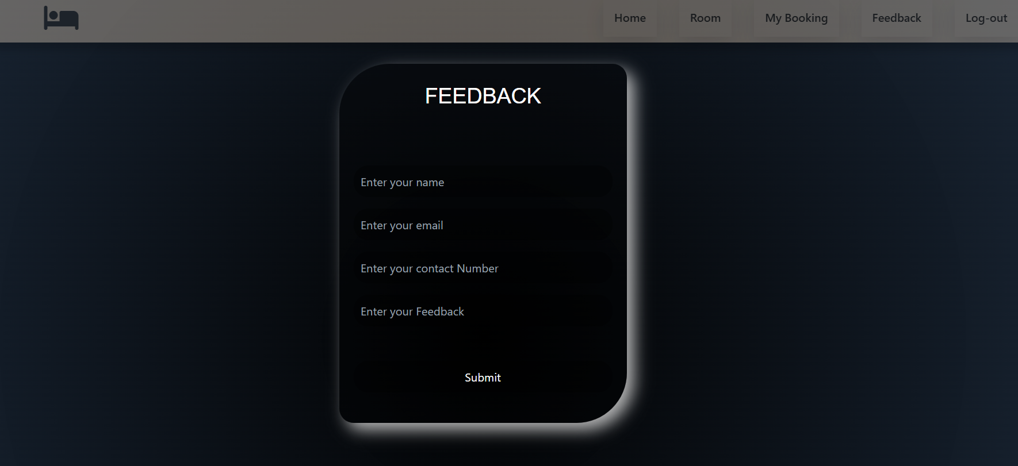

Admin Home

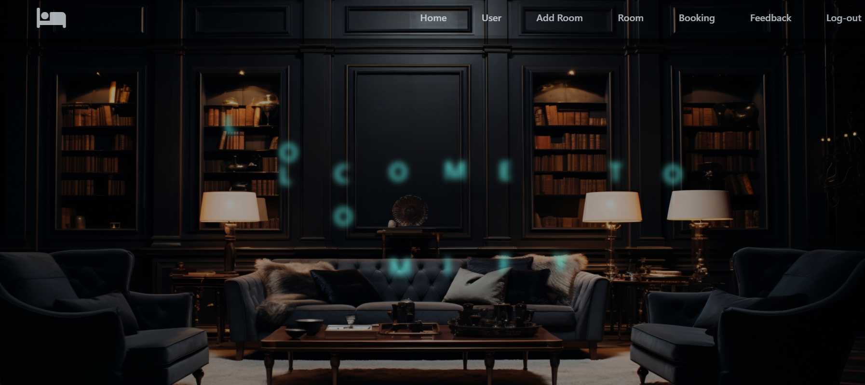

Users Page

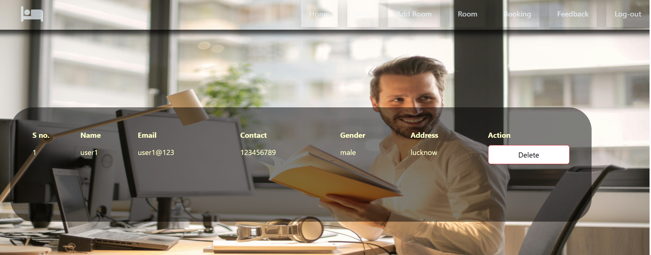

Add a Room

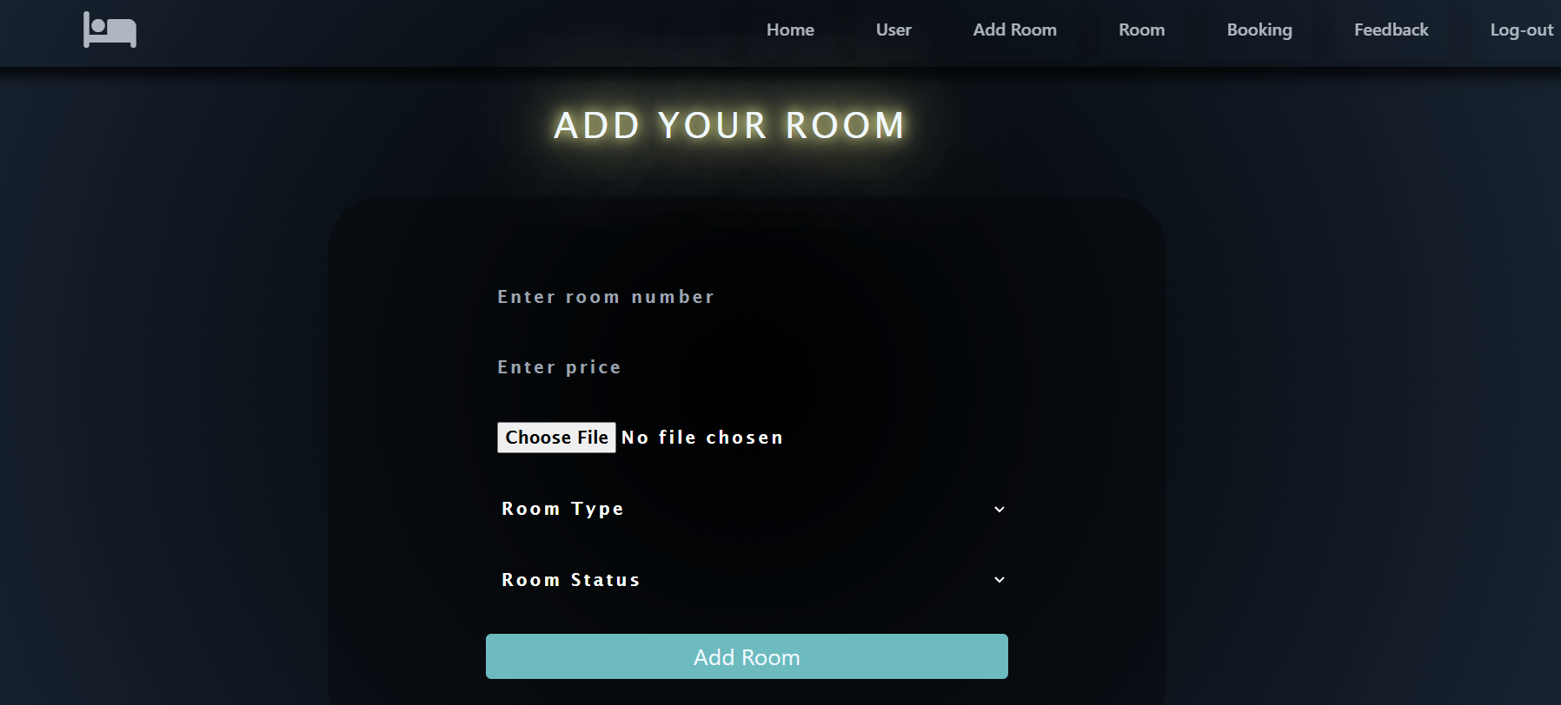

Room Page

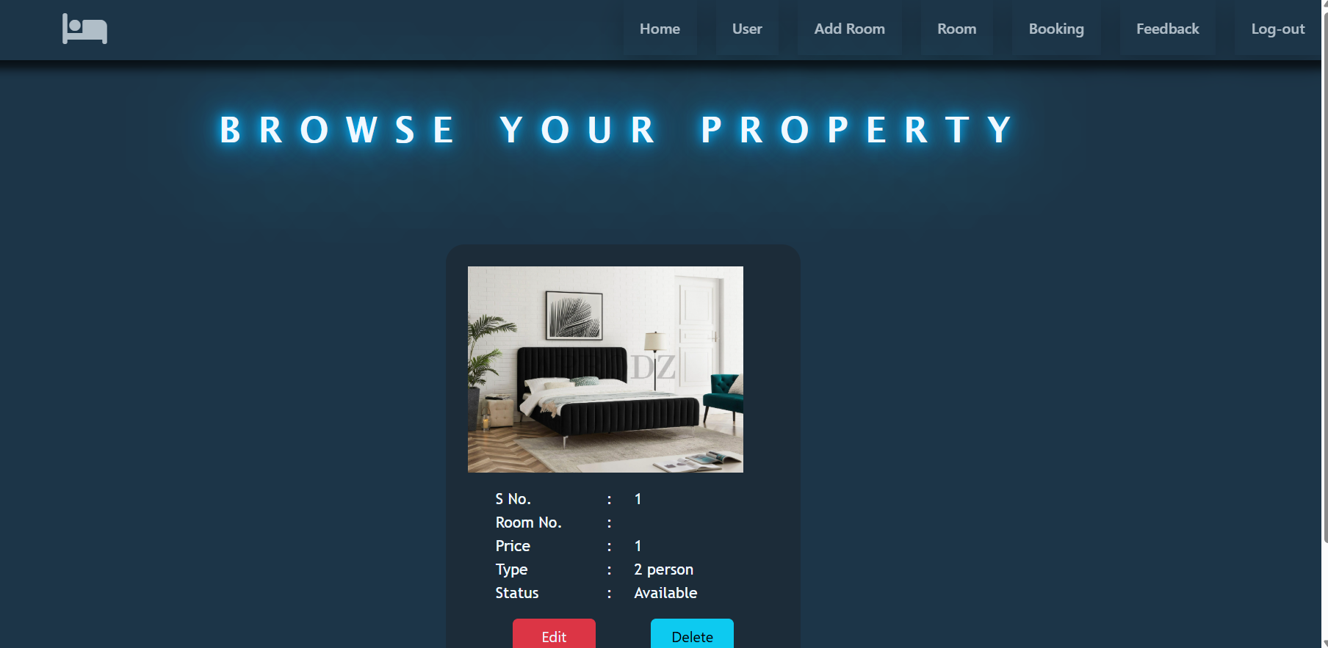

Bookings Page

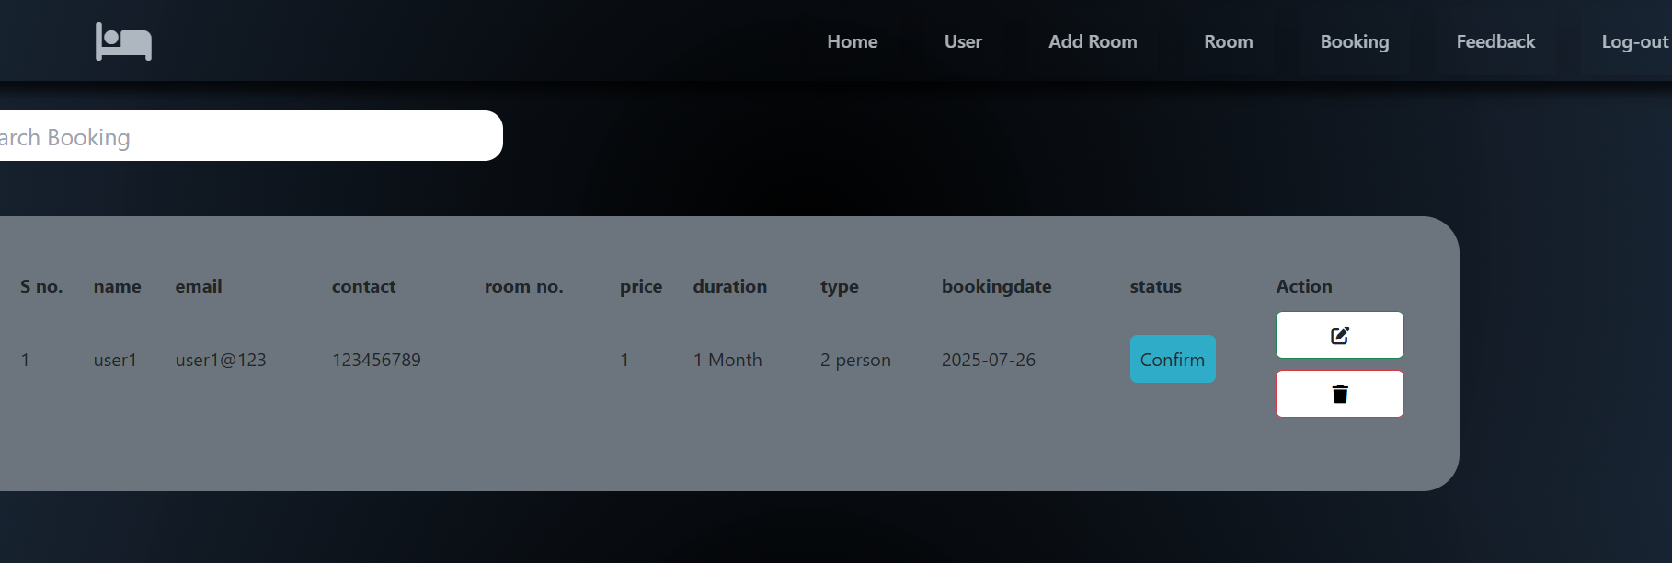

Feedbacks Page

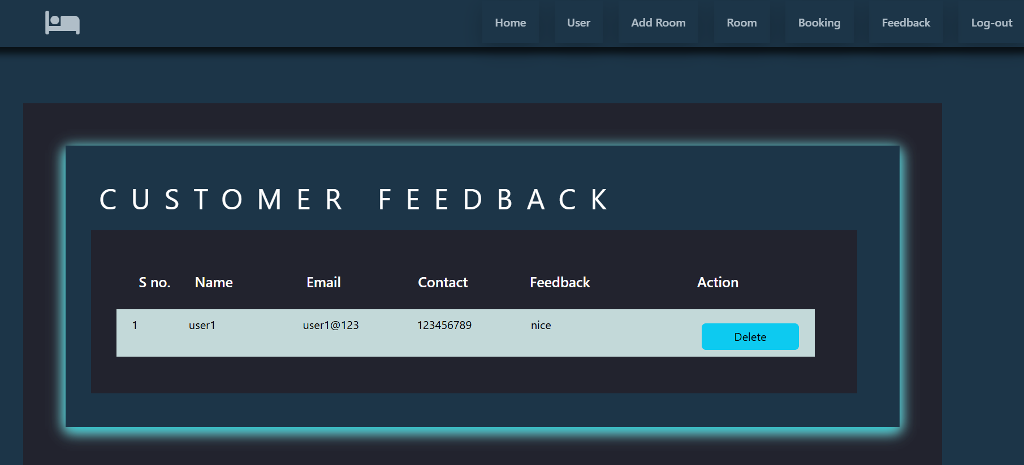

TESTING
- Testing Plan
- Testing Strategy
- Testing Methods
- Test cases and results

Testing:
Generally, it has been specified thought for testing that: “Testing is the critical element of any software quality assurance and represents the ultimate review of specification, design and code generation.” Software testing has a dual function; it is used to establish the presence of defects in program and it is used to help judge whether the program is usable in practice. Thus software testing is used for validation and verification, which ensure that software conforms to its specification and meets the need of the software customer.

Testability
Software Testability is simply how easily a computer program can be tasted. The check list that follows provides a set of characteristics that lead to testable software.
- Operability
- Observables
- Controllability
- Decomposability
- Simplicity
- Stability
- Understandability
The following are the attributes of the Good Test:-
- A good test has a high probability of finding an error.
- A good test is not redundant.
- A good test should be “Best of Breed”.
- A good test would be neither too simple nor too complex.

Compartmentalization:
In this step we divide the project into number of manageable activities and task like
- Selection Module
- System Admin data module
- Dept. Admin data module
- Store and assign rendered module
- Employee data module
- Task creation data module
- Task allocation and reply to data module
- Insert category and password Authority module
- Testing Module
- Documentation Module

Interdependency: Interdependencies of each compartmentalized activity were then found out. Some tasks must occur in sequence while there are many tasks which can occur in parallel.
Software Inspection: Analyze and check system representations such as the requirements document, design, diagrams and the program source code. They may be applied at all stages of process.

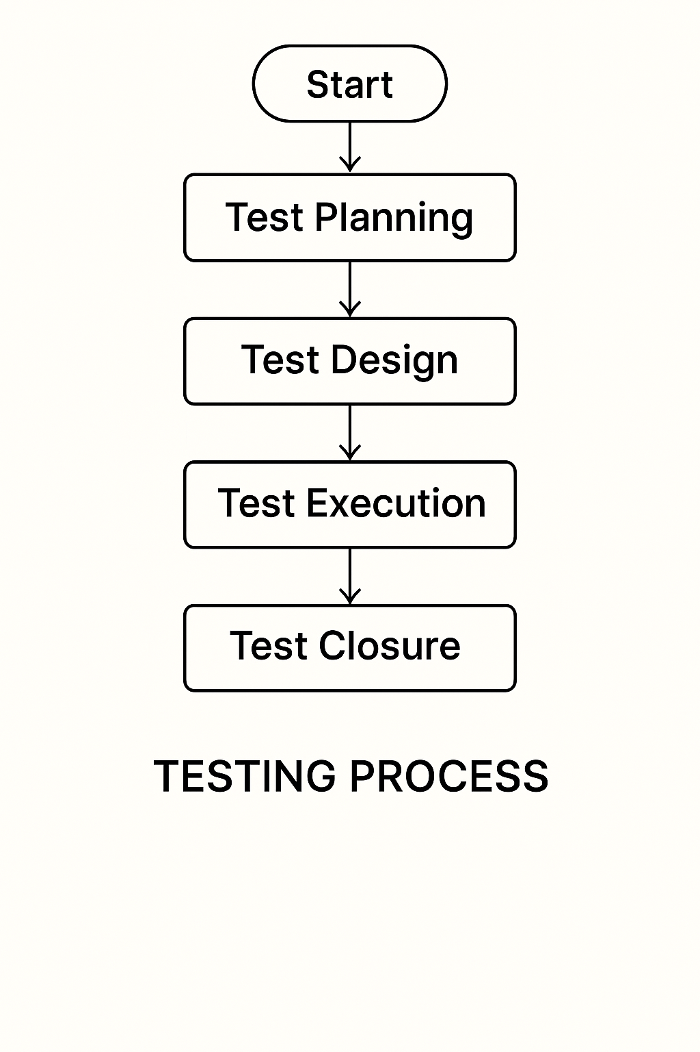

Figure for Testing Process

Test Plan:
The Testing Process: Developer tests the software process activity such as design, implementation and the requirement engineering. Because, design errors are very costly to repair when the system has been started to operate. Therefore, it is quite obvious to repair them at early stage of the system. So, analysis is the most important process of any project.
Requirements Tractability: As most interested portion is whether the system is meeting its requirements or not, for that testing should be planned so that all requirements are individually tested. Developer checked the output of certain combinations of input, which gives desirable results, or not. Strictly stick to our requirements specifications, give you the path to get desirable results from the system.

Tested Items
Our tested items are like:
- Data fetching from the database
- Data insertion, updating and deleting in the database
- Form access to login

Testing Schedule:
Developer has tested each procedure back to back so that errors and omissions can be found as earliest as possible. Once the system has been developed by fully developer tested it on other machines, which differs in configuration.
Testing Methods:
Software testing involves executing an implementation of the software which tests data and examining the outputs of the software and its operational behavior to check that it is performing as required.
Statistical Testing:
Statistical testing is used to test the program’s performance and reliability and to check how it works under operational conditions. Tests are designed to reflect the actual user inputs and their frequency. The stages involved in the static analysis for this system are follows:
Control Flow Analysis:
- Unreachable code
- Unconditional branches into loops
Data Use analysis:
- Variable used before initialization
- Variables declared but never used
- Variables assigned twice but never used between assignments
- Possible array bound violations
- Declared variables

Interface Analysis:
- Parameter type mismatches
- Parameter number mismatches
- Non-usage of the results of function
- Uncalled functions and procedures
Storage Management Faults:
- Data not stored in proper tables
- Data cannot be fetched from proper table
Defect Testing:
Defect testing is intended to find inconsistencies between a program and its specifications. These inconsistencies are usually due to the program faults or defects.
Unit Testing:
The Developer carries out unit testing to check if the particular module or unit of code is working fine. The unit testing comes at the very basic level as it is carried out as and when the unit of the code is developed, or a particular functionality is built. In this application we test one most important module as task allocation which is as follows:
Loop Testing:
The Tester has tested some conditions in a code of application. So, they test the looping in source code of application for finding miss route or any error or wrong direction of flow in code.
Black-Box Testing:
In black box testing or functional testing, the developer is concerned about the output of the module and software, i.e. whether the software gives proper output as per the requirements or not. In another words, this testing aims to test a program behavior against specification without making any reference to the internal structure of the program or the algorithms used.
This can be done in the following way:
- Input Interface
- Processing
- Output Interface
The tested program gets certain inputs. Then the program does its job and generates a certain output, which is collected by a second interface. This result is then compared to the excepted output, which was determined before the test.
Whitebox Testing:
It is also called ‘GLASS BOX’ or ‘STRUCTURAL’ testing. Tester has access to system design.
- Simple Loops
- Nested Loops
- Concatenated Loops
- Unstructured Loops
- Continuous Loops
They can:
- Examine the design document
- View source code
- Individual paths examine
- Logical paths examine one time
- Logical decision on their true and false.
The intention in white-box testing is to ensure that all possible feasible flow of control path through a sub- program is traversed while the software is under tested. This is not the same as saying that all statements in the sub-program will be executed as it is possible for all statements to be executed but for not all of the possible paths to be traversed. However, the converse is true; whether all the possible paths through a sub- program are traversed then all statements in sub-programs will necessarily be executed.
Advantages of White box testing:
- As the knowledge of internal coding structure is prerequisite, it becomes very easy to find out which type of input / data can help in testing the application effectively.
- The other advantage of white box testing is that it helps with optimizing the code.
- It helps in removing the extra lines of code, which can bring in hidden defects.
Structure Testing:
Developer has done his path testing to exercise every independent execution path through a component or program. If every independent path is executed, then all statements in the components must have been executed at least once. The structure of our program is also checked.
Integration Testing:
After our individual modules the Developer tested out Developer go to the integrated to create a complete system. This integration process involves building the system for problems that arise from component interactions. Developer has applied a top-down strategy to validate high-level components of a system before design and implementations have been completed. Because our development process started with high-level components and Developer worked down the component hierarchy.
Performance Testing:
Performance testing is designed to test the runtime performance of the system within the context of the system. These tests Developer performed as module level as developer as system level. Individual modules developers tested for required performance.
Condition Testing:
Condition testing is a test case design method that exercises the logical conditions contained in a program module. If the condition is incorrect, then as least one part of the condition is incorrect. It may include:
- Boolean variable error
- String index out of Bound error
- Null pointer Assignment
- Input Output Connection Exceptions
- Arithmetic expression error
- Parsing (conversion) errors
- Image unloaded errors
Interface Testing:
Interface testing is an integral part of integration testing. Therefore, the developer checked for the following.
- Interface misuse
- Interface misunderstanding
Developer examined the code to be tested and explicitly list each call to an external component. In the system, standards tests for various modules have been performed, which are follows.
Object Testing:
Object testing is to test objects as individual components, which are often larger than single function. Here the following activities have taken place.
- Testing the individual operations associated with object.
- Testing individual object classes.
- Testing cluster of objects.
- Testing object-oriented systems.
Now we will discuss how testing and debugging is done of this application. Our application can be divided into parts like:
- To make queries to database and retrieve information from it.
- Reduce some memory requirements for the database.
- Maintain database so that unauthorized access can not affect.
Limitations
- It can run only on windows servers. It is not compatible with LINUX servers.
- It is not cent percent safe from professional hackers.
- Only registered user can buy and sell their items using this website.
CONCLUSION
The Roomify platform provides a comprehensive digital solution to the common challenges faced in the room rental process. It creates a seamless connection between room seekers—such as students, professionals, and travelers—and room providers—such as landlords, PG owners, and hostel managers—eliminating the need for brokers and manual intervention.
For room seekers, Roomify offers an easy, trustworthy way to search, filter, and book verified accommodations based on preferences like location, rent, and amenities. For room providers, the platform simplifies the listing process, manages inquiries efficiently, and reduces the time required to fill vacant rooms.
By offering features like real-time availability, direct communication, reviews, and secure booking options, Roomify increases transparency, convenience, and trust in the renting experience.
In conclusion, Roomify not only modernizes the traditional room rental process but also empowers both parties with tools that save time, reduce cost, and improve the quality of the rental experience—making it an essential platform for today’s fast-moving, digitally-driven world

FUTURE SCOPE OF THE PROJECT
As the demand for rental accommodation continues to grow, especially among students, migrants, the Roomify platform holds great potential for expansion and innovation. The following future enhancements can significantly boost its usability, reach, and value for both room seekers and providers:
1. Mobile Application Development
- Launching dedicated Android and iOS apps to allow users to browse, book, and manage listings on the go with push notifications and real-time chat.
2. AI-Based Room Recommendations
- Integrating machine learning to offer personalized room suggestions based on user behavior, preferences, search history, and location trends.
3. Multi-City & International Expansion
- Expanding Roomify to support listings across multiple cities, and eventually across countries, with multilingual support and currency conversion.
4. Virtual Room Tours
- Allowing providers to upload 360-degree photos or video tours, enabling seekers to explore rooms virtually without physical visits.
5. KYC & Tenant Verification
- Adding optional identity verification for seekers and document upload features for providers to build trust and improve safety.
6. Advanced Booking & Payment Integration
- Enabling online payments, booking deposits, or security fees, along with auto-generated rent receipts and booking confirmation.
7. Rating & Dispute Resolution System
- Expanding the review system and adding support for reporting issues or disputes between seekers and providers through the platform.
8. PG/Hostel Chain & Agent Integration
- Partnering with PG networks, hostel chains, or verified agents to onboard bulk listings and expand the provider base.
9. Smart Analytics Dashboard
- Giving room providers and admins analytics like views, inquiries, booking trends, and vacancy rates to optimize listings and pricing.

BIBLIOGRAPHY
Reference Book:
- Head First JAVASCRIPT with MERN & MONGODB- By Lynn Beighley & Michael Morrison, The Complete Reference- JAVASCRIPT- with MERN (Dwight Merriman, Eliot Horowitz, and Kevin Ryan).
Reference websites:
- www.youtube.com
- www.w3schools.com
- www.javatpoints.edu

