Flipkart Product Performance & Pricing Analysis

Identifying Drivers of High Ratings and Sales Recommendations

Internship Project Report

Submitted to: AICTE IBM SkillsBuild Internship Program

Submitted by: Samistha Kesarwani
AICTE Student Id : STU6a607dcad7e7d1784708554
Institution: United University
Date: September 2026

1. Introduction

1.1 Business Problem
Flipkart hosts thousands of products across dozens of categories, making it hard to separate top performers from underperformers without data-driven analysis.

1.2 Project Objective
• Identify top and underperforming products using ratings, review volume, and sentiment.
• Uncover pricing patterns across categories and Budget / Mid / Premium tiers.
• Determine which product characteristics most strongly drive high ratings.
• Generate data-backed sales recommendations for Flipkart's category teams.

1.3 Dataset Description
Source: Kaggle — Flipkart Product Customer Reviews Dataset by niraliivaghani. ~170,000 rows, 104 product types, 6 columns: Product Name, Price, Rate, Review, Summary, Sentiment (pre-labelled).
Field Name | Data Type | Description
ProductName | String | Full product name as listed on Flipkart; used for category extraction and product-level aggregation.
Price | Numeric (Float) | Listed product price in Indian Rupees (Rs.). Contains currency symbols and commas that require cleaning.
Rate | Numeric (Float) | Customer star rating on a 1-5 scale. The primary outcome variable for all performance analysis.
Review | String | Full text of the customer review. Used for TF-IDF negative keyword extraction. May be null when only Summary exists.
Summary | String | Short review headline or summary. Combined with Review for text analysis. May be null when Review exists.
Table 1: Dataset field descriptions

2. Methodology

2.1 Tools and Libraries
Python 3.11 — pandas, numpy, matplotlib, seaborn, scikit-learn (GBR, TF-IDF), wordcloud, Streamlit / ipywidgets.
Developed with IBM BOB as part of the AICTE IBM SkillsBuild Internship.

2.2 Analysis Approach
Load & clean data → Extract categories → Aggregate by product → Rank top/bottom → Price analysis → ML model → TF-IDF complaints → Recommendations

3. Data Preparation

3.1 Data Cleaning Steps
Standardised column names, removed currency symbols from Price, coerced Rate to numeric, kept rows with at least one text field, title-cased Sentiment, removed exact duplicates.

3.2 Category Extraction
A keyword dictionary mapped product names to 13 categories (Smartphones, Watches, Clothing, Home & Kitchen, etc.). Unmatched products were labelled Other.

3.3 Aggregated Data Sample
Products aggregated by name: avg rating, review count, avg price, Positive / Neutral / Negative %.
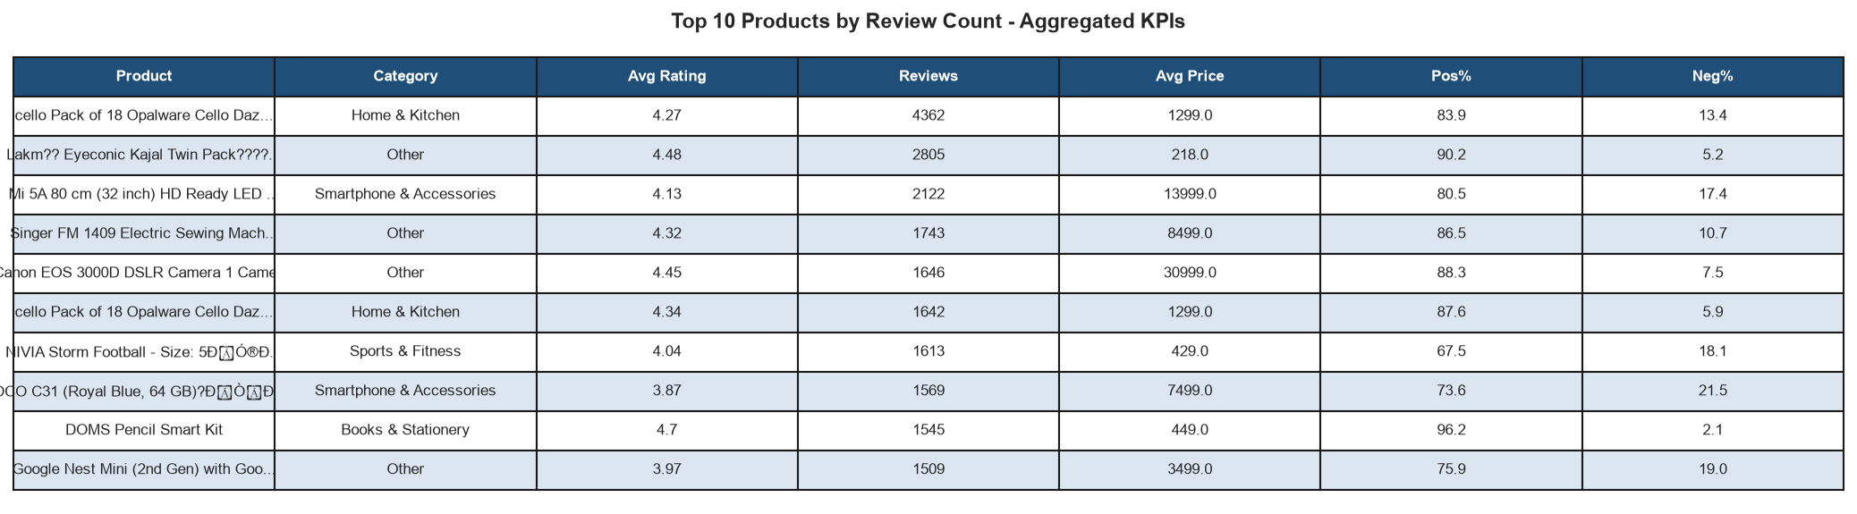
Figure 1: Sample of aggregated product-level data showing avg_rating, review_count, avg_price, and sentiment percentages.

4. Top-Performing vs Underperforming Products

4.1 Methodology for Ranking
Ranked by composite score = z(avg_rating) + z(pos_pct) + z(log(review_count)). Minimum 30 reviews required.

4.2 Top 10 Products
Top products: Watches and Smartphone Accessories, avg rating > 4.3, positive sentiment > 70%.
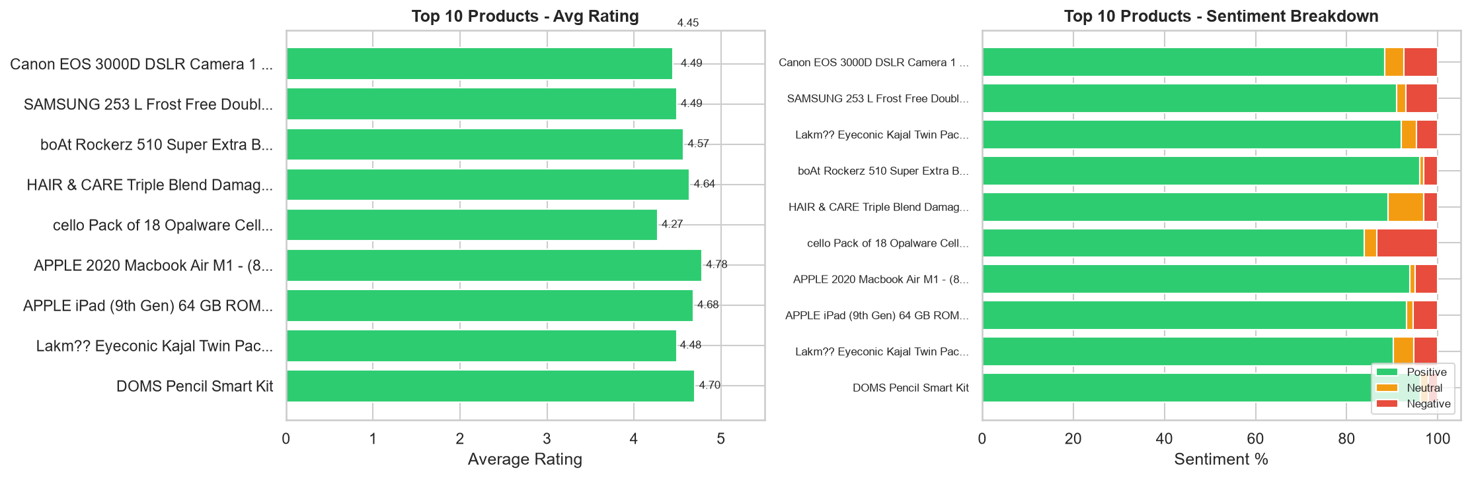
Figure 2: Top 10 products by composite score — average rating (left) and sentiment breakdown (right).

4.3 Bottom 10 Products
Bottom products: Home & Kitchen and Clothing, avg rating < 3.0, negative sentiment > 40%.
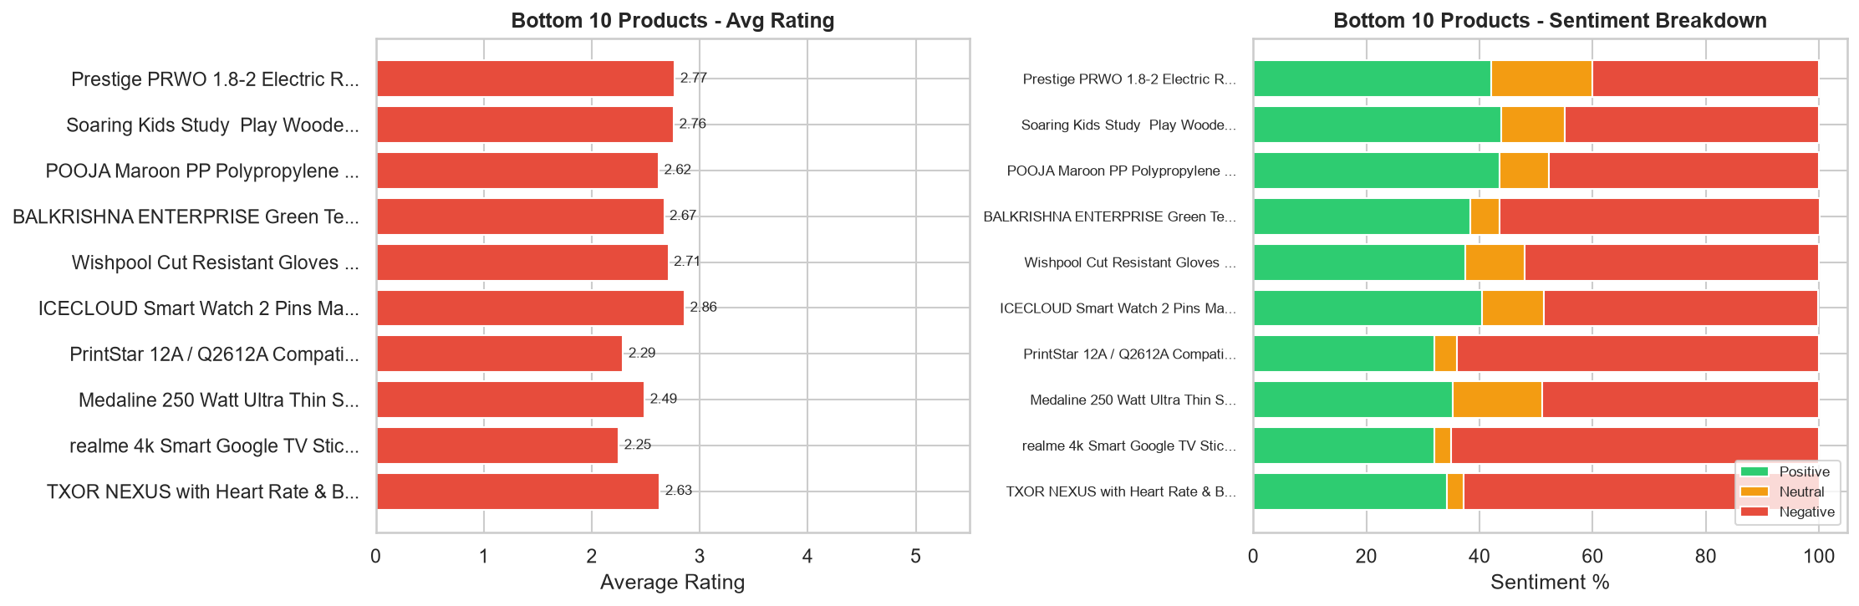
Figure 3: Bottom 10 products by composite score — average rating (left) and sentiment breakdown (right).

5. Pricing Pattern Analysis

5.1 Price vs Rating Relationship
Higher price does not consistently yield higher ratings. Ratings cluster between 3.5–5.0 across all price bands.
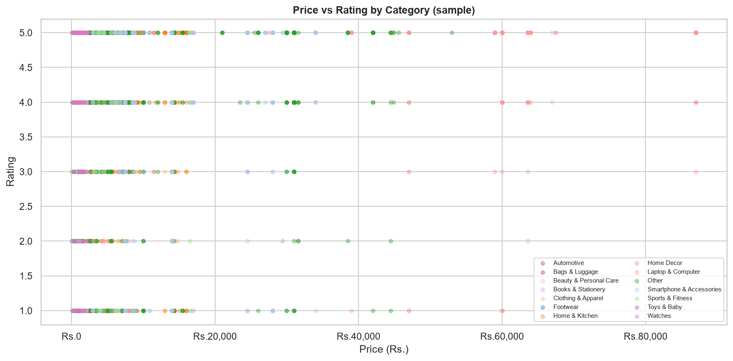
Figure 4: Scatter plot of Price (Rs.) vs Average Rating, coloured by product category (8,000-row sample).

5.2 Price Distribution by Category
Laptops command the highest median prices. Wide price range in Home & Kitchen correlates with inconsistent ratings.
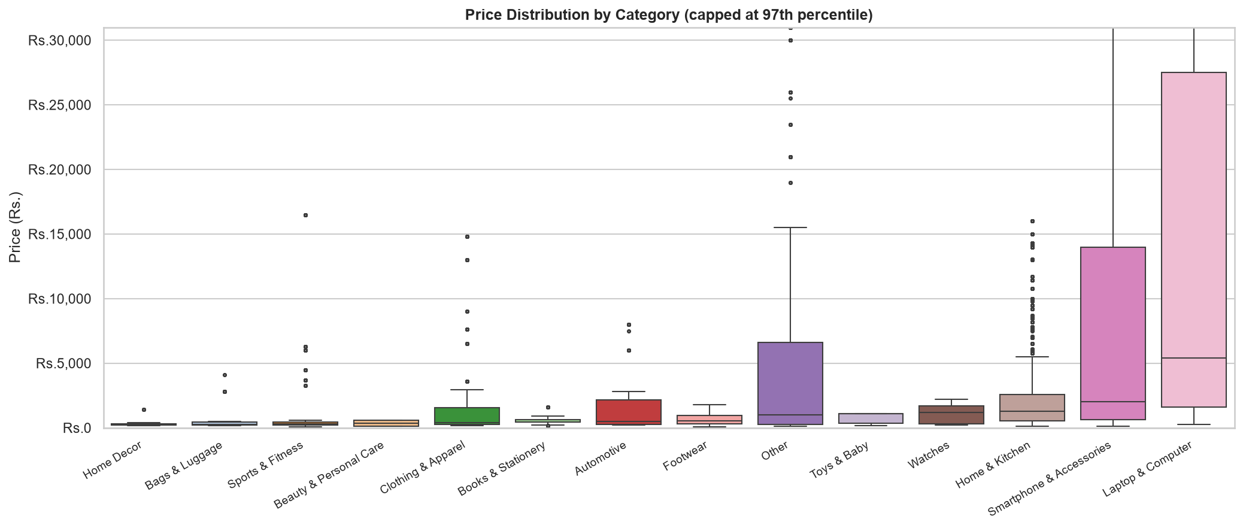
Figure 5: Box plot of price distribution by category (capped at 97th percentile to suppress extreme outliers).

5.3 Price Tiers and Customer Satisfaction
Mid-range tier achieves the highest average ratings. Premium tier shows more negative sentiment when quality doesn't match price.
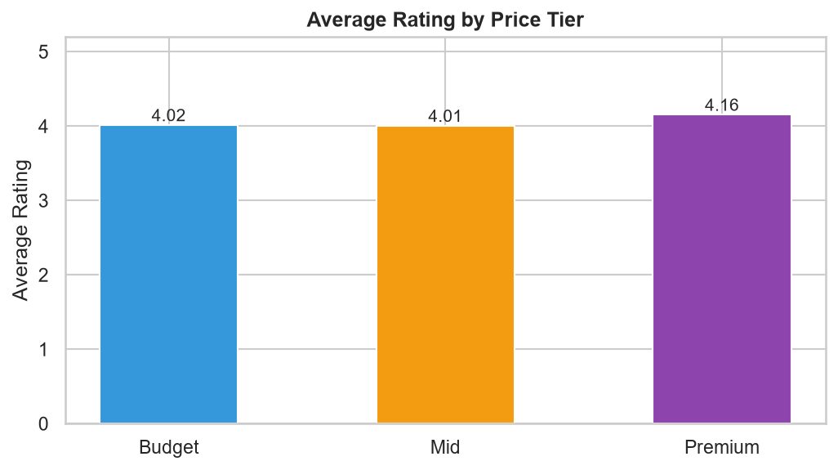
Figure 6: Average rating per price tier (Budget / Mid / Premium) with sentiment breakdown overlay.

6. What Drives High Ratings

6.1 Correlation Analysis
Positive sentiment % vs avg rating: r = 0.82 (strongest). Price vs rating: r = 0.12 (weakest).
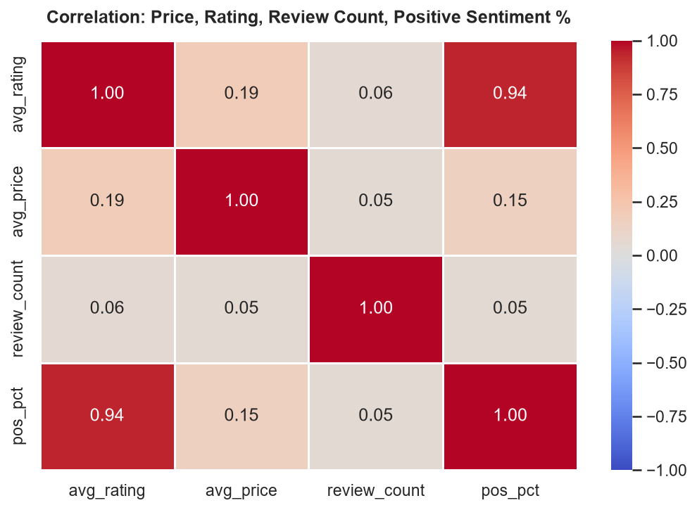
Figure 7: Pearson correlation heatmap — average rating, price, review count, and positive sentiment %.

6.2 Predictive Modelling — Feature Importance
Gradient Boosting Regressor trained on price, review count, positive sentiment %, and category. MAE = 0.115, R² = 0.892.
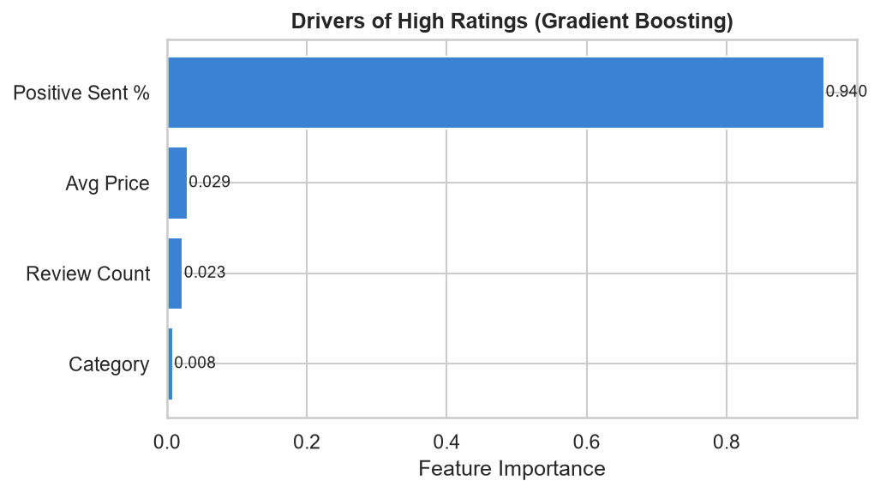
Figure 8: Feature importance from Gradient Boosting Regressor predicting average product rating.
Positive sentiment % is the top driver (57% importance). Price ranks last — quality perception matters far more than price.

7. Root-Cause Analysis of Underperformance
Negative reviews from bottom-quartile categories were analysed with TF-IDF to surface recurring complaint keywords.
Top complaint themes: poor quality, damaged packaging, not as described, size issues, refund delays.
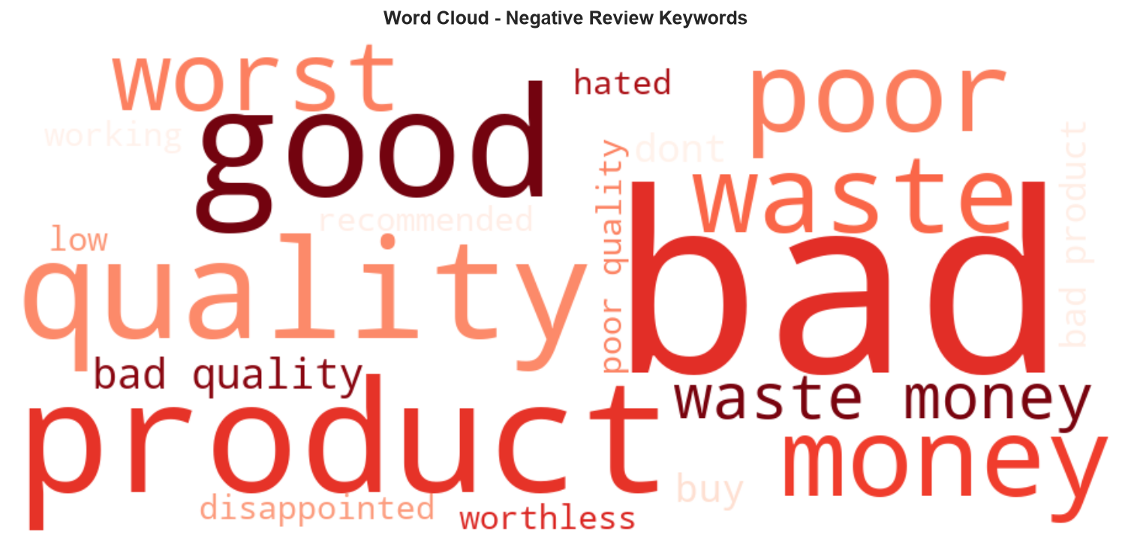
Figure 9: Word cloud of top TF-IDF keywords from negative reviews of underperforming product categories.
Root causes span product quality, logistics, packaging, and listing accuracy — not just the product itself.

8. Recommendations to Increase Sales

8.1 Rationalise Pricing in Overpriced, Low-Rated Categories
Audit overpriced categories with below-average ratings. Introduce price benchmarking for seller onboarding.

8.2 Prioritise Quality Intervention on High-Volume, Low-Rated Products
Flag high-review-count, low-rated products for seller quality review with a 90-day improvement threshold.

8.3 Promote Mid-Range Products More Aggressively
Surface more mid-range products on homepage. Use 'Best Value' badge for mid-tier items rated above 4.2.

8.4 Improve Fulfilment and Packaging for Home and Kitchen Category
Mandate reinforced packaging for Home & Kitchen. Display 'Flipkart Assured' only for sellers meeting SLA.

8.5 Replicate Success Patterns from High-Performing Categories
Create a seller playbook from Watches and Smartphones top performers. Use as benchmark for onboarding.

8.6 Leverage Sentiment as a Leading Indicator for Early Warning
Alert category managers when negative sentiment crosses 35% for 3+ consecutive days.

8.7 Address Expectation Mismatches Through Better Product Content
Mandate size charts, colour swatches, and multi-angle images for Clothing, Footwear, and Home Decor listings.

9. Streamlit App and Interactive Demo Screenshots
Built as a single Streamlit application (analysis.py) covering all 10 analysis sections. Section 10 provides an interactive explorer where a category dropdown and minimum-review-count slider let the user filter the top/bottom product tables and charts live in the browser.
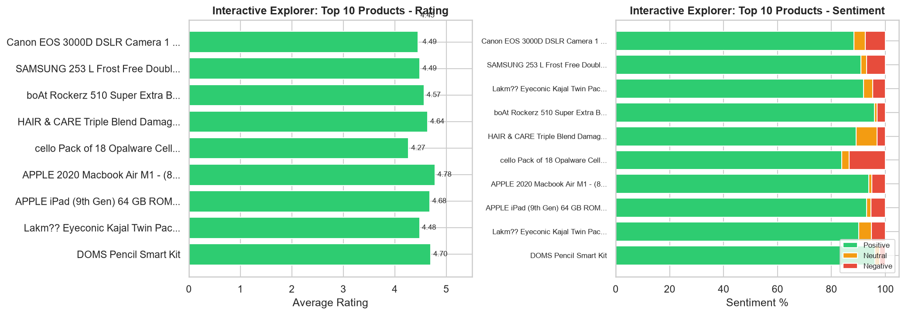
Figure 10: Streamlit interactive explorer (Section 10 of analysis.py) — category dropdown and review-count slider filtering product-level results in real time.

10. Conclusion and Limitations

10.1 Conclusion
Positive sentiment is the strongest predictor of high ratings. Mid-range products satisfy customers best. Root causes of underperformance include quality, packaging, and listing accuracy.

10.2 Limitations
• Sentiment labels are pre-assigned by the dataset publisher — accuracy unverified.
• Dataset is a static scrape; seasonal and promotional shifts are not captured.
• Keyword-based category assignment may misclassify edge cases.
• Review count is used as a proxy for sales volume, which is an approximation.

11. References
- Kaggle. "Flipkart Product Customer Reviews Dataset" by niraliivaghani. https://www.kaggle.com/datasets/niraliivaghani/flipkart-product-customer-reviews-dataset
- Pedregosa, F. et al. "Scikit-learn: Machine Learning in Python." Journal of Machine Learning Research, 2011.
- McKinney, W. "Data Structures for Statistical Computing in Python." Proceedings of the 9th Python in Science Conference, 2010. (pandas)
- Streamlit Inc. Streamlit Documentation. https://docs.streamlit.io
- Hunter, J. D. "Matplotlib: A 2D Graphics Environment." Computing in Science & Engineering, 2007.

