Final Project

Sentiment Analysis of Restaurant Reviews from Yelp

Harsh Patil - hpp6869@rit.edu

Samita Pradhan - sap1009@rit.edu

For the final project submission, we have three java files, SentimentAnalysisHelper.java, SentimentAnalysis.java and WordScore.java. We also developed an Android application, which worked similar to the desktop application. Using Android, we could improve the user interaction and provide additional features to the users.

We have two folders in this submission one for the desktop app named ‘Sentiment’ and another ‘KPT’ which represent the android application source file. Apart from these, we also included the presentation slides.

# System Design

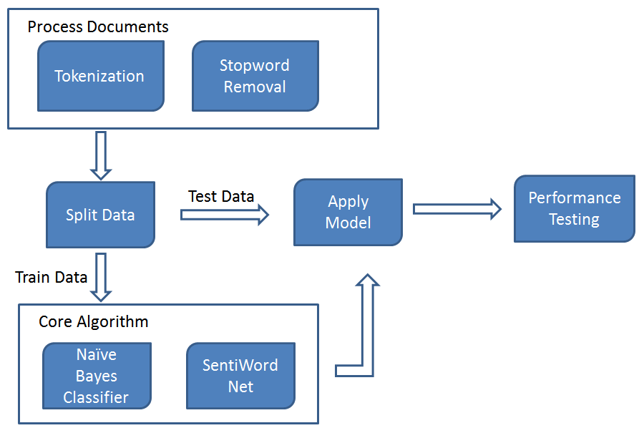

# Accuracy

* We use 90-10 split for our training and testing data from a total of 4400 records
* Gives an accuracy of 77.25% (previous was 72 before improvements)
* The algorithm correctly classifies 309 out of 400 test reviews