Stage 2 Phase B: Two-Node FedAvg Simulation
Two simulated nodes with laptop-side weight aggregation
Generated 2026-10-24 16:12
WARNING: GENERATED FROM SIMULATED / TEST DATA (pipeline test). Do not use any number in the thesis or paper.

1. Method
The development training split was divided into two disjoint, stratified partitions. Both nodes started each round from the same global neural-network weights, trained locally, and returned weights to a laptop-side aggregator. The aggregator computed a sample-count-weighted FedAvg update. This run is an in-process simulation and does not use MQTT.
Property | Value
Nodes | 2
Rounds | 5
Local epochs per round | 3
Node 1 rows | 2000
Node 2 rows | 2000
Round | Global precision | Global recall | Global F1 | Global ROC-AUC
1 | 0.2259 | 0.9375 | 0.3641 | 0.9010
2 | 0.3122 | 0.9250 | 0.4669 | 0.9229
3 | 0.3695 | 0.9375 | 0.5300 | 0.9409
4 | 0.4444 | 0.9500 | 0.6056 | 0.9536
5 | 0.4720 | 0.9500 | 0.6307 | 0.9614
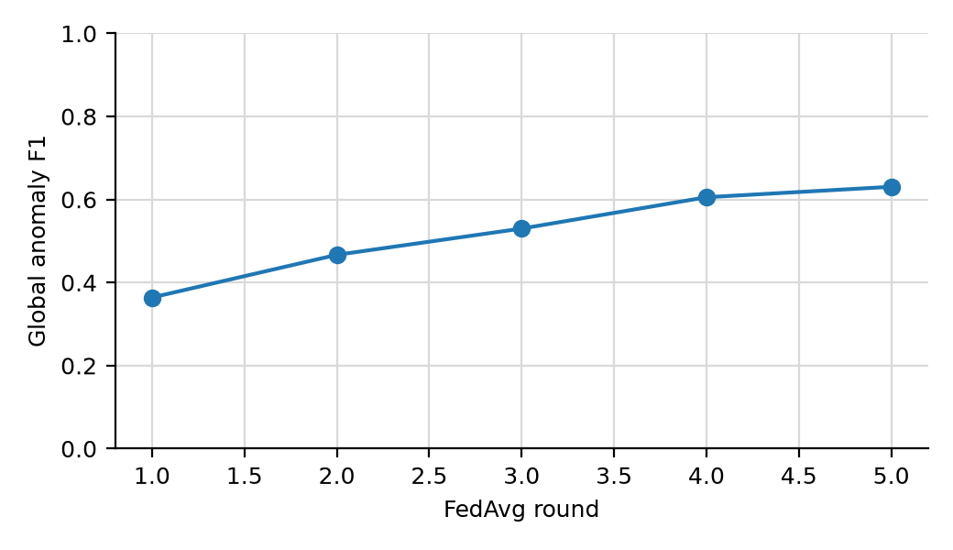
Global anomaly F1 over two-node FedAvg rounds.

2. Interpretation limit
This report validates two-node weight averaging, not wireless federation. The labels are synthetic and the nodes run in one Python process. MQTT latency, message loss, and ESP32 inference are not measured here.

