Stage 2 Energy-Aware Policy Check
Physical node telemetry with simulated battery level
Generated 2026-10-24 22:45

1. Scope
This report checks mode-dependent sample intervals and confidence-indicator PWM caps using node telemetry. The firmware battery percentage is randomly simulated; no battery voltage, current, or energy consumption was measured.
Node | Rows | Duration (s) | Median interval (ms) | Battery start/end (%) | LDR10 range
1 | 50 | 548.0 | 14996 | 79/0 | 339–726
2 | 51 | 821.4 | 14998 | 79/0 | 301–330
Node | Mode | Rows | Battery range (%) | PWM max/cap | Cap pass (%) | Interval expected/observed (ms)
1 | NORMAL | 10 | 61–79 | 218/255 | 100.0 | 2000/2000.257
1 | ECO | 7 | 26–57 | 128/128 | 100.0 | 5000/5000.841
1 | CRITICAL | 33 | 0–4 | 0/0 | 100.0 | 15000/15000.032
2 | NORMAL | 7 | 65–79 | 222/255 | 100.0 | 2000/2000.7939999999999
2 | ECO | 11 | 21–59 | 128/128 | 100.0 | 5000/5000.138
2 | CRITICAL | 33 | 0–3 | 0/0 | 100.0 | 15000/14999.91
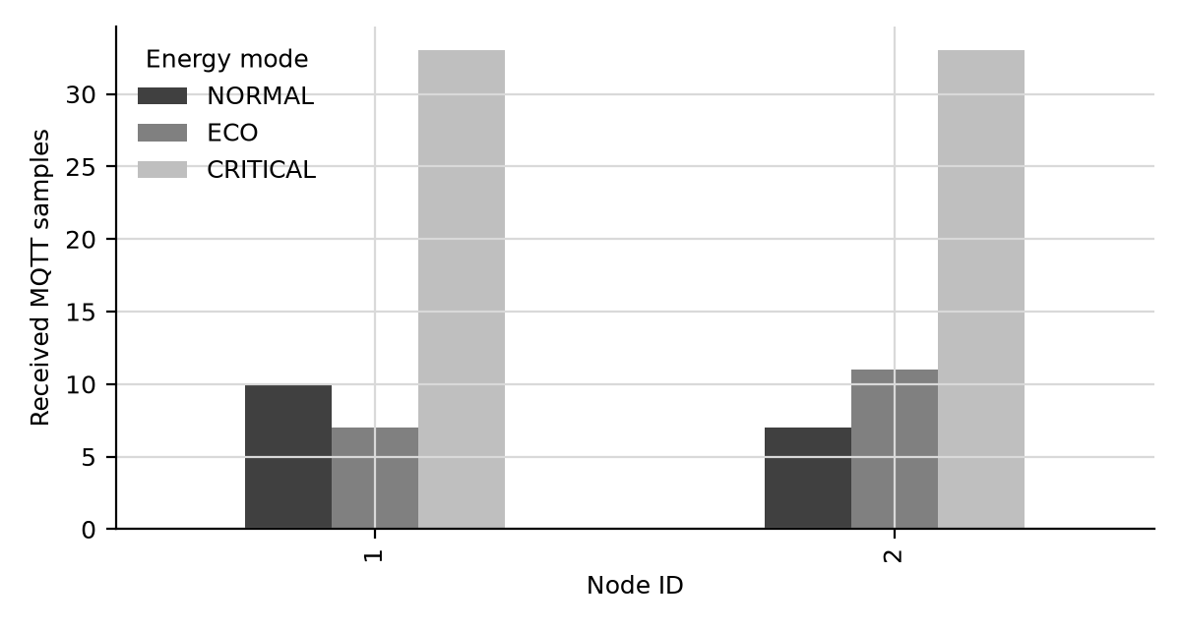
Received MQTT samples per node and simulated energy mode.

2. Interpretation
Passing these checks demonstrates the firmware's simulated energy policy only. It does not demonstrate battery life, measured energy savings, or performance under a physical low-voltage condition.

