Step S1.1 Report: Synthetic Smart-Lighting Dataset
TinyFL / Stage 1, from-scratch rebuild on the ESP32-S3 rig
Generated 2026-10-10 18:59

1. Purpose
No labelled dataset linking PIR, LDR, temperature and humidity readings to a suitable LED brightness exists, so a physics-inspired synthetic dataset is generated. It is the single starting point for model training (S1.2), C export (S1.3) and on-device benchmarking (S1.4). The generator is deterministic (seed 42) so every number in later reports can be reproduced.

2. Generation method
Each sample draws a true room state, derives the target brightness from lighting heuristics, and then produces noisy sensor features, so the model must learn to see through realistic sensor error.
Item | Definition
Occupancy | Bernoulli(0.5)
Ambient light | LDR ~ Uniform(0, 1023) (10-bit scale used by the model)
Temperature / humidity | Uniform(15, 35) C / Uniform(30, 80) %
Daylight harvesting | day = clip((700 - LDR) / 400, 0, 1): full output at LDR <= 300, off at LDR >= 700
Comfort term | 255 x (0.003 x (T - 25) + 0.0015 x (RH - 55)): warm/humid rooms are lit slightly less
Target PWM | 0 if unoccupied, else 255 x day - comfort; plus N(0, 3^2); clipped 0-255; rounded
Sensor noise | LDR N(0, 10^2); T N(0, 0.5^2); RH N(0, 2^2); PIR flipped with probability 2%
Quantisation | Temperature and humidity rounded to integers (the rig uses a DHT11)
Table 1. Generator definition. All coefficients are modelling assumptions, not measured values.

3. Dataset summary
Column | Mean | SD | Min | Max
pir | 0.50 | 0.50 | 0 | 1
ldr | 514.58 | 295.53 | 0 | 1023
temp | 25.04 | 5.79 | 15 | 35
hum | 55.07 | 14.51 | 30 | 80
pwm | 61.74 | 97.39 | 0 | 255
Table 2. Descriptive statistics, n = 10000 (SHA-256 prefix 959d43ae16e6579b).
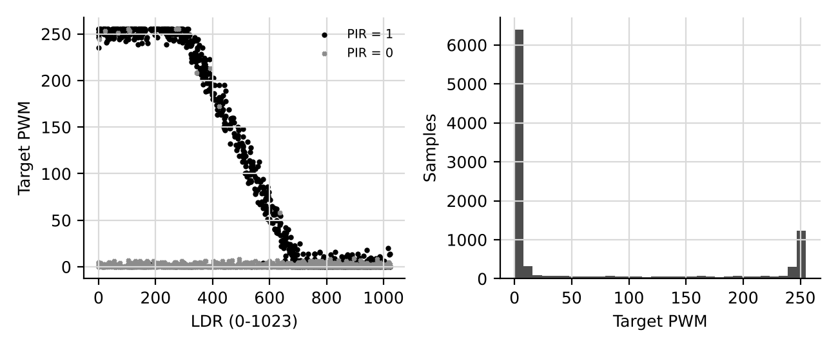
Figure 1. Left: target PWM versus LDR (800 samples per PIR state). Right: target distribution.
50.1% of samples have PIR = 1. 37.7% of targets are 0 (lights off) and 7.7% are 255 (full brightness); the remainder is the daylight-harvesting ramp. Pearson correlation with the target: pir +0.60, ldr -0.52, temp -0.01, hum -0.03.

4. Data integrity checks
Check | Result | Evidence
No missing values | PASS | 0 missing
PIR binary | PASS | values 0,1
LDR within 0-1023 | PASS | 0-1023
Temperature within 15-35 C | PASS | 15-35
Humidity within 30-80 % | PASS | 30-80
Target within 0-255 | PASS | 0-255
Table 3. Automated integrity checks.

5. Limitations
The target function is a designed rule set, so a model that scores highly has learned the rules, not real occupant preference. The coefficients and noise levels are assumptions. Real-sensor validation (S1.5 and S1.6) is what tests whether the synthetic ranges and the 300/700 LDR thresholds hold on the actual prototype.

6. Draft text for the thesis
A synthetic dataset of 10,000 samples was generated with a fixed random seed. Occupancy, ambient light, temperature and humidity were sampled uniformly over the ranges of the target environment, and the target PWM was computed from occupancy-based and daylight-harvesting rules with a small temperature/humidity comfort adjustment. Gaussian sensor noise, a 2% PIR error rate and DHT11 integer quantisation were then applied to the features.

