Step S1.2 Report: Model Training and Comparison
TinyFL / Stage 1, regression of LED PWM from PIR, LDR, temperature and humidity
Generated 2026-10-10 19:00

1. Purpose
Compare candidate regressors on the S1.1 dataset with evidence rather than assumption, and fix the model that will be exported to C for the ESP32-S3.

2. Method
The dataset (S1.1) was split 80/20 at random with seed 42 (8000 training, 2000 test samples). Each candidate was scored by 5-fold cross-validation on the training part, then refitted on the whole training part and scored once on the held-out test part. Feature order is [PIR, LDR, temperature, humidity], matching the firmware. The Random Forest uses 10 trees, maximum depth 5 (small enough for a microcontroller). The decision tree uses depth 5. KNN (k = 5) is reported both on raw features, as in the published paper, and on standardised features, because unscaled distances are dominated by the 0-1023 LDR range.

3. Results

3.1 Cross-validation
Model | MSE (mean +/- SD) | RMSE | R2 (mean +/- SD)
Random Forest (10 trees, depth 5) | 567.57 +/- 131.63 | 23.82 | 0.9403 +/- 0.0138
Decision Tree (depth 5) | 587.25 +/- 131.61 | 24.23 | 0.9383 +/- 0.0135
Linear Regression | 3472.11 +/- 104.53 | 58.92 | 0.6345 +/- 0.0076
KNN k=5 (unscaled, paper protocol) | 7775.54 +/- 135.83 | 88.18 | 0.1811 +/- 0.0176
KNN k=5 (standardised) | 675.04 +/- 137.13 | 25.98 | 0.9290 +/- 0.0143
Table 1. 5-fold cross-validation on the training set.

3.2 Held-out test set
Model | RMSE | MAE | R2 | Max abs error
Random Forest (10 trees, depth 5) | 24.17 | 7.13 | 0.9380 | 250.6
Decision Tree (depth 5) | 24.12 | 7.18 | 0.9383 | 250.8
Linear Regression | 58.82 | 51.95 | 0.6330 | 201.7
KNN k=5 (unscaled, paper protocol) | 85.02 | 57.63 | 0.2332 | 255.0
KNN k=5 (standardised) | 26.44 | 7.65 | 0.9258 | 254.4
Table 2. Test-set performance of all models.
Random Forest metric | Value
MSE | 584.37
RMSE | 24.17
MAE | 7.13 (2.8% of full scale)
R2 | 0.9380
Explained variance | 93.8%
Max abs error | 250.6
Error SD | 24.15
Error mean | -1.01
Samples with |error| > 40 | 1.25%
Table 3. Detailed test-set metrics of the selected Random Forest.
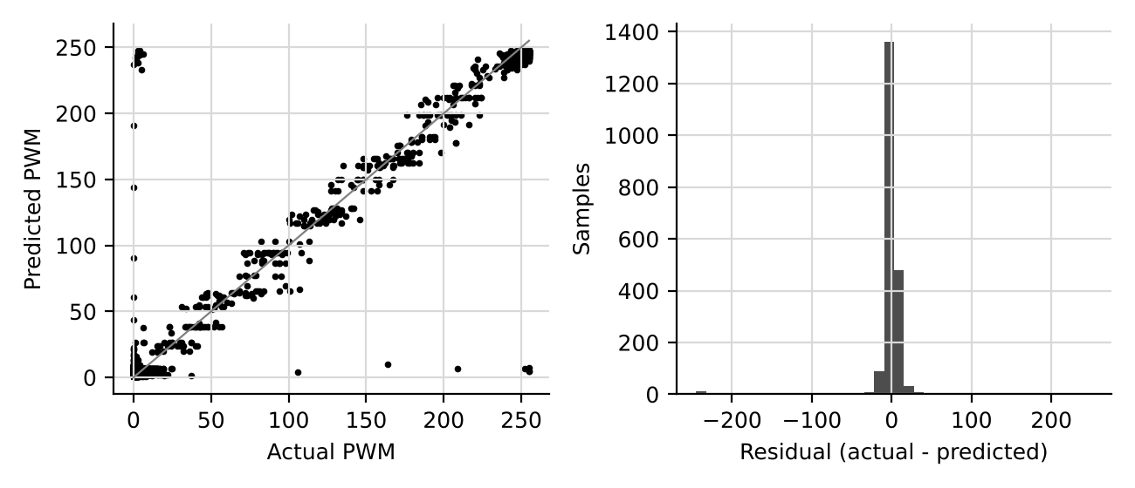
Figure 1. Left: actual vs predicted PWM on the test set. Right: residual distribution.

3.3 Feature importance and learning curve
Rank | Feature | Importance | %
1 | ldr | 0.617 | 61.7
2 | pir | 0.380 | 38.0
3 | temp | 0.002 | 0.2
4 | hum | 0.001 | 0.1
Table 4. Random Forest feature importance (impurity based).
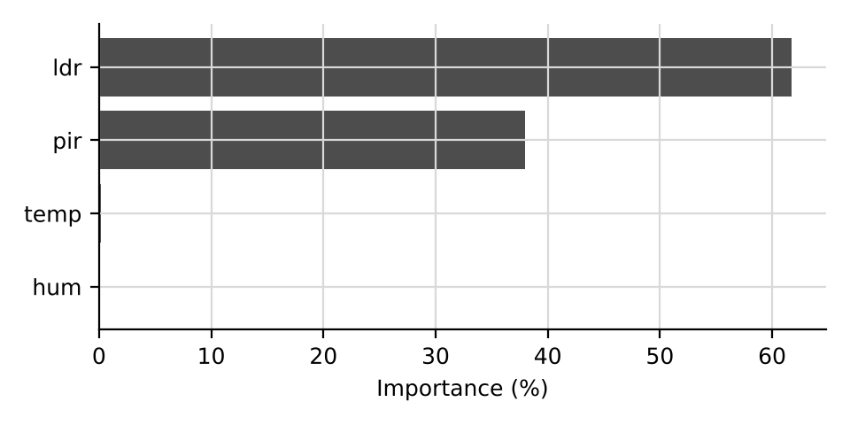
Figure 2. Feature importance.
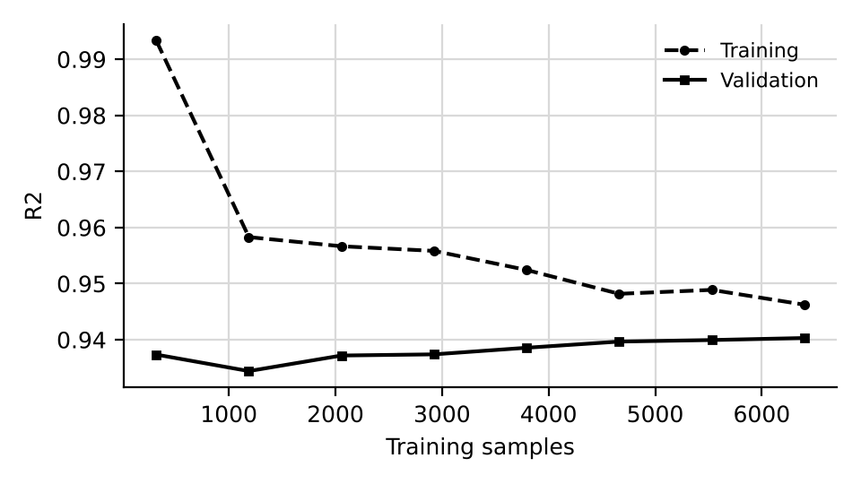
Figure 3. Learning curve; validation R2 is within 0.005 of its final value from about 320 samples.

4. Comparison with the published paper
Random Forest metric | Published (original dataset) | This rebuild (S1.1 dataset)
R2 | 0.9789 | 0.9380
RMSE | 8.98 | 24.17
MAE | 4.88 | 7.13
Table 5. The published figures came from a different generated dataset, so differences are expected.
Do not mix the two sets of numbers inside one document. Either update the paper/thesis tables to the values in this report (recommended, because they are reproducible from the seeded scripts) or locate the original generator and dataset.

5. Limitations
Scores measure how well a model recovers the designed rule set from noisy synthetic inputs, not agreement with real occupants. The impurity-based importance is biased towards features with many split points and is indicative only. One random split is used; the cross-validation SD gives the spread.

6. Draft text for the thesis
Four regression algorithms were compared using 5-fold cross-validation on 8000 training samples. The best cross-validated model was Random Forest (10 trees, depth 5) (R2 = 0.9403). The selected Random Forest (10 trees, depth 5) achieved R2 = 0.9380, RMSE = 24.17 and MAE = 7.13 PWM units (2.8% of full scale) on the 2000-sample held-out set. PIR (38.0%) and LDR (61.7%) dominated the feature importance, consistent with occupancy-based control and daylight harvesting. [State here whether the Random Forest was chosen for accuracy, size, or both, citing Table 1 and the S1.3 footprint.]

