Step S1.3 Report: Conversion to C and Host Verification
TinyFL / Stage 1, Random Forest to dependency-free C++ for the ESP32-S3
Generated 2026-10-10 19:01

1. Purpose
The ESP32-S3 cannot run a scikit-learn model, so the trained Random Forest is converted to nested if/else C++ with micromlgen. Before any hardware is involved, this step proves on the host that the generated code reproduces the Python model, and quantifies the size/accuracy trade-off behind the choice of 10 trees and depth 5.

2. Method
The saved model from S1.2 was exported with micromlgen. A second header was derived from it by adding the f suffix to every numeric literal, because the generated code uses double-precision constants and the ESP32-S3 has a single-precision FPU only; S1.4 measures whether this matters. Both headers were compiled with g++ -O2 and run on every held-out test row; the outputs were compared with the Python predictions. Feature order is {PIR, LDR, temperature, humidity}.

3. Results
Property | Value
Trees | 10
Maximum depth | 5
Total nodes | 618
Total leaves | 314
Features | pir, ldr, temp, hum
Table 1. Structure of the exported model.
Variant | Source bytes | Max abs diff vs Python | Mean abs diff | Equal after uint8 rounding | R2 of C output
micromlgen (double literals) | 77509 | 3.23e-05 | 3.11e-06 | 100.00% | 0.9380
float-literal variant | 78133 | 3.23e-05 | 3.02e-06 | 100.00% | 0.9380
Table 2. Host parity test on 2000 held-out rows. Source size is text size, not flash size.

3.1 Size versus accuracy
Trees \ depth | 3 | 4 | 5 | 6 | 8
1 | 0.9263 | 0.9341 | 0.9335 | 0.9274 | 0.9289
5 | 0.9289 | 0.9361 | 0.9378 | 0.9364 | 0.9369
10 | 0.9311 | 0.9369 | 0.9380 | 0.9378 | 0.9384
20 | 0.9312 | 0.9370 | 0.9385 | 0.9394 | 0.9388
50 | 0.9308 | 0.9370 | 0.9387 | 0.9393 | 0.9391
Table 3. Test R2 for different forest sizes (trained on the S1.2 training set).
Trees \ depth | 3 | 4 | 5 | 6 | 8
1 | 15 | 31 | 57 | 107 | 351
5 | 75 | 155 | 309 | 599 | 2009
10 | 150 | 308 | 618 | 1196 | 4016
20 | 300 | 618 | 1230 | 2362 | 7986
50 | 750 | 1546 | 3062 | 5910 | 19976
Table 4. Total tree nodes for the same configurations.
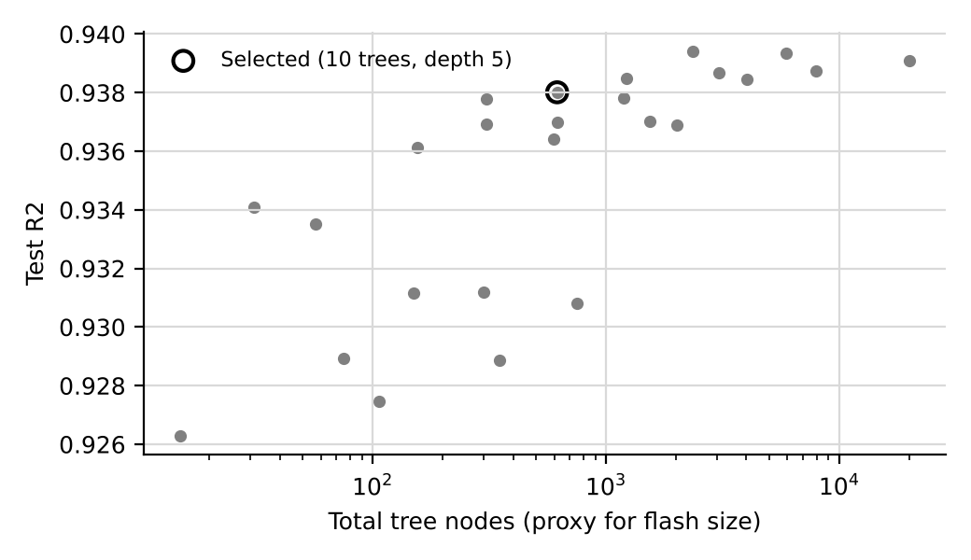
Figure 1. Accuracy versus model size for 25 configurations.

4. Output files
firmware/s1_4_benchmark/src/smart_light_model.h, smart_light_model_f32.h and test_vectors.h (the first 500 test rows with the expected prediction). Flash, RAM and latency are measured on the board in S1.4; node counts here are only a proxy.

5. Limitations
Host parity shows the C code equals the Python model, not that the model is right for real rooms. The host uses a different compiler and CPU from the ESP32-S3, so tiny floating-point differences can still appear on the board; S1.4 checks this directly.

6. Draft text for the thesis
The trained Random Forest (10 trees, depth 5, 618 nodes) was converted to dependency-free C++ using micromlgen. On the held-out test set, the generated code reproduced the Python predictions with a maximum absolute difference of 3.2e-05 PWM units, and 100.00% of outputs were identical after conversion to the 8-bit PWM value.

