Step S1.4 Report: On-device Benchmark of the Random Forest
TinyFL / Stage 1, ESP32-S3 at 240 MHz, SDK v5.5.2-729-g87912cd291, Arduino core 3.3.7, optimisation Os
Generated 2026-10-24 14:02

1. Purpose
Measure, on the target microcontroller, what the exported model costs in flash, stack, heap and time, and confirm that it produces the same predictions as the Python model. These measured figures replace estimates in the paper and thesis.

2. Method
The firmware embeds 500 held-out test rows with the Python prediction for each. For every row it calls predict() on the board and records the output and the call time (esp_timer, 1 us resolution). A 20-pass batch gives the mean time in nanoseconds with less quantisation error. Flash cost is the difference in firmware size between the model build and a reference build with the model removed; stack use is measured in a separate task of 4096 bytes whose high-water mark is read after the work; heap is compared before and after. No sensors are involved.

3. Results

3.1 On-device correctness
Variant | Rows | Max abs diff vs Python | Mean abs diff | Equal after uint8 rounding
model (double literals) | 500 | 3.10e-05 | 3.60e-06 | 100.00%
model (float literals) | 500 | 3.10e-05 | 3.60e-06 | 100.00%
Table 1. Board predictions compared with the Python model on the same inputs.

3.2 Latency
Variant | Batch mean (us) | Per-call min | median | p99 | max (us)
model (double literals) | 1.57 | 1 | 2 | 3 | 3
model (float literals) | 1.58 | 1 | 2 | 3 | 7
Table 2. Inference time. The batch mean is the most accurate average; per-call values are limited by the 1 us timer.
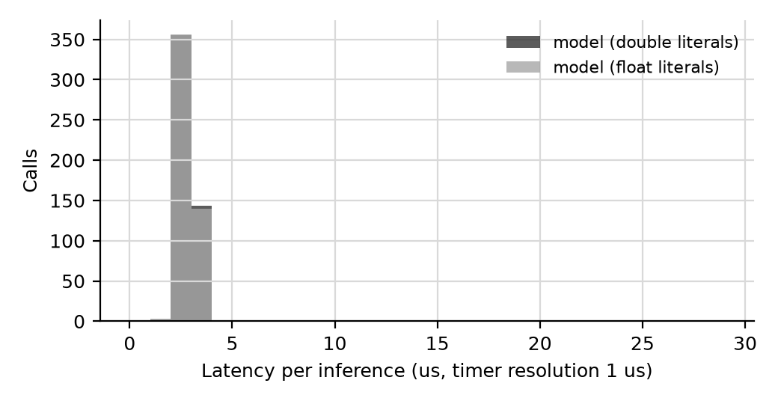
Figure 1. Distribution of per-call latency.

3.3 Memory
Variant | Flash added (B) | Stack used delta (B) | Static RAM delta (B) | Heap change (B)
model (double literals) | 9,104 B | 52 B | not supplied | +0
model (float literals) | 9,104 B | 52 B | not supplied | +0
Table 3. Resource cost of the model relative to the reference build.

4. Comparison with the published claims
Quantity | Paper | Measured (model (double literals)) | Relation
Flash | ~3.2 KB | 9,104 B | 2.78x the paper value (above)
RAM | <1 KB | stack 52 B; heap +0 B | 0.05x the paper value (below)
Latency | ~0.3 ms | 0.0016 ms | 0.01x the paper value (below)
Table 4. Published claims versus measured values. Update the paper's Table 6 to the measured numbers.

5. Limitations
Latency covers predict() only, not sensor reads or PWM update. Flash delta depends on the compiler version and optimisation level, which are stated above; rebuild and re-measure if either changes. Stack measurement has the granularity of the RTOS stack fill and is an indication, not an exact figure.

6. Draft text for the thesis
The exported model was benchmarked on the ESP32-S3 at 240 MHz using 500 held-out test vectors. Board predictions matched the Python model to within 3.1e-05 PWM units. Mean inference time was 1.6 us, with a 99th-percentile per-call time of 3 us. The model added 9,104 bytes of flash and used no heap memory. a sentence on the float-literal variant if it differs.]

