Step S1.5 Report: Hardware Bring-up and Sensor Characterisation
TinyFL / Stage 1 hardware validation, ESP32-S3 prototype
Generated 2026-10-24 14:04 from s1_5_session1.csv

1. Purpose
This step verifies that every peripheral on the prototype works at the pin assignments used in the firmware, and characterises the raw behaviour of each sensor (noise, range, polarity, response) before any machine-learning model is run on real readings. The measurements form the sensor characterisation section of the implementation chapter and give the real-sensor input ranges needed to validate the simulated training data used in Stage 1 and Stage 2.

2. Test setup
Function | Device | GPIO
I2C SDA / SCL | SSD1306 OLED 128x64 (0x3C) | 8 / 9
Motion | PIR (HC-SR501) | 4
Ambient light | LDR (GL5528) divider, ADC1 | 1
Temperature / humidity | DHT11 | 5
Light actuator | LED via PWM (5 kHz, 8-bit) | 6
Table 1. Pin assignment used in this session.
Board: ESP32-S3 rev 2, 2 cores at 240 MHz. Firmware image: 379472 bytes (bring-up firmware including OLED and logging libraries, not the ML model). Free heap at boot: 343592 bytes.

3. Method
A single continuous session was logged at 10 Hz (DHT11 sampled every 2 s, its maximum rate being 1 Hz). The operator set a label before each condition: dark (LDR covered), ambient (room light), bright (torch at the LDR), still (no movement in front of the PIR), motion (repeated movement), and ramp (LED duty 0 to 255 to 0 over 10 s). The session contains 4372 samples over 437 s. The ADC runs at 12 bits (0-4095); a 10-bit value (raw >> 2) is also logged because the Stage 1 model was trained on a 0-1023 scale.

4. Results

4.1 Light sensor (LDR)
Label | n | Mean (12-bit) | SD | Min | Max | Mean (10-bit)
none | 1332 | 2747 | 775.4 | 60 | 4095 | 686
warmup | 389 | 3057 | 134.2 | 2844 | 3404 | 764
bright | 583 | 2978 | 400.4 | 947 | 3655 | 744
dark | 335 | 2973 | 92.7 | 2885 | 3359 | 743
ramp | 331 | 2963 | 36.6 | 2887 | 3173 | 740
ambient | 578 | 2952 | 36.5 | 2868 | 3351 | 738
still | 340 | 2985 | 97.9 | 2891 | 3635 | 746
motion | 484 | 2924 | 73.1 | 2709 | 3325 | 730
Table 2. LDR readings per labelled condition.
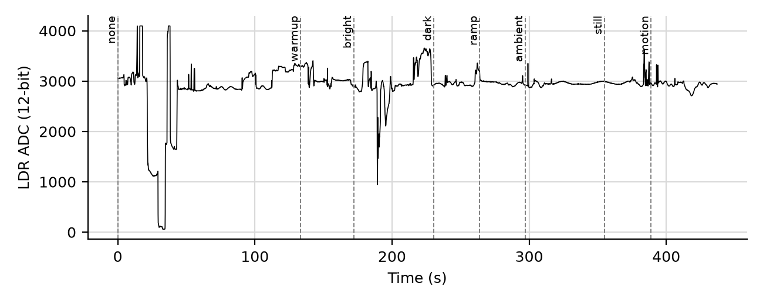
Figure 1. LDR ADC value over the session.
Polarity: not monotonic. The Stage 1 rules (LDR > 700 means bright, LDR < 300 means dark, on a 0-1023 scale) hold on this hardware only if the 10-bit means above fall on the correct sides of those thresholds; compare Table 2 against them before reusing the model.

4.2 Motion sensor (PIR)
Label | HIGH (% of samples) | Rising edges
none | 15.4 | 19
warmup | 19.8 | 6
bright | 21.1 | 11
dark | 23.0 | 7
ramp | 17.2 | 5
ambient | 7.8 | 4
still | 16.2 | 5
motion | 20.9 | 9
Table 3. PIR output per labelled condition.
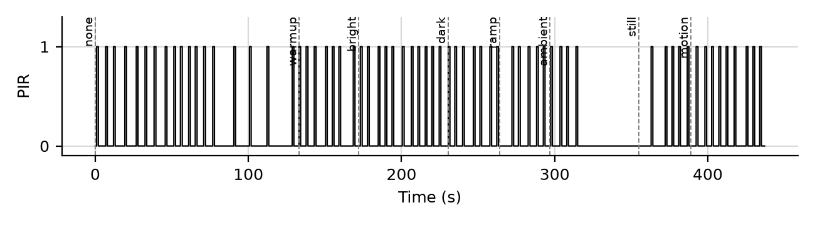
Figure 2. PIR output over the session.

4.3 Temperature and humidity (DHT11)
Quantity | Mean | SD | Min | Max
Temperature (C) | 32.8 | 0.08 | 33 | 33
Humidity (%) | 42.1 | 0.48 | 41 | 44
Table 4. DHT11 statistics from 219 valid readings (219 attempts, 100.0% success).
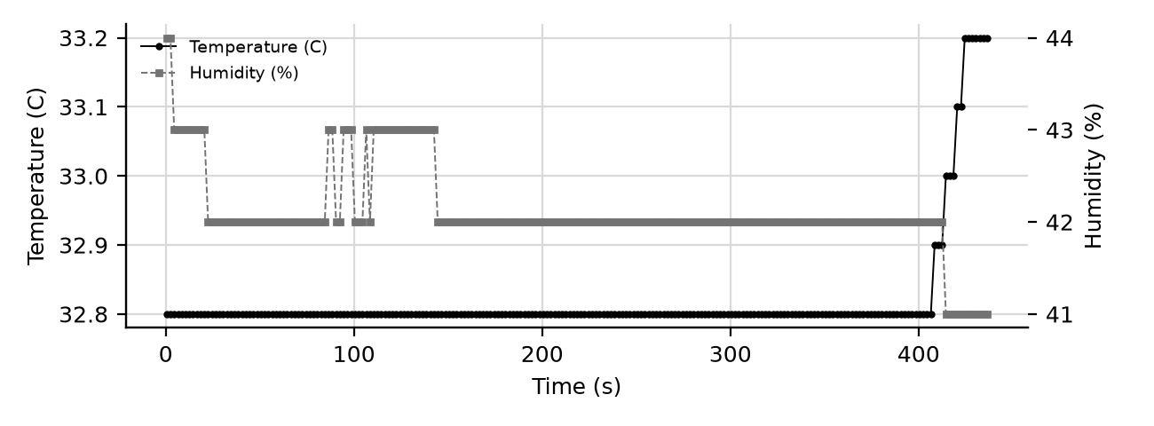
Figure 3. DHT11 temperature and humidity.
The DHT11 reports integer values with a datasheet accuracy of about +/-2 C and +/-5 %RH, which is coarser than the DHT22 named in the Stage 1 paper.

4.4 PWM output
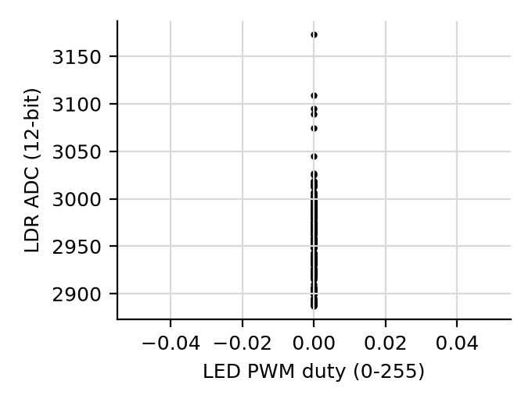
Figure 4. LDR response during the PWM ramp (r = +nan).

5. Acceptance checks
Criteria are engineering thresholds chosen for this prototype, not standards: LDR noise SD <= 2.0% of full scale; level separation >= 10 SD; DHT11 success >= 95%; PIR HIGH <= 5% when still and >= 10% with motion; logging period 90-110 ms.
Check | Result | Evidence
LDR separates dark / ambient / bright | FAIL | not monotonic; min step between levels = 0.1 sd
LDR noise within a steady label | FAIL | worst SD = 9.78% of full scale (limit 2.0%)
LDR not saturated | PASS | 0.0% of samples at an ADC rail (limit 1.0%)
PIR quiet when still | FAIL | HIGH 16.2% of time (limit 5.0%)
PIR responds to motion | PASS | HIGH 20.9%, 9 rising edge(s)
DHT11 read success | PASS | 219/219 valid (100.0%; limit 95.0%)
DHT11 values within datasheet range | PASS | T 33-33 C, RH 41-44 %
PWM ramp output present | FAIL | max duty logged = 0; PWM-vs-LDR correlation r = +nan (only meaningful if the LED shines on the LDR)
Logging period 100 ms | PASS | median 100 ms, 99th pct 100 ms
OLED detected at 0x3C | PASS | firmware reported oled=ok
Table 5. Step S1.5 acceptance checks (computed automatically).

6. Draft text for the thesis
All peripherals of the ESP32-S3 prototype were exercised at their assigned pins and logged at 10 Hz for 437 s. 6 of 10 automated acceptance checks passed. The DHT11 returned valid readings in 100.0% of 219 attempts. The LDR showed not monotonic, with a minimum separation of 0 standard deviations between lighting levels. [Add one sentence on any FAIL above and the corrective action taken.]

7. Limitations
Single session, single prototype, single room; no calibrated lux meter, so lighting levels are qualitative labels rather than lux values. PIR behaviour depends on the sensitivity and delay potentiometers, which should be recorded with the photo of the rig.

