Step S1.6 Report: Closed-Loop Model Validation
ESP32-S3 real sensor inputs, Random Forest PWM versus rule baseline
Generated 2026-10-24 15:28

1. Method
The firmware reads PIR, LDR and DHT11 values every 100 ms, maps the LDR into the model's 0-1023 feature scale, runs the exported float Random Forest, and drives the LED with the model PWM. A rule baseline uses PIR=0 -> 0 and a linear 300-700 LDR ramp when PIR=1. Metrics are computed from the captured CSV files.
Metric | Value
Sessions / rows | 3 / 18003
Model-rule MAE (PWM) | 1.37
Model-rule correlation | 0.9966
PIR-off fraction | 93.30%
Calibration valid rows | 100.00%
Motion-to-model change median | 0.0 s
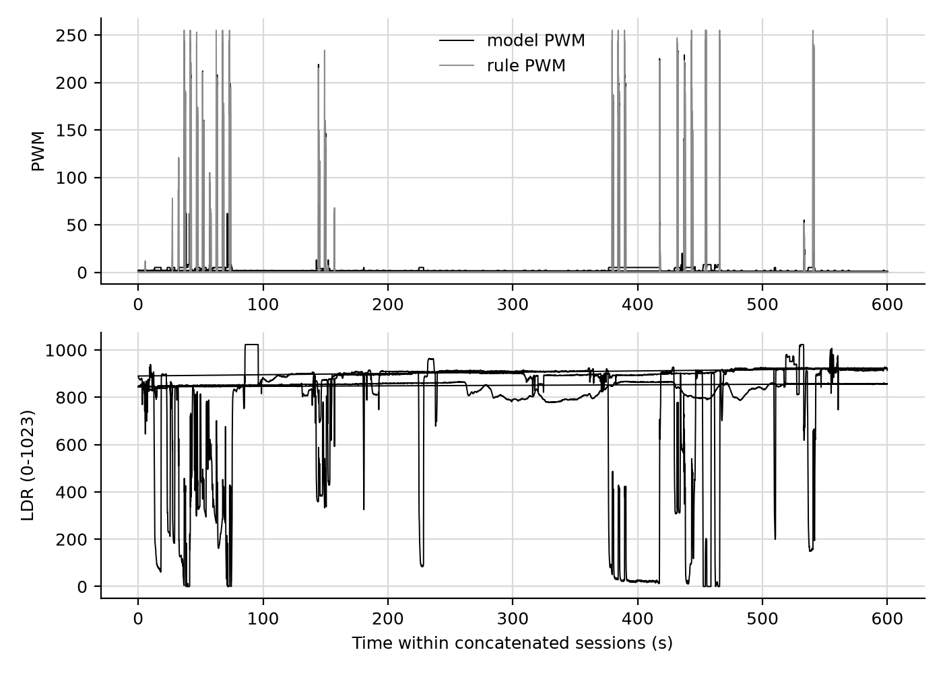
Model/rule PWM and calibrated LDR over the captured sessions.

2. Input coverage
Input | Minimum | Maximum
Temperature (C) | 31.0 | 31.7
Humidity (%) | 64.0 | 68.0
LDR (0-1023) | 0 | 1023

3. Limitations
The rule baseline is a designed comparator, not ground truth. Results depend on the LDR calibration and the single-room test setup. Report at least three sessions and retain the raw CSV files before using these numbers in the thesis.

