Stage 2 Phase A: Development Data and Split
TinyFL federated anomaly detection; reproducible synthetic pipeline check
Generated 2026-10-24 15:37
WARNING: GENERATED FROM SIMULATED / TEST DATA (pipeline test). Do not use any number in the thesis or paper.

1. Data source and scope
This dataset is generated from explicit software assumptions because no Stage 2 anomaly CSV was present. It is for validating the data pipeline only. It is not measured sensor data and must not be used as thesis or paper evidence.

2. Synthetic label rules
Class/type | Generated conditions
Normal | Temperature 24-31 C, humidity 60-80%; PIR high with probability 8%
temperature_event | Temperature 32-35 C; humidity 60-80%
humidity_event | Temperature 24-31 C; humidity 81-90%
pir_burst | Nominal temperature/humidity; PIR high
DHT11-like temperature and humidity values are integer-valued. The PIR burst is a synthetic single-row proxy; it does not model a temporal motion sequence.

3. Dataset and split
Type | Rows
normal | 4600
temperature_event | 134
humidity_event | 133
pir_burst | 133
Split | Rows | Normal | Anomaly | Anomaly rate
Train | 4000 | 3680 | 320 | 8.00%
Test | 1000 | 920 | 80 | 8.00%
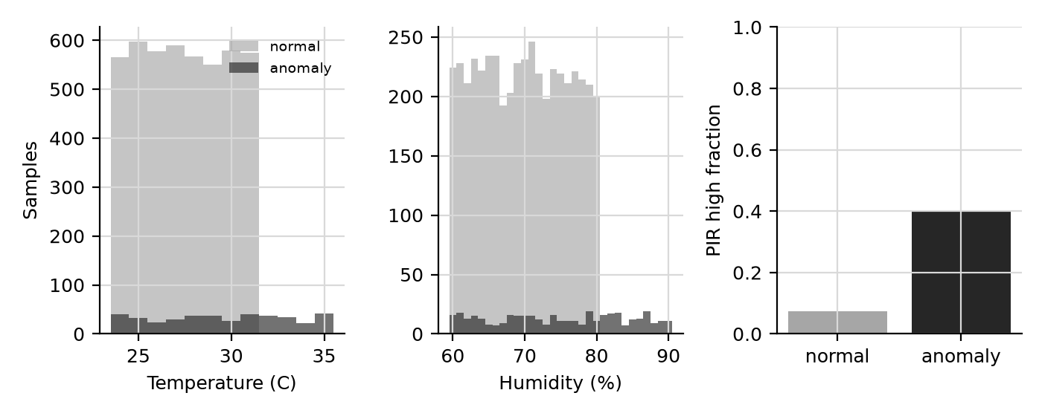
Synthetic feature distributions by generated label.

4. Train-only normalization
Feature | Train mean | Train population SD
temperature | 27.63850 | 2.47655
humidity | 70.33525 | 6.49676
pir | 0.10025 | 0.30033
Normalization is z-score scaling; statistics were fitted on training rows only (ddof=0).

5. Limitations
The labels are directly constructed from the generated conditions, so model results measure recovery of these assumptions, not real-world anomaly detection. Replace this dataset with the actual Stage 2 dataset before drawing scientific conclusions or citing metrics.

