Stage 2 Phase A: Neural Network Baseline
Held-out evaluation on development-only synthetic data
Generated 2026-10-24 15:59
WARNING: GENERATED FROM SIMULATED / TEST DATA (pipeline test). Do not use any number in the thesis or paper.

1. Architecture and training
The classifier is Dense(16, relu) -> Dense(8, relu) -> Dense(1, sigmoid), with binary cross-entropy and Adam. The three inputs were normalized using statistics fitted on the training split only. Class weighting addresses the approximately 92/8 normal/anomaly imbalance. Validation data was held out from the training split, and early stopping restored the best validation-loss weights.
Property | Value
Parameters | 209
Training rows | 3200
Validation rows | 800
Epochs run | 65
Class weight anomaly | 11.500

2. Held-out test metrics
Metric | Value
Accuracy | 0.9330
Precision (anomaly) | 0.5442
Recall (anomaly) | 1.0000
F1 (anomaly) | 0.7048
ROC-AUC | 0.9793
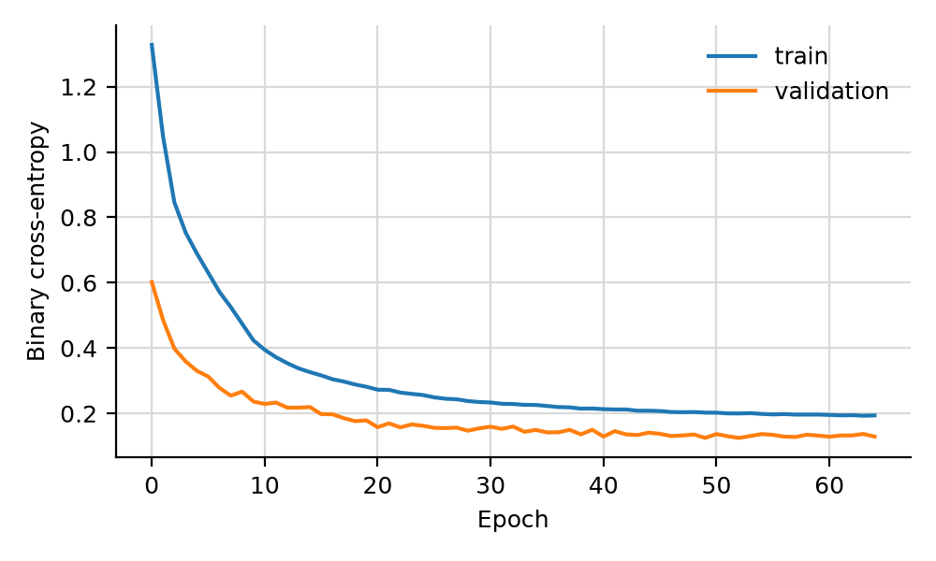
Training and validation loss.
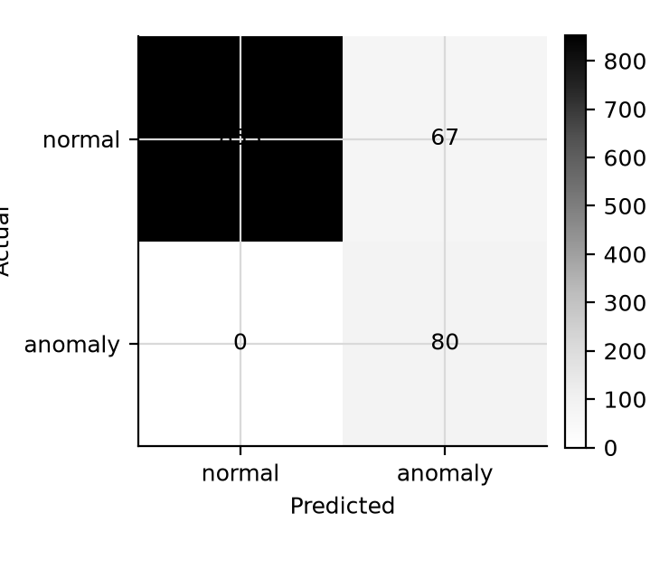
Confusion matrix; rows are actual labels, columns are predictions.

3. Interpretation limit
These metrics describe a neural network evaluated against labels generated by the development simulator. They do not measure real-world sensor anomaly detection and must not be cited as thesis or paper results.

