Stage 2 Phase A: Random Forest Baseline
Held-out evaluation on development-only synthetic data
Generated 2026-10-24 15:39
WARNING: GENERATED FROM SIMULATED / TEST DATA (pipeline test). Do not use any number in the thesis or paper.

1. Method
A class-weighted RandomForestClassifier was fitted on the 4,000-row training split. The 1,000-row test split was used only for evaluation. Features were temperature, humidity, and PIR; anomaly was the positive class. The decision threshold is 0.5.
Metric | Held-out test
Accuracy | 0.9400
Precision (anomaly) | 0.6020
Recall (anomaly) | 0.7375
F1 (anomaly) | 0.6629
ROC-AUC | 0.9794
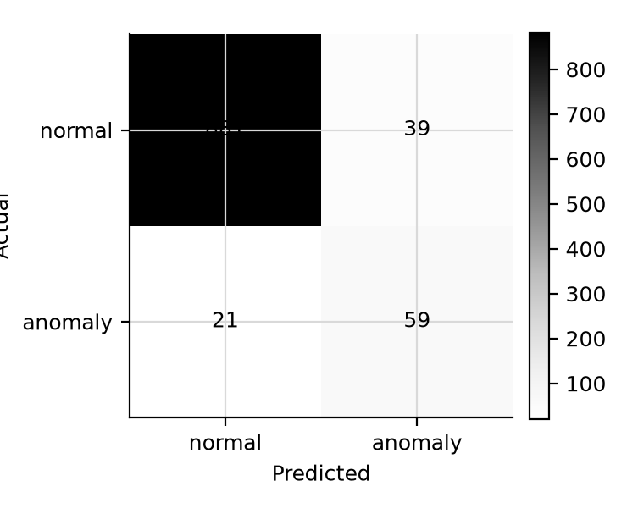
Confusion matrix; rows are actual labels, columns are predictions.

2. Interpretation limit
These metrics describe a classifier evaluated against labels generated by the development simulator. They do not measure real-world sensor anomaly detection and must not be cited as thesis or paper results. Replace the development data with the project dataset before drawing performance conclusions.

