General
- Ability to attach multiple files in the new case and in the report.
- Shouldn’t the latest cases be on the top in every dashboard?
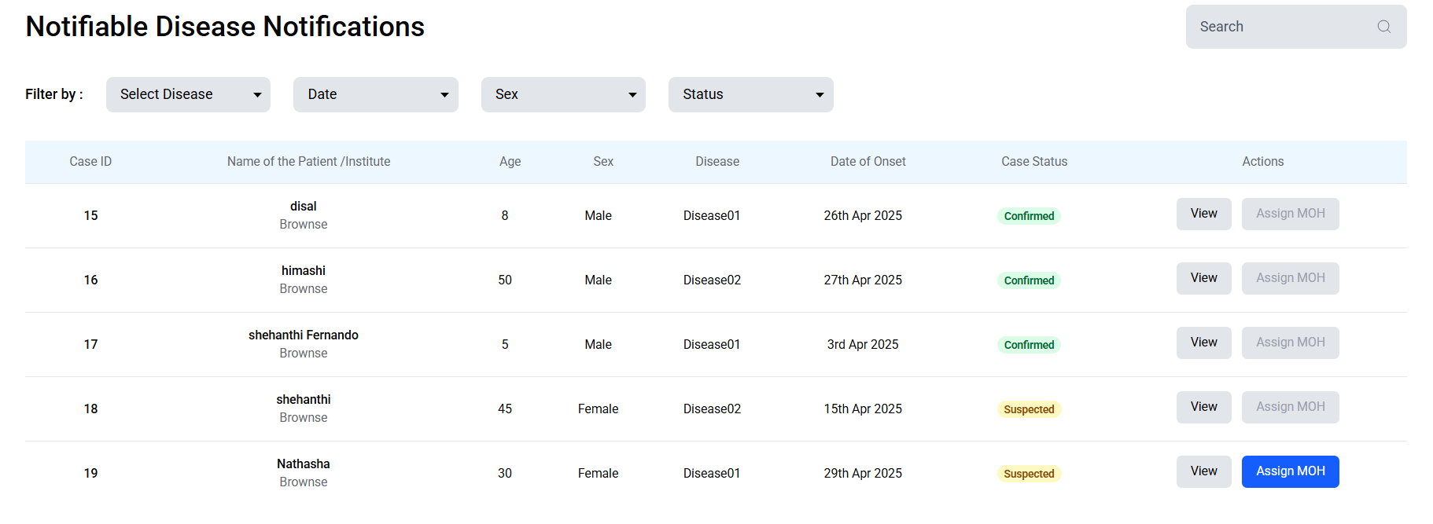

Login Page
- When I log using incorrect credentials at first the error message displays. but again when I login with correct credentials, I can log in but the error message displays before login in.

Doctor
- Make the “confirm case” button blue if the case can be confirmed. If its already confirmed, then make it grey and disabled.
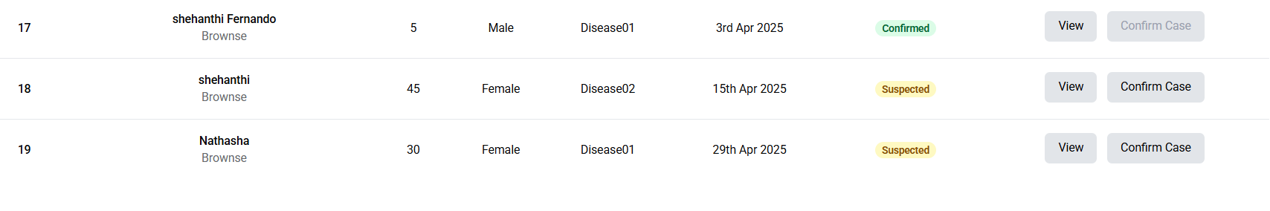
- Rename as “Notifiable Disease Notification Form”
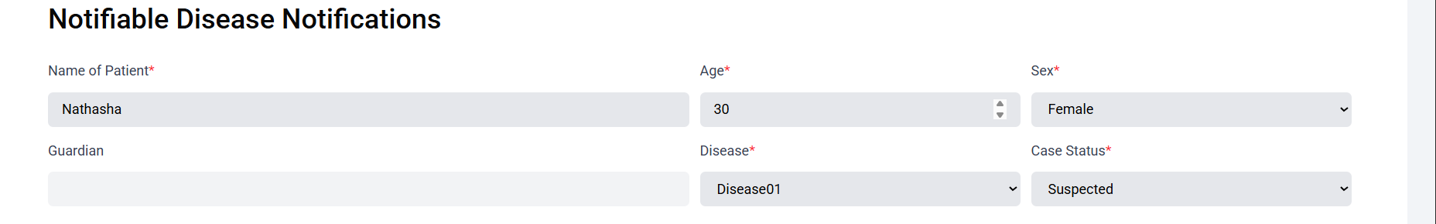
- Date of Onset field is missing a *.
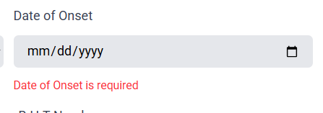\

IDU
- On the dashboard, both of these buttons direct to the same page. According to the Figma when clicked “Assign MOH” the sub assign MOH UI should display.

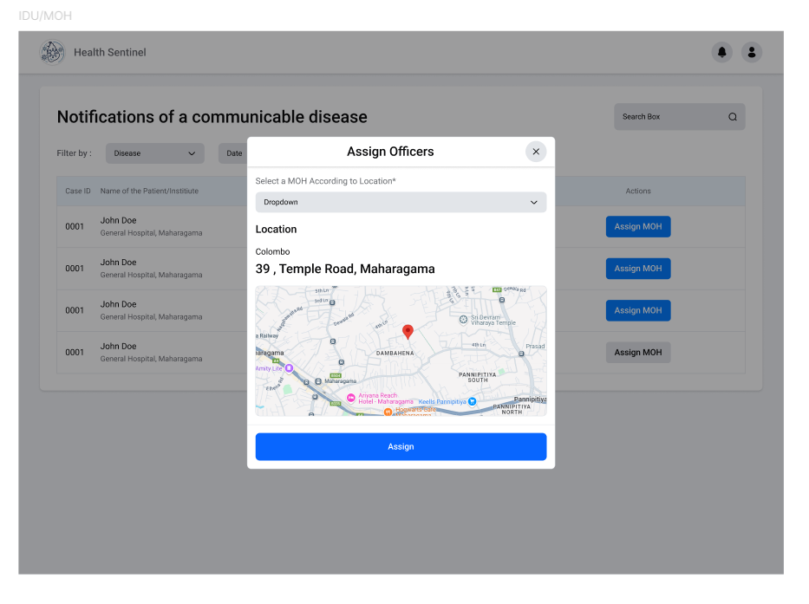
- After assigning the MOH, it instantly doesn’t update the MOH and the Assign MOH button doesn’t get disabled. (the ss is after assigning the MOH)
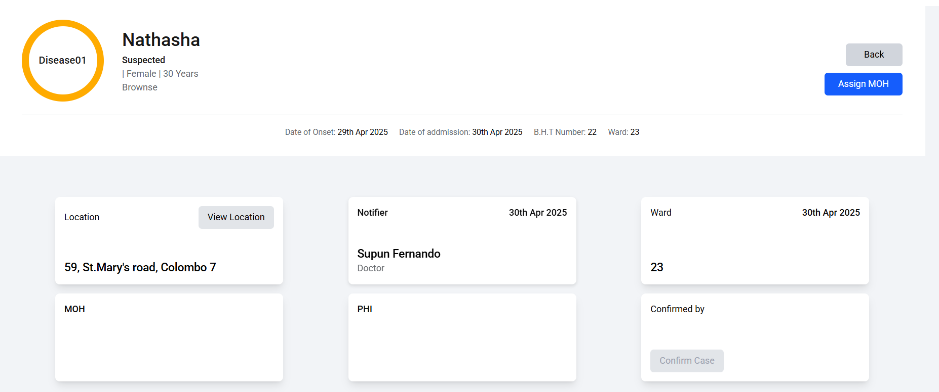
- After assigning the MOH make the “assign MOH” button grey and disabled on the dashboard.

- Remove the marked button.
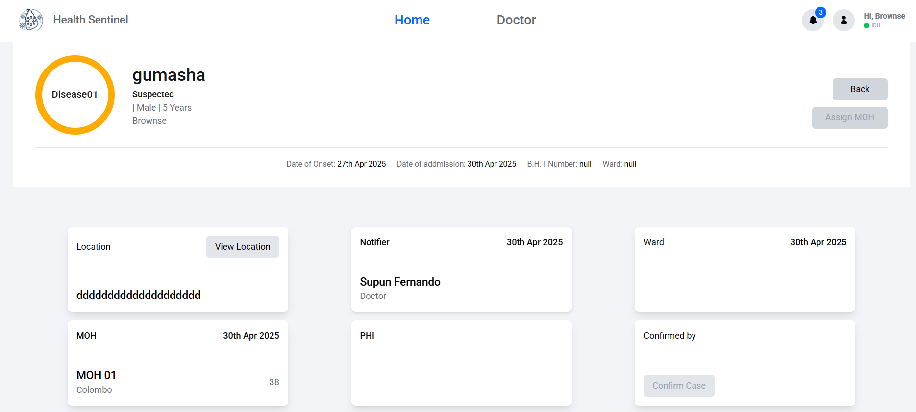
- Can’t we have all the pw requirements together.
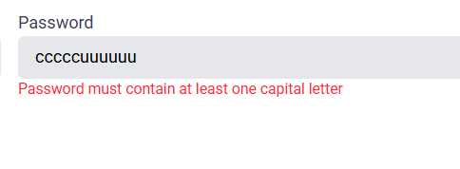
- When adding a doctor, can enter a invalid pw.
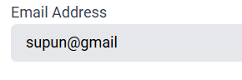
- Add the pw constraints to the pw, when adding a doctor.
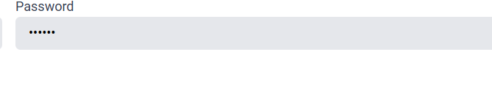
- After submitting a new doctor, it doesn’t get updated instantly in the list of doctors.
- Error when editing submitting the doctors.
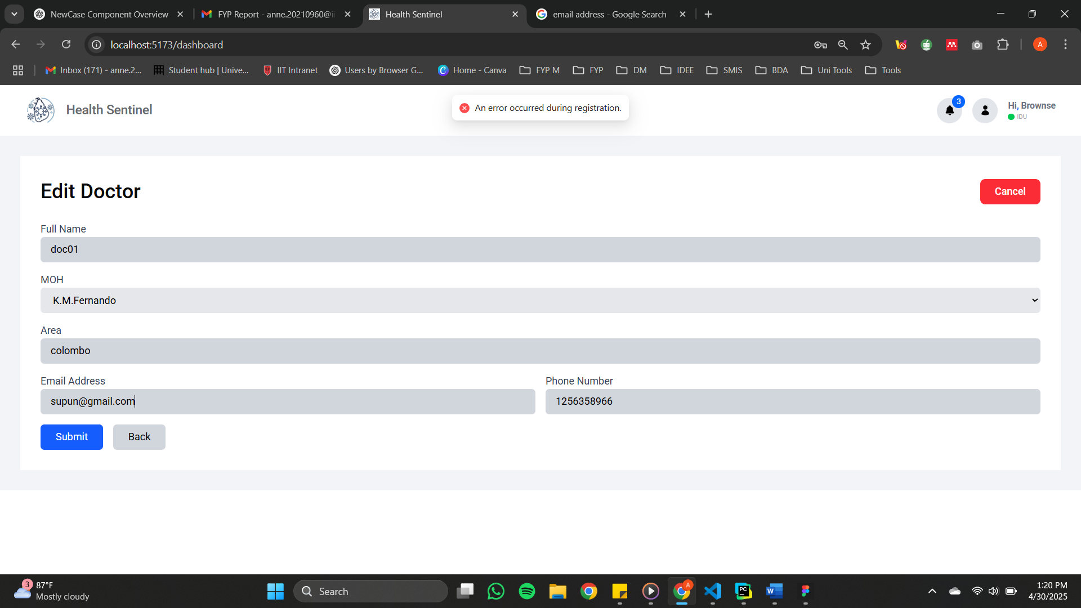
- Display the address of the patient. Not Colombo.
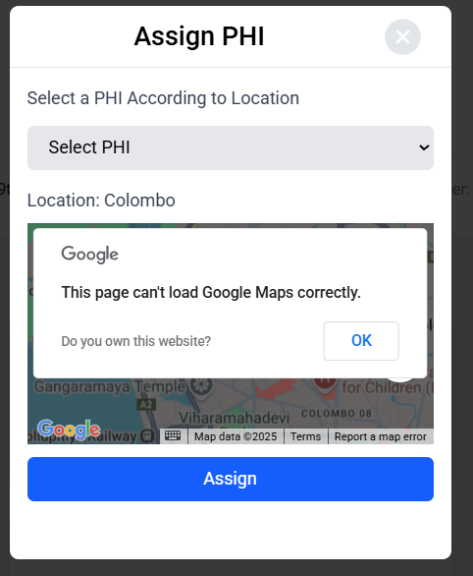

MOH
- Both buttons direct to the same UI. According to the Figma UI when “Assign UI” is selected the sub tab should display.

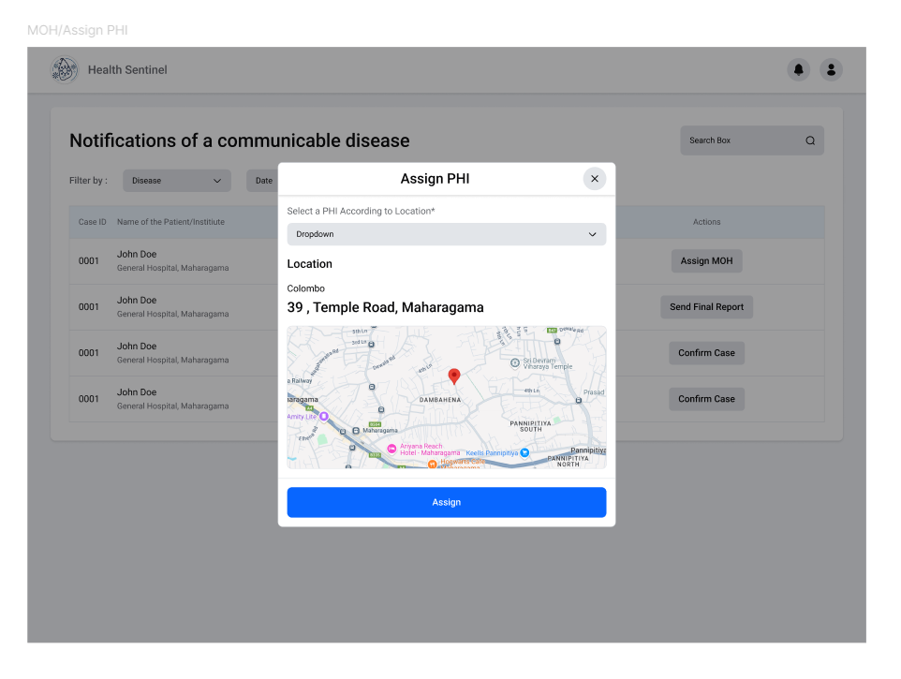
- Display the address of the patient. Not Colombo.

- After assigning the PHI, the PHI doesn’t show in the box instantly. Must refresh. Also, the Assign PHI button should be disabled. (ss is after assigning the PHI)
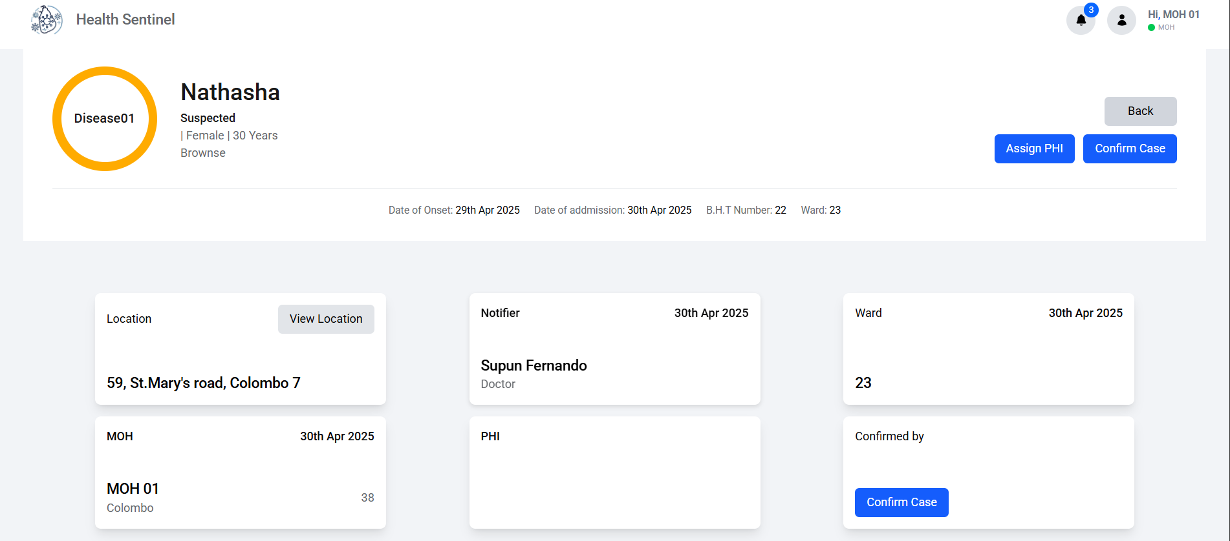
- Remove confirm case button from the marked area.


PHI
- When the case is unassigned, remove the data from the notification card.
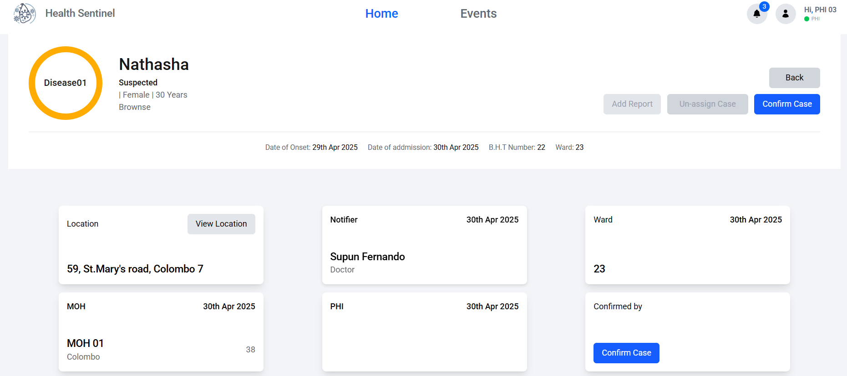
- And when the case is unassigned, remove it from the dashboard of the relevant PHI.
- When “Confirm Unassign” is clicked, It should go back to the MOH with the remark as a notification. Then in the MOH’s dashboard, the button should display as “Re-assign PHI”.
- In the marked place, show the area of the confirming person.
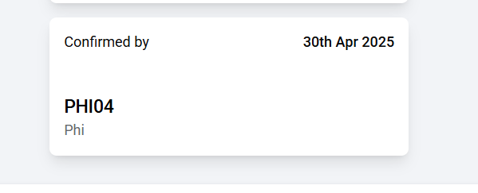
- In the report make it so that the age cannot be 0 or less. But there is a problem if there are infants who are months old.
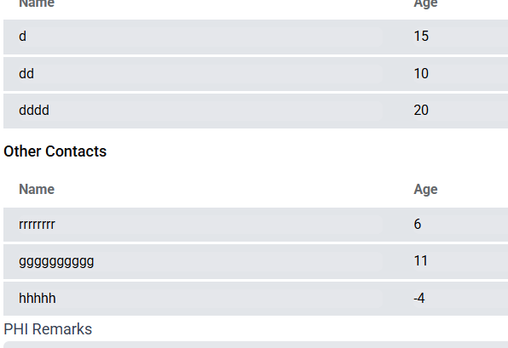
- The marked details did not display from the report filled.
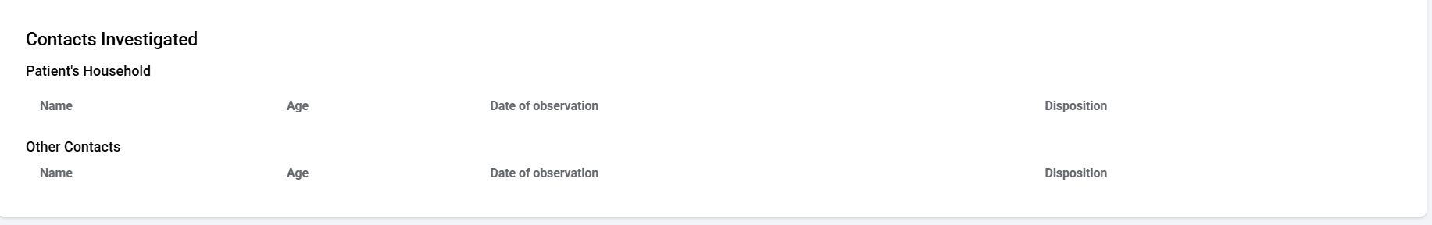
- The marked word should be “Observation”

Epidemiology unit
- Marked the case as received from the dashboard, but the “mark as received” button is enabled on the report.
