**Table of Contents**

**1. Introduction 1**

1.1 Purpose 1

1.2 Intended Audience and Reading Suggestions 1

1.3 Product Scope 1

**2. Overall Description** **2**

2.1 Product Perspective 2

2.2 Product Functions 2

2.3 User Classes, Roles and Characteristics 2

2.4 Operating Environment 2

2.5 System Design 3

2.6 Assumptions and Dependencies 3

**3. Requirement Elicitation 3**

3.1 Introduction 3

3.2 User Task Breakdown 3

3.3 Functional Requirements 4

3.4 Non-Functional Requirements 4  
**4. UML Diagrams 5**4.1 Class Diagram 5  
4.2 Sequence Diagrams 6  
4.3 Use Case Diagrams 9  
**5. System Features 9**  
5.1 System Feature Visit Maintenance Platform Website 9  
5.2 System Feature Click on Service Image 10  
5.3 System Feature Registration 10  
5.4 System Feature Login 10  
5.5 System Feature Logout 11  
5.6 System Feature Booking 11  
**6. Test Cases 12**  
**Appendix A: Questionnaire 13  
Table of Figures**Figure 4.1 Class Diagram 5  
Figure 4.2.1 Sequence Diagram for Registration 6  
Figure 4.2.2 Sequence Diagram for Login 7  
Figure 4.2.3 Sequence Diagram for Orders 8  
Figure 6.1 Test Case for Login 12

**1. Introduction**We all want to and need to maintain our homes, but we can't always invest the time that is needed. This is where this website comes to help us. This website offers users a wide array of services to help them maintain their homes. This website offers services for cleaning homes, fixing broken appliances, making or repairing furniture and even offers pest control. All the necessary information about the services are available in the website, and the users can choose and order the services they require directly from the website.

**1.1 Purpose**

The document is about the software requirement specification for the Maintenance Application. The goal of this document is to provide an elaborate description of the requirements regarding the Maintenance Platform. The following chapters contain all necessary requirements that are required. The report consists of use cases that outline interactions the users will have with the system. It also consists of the class diagrams, functional and non-functional requirements of the Maintenance Platform.

**1.2 Intended Audience and Reading Suggestions**

This document is intended for any individual user, developer, tester, project manager or documentation writer that needs to understand the basic system architecture and its specifications. Here are the potential uses for each one of the reader types:

i) **Developer-** This document will help the developer to change or modify the existing program.

The developer will also need to update this document after changing the existing

program so as to preserve this document and to allow the passing of information.

ii) **User-** This document will help the user understand the functions of the program described in

the document and allow them to determine if the program meets their needs.

iii) **Stakeholder-** This document will allow the stakeholders to check if the developers delivered

all the necessary features that the program needed.

**1.3 Product Scope**

This product aims to provide services that are in demand during all times. People always need their homes cleaned or appliances fixed, as a result this product will always be in use. From a corporate standpoint if the service is always in demand then there will always be customers.

**2. Overall Description**

**2.1 Product Perspective**

The product idea came from the lack of access to professional handymen in the community. This is a standalone product with a goal to provide maintenance services to customers.

**2.2 Product Functions**

There are X functions to this product, they are:

1) Display offered services in full detail.

2) User accounts

3) Order services

These functions are elaborated in detail in Section 3 Requirement Elicitation.

**2.3 User Classes, Roles and Characteristics**

**Physical Actors:**

- **Customer:**The customer is the one that looks at all the services available on the website and then order the service they want. They register their accounts and then their orders are placed in the database.

- **Service Provider:**The company has access to the database where the orders are stored and can send out the service man accordingly.

**System Actors:**

- **Client:**The client connects the program to the database. It contains the user interface and collects the data that is then sent into the database.

- **Database:**The database connects to all the different clients being hosted on different user devices and then stores the data from all the unique clients with unique ids.

**2.4 Operating Environment**

The product will operate on browsers such as Google Chrome, Mozilla Firefox, Microsoft Edge, Safari and Opera Mini. The website can also be viewed on browsers on mobile devices. The product will only work when there is a working internet connection to be able to load the website and also send and retrieve data from the website.

**2.5 System Design**

**Front End:** HTML, CSS, JAVAScript, Bootstrap and JQuery.

**Back End:** JAVASCRIPT.

**Server Side:** NodeJS, EJS, BCrypt, Express, Passport JS and Mongoose.

**Database:** MongoDB.

**2.6 Assumptions and Dependencies**

Some dependencies such as Bootstrap and JQuery are connected to the website via URLs, as a result the website heavily relies on the sources for the URLs being live for as long as the website lives.

**3. Requirement Elicitation**

**3.1 Introduction**

Requirements elicitation is the process by which we determine the features, the functional and non-functional requirements of the project through questionnaires or surveys. For this project we used questionnaires to determine the requirements. Questionnaires were filled out by both prospective users and the stakeholders of this project. The questionnaires are included at the end of this document in the appendix.

**3.2 User Task Breakdown**

**From Stakeholders:** 1) Users can find the services they need

2)Simple, easy to use website design

**From Users:** 1) Services wanted-

i)cleaning

ii)carpentry

iii)electrical

iv)pest control

v)plumbing

vi)painting

vii)moving

viii)appliance repair

2)Simple, easy to use website design

3)Simple order process

4)Fast service delivery

**3.3 Functional Requirements**

It defines the system or its component. It describes the functions the software must perform. It can be a calculation, data manipulation, business process, user interaction, or any other specific functionality which defines what function the system is likely to perform.

1. Interactive website interface
2. Images and names of services provided
3. Prices of the different services provided
4. Search option
5. Company Information displayed
6. Order Page
7. Login Page

**3.4 Non-Functional Requirements**

It defines the quality attribute of a software system. A non-functional requirement is essential to ensure the usability and effectiveness of the entire software system. Non-functional Requirements impose constraints or restrictions on the design of the system.

1. Encrypt user passwords
2. Encrypt data stored in database
3. Valid email needs to be used
4. Same email cannot be used twice
5. Email and password both required to login
6. Register account before ordering
7. All criteria need to be filled before placing order
8. Call to confirm order
9. Orders can only be for the provided services
10. Search past orders with userid
11. Service providers can see but not change the orders

**4. UML Diagrams**

**4.1 Class Diagram**

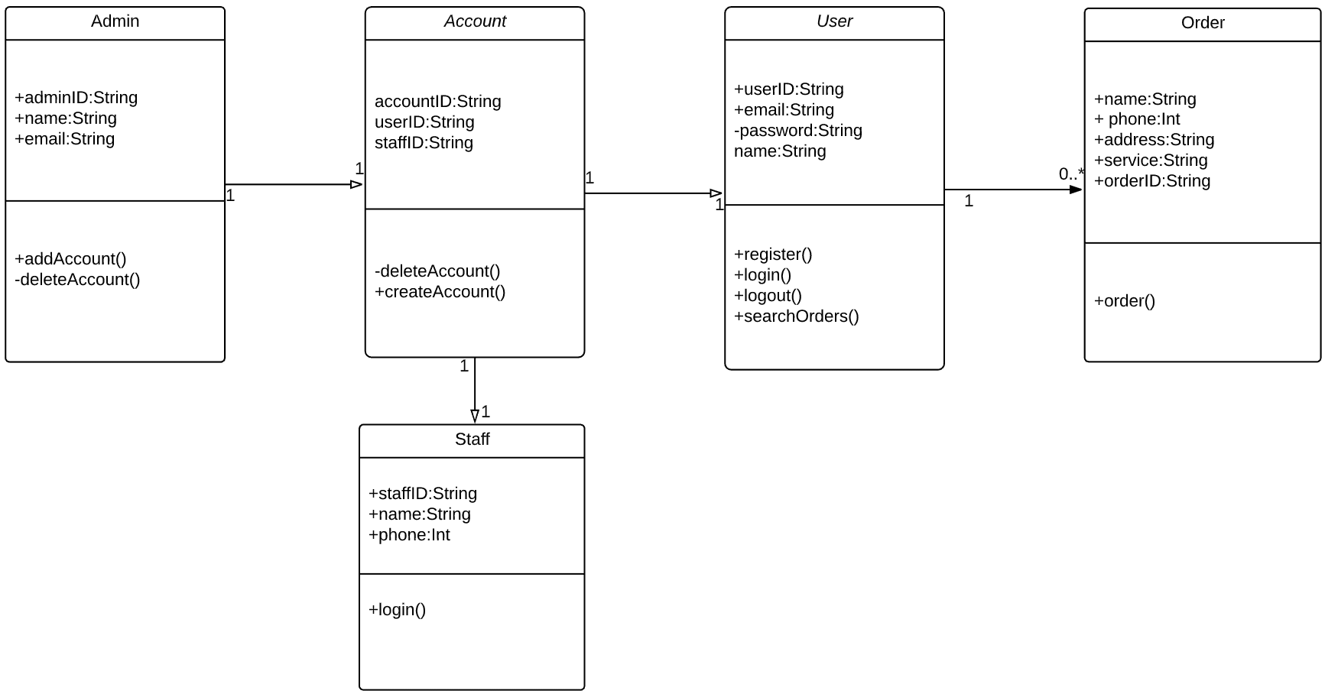

**Figure 4.1 Class Diagram**

**4.2 Sequence Diagrams**

**4.2.1 Registration**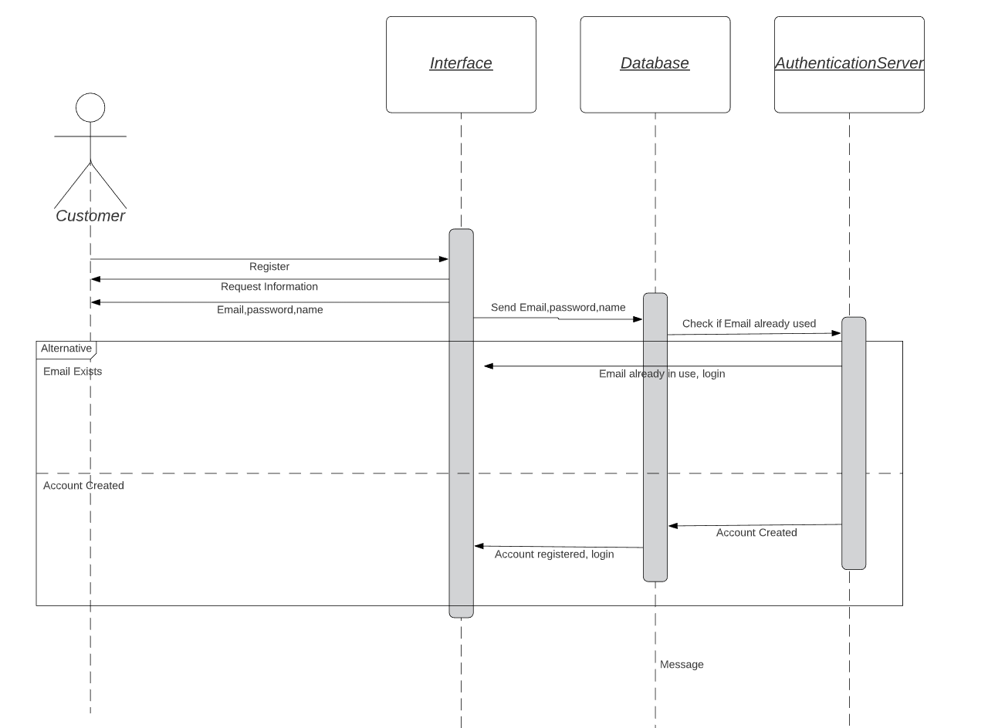

**Figure 4.2.1 Sequence Diagram for Registration**

**4.2.2 Login**

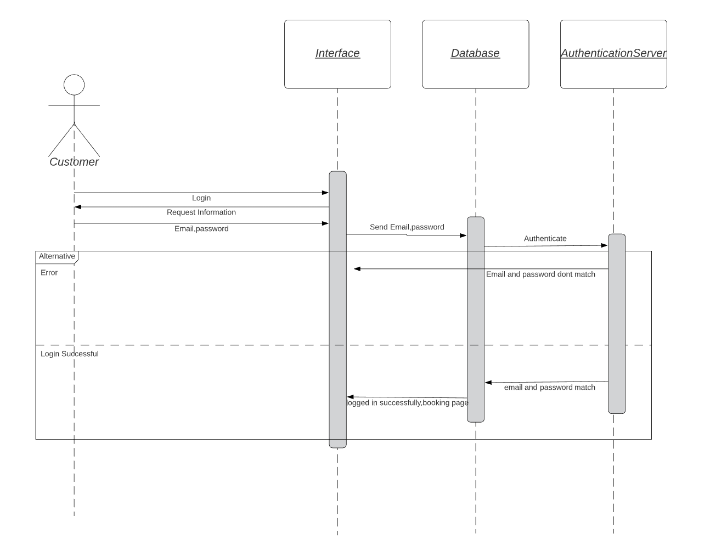

**Figure 4.2.2 Sequence Diagram for Login**

**4.2.3 Orders**

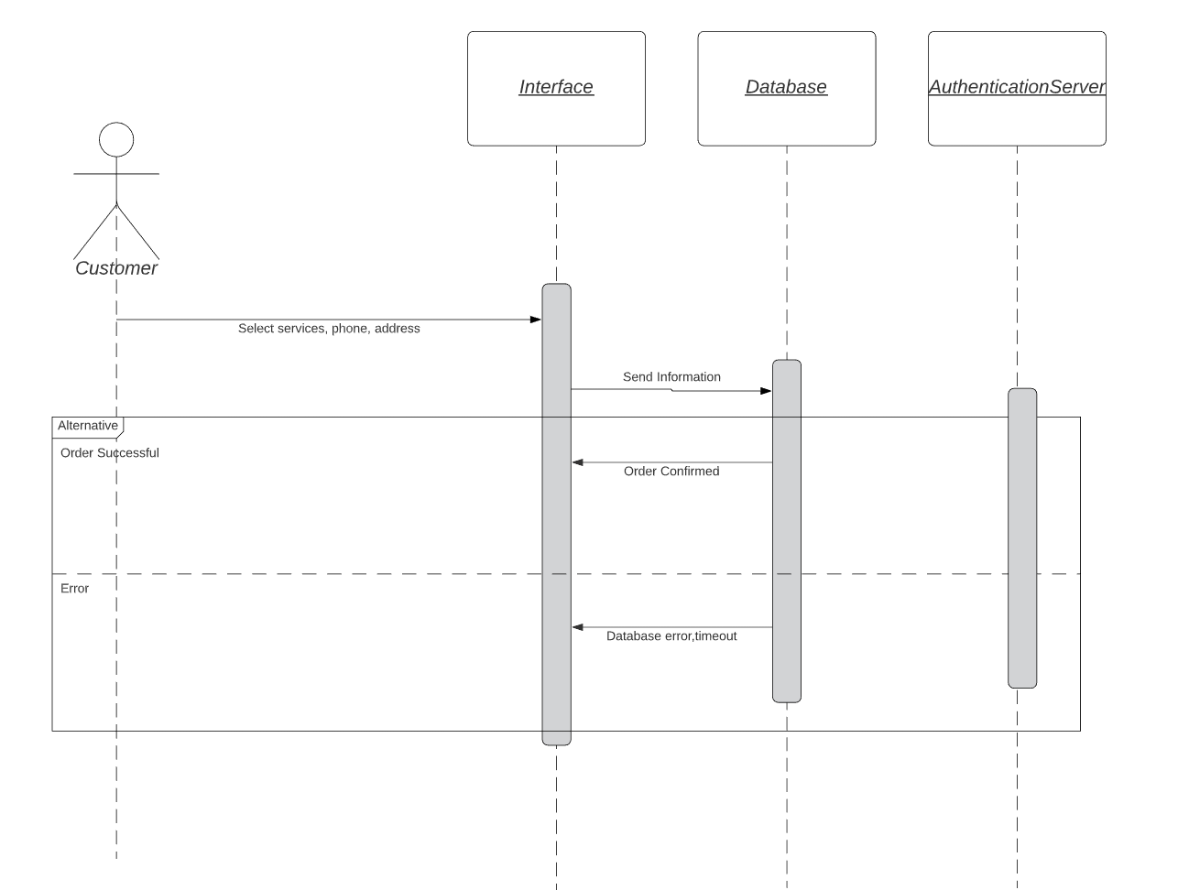

**Figure 4.2.3 Sequence Diagram for Orders**

**4.3 Use Case Diagram**

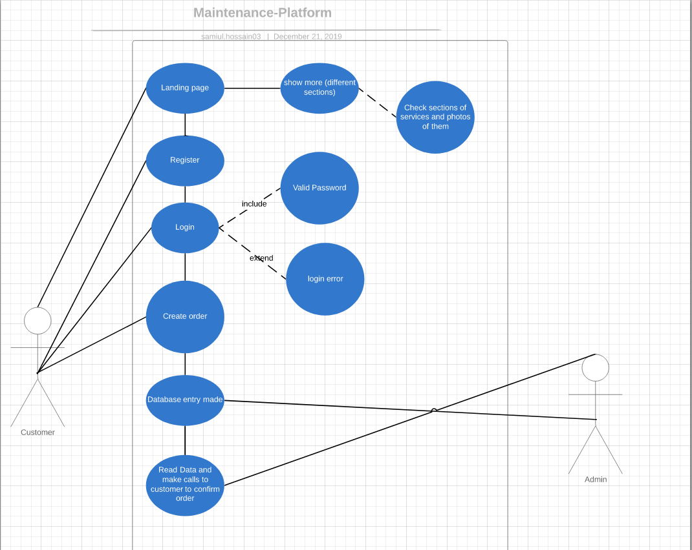

**5. System Features**

**5.1 System Feature Visit Maintenance Platform Website**

**5.1.1** Description and Priority

A user visits the website and is displayed with the homepage.

Priority level=low

**5.1.2** Stimulus/Response Sequences

Preconditions:None

1.User enters the URL.

2.Maintenance Platform home page is displayed.

**5.2 System Feature Click on Service Image**

**5.2.1** Description and Priority

A user clicks on one of the images of the services provided, example electrical and is redirected to a new page.

Priority level=low

**5.2.2** Stimulus/Response Sequences

Preconditions:None

1.User clicks on image.

2.Website redirects to new page

3.Relevant information is displayed

**5.3 System Feature Registration**

**5.3.1** Description and Priority

A user clicks on the sign up button and is redirected to the registration page.

Priority level=medium

**5.3.2** Stimulus/Response Sequences

Preconditions:None

1.User clicks on the sign up button.

2.Redirected to the sign up page

3.User fills up the required fields

4.If email not used, new account is created, else error message is displayed saying ‘email already used’

5. If successful redirected to login page.

**5.4 System Feature Login**

**5.4.1** Description and Priority

A user clicks on the login in button and is taken to the login page

Priority level=medium

**5.4.2** Stimulus/Response Sequences

Preconditions: Registration

1.User clicks on the login button.

2.Redirected to the login page

3.User enters email and password

4.If email and password match database user is logged in and redirected to the booking page, else error is displayed and email and password are asked again

**5.5 System Feature Logout**

**5.5.1** Description and Priority

A user clicks on the logout button the booking page and is logged out of the server

Priority level=medium

**5.5.2** Stimulus/Response Sequences

Preconditions: Login

1.User clicks on the logout button.

2.They are redirected out of the booking page and can not access it without logging in again

**5.6 System Feature Booking**

**5.6.1** Description and Priority

A user logs in and is redirected to the booking page and is displayed with a form. Filling up the form and submitting it saves it into the database and their order is confirmed.

Priority level=high

**5.6.2** Stimulus/Response Sequences

Preconditions: Login

1.A form is presented to the user.

2.The user enters his name, address, phone number and the service they want.

3.If data is stored in the database then they are given a confirmation of the order and a phone call is placed to them.

**6. Test Cases**

**6.1 Test Case for Login**

|  |  |  |  |  |  |  |  |
| --- | --- | --- | --- | --- | --- | --- | --- |
| **Test Case ID** | **Test Case** | **Test Steps** | **Test Data** | **Expected Results** | **Post Condition** | **Actual Result** | **Status(P or F)** |
| T001 | Enter valid Email and Password | 1.Enter Email  2.Enter Password  3.Click Login | **Valid** Email: mhtahmed7@gmail.com  **Valid** Password:123456 | Successful Login | Redirected to booking page | Redirected to booking page | P |
| T002 | Enter valid Email and invalid Password | 1.Enter Email  2.Enter Password  3.Click Login | **Valid** Email: mhtahmed7@gmail.com  **Invalid** Password:123 | Error Message. Login failed | Email and password is asked again | Error Message. Login failed | P |
| T003 | Enter invalid Email and valid Password | 1.Enter Email  2.Enter Password  3.Click Login | **Invalid** Email: hello12  **Valid** Password:123456 | Error Message. Login failed | Email and password is asked again | Error Message. Login failed | P |
| T004 | Enter invalid Email and Invalid Password | 1.Enter Email  2.Enter Password  3.Click Login | **Invalid** Email: hello12  **Invalid** Password | Error Message. Login failed | Email and password is asked again | Error Message. Login failed | P |

**Figure 6.1 Test Case for Login**

**Appendix A: Questionnaire**

**Questionnaire to Stakeholders:**

1. Who are the users?
2. What are the benefits?
3. What is the purpose and objectives of the project?
4. Do you want to add extra functionalities like expanding to support business clients?
5. What functions are required?
6. Can it be collaborated with social media?
7. Is it possible to rate the handiwork after completion?

**Questionnaire to Users:**

1. Would you use this service?
2. What services would you like there to be?
3. Would you like to rate the handiwork after completion?
4. How would you like to contact us?
5. How would you like to pay for the services?
6. Would you like the option to be available to order multiple services at once?
7. Would you like to see reviews/photos of our previous works?
8. Would you like to see the probable costs of the services before ordering?

**GitHub link: https://github.com/Samiul-Hossain/maintenance-platform**



**Project Report**

**CSE 327: Software Engineering**

**Semester: Fall 2019**

**Section: 4**

**Project:**

**Maintenance Platform Web Application**

**Submitted by**-

Mohit Uddin Ahmed - 1632259042

Samiul Hossain - 1711626042

**Submitted to**- ABH3

**Date**:21/12/2019