ReMedFiLM
Complete Scientific Report
Version 8 · analysis-only reconstruction from frozen artifacts
Proposed model. ReMedFiLM FULL, implemented as RA-MedFiLM-BARR, is the four-component system G + R_psi + B_phi + S_omega. GlobalMedFiLM is the `G` backbone and a legitimate ablation baseline only — it is not the proposed model and must never be labelled ReMedFiLM FULL. This distinction is enforced throughout V8.
Abstract
On the held-out VAL808 split (n = 808, seed 42), the proposed ReMedFiLM FULL attains a domain-equal-weight macro Dice of 0.837290, against 0.835080 for its GlobalMedFiLM backbone; the paired gain is +0.002210 (95% bootstrap CI 0.001148–0.003292, 10,000 domain-stratified image resamples). The gain is concentrated in KUB radiography (+0.007454). On 884 retrospective external images the system is directionally consistent but the margin is small, and on 20 KUB stone images both systems perform poorly (FULL 0.0821 vs G 0.0808). A 13-arm ablation shows that learned benefit routing dominates the gain, while the incremental contribution of the post-safety gate is not established (A8 − A7 CI includes zero). V8 also adjudicates a legacy headline value, 0.837862, and rejects it as a reporting inconsistency rather than a second experimental configuration. All V8 numbers trace to a single source-linked registry of 291 metric records. No model was retrained, no new inference was run, no checkpoint was modified, and the protected TEST1683 inputs were not opened.

Status of evidence
Established: paired VAL808 preservation result; frozen state-machine counts; external descriptive comparison; historical 13-arm ablation; staged objectives. Not established: C1 (learned vs identity FiLM), C2 (causal safety-gate attribution), C3 (matched multi-seed baseline matrix), any prospective TEST1683 evaluation, and patient-level independence of the BrEaST external cohort. No p-values are added in V8 beyond the pre-registered bootstrap intervals.

Contents
Table of contents is generated on open / export.
This report is deliberately undated: the build host clock is not synchronised (NTP leap indicator 3), so absolute timestamps would carry an unquantified offset. Provenance is established by SHA-256 digests in Section 11 instead.

1. Overview and contributions
Medical segmentation models are usually evaluated as single monolithic networks. ReMedFiLM asks a different question: given one task-conditioned global segmenter, can a conditional system decide per image whether a regional refinement should be executed, and whether its result is safe to keep? The proposed answer is a four-component, sequentially trained system whose inference path is a verified state machine rather than a single joint network.

1.1 Canonical identity
ReMedFiLM FULL = RA-MedFiLM-BARR = G + R_psi + B_phi + S_omega. The assembly wrapper itself has zero trainable parameters and defines no loss: it is an inference-time composition of four independently trained modules. Conflating the assembly with any one component — most often with the GlobalMedFiLM backbone — is the principal scientific error corrected in V8.
Table 1. Canonical component chain of the proposed model (verified by read-only checkpoint state-dict loading).
Component | Implementation class | Parameters
G — task-conditioned backbone | GlobalMedFiLM | 3,523,001
R_psi — regional refiner | BARRRegionalRefinerV1 | 1,276,401
B_phi — benefit router | BARRBenefitRouterV1 | 36,801
S_omega — post-safety gate | BARRPostSafetyV1 | 1,217
ReMedFiLM FULL (assembly) | RAMedFiLMBARR | 4,837,420
Total is the sum of the four component counts; the wrapper adds no parameters. FiLM + task-embedding parameters inside G are 90,768 (2.58% of G). Freezing a module does not reduce total parameter count.

1.2 Contributions
- A task-conditioned global backbone. GlobalMedFiLM uses one shared encoder–decoder for four imaging domains; task identity enters only through a 32-D embedding and five FiLM modulation sites, F_hat = (1 + gamma(t)) F + beta(t).
- A four-state conditional inference machine. Benefit routing and a post-safety gate decide per image whether to execute an offline regional refinement, with a deterministic global fallback on both skip and reject paths.
- A strictly staged, independently supervised training protocol. G, R_psi, B_phi and S_omega have four distinct objectives and are trained sequentially against frozen upstream outputs; there is no joint end-to-end optimisation.
- A source-linked evidence base. 291 metric records with run IDs, seeds, checkpoint digests, metric definitions, aggregation rules and SHA-256 source digests, plus a 33-figure evidence map and a 20-arrow code-verification manifest.
- An explicit negative-results record. Unresolved comparisons, a non-established safety contribution, a clinically important external false-positive pattern, and a rejected legacy headline value are all reported rather than suppressed.

1.3 Headline result and its provenance
The result reported for the proposed system is the paired comparison on VAL808: FULL 0.837290 versus backbone 0.835080, a difference of +0.002210 Dice (+0.2210 percentage points). Section 11 adjudicates the three values that circulated in earlier report versions and explains why only one of them is a measurement of the proposed model.
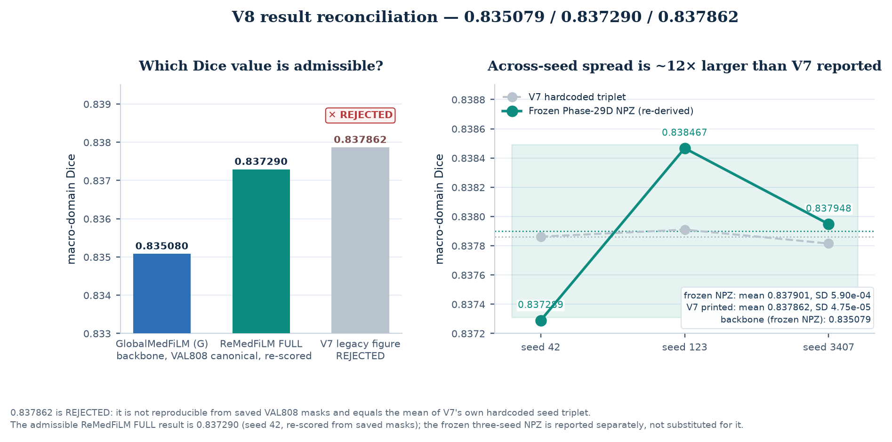
Figure 1. V8 adjudication of the three VAL808 macro-Dice values. Left: the canonical FULL result (teal), its GlobalMedFiLM comparator (blue), and the legacy 0.837862 (rejected). Right: the genuine three-seed values re-aggregated from the frozen per-sample NPZ archive, with seed 42 matching the saved-mask re-score to approximately 6×10⁻⁷. The legacy value is the mean of three numbers hard-coded into the V5/V6/V7 generators, not a measurement. [V8 registry; frozen NPZ; V7 generator]

2. Methodology: the proposed ReMedFiLM FULL system

2.1 Verified architecture
Every arrow in the V8 methodology figure was checked against source code. The verification manifest records 20 supported arrows and 13 arrows removed or corrected relative to the V5–V7 diagram. The most consequential corrections are: B_phi is pre-refinement and never sees the ROI crop or a global feature tensor; S_omega is post-candidate-composition; R_psi is an offline out-of-fold producer and is not invoked online; fusion is deterministic replacement inside the ROI with no alpha blending; and there are two distinct skip states rather than one.
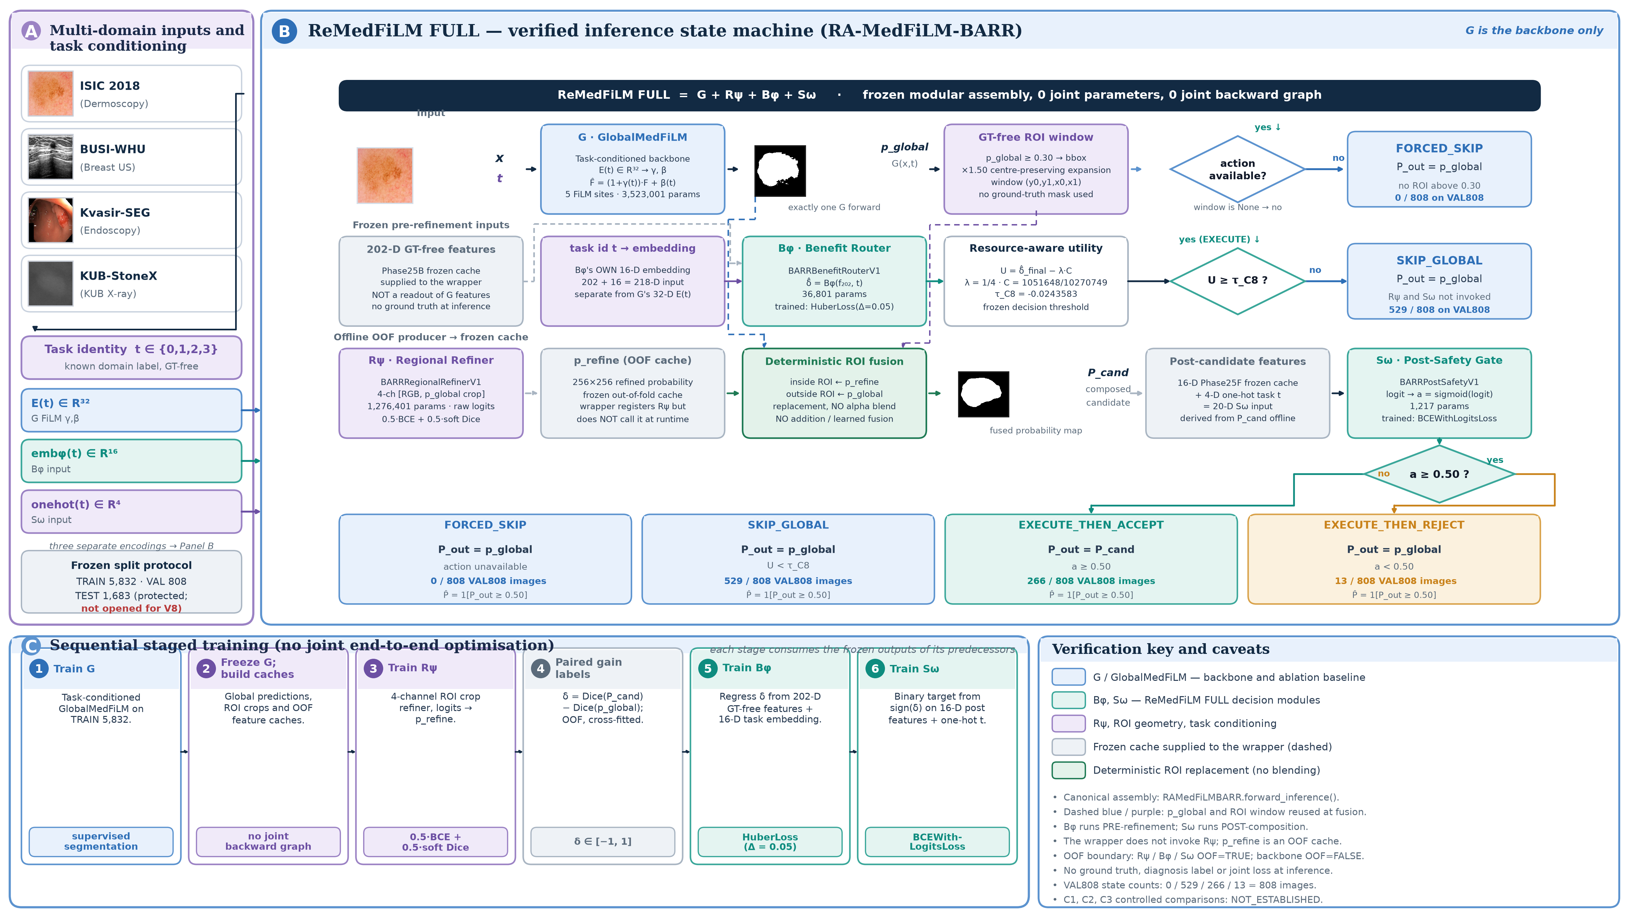
Figure 2. Code-verified three-panel methodology. Panel A: four multi-domain inputs and three distinct task representations. Panel B: the full inference state machine of RAMedFiLMBARR.forward_inference, showing G → action/ROI → B_phi → utility test → offline OOF refined crop → deterministic fusion → S_omega → accept/reject, with both skip states. Panel C: the six-step sequential training dependency, explicitly not joint end-to-end training. Blue denotes GlobalMedFiLM, teal denotes the proposed ReMedFiLM FULL system. [v8_figure_methodology.py; 20 verified arrows]

2.2 G: task-conditioned GlobalMedFiLM (backbone only)
GlobalMedFiLM is a single shared encoder–decoder with channel widths (24, 48, 96, 192, 256) and five FiLM sites at bridge, decoder4, decoder3, decoder2 and decoder1. A 32-D learned task embedding is mapped through a 64-D hidden layer to gamma = tanh(gamma_raw) and beta = tanh(beta_raw) at each site; the output projections are zero-initialised so every site begins as an exact identity transform. The source file states explicitly that the module contains no ROI proposal, localiser, crop branch, router, gain label or safety head. It is the `G` component and a legitimate ablation baseline, not the proposed system.

2.3 R_psi, B_phi and S_omega
BARRRegionalRefinerV1 (R_psi) is a plain 4-channel CNN over ROI crops; it has no FiLM, attention or residual-correction head, and emits a refined crop probability map, not an additive delta P. BARRBenefitRouterV1 (B_phi) consumes a frozen, ground-truth-free 202-D numeric feature vector plus its own 16-D task embedding (218 inputs) and regresses delta_dice through Linear(218,128) → LayerNorm → SiLU → Dropout → Linear(128,64) → … → Linear(64,1). BARRPostSafetyV1 (S_omega) consumes 16 frozen post-candidate numeric features concatenated with a 4-D one-hot task vector (20 inputs) through Linear(20,32) → SiLU → Linear(32,16) → SiLU → Linear(16,1). The three modules therefore use three different task representations: 32-D embedding, 16-D embedding, and 4-D one-hot.

2.4 Verified inference state machine
forward_inference executes G exactly once, derives action availability and the ROI window from p_global >= 0.30, and then follows one of four states. The router utility is U = delta_hat_final − (1/4)(1051648/10270749) with tau_C8 = -0.024358327623641256; U < tau_C8 returns SKIP_GLOBAL. On the execute path a supplied out-of-fold oof_refined_crop_prob is fused by replacing p_global inside the (1.5× expanded) ROI while retaining p_global outside it. S_omega then scores post-candidate features and accepts when its sigmoid is >= 0.50; rejection restores p_global. The final binary mask uses the separate SEGMENTATION_OUTPUT_THRESHOLD = 0.50.
Three distinct 0.50 / 0.30 thresholds — not interchangeable
ROI_PROPOSAL_THRESHOLD = 0.30 governs bbox/action availability; SEGMENTATION_OUTPUT_THRESHOLD = 0.50 binarises the final mask and all reported Dice; SOMEGA_ACCEPT_THRESHOLD = 0.50 governs the post-safety accept decision. Only the first is a proposal threshold.

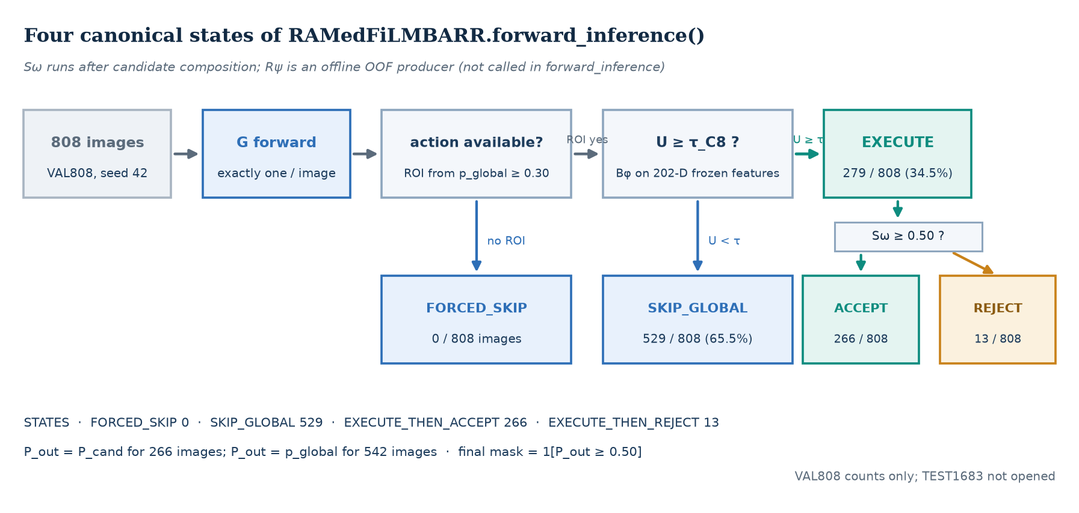
Figure 3. The four canonical VAL808 states of RAMedFiLMBARR.forward_inference. FORCED_SKIP occurs when no action is available; SKIP_GLOBAL occurs when the router utility falls below tau_C8. Executed cases split into accept and reject according to S_omega. Counts are from the frozen Phase 27 prediction table. [phase27_val808_predictions.csv]
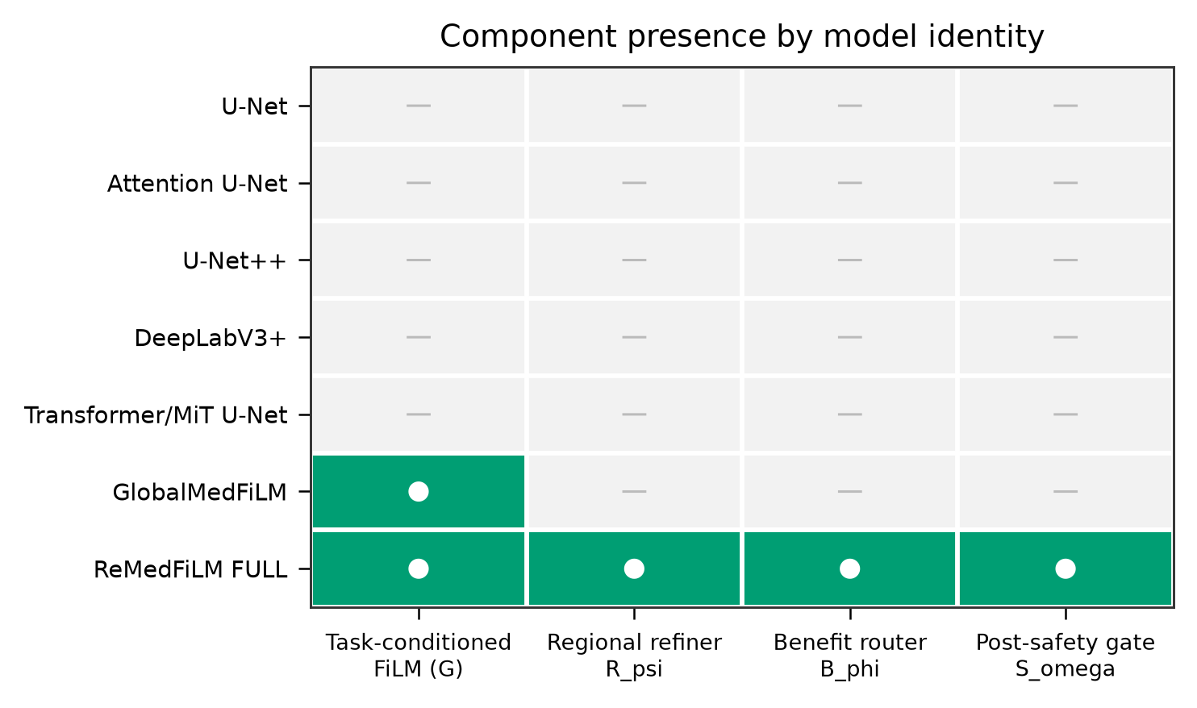
Figure 4. Component-presence matrix. Only the FULL assembly instantiates all four components; GlobalMedFiLM alone instantiates G only. This is the identity check that prevents the backbone from being reported as the proposed model. [figure_registry.json / A02]

2.5 Staged training — sequential, not joint
The six-step dependency is: train G → generate global predictions/ROIs → train R_psi → create paired gain labels → train B_phi → train S_omega. Inference uses frozen modules and frozen out-of-fold caches. The wrapper defines no trainable parameters and no unified objective, so no joint end-to-end backpropagation occurs; claims of end-to-end training in earlier versions are unsupported.
Table 2. Verified per-stage objectives. Each stage is supervised independently; no gradient passes between stages.
Stage | Module | Objective | Target
1 | G | BCEWithLogits + soft Dice (historical train_loss / val_loss) | binary mask
2 | R_psi | 0.5 × BCEWithLogits + 0.5 × soft Dice | ROI-crop mask
3 | B_phi | nn.HuberLoss(delta=0.05, reduction='mean') | delta_dice
4 | S_omega | BCEWithLogitsLoss(reduction='mean') | binary safety_target
Phase 25C gain labels contain delta_dice, gain_category, global_dice and candidate_refined_dice. S_omega targets sign(delta_dice) — it scores refinement benefit, not lesion presence or clinical reliability.
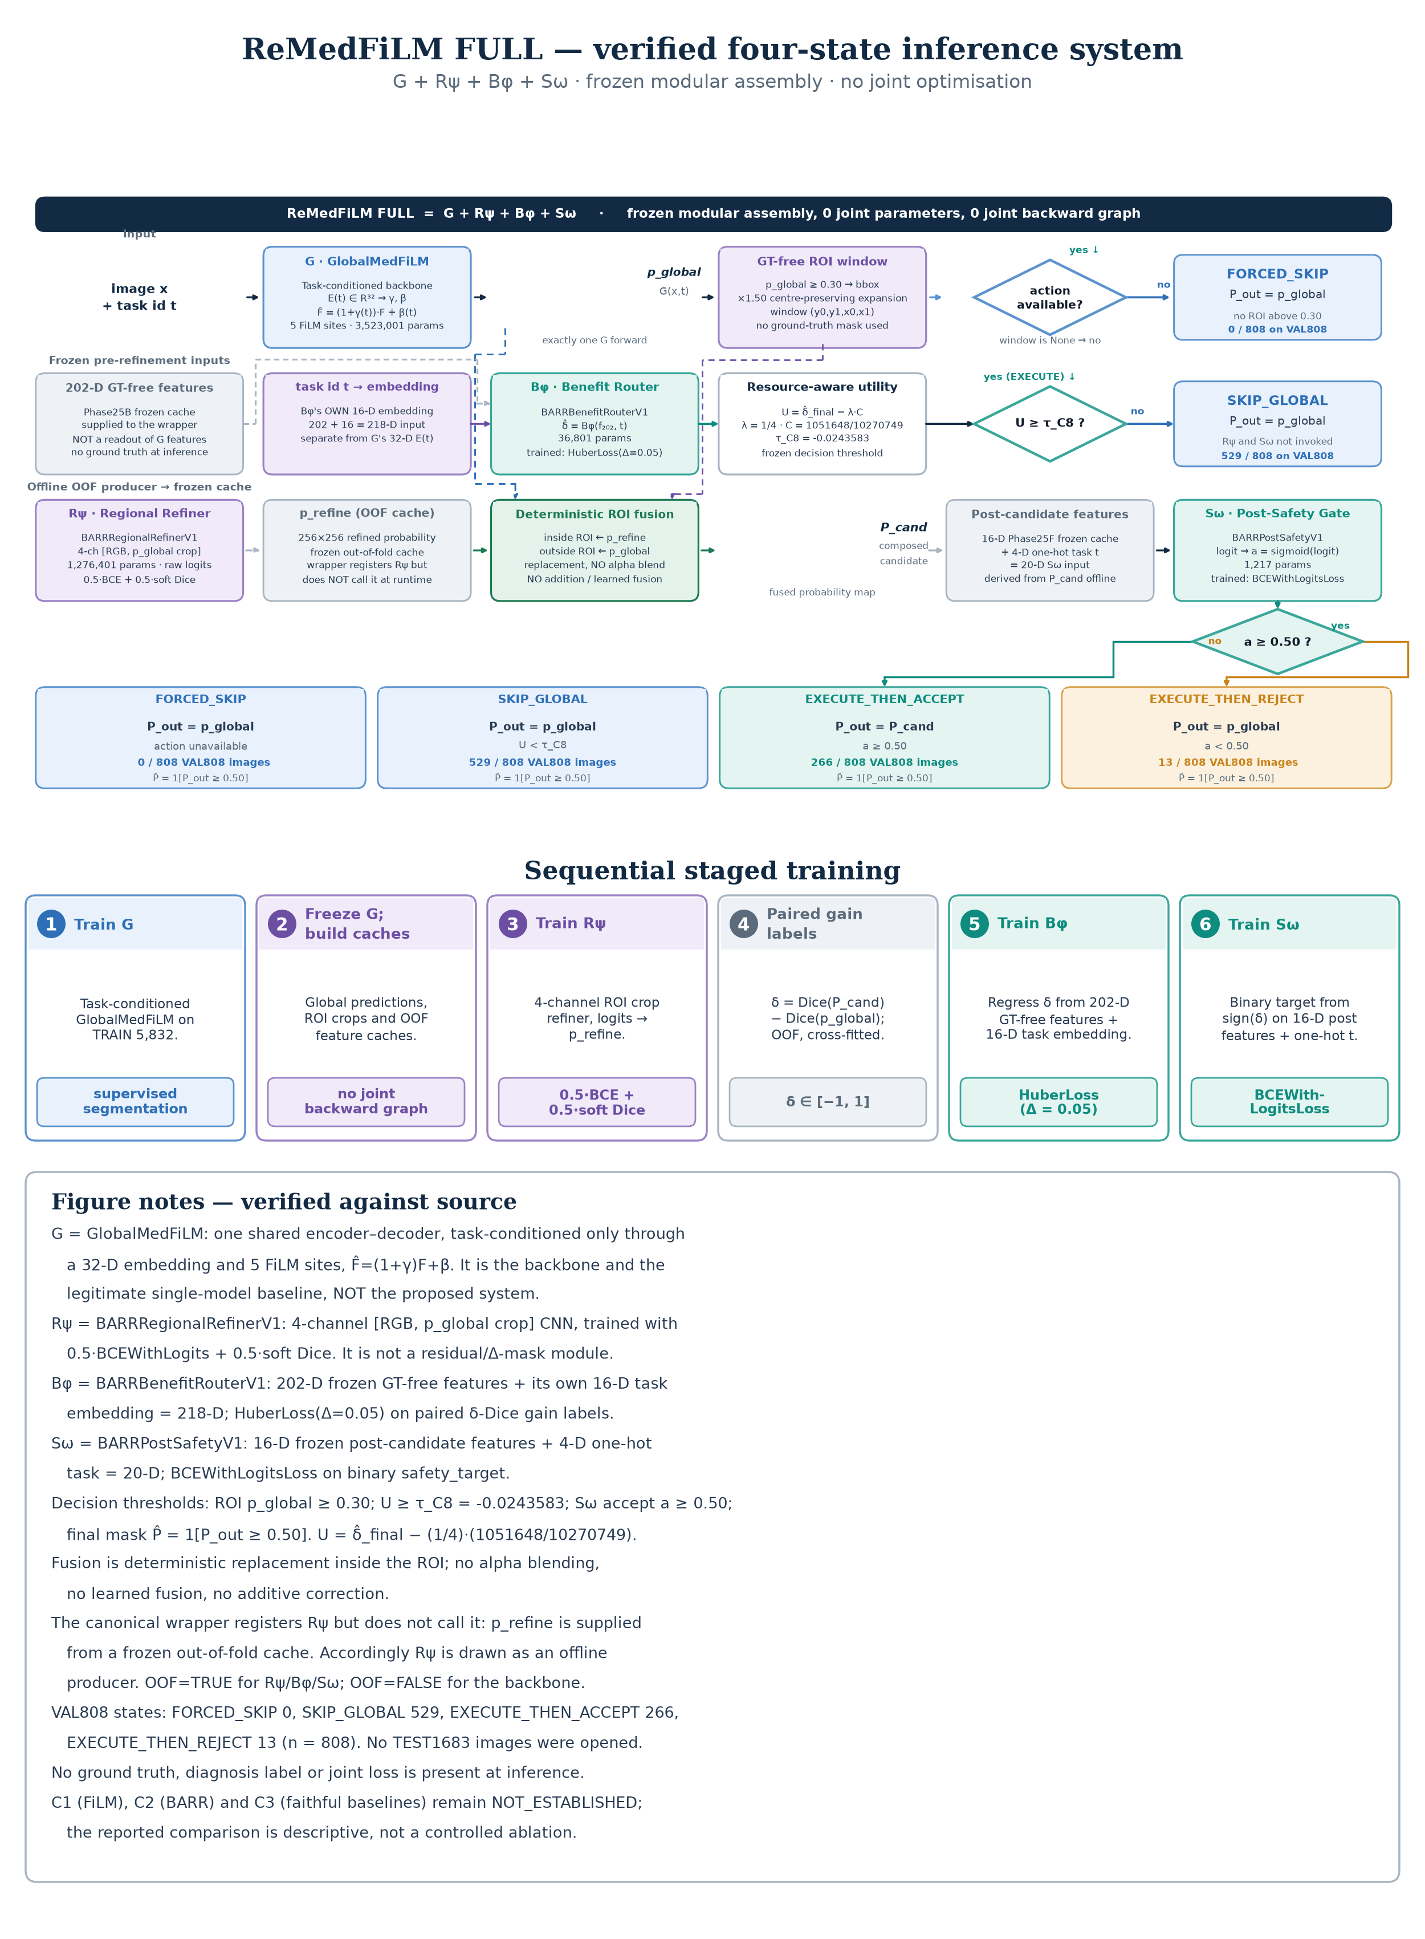
Figure 5. Portrait print variant of the same verified state machine shown in Figure 2, reformatted for single-column manuscript reproduction. It is not a second architecture and introduces no additional pathways or objectives. [v8_figure_methodology.py / manuscript variant]

3. Datasets, splits and evaluation protocol

3.1 Datasets and licensing
Table 3. Source datasets. Dataset licences are separate from the repository code, which currently has no licence file.
Dataset | Modality / target | Licence / use condition | Role
ISIC 2018 | Dermoscopy / skin lesion | Task 1 data: CC0 | internal
BUSI-WHU | Breast ultrasound / lesion | CC BY 4.0, attribution required | internal
Kvasir-SEG | Endoscopy / GI polyp | Research/educational; commercial use needs written permission | internal + CVC external comparator context
KUB-StoneX | KUB radiography / stone | CC BY 4.0, attribution required | internal

KUB unit-of-analysis caveat. The KUB manifest contains full-field radiographs and ROI instance patches; these are different units of analysis and must not be pooled as if interchangeable. The BUSI-WHU workbook distributed with the dataset is deliberately excluded from all published artifacts.

3.2 Split accounting and protected data
Internal data are partitioned into TRAIN (n = 5,832), VAL808 (n = 808) and the protected TEST1683 cohort. Router development used ROUTER_DEV (4,957) plus a locked ROUTER_HOLDOUT (875), which together reconstitute TRAIN. VAL808 domain counts are ISIC 357, BUSI 84, Kvasir 87 and KUB 280. TEST1683 was never opened during V8 reconstruction, and V8 reports no prospective test result.
Table 4. Population accounting used in V8. Values are counts of images unless stated.
Population | n | Status in V8
TRAIN | 5,832 | component training; frozen
VAL808 | 808 | canonical paired evaluation, seed 42
ROUTER_DEV + ROUTER_HOLDOUT | 4,957 + 875 | 13-arm ablation population
TEST1683 | 1,683 | PROTECTED — not opened
EXTERNAL884 | 612 + 252 + 20 | retrospective, no training



