RA-MedFiLM-BARR:
Benefit-Aware Regional Refinement for
Multi-Domain Medical Image Segmentation

Comprehensive Research, Methodology, Experimental Evidence, Robustness Analysis, and Final Manuscript Summary

Author | [AUTHOR NAME]
Supervisor | [SUPERVISOR NAME]
Department | [DEPARTMENT]
Institution | [INSTITUTION]
Date | [DATE]

Frozen final scientific scope: MANUSCRIPT_ASSEMBLY_WITH_DESCRIPTIVE_PHASE39_TEST_ONLY
scientific_delta = 0 | Document assembly only | No TEST access, inference, training, or new statistics
This report is bound to the frozen manuscript reports/manuscript/final/manuscript_final.md
SHA-256 757cb73d419c224909e884b610d69d3fe62da5c33d9cb63115789179da9935a4

Executive Summary
Multi-domain medical image segmentation is usually served by a single global model that processes every input at a fixed computational cost. A natural improvement is to keep a strong global segmenter and add an optional regional refinement that runs only when it is expected to help. The hard part is not the refinement itself: it is deciding, before the expensive computation is performed, whether that refinement is worth running, and protecting the global prediction when it is not.
This report documents RA-MedFiLM-BARR (system A8/C9): a frozen, four-component pipeline that addresses exactly that problem. A shared FiLM-conditioned global segmenter (GlobalMedFiLM, denoted G) produces a global probability map. A learned benefit router (BARRBenefitRouterV1, denoted B_phi) reads a 202-dimensional, ground-truth-free description of the current prediction and geometry and predicts the paired Dice gain that a regional refinement would produce. If that predicted gain is too small, the pipeline skips refinement and keeps the global prediction. If the router decides to execute, a regional refiner (BARRRegionalRefinerV1, denoted R_psi) refines the proposed region, and a post-safety stage (BARRPostSafetyV1, denoted S_omega) decides whether the refinement is safe to accept. Accepted refinements are fused back by a pad-aware fusion; rejected ones fall back to the global prediction.
The central contribution is at the SYSTEM-INTEGRATION level rather than the level of any single component. The specific integration is: (i) a pre-execution, learned regression of the paired ground-truth-derived Dice gain of an optional regional refinement, used as an execute/skip gate; (ii) a post-safety accept/reject stage with a preserved-output fallback; and (iii) this combination applied to multi-domain medical binary segmentation under an explicit preservation constraint. The individual mechanisms (conditional compute, cascades, learned routing, paired-gain estimation, multi-domain segmentation, ground-truth-free quality estimation, rejection/abstention) are established prior art.
The strongest supporting evidence is drawn from frozen development and holdout analyses. On the development set VAL808 (n = 808) the system preserved macro-domain Dice relative to the global reference (difference 0.002210; 95% bootstrap confidence interval [0.001133, 0.003298]; lower bound greater than -0.005). On a one-shot held-out evaluation (ROUTER_HOLDOUT, n = 875) it was non-inferior to the global reference (difference 0.001739; 95% confidence interval [0.001117, 0.002405]), under a disclosed post-first-open scientific source-freeze protocol deviation that is stated verbatim in this report. A thirteen-arm module ablation reported a mean routed true DeltaDice of 0.007516 for the A8/C9 routing-plus-post-safety policy, together with an explicitly reported negative result: the F1 integrated refiner did not improve the pipeline (mean -0.000433). Three-seed reproducibility was descriptive and sign-consistent, with no pass/fail gate and no best-seed selection.
The final system was subsequently evaluated descriptively on all 1,683 TEST samples. The descriptive final-system Dice was 0.88693 for ISIC (n = 735), 0.85042 for BUSI (n = 174), 0.85071 for KVASIR (n = 216), and 0.73769 for KUB (n = 558); the descriptive macro-domain Dice was 0.8314368385956257. No post-hoc TEST sample exclusion was applied.
The TEST limitation (read this before quoting any TEST number)
• The frozen Phase39 protocol prespecified a comparison of the final system against the frozen global reference C-gGLOBAL, with a macro-domain Dice-difference primary endpoint, a confidence-interval decision rule, and per-domain harm rules.
• The successful Phase39 v1.2 execution did NOT emit the required C-gGLOBAL comparator quantities. The primary comparative endpoint is therefore NOT PRODUCED, and the frozen statistical decision is NOT EVALUABLE from the v1.2 output.
• No additional TEST inference was performed to reconstruct the missing endpoint.
• Consequently, the descriptive TEST Dice reported above must NOT be interpreted as superiority, non-inferiority, preservation confirmation, harm-free refinement, or comparative benefit.
• Evidence class: POST_PROTOCOL_TECHNICAL_RECOVERY_TEST_RESULT_WITH_TWO_DISCLOSED_PREOUTCOME_TECHNICAL_FAILURES

Publication status: the frozen manuscript is assembly-complete under the reduced scope MANUSCRIPT_ASSEMBLY_WITH_DESCRIPTIVE_PHASE39_TEST_ONLY, with all numbers provenance-bound and all claims evidence-bound. It is ready for supervisor review as a methodological and descriptive report. It is not ready to support a claim of TEST-confirmed comparative benefit against the global reference.

Table of Contents
The entries below are the report's major sections. In Microsoft Word, right-click the field and choose "Update Field" (or press F9) to populate the automatic Table of Contents with page numbers.

Executive Summary
Section 1 - Research Background
1.1 Medical image segmentation
1.2 Multi-domain segmentation and domain heterogeneity
1.3 Why not always refine?
1.4 The decision problem
1.5 Conditional computation and preservation
Section 2 - Problem Statement
2.1 Desired behaviour
2.2 Formal notation used in this project
Section 3 - Literature Review and Prior Art
3.1 Adaptive inference and the value of computation
3.2 Conditional computation, cascades, and routing
3.3 Treatment-effect estimation and learning to defer
3.4 Segmentation refinement
3.5 Medical dynamic computation
3.6 Universal / multi-domain segmentation
3.7 Ground-truth-free quality estimation, rejection, and abstention
3.8 Mechanisms that already exist versus the contribution of this work
Section 4 - Research Gap and Novelty
4.1 The specific integration
4.2 What is occupied by prior work
4.3 Why the combination is the defensible contribution
Section 5 - Research Questions and Hypotheses
Section 6 - Datasets and Tasks
6.1 Population structure
6.2 Final TEST cohort
6.3 KUB reporting-only subgroups
Section 7 - Complete RA-MedFiLM-BARR Methodology
7.1 Step-by-step methodology flow
7.2 Frozen system architecture schematic (existing frozen figure)
7.3 Frozen inference state machine (existing frozen figure)
7.4 Four-domain input illustration (existing frozen montage)
Section 8 - Final System Architecture
8.1 Component purposes
8.2 Checkpoint identities
Section 9 - GlobalMedFiLM (G)
9.1 Role of the global model
9.2 Task mapping
9.3 Frozen architecture facts
9.4 FiLM conditioning and shared representation
9.5 Frozen inference semantics
Section 10 - ROI Extraction
10.1 Why empty-ROI handling matters
10.2 Frozen ROI illustration (existing frozen figure)
Section 11 - Benefit Router B_phi
11.1 The 202-D feature representation
11.2 Benefit estimation and the execute/skip gate
11.3 Router attribution illustration (existing frozen figure)
Section 12 - Regional Refiner R_psi
12.1 What the refiner sees and produces
12.2 Why refinement is conditional rather than always-run
Section 13 - Post-Safety S_omega
13.1 Frozen forward semantics
13.2 Why this creates a second protection layer
Section 14 - State Machine
Section 15 - Fusion and Final Scoring
15.1 D61 canonical pad-aware fusion
15.2 D75 / POLICY_B final segmentation scoring
15.3 Segmentation output threshold
Section 16 - Development and Experimental Governance
16.1 Governance principles observed throughout
Section 17 - Development and Preservation Results
17.1 ROUTER_HOLDOUT per-domain deltas (Phase30, one-shot)
17.2 Frozen development performance figure (existing frozen figure)
Section 18 - Ablation Study
18.1 What happens without the key modules
18.2 Benefit of the final configuration
18.3 Negative ablation finding
18.4 Frozen ablation figure (existing frozen figure)
Section 19 - Reproducibility
19.1 What this shows
19.2 What reproducibility does NOT prove
Section 20 - One-Shot ROUTER_HOLDOUT Evidence
20.1 Mandatory qualifier
20.2 Frozen holdout figure (existing frozen figure)
Section 21 - Statistical Governance
21.1 The frozen preservation rule
21.2 Why no new confirmatory procedure
Section 22 - Failure-Mode Analysis
22.1 Practical meaning of each family
Section 23 - Computational Efficiency
23.1 Interpretation
Section 24 - Interpretability
24.1 Router feature-group attribution
24.2 Saliency self-consistency
24.3 What was observed and what is only descriptive
Section 25 - Robustness
25.1 Image-perturbation robustness
25.2 Proposal / ROI-perturbation robustness
25.3 KUB reporting-only subgroup robustness
25.4 Frozen robustness figures (existing frozen figures)
Section 26 - Final TEST Evaluation
Section 27 - Phase39 Protocol History and Limitation
27.1 Preserved evidence class
27.2 Terminology constraint
Section 28 - Missing Phase39 Primary Endpoint
28.1 What the descriptive TEST Dice cannot be interpreted as
Section 29 - What We Can Claim
Section 30 - What We Cannot Claim
Section 31 - Summary of Contributions
A. Methodological / system-integration contribution
B. Empirical contribution
C. Governance / reproducibility contribution
Section 32 - Limitations
32.1 Protocol limitations
32.2 Evidence limitations
32.3 Missing primary endpoint
32.4 Dataset, domain, and generalisation limits
Section 33 - Future Work
Section 34 - Conclusion
References
Appendix A - Frozen Model and Checkpoint Identities
Appendix B - Major Phase Timeline
Appendix C - Result Provenance Map
Appendix D - Claim Ledger
Appendix E - Phase39 Execution and Protocol History
Appendix F - Reproducibility and Governance Summary
Appendix G - Reference List
Supervisor Quick Review

List of Figures
Figure 1. Overall RA-MedFiLM-BARR methodology and multi-domain inference pipeline (researcher-supplied methodology infographic).
Figure 2. Frozen full-system architecture.
Figure 3. Canonical inference state machine.
Figure 4. Four-domain input montage.
Figure 5. Predicted ROI localisation panel.
Figure 6. Router feature-group attribution (Phase35).
Figure 7. Post-safety 20-D input breakdown.
Figure 8. Per-domain DeltaDice forest plot on VAL808 (Phase27).
Figure 9. Ablation arm matrix overview (Phase28).
Figure 10. Seed-wise macro DeltaDice on VAL808 (Phase29).
Figure 11. Per-sample final Dice distribution (Phase29).
Figure 12. Compute frontier (frozen).
Figure 13. FiLM gamma heatmap (Phase35).
Figure 14. Image-perturbation DeltaDice heatmap (Phase36).
Figure 15. Proposal-perturbation DeltaDice (Phase36).
Figure 16. Dice distributions (Phase27).

List of Tables
Table 0a. Abbreviations and symbols
Table 5-1. Research questions and frozen evidence
Table 6-1. Task, domain, and modality summary
Table 6-2. Population and split summary
Table 6-3. Frozen TEST cohort composition
Table 6-4. KUB reporting-only subgroup metadata
Table 8-1. Final architecture and component specification
Table 8-2. Frozen component specification with checkpoint identities
Table 8-3. Frozen checkpoint identities
Table 9-1. Frozen GlobalMedFiLM architecture facts
Table 10-1. Frozen ROI proposal parameters
Table 11-1. Frozen B_phi specification
Table 11-2. The 192 deep feature taps
Table 12-1. Frozen R_psi specification
Table 13-1. Frozen S_omega specification
Table 14-1. The four-state decision machine
Table 16-1. Major phase timeline
Table 17-1. VAL808 multi-domain development preservation results
Table 17-2. ROUTER_HOLDOUT per-domain and macro DeltaDice
Table 18-1. Frozen 13-arm ablation results
Table 19-1. Three-seed reproducibility summary
Table 20-1. One-shot ROUTER_HOLDOUT result
Table 21-1. Statistical test registry
Table 22-1. Descriptive failure-mode prevalence
Table 23-1. Computational-efficiency summary
Table 24-1. Router feature-group attribution
Table 24-2. Saliency self-consistency
Table 25-1. Phase36 image-perturbation summary
Table 25-2. Phase36 proposal-perturbation summary
Table 25-3. KUB reporting-only subgroup robustness
Table 26-1. Descriptive Final-System Performance on the Frozen TEST Cohort
Table 27-1. Phase39 execution history
Table 29-1. Claim / evidence boundary
Table 32-1. Key limitations summary
Table A-1. Frozen checkpoint identities
Table B-1. Major phase timeline
Table C-1. Result provenance map
Table D-1. Frozen claim ledger
Table E-1. Phase39 execution and protocol history
Table F-1. Reproducibility and governance summary

Abbreviations and Symbols
Table 0a. Abbreviations and symbols used in this report.
Term | Meaning
G | GlobalMedFiLM - the shared global FiLM-conditioned segmenter (3,523,001 parameters)
B_phi | BARRBenefitRouterV1 - the learned pre-execution benefit router (36,801 parameters)
R_psi | BARRRegionalRefinerV1 - the on-demand regional refiner (1,276,401 parameters)
S_omega | BARRPostSafetyV1 - the post-refinement accept/reject safety stage (1,217 parameters)
ROI | Region of interest, proposed ground-truth-free from the global probability
FiLM | Feature-wise Linear Modulation; F_hat = (1 + gamma) * F + beta
Dice | Dice similarity coefficient (segmentation overlap metric)
IoU | Intersection over Union (secondary overlap metric)
HD95 | 95th-percentile Hausdorff distance (boundary metric)
VAL | Validation; VAL808 is the frozen development set (n = 808)
TEST | The final descriptive evaluation cohort (n = 1,683); closed population
ROUTER_HOLDOUT | The one-shot held-out evaluation population (n = 875)
D61 | The canonical pad-aware fuse_full_field fusion contract
D75 / POLICY_B | The frozen final segmentation scoring representation (live f32 -> f16 -> f32, threshold >= 0.50)
C-gGLOBAL | The frozen global comparator used by the Phase39 primary endpoint
tau / tau_C8_final | The frozen runtime router threshold (-0.024358327623641256)
202-D | The ground-truth-free pre-refinement feature vector consumed by B_phi
MAC | Multiply-accumulate operation (analytical compute unit)
CI | Confidence interval
A8/C9 | The final canonical system configuration / policy identifier

Section 1 - Research Background

1.1 Medical image segmentation
Medical image segmentation assigns a label to every pixel of a medical image, typically separating an anatomical structure or a lesion (foreground) from the surrounding tissue (background). It underpins measurement, staging, treatment planning, and quantitative follow-up. In this project every task is BINARY foreground/background segmentation, and the four domains differ in modality, appearance, and target.

1.2 Multi-domain segmentation and domain heterogeneity
Clinical imaging spans markedly different modalities. Dermoscopy (ISIC), ultrasound (BUSI), endoscopy (KVASIR), and radiography (KUB) differ in contrast mechanism, noise structure, resolution, and the geometry of the structure being segmented. A single shared model is attractive because it amortises one set of weights across all domains, but heterogeneity means that one fixed computational path will not be equally appropriate for every image. A shared model may therefore produce segmentation quality that varies substantially from image to image.

1.3 Why not always refine?
A regional refiner is a second, more expensive network that re-segments a local crop at higher effective resolution. Running it on every image has three costs. First, compute: the refiner roughly doubles the per-image budget. Second, risk: an unconditional refiner can degrade a prediction that was already good, particularly when the region is ambiguous or the crop contains little signal. Third, utility: on many images the global prediction is already correct and refinement changes nothing.

1.4 The decision problem
The interesting problem is therefore not refinement but the decision to refine. That decision must be made BEFORE the refinement is computed (otherwise no compute is saved), must be learnable from paired outcomes, and must be governed by a preservation constraint so that the global prediction is protected when refinement is not warranted. In this project the decision target is the paired difference between the outcome after refinement and the outcome without it, estimated per image before deciding.

1.5 Conditional computation and preservation
Conditional computation is the general idea of spending computation only where it is expected to help. Applied here, it produces a pipeline in which the global model always runs, a cheap router always runs, and the expensive refiner runs only when the router expects a benefit. A further safety stage protects against a refinement that is executed but turns out to be unhelpful, by reverting to the global prediction.

Section 2 - Problem Statement
The core research problem is to decide, before running an optional regional refinement, whether that refinement is likely to be beneficial, and to combine the global and refined predictions so that the global prediction is preserved whenever refinement should not be used.

2.1 Desired behaviour
The desired behaviour of the system is the following sequence:
- Run the global segmentation model G to obtain the global prediction p_global.
- Inspect the current prediction, its geometry, and learned features.
- Estimate whether regional refinement is likely to be beneficial.
- Skip refinement when the expected benefit is low (preserving compute and the prediction).
- Execute refinement when it is expected to be appropriate.
- Apply a post-refinement safety decision to the executed refinement.
- Fuse safely when the refinement is accepted, and preserve the global prediction otherwise.

2.2 Formal notation used in this project
The report uses only notation that is already frozen in the repository. The frozen decision vocabulary distinguishes the router decision from the final state:
- Router decision (B_phi gate): EXECUTE iff U(delta_hat_final) >= tau_C8_final, else SKIP, where U = delta_hat_final - 0.25 * C_ACTION.
- Final state: exactly one of FORCED_SKIP, SKIP_GLOBAL, EXECUTE_THEN_ACCEPT, or EXECUTE_THEN_REJECT.
- Probability operator: p_global = sigmoid(logits.float()).
- Final scoring: mask = (probability >= 0.50) under the frozen D75/POLICY_B representation.
- Fusion: canonical D61 pad-aware fuse_full_field(p_global, refined, geom).
No mathematical definition beyond the frozen threshold contract is introduced in this report.

Section 3 - Literature Review and Prior Art
This section summarises the frozen prior-art families that frame the contribution. The mapping below is taken from the frozen manuscript's related-work analysis, and every citation resolves to the frozen reference set (Section 39).

3.1 Adaptive inference and the value of computation
The idea of spending computation only when it is expected to improve a decision originates in metareasoning, where a computation is executed only if its expected value exceeds its cost [russell1991metareasoning], and is formalised for adaptive inference by the theory of achievable performance-preserving efficiency gains [hor2024adaptiveinference]. Learned, differentiable allocation of computation with an explicit cost penalty appears in adaptive computation time [graves2016act].

3.2 Conditional computation, cascades, and routing
The architectural pattern of a cheap stage gating an expensive one is canonical: boosted cascades reject easy cases early [viola2001cascade]; optimal pass-on criteria decide whether to escalate to a more expensive cascade stage [latotzke2021cascade]; and region proposals gate an expensive per-region head [ren2015fasterrcnn]. Learned per-input execute/skip of computation appears in SkipNet [wang2018skipnet] and mixture-of-depths routing [raposo2024mod]. Modality-specific mixture-of-experts routing in medical segmentation is occupied by M4oE [jiang2024m4oe].

3.3 Treatment-effect estimation and learning to defer
The decision target used here is a paired difference of outcomes under two conditions, estimated per unit before deciding. That is the standard causal-inference structure of conditional average treatment effects [kunzel2019metalearners]. The closest general formulation is learning to defer to a costlier expert with an explicit cost and a preservation structure [mozannar2020defer], and its dense medical-segmentation analogue routes to a human expert before finalising [tian2026deferredseg].

3.4 Segmentation refinement
Within segmentation, unconditional refinement primitives are established [wang2023segrefiner], and the always-run coarse-to-fine cascade is the canonical baseline [isensee2021nnunet]. The single closest functional analogue judges whether a refinement was worth it AFTER running it and may revert, so it saves no compute [moon2024jfs]. Acting on the region that provides the most gain is also explored for cropping in vision-language models [zhao2026lfpc], and regional zoom/refinement for small structures is prior art [bouzid2023scaleaware, chou2024tinylessurvey].

3.5 Medical dynamic computation
In medical imaging, deciding compute allocation BEFORE running the model is occupied by Med-DANet and Med-DANet V2, which select a crop and a quantisation level rather than a refinement gain [shen2022meddanet, shen2024meddanetv2], and by adaptive patching that allocates attention by image detail [zhang2024adaptivepatching].

3.6 Universal / multi-domain segmentation
A shared multi-domain medical segmentor is not a novel component, as shown by universal few-shot segmentation [butoi2023universeg] and promptable universal medical segmentation [ma2024medsam].

3.7 Ground-truth-free quality estimation, rejection, and abstention
Ground-truth-free estimation of the quality of a CURRENT prediction is solved [laves2018qualitypred, borges2024sdc, huang2024evanyseg], and is distinct from predicting the gain of a FUTURE action. Rejection and abstention mechanisms preserve reliability at the pixel or decision level [sanisoglu2026abstain, chow1970reject], and conformal methods control the risk of a single output [tan2026cls]; none of these bounds the gain of an optional refinement. Device-aware lightweight segmentation is likewise crowded [zhang2023mobilesam].

3.8 Mechanisms that already exist versus the contribution of this work
Where the boundary lies
• INDIVIDUAL MECHANISMS ALREADY EXIST: conditional computation, cascades, learned execute/skip routing, paired-gain / treatment-effect estimation, learning to defer, segmentation refinement primitives, multi-domain universal segmentation, ground-truth-free quality estimation, and rejection/abstention.
• DEFENSIBLE CONTRIBUTION OF THIS WORK: the specific integration of a pre-execution, learned, ground-truth-derived paired-Dice-gain gate for an OPTIONAL regional refinement, with a post-safety accept/reject stage and a preserved-output fallback, applied to multi-domain medical binary segmentation under an explicit preservation constraint.

Section 4 - Research Gap and Novelty
The defensible novelty of this work is primarily at the SYSTEM-INTEGRATION / SPECIFICATION level, not the level of individual components. This distinction matters for a supervisor because it determines what can and cannot be claimed.

4.1 The specific integration
The contribution is the specific combination of:
- Shared multi-domain segmentation (one global model across four clinical domains).
- A global prediction produced by that shared model.
- Pre-execution benefit estimation, made before the expensive computation.
- GT-derived paired Dice-gain supervision used during development to train the router.
- A learned benefit router that produces the execute/skip gate.
- Conditional regional refinement, executed only on the EXECUTE branch.
- A post-refinement safety decision that can reject an executed refinement.
- A safe global fallback that preserves the global prediction.
- Pad-aware fusion that pastes accepted refinements back into the full field.
- Multi-domain medical binary segmentation as the application setting.
- Frozen, preservation-oriented governance throughout.

4.2 What is occupied by prior work
Section 3 documents that the individual mechanisms are occupied: the gate concept [viola2001cascade, latotzke2021cascade, wang2018skipnet], the paired-gain target formulation [kunzel2019metalearners], conditional compute [graves2016act, raposo2024mod], learning to defer [mozannar2020defer, tian2026deferredseg], refinement primitives [wang2023segrefiner], post-hoc-refinement judging [moon2024jfs], medical dynamic compute [shen2022meddanet, shen2024meddanetv2, zhang2024adaptivepatching], and multi-domain segmentation [butoi2023universeg, ma2024medsam].

4.3 Why the combination is the defensible contribution
The closest single functional analogue judges whether a refinement was worth it after running it [moon2024jfs] and therefore saves no compute. The medical dynamic-compute family decides compute allocation before running the model but selects a crop or a quantisation level rather than predicting the gain of an optional refinement [shen2022meddanet, shen2024meddanetv2]. This work combines a pre-execution learned paired-Dice-gain gate with a post-safety accept/reject and a preserved-output fallback for an OPTIONAL refinement in multi-domain medical segmentation, and evaluates it under an explicit preservation constraint. That integration, and its frozen preservation-oriented evaluation, is the defensible contribution. No stronger novelty claim is made.

Section 5 - Research Questions and Hypotheses
The following research questions are derived from the frozen project evidence. Where the project used frozen wording, that wording is preserved.
Table 5-1. Research questions and the frozen evidence that addresses them.
ID | Research question | How it is addressed (frozen evidence)
RQ1 | Can a learned router estimate, before refinement is computed, when regional refinement is beneficial? | Addressed by the Phase28 ablation (B_phi benefit capture and harmful-activation share on ROUTER_DEVELOPMENT) and the Phase27/30 preservation evaluations.
RQ2 | Can conditional regional refinement improve selected cases without materially degrading the shared global model? | Addressed by the Phase27 VAL808 preservation evaluation and the Phase30 one-shot ROUTER_HOLDOUT non-inferiority evaluation.
RQ3 | Does the system remain reproducible across seeds? | Addressed by the Phase29 three-seed reproducibility analysis (seeds 42/123/3407), which is descriptive with no pass/fail gate and no best-seed selection.
RQ4 | What failure modes occur in practice? | Addressed by the Phase33 descriptive failure analysis on ROUTER_HOLDOUT.
RQ5 | What is the computational cost of conditional refinement? | Addressed by the Phase34 analytical MAC lower bound and hardware-specific measured runtime profile.
RQ6 | How robust is the system to image and proposal perturbations? | Addressed by the Phase36 synthetic image-perturbation and proposal-perturbation studies on VAL808.
RQ7 | How interpretable are the FiLM and routing decisions? | Addressed by the Phase35 descriptive model-mechanism evidence.

No new confirmatory hypothesis test was created. The Phase31 statistical-governance closure established that no new confirmatory significance procedure is eligible, so all reported statistical evidence is descriptive (bootstrap confidence intervals only).

Section 6 - Datasets and Tasks
Four clinical domains are used. All four are BINARY foreground/background segmentation tasks. Task identity is frozen and differs from an alphabetical order.
Table 6-1. Task, domain, and modality summary. Task IDs: 0 = ISIC, 1 = BUSI, 2 = KVASIR, 3 = KUB.
Task | Domain | Modality | Channels | Segmentation target
Task 0 | ISIC | RGB dermoscopy | 3-channel RGB | Binary foreground / background
Task 1 | BUSI | Ultrasound | L -> RGB | Binary foreground / background
Task 2 | KVASIR | RGB endoscopy | 3-channel RGB | Binary foreground / background
Task 3 | KUB | Radiograph | L / RGB | Binary foreground / background

6.1 Population structure
The frozen population structure distinguishes the development training set, the development validation set VAL808, the ablation/reproducibility development population ROUTER_DEVELOPMENT, the one-shot held-out population ROUTER_HOLDOUT, and the final TEST cohort.
Table 6-2. Population and split summary. TEST counts are metadata only.
Population | n | Per-domain composition | Role
TRAIN | 5,832 | ISIC 2,556 / BUSI 602 / KVASIR 696 / KUB 1,978 | Development training set
VAL808 | 808 | ISIC 357 / BUSI 84 / KVASIR 87 / KUB 280 | Frozen development / validation set (Phase27)
ROUTER_DEVELOPMENT | 4,957 | Budget K = 1,239 routed rows | Ablation / reproducibility development population (Phase28/29)
ROUTER_HOLDOUT | 875 | BUSI 90 / ISIC 383 / KUB 298 / KVASIR 104 | One-shot held-out evaluation (Phase30)
TEST | 1,683 | ISIC 735 / BUSI 174 / KVASIR 216 / KUB 558 | Final descriptive evaluation cohort (Phase39 v1.2)

6.2 Final TEST cohort
The final TEST cohort contains 1,683 samples. Its per-domain composition is ISIC 735, BUSI 174, KVASIR 216, and KUB 558.
Table 6-3. Frozen TEST cohort composition and descriptive final-system Dice.
Domain | n | Descriptive final-system Dice | Status
ISIC | 735 | 0.88693 | PRESENT
BUSI | 174 | 0.85042 | PRESENT
KVASIR | 216 | 0.85071 | PRESENT
KUB | 558 | 0.73769 | PRESENT
MACRO (macro-domain Dice) | 1,683 | 0.8314368385956257 | PRESENT

6.3 KUB reporting-only subgroups
The KUB domain carries subgroup identity metadata (Kidney_Stone, Bladder_Stone, Ureteric_Stone). This identity is REPORTING METADATA ONLY. It is never used as a segmentation class, a task ID, a model input, a routing input, or a conditioning variable.
Table 6-4. KUB reporting-only subgroup metadata.
KUB subgroup | n (VAL808 KUB subset) | Role
Kidney_Stone | 112 | REPORTING-ONLY metadata
Bladder_Stone | 144 | REPORTING-ONLY metadata
Ureteric_Stone | 24 | REPORTING-ONLY metadata

Section 7 - Complete RA-MedFiLM-BARR Methodology
This section explains the complete methodology from the input image to the final segmentation. The researcher-supplied methodology infographic is reproduced first, followed by a step-by-step verbal description of the entire flow.
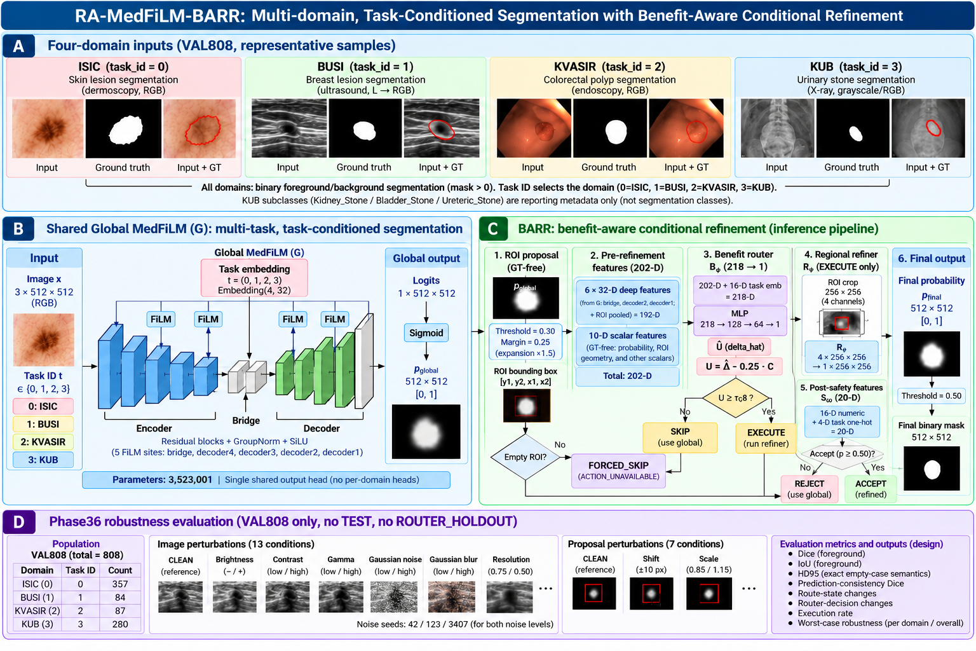
Figure 1. Overall RA-MedFiLM-BARR methodology and multi-domain inference pipeline (researcher-supplied methodology infographic; aspect ratio preserved).

7.1 Step-by-step methodology flow

Step 1 - Multi-domain input
A [3, 512, 512] image from one of four domains (ISIC, BUSI, KVASIR, KUB) is passed to the shared global segmenter. Domain identity enters ONLY as a frozen task ID (0=ISIC, 1=BUSI, 2=KVASIR, 3=KUB).

Step 2 - Global prediction (G)
GlobalMedFiLM (3,523,001 parameters) produces global logits; the canonical probability is p_global = sigmoid(logits.float()). FiLM conditioning modulates five internal stages (bridge, decoder4/3/2/1) using a learned 32-D task embedding.

Step 3 - GT-free ROI proposal
A region of interest is derived from p_global alone (threshold 0.30, fractional margin 0.25, x1.5 expansion; 512 canvas, 256 crop). No ground truth is used. An empty proposal yields ACTION_UNAVAILABLE and the FORCED_SKIP state.

Step 4 - 202-D feature assembly
Six groups of 32-D G feature taps (bridge, decoder2, decoder1; each in GLOBAL and ROI scope) plus 10 prediction/geometry scalars form a ground-truth-free 202-D vector.

Step 5 - Benefit routing (B_phi)
BARRBenefitRouterV1 (36,801 parameters) consumes the 202-D vector plus a 16-D task embedding and regresses the paired refinement Dice gain delta_hat. The resource-aware utility U = delta_hat - 0.25*C is compared with the frozen tau to decide SKIP or EXECUTE.

Step 6 - Conditional regional refinement (R_psi)
Only on EXECUTE: the ROI crop (RGB plus the global-probability channel, [B,4,256,256]) is refined by BARRRegionalRefinerV1 (1,276,401 parameters) into a regional probability.

Step 7 - Post-refinement safety (S_omega)
A 16-D numeric description of the change plus a 4-D task one-hot is scored by BARRPostSafetyV1 (1,217 parameters); the refinement is ACCEPTED iff sigmoid(logit) >= 0.50.

Step 8 - Pad-aware fusion and final scoring
Accepted refinements are pasted back into the full-field global probability by the canonical D61 pad-aware fuse_full_field. Output is scored under the frozen D75/POLICY_B representation (live f32 -> f16 -> f32, threshold >= 0.50). The pipeline emits exactly one of four states.

7.2 Frozen system architecture schematic (existing frozen figure)
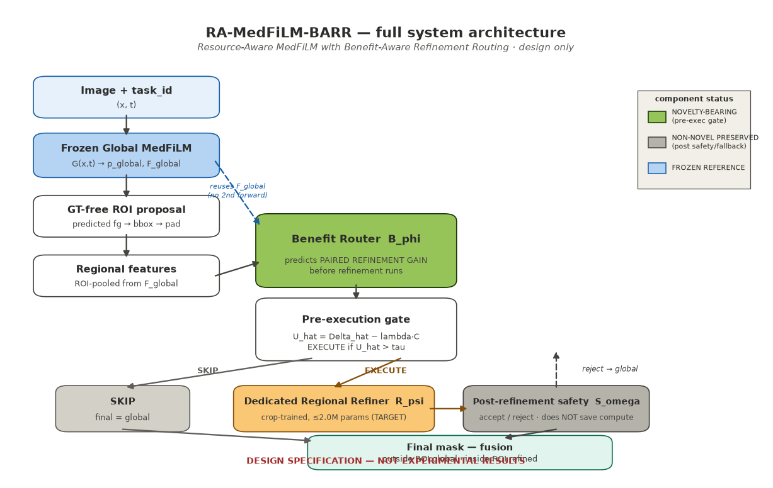
Figure 2. Frozen full-system architecture (existing frozen visual reference; source: reports/figures/methodology_diagram_package/existing_visual_references/).

7.3 Frozen inference state machine (existing frozen figure)
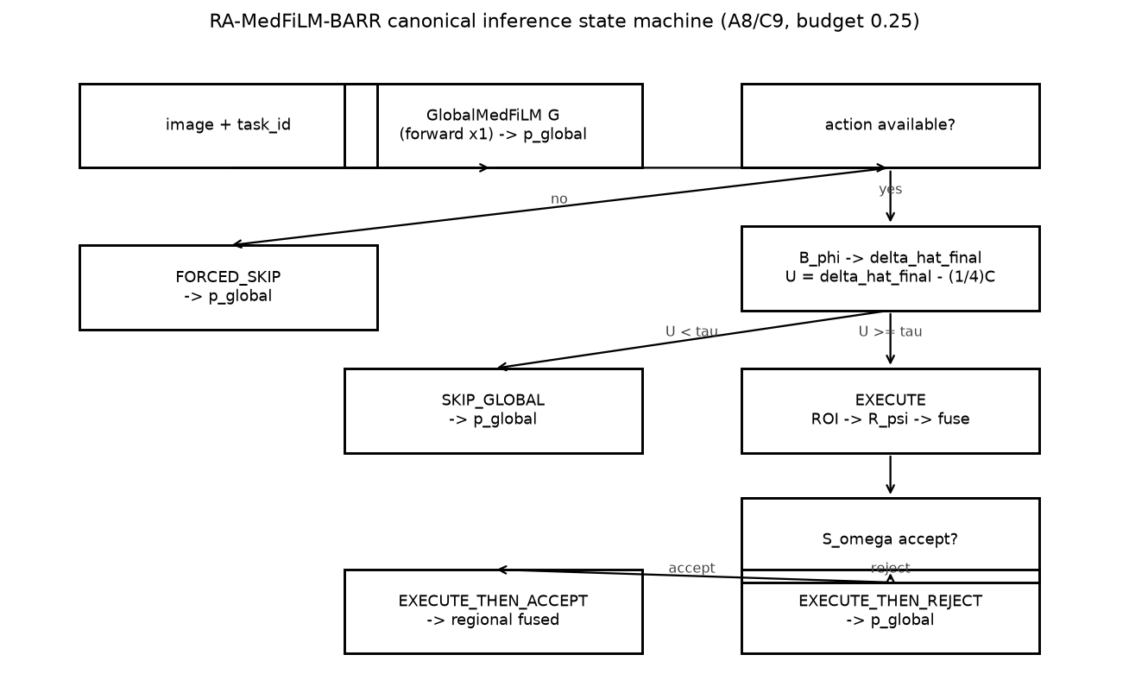
Figure 3. Canonical inference state machine: FORCED_SKIP, SKIP_GLOBAL, EXECUTE_THEN_ACCEPT, EXECUTE_THEN_REJECT (existing frozen visual reference).

7.4 Four-domain input illustration (existing frozen montage)
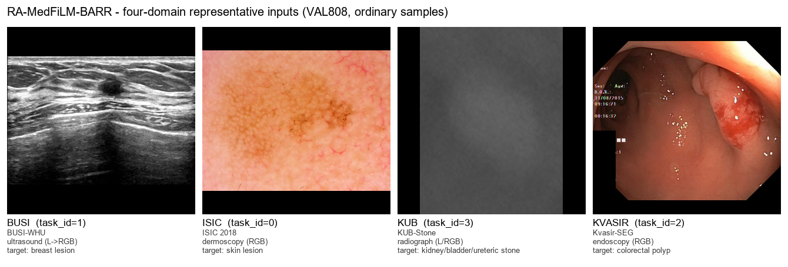
Figure 4. Four-domain input montage (BUSI | ISIC | KUB | KVASIR) with task IDs and modalities. No performance numbers are encoded in this figure.

Section 8 - Final System Architecture
The final system is a frozen four-component conditional-refinement pipeline. No component was trained, selected, or tuned in the release process (scientific_delta = 0).
Table 8-1. Final architecture and component specification.
Component | Class | Parameters | Primary output / input | Execution condition
G | GlobalMedFiLM | 3,523,001 | Always executed | always executed
B_phi | BARRBenefitRouterV1 | 36,801 | 202-D features + task embedding | pre-gate (always executed)
R_psi | BARRRegionalRefinerV1 | 1,276,401 | [B,4,256,256] ROI crop | EXECUTE branch only
S_omega | BARRPostSafetyV1 | 1,217 | 16-D numeric + 4-D task one-hot | EXECUTE branch only
-- | RAMedFiLMBARR (assembly wrapper) | 0 trainable | assembly only | assembly only

Table 8-2. Frozen component specification with checkpoint identities (source: reports/tables/phase37_consolidated/T37-01).
Component | Parameters | Checkpoint bytes | Checkpoint SHA-256 | Execution role
G | 3523001 | 42369710 | 286689fdd5c63ad75a383151d267af8b476e7a98327632de292ce6ed5b5ba1b7 | always executed
R_psi | 1276401 | 15425424 | 6d28608a669df497740b6594ab346136f4efdf3f66002a868a1f1a3ec6689109 | EXECUTE branch only
B_phi | 36801 | 455682 | 8a412b2fe82f225f844fda07379a6436c1d73d435f885b26a1d88d5b2f9fc43b | pre-gate (always executed)
S_omega | 1217 | 7816 | eee9b97b9921e53fc07eac9281dce64ba518c6e1659916b97b0b3bec21ec6d2e | EXECUTE branch only

The total parameter count is 4,837,420, of which 0 are trainable in the assembly wrapper.

8.1 Component purposes
- G (GlobalMedFiLM) always runs and produces the global prediction for every input.
- B_phi (BARRBenefitRouterV1) is a cheap pre-gate that always runs and decides SKIP or EXECUTE before any refinement is computed.
- R_psi (BARRRegionalRefinerV1) runs only on the EXECUTE branch and refines the proposed region.
- S_omega (BARRPostSafetyV1) runs only on the EXECUTE branch, after R_psi, and decides whether the refinement is accepted or rejected.
- The RAMedFiLMBARR assembly wrapper adds no parameters and performs assembly only; it has no learned layers, loss, optimizer, or backward pass.

8.2 Checkpoint identities
Checkpoint replacement is not permitted. The load contract fails closed on any SHA-256 mismatch, requires strict loading with zero missing/unexpected keys, requires all weights finite, requires all modules in eval mode with requires_grad=False, and requires CUDA-only execution.
Table 8-3. Frozen checkpoint identities used by the final system.
Component | Class | Checkpoint path | SHA-256
G | GlobalMedFiLM | checkpoints/phase21_global_medfilm_fourdomain_seed42_clean_v3/best.pt | 286689fdd5c63ad75a383151d267af8b476e7a98327632de292ce6ed5b5ba1b7
B_phi | BARRBenefitRouterV1 | checkpoints/phase25d_barr_benefit_router_v1_2_1_seed42/final/final.pt | 8a412b2fe82f225f844fda07379a6436c1d73d435f885b26a1d88d5b2f9fc43b
R_psi | BARRRegionalRefinerV1 | checkpoints/phase25a_barr_regional_refiner_v1_1_roi030/final/final.pt | 6d28608a669df497740b6594ab346136f4efdf3f66002a868a1f1a3ec6689109
S_omega | BARRPostSafetyV1 | checkpoints/phase25f_barr_post_safety_v1_0_seed42/final/final.pt | eee9b97b9921e53fc07eac9281dce64ba518c6e1659916b97b0b3bec21ec6d2e

Section 9 - GlobalMedFiLM (G)
GlobalMedFiLM is the shared global segmenter. It is the component that is always executed, and it defines the baseline prediction that the rest of the pipeline may (or may not) refine.

9.1 Role of the global model
The global model provides a single shared representation and a single shared output head across all four domains. Multi-domain conditioning enters only through a learned task embedding, so the model does not carry per-domain heads. Its output is a single-channel probability map p_global.

9.2 Task mapping
Task mapping is frozen: 0 = ISIC, 1 = BUSI, 2 = KVASIR, 3 = KUB.

9.3 Frozen architecture facts
Table 9-1. Frozen GlobalMedFiLM architecture facts (source: methodology_diagram_manifest.json).
Property | Value
Class | GlobalMedFiLM
Architecture ID | global_medfilm_shared_residual_unet_film5_no_se_no_deep_supervision_v1
Parameters | 3,523,001
Number of tasks | 4
Input | 3 channels, 512 x 512
Output | single-channel global logits [1,H,W] -> p_global = sigmoid(logits)
Encoder channels | encoder1 24 / encoder2 48 / encoder3 96 / encoder4 192 / bridge 256
Decoder channels | decoder4 192 / decoder3 96 / decoder2 48 / decoder1 24
FiLM locations | bridge, decoder4, decoder3, decoder2, decoder1
FiLM rule | F_hat = (1 + gamma) * F + beta ; gamma,beta = tanh(W e + b) ; zero-initialized output
Task embedding | nn.Embedding(4, 32); task conditioning entry point ONLY
Output head | single shared nn.Conv2d(24, 1, kernel_size=1); no dataset-specific head
Normalization / activation | GroupNorm / SiLU
BARR feature taps | bridge (256), decoder1 (24), decoder2 (48)
Absent modules | SE, attention, dropout (G core), deep supervision, per-domain heads

9.4 FiLM conditioning and shared representation
FiLM (Feature-wise Linear Modulation) modulates intermediate features with a task-conditioned affine transform: F_hat = (1 + gamma) * F + beta, where gamma and beta are produced by tanh(W e + b) from the task embedding e, with a zero-initialised output. The task embedding (dimension 32) is used ONLY as this conditioning entry point; task_id is never concatenated, channelised, or routed to a per-domain head. The output head is a single shared 1x1 convolution.

9.5 Frozen inference semantics
- Input tensor shape [3, 512, 512].
- fp32 model and fp32 input.
- CUDA required for scientific execution.
- autocast fp16 enabled.
- torch.no_grad() for global inference.
- Domain-local contiguous batches of 8.
- Canonical probability operator: sigmoid(logits.float()).
- Final scoring uses the frozen D75/POLICY_B representation (live float32, persisted float16, scored float32, threshold >= 0.50).
These details are frozen and are not changed anywhere in this report.

Section 10 - ROI Extraction
A region of interest is proposed from the global probability alone. The proposal is ground-truth-free: no label or mask information is used at any point.
Table 10-1. Frozen ROI proposal parameters.
Property | Frozen value | Symbol / note
p_global threshold | 0.30 | ROI_PROPOSAL_THRESHOLD
Fractional margin | 0.25 | ROI_FRACTIONAL_MARGIN
Expansion factor | x1.5 | (1 + 2*margin) = 1.50; centre-preserving
Canvas | 512 | rasterisation canvas
Crop | 256 | ROI crop resized to 256 x 256 for R_psi
GT involvement | None | ROI is GROUND-TRUTH-FREE (derived from p_global only)
Empty ROI behaviour | ACTION_UNAVAILABLE -> FORCED_SKIP | router and refiner are not invoked

10.1 Why empty-ROI handling matters
When the proposal is empty, the pipeline cannot form a crop. The frozen behaviour is ACTION_UNAVAILABLE, which forces the FORCED_SKIP state. In FORCED_SKIP the router, refiner, and safety stage are not invoked at all, and the global prediction is emitted unchanged. This is the safest possible behaviour: it neither spends compute nor risks altering a prediction for which no region could be identified.

10.2 Frozen ROI illustration (existing frozen figure)
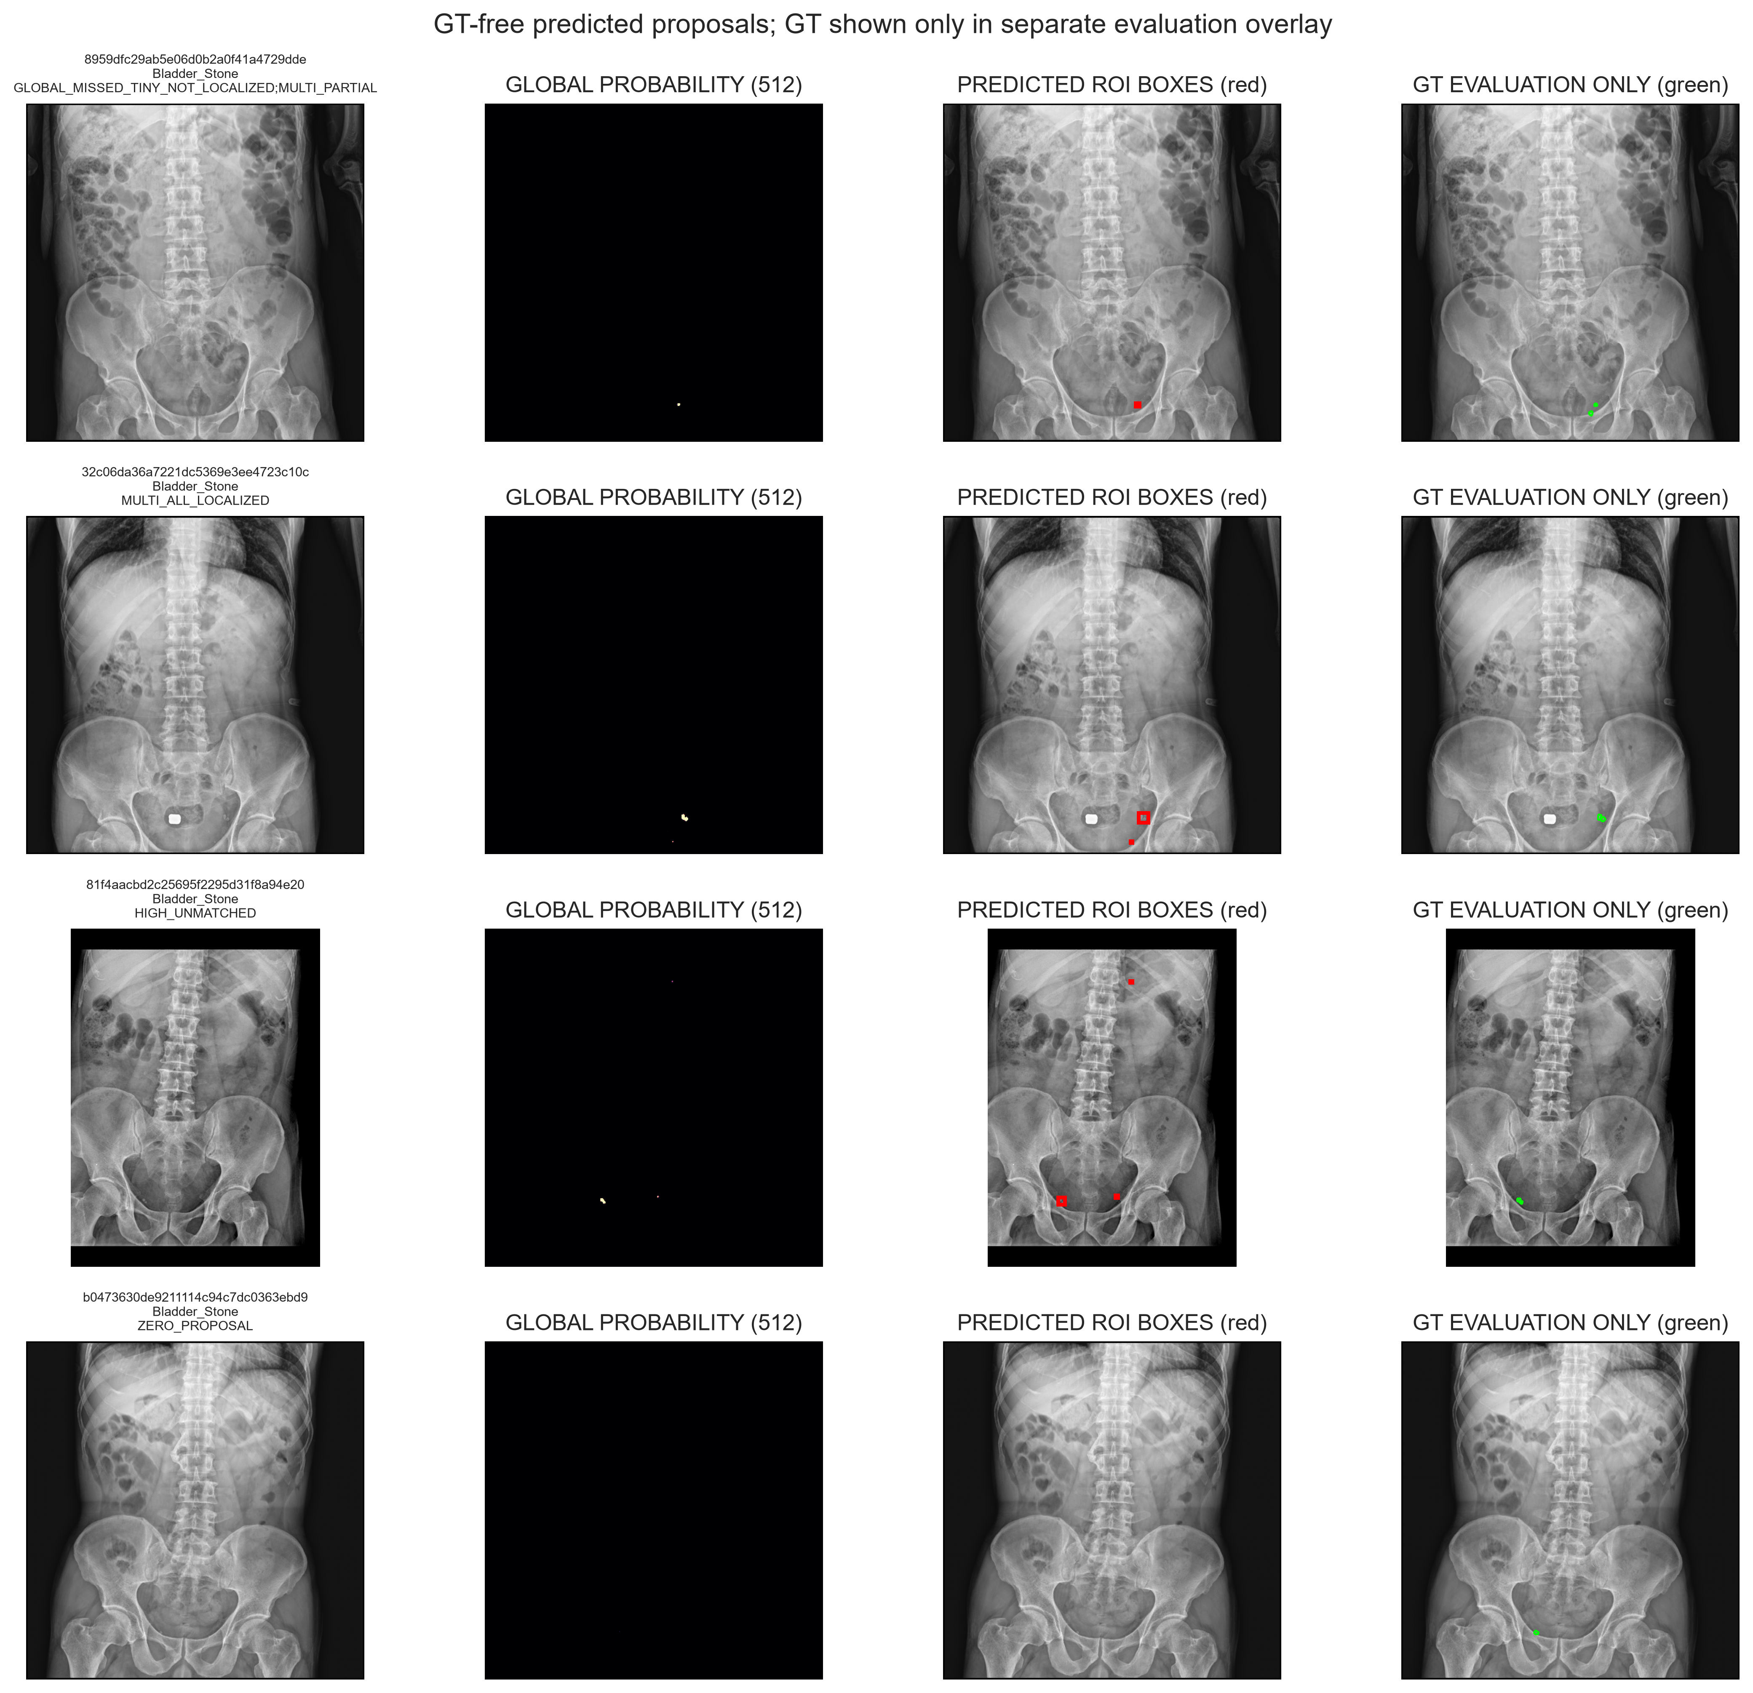
Figure 5. Predicted ROI localisation panel (existing frozen visual reference). The ROI is derived ground-truth-free from p_global.

Section 11 - Benefit Router B_phi
The benefit router is the component that decides whether the optional refinement is worth running. It runs before the refiner whenever an action is available.
Table 11-1. Frozen B_phi specification (source: methodology_diagram_manifest.json; thresholds_and_decisions.json).
Property | Frozen value
Class | BARRBenefitRouterV1
Parameters | 36,801
Architecture | nn.Embedding(4,16) + MLP[218 -> 128 -> 64 -> 1] with LayerNorm + SiLU + Dropout(0.10)
Numeric input dimension | 202 (192 deep + 10 scalar)
Task embedding dimension | 16
Total input dimension | 218
Output | 1 scalar delta_hat (paired refinement gain); Huber loss delta = 0.05
Input scalar normalisation | FIT-only, SCALAR_NORMALIZE_IDX=[192,193,194,195,196,197,200,201], ddof=0
Frozen tau (runtime authority) | tau_C8_final = float -0.024358327623641256 (exact rational -5003565381643716252018011/205414980000000000000000000)
Utility | U = delta_hat_final - 0.25 * C_ACTION ; C_ACTION = 1051648/10270749
Gate | EXECUTE iff U >= tau_C8_final, else SKIP
Bypassed when | FORCED_SKIP (empty ROI proposal)

11.1 The 202-D feature representation
The router consumes a canonical 202-dimensional, ground-truth-free feature vector assembled from six groups of G feature taps (each 32-D, in GLOBAL and ROI scope) plus ten prediction- and geometry-derived scalars.
Table 11-2. The 192 deep feature taps (6 groups x 32) that form the first part of the 202-D vector.
Group | Tap | Scope | Index range | Dim
bridge_global | bridge | GLOBAL | [0, 32) | 32
bridge_roi | bridge | ROI | [32, 64) | 32
decoder2_global | decoder2 | GLOBAL | [64, 96) | 32
decoder2_roi | decoder2 | ROI | [96, 128) | 32
decoder1_global | decoder1 | GLOBAL | [128, 160) | 32
decoder1_roi | decoder1 | ROI | [160, 192) | 32

The remaining ten scalars, in frozen order, are: entropy_proxy_mean, frac_prob_within_0p05_of_boundary, frac_prob_within_0p02_of_boundary, mean_boundary_margin, pred_foreground_fraction, pred_foreground_pixels, pred_roi_exists, pred_empty, predicted_roi_area_fraction, predicted_roi_side.

11.2 Benefit estimation and the execute/skip gate
The router regresses the paired refinement gain delta_hat. The deployed runtime gate uses the resource-aware utility U = delta_hat_final - 0.25 * C_ACTION and compares it against the frozen runtime threshold tau_C8_final. If U >= tau_C8_final the router decides EXECUTE; otherwise it decides SKIP. The scientific out-of-fold threshold is a SEPARATE score space used only for scientific evidence and is never used as a runtime gate.
IMPORTANT: the router does not perfectly predict improvement. Its behaviour is characterised empirically by benefit capture and by the harmful-activation share reported in the ablation (Section 18) and failure analysis (Section 22). No claim of perfect prediction is made anywhere.

11.3 Router attribution illustration (existing frozen figure)
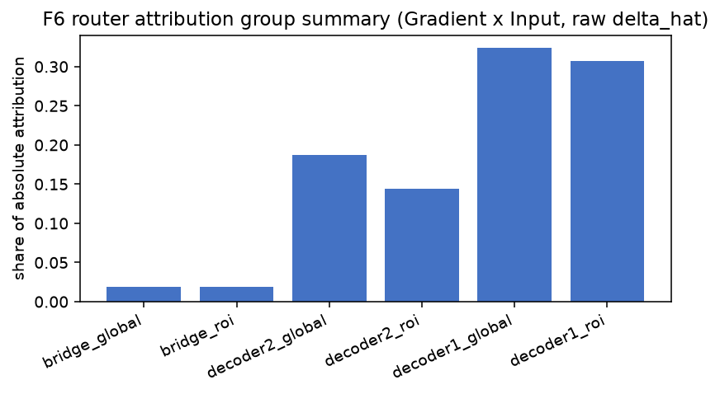
Figure 6. Router feature-group attribution (existing frozen Phase35 figure). Attribution concentrates on decoder1 feature groups; this is descriptive evidence.

Section 12 - Regional Refiner R_psi
The regional refiner is the expensive component. It is executed only on the EXECUTE branch, i.e. only when the router expects the refinement to be beneficial.
Table 12-1. Frozen R_psi specification.
Property | Frozen value
Class | BARRRegionalRefinerV1
Parameters | 1,276,401
Architecture | narrowed-channel residual U-Net; channels (16,32,64,96,128); GroupNorm + SiLU
Input | [B, 4, 256, 256] = channels [R, G, B, p_global_crop]
Output | [B, 1, 256, 256] single-channel raw logits, no internal sigmoid
Executed when | EXECUTE branch only
Bypassed when | SKIP_GLOBAL and FORCED_SKIP

12.1 What the refiner sees and produces
- Extraction: the proposed ROI is cropped from the input image at the frozen canvas/crop geometry.
- Image crop: the RGB crop is one part of the refiner input.
- Global-probability channel: the cropped p_global is supplied as an additional channel, so the refiner sees both the raw appearance and the global model's belief.
- Regional refinement: the narrowed-channel residual U-Net produces a single-channel regional logit map with no internal sigmoid.
- Map-back: an accepted regional prediction is pasted back into the full field by the canonical pad-aware D61 fuse_full_field operation.

12.2 Why refinement is conditional rather than always-run
Running the refiner unconditionally would roughly double the per-image compute and could degrade already-correct predictions. Making it conditional means that the expensive work is reserved for cases where the router expects a paired gain, and the global prediction is preserved everywhere else. Section 23 quantifies the resulting analytical compute behaviour.

Section 13 - Post-Safety S_omega
The post-safety stage is the second protection layer. It acts AFTER a refinement has already been computed, and it can reject that refinement.
Table 13-1. Frozen S_omega specification.
Property | Frozen value
Class | BARRPostSafetyV1
Parameters | 1,217
Architecture | MLP Linear(20,32) -> SiLU -> Linear(32,16) -> SiLU -> Linear(16,1)
Numeric input dimension | 16
Task one-hot dimension | 4
Total input dimension | 20
Output | 1 scalar safety logit; ACCEPT iff sigmoid(logit) >= 0.50
Acceptance threshold | 0.50
Normalisation | None inside S_omega
Executed when | EXECUTE branch only, after R_psi
Bypassed when | SKIP_GLOBAL and FORCED_SKIP

13.1 Frozen forward semantics
The stage consumes a 20-dimensional input: a 16-dimensional normalised numeric description of the change between the global and refined predictions, plus a 4-dimensional task one-hot. It emits a single safety logit. The refinement is ACCEPTED if and only if sigmoid(logit) >= 0.50; otherwise it is REJECTED.
The frozen numeric feature order is: global_prob_mean, refined_prob_mean, mean_abs_prob_change, max_abs_prob_change, frac_abs_prob_change_ge_0p10, global_entropy_mean, refined_entropy_mean, global_foreground_fraction, refined_foreground_fraction, binary_xor_fraction, global_component_count, refined_component_count, global_boundary_fraction, refined_boundary_fraction, predicted_roi_area_fraction, predicted_roi_side_normalized.
The frozen task one-hot order is: task_0_ISIC, task_1_BUSI, task_2_KVASIR, task_3_KUB.
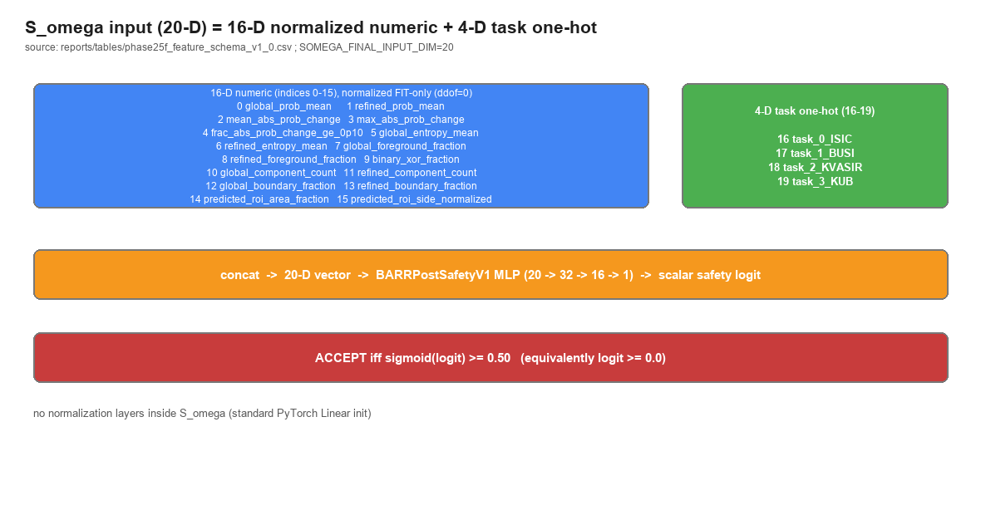
Figure 7. Post-safety 20-D input breakdown (existing frozen visual reference): 16-D numeric + 4-D task one-hot.

13.2 Why this creates a second protection layer
The router protects compute and the global prediction at the decision point. The post-safety stage protects against an executed refinement that turns out to be unhelpful. Together they produce the EXECUTE_THEN_REJECT state, in which the refinement has run but the global prediction is restored as the final output.

Section 14 - State Machine
The pipeline emits exactly one of four states. The table below gives the trigger, whether the refiner and post-safety stage execute, the source of the final prediction, and the interpretation of each state.
Table 14-1. The four-state decision machine.
State | Trigger | Refiner executed? | Post-safety executed? | Final source | Interpretation
FORCED_SKIP | ROI proposal empty (ACTION_UNAVAILABLE) | No | No | Global prediction | Global prediction is emitted unchanged; router/refiner/safety never invoked.
SKIP_GLOBAL | Router gate decided SKIP (U < tau_C8_final) | No | No | Global prediction | Benefit expected to be low; global prediction is the final output.
EXECUTE_THEN_ACCEPT | Router decided EXECUTE and S_omega accepted (>= 0.50) | Yes | Yes | Fused (D61 pad-aware) prediction | Refinement judged safe; pad-aware fusion of the refined region is emitted.
EXECUTE_THEN_REJECT | Router decided EXECUTE and S_omega rejected (< 0.50) | Yes | Yes | Global prediction (fallback) | Refinement ran but was not accepted; the global prediction is restored.

Note the distinction between the router decision (SKIP / EXECUTE) and the final state. FORCED_SKIP is decided BEFORE the router (empty proposal), so it has no router decision of its own.

Section 15 - Fusion and Final Scoring

15.1 D61 canonical pad-aware fusion
Accepted refinements are combined with the global prediction by the canonical D61 pad-aware fuse_full_field(p_global, refined, geom). The refined regional prediction is pasted back into the full-field global probability on the original raster geometry with correct canvas/crop padding, so no misalignment is introduced by the crop-and-resize step.

15.2 D75 / POLICY_B final segmentation scoring
The final segmentation is scored under the frozen D75/POLICY_B representation: the live float32 probability is persisted as float16 and then scored as float32, against a threshold of >= 0.50. This ensures that all reported metrics use the exact deployed representation rather than a development-time approximation.
Scope of D75 / POLICY_B
• D75 / POLICY_B applies to FINAL segmentation scoring only.
• It does NOT apply to model, router, ROI, refiner, safety, or fusion internals.

15.3 Segmentation output threshold
The final mask is (probability >= 0.50). This threshold is frozen and is distinct from the ROI proposal threshold (0.30) and the S_omega acceptance threshold (0.50), which applies to a different quantity (the safety probability).

Section 16 - Development and Experimental Governance
The project advanced through a sequence of scientifically gated phases. This section summarises those stages rather than reproducing internal logs. Every stage below produced a frozen artifact, and every number in this report traces to one of them.
Table 16-1. Major phase timeline.
Stage | Purpose | Population | Output | Scientific interpretation | Qualifier
Phase 27 | Multi-domain preservation evaluation (final system vs global reference) | VAL808 (n=808) | Macro DeltaDice 0.002210, 95% CI [0.001133, 0.003298] | Descriptive preservation / non-inferiority on the development set | Continuity/development evidence only; NOT a superiority claim
Phase 28 | Comprehensive 13-arm module ablation | ROUTER_DEVELOPMENT (n=4957), K=1239 | A8/C9 mean routed true DeltaDice 0.007516; F1 refiner negative | Descriptive ablation contribution; no deployment winner selected | Ablation on ROUTER_DEVELOPMENT only; ROUTER_HOLDOUT/TEST/VAL808 reads = 0
Phase 29 | Three-seed reproducibility (42/123/3407) | ROUTER_DEVELOPMENT + VAL808 | macro DeltaDice 3-seed means 0.001215 / 0.002822 | Descriptive reproducibility; sign-consistent across seeds | NO numeric pass/fail gate; no best-seed selection
Phase 30 | One-shot ROUTER_HOLDOUT evaluation | ROUTER_HOLDOUT (n=875) | macro DeltaDice 0.001739, 95% CI [0.001117, 0.002405] | One-shot descriptive non-inferiority | ONE_SHOT_ROUTER_HOLDOUT_RESULT_WITH_DISCLOSED_POST_FIRST_OPEN_SCIENTIFIC_SOURCE_FREEZE_DEVIATION
Phase 31 | Statistical / governance closure | multi-population registry | 0 new p-values, 0 new effect sizes, 0 new bootstrap computations | Governance only; statistical evidence is descriptive | NO_NEW_CONFIRMATORY_SIGNIFICANCE_PROCEDURE_IS_ELIGIBLE
Phase 32 | External / domain-shift eligibility closure | EXTERNAL (19 candidates) | 0 primary-eligible / 0 secondary-eligible / 11 ineligible | Governance only; no external validation performed | NO_PROSPECTIVE_CLEAN_EXTERNAL_COHORT_ELIGIBLE
Phase 33 | Descriptive failure analysis | ROUTER_HOLDOUT (n=875) | LOW_OVERLAP 10.06%; harmful activation 12.92% of EXECUTE; EXECUTE_THEN_REJECT 1.67% | Descriptive failure analysis | ONE_SHOT_ROUTER_HOLDOUT_RESULT_WITH_DISCLOSED_POST_FIRST_OPEN_SCIENTIFIC_SOURCE_FREEZE_DEVIATION
Phase 34 | Efficiency / resource profile | analytical + measured synthetic batch path | MAC lower bound 3.244e10; weighted latency 16.589 ms | Descriptive analytical compute + hardware-specific runtime | NOT_END_TO_END_PIPELINE_LATENCY; hardware = RTX 3060 Ti
Phase 35 | Interpretability / mechanism evidence | model-mechanism | FiLM task-modulated; router attribution concentrated on decoder1 | Descriptive model-mechanism evidence | No causal claims
Phase 36 | Synthetic robustness studies | VAL808 (n=808) | 12,928 image rows; 4,848 proposal rows | Development-set synthetic perturbation robustness | Synthetic perturbations only; not real-world acquisition shift
Phase 37-38 | Evidence consolidation and protocol freeze | frozen artifacts (28 + 37 artifacts) | Consolidated evidence tables; frozen protocol manifests | Governance / provenance freeze | Not reported / not applicable
Phase 39 | Final TEST evaluation | TEST (n=1683) | Descriptive final-system Dice; macro 0.8314368385956257 | POST_PROTOCOL_TECHNICAL_RECOVERY_TEST_RESULT_WITH_TWO_DISCLOSED_PREOUTCOME_TECHNICAL_FAILURES | Primary comparative endpoint NOT PRODUCED
Phase 40 | Manuscript assembly (reduced scope) | manuscript artifacts (17 artifacts) | Frozen manuscript release | MANUSCRIPT_ASSEMBLY_WITH_DESCRIPTIVE_PHASE39_TEST_ONLY | scientific_delta = 0

16.1 Governance principles observed throughout
- Final system freeze before evaluation: components and thresholds are frozen and fail closed on any hash mismatch.
- Preservation evaluation: the system is evaluated against a preservation constraint rather than a superiority objective.
- Module ablation: every major module's contribution is measured, including negative results.
- Seed reproducibility: behaviour is checked across seeds without selecting a best seed.
- ROUTER_HOLDOUT evaluation: a single held-out evaluation, with its protocol deviation disclosed.
- Statistical governance: no new confirmatory significance procedure is created.
- External/domain-shift assessment: eligibility is assessed and honestly reported as negative.
- Failure analysis, efficiency, interpretability, and robustness: each is a separate, descriptive evidence family.
- Manuscript freeze, TEST evaluation, and final publication scope: the missing comparative endpoint is disclosed rather than worked around.
These principles are why the report can state a precise claim boundary (Section 29) and a precise list of things that cannot be claimed (Section 30).

Section 17 - Development and Preservation Results
On the frozen development set VAL808 (n = 808), the final system preserved macro-domain Dice relative to the global reference. These are DEVELOPMENT / frozen-validation results. They are NOT Phase39 TEST comparative confirmation.
Table 17-1. VAL808 multi-domain development preservation results (Phase27).
Domain | n | Global Dice | Final Dice | Delta Dice | 95% CI low | 95% CI high | Harm flag
BUSI | 84 | 0.8588214375680574 | 0.8589126018391846 | 0.000091 | 0.000000 | 0.000273 | No harm flag
ISIC | 357 | 0.8971889499163059 | 0.8980801299180301 | 0.000891 | -0.000211 | 0.002032 | No harm flag
KUB | 280 | 0.7640588414471431 | 0.771512927778779 | 0.007454 | 0.004550 | 0.010114 | No harm flag
KVASIR | 87 | 0.8202466114984852 | 0.8206507619743234 | 0.000404 | -0.002362 | 0.003744 | No harm flag
MACRO | 808 | -- | -- | 0.002210 | 0.001133 | 0.003298 | No harm flag

The macro-domain Dice difference was 0.002210 with a 95% bootstrap confidence interval of [0.001133, 0.003298]. The lower bound exceeds -0.005, satisfying the frozen preservation rule strictly. No domain harm flag was raised.

17.1 ROUTER_HOLDOUT per-domain deltas (Phase30, one-shot)
Table 17-2. ROUTER_HOLDOUT per-domain and macro DeltaDice (one-shot; see Section 20 for the mandatory qualifier).
Domain | Delta Dice | 95% CI low | 95% CI high
BUSI | 0.000005152 | 0.000000 | 0.0000155
ISIC | 0.000986291 | 0.000328887 | 0.001764382
KUB | 0.005944727 | 0.003634999 | 0.008455643
KVASIR | 0.000019953 | 0.000000 | 0.0000599
MACRO | 0.001739031 | 0.001117294 | 0.002404981

17.2 Frozen development performance figure (existing frozen figure)
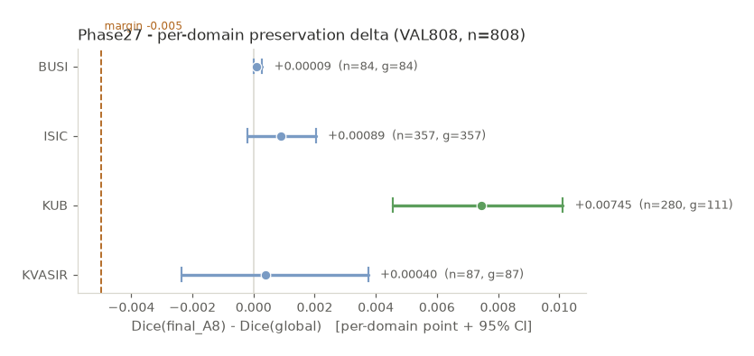
Figure 8. Per-domain DeltaDice forest plot on VAL808 (existing frozen Phase27 figure).

Section 18 - Ablation Study
A comprehensive thirteen-arm ablation was performed on the development population ROUTER_DEVELOPMENT (n = 4,957; routed budget K = 1,239). Arm labels are reproduced exactly as frozen; no variant has been renamed in a way that changes its scientific meaning.
Table 18-1. Frozen 13-arm ablation results (Phase28).
Arm | n routed | Budget frac. | Sum true delta | Mean routed delta Dice | Benefit capture | n beneficial | n harmful | Harmful share | Evidence class
A0 | 0 | 0.0000 | 0.000000 | 0.000 | 0 | 0 | 0.000 | ENDPOINT_BY_CONSTRUCTION
A1 | 4957 | 1.0000 | 0.001658 | 1.000 | 2775 | 2115 | 0.427 | ENDPOINT_BY_CONSTRUCTION
A2 | 1239 | 0.2499 | 0.001413 | 0.246 | 669 | 550 | 0.444 | PRIOR_CANONICAL_EVIDENCE_EXACT
A3 | 1239 | 0.2499 | 0.007185 | 0.584 | 844 | 395 | 0.319 | PRIOR_CANONICAL_EVIDENCE_EXACT
A4 | 1239 | 0.2499 | 0.007119 | 0.582 | 843 | 396 | 0.320 | PRIOR_CANONICAL_EVIDENCE_EXACT
A5 | 1239 | 0.2499 | -0.000433 | 0.184 | 597 | 575 | 0.464 | PRIOR_CANONICAL_EVIDENCE_EXACT
A6 | 1239 | 0.2499 | 0.007247 | 0.602 | 827 | 412 | 0.333 | PRIOR_CANONICAL_EVIDENCE_EXACT
A7 | 1239 | 0.2499 | 0.007247 | 0.602 | 827 | 412 | 0.333 | PRIOR_CANONICAL_EVIDENCE_EXACT
A8 | 1205 | 0.2431 | 0.007516 | 0.597 | 815 | 390 | 0.324 | PRIOR_CANONICAL_EVIDENCE_EXACT
R1 | 1239 | 0.2499 | 0.003320 | 0.495 | 723 | 463 | 0.374 | PHASE28_TRAINED_ABLATION_VARIANT
R2 | 1239 | 0.2499 | 0.001191 | 0.246 | 678 | 539 | 0.435 | PHASE28_TRAINED_ABLATION_VARIANT
R3 | 1239 | 0.2499 | 0.001251 | 0.244 | 702 | 524 | 0.423 | PHASE28_TRAINED_ABLATION_VARIANT
F1 | 1239 | 0.2499 | -0.032585 | 0.283 | 256 | 853 | 0.688 | PHASE28_TRAINED_ABLATION_VARIANT

18.1 What happens without the key modules
Arm A5 (the variant associated with the negative result) produced a mean routed true DeltaDice of -0.000433, i.e. it did not improve the pipeline; the F1 arm's summed true delta of -40.3732357728 corresponds to a strongly harmful configuration. Arm A2, which represents the weaker routing configuration, achieved a mean of 0.001413 with benefit capture 0.246, well below the final policy. The final configuration A8 (with post-safety) achieved the highest mean routed true DeltaDice among the routed arms.

18.2 Benefit of the final configuration
The A8/C9 routing-plus-post-safety policy achieved a mean routed true DeltaDice of 0.007516 with benefit capture 0.597 and harmful-activation share 0.324. A7 and A6 achieved 0.007247 with benefit capture 0.602, which is higher in capture but lower in mean routed gain, indicating the trade-off between capture and per-decision safety that the final policy resolves.

18.3 Negative ablation finding
Explicitly reported negative result
• The F1 integrated refiner did NOT improve the pipeline (mean -0.000433; summed true delta -40.3732357728; harmful share 0.688).
• This negative result is reported as frozen evidence rather than hidden.
• No deployment winner was selected on the basis of this ablation; the canonical bundle was left unchanged.

18.4 Frozen ablation figure (existing frozen figure)
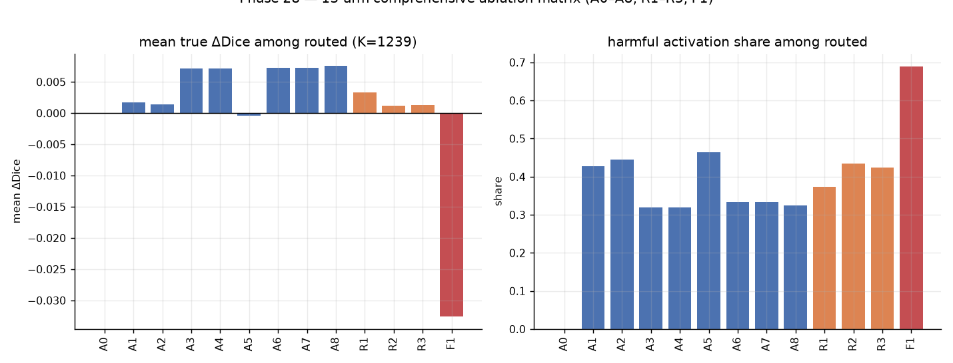
Figure 9. Ablation arm matrix overview (existing frozen Phase28 figure).

Section 19 - Reproducibility
The policy was evaluated across three seeds (42, 123, and 3407) on the ROUTER_DEVELOPMENT population and on VAL808. The analysis is DESCRIPTIVE: there is no numeric pass/fail gate and no best-seed selection.
Table 19-1. Three-seed reproducibility summary (Phase29).
Population | Metric | Seed 42 | Seed 123 | Seed 3407 | Mean | Sign-consistent
ROUTER_DEVELOPMENT | macro_domain_final_dice | 0.9304901760 | 0.9303465583 | 0.9303620955 | 0.9303996099 | True
ROUTER_DEVELOPMENT | macro_domain_delta_dice | 0.0013053961 | 0.0011617784 | 0.0011773155 | 0.0012148300 | True
ROUTER_DEVELOPMENT | routed_candidate_mean_delta_dice | 0.0072466292 | 0.0065878388 | 0.0066232275 | 0.0068192318 | True
ROUTER_DEVELOPMENT | benefit_capture | 0.6021987300 | 0.5603838551 | 0.5869805243 | 0.5831877031 | True
ROUTER_DEVELOPMENT | harmful_activation_share | 0.1081517353 | 0.1242937853 | 0.1420500404 | 0.1248318536 | True
ROUTER_DEVELOPMENT | safety_accept_fraction | 0.9725585149 | 0.8555286521 | 0.9539951574 | 0.9273607748 | True
ROUTER_DEVELOPMENT | n_selected | 1239 | 1239 | 1239 | 1239.0 | NA
VAL808_PHASE_D | macro_final_dice | 0.8372891054 | 0.8384669007 | 0.8379477614 | 0.8379012558 | True
VAL808_PHASE_D | macro_global_dice | 0.8350789601 | 0.8350789601 | 0.8350789601 | 0.8350789601 | True
VAL808_PHASE_D | macro_delta_dice | 0.0022101453 | 0.0033879406 | 0.0028688013 | 0.0028222957 | True
VAL808_PHASE_D | selected_fraction | 0.3452970297 | 0.3155940594 | 0.3242574257 | 0.3283828383 | True
VAL808_PHASE_D | safety_accept_fraction | 0.9534050179 | 0.9019607843 | 0.9770992366 | 0.9441550130 | True

19.1 What this shows
The ROUTER_DEVELOPMENT macro DeltaDice three-seed mean was 0.001215, and the VAL808 three-seed mean was 0.002822. All seeds were positive (sign-consistent). For VAL808 the global Dice is seed-invariant (range = 0), as expected because the global model is frozen.

19.2 What reproducibility does NOT prove
Three-seed consistency shows that the routed behaviour is stable across the seeds; it does not establish statistical significance, does not constitute a confirmatory test, and does not license a claim of superiority. The statistical evidence remains descriptive (Section 21).
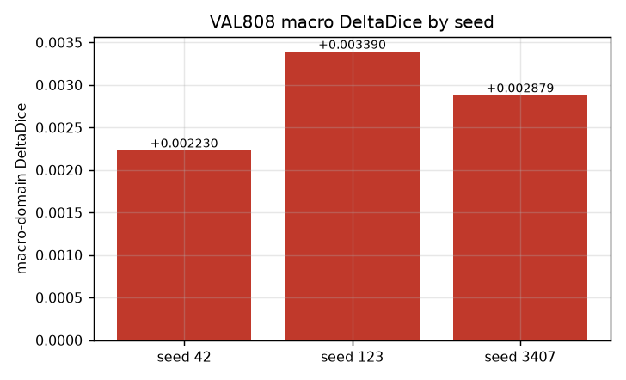
Figure 10. Seed-wise macro DeltaDice on VAL808 (existing frozen Phase29 figure).

Section 20 - One-Shot ROUTER_HOLDOUT Evidence
A single one-shot held-out evaluation was performed on ROUTER_HOLDOUT (n = 875). This is the final development validation of the frozen system.
Table 20-1. One-shot ROUTER_HOLDOUT result (Phase30).
Quantity | Frozen value
Final system (A8/C9) macro Dice | 0.9302871820357663
Global reference macro Dice | 0.9285481511747413
Macro DeltaDice | 0.0017390308610248934
95% domain-stratified bootstrap CI | [0.00111729355352301, 0.0024049809029647283]

The final-system macro Dice was 0.930287 versus 0.928548 for the global reference, a macro DeltaDice of 0.001739 with a 95% domain-stratified bootstrap confidence interval of [0.001117, 0.002405]. This satisfies the prespecified numerical non-inferiority margin.

20.1 Mandatory qualifier
Preserved verbatim (Phase30 evidence class)
• ONE_SHOT_ROUTER_HOLDOUT_RESULT_WITH_DISCLOSED_POST_FIRST_OPEN_SCIENTIFIC_SOURCE_FREEZE_DEVIATION
•
• Any ROUTER_HOLDOUT-derived statement in this report preserves this exact qualifier. The protocol deviation occurred because the Stage-B scientific scoring source was not included in the pre-open source freeze; predictions and decision rules were frozen before ground-truth access, ground truth was read once, and no scientific rerun or recomputation occurred.

20.2 Frozen holdout figure (existing frozen figure)
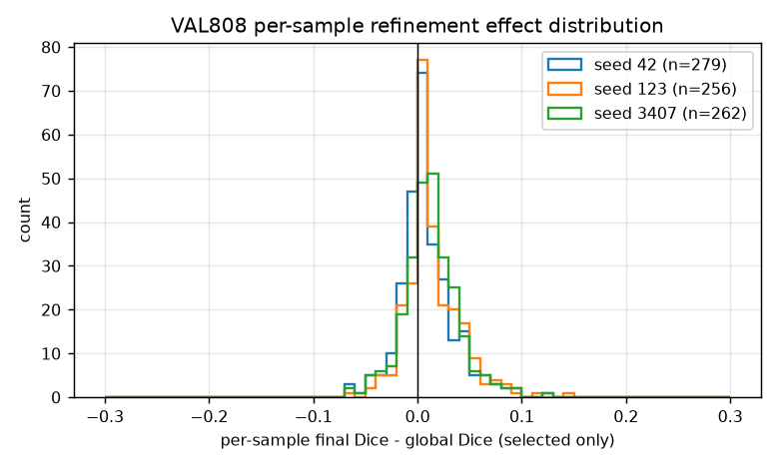
Figure 11. Per-sample final Dice distribution on the frozen validation population (existing frozen Phase29 figure).

Section 21 - Statistical Governance
The Phase31 statistical-governance closure established a key result: NO new confirmatory significance procedure is eligible. The statistical evidence reported throughout this report is descriptive (bootstrap confidence intervals only).
Table 21-1. Statistical test registry (Phase31). No confirmatory test was authorized.
Test ID | Population | Comparison | Test name | Provenance class | Authorized
T01 | ROUTER_HOLDOUT (875) | A8/C9 vs global reference | paired Wilcoxon | POST_HOC_EXPLORATORY_ONLY | False
T02 | ROUTER_HOLDOUT (875) | A8/C9 vs global reference | paired bootstrap p (exploratory) | POST_HOC_EXPLORATORY_ONLY | False
T03 | ROUTER_HOLDOUT (875) | A8 vs A7 | descriptive bootstrap CI only | DESCRIPTIVE_ONLY_BY_PREDECESSOR_AUTHORITY | False
T04 | ROUTER_DEVELOPMENT | learned paired gain vs global uncertainty | unspecified | PREOUTCOME_HYPOTHESIS_METHOD_INCOMPLETE | False
SUMMARY | multi | n_tests=4; n_confirmatory=0; n_exploratory=2 | NONE_AUTHORIZED | GOVERNANCE_ONLY | False

21.1 The frozen preservation rule
Preservation rule (frozen)
• PRESERVATION_ASSERTED if and only if the macro lower 95% percentile-CI bound > -0.005, strict.
• The per-domain harm rule is applied per domain; a domain harm flag is raised only when its own criterion is violated.
• The rule applies to the populations for which it was frozen (VAL808 and ROUTER_HOLDOUT).
• It does NOT apply to TEST, because the Phase39 comparative quantities required to evaluate it on TEST were not produced.

21.2 Why no new confirmatory procedure
A confirmatory procedure may not be created merely because it is conventional. The frozen position is that no pre-outcome confirmatory method was frozen for these comparisons, so no confirmatory test can be run after the fact without changing the scientific meaning of the evidence. Zero new p-values, zero new effect sizes, and zero new bootstrap computations were produced.

Section 22 - Failure-Mode Analysis
A descriptive failure analysis was performed on the frozen ROUTER_HOLDOUT tables. The analysis characterises the prevalence of failure families; it does not establish causal relationships.
Table 22-1. Descriptive failure-mode prevalence on ROUTER_HOLDOUT (Phase33).
Failure family | Eligible population n | Failure n | Failure rate | Population definition
LOW_OVERLAP | 875 | 88 | 0.10057142857142858 | All 875 ROUTER_HOLDOUT rows
EMPTY_PREDICTION | 875 | 0 | 0.0 | All 875 ROUTER_HOLDOUT rows
ROUTER_HARMFUL_ACTIVATION | 240 | 31 | 0.12916666666666668 | EXECUTE rows (240)
ROUTER_MISSED_BENEFIT | 635 | 0 | 0.0 | SKIP rows (635)
EXECUTE_THEN_REJECT | 240 | 4 | 0.016666666666666666 | EXECUTE rows (240)

Per-domain summary: BUSI n=90 / ISIC n=383 / KUB n=298 / KVASIR n=104; KUB highest low-overlap (0.2450) and harmful-activation (0.0872).

22.1 Practical meaning of each family
- LOW_OVERLAP (10.06% of 875): the global prediction overlaps the ground truth poorly, so the case is intrinsically hard for the shared model.
- ROUTER_HARMFUL_ACTIVATION (12.92% of the 240 EXECUTE rows): the router chose to execute but the refinement did not help on that row.
- EXECUTE_THEN_REJECT (1.67% of the 240 EXECUTE rows): the refinement executed and was rejected by the safety stage, so the global prediction was restored. The safety stage behaved as designed.
- ROUTER_MISSED_BENEFIT (0 of 635 SKIP rows): no SKIP row was later found to have had an available benefit in this descriptive tabulation.
- EMPTY_PREDICTION (0 of 875): no row produced an empty final prediction.
These are descriptive prevalences. They are not converted into causal statements, and they are not described with minimising language such as "rare" or "negligible".

Section 23 - Computational Efficiency
Efficiency was characterised analytically (MAC lower bounds) and empirically (measured paths on an NVIDIA GeForce RTX 3060 Ti). Units are taken verbatim from the frozen tables.
Table 23-1. Computational-efficiency summary (Phase34).
Quantity | Value | Unit | Classification
A8/C9 expected analytical MAC lower bound | 32437902022.582855 | MACs | ANALYTICAL_MAC_LOWER_BOUND
Analytical MAC ratio vs global-only (C1) | 1.0280859651011032 | ratio | ANALYTICAL_RATIO
Analytical MAC saving vs always-refine (C2) | 2344501561.417145 | MACs | ANALYTICAL_SAVING_MACS
Measured latency - SKIP path (batch-1, v1.4) | 15.71835146522522 | ms | WEIGHTED_HARDWARE_SPECIFIC_RUNTIME_ESTIMATE
Measured latency - EXECUTE path (batch-1, v1.4) | 18.894091419219972 | ms | WEIGHTED_HARDWARE_SPECIFIC_RUNTIME_ESTIMATE
Measured latency - weighted (p_SKIP=0.7257, p_EXECUTE=0.2743) | 16.589411566892352 | ms | WEIGHTED_HARDWARE_SPECIFIC_RUNTIME_ESTIMATE
Measured throughput - SKIP path (batch-8) | 93.17560442781323 | samples/s | MODEL_COMPUTE_PATH_RUNTIME
Measured throughput - EXECUTE path (batch-8) | 80.26287810203608 | samples/s | MODEL_COMPUTE_PATH_RUNTIME
GPU peak allocated - SKIP path | 336239104 | bytes | GPU_MEMORY
GPU peak allocated - EXECUTE path | 345559552 | bytes | GPU_MEMORY
Total parameters (G+R_psi+B_phi+S_omega) | 4837420 | parameters | STATIC_MODEL_RESOURCE_PROFILE

23.1 Interpretation
The A8/C9 expected analytical MAC lower bound was 3.244e10 MACs, a ratio of 1.028 versus the global-only path (C1), and a saving of 2.345e9 MACs versus the always-refine path (C2). The measured weighted latency was 16.589 ms with a SKIP path of 15.718 ms and an EXECUTE path of 18.894 ms.
Efficiency claim boundary (frozen)
• The MAC figures are an ANALYTICAL LOWER BOUND, not a measured end-to-end cost.
• The latency figures are HARDWARE-SPECIFIC runtime estimates on an RTX 3060 Ti, and are NOT end-to-end pipeline latencies, NOT real-time guarantees, NOT mobile estimates, and NOT energy measurements.
• No hardware-independent efficiency claim is made.

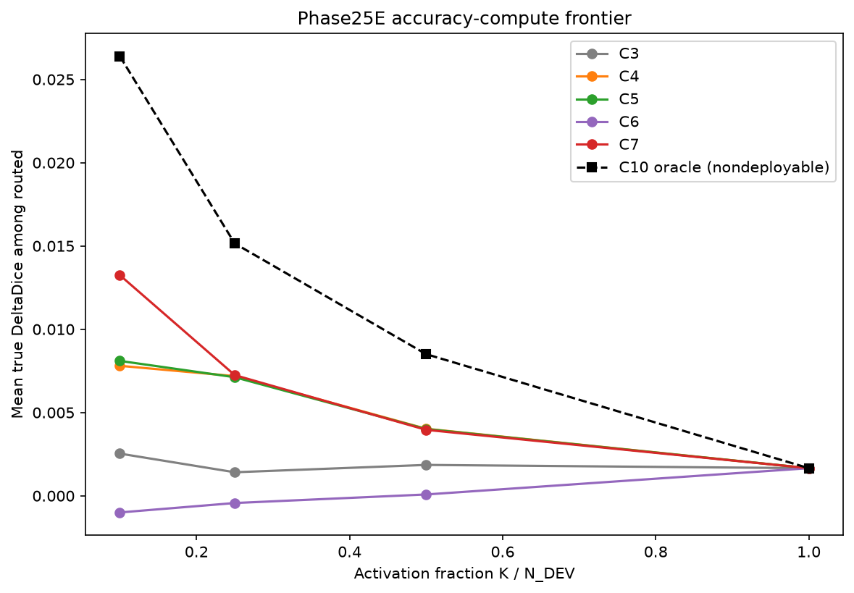
Figure 12. Compute frontier (existing frozen figure from the router-development evidence base).

Section 24 - Interpretability
Descriptive model-mechanism evidence was collected in Phase35. It characterises how the frozen model behaves; it does not establish causal explanations.

24.1 Router feature-group attribution
Table 24-1. Router feature-group attribution (Phase35). Attribution concentrates on decoder1 groups.
Feature group | Absolute total | Share
bridge_global | 0.7022336934747089 | 0.018495175385098966
bridge_roi | 0.7230366555447487 | 0.019043076227212012
decoder2_global | 7.10764316959649 | 0.1871985184104845
decoder2_roi | 5.460231437830695 | 0.1438095879253719
decoder1_global | 12.301891267383665 | 0.3240027339515185
decoder1_roi | 11.673443601480157 | 0.30745090810031406

24.2 Saliency self-consistency
Table 24-2. Saliency self-consistency by domain and tap (Phase35).
Feature | Absolute mean/total | Share / median
bridge | ISIC | 0.21552787398104556 | 0.06956793181598186
bridge | BUSI | 0.17095443938160315 | 0.054967453703284264
bridge | KVASIR | 0.3127893512719311 | 0.13337256759405136
bridge | KUB | 0.20097172392269158 | 0.0034866328714997508
decoder1 | ISIC | 0.9999990127980709 | 1.0
decoder1 | BUSI | 0.9999999664723873 | 1.0
decoder1 | KVASIR | 0.9999996721744537 | 1.0
decoder1 | KUB | 0.9999994933605194 | 1.0

24.3 What was observed and what is only descriptive
- Observed: FiLM parameters are task-modulated, i.e. they differ by domain.
- Observed: router attribution concentrates on decoder1 feature groups (combined share of approximately 0.631 across the two decoder1 groups).
- Observed: decoder1 saliency self-consistency is approximately 1.0 across all domains.
- Descriptive only: no causal claim is made about WHY the router attends where it does.
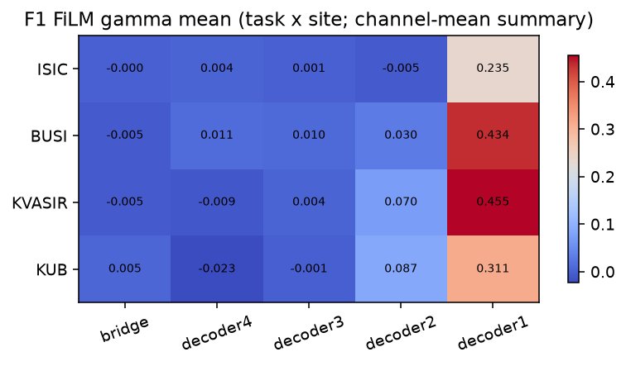
Figure 13. FiLM gamma heatmap (existing frozen Phase35 figure), showing task-modulated FiLM parameters.

Section 25 - Robustness
Synthetic robustness studies were run on the development set VAL808 (n = 808). Two categories were evaluated: image-perturbation robustness and proposal/ROI-perturbation robustness. These are synthetic perturbations of a development set; they are not real-world acquisition shift.

25.1 Image-perturbation robustness
12,928 synthetic image-perturbation paired rows were emitted across 16 conditions and 4 domains. The clean G reproduction was bit-identical, and the clean equivalence check passed for all rows.
Table 25-1. Phase36 image-perturbation paired DeltaDice by domain and condition.
Domain | Condition | n | Mean paired DeltaDice | Median paired DeltaDice
BUSI | BRIGHTNESS_NEG | 84 | -0.005977 | 0.000436
ISIC | BRIGHTNESS_NEG | 357 | -0.000858 | -0.000594
KUB | BRIGHTNESS_NEG | 280 | -0.016720 | 0.000000
KVASIR | BRIGHTNESS_NEG | 87 | -0.007922 | -0.001392
BUSI | BRIGHTNESS_POS | 84 | -0.004116 | -0.001763
ISIC | BRIGHTNESS_POS | 357 | -0.004450 | -0.000359
KUB | BRIGHTNESS_POS | 280 | -0.008172 | 0.000000
KVASIR | BRIGHTNESS_POS | 87 | -0.009699 | -0.001401
BUSI | CONTRAST_LOW | 84 | -0.002394 | -0.001151
ISIC | CONTRAST_LOW | 357 | -0.005262 | -0.001289
KUB | CONTRAST_LOW | 280 | -0.004774 | -0.000222
KVASIR | CONTRAST_LOW | 87 | -0.000549 | -0.000707
BUSI | CONTRAST_HIGH | 84 | -0.0000341 | 0.000212
ISIC | CONTRAST_HIGH | 357 | 0.000572 | 0.000282
KUB | CONTRAST_HIGH | 280 | -0.001432 | -0.0000795
KVASIR | CONTRAST_HIGH | 87 | -0.003817 | -0.000319
BUSI | GAMMA_LOW | 84 | -0.012725 | -0.003971
ISIC | GAMMA_LOW | 357 | -0.002545 | -0.000336
KUB | GAMMA_LOW | 280 | -0.004263 | -0.001096
KVASIR | GAMMA_LOW | 87 | -0.009446 | -0.000470
BUSI | GAMMA_HIGH | 84 | -0.001724 | 0.001546
ISIC | GAMMA_HIGH | 357 | -0.000507 | -0.000322
KUB | GAMMA_HIGH | 280 | -0.0000781 | 1.21e-12
KVASIR | GAMMA_HIGH | 87 | -0.001462 | -0.000905
BUSI | GAUSSIAN_BLUR_LOW | 84 | 0.000690 | 0.000454
ISIC | GAUSSIAN_BLUR_LOW | 357 | -0.000708 | -0.000192
KUB | GAUSSIAN_BLUR_LOW | 280 | -0.005898 | 0.000000
KVASIR | GAUSSIAN_BLUR_LOW | 87 | -0.001399 | -0.000366
BUSI | GAUSSIAN_BLUR_HIGH | 84 | -0.003057 | -0.000347
ISIC | GAUSSIAN_BLUR_HIGH | 357 | -0.004973 | -0.000672
KUB | GAUSSIAN_BLUR_HIGH | 280 | -0.056275 | -0.011809
KVASIR | GAUSSIAN_BLUR_HIGH | 87 | -0.014409 | -0.006818
BUSI | RESOLUTION_075 | 84 | -0.001521 | 0.001104
ISIC | RESOLUTION_075 | 357 | -0.002164 | -0.000212
KUB | RESOLUTION_075 | 280 | -0.034207 | -0.004405
KVASIR | RESOLUTION_075 | 87 | -0.006006 | -0.001894
BUSI | RESOLUTION_050 | 84 | -0.003723 | -0.001315
ISIC | RESOLUTION_050 | 357 | -0.004636 | -0.000498
KUB | RESOLUTION_050 | 280 | -0.054385 | -0.012256
KVASIR | RESOLUTION_050 | 87 | -0.016622 | -0.007257
BUSI | GAUSSIAN_NOISE_LOW | 252 | -0.009229 | 0.000279
ISIC | GAUSSIAN_NOISE_LOW | 1071 | -0.002824 | -0.000611
KUB | GAUSSIAN_NOISE_LOW | 840 | -0.115273 | -0.063727
KVASIR | GAUSSIAN_NOISE_LOW | 261 | -0.006576 | -0.001311
BUSI | GAUSSIAN_NOISE_HIGH | 252 | -0.089883 | -0.011001
ISIC | GAUSSIAN_NOISE_HIGH | 1071 | -0.031531 | -0.007134
KUB | GAUSSIAN_NOISE_HIGH | 840 | -0.363643 | -0.295749
KVASIR | GAUSSIAN_NOISE_HIGH | 261 | -0.060405 | -0.023059

The largest adverse image-perturbation sensitivity was on KUB, especially under GAUSSIAN_NOISE_HIGH (mean paired DeltaDice -0.363643 for KUB). This is a synthetic worst-case characterisation, not a clinical robustness claim.

25.2 Proposal / ROI-perturbation robustness
4,848 synthetic proposal-perturbation paired rows were emitted across 6 proposal conditions (four translations of 10 pixels and two scale factors).
Table 25-2. Phase36 proposal-perturbation paired DeltaDice by domain and condition.
Domain | Proposal condition | n applicable | Mean paired DeltaDice | Median paired DeltaDice
BUSI | SHIFT_LEFT_10 | 84 | 0.000202 | 0.000000
BUSI | SHIFT_RIGHT_10 | 84 | 0.0000214 | 0.000000
BUSI | SHIFT_UP_10 | 84 | 0.0000214 | 0.000000
BUSI | SHIFT_DOWN_10 | 84 | 0.0000214 | 0.000000
BUSI | SCALE_085 | 84 | 0.000903 | 0.000000
BUSI | SCALE_115 | 84 | 0.0000214 | 0.000000
ISIC | SHIFT_LEFT_10 | 357 | -0.0000592 | 0.000000
ISIC | SHIFT_RIGHT_10 | 357 | -0.0000686 | 0.000000
ISIC | SHIFT_UP_10 | 357 | -0.000286 | 0.000000
ISIC | SHIFT_DOWN_10 | 357 | -0.0000021 | 0.000000
ISIC | SCALE_085 | 357 | -0.000408 | 0.000000
ISIC | SCALE_115 | 357 | -0.000387 | 0.000000
KUB | SHIFT_LEFT_10 | 280 | -0.000830 | 0.000000
KUB | SHIFT_RIGHT_10 | 280 | 0.000131 | 0.000000
KUB | SHIFT_UP_10 | 280 | -0.000481 | 0.000000
KUB | SHIFT_DOWN_10 | 280 | -0.000755 | 0.000000
KUB | SCALE_085 | 280 | -0.000479 | 0.000000
KUB | SCALE_115 | 280 | -0.001193 | 0.000000
KVASIR | SHIFT_LEFT_10 | 87 | 0.0000149 | 0.000000
KVASIR | SHIFT_RIGHT_10 | 87 | 0.0000421 | 0.000000
KVASIR | SHIFT_UP_10 | 87 | 0.0000411 | 0.000000
KVASIR | SHIFT_DOWN_10 | 87 | -0.0000825 | 0.000000
KVASIR | SCALE_085 | 87 | 0.000136 | 0.000000
KVASIR | SCALE_115 | 87 | 0.0000702 | 0.000000

All proposal-perturbation median effects were 0.000000, and the means are small in magnitude, indicating that the pipeline is comparatively insensitive to the synthetic proposal perturbations tested. This is not a claim of independence from the proposal algorithm.

25.3 KUB reporting-only subgroup robustness
The KUB domain's subgroup metadata is reporting-only. The table below is provided for completeness and must not be read as a use of subgroup identity as a model input.
Table 25-3. KUB reporting-only subgroup robustness (selected conditions).
KUB subgroup | Condition | n | Mean paired DeltaDice | Median paired DeltaDice
Bladder_Stone | GAUSSIAN_NOISE_HIGH | 432 | -0.341097 | -0.237795
Bladder_Stone | GAUSSIAN_NOISE_LOW | 432 | -0.109659 | -0.065111
Bladder_Stone | GAUSSIAN_BLUR_HIGH | 144 | -0.074989 | -0.014455
Bladder_Stone | RESOLUTION_050 | 144 | -0.073459 | -0.014098
Bladder_Stone | BRIGHTNESS_NEG | 144 | -0.023522 | 3.14e-10
Kidney_Stone | GAUSSIAN_NOISE_HIGH | 336 | -0.420584 | -0.398294
Kidney_Stone | GAUSSIAN_NOISE_LOW | 336 | -0.132424 | -0.064377
Kidney_Stone | GAUSSIAN_BLUR_HIGH | 112 | -0.031344 | -0.009508
Kidney_Stone | RESOLUTION_050 | 112 | -0.029612 | -0.011413
Kidney_Stone | BRIGHTNESS_NEG | 112 | -0.012059 | -0.001855
Ureteric_Stone | GAUSSIAN_NOISE_HIGH | 72 | -0.233187 | -0.172234
Ureteric_Stone | GAUSSIAN_NOISE_LOW | 72 | -0.068921 | -0.046640
Ureteric_Stone | GAUSSIAN_BLUR_HIGH | 24 | -0.060336 | -0.013041
Ureteric_Stone | RESOLUTION_050 | 24 | -0.055549 | -0.011133
Ureteric_Stone | BRIGHTNESS_NEG | 24 | 0.002337 | 0.001125

25.4 Frozen robustness figures (existing frozen figures)
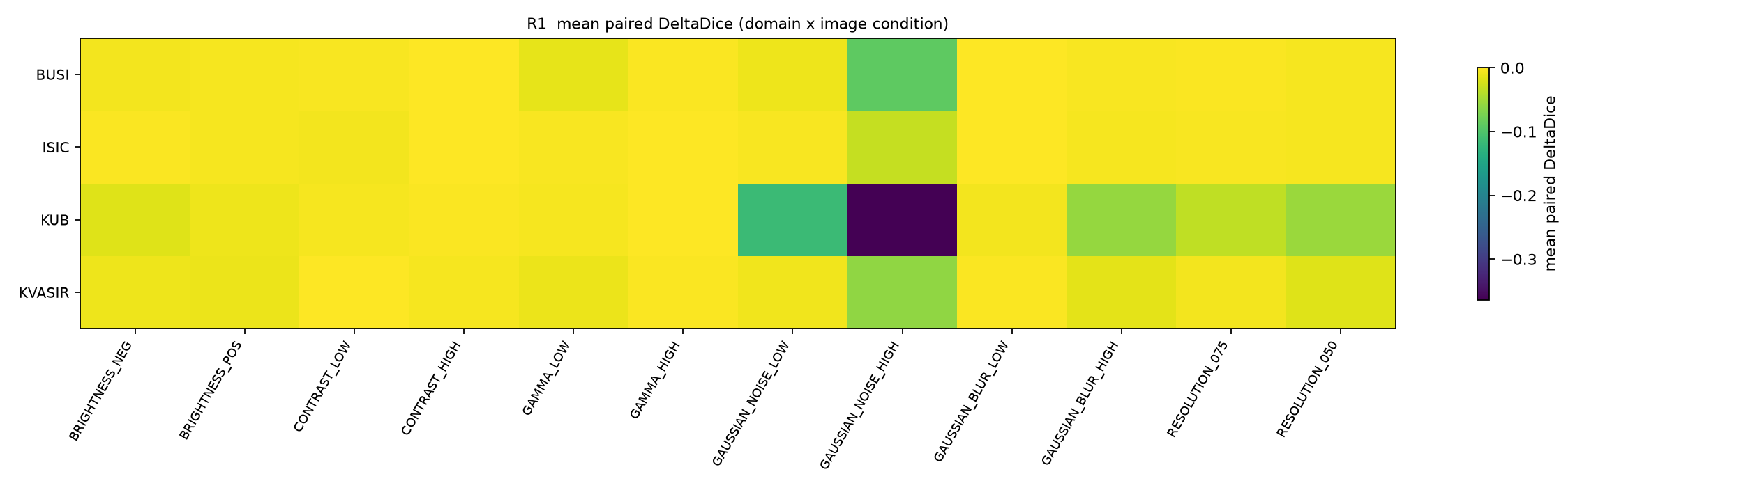
Figure 14. Image-perturbation mean paired DeltaDice heatmap (existing frozen Phase36 figure).
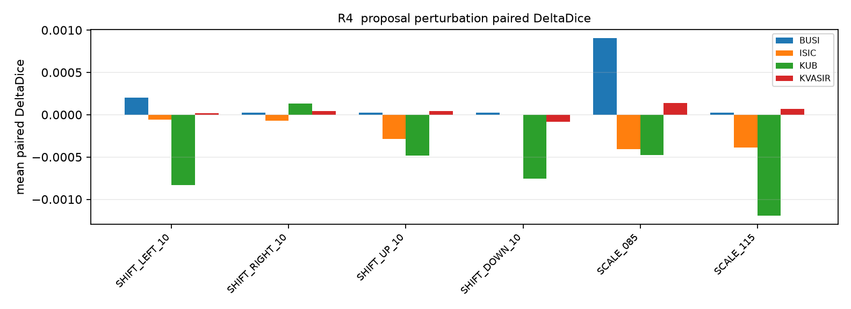
Figure 15. Proposal-perturbation paired DeltaDice (existing frozen Phase36 figure).

Section 26 - Final TEST Evaluation
This section reports the frozen descriptive TEST results with maximum transparency. Phase39 v1.2 successfully evaluated all 1,683 TEST samples. The results below are DESCRIPTIVE FINAL-SYSTEM performance. They are NOT a primary TEST result and NOT a comparative TEST result.
Table 26-1. Descriptive Final-System Performance on the Frozen TEST Cohort.
Domain | n | Descriptive final-system Dice | Status
ISIC | 735 | 0.88693 | PRESENT
BUSI | 174 | 0.85042 | PRESENT
KVASIR | 216 | 0.85071 | PRESENT
KUB | 558 | 0.73769 | PRESENT
MACRO (macro-domain Dice) | 1,683 | 0.8314368385956257 | PRESENT
macro DeltaDice vs C-gGLOBAL | - | NOT_PRODUCED_BY_FROZEN_PHASE39_EXECUTION | NOT_PRODUCED
comparative confidence interval | - | NOT_PRODUCED_BY_FROZEN_PHASE39_EXECUTION | NOT_PRODUCED
per-domain harm flag | - | NOT_PRODUCED_BY_FROZEN_PHASE39_EXECUTION | NOT_PRODUCED

Descriptive final-system Dice by domain was: ISIC (n = 735) 0.88693; BUSI (n = 174) 0.85042; KVASIR (n = 216) 0.85071; KUB (n = 558) 0.73769. The descriptive macro-domain Dice was 0.8314368385956257. No post-hoc sample exclusion was applied.
How this table must be read
• Title constraint observed: this table is titled "Descriptive Final-System Performance on the Frozen TEST Cohort". It is deliberately NOT titled "Primary TEST Result" and NOT titled "Comparative TEST Result".
• The three NOT_PRODUCED rows (macro DeltaDice vs C-gGLOBAL, comparative CI, per-domain harm flag) were not emitted by the frozen v1.2 execution.
• No quantity in this table supports a comparative conclusion against C-gGLOBAL.

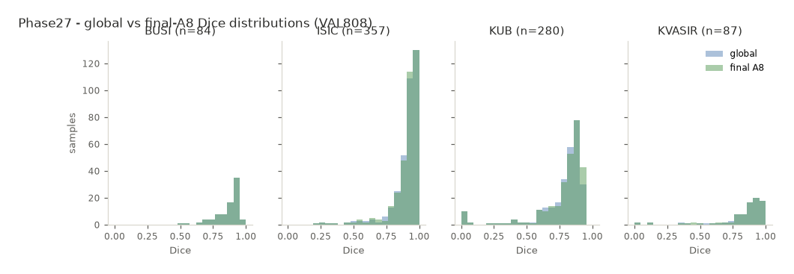
Figure 16. Dice distributions (existing frozen Phase27 figure; development-set distribution shown for context, not a TEST comparative figure).

Section 27 - Phase39 Protocol History and Limitation
The Phase39 protocol history is disclosed in full. Two pre-outcome technical attempts were consumed before a post-protocol technical-recovery execution succeeded.
Table 27-1. Phase39 execution history.
Attempt | Failure / action | Outcome | Evidence anchors
v1.0 (consumed) | Pre-inference MODEL_LOAD failure (D98: NameError: name 'FEATURE_DIM' is not defined in the extracted S_omega class closure). test_inference_started=false. | No TEST scientific outcome observed. | Failure artifact SHA-256 19e8d3f5...; process-exit 3924c407...; journal 65c05113...
v1.1 (consumed) | Pre-inference preflight failure at stage SCIENCE_LOOP (D99: PHASE39_UNEXPECTED_TASK_DOMAIN: /3; the manifest domain was read from a non-canonical `domain` field instead of the canonical `dataset` column). | TEST membership accessed; no TEST image/GT/model-forward/metric result before failure. | Failure artifact SHA-256 e0a1ebe3...; process-exit 4c616957...; journal 3690d1b7...; START 77486cdf...
Post-protocol technical-recovery amendment | A disclosed post-protocol amendment (not a retroactive reinterpretation of the frozen Phase38 retry policy) repaired D98 and D99 and bound the v1.0+v1.1 history. | Repairs are technical only; no scientific protocol change. | Bound to the v1.0+v1.1 history
v1.2 (successful, descriptive) | Evaluated the frozen system on all 1,683 TEST samples. | Descriptive final-system segmentation performance obtained. | Result artifact SHA-256 b9d5c74a316839cace0d085f3a8330f0378755687c6e0b67635371280896959d; process-exit 717c065f... (exit code 0); journal 5803fcc8...; START 46f109ae...

27.1 Preserved evidence class
Preserved verbatim (Phase39 evidence class)
• POST_PROTOCOL_TECHNICAL_RECOVERY_TEST_RESULT_WITH_TWO_DISCLOSED_PREOUTCOME_TECHNICAL_FAILURES

27.2 Terminology constraint
The TEST evaluation must NEVER be called UNTOUCHED_ONE_SHOT_TEST. That phrase is not used as an affirmative description anywhere in this report, because two pre-outcome technical attempts were consumed before the successful recovery execution.

Section 28 - Missing Phase39 Primary Endpoint
This section is mandatory and must be read before any TEST number is quoted.
The frozen Phase39 protocol prespecified a comparison of the final system against C-gGLOBAL, and required: a macro-domain Dice difference; a confidence interval; per-domain harm checks; and a frozen preservation decision.
The successful v1.2 execution did NOT emit the required C-gGLOBAL comparator quantities.
Adjudicated status
• PRIMARY_ENDPOINT_NOT_PRODUCED.
• FROZEN_STATISTICAL_DECISION_NOT_EVALUABLE_FROM_V1_2_OUTPUT.
• No additional TEST inference was performed to reconstruct the missing endpoint.
• The comparator quantities are NOT derivable without new TEST inference, and none was performed.
• Source adjudication artifact: reports/audits/phase39_v1_2_scientific_protocol_completeness_adjudication.json (SHA-256 78a6ead5972ff6ba658dbfac3c68e686ea3662bbe22c01348652e6f083d102cc), field primary_endpoint_present = false.

28.1 What the descriptive TEST Dice cannot be interpreted as
- Superiority of the final system over the comparator.
- Non-inferiority of the final system versus the comparator.
- Preservation confirmation on TEST.
- Harm-free refinement on TEST.
- Comparative benefit on TEST.
These prohibitions are absolute for this report. They are not softened, hedged, or reinterpreted anywhere.

Section 29 - What We Can Claim
The table below is the supervisor-facing claim ledger. Each row gives the claim, its evidence, its population, its status, the exact allowed wording, and the forbidden wording. It is derived directly from the frozen final claim ledger.
Table 29-1. Claim / evidence boundary (frozen final claim ledger).
ID | Claim | Evidence | Population | Status | Allowed wording | Forbidden wording
C-A1 | Preservation on development population (VAL808) | Phase27 VAL808 preservation freeze | VAL808 (n=808) | Descriptive preservation / non-inferiority | "The frozen A8/C9 policy preserves macro-domain Dice relative to the canonical GlobalMedFiLM global reference on VAL808 (macro DeltaDice 0.002210, 95% bootstrap CI [0.001133, 0.003298]; lower bound > -0.005)." | "improved / superior / outperforms"
C-A2 | One-shot ROUTER_HOLDOUT non-inferiority | Phase30 primary non-inferiority result | ROUTER_HOLDOUT (n=875) | One-shot descriptive non-inferiority WITH disclosed protocol deviation | "On the one-shot ROUTER_HOLDOUT (n=875) the frozen A8/C9 policy was non-inferior to the global reference (macro DeltaDice 0.001739, 95% CI [0.001117, 0.002405])." (must carry the Phase30 qualifier) | "confirmatory / no protocol deviations"
C-B1 | Ablation / module contribution | Phase28 13-arm ablation table | ROUTER_DEVELOPMENT (n=4957) | Descriptive ablation contribution | "In the frozen 13-arm ablation on ROUTER_DEVELOPMENT, the A8/C9 routing+post-safety policy achieved mean routed true DeltaDice 0.007516 (benefit capture 0.597, harmful-activation share 0.324), while the F1 integrated refiner did not improve the pipeline (mean -0.000433; negative result)." | "optimal / best / SOTA"
C-C1 | Three-seed reproducibility | Phase29 three-seed descriptive summary | ROUTER_DEVELOPMENT + VAL808 | Descriptive reproducibility (no pass/fail gate) | "The frozen policy reproduced across three seeds (42/123/3407) on ROUTER_DEVELOPMENT (macro DeltaDice 3-seed mean 0.001215) and VAL808 (mean 0.002822), sign-consistent, descriptive with no pass/fail gate and no best-seed selection." | "statistically confirmed / significant"
C-D1 | One-shot ROUTER_HOLDOUT is the final development validation | Phase30 primary non-inferiority result | ROUTER_HOLDOUT (n=875) | Descriptive one-shot with disclosed deviation | "The one-shot ROUTER_HOLDOUT evaluation (n=875) is the final development validation (A8/C9 macro Dice 0.930287 vs global 0.928548)." | "confirmatory / validated without caveat"
C-E1 | Statistical governance | Phase31 final closure | multi-population governance | Governance only; no statistical execution | "No new confirmatory significance procedure is eligible; the statistical evidence is descriptive (bootstrap CIs only)." | "any confirmatory significance / p-value"
C-F1 | External / domain-shift eligibility | Phase32 final closure | EXTERNAL (19 candidates) | Governance only; no external execution | "No prospective clean external cohort was eligible; external validation was not performed (0 of 19 candidates)." | "generalizes to external domains"
C-G1 | Failure-mode description | Phase33 final closure | ROUTER_HOLDOUT (n=875) | Descriptive failure analysis | "Descriptive failure analysis on the frozen ROUTER_HOLDOUT tables: LOW_OVERLAP 10.06% of 875; harmful router activation 12.92% of the 240 EXECUTE rows; missed-benefit 0; empty-prediction 0; execute-then-reject 1.67%." | "rare / negligible / clinically safe"
C-H1 | Computational efficiency | Phase34 efficiency result | analytical + measured synthetic batch path (RTX 3060 Ti) | Analytical MAC lower bound / hardware-specific runtime | "Conditional computation: A8/C9 expected analytical MAC lower bound 3.244e10 (ratio 1.028 vs global-only; saving 2.345e9 MACs vs always-refine); total frozen parameters 4,837,420; weighted measured latency 16.589 ms on an RTX 3060 Ti." | "end-to-end / real-time / mobile / energy / hardware-independent"
C-I1 | Interpretability (descriptive mechanism evidence) | Phase35 interpretability result | model-mechanism | Descriptive model-mechanism evidence | "Descriptive model-mechanism evidence: FiLM parameters are task-modulated; router attribution concentrates on decoder1 feature groups." | "causes / proves / explains why"
C-J1 | Image-perturbation robustness | Phase36 robustness result | VAL808 (n=808); 12,928 image rows | Development-set synthetic perturbation robustness | "Synthetic image-perturbation robustness on VAL808: 12,928 paired rows across 16 conditions x 4 domains; clean G reproduction bit-identical." | "real-world acquisition shift / clinically robust"
C-K1 | Proposal-perturbation robustness | Phase36 robustness result | VAL808 (n=808); 4,848 proposal rows | Development-set synthetic perturbation robustness | "Synthetic proposal-perturbation robustness on VAL808: 4,848 paired rows across 6 proposal conditions." | "proposal-algorithm variation / proposal-independent"
C-L1 | KUB reporting-only subgroup observations | Phase36 robustness result | VAL808 KUB subset (n=280) | Development-set reporting-only metadata | "KUB subgroup observations (Kidney_Stone/Bladder_Stone/Ureteric_Stone) are REPORTING-ONLY metadata, never classes/task-IDs/model inputs." | "any use as class / task_id / model input / routing input"
C-T1 | Descriptive final TEST performance | Phase39 v1.2 scientific result | TEST (n=1683) | POST_PROTOCOL_TECHNICAL_RECOVERY_TEST_RESULT_WITH_TWO_DISCLOSED_PREOUTCOME_TECHNICAL_FAILURES | "RA-MedFiLM-BARR was evaluated descriptively on all 1,683 TEST samples; final-system Dice by domain (ISIC 735 mean 0.88693; BUSI 174 mean 0.85042; KVASIR 216 mean 0.85071; KUB 558 mean 0.73769) and descriptive macro-domain Dice 0.8314368385956257. No post-hoc TEST sample exclusion." | "primary endpoint / superior / noninferior / preservation confirmation / benefit over C-gGLOBAL / harm-free / significant improvement / TEST-confirmed"
C-T2 | Missing Phase39 comparative endpoint | Phase39 v1.2 protocol-completeness adjudication | TEST (n=1683) | PRIMARY_ENDPOINT_NOT_PRODUCED__NOT_DERIVABLE_WITHOUT_NEW_TEST_INFERENCE | "NOT_ESTABLISHED" | "any assertion of TEST comparative result"

Section 30 - What We Cannot Claim
We cannot claim from Phase39 TEST:
• Superiority of RA-MedFiLM-BARR over the C-gGLOBAL comparator on TEST.
• Non-inferiority of RA-MedFiLM-BARR versus C-gGLOBAL on TEST.
• TEST-confirmed preservation of global performance.
• Harm-free refinement on TEST.
• A statistically significant TEST improvement.
• A successful primary comparative endpoint on TEST.
• A successful per-domain TEST harm gate.
• Any confirmatory TEST result.
• That the TEST evaluation was an untouched one-shot TEST execution.

This transparency is deliberate and is important for the supervisor. The absence of a comparative TEST endpoint is a limitation of the executed protocol, not a defect of the architecture, and it is disclosed rather than concealed.

Section 31 - Summary of Contributions

A. Methodological / system-integration contribution
The specification and frozen evaluation of a conditional regional-refinement architecture that combines (i) a pre-execution, learned, ground-truth-derived paired-Dice-gain gate for an optional regional refinement, (ii) a post-safety accept/reject stage, and (iii) a preserved-output fallback, applied to multi-domain medical binary segmentation under an explicit preservation constraint. The novelty is conservative and tied to the frozen literature evidence in Section 3.

B. Empirical contribution
A full experimental programme on frozen populations: multi-domain development preservation (Phase27), a thirteen-arm module ablation including an explicitly reported negative result (Phase28), three-seed reproducibility (Phase29), the one-shot ROUTER_HOLDOUT evaluation with its qualifier (Phase30), descriptive statistical governance (Phase31), an external-cohort eligibility negative result (Phase32), a descriptive failure analysis (Phase33), an efficiency profile (Phase34), descriptive mechanism evidence (Phase35), synthetic image and proposal robustness studies (Phase36), and a descriptive final TEST evaluation (Phase39).

C. Governance / reproducibility contribution
A preservation-oriented governance discipline in which the system is frozen before evaluation, checkpoint identities are hash-bound with fail-closed loading, statistical evidence remains descriptive, protocol deviations are disclosed verbatim, negative results are reported, and a missing primary endpoint is disclosed rather than reconstructed with new inference. Every number in this report is provenance-bound, and every claim maps to the frozen claim ledger.

Section 32 - Limitations
The frozen final limitations wording is the authority for this section. The limitations below are reproduced faithfully and not softened.

32.1 Protocol limitations
The original Phase39 one-shot TEST protocol was not completed as intended. Two pre-outcome technical attempts were consumed before a post-protocol technical-recovery execution successfully evaluated the frozen system on all 1,683 TEST samples. No TEST image, label, prediction, metric, or scientific outcome had been observed before the recovery amendment. The successful recovery produced descriptive final-system segmentation performance but did not emit the prespecified C-gGLOBAL comparative quantities required to evaluate the frozen macro-domain Dice-difference endpoint and the associated per-domain harm rules. We therefore do not claim TEST-confirmed superiority, non-inferiority, preservation, or harm-free refinement, and no additional TEST inference was performed to reconstruct the missing endpoint.

32.2 Evidence limitations
- The one-shot ROUTER_HOLDOUT result (Phase30) carries a disclosed post-first-open scientific source-freeze protocol deviation: ONE_SHOT_ROUTER_HOLDOUT_RESULT_WITH_DISCLOSED_POST_FIRST_OPEN_SCIENTIFIC_SOURCE_FREEZE_DEVIATION.
- No prospective clean external cohort was eligible (Phase32), so external validation was not performed.
- The statistical evidence is descriptive only (Phase31); no confirmatory significance procedure is eligible.
- Efficiency results are hardware-specific (RTX 3060 Ti) analytical and measured estimates, not end-to-end pipeline latency.
- Interpretability results are descriptive model-mechanism evidence, not causal claims.
- Robustness results are on synthetic perturbations of the development set, not real-world acquisition shift.
- KUB subgroups are REPORTING-ONLY metadata.

32.3 Missing primary endpoint
The missing Phase39 comparative primary endpoint (Section 28) is the single most important limitation of the published evidence. It is not concealed and is not reconstructed.

32.4 Dataset, domain, and generalisation limits
- The evaluation uses four specific clinical domains; generalisation to other modalities is not demonstrated.
- The per-domain population sizes are unequal, and KUB is the largest domain in VAL808 and TEST.
- The KUB subgroup metadata is reporting-only and is never used as a model input.
- The methodological assumptions (preservation constraint, frozen thresholds, fixed checkpoints) are part of the specification and are not free parameters.
Table 32-1. Key limitations summary.
Limitation | Nature | Disclosed wording
Missing Phase39 comparative primary endpoint | Protocol / evidence | PRIMARY_ENDPOINT_NOT_PRODUCED; FROZEN_STATISTICAL_DECISION_NOT_EVALUABLE_FROM_V1_2_OUTPUT
Post-protocol technical-recovery status | Protocol / governance | POST_PROTOCOL_TECHNICAL_RECOVERY_TEST_RESULT_WITH_TWO_DISCLOSED_PREOUTCOME_TECHNICAL_FAILURES
ROUTER_HOLDOUT source-freeze deviation | Protocol / evidence | ONE_SHOT_ROUTER_HOLDOUT_RESULT_WITH_DISCLOSED_POST_FIRST_OPEN_SCIENTIFIC_SOURCE_FREEZE_DEVIATION
No external validation | Evidence | No prospective clean external cohort was eligible (Phase32)
Descriptive-only statistics | Statistical | No new confirmatory significance procedure is eligible (Phase31)
Hardware-specific efficiency | Interpretation | Not end-to-end; RTX 3060 Ti; analytical MAC lower bound
Descriptive mechanism evidence | Interpretation | Not causal claims (Phase35)
Synthetic robustness only | Evidence | Synthetic perturbations of the development set; not real-world acquisition shift
KUB subgroups reporting-only | Governance | Reporting metadata only; never classes/task-IDs/model inputs

Section 33 - Future Work
The following are clearly labelled SUGGESTIONS for future work. None of them has been performed, and none of them is a claim about the present system.
- Independent external cohorts: evaluate on cohorts that were not seen, in any form, during development, with provenance that permits a genuinely external claim.
- Prospective validation: fix the analysis plan before data access, so that a comparative endpoint can be evaluated confirmatorily.
- A new study specifically designed to evaluate comparative TEST preservation: that is, a study that actually produces the C-gGLOBAL comparator quantities missing from Phase39.
- Improved uncertainty and benefit estimation: better calibrated paired-gain prediction, potentially reducing the harmful-activation share.
- Broader modality and domain validation: extend beyond the four current domains.
- Deployment and runtime profiling on real clinical hardware: replace the current RTX 3060 Ti batch-path measurements with end-to-end pipeline profiling on target hardware.
These suggestions are consistent with the disclosed limitations and do not imply that any of them was already performed.

Section 34 - Conclusion
This report documents RA-MedFiLM-BARR, a frozen conditional regional-refinement pipeline for multi-domain medical image segmentation. The system couples a shared FiLM-conditioned global segmenter with a learned pre-execution benefit router, an on-demand regional refiner, and a post-refinement safety stage, assembled by pad-aware fusion and a four-state decision machine with a preserved-output fallback.
The evidence that supports the work is development-set and holdout evidence: preservation of macro-domain Dice on VAL808 (macro DeltaDice 0.002210, 95% CI [0.001133, 0.003298]); a thirteen-arm ablation that includes an explicitly reported negative result; three-seed descriptive reproducibility; the one-shot ROUTER_HOLDOUT non-inferiority result with its mandatory disclosed deviation qualifier; descriptive failure modes; a bounded analytical and hardware-specific efficiency profile; descriptive mechanism evidence; and synthetic robustness studies.
The integration is useful because it makes the decision to refine explicit, learned, and made before the expensive computation, and because it protects the global prediction at two points: at the router gate (which can skip refinement) and at the post-safety stage (which can reject an executed refinement).
The descriptive TEST evaluation on all 1,683 samples shows that the frozen system produces final-system segmentation performance of 0.88693 (ISIC), 0.85042 (BUSI), 0.85071 (KVASIR), and 0.73769 (KUB), with a descriptive macro-domain Dice of 0.8314368385956257. The TEST evaluation does NOT establish comparative benefit: the prespecified C-gGLOBAL comparator quantities were not produced, so no TEST superiority, non-inferiority, preservation, or harm-free conclusion is asserted.
Manuscript readiness: the frozen manuscript is assembly-complete under the reduced scope MANUSCRIPT_ASSEMBLY_WITH_DESCRIPTIVE_PHASE39_TEST_ONLY, with scientific_delta = 0, all numbers provenance-bound, and all claims evidence-bound. It is ready for supervisor review and for submission as a methodological and descriptive report. It is not ready to support a claim of TEST-confirmed comparative benefit against the global reference.

References
The reference set below is the frozen final reference set. It was verified for existence, completeness of author/title/year metadata, absence of placeholder metadata, absence of duplicates, and support of the associated statements. Style: author(s) (year). Title. Venue. DOI/URL.
[russell1991metareasoning] Russell, S.; Wefald, E. (1991). Principles of Metareasoning. Artificial Intelligence 49(1-3). 10.1016/0004-3702(91)90015-C
[hor2024adaptiveinference] Hor, S.; Qian, Y.; Pilanci, M.; Arbabian, A. (2024). Adaptive Inference: Theoretical Limits and Unexplored Opportunities. arXiv preprint (cs.LG). 10.48550/arXiv.2402.04359
[graves2016act] Graves, A. (2016). Adaptive Computation Time for Recurrent Neural Networks. arXiv preprint. 10.48550/arXiv.1603.08983
[viola2001cascade] Viola, P.; Jones, M. (2001). Rapid Object Detection Using a Boosted Cascade of Simple Features. CVPR 2001. 10.1109/CVPR.2001.990517
[latotzke2021cascade] Latotzke, C.; Loh, J.; Gemmeke, T. (2021). Cascaded Classifier for Pareto-Optimal Accuracy-Cost Trade-Off Using off-the-Shelf ANNs. LOD 2021 (Springer LNCS). 10.1007/978-3-030-95470-3_32
[ren2015fasterrcnn] Ren, S.; He, K.; Girshick, R.; Sun, J. (2015). Faster R-CNN: Towards Real-Time Object Detection with Region Proposal Networks. NeurIPS 2015. 10.48550/arXiv.1506.01497
[wang2018skipnet] Wang, X.; Yu, F.; Dou, Z.-Y.; Darrell, T.; Gonzalez, J. E. (2018). SkipNet: Learning Dynamic Routing in Convolutional Networks. ECCV 2018. 10.48550/arXiv.1711.09485
[raposo2024mod] Raposo, D.; Ritter, S.; Richards, B.; Lillicrap, T.; Humphreys, P. C.; Santoro, A. (2024). Mixture-of-Depths: Dynamically Allocating Compute in Transformer-Based Language Models. arXiv preprint. 10.48550/arXiv.2404.02258
[jiang2024m4oe] Jiang, Y.; Shen, Y. (2024). M4oE: A Foundation Model for Medical Multimodal Image Segmentation with Mixture of Experts. MICCAI 2024 (arXiv:2405.09446). 10.48550/arXiv.2405.09446
[kunzel2019metalearners] Kunzel, S. R.; Sekhon, J. S.; Bickel, P. J.; Yu, B. (2019). Metalearners for Estimating Heterogeneous Treatment Effects Using Machine Learning. PNAS 116(10). 10.1073/pnas.1804597116
[mozannar2020defer] Mozannar, H.; Sontag, D. (2020). Consistent Estimators for Learning to Defer to an Expert. ICML 2020. https://proceedings.mlr.press/v119/mozannar20b.html
[tian2026deferredseg] Tian, Z.; Sun, Y.; Wang, Y.; Shi, Y.; Yin, Y. (2026). DeferredSeg: A Multi-Expert Deferral Framework for Medical Image Segmentation. Pattern Recognition (arXiv:2604.12411). 10.48550/arXiv.2604.12411
[wang2023segrefiner] Wang, M.; Ding, H.; Wang, M.; et al. (2023). SegRefiner: Towards Model-Agnostic Segmentation Refinement with Discrete Diffusion Process. NeurIPS 2023. 10.48550/arXiv.2312.12425
[isensee2021nnunet] Isensee, F.; Jaeger, P. F.; Kohl, S. A. A.; Petersen, J.; Maier-Hein, K. H. (2021). nnU-Net: a self-configuring method for deep learning-based biomedical image segmentation. Nature Methods 18:203-211. 10.1038/s41592-020-01008-z
[moon2024jfs] Moon, S.; Liu, Q. (T.); Kong, H.; Khan, M. H. (2024). Judging from Support-set: A New Way to Utilize Few-Shot Segmentation for Segmentation Refinement Process. ICIP 2025 (arXiv:2407.04519). 10.48550/arXiv.2407.04519
[zhao2026lfpc] Zhao, X.; Tan, Z.; Sheng, D.; Chen, T.; Liu, Y.; Wu, Y.; Gong, T.; Chu, Q.; Yu, N. (2026). Learning to Focus and Precise Cropping: A Reinforcement Learning Framework with Information Gaps and Grounding Loss for MLLMs. CVPR 2026 (arXiv:2603.27494). 10.48550/arXiv.2603.27494
[bouzid2023scaleaware] (arXiv:2305.19063, scale-aware SR for lesions) (2023). Scale-aware Super-resolution Network with Dual Affinity learning for lesion segmentation. arXiv preprint. 10.48550/arXiv.2305.19063
[chou2024tinylessurvey] Chou, P.-H.; et al. (2024). From single to universal: tiny lesion detection in medical imaging. Artificial Intelligence Review 57. 10.1007/s10462-024-10762-x
[shen2022meddanet] Shen, H.; Zhang, Y.; Wang, W.; Chen, C.; Liu, J.; Song, S.; Li, J. (2022). Med-DANet: Dynamic Architecture Network for Efficient Medical Volumetric Segmentation. ECCV 2022 (Springer LNCS). 10.1007/978-3-031-19803-8_30
[shen2024meddanetv2] Shen, H.; Zhang, Y.; Wang, W.; Chen, C.; Liu, J.; Song, S.; Li, J. (2024). Med-DANet V2: A Flexible Dynamic Architecture for Efficient Medical Volumetric Segmentation. WACV 2024, pp. 7871-7881. https://openaccess.thecvf.com/content/WACV2024/html/Shen_Med-DANet_V2_A_Flexible_Dynamic_Architecture_for_Efficient_Medical_Volumetric_WACV_2024_paper.html
[zhang2024adaptivepatching] Zhang, E.; Lyngaas, I.; Chen, Q.; Wang, X.; Igarashi, K.; Huo, Z.; Wahib, M.; Munetomo, M. (2024). Adaptive Patching for High-resolution Image Segmentation with Transformers. arXiv preprint (cs.CV). 10.48550/arXiv.2404.09707
[butoi2023universeg] Butoi, V. I.; Gonzalez Ortiz, J. J.; Ma, T.; Sabuncu, M. R.; Guttag, J.; Dalca, A. V. (2023). UniverSeg: Universal Medical Image Segmentation. ICCV 2023, pp. 21438-21451. 10.1109/ICCV51070.2023.01960
[ma2024medsam] Ma, J.; He, Y.; Li, F.; Han, L.; et al. (2024). Segment Anything in Medical Images. Nature Communications 15:654. 10.1038/s41467-024-44824-z
[laves2018qualitypred] Laves, M.-H.; Ihler, S.; Ortmaier, T. (2018). Real-time Prediction of Segmentation Quality. MICCAI 2018. 10.1007/978-3-030-00937-3_18
[borges2024sdc] Borges, B. L. C.; Pacheco, B. M.; Silva, D. (2024). Soft Dice Confidence: A Near-Optimal Confidence Estimator for Selective Prediction in Semantic Segmentation. Machine Learning (2026) / arXiv:2402.10665. 10.1007/s10994-026-07096-w
[huang2024evanyseg] Huang, S.; et al. (EvanySeg) (2024). Towards Ground-truth-free Evaluation of Any Segmentation in Medical Images. arXiv preprint (eess.IV). 10.48550/arXiv.2409.14874
[sanisoglu2026abstain] Sanisoglu, N.; Navab, N.; Kim, S. T. (2026). Learning to Abstain: Reliable Medical Image Segmentation With Rejection Option. IEEE Access vol. 14, pp. 32655-32665. 10.1109/ACCESS.2026.3669004
[chow1970reject] Chow, C. K. (1970). On Optimum Recognition Error and Reject Tradeoff. IEEE Transactions on Information Theory 16(1). 10.1109/TIT.1970.1054406
[tan2026cls] Tan, B.; et al. (CLS) (2026). Conformal 3D Lesion Segmentation with Balanced Risk Control. Springer LNCS (MICCAI-adjacent). 10.1007/978-3-032-38085-2_11
[zhang2023mobilesam] Zhang, C.; Han, D.; Qiao, Y.; Kim, J. U.; Bae, S.-H.; Lee, S.; Hong, C. S. (2023). Faster Segment Anything: Towards Lightweight SAM for Mobile Applications (MobileSAM). arXiv preprint. 10.48550/arXiv.2306.14289

Appendix A - Frozen Model and Checkpoint Identities
The identities below are the frozen checkpoint identities used by the final system. The load contract fails closed on any mismatch.
Table A-1. Frozen checkpoint identities.
Component | Class | Checkpoint path | SHA-256
G | GlobalMedFiLM | checkpoints/phase21_global_medfilm_fourdomain_seed42_clean_v3/best.pt | 286689fdd5c63ad75a383151d267af8b476e7a98327632de292ce6ed5b5ba1b7
B_phi | BARRBenefitRouterV1 | checkpoints/phase25d_barr_benefit_router_v1_2_1_seed42/final/final.pt | 8a412b2fe82f225f844fda07379a6436c1d73d435f885b26a1d88d5b2f9fc43b
R_psi | BARRRegionalRefinerV1 | checkpoints/phase25a_barr_regional_refiner_v1_1_roi030/final/final.pt | 6d28608a669df497740b6594ab346136f4efdf3f66002a868a1f1a3ec6689109
S_omega | BARRPostSafetyV1 | checkpoints/phase25f_barr_post_safety_v1_0_seed42/final/final.pt | eee9b97b9921e53fc07eac9281dce64ba518c6e1659916b97b0b3bec21ec6d2e

Component checkpoint SHA values as proposed in the work order and confirmed in the frozen repository authority:
G SHA: 286689fdd5c63ad75a383151d267af8b476e7a98327632de292ce6ed5b5ba1b7
R_psi SHA: 6d28608a669df497740b6594ab346136f4efdf3f66002a868a1f1a3ec6689109
B_phi SHA: 8a412b2fe82f225f844fda07379a6436c1d73d435f885b26a1d88d5b2f9fc43b
S_omega SHA: eee9b97b9921e53fc07eac9281dce64ba518c6e1659916b97b0b3bec21ec6d2e

Appendix B - Major Phase Timeline
A compact version of the governance timeline, for quick reference.
Table B-1. Major phase timeline (qualifier column omitted for width).
Stage | Purpose | Population | Output | Interpretation
Phase 27 | Multi-domain preservation evaluation (final system vs global reference) | VAL808 (n=808) | Macro DeltaDice 0.002210, 95% CI [0.001133, 0.003298] | Descriptive preservation / non-inferiority on the development set
Phase 28 | Comprehensive 13-arm module ablation | ROUTER_DEVELOPMENT (n=4957), K=1239 | A8/C9 mean routed true DeltaDice 0.007516; F1 refiner negative | Descriptive ablation contribution; no deployment winner selected
Phase 29 | Three-seed reproducibility (42/123/3407) | ROUTER_DEVELOPMENT + VAL808 | macro DeltaDice 3-seed means 0.001215 / 0.002822 | Descriptive reproducibility; sign-consistent across seeds
Phase 30 | One-shot ROUTER_HOLDOUT evaluation | ROUTER_HOLDOUT (n=875) | macro DeltaDice 0.001739, 95% CI [0.001117, 0.002405] | One-shot descriptive non-inferiority
Phase 31 | Statistical / governance closure | multi-population registry | 0 new p-values, 0 new effect sizes, 0 new bootstrap computations | Governance only; statistical evidence is descriptive
Phase 32 | External / domain-shift eligibility closure | EXTERNAL (19 candidates) | 0 primary-eligible / 0 secondary-eligible / 11 ineligible | Governance only; no external validation performed
Phase 33 | Descriptive failure analysis | ROUTER_HOLDOUT (n=875) | LOW_OVERLAP 10.06%; harmful activation 12.92% of EXECUTE; EXECUTE_THEN_REJECT 1.67% | Descriptive failure analysis
Phase 34 | Efficiency / resource profile | analytical + measured synthetic batch path | MAC lower bound 3.244e10; weighted latency 16.589 ms | Descriptive analytical compute + hardware-specific runtime
Phase 35 | Interpretability / mechanism evidence | model-mechanism | FiLM task-modulated; router attribution concentrated on decoder1 | Descriptive model-mechanism evidence
Phase 36 | Synthetic robustness studies | VAL808 (n=808) | 12,928 image rows; 4,848 proposal rows | Development-set synthetic perturbation robustness
Phase 37-38 | Evidence consolidation and protocol freeze | frozen artifacts (28 + 37 artifacts) | Consolidated evidence tables; frozen protocol manifests | Governance / provenance freeze
Phase 39 | Final TEST evaluation | TEST (n=1683) | Descriptive final-system Dice; macro 0.8314368385956257 | POST_PROTOCOL_TECHNICAL_RECOVERY_TEST_RESULT_WITH_TWO_DISCLOSED_PREOUTCOME_TECHNICAL_FAILURES
Phase 40 | Manuscript assembly (reduced scope) | manuscript artifacts (17 artifacts) | Frozen manuscript release | MANUSCRIPT_ASSEMBLY_WITH_DESCRIPTIVE_PHASE39_TEST_ONLY

Appendix C - Result Provenance Map
Every headline number in this report maps to a frozen artifact. The map below lists the main values and their frozen locators, transcribed from reports/manuscript/final/final_number_provenance.json.
Table C-1. Result provenance map.
Quantity | Value | Frozen artifact | Locator
G parameters | 3,523,001 | reports/audits/phase38_final_system_checkpoint_manifest.json | components.G.parameters
B_phi parameters | 36,801 | reports/audits/phase38_final_system_checkpoint_manifest.json | components.B_phi.parameters
R_psi parameters | 1,276,401 | reports/audits/phase38_final_system_checkpoint_manifest.json | components.R_psi.parameters
S_omega parameters | 1,217 | reports/audits/phase38_final_system_checkpoint_manifest.json | components.S_omega.parameters
Total parameters | 4,837,420 | reports/audits/phase38_final_system_checkpoint_manifest.json | total_parameters
VAL808 macro DeltaDice | 0.0022101452700813433 | reports/audits/phase27_final_freeze.json | macro_point
VAL808 macro CI low | 0.001133428168276068 | reports/audits/phase27_final_freeze.json | macro_ci[0]
VAL808 macro CI high | 0.003298131445733337 | reports/audits/phase27_final_freeze.json | macro_ci[1]
Ablation A8 mean routed delta | 0.007515754298 | reports/tables/phase28_table_02_arm_primary_metrics.csv | A8 mean_true_delta_dice_routed
Ablation A5 negative result | -0.000433374404 | reports/tables/phase28_table_02_arm_primary_metrics.csv | A5 mean_true_delta_dice_routed
Repro ROUTER_DEVELOPMENT mean | 0.0012148299969405082 | reports/tables/phase29_three_seed_dev_summary.csv | macro_domain_delta_dice mean
Repro VAL808 mean | 0.0028222956994930896 | reports/audits/phase29_phase_d_three_seed_descriptive_summary.json | macro_delta_dice.mean
ROUTER_HOLDOUT A8/C9 macro Dice | 0.9302871820357663 | reports/audits/phase30_primary_noninferiority_result.json | a8_macro_dice
ROUTER_HOLDOUT global macro Dice | 0.9285481511747413 | reports/audits/phase30_primary_noninferiority_result.json | global_macro_dice
ROUTER_HOLDOUT macro DeltaDice | 0.0017390308610248934 | reports/audits/phase30_primary_noninferiority_result.json | macro_delta_dice
ROUTER_HOLDOUT macro CI | [0.00111729355352301, 0.0024049809029647283] | reports/audits/phase30_primary_noninferiority_result.json | macro_ci
LOW_OVERLAP failure rate | 0.10057142857142858 | reports/tables/phase33_failure_prevalence_overall_v1_2.csv | LOW_OVERLAP.failure_rate
ROUTER_HARMFUL_ACTIVATION rate | 0.12916666666666668 | reports/tables/phase33_failure_prevalence_overall_v1_2.csv | ROUTER_HARMFUL_ACTIVATION.failure_rate
EXECUTE_THEN_REJECT rate | 0.016666666666666666 | reports/tables/phase33_failure_prevalence_overall_v1_2.csv | EXECUTE_THEN_REJECT.failure_rate
Analytical MAC lower bound | 32437902022.582855 | reports/tables/phase34_analytical_compute_summary_v1_3.csv | FINAL_A8_C9_EXPECTED_CONDITIONAL.macs
Analytical MAC ratio | 1.0280859651011032 | reports/tables/phase34_analytical_compute_summary_v1_3.csv | RATIO_A8C9_vs_C1.macs
Analytical MAC saving | 2344501561.417145 | reports/tables/phase34_analytical_compute_summary_v1_3.csv | SAVING_vs_literal_C2.macs
Weighted latency (ms) | 16.589411566892352 | reports/tables/phase34_conditional_runtime_estimate_v1_4.csv | L_weighted_ms
Image-robustness rows | 12928 | reports/audits/phase36_robustness_scientific_result_v1_23.json | counts.image_rows_emitted
Proposal-robustness rows | 4848 | reports/audits/phase36_robustness_scientific_result_v1_23.json | counts.proposal_rows_emitted
TEST n | 1683 | reports/audits/phase39_final_test_v1_2_scientific_result.json | test_n
TEST ISIC Dice | 0.8869294005502611 | reports/audits/phase39_final_test_v1_2_scientific_result.json | summary.per_domain[ISIC].dice_mean
TEST BUSI Dice | 0.8504187847033107 | reports/audits/phase39_final_test_v1_2_scientific_result.json | summary.per_domain[BUSI].dice_mean
TEST KVASIR Dice | 0.8507055649364359 | reports/audits/phase39_final_test_v1_2_scientific_result.json | summary.per_domain[KVASIR].dice_mean
TEST KUB Dice | 0.7376936041924949 | reports/audits/phase39_final_test_v1_2_scientific_result.json | summary.per_domain[KUB].dice_mean
TEST descriptive macro Dice | 0.8314368385956257 | reports/audits/phase39_final_test_v1_2_scientific_result.json | summary.macro_dice
TEST primary endpoint | NOT_PRODUCED_BY_FROZEN_PHASE39_EXECUTION | reports/audits/phase39_v1_2_scientific_protocol_completeness_adjudication.json | primary_endpoint_present=false

Appendix D - Claim Ledger
The full frozen claim ledger, in supervisor-readable form.
Table D-1. Frozen claim ledger (all TEST-confirmed = No).
ID | Claim family | Population | Status | TEST-confirmed | Confirmatory status
C-A1 | A | VAL808 (n=808) | Descriptive preservation / non-inferiority | No | CONTINUITY_DEVELOPMENT_EVIDENCE
C-A2 | A | ROUTER_HOLDOUT (n=875) | One-shot descriptive non-inferiority | No | ONE_SHOT_ROUTER_HOLDOUT_RESULT_WITH_DISCLOSED_POST_FIRST_OPEN_SCIENTIFIC_SOURCE_FREEZE_DEVIATION
C-B1 | B | ROUTER_DEVELOPMENT (n=4957) | Descriptive ablation | No | PHASE28_CANONICAL_COMPREHENSIVE_SYSTEM_ABLATION_EXECUTION
C-C1 | C | ROUTER_DEVELOPMENT + VAL808 | Descriptive reproducibility | No | DESCRIPTIVE_THREE_SEED_REPRODUCIBILITY
C-E1 | E | multi-population governance | Governance only | No | GOVERNANCE_ONLY_STATISTICAL_PROVENANCE_CLOSURE
C-F1 | F | EXTERNAL (19 candidates) | Governance only (negative) | No | GOVERNANCE_ONLY_EXTERNAL_PROVENANCE_AND_DOMAIN_SHIFT_ELIGIBILITY_CLOSURE
C-G1 | G | ROUTER_HOLDOUT (n=875) | Descriptive failure analysis | No | DESCRIPTIVE_FINAL_SYSTEM_FAILURE_ANALYSIS_CLOSURE
C-H1 | H | analytical + measured (RTX 3060 Ti) | Analytical / hardware-specific | No | ANALYTICAL_MAC_LOWER_BOUND
C-I1 | I | model-mechanism | Descriptive mechanism | No | DESCRIPTIVE_MODEL_MECHANISM_EVIDENCE
C-J1 | J | VAL808 (n=808) | Synthetic robustness | No | DEVELOPMENT_SET_SYNTHETIC_PERTURBATION_ROBUSTNESS_EVIDENCE
C-K1 | K | VAL808 (n=808) | Synthetic robustness | No | DEVELOPMENT_SET_SYNTHETIC_PERTURBATION_ROBUSTNESS_EVIDENCE
C-L1 | L | VAL808 KUB subset (n=280) | Reporting-only metadata | No | DEVELOPMENT_SET_SYNTHETIC_PERTURBATION_ROBUSTNESS_EVIDENCE
C-T1 | TEST_descriptive | TEST (n=1683) | Descriptive TEST performance | No | POST_PROTOCOL_TECHNICAL_RECOVERY_TEST_RESULT_WITH_TWO_DISCLOSED_PREOUTCOME_TECHNICAL_FAILURES
C-T2 | TEST_comparative | TEST (n=1683) | PRIMARY_ENDPOINT_NOT_PRODUCED__NOT_DERIVABLE_WITHOUT_NEW_TEST_INFERENCE | No | POST_PROTOCOL_TECHNICAL_RECOVERY_TEST_RESULT_WITH_TWO_DISCLOSED_PREOUTCOME_TECHNICAL_FAILURES

Appendix E - Phase39 Execution and Protocol History
The full Phase39 execution history with evidence anchors.
Table E-1. Phase39 execution and protocol history.
Attempt | Failure / action | Outcome | Evidence anchors
v1.0 (consumed) | Pre-inference MODEL_LOAD failure (D98: NameError: name 'FEATURE_DIM' is not defined in the extracted S_omega class closure). test_inference_started=false. | No TEST scientific outcome observed. | Failure artifact SHA-256 19e8d3f5...; process-exit 3924c407...; journal 65c05113...
v1.1 (consumed) | Pre-inference preflight failure at stage SCIENCE_LOOP (D99: PHASE39_UNEXPECTED_TASK_DOMAIN: /3; the manifest domain was read from a non-canonical `domain` field instead of the canonical `dataset` column). | TEST membership accessed; no TEST image/GT/model-forward/metric result before failure. | Failure artifact SHA-256 e0a1ebe3...; process-exit 4c616957...; journal 3690d1b7...; START 77486cdf...
Post-protocol technical-recovery amendment | A disclosed post-protocol amendment (not a retroactive reinterpretation of the frozen Phase38 retry policy) repaired D98 and D99 and bound the v1.0+v1.1 history. | Repairs are technical only; no scientific protocol change. | Bound to the v1.0+v1.1 history
v1.2 (successful, descriptive) | Evaluated the frozen system on all 1,683 TEST samples. | Descriptive final-system segmentation performance obtained. | Result artifact SHA-256 b9d5c74a316839cace0d085f3a8330f0378755687c6e0b67635371280896959d; process-exit 717c065f... (exit code 0); journal 5803fcc8...; START 46f109ae...

Appendix F - Reproducibility and Governance Summary
This appendix summarises the reproducibility and governance guarantees that make the evidence in this report auditable.
Table F-1. Reproducibility and governance summary.
Governance property | Value | Detail
Final system frozen before evaluation | Yes | Components, thresholds, and checkpoints are frozen; loading fails closed on hash mismatch.
Checkpoint identity binding | Yes | All four component checkpoints are SHA-256 bound (Appendix A).
Strict loading contract | Yes | Zero missing/unexpected keys; all weights finite; eval mode; requires_grad=False; CUDA only.
Statistical evidence type | Descriptive | Bootstrap confidence intervals only; no confirmatory procedure is eligible (Phase31).
Protocol deviation disclosures | Yes | Phase30 qualifier and Phase39 evidence class are disclosed verbatim.
Negative results reported | Yes | F1 integrated refiner negative result reported in the ablation and in the claim ledger.
Missing endpoint disclosed | Yes | Phase39 primary comparative endpoint declared NOT PRODUCED in the main text.
Number provenance | Complete | Every number maps to a frozen artifact (Appendix C; numeric audit all_pass = true).
Claim provenance | Complete | Every claim maps to the frozen claim ledger (claim audit all_pass = true; 0 orphans).
Reference verification | Complete | 30 cited references; 0 placeholders; 0 duplicates; all cited in body.
scientific_delta | 0 | No new science; document assembly only.
TEST access / inference / training | 0 / 0 / 0 | No TEST image read, no inference, no training, no new statistics.

Appendix G - Reference List
The 30 frozen references are listed here for convenience. The main reference list appears before the appendices; this appendix repeats it in compact form.
1. [russell1991metareasoning] Russell, S.; Wefald, E. (1991). Principles of Metareasoning. Artificial Intelligence 49(1-3). 10.1016/0004-3702(91)90015-C
2. [hor2024adaptiveinference] Hor, S.; Qian, Y.; Pilanci, M.; Arbabian, A. (2024). Adaptive Inference: Theoretical Limits and Unexplored Opportunities. arXiv preprint (cs.LG). 10.48550/arXiv.2402.04359
3. [graves2016act] Graves, A. (2016). Adaptive Computation Time for Recurrent Neural Networks. arXiv preprint. 10.48550/arXiv.1603.08983
4. [viola2001cascade] Viola, P.; Jones, M. (2001). Rapid Object Detection Using a Boosted Cascade of Simple Features. CVPR 2001. 10.1109/CVPR.2001.990517
5. [latotzke2021cascade] Latotzke, C.; Loh, J.; Gemmeke, T. (2021). Cascaded Classifier for Pareto-Optimal Accuracy-Cost Trade-Off Using off-the-Shelf ANNs. LOD 2021 (Springer LNCS). 10.1007/978-3-030-95470-3_32
6. [ren2015fasterrcnn] Ren, S.; He, K.; Girshick, R.; Sun, J. (2015). Faster R-CNN: Towards Real-Time Object Detection with Region Proposal Networks. NeurIPS 2015. 10.48550/arXiv.1506.01497
7. [wang2018skipnet] Wang, X.; Yu, F.; Dou, Z.-Y.; Darrell, T.; Gonzalez, J. E. (2018). SkipNet: Learning Dynamic Routing in Convolutional Networks. ECCV 2018. 10.48550/arXiv.1711.09485
8. [raposo2024mod] Raposo, D.; Ritter, S.; Richards, B.; Lillicrap, T.; Humphreys, P. C.; Santoro, A. (2024). Mixture-of-Depths: Dynamically Allocating Compute in Transformer-Based Language Models. arXiv preprint. 10.48550/arXiv.2404.02258
9. [jiang2024m4oe] Jiang, Y.; Shen, Y. (2024). M4oE: A Foundation Model for Medical Multimodal Image Segmentation with Mixture of Experts. MICCAI 2024 (arXiv:2405.09446). 10.48550/arXiv.2405.09446
10. [kunzel2019metalearners] Kunzel, S. R.; Sekhon, J. S.; Bickel, P. J.; Yu, B. (2019). Metalearners for Estimating Heterogeneous Treatment Effects Using Machine Learning. PNAS 116(10). 10.1073/pnas.1804597116
11. [mozannar2020defer] Mozannar, H.; Sontag, D. (2020). Consistent Estimators for Learning to Defer to an Expert. ICML 2020. https://proceedings.mlr.press/v119/mozannar20b.html
12. [tian2026deferredseg] Tian, Z.; Sun, Y.; Wang, Y.; Shi, Y.; Yin, Y. (2026). DeferredSeg: A Multi-Expert Deferral Framework for Medical Image Segmentation. Pattern Recognition (arXiv:2604.12411). 10.48550/arXiv.2604.12411
13. [wang2023segrefiner] Wang, M.; Ding, H.; Wang, M.; et al. (2023). SegRefiner: Towards Model-Agnostic Segmentation Refinement with Discrete Diffusion Process. NeurIPS 2023. 10.48550/arXiv.2312.12425
14. [isensee2021nnunet] Isensee, F.; Jaeger, P. F.; Kohl, S. A. A.; Petersen, J.; Maier-Hein, K. H. (2021). nnU-Net: a self-configuring method for deep learning-based biomedical image segmentation. Nature Methods 18:203-211. 10.1038/s41592-020-01008-z
15. [moon2024jfs] Moon, S.; Liu, Q. (T.); Kong, H.; Khan, M. H. (2024). Judging from Support-set: A New Way to Utilize Few-Shot Segmentation for Segmentation Refinement Process. ICIP 2025 (arXiv:2407.04519). 10.48550/arXiv.2407.04519
16. [zhao2026lfpc] Zhao, X.; Tan, Z.; Sheng, D.; Chen, T.; Liu, Y.; Wu, Y.; Gong, T.; Chu, Q.; Yu, N. (2026). Learning to Focus and Precise Cropping: A Reinforcement Learning Framework with Information Gaps and Grounding Loss for MLLMs. CVPR 2026 (arXiv:2603.27494). 10.48550/arXiv.2603.27494
17. [bouzid2023scaleaware] (arXiv:2305.19063, scale-aware SR for lesions) (2023). Scale-aware Super-resolution Network with Dual Affinity learning for lesion segmentation. arXiv preprint. 10.48550/arXiv.2305.19063
18. [chou2024tinylessurvey] Chou, P.-H.; et al. (2024). From single to universal: tiny lesion detection in medical imaging. Artificial Intelligence Review 57. 10.1007/s10462-024-10762-x
19. [shen2022meddanet] Shen, H.; Zhang, Y.; Wang, W.; Chen, C.; Liu, J.; Song, S.; Li, J. (2022). Med-DANet: Dynamic Architecture Network for Efficient Medical Volumetric Segmentation. ECCV 2022 (Springer LNCS). 10.1007/978-3-031-19803-8_30
20. [shen2024meddanetv2] Shen, H.; Zhang, Y.; Wang, W.; Chen, C.; Liu, J.; Song, S.; Li, J. (2024). Med-DANet V2: A Flexible Dynamic Architecture for Efficient Medical Volumetric Segmentation. WACV 2024, pp. 7871-7881. https://openaccess.thecvf.com/content/WACV2024/html/Shen_Med-DANet_V2_A_Flexible_Dynamic_Architecture_for_Efficient_Medical_Volumetric_WACV_2024_paper.html
21. [zhang2024adaptivepatching] Zhang, E.; Lyngaas, I.; Chen, Q.; Wang, X.; Igarashi, K.; Huo, Z.; Wahib, M.; Munetomo, M. (2024). Adaptive Patching for High-resolution Image Segmentation with Transformers. arXiv preprint (cs.CV). 10.48550/arXiv.2404.09707
22. [butoi2023universeg] Butoi, V. I.; Gonzalez Ortiz, J. J.; Ma, T.; Sabuncu, M. R.; Guttag, J.; Dalca, A. V. (2023). UniverSeg: Universal Medical Image Segmentation. ICCV 2023, pp. 21438-21451. 10.1109/ICCV51070.2023.01960
23. [ma2024medsam] Ma, J.; He, Y.; Li, F.; Han, L.; et al. (2024). Segment Anything in Medical Images. Nature Communications 15:654. 10.1038/s41467-024-44824-z
24. [laves2018qualitypred] Laves, M.-H.; Ihler, S.; Ortmaier, T. (2018). Real-time Prediction of Segmentation Quality. MICCAI 2018. 10.1007/978-3-030-00937-3_18
25. [borges2024sdc] Borges, B. L. C.; Pacheco, B. M.; Silva, D. (2024). Soft Dice Confidence: A Near-Optimal Confidence Estimator for Selective Prediction in Semantic Segmentation. Machine Learning (2026) / arXiv:2402.10665. 10.1007/s10994-026-07096-w
26. [huang2024evanyseg] Huang, S.; et al. (EvanySeg) (2024). Towards Ground-truth-free Evaluation of Any Segmentation in Medical Images. arXiv preprint (eess.IV). 10.48550/arXiv.2409.14874
27. [sanisoglu2026abstain] Sanisoglu, N.; Navab, N.; Kim, S. T. (2026). Learning to Abstain: Reliable Medical Image Segmentation With Rejection Option. IEEE Access vol. 14, pp. 32655-32665. 10.1109/ACCESS.2026.3669004
28. [chow1970reject] Chow, C. K. (1970). On Optimum Recognition Error and Reject Tradeoff. IEEE Transactions on Information Theory 16(1). 10.1109/TIT.1970.1054406
29. [tan2026cls] Tan, B.; et al. (CLS) (2026). Conformal 3D Lesion Segmentation with Balanced Risk Control. Springer LNCS (MICCAI-adjacent). 10.1007/978-3-032-38085-2_11
30. [zhang2023mobilesam] Zhang, C.; Han, D.; Qiao, Y.; Kim, J. U.; Bae, S.-H.; Lee, S.; Hong, C. S. (2023). Faster Segment Anything: Towards Lightweight SAM for Mobile Applications (MobileSAM). arXiv preprint. 10.48550/arXiv.2306.14289

Supervisor Quick Review
A one-page summary for the supervisor, answered from frozen evidence only.

1. What is RA-MedFiLM-BARR?
RA-MedFiLM-BARR (system A8/C9) is a frozen four-component conditional-regional-refinement pipeline for multi-domain binary medical image segmentation. A shared FiLM-conditioned global segmenter (GlobalMedFiLM, G) is coupled with a learned benefit router (BARRBenefitRouterV1, B_phi), an on-demand regional refiner (BARRRegionalRefinerV1, R_psi), and a post-safety accept/reject stage (BARRPostSafetyV1, S_omega), assembled by pad-aware fusion and a four-state decision machine with a preserved-output fallback. Total 4,837,420 parameters.

2. What is the central research contribution?
The specification and frozen evaluation of a conditional regional-refinement architecture that decides, BEFORE running the expensive refinement, whether that refinement is expected to help, and that protects the global prediction when refinement should not be used.

3. What is actually novel?
The novelty is at the SYSTEM-INTEGRATION level, not the individual mechanisms. The specific integration is: (i) a pre-execution, learned regression of the paired GT-derived Dice gain of an optional regional refinement used as an execute/skip gate; (ii) a post-safety accept/reject stage with a preserved-output fallback; (iii) applied to multi-domain medical binary segmentation under an explicit preservation constraint. The gate concept, paired-gain target formulation, conditional compute, and multi-domain segmentation are individually established prior art.

4. What are the strongest results?
Development preservation on VAL808 (macro DeltaDice 0.002210, 95% CI [0.001133, 0.003298]); the 13-arm ablation showing A8/C9 mean routed true DeltaDice 0.007516 with an explicitly reported F1 negative result; three-seed reproducibility; and the one-shot ROUTER_HOLDOUT non-inferiority (macro DeltaDice 0.001739, 95% CI [0.001117, 0.002405]) with its mandatory disclosed protocol-deviation qualifier.

5. What is the most important limitation?
The frozen Phase39 TEST primary comparative endpoint against C-gGLOBAL was NOT produced. The successful v1.2 execution emitted descriptive final-system Dice only, so no TEST superiority, non-inferiority, preservation, or harm-free conclusion can be asserted.

6. What can we safely claim in a paper?
The architecture and system-integration contribution; descriptive development preservation (VAL808); the ablation contribution including the negative result; descriptive three-seed reproducibility; the one-shot ROUTER_HOLDOUT non-inferiority WITH the mandatory qualifier; descriptive failure modes; analytical/hardware-specific efficiency; descriptive mechanism evidence; synthetic image and proposal robustness; KUB reporting-only subgroup observations; and descriptive final-system TEST Dice.

7. What must we NOT claim?
Any TEST superiority, non-inferiority, preservation confirmation, harm-free refinement, significant TEST improvement, successful comparative primary endpoint, successful TEST harm gate, or confirmatory TEST result. The TEST evaluation must never be represented as an untouched one-shot TEST execution; its correct evidence class is POST_PROTOCOL_TECHNICAL_RECOVERY_TEST_RESULT_WITH_TWO_DISCLOSED_PREOUTCOME_TECHNICAL_FAILURES.

8. Is the work manuscript-ready?
The frozen manuscript is assembly-complete under the scope MANUSCRIPT_ASSEMBLY_WITH_DESCRIPTIVE_PHASE39_TEST_ONLY (scientific_delta = 0), with all numbers provenance-bound and all claims evidence-bound. It is ready for supervisor review and for submission as a descriptive / methodological report. It is NOT ready to support a claim of TEST-confirmed comparative benefit against the global reference; that would require a newly designed study that actually produces the missing comparative endpoint.

