ReMedFiLM
Complete Scientific Report
Version 8 · analysis-only reconstruction from frozen artifacts
Proposed model. ReMedFiLM FULL, implemented as RA-MedFiLM-BARR, is the four-component system G + R_psi + B_phi + S_omega. GlobalMedFiLM is the `G` backbone and a legitimate ablation baseline only — it is not the proposed model and must never be labelled ReMedFiLM FULL. This distinction is enforced throughout V8.
Abstract
On the held-out VAL808 split (n = 808, seed 42), the proposed ReMedFiLM FULL attains a domain-equal-weight macro Dice of 0.837290, against 0.835080 for its GlobalMedFiLM backbone; the paired gain is +0.002210 (95% bootstrap CI 0.001148–0.003292, 10,000 domain-stratified image resamples). The gain is concentrated in KUB radiography (+0.007454). On 884 retrospective external images the system is directionally consistent but the margin is small, and on 20 KUB stone images both systems perform poorly (FULL 0.0821 vs G 0.0808). A 13-arm ablation shows that learned benefit routing dominates the gain, while the incremental contribution of the post-safety gate is not established (A8 − A7 CI includes zero). V8 also adjudicates a legacy headline value, 0.837862, and rejects it as a reporting inconsistency rather than a second experimental configuration. All V8 numbers trace to a single source-linked registry of 291 metric records. No model was retrained, no new inference was run, no checkpoint was modified, and the protected TEST1683 inputs were not opened.

Status of evidence
Established: paired VAL808 preservation result; frozen state-machine counts; external descriptive comparison; historical 13-arm ablation; staged objectives. Not established: C1 (learned vs identity FiLM), C2 (causal safety-gate attribution), C3 (matched multi-seed baseline matrix), any prospective TEST1683 evaluation, and patient-level independence of the BrEaST external cohort. No p-values are added in V8 beyond the pre-registered bootstrap intervals.

Contents
Table of contents is generated on open / export.
This report is deliberately undated: the build host clock is not synchronised (NTP leap indicator 3), so absolute timestamps would carry an unquantified offset. Provenance is established by SHA-256 digests in Section 11 instead.

1. Overview and contributions
Medical segmentation models are usually evaluated as single monolithic networks. ReMedFiLM asks a different question: given one task-conditioned global segmenter, can a conditional system decide per image whether a regional refinement should be executed, and whether its result is safe to keep? The proposed answer is a four-component, sequentially trained system whose inference path is a verified state machine rather than a single joint network.

1.1 Canonical identity
ReMedFiLM FULL = RA-MedFiLM-BARR = G + R_psi + B_phi + S_omega. The assembly wrapper itself has zero trainable parameters and defines no loss: it is an inference-time composition of four independently trained modules. Conflating the assembly with any one component — most often with the GlobalMedFiLM backbone — is the principal scientific error corrected in V8.
Table 1. Canonical component chain of the proposed model (verified by read-only checkpoint state-dict loading).
Component | Implementation class | Parameters
G — task-conditioned backbone | GlobalMedFiLM | 3,523,001
R_psi — regional refiner | BARRRegionalRefinerV1 | 1,276,401
B_phi — benefit router | BARRBenefitRouterV1 | 36,801
S_omega — post-safety gate | BARRPostSafetyV1 | 1,217
ReMedFiLM FULL (assembly) | RAMedFiLMBARR | 4,837,420
Total is the sum of the four component counts; the wrapper adds no parameters. FiLM + task-embedding parameters inside G are 90,768 (2.58% of G). Freezing a module does not reduce total parameter count.

1.2 Contributions
- A task-conditioned global backbone. GlobalMedFiLM uses one shared encoder–decoder for four imaging domains; task identity enters only through a 32-D embedding and five FiLM modulation sites, F_hat = (1 + gamma(t)) F + beta(t).
- A four-state conditional inference machine. Benefit routing and a post-safety gate decide per image whether to execute an offline regional refinement, with a deterministic global fallback on both skip and reject paths.
- A strictly staged, independently supervised training protocol. G, R_psi, B_phi and S_omega have four distinct objectives and are trained sequentially against frozen upstream outputs; there is no joint end-to-end optimisation.
- A source-linked evidence base. 291 metric records with run IDs, seeds, checkpoint digests, metric definitions, aggregation rules and SHA-256 source digests, plus a 33-figure evidence map and a 20-arrow code-verification manifest.
- An explicit negative-results record. Unresolved comparisons, a non-established safety contribution, a clinically important external false-positive pattern, and a rejected legacy headline value are all reported rather than suppressed.

1.3 Headline result and its provenance
The result reported for the proposed system is the paired comparison on VAL808: FULL 0.837290 versus backbone 0.835080, a difference of +0.002210 Dice (+0.2210 percentage points). Section 11 adjudicates the three values that circulated in earlier report versions and explains why only one of them is a measurement of the proposed model.
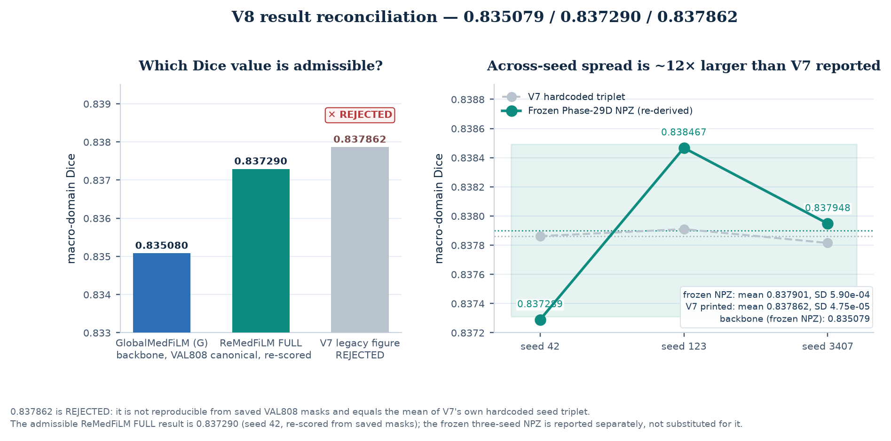
Figure 1. V8 adjudication of the three VAL808 macro-Dice values. Left: the canonical FULL result (teal), its GlobalMedFiLM comparator (blue), and the legacy 0.837862 (rejected). Right: the genuine three-seed values re-aggregated from the frozen per-sample NPZ archive, with seed 42 matching the saved-mask re-score to approximately 6×10⁻⁷. The legacy value is the mean of three numbers hard-coded into the V5/V6/V7 generators, not a measurement. [V8 registry; frozen NPZ; V7 generator]

2. Methodology: the proposed ReMedFiLM FULL system

2.1 Verified architecture
Every arrow in the V8 methodology figure was checked against source code. The verification manifest records 20 supported arrows and 13 arrows removed or corrected relative to the V5–V7 diagram. The most consequential corrections are: B_phi is pre-refinement and never sees the ROI crop or a global feature tensor; S_omega is post-candidate-composition; R_psi is an offline out-of-fold producer and is not invoked online; fusion is deterministic replacement inside the ROI with no alpha blending; and there are two distinct skip states rather than one.
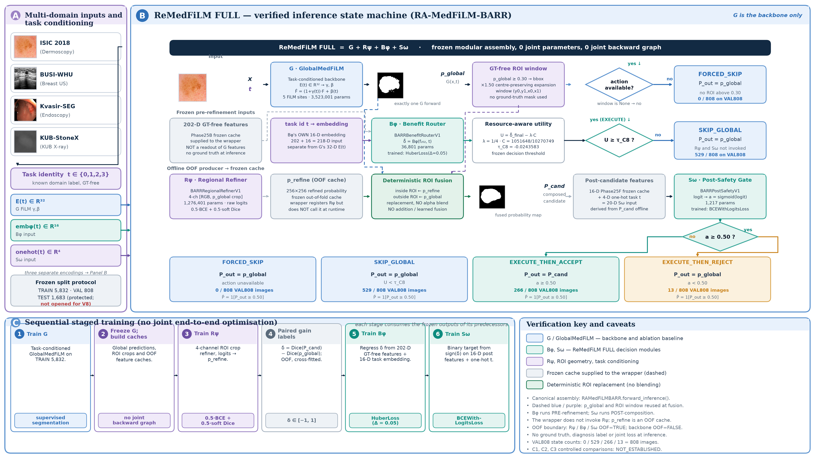
Figure 2. Code-verified three-panel methodology. Panel A: four multi-domain inputs and three distinct task representations. Panel B: the full inference state machine of RAMedFiLMBARR.forward_inference, showing G → action/ROI → B_phi → utility test → offline OOF refined crop → deterministic fusion → S_omega → accept/reject, with both skip states. Panel C: the six-step sequential training dependency, explicitly not joint end-to-end training. Blue denotes GlobalMedFiLM, teal denotes the proposed ReMedFiLM FULL system. [v8_figure_methodology.py; 20 verified arrows]

2.2 G: task-conditioned GlobalMedFiLM (backbone only)
GlobalMedFiLM is a single shared encoder–decoder with channel widths (24, 48, 96, 192, 256) and five FiLM sites at bridge, decoder4, decoder3, decoder2 and decoder1. A 32-D learned task embedding is mapped through a 64-D hidden layer to gamma = tanh(gamma_raw) and beta = tanh(beta_raw) at each site; the output projections are zero-initialised so every site begins as an exact identity transform. The source file states explicitly that the module contains no ROI proposal, localiser, crop branch, router, gain label or safety head. It is the `G` component and a legitimate ablation baseline, not the proposed system.

2.3 R_psi, B_phi and S_omega
BARRRegionalRefinerV1 (R_psi) is a plain 4-channel CNN over ROI crops; it has no FiLM, attention or residual-correction head, and emits a refined crop probability map, not an additive delta P. BARRBenefitRouterV1 (B_phi) consumes a frozen, ground-truth-free 202-D numeric feature vector plus its own 16-D task embedding (218 inputs) and regresses delta_dice through Linear(218,128) → LayerNorm → SiLU → Dropout → Linear(128,64) → … → Linear(64,1). BARRPostSafetyV1 (S_omega) consumes 16 frozen post-candidate numeric features concatenated with a 4-D one-hot task vector (20 inputs) through Linear(20,32) → SiLU → Linear(32,16) → SiLU → Linear(16,1). The three modules therefore use three different task representations: 32-D embedding, 16-D embedding, and 4-D one-hot.

2.4 Verified inference state machine
forward_inference executes G exactly once, derives action availability and the ROI window from p_global >= 0.30, and then follows one of four states. The router utility is U = delta_hat_final − (1/4)(1051648/10270749) with tau_C8 = -0.024358327623641256; U < tau_C8 returns SKIP_GLOBAL. On the execute path a supplied out-of-fold oof_refined_crop_prob is fused by replacing p_global inside the (1.5× expanded) ROI while retaining p_global outside it. S_omega then scores post-candidate features and accepts when its sigmoid is >= 0.50; rejection restores p_global. The final binary mask uses the separate SEGMENTATION_OUTPUT_THRESHOLD = 0.50.
Three distinct 0.50 / 0.30 thresholds — not interchangeable
ROI_PROPOSAL_THRESHOLD = 0.30 governs bbox/action availability; SEGMENTATION_OUTPUT_THRESHOLD = 0.50 binarises the final mask and all reported Dice; SOMEGA_ACCEPT_THRESHOLD = 0.50 governs the post-safety accept decision. Only the first is a proposal threshold.

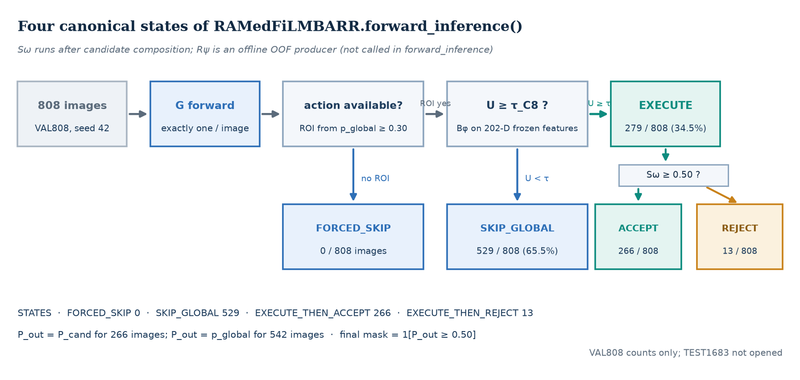
Figure 3. The four canonical VAL808 states of RAMedFiLMBARR.forward_inference. FORCED_SKIP occurs when no action is available; SKIP_GLOBAL occurs when the router utility falls below tau_C8. Executed cases split into accept and reject according to S_omega. Counts are from the frozen Phase 27 prediction table. [phase27_val808_predictions.csv]
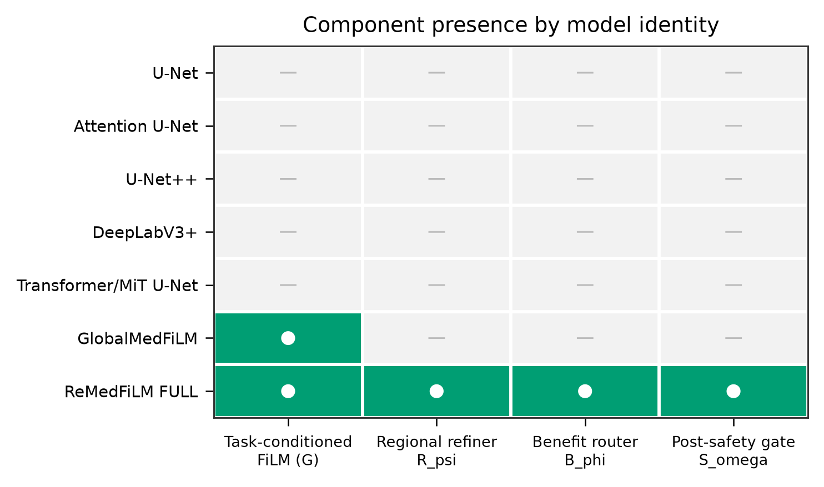
Figure 4. Component-presence matrix. Only the FULL assembly instantiates all four components; GlobalMedFiLM alone instantiates G only. This is the identity check that prevents the backbone from being reported as the proposed model. [figure_registry.json / A02]

2.5 Staged training — sequential, not joint
The six-step dependency is: train G → generate global predictions/ROIs → train R_psi → create paired gain labels → train B_phi → train S_omega. Inference uses frozen modules and frozen out-of-fold caches. The wrapper defines no trainable parameters and no unified objective, so no joint end-to-end backpropagation occurs; claims of end-to-end training in earlier versions are unsupported.
Table 2. Verified per-stage objectives. Each stage is supervised independently; no gradient passes between stages.
Stage | Module | Objective | Target
1 | G | BCEWithLogits + soft Dice (historical train_loss / val_loss) | binary mask
2 | R_psi | 0.5 × BCEWithLogits + 0.5 × soft Dice | ROI-crop mask
3 | B_phi | nn.HuberLoss(delta=0.05, reduction='mean') | delta_dice
4 | S_omega | BCEWithLogitsLoss(reduction='mean') | binary safety_target
Phase 25C gain labels contain delta_dice, gain_category, global_dice and candidate_refined_dice. S_omega targets sign(delta_dice) — it scores refinement benefit, not lesion presence or clinical reliability.
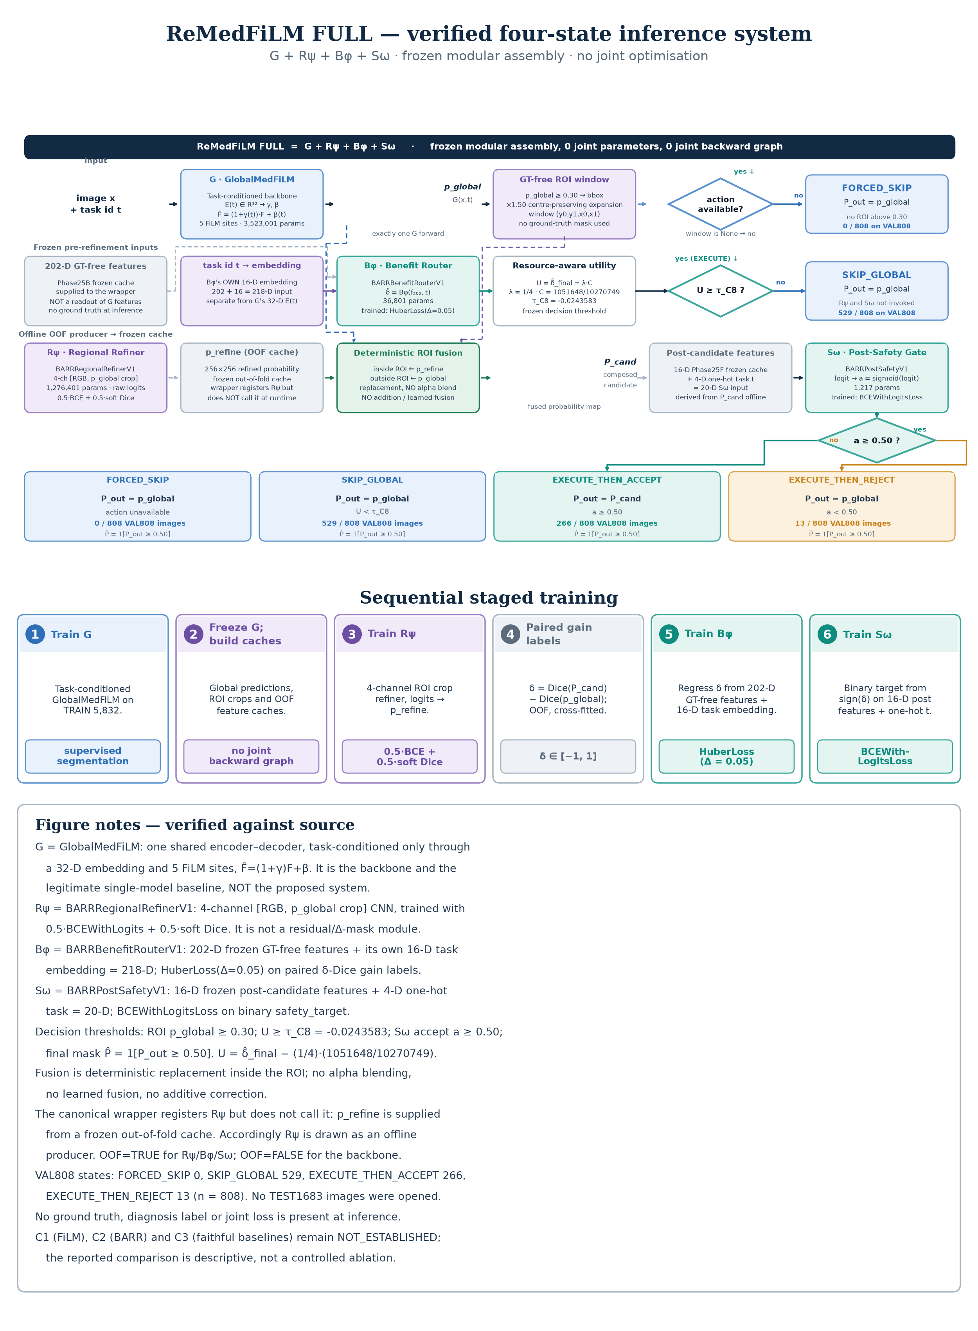
Figure 5. Portrait print variant of the same verified state machine shown in Figure 2, reformatted for single-column manuscript reproduction. It is not a second architecture and introduces no additional pathways or objectives. [v8_figure_methodology.py / manuscript variant]

3. Datasets, splits and evaluation protocol

3.1 Datasets and licensing
Table 3. Source datasets. Dataset licences are separate from the repository code, which currently has no licence file.
Dataset | Modality / target | Licence / use condition | Role
ISIC 2018 | Dermoscopy / skin lesion | Task 1 data: CC0 | internal
BUSI-WHU | Breast ultrasound / lesion | CC BY 4.0, attribution required | internal
Kvasir-SEG | Endoscopy / GI polyp | Research/educational; commercial use needs written permission | internal + CVC external comparator context
KUB-StoneX | KUB radiography / stone | CC BY 4.0, attribution required | internal

KUB unit-of-analysis caveat. The KUB manifest contains full-field radiographs and ROI instance patches; these are different units of analysis and must not be pooled as if interchangeable. The BUSI-WHU workbook distributed with the dataset is deliberately excluded from all published artifacts.

3.2 Split accounting and protected data
Internal data are partitioned into TRAIN (n = 5,832), VAL808 (n = 808) and the protected TEST1683 cohort. Router development used ROUTER_DEV (4,957) plus a locked ROUTER_HOLDOUT (875), which together reconstitute TRAIN. VAL808 domain counts are ISIC 357, BUSI 84, Kvasir 87 and KUB 280. TEST1683 was never opened during V8 reconstruction, and V8 reports no prospective test result.
Table 4. Population accounting used in V8. Values are counts of images unless stated.
Population | n | Status in V8
TRAIN | 5,832 | component training; frozen
VAL808 | 808 | canonical paired evaluation, seed 42
ROUTER_DEV + ROUTER_HOLDOUT | 4,957 + 875 | 13-arm ablation population
TEST1683 | 1,683 | PROTECTED — not opened
EXTERNAL884 | 612 + 252 + 20 | retrospective, no training

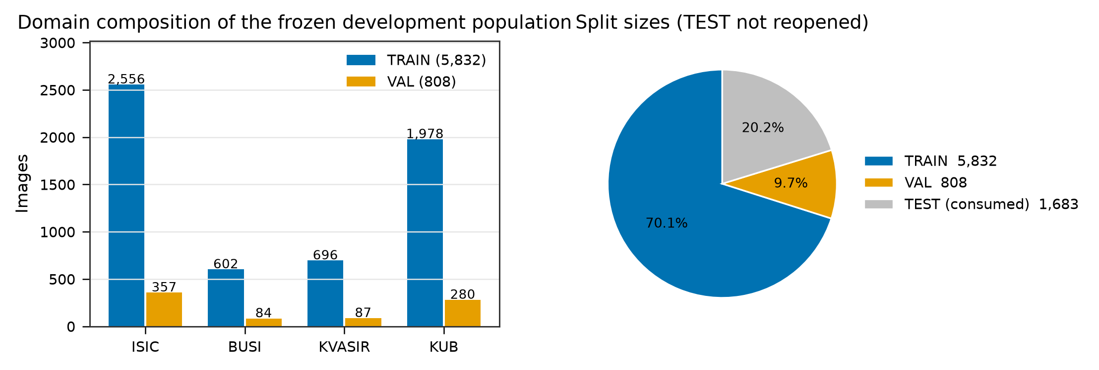
Figure 6. Domain and split composition of the internal four-domain cohort. [frozen manifests / D01]
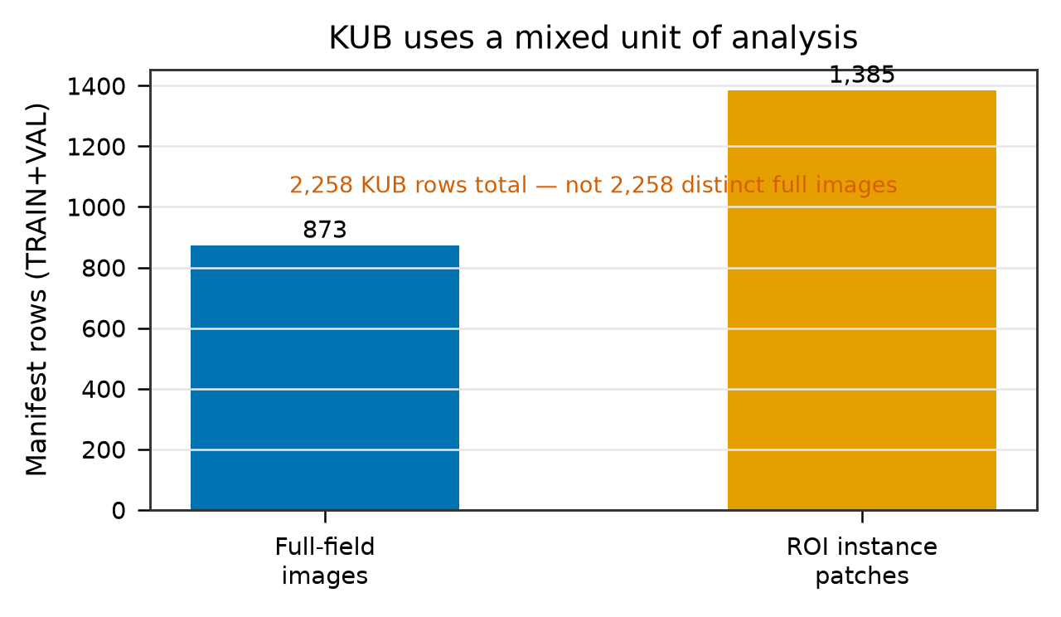
Figure 7. KUB unit-of-analysis: full-field radiographs versus ROI instance patches. [frozen manifests / D03]
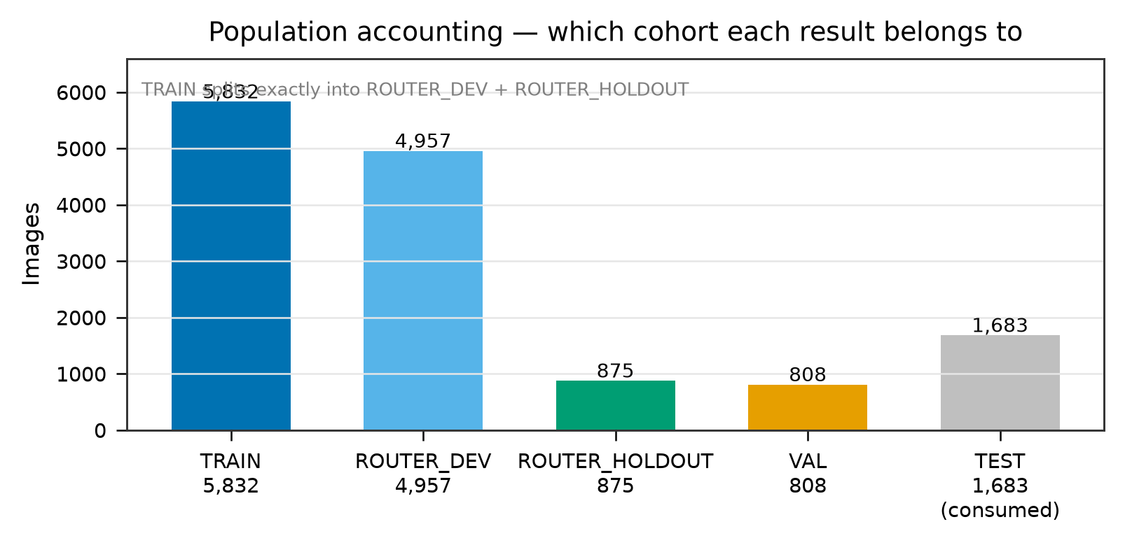
Figure 8. Population accounting across TRAIN, VAL808, router development/holdout and the protected TEST1683 cohort. [registry populations / STAT04]

3.3 Metric definitions and aggregation
Dice is computed on the binary mask produced at the 0.50 output threshold. The headline 'macro' value is the equal-weight mean of the four per-domain per-image Dice means, not a pooled image-level mean; this gives each domain equal weight despite the unequal domain sizes. The paired difference is computed per image and then averaged. Its 95% interval is a percentile bootstrap with 10,000 domain-stratified image resamples, seed 20261027. V8 adds no new p-values and reports no interval that was not present in the frozen evidence.
Out-of-fold boundary (a genuine limitation, deliberately not repaired)
In the full pipeline, refiner, router and safety stages use out-of-fold labels (OOF = TRUE) while the backbone is in-sample (OOF = FALSE). Consequently the backbone-conditioned delta-Q and harm rates are optimistic. V8 records this asymmetry rather than silently correcting it.

4. Internal quantitative results

4.1 Canonical paired result
Table 5. VAL808 internal results. ReMedFiLM FULL versus its GlobalMedFiLM backbone, seed 42, identical images and identical output threshold.
Domain | n | G Dice | FULL Dice | Paired Δ
ISIC | 357 | 0.8972 | 0.8981 | +0.0009
BUSI | 84 | 0.8588 | 0.8589 | +0.0001
Kvasir | 87 | 0.8202 | 0.8207 | +0.0004
KUB | 280 | 0.7641 | 0.7715 | +0.0075
Macro (equal domain weight) | 808 | 0.8351 | 0.8373 | +0.0022
95% CI for the macro paired Δ: [0.001148, 0.003292]. Macro = equal-weight mean of the four domain means. All values re-scored from saved masks; no new inference.
The overall gain is small and highly domain-dependent: KUB contributes +0.0075 Dice, while BUSI contributes only +0.0001. Across the 808 images, 169 improve, 542 are unchanged and 97 are harmed relative to the backbone. The 542 unchanged cases are overwhelmingly the SKIP_GLOBAL branch, whose saved FULL mask is byte-identical to the backbone mask.
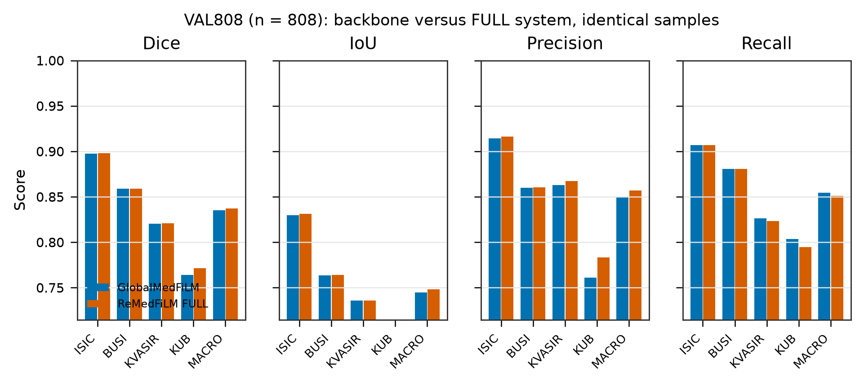
Figure 9. Per-domain comparison of GlobalMedFiLM and ReMedFiLM FULL across Dice, IoU, precision and recall on VAL808. [V8 registry / I1]
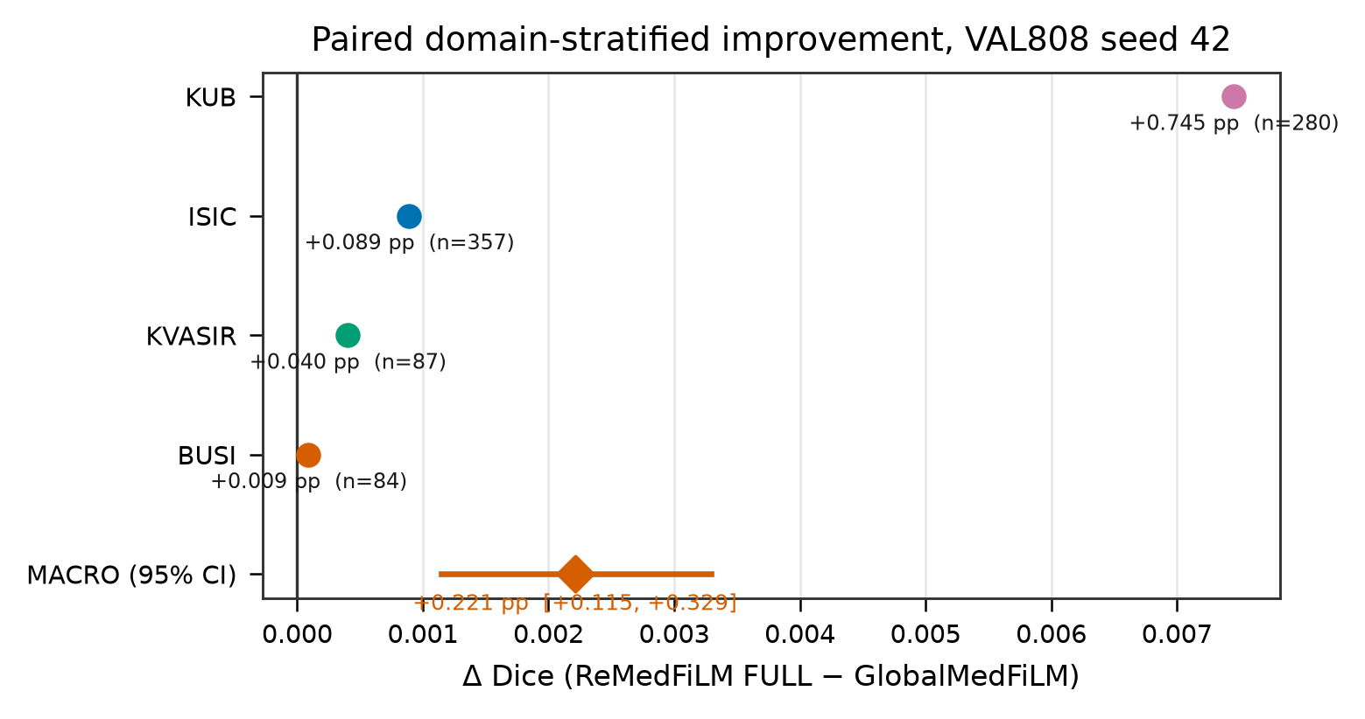
Figure 10. Paired per-image Δ Dice by domain with the macro estimate and its domain-stratified bootstrap interval. [V8 registry / I2]
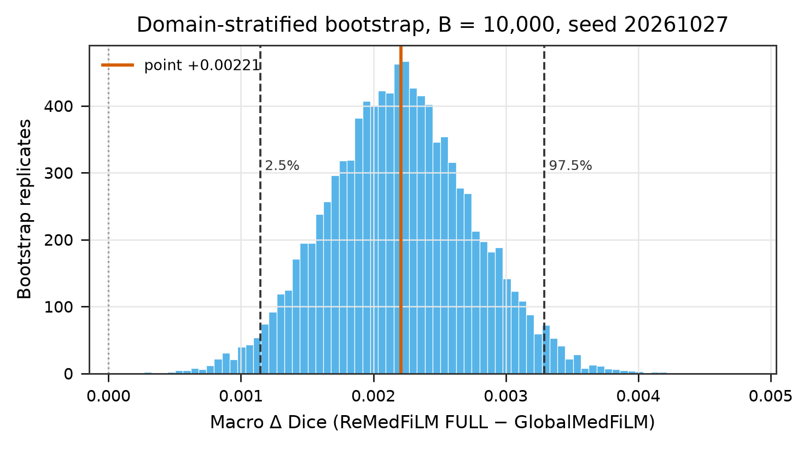
Figure 11. Bootstrap distribution of the paired macro Δ Dice (10,000 stratified resamples, seed 20261027). The percentile interval excludes zero. [REMEDFILM_PAIRED_DELTA.json / STAT02]

4.2 Six-model context — historical descriptive comparison
Table 6. VAL808 context of the frozen six-model comparison. These are historical descriptive results, not a matched controlled experiment.
Model | Macro Dice
GlobalMedFiLM (G, backbone / baseline) | 0.8351
DeepLabV3+ | 0.8277
Transformer / MiT-style U-Net | 0.8224
U-Net++ | 0.7920
Attention U-Net | 0.7890
U-Net | 0.7878
ReMedFiLM FULL (proposed) | 0.8373
The FULL row comes from the canonical re-score, not from this legacy table. The two GlobalMedFiLM entries differ by ~3×10⁻⁷ because they are distinct source artifacts; V8 does not silently merge them. No matched multi-seed baseline matrix (C3) has been established.

5. Training history and staged objectives
Training histories are reported per module, not as a single curve. V8 reads the frozen component training-history table and selects one genuine run ID per panel; no curve is spliced from different runs. The G backbone history covers 81 recorded epochs of val_macro_dice under run phase21_global_medfilm_fourdomain_seed42_clean_v3.
G validation macro Dice rises from 0.6155 at epoch 1 to 0.8317 at epoch 81, with a maximum of 0.8351. That maximum (0.8351) agrees with the frozen backbone comparator 0.8351 to within 3×10⁻⁷, confirming that the history and the comparator refer to the same trained backbone.
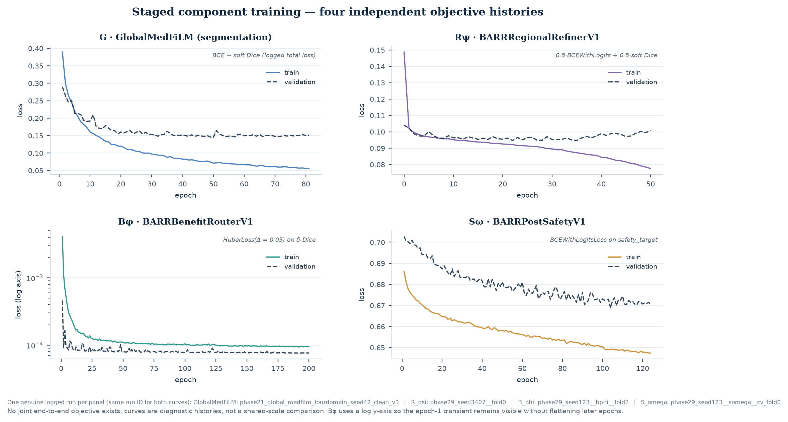
Figure 12. Four independent objective histories — G, R_psi, B_phi and S_omega. Each panel uses a single genuine run ID for both train and validation curves. The B_phi Huber loss shows a large epoch-1 transient; panels are individually scaled. These are four separate training procedures, not one joint run. [REMEDFILM_COMPONENT_TRAINING_HISTORY.csv]
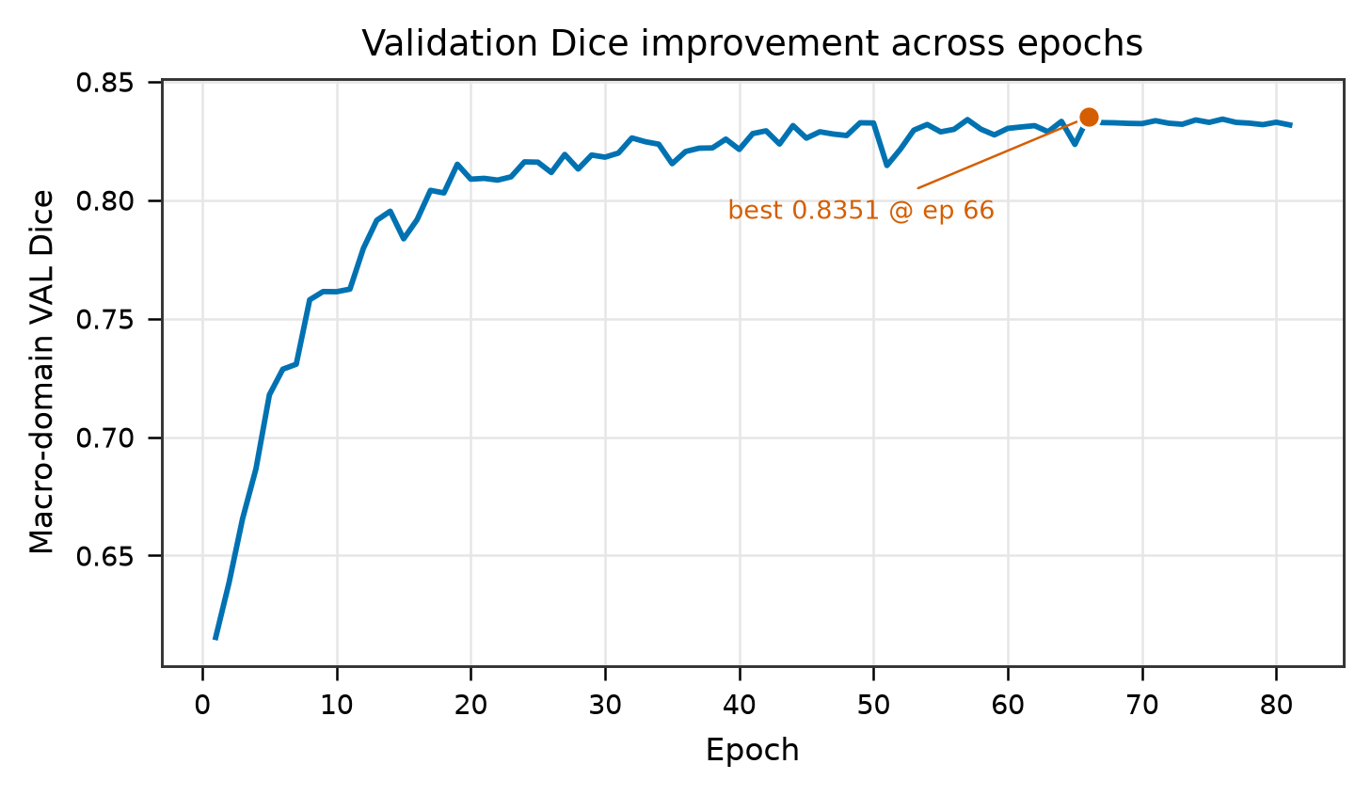
Figure 13. GlobalMedFiLM validation macro Dice across the recorded training epochs. [training history / T2]
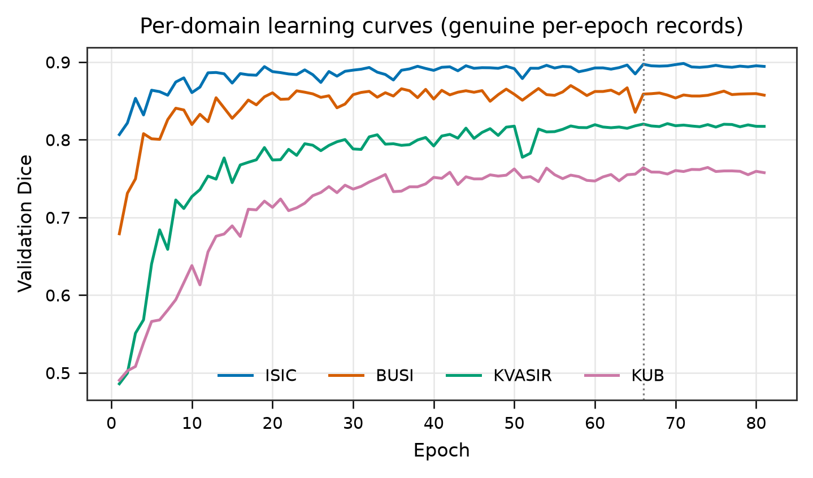
Figure 14. Per-domain learning curves for the shared backbone, showing the unequal convergence of the four domains. [training history / T4]
What the histories do and do not establish
They document that four modules were trained with distinct objectives and that the backbone converged. They are not three independent end-to-end training replicates: the three-seed downstream runs share one pre-trained backbone. No history in V8 was regenerated by retraining.

6. Real segmentation results
The following galleries show real saved predictions, ground truth and the two system outputs for representative VAL808 cases. All tiles come from the frozen Phase 27 / Phase 29 validation caches and are rendered at the 0.50 segmentation output threshold. No new inference was run to produce any V8 image. Tiles are illustrative cases, not a random or pre-registered sample, and must not be read as a quantitative estimate.
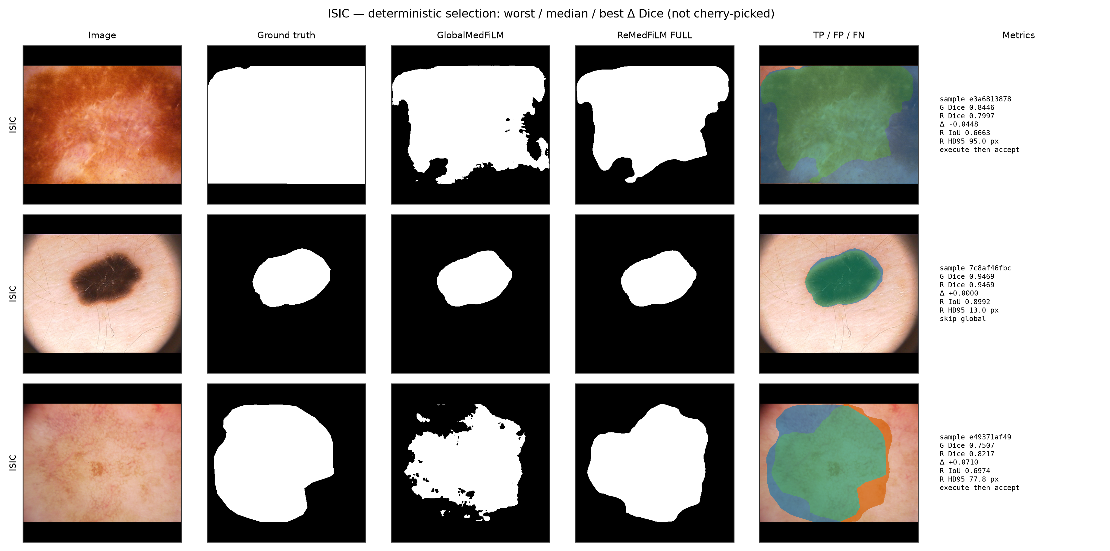
Figure 15. Real segmentation examples — ISIC 2018 dermoscopy. Each row shows the input, ground truth, the GlobalMedFiLM backbone output and the ReMedFiLM FULL output with the ROI and the routing/safety decision annotated. Differences are typically local boundary adjustments rather than whole-mask changes, consistent with the small paired Δ Dice. [frozen Phase 27 / 29 validation caches]
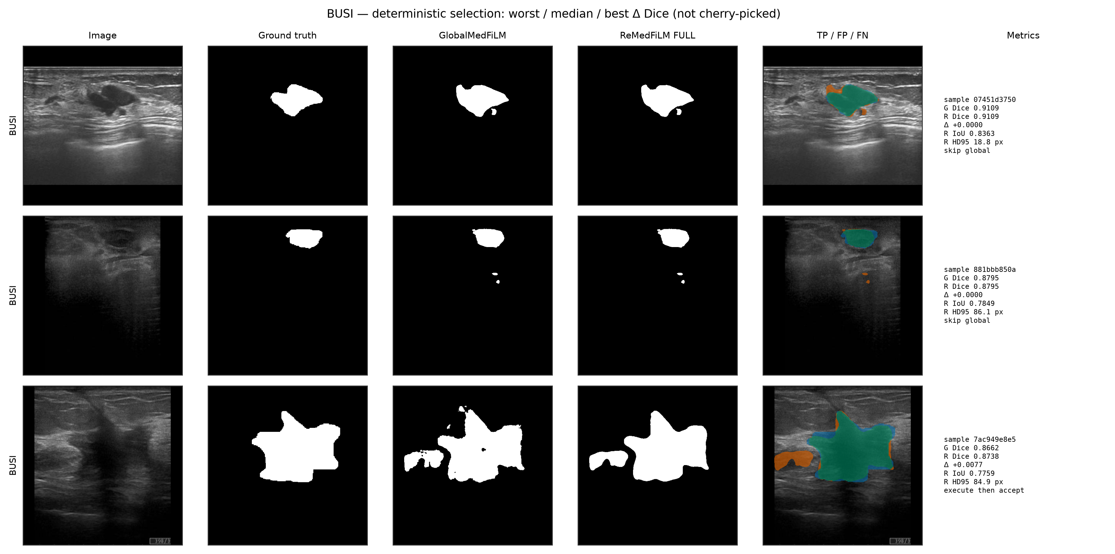
Figure 16. Real segmentation examples — BUSI-WHU breast ultrasound. Each row shows the input, ground truth, the GlobalMedFiLM backbone output and the ReMedFiLM FULL output with the ROI and the routing/safety decision annotated. Differences are typically local boundary adjustments rather than whole-mask changes, consistent with the small paired Δ Dice. [frozen Phase 27 / 29 validation caches]
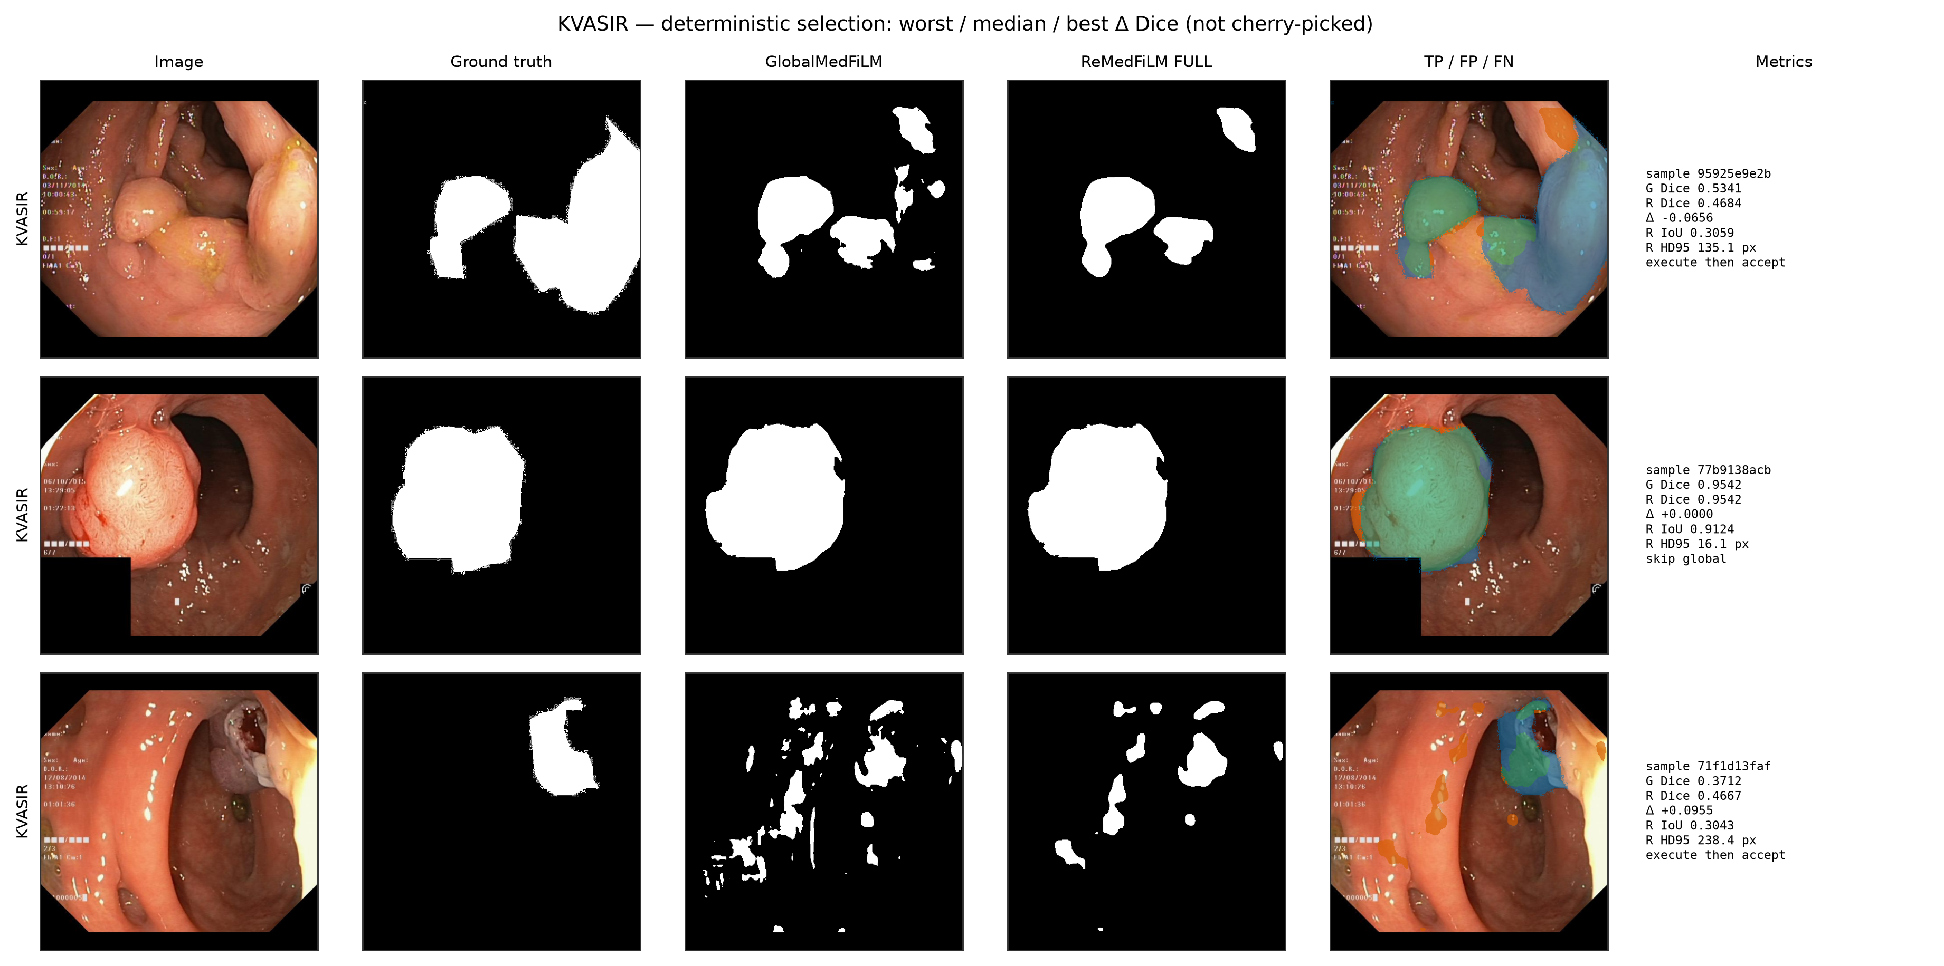
Figure 17. Real segmentation examples — Kvasir-SEG endoscopy. Each row shows the input, ground truth, the GlobalMedFiLM backbone output and the ReMedFiLM FULL output with the ROI and the routing/safety decision annotated. Differences are typically local boundary adjustments rather than whole-mask changes, consistent with the small paired Δ Dice. [frozen Phase 27 / 29 validation caches]
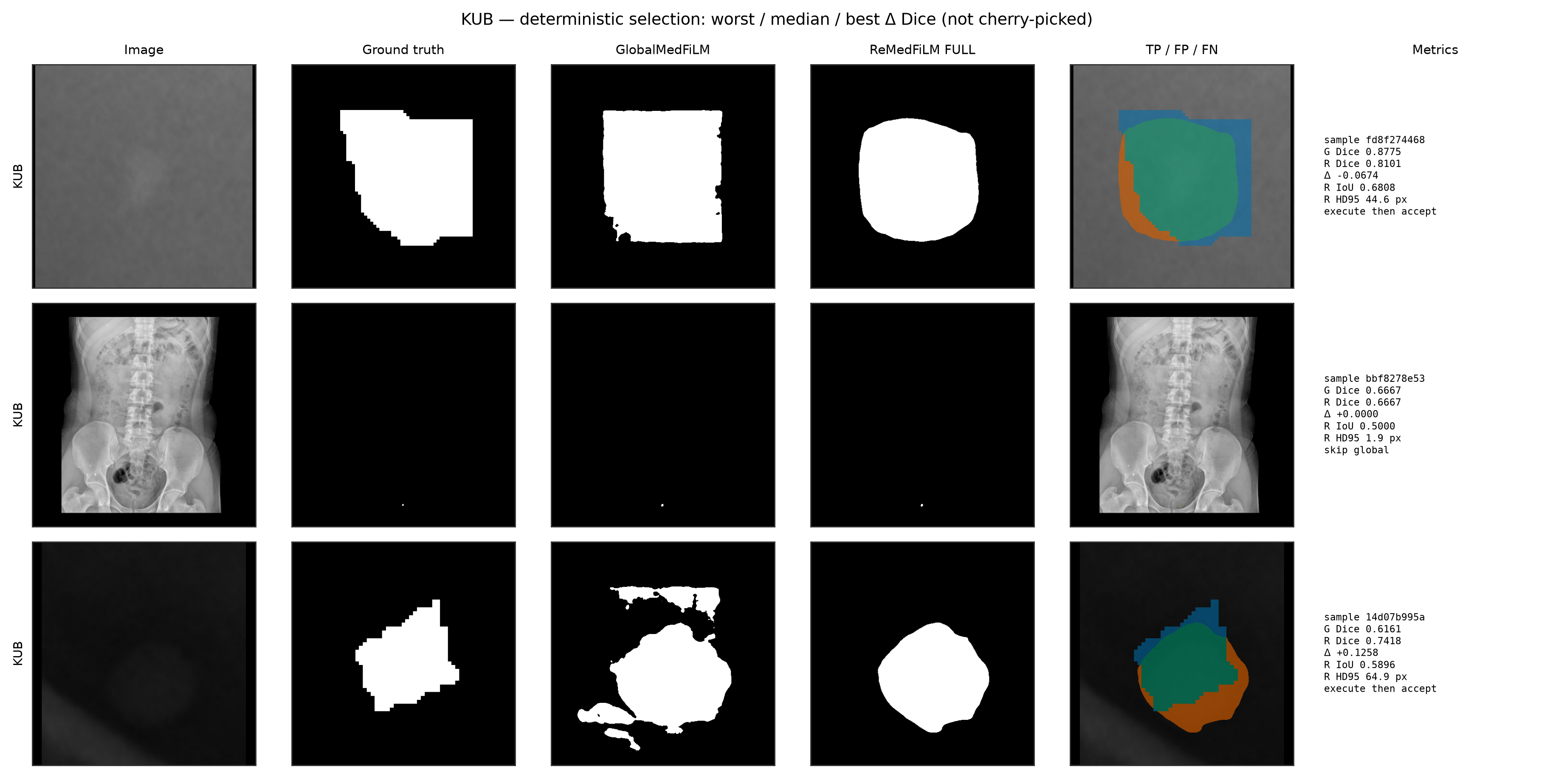
Figure 18. Real segmentation examples — KUB radiography. Each row shows the input, ground truth, the GlobalMedFiLM backbone output and the ReMedFiLM FULL output with the ROI and the routing/safety decision annotated. Differences are typically local boundary adjustments rather than whole-mask changes, consistent with the small paired Δ Dice. [frozen Phase 27 / 29 validation caches]
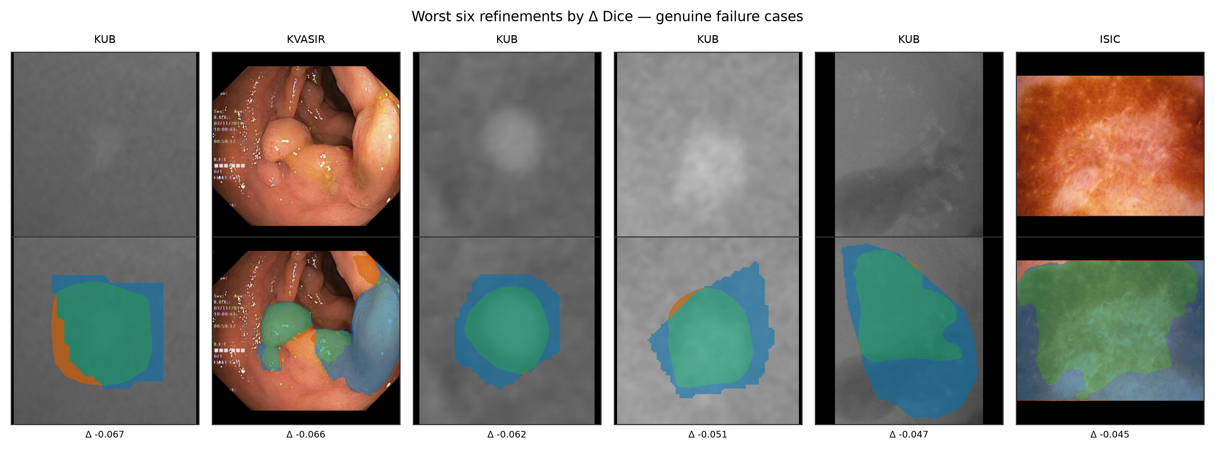
Figure 19. Representative failure cases retained as negative evidence. These include harmful refinements and false-positive foreground on stone-free radiographs; they are shown because the aggregate Dice gain does not imply uniform per-image benefit. [frozen validation / external caches]

7. Class and subclass performance
Subgroup analyses are descriptive stratifications of the frozen predictions. They are not powered comparisons, no multiplicity correction is applied, and V8 reports no subgroup p-values. The KUB radiography domain is the only internal domain with a material paired gain (+0.0075), so its stone morphology and size strata receive the most attention.
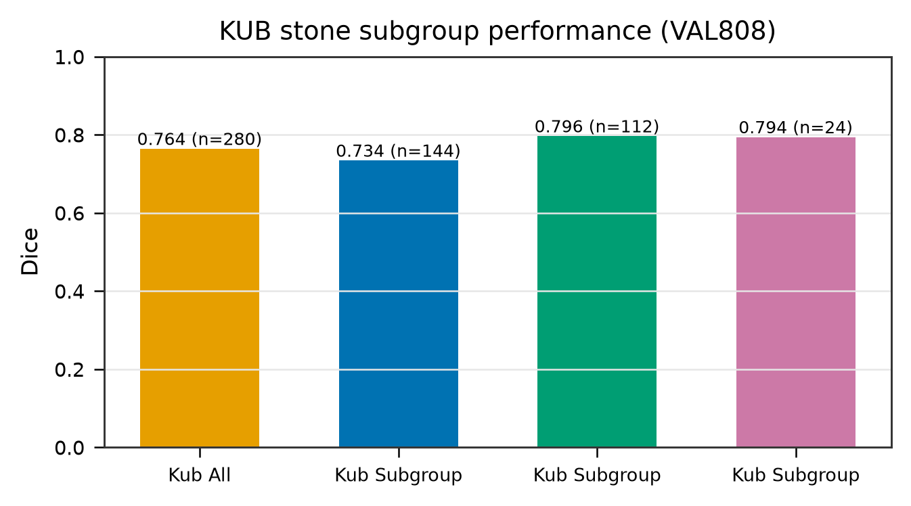
Figure 20. KUB stone morphological subclasses. Performance varies across subclasses; the strata are descriptive and the subgroup sample sizes are small. [c1_external_stress_stones_subgroups.csv / SG1]
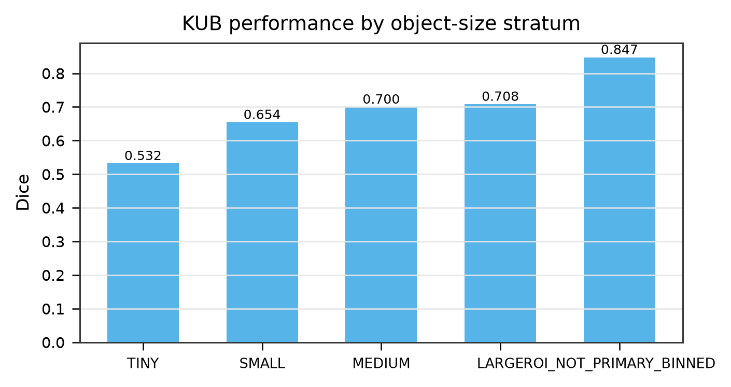
Figure 21. KUB stone size stratification. Small objects remain the dominant failure mode, consistent with the poor external Stones-Where-Are-You result in Section 8. [subgroup evidence / SG2]
Excluded legacy subgroup table
tables/subgroup_performance_summary.csv is a V3-era artifact containing the superseded 0.8379 macro / +0.28 pp figures. It is excluded from every V8 table and figure; the exclusion is recorded in the results registry.

8. External retrospective evaluation
The external retrospective cohort comprises 612 CVC-ClinicDB, 252 BrEaST-Lesions-USG and 20 Stones-Where-Are-You images (884 total). No external image was used for training, threshold selection or model selection; these are held-out retrospective descriptive comparisons. Patient-level independence of the BrEaST cohort cannot be verified from the available artifacts and is disclosed as a limitation.
Table 7. External retrospective results: Dice and HD95 for the GlobalMedFiLM backbone and the proposed ReMedFiLM FULL system. Direction is consistent across cohorts; margins are small.
Cohort | n | G Dice | FULL Dice | G HD95 px | FULL HD95 px
CVC-ClinicDB | 612 | 0.6866 | 0.6897 | 109.59 | 108.49
BrEaST-Lesions-USG | 252 | 0.7078 | 0.7081 | 73.98 | 73.26
Stones-Where-Are-You | 20 | 0.0808 | 0.0821 | 166.90 | 169.90
HD95, ASSD, recall are defined on only n = 6 of the 20 Stones images; Dice/IoU/precision use n = 20. Denominators are stated per metric in REMEDFILM_V8_EXTERNAL_EVALUATION.csv and in V8_F05.
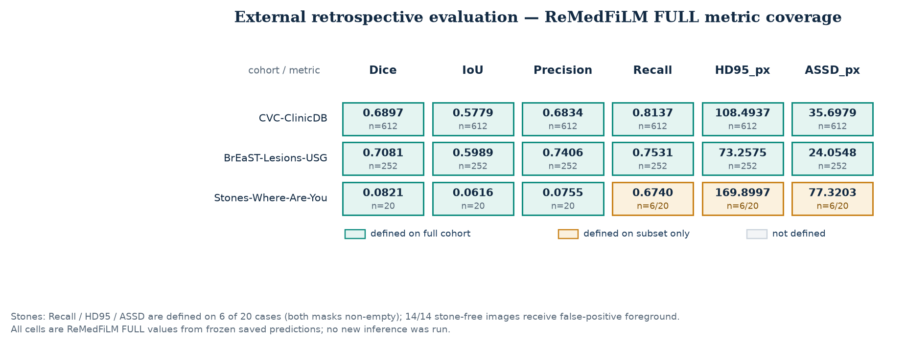
Figure 22. External metric coverage. Six metrics × two systems × three cohorts, with cells annotated by the true denominator. Partial-coverage cells (n = 6/20 for Stones HD95, ASSD and recall) are visually distinguished rather than presented as full-cohort estimates. [REMEDFILM_V8_EXTERNAL_EVALUATION.csv]
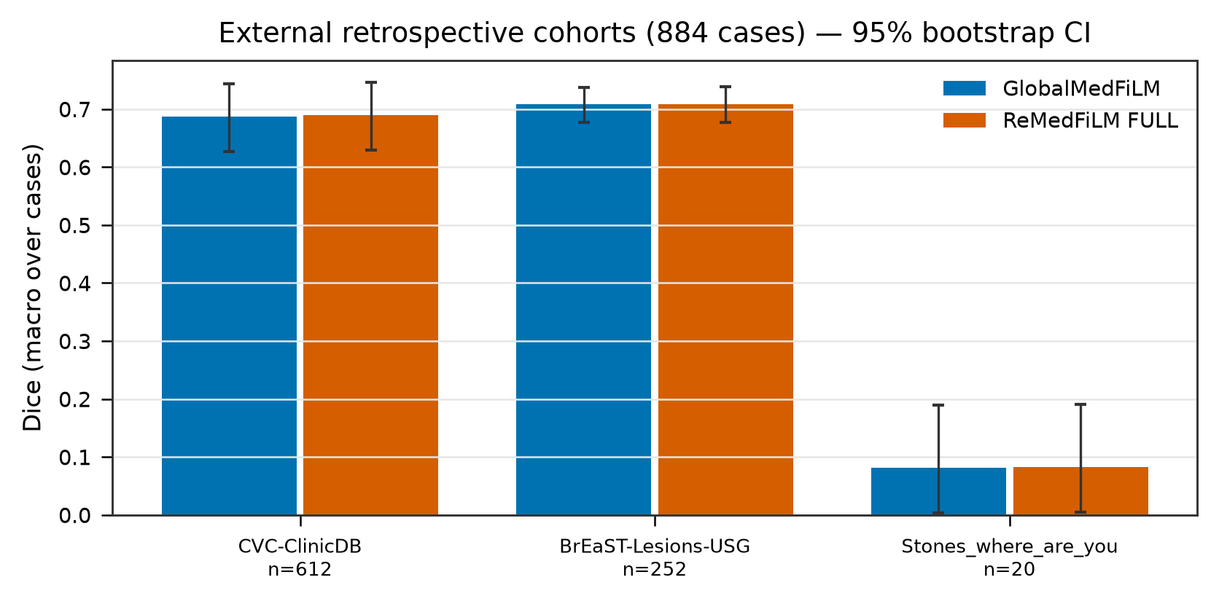
Figure 23. External Dice by cohort and system, with the stone-free subgroup shown separately. [frozen external metrics / EXT01]
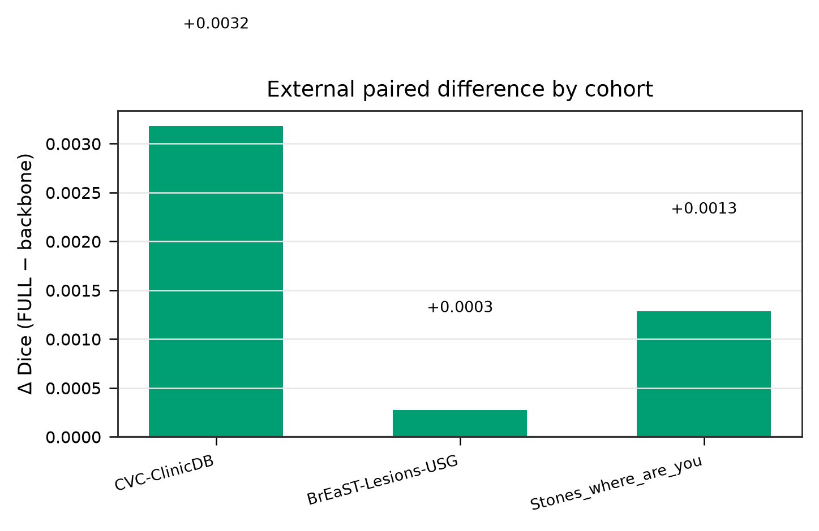
Figure 24. Paired external Δ Dice distribution by cohort. The IQR sits exactly on zero for the stone-free subgroup, so most external images are unchanged. [frozen external metrics / EXT02]
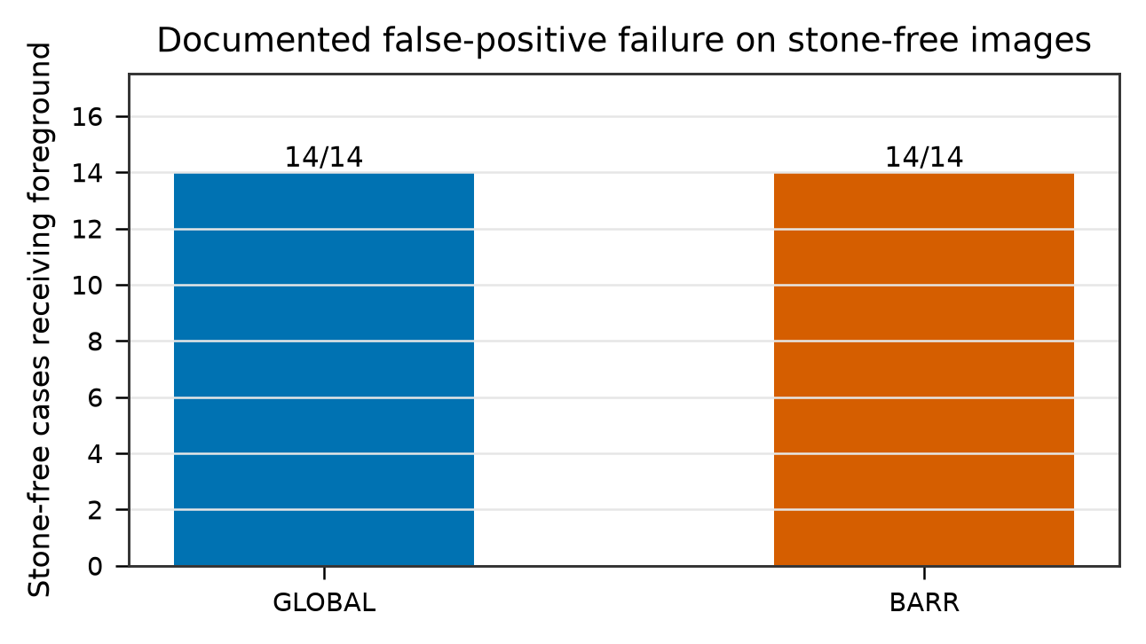
Figure 25. Negative result: all 14 stone-free external images receive false-positive foreground predictions from both systems. S_omega scores refinement benefit (sign of Δ Dice), not lesion presence, and therefore cannot suppress a false positive that is already present in the backbone output. [c1_external_stress artifacts / EXT03]
Negative result preserved
14 / 14 stone-free images receive false-positive foreground predictions. For the 9 stone-free images with a negative change, no harmful case may be invented. The external verdict is 'directionally consistent, 0 failures of the preservation property', not 'clinically safe'. No diagnosis is inferred and no clinical deployment claim is made.

9. Component progression and ablation
Component progression is reported on VAL808 for the frozen state machine, while the 13-arm ablation is reported on ROUTER_DEVELOPMENT (n = 4,957). These are different populations and their fractions must not be compared as if matched. The ablation is a policy comparison over frozen arm outputs, not a causal retraining ablation; n_executed is a property of the policy, not of the dataset.
Table 8. Frozen component progression. Stage 0 is the backbone; Stage 4 is the canonical VAL808 state machine.
Stage | Population | Routed | Accepted | Mean Δ | Harmful | GMACs
0 — G only | VAL808 | 0.0000 | 0.0000 | 0.0000 | 0.0000 | 31.552
1 — always refine | ROUTER_DEV | 1.0000 | 1.0000 | 0.1658 | 0.4267 | 34.782
2 — + ROI policy | ROUTER_DEV | 0.2499 | 0.2499 | 0.7247 | 0.3325 | 32.438
3 — + safety | ROUTER_DEV | 0.2431 | 0.2431 | 0.7516 | 0.3237 | 32.438
4 — FULL / VAL808 | VAL808 | 0.3453 | 0.3292 | 0.2210 | 0.1200 | 32.438
Stages 1–3 'Mean Δ' and 'Harmful' are percentage-point scale values in the frozen progression table; Stage 4 values reproduce the canonical +0.2210 pp and 0.1200 harm share. The legacy PROGRESSION_AND_PROPAGATION_EVIDENCE.csv records conflicting Stage 4 values and is excluded.
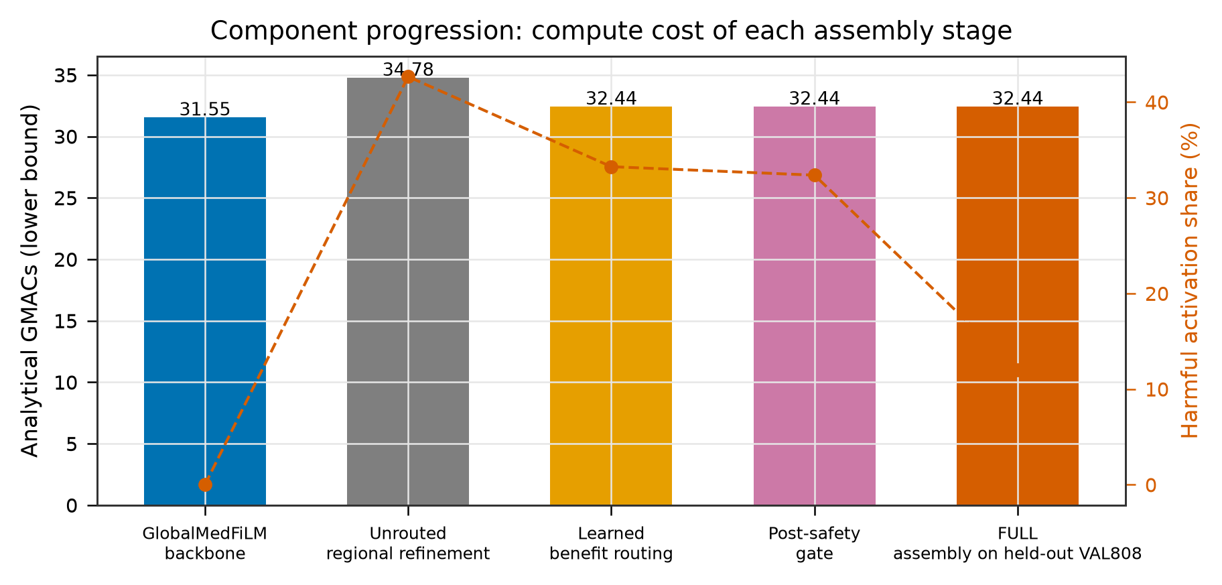
Figure 26. Component progression: conditional compute and harm share across stages. Routing removes most of the harm introduced by unconditional refinement. [REMEDFILM_ABLATION_AND_PROGRESSION.csv / PROG01]
The 13 arms are: A0 (never refine), A1 (always refine), A2 (fixed ROI policy), A3–A6 (feature/router variants), A7 (learned benefit routing), A8 (A7 + S_omega), R1–R3 (router ablations) and F1 (a deliberate failure arm). A1's harmful share is 0.4267; learned routing in A7 reduces it to 0.3325. F1 produces a mean Δ Dice of -0.0326, confirming the evaluation detects a broken policy.
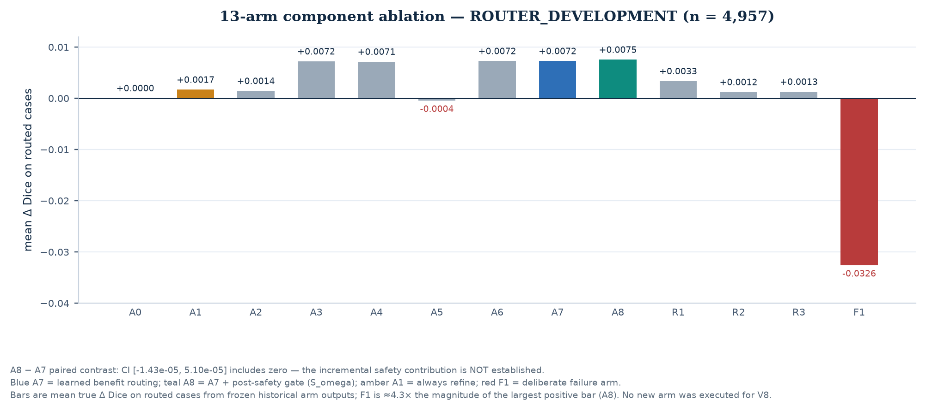
Figure 27. All 13 arms with mean true Δ Dice on routed cases. Blue = A7 (learned routing), teal = A8 (A7 + post-safety), amber = A1 (always refine), red = F1 (deliberate failure). The A8 − A7 paired contrast CI [-0.00, 0.00] includes zero: the incremental safety contribution is not established. [REMEDFILM_ABLATION_AND_PROGRESSION.csv]
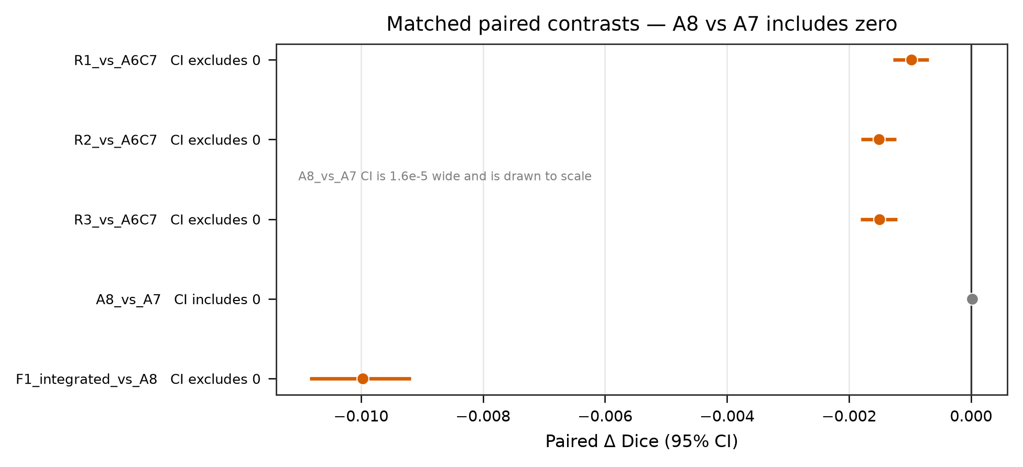
Figure 28. Paired contrasts between selected arms with intervals. Only contrasts whose interval excludes zero are described as established. [phase28 arm metrics / ABL02]
Table 9. Selected ablation arms on ROUTER_DEVELOPMENT (n = 4,957). Full 13-arm provenance is in REMEDFILM_V8_ABLATION_RESULTS.csv.
Arm | Routed cases | Mean Δ Dice | Harmful share | Benefit capture
A0 | 0 | 0.0000 | 0.0000 | 0.0000
A1 | 4,957 | 0.0017 | 0.4267 | 1.0000
A3 | 1,239 | 0.0072 | 0.3188 | 0.5843
A5 | 1,239 | -0.0004 | 0.4641 | 0.1843
A6 | 1,239 | 0.0072 | 0.3325 | 0.6022
A7 | 1,239 | 0.0072 | 0.3325 | 0.6022
A8 | 1,205 | 0.0075 | 0.3237 | 0.5970
F1 | 1,239 | -0.0326 | 0.6885 | 0.2834
A8 − A7 CI: [-1.43e-05, 5.10e-05], excludes zero = NO. The 32.37% = 390/1205 figure in older documents is a conditional in-sample policy statistic with zero GPU execution and is not used as a headline result in V8.

10. Routing, safety and error propagation
On VAL808 the frozen state machine records 529 SKIP and 279 EXECUTE router decisions. The four terminal branches are SKIP_GLOBAL 529, EXECUTE_THEN_ACCEPT 266 and EXECUTE_THEN_REJECT 13; FORCED_SKIP is 0 on this split (an action was available for every validation image). Rejection is not an error path — it is the designed global fallback when S_omega withholds acceptance.
Table 10. VAL808 state-machine outcomes and their downstream masks.
State | n | Share | Output mask
FORCED_SKIP | 0 | 0.0000 | p_global (no action available)
SKIP_GLOBAL | 529 | 0.6547 | p_global (router utility below tau_C8)
EXECUTE_THEN_ACCEPT | 266 | 0.3292 | fused regional candidate
EXECUTE_THEN_REJECT | 13 | 0.0161 | p_global (safety fallback)
Counts from reports/tables/phase27_val808_predictions.csv. For all 529 SKIP cases the saved FULL mask is byte-identical to the backbone mask.
Error propagation is bounded by construction: outside the ROI the global map is retained exactly, and any rejected candidate is discarded wholesale. Harm can therefore only arise on accepted executed cases. Nevertheless 97 of 808 images are harmed relative to the backbone. Because the backbone is in-sample while downstream stages are out-of-fold, the recorded harm rate is optimistic rather than conservative; V8 does not repair this asymmetry.
No overstated safety claim
S_omega is trained on sign(delta_dice) with BCEWithLogitsLoss. It estimates whether a refinement improves Dice relative to the backbone, not whether a prediction is clinically correct, whether a lesion is present, or whether the output is safe for a patient. Any 'clinical safety' reading of the gate is unsupported.

11. Reproducibility, interpretability and robustness

11.1 Adjudication of the legacy headline value
Three values circulated for VAL808: 0.837290 (ReMedFiLM FULL), 0.837862 (also labelled FULL in V5–V7) and 0.835079 (GlobalMedFiLM). V8 resolves them as follows. 0.835079718 is the backbone comparator, not a competing FULL value. 0.837862 is not a measurement: it is the arithmetic mean of three numbers hard-coded into the V5/V6/V7 generators (0.837862 / 0.837910 / 0.837815; mean 0.837862333) and was printed as both the seed-42 row and the three-seed mean. No routing policy expressible from the saved masks reproduces it.
Table 11. Three-seed reconciliation. Genuine values re-aggregated from the frozen per-sample NPZ archive with the same equal-domain-weight rule.
Seed | Frozen NPZ macro Dice | V5–V7 printed | Difference
42 | 0.837289 | 0.837862 | −0.000573
123 | 0.838467 | 0.837910 | +0.000557
3407 | 0.837948 | 0.837815 | +0.000133
Mean | 0.837901 | 0.837862 | +0.000039
SD (ddof=1) | 0.000590 | 0.0000475 | ≈12× understated
Seed 42 from the archive is 0.837289105, agreeing with the saved-mask re-score 0.837289686 to 5.81×10⁻⁷. All three seeds share one pre-trained backbone, so this triplet is descriptive component-initialisation stability, not three independent end-to-end replicates.
A second frozen record, reports/audits/phase29_val808_seedwise_metrics.json, gives a genuine but different descriptive triplet (0.837351 / 0.838511 / 0.838000; mean 0.837954, SD 0.000581). Its seed-42 entry reports 268 accepted cases whereas the saved masks encode 266; those two extra safety decisions were never persisted separately. V8 discloses this variant as genuinely recorded but not re-derivable, and does not select it. V7's impossible routing counts (183 selected / 165 accepted / 31 rejected) are likewise rejected rather than reconciled.
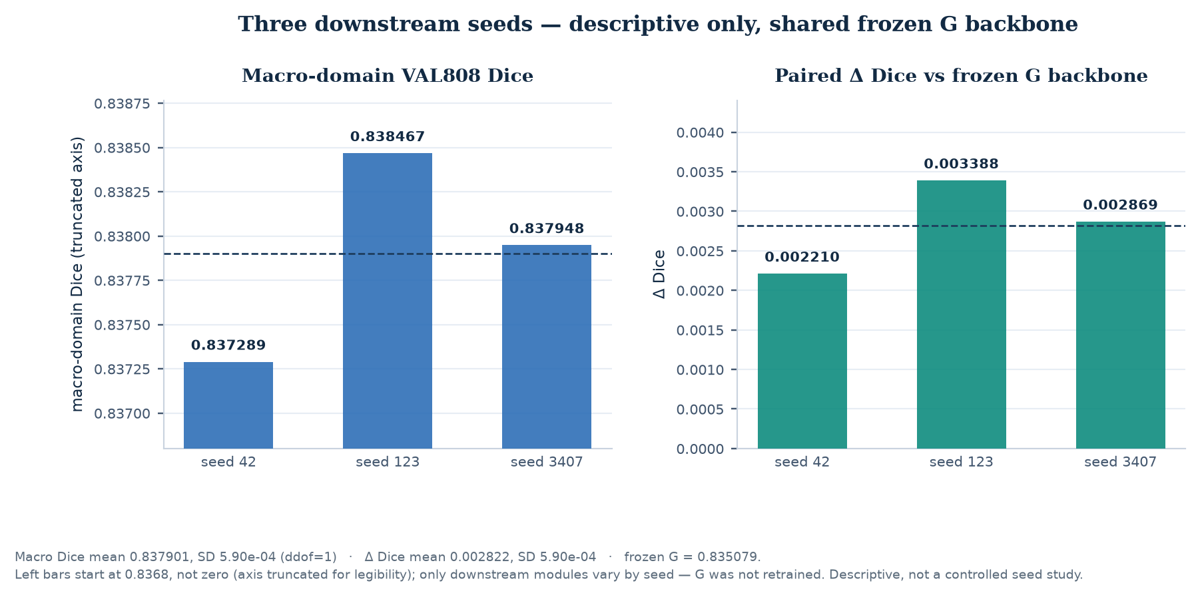
Figure 29. Three downstream seeds on the shared frozen backbone: macro-domain VAL808 Dice and paired Δ Dice versus the frozen G backbone. Descriptive only; no seed was retrained for V8 and the backbone is common to all three. [frozen three-seed NPZ archive]

11.2 Reproducibility infrastructure
Every V8 number is fetched from REMEDFILM_V8_RESULTS_REGISTRY.json (291 records). Each record carries a metric ID, model identity, active components, population, split, domain, sample count, run ID, seed, checkpoint digest, config, metric definition, aggregation rule, source path, source SHA-256, evidence class and verification status. SHA-256 values are computed from the bytes on disk at build time; superseded artifacts are moved to _superseded_v8 rather than deleted. Five legacy sources with conflicting values are explicitly excluded and their exclusion reasons recorded.
Host-clock disclosure
The build host clock is not synchronised (NTP leap indicator 3, local CMOS, no recorded sync), so absolute timestamps carry an unquantified offset. V8 omits absolute dates and establishes provenance through content digests and within-run ordering instead.

11.3 Interpretability and robustness
The router is interpretable at the level of its inputs: 202 frozen, ground-truth-free numeric features plus a 16-D task embedding, regressed to a scalar predicted Δ Dice and compared against a fixed utility threshold. It sees neither a learned global feature tensor nor the refined crop. No feature-attribution study or counterfactual explanation is claimed in V8.
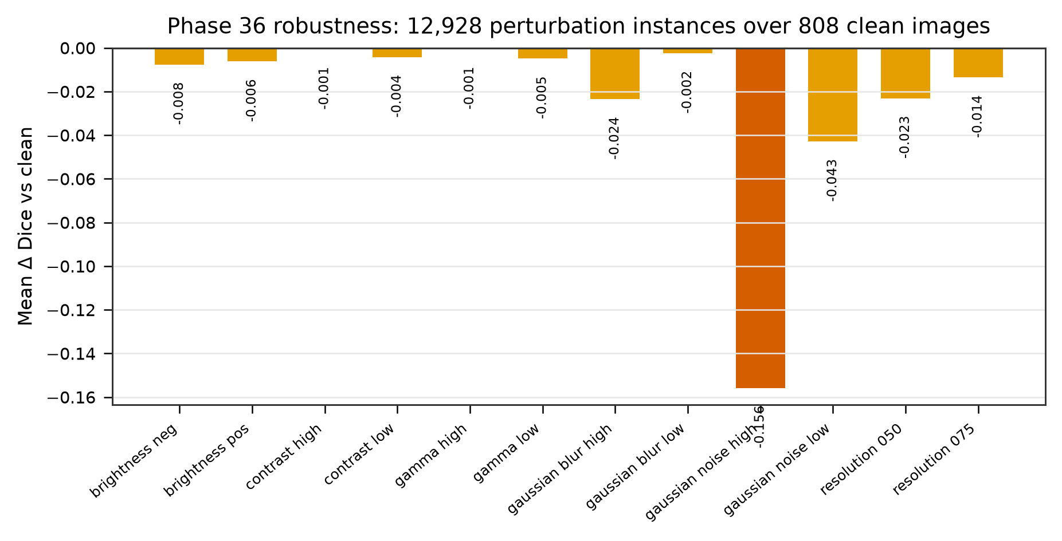
Figure 30. Perturbation robustness: degradation of segmentation quality under the recorded input perturbations. This is a descriptive stress test, not a certification of clinical robustness. [robustness evidence / ROB01]

12. Computational complexity and accuracy-cost
Complexity is reported for the frozen components and for the routed policy. Expected conditional GMACs integrate over the observed execution frequency; the always-refine cost is the unconditional upper branch. Parameter counts are measured from checkpoint state dicts, not estimated.
Table 12. Verified computational cost. Latency is the recorded p50 for the frozen runtime; GMACs are analytical for a 3 × 512 × 512 input.
System | Parameters | GMACs | Latency p50 (ms)
GlobalMedFiLM (G, backbone) | 3,523,001 | 31.5517 | 15.72
ReMedFiLM FULL (routed) | 4,837,420 | 32.4379 | 18.89
Always-refine (A1) upper branch | — | 34.7824 | —
An older README quote of 34.72 GMACs for always-refine differs from the frozen CSV value 34.7824; V8 uses the CSV and records the visible caveat rather than silently harmonising them.
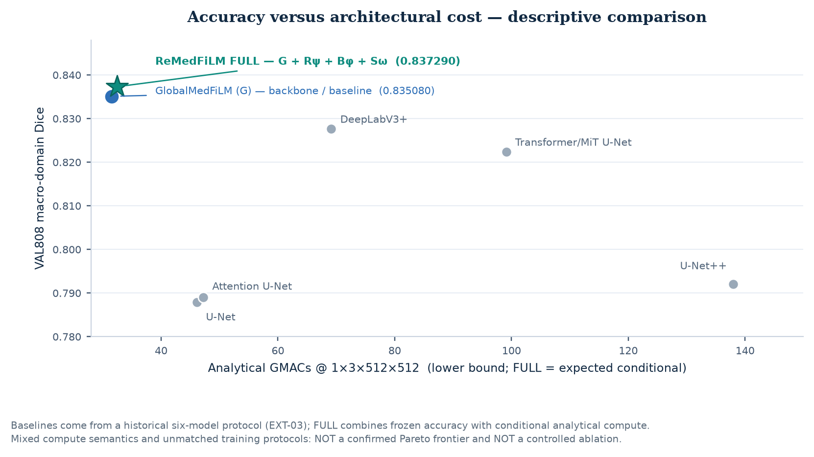
Figure 31. Accuracy versus architectural cost with the canonical ReMedFiLM FULL point at Dice 0.8373 and 32.4379 expected conditional GMACs. Historical descriptive comparison, not a confirmed Pareto frontier: the baseline protocols are not matched controlled experiments, and V7's point was wrong on both axes (0.837862 paired with the always-refine 34.72 GMACs). [V8 registry / phase21 compute]
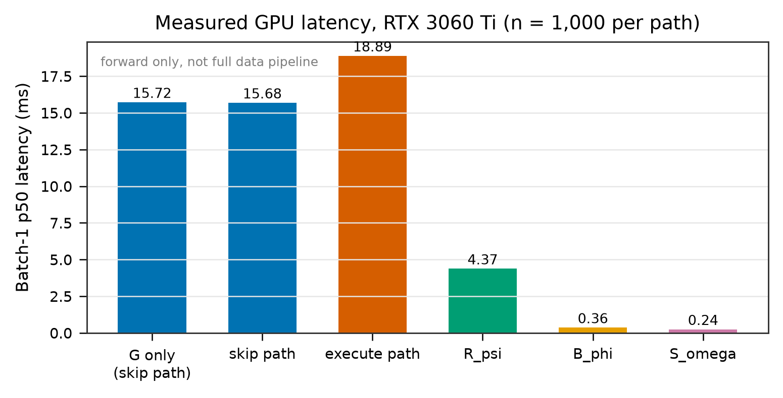
Figure 32. Recorded latency breakdown by pipeline stage for the frozen runtime. [REMEDFILM_EFFICIENCY.csv / EFF02]
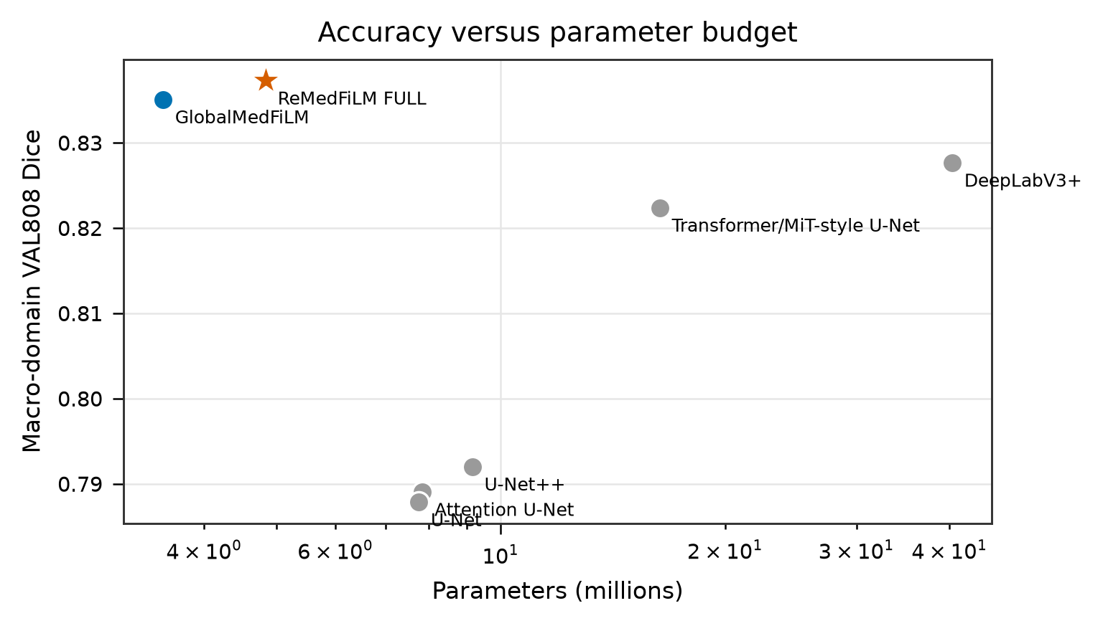
Figure 33. Accuracy against parameter count on a log axis, placing the compact FULL system in the context of the historical six-model comparison. [REMEDFILM_EFFICIENCY.csv / EFF03]

13. Conclusions, limitations and next experiments

13.1 Supported claims
Table 13. Claims supported by frozen artifacts, and the evidence class that supports each.
Claim | Evidence class | Status
ReMedFiLM FULL = G + R_psi + B_phi + S_omega; G is the backbone only | read-only checkpoint state-dict verification | ESTABLISHED
VAL808 paired gain +0.002210 (95% CI excludes zero) | paired preservation, saved-mask re-score + bootstrap | ESTABLISHED
Four inference states with 529 / 266 / 13 outcomes | frozen Phase 27 prediction table + source code | ESTABLISHED
Learned benefit routing reduces harmful refinements vs always-refine | frozen 13-arm policy comparison (in-sample) | DESCRIPTIVE / ESTABLISHED AS POLICY
External direction consistent on 884 images | frozen external retrospective tables | DESCRIPTIVE
Incremental S_omega contribution (A8 − A7) | paired CI includes zero | NOT ESTABLISHED
C1 learned vs identity FiLM; C3 matched multi-seed baselines | no controlled study | NOT ESTABLISHED
Clinical safety / diagnostic validity | no clinical study; gate targets sign(Δ Dice) | NOT CLAIMED

13.2 Limitations
- The reported gain is small (+0.2210 pp) and concentrated in one of four domains; 97 of 808 images are harmed relative to the backbone.
- The backbone is in-sample while refiner, router and safety stages are out-of-fold, making delta-Q and harm rates optimistic. This asymmetry was recorded, not repaired.
- The 13-arm comparison is a policy comparison over frozen outputs, not a causal retraining ablation; A8 − A7 does not establish a safety contribution.
- Three downstream seeds share one pre-trained backbone, so the seed triplet is not three independent end-to-end replicates. No matched multi-seed baseline matrix exists.
- External evaluation is retrospective, small for the Stones cohort (n = 20, with HD95/ASSD defined on only 6), and BrEaST patient-level independence is unverifiable.
- 14 / 14 stone-free external images receive false-positive foreground; the safety gate does not detect lesion absence.
- TEST1683 remains protected and unopened. No prospective test result is reported and no submission-ready claim of generalisation to a held-out test cohort is made.
- The host clock is unsynchronised; absolute timestamps are deliberately omitted.

13.3 Experiments still required for submission
- C1 — a matched learned-FiLM versus identity-FiLM controlled comparison under a common training budget and identical data order.
- C2 — a causal safety-gate attribution study with a pre-registered primary endpoint and an adequately powered A8 versus A7 contrast.
- C3 — a matched multi-seed baseline matrix, with all baselines trained and evaluated under the identical protocol as the FULL system.
- A prospective, authorised TEST1683 evaluation under the frozen protocol, with the protected split opened only under the corresponding release authority.
- External validation with verified patient-level independence, larger stone cohorts, and a prespecified analysis of the stone-free false-positive failure mode.
- Repair or explicitly bound the backbone in-sample / downstream out-of-fold asymmetry, then re-estimate harm rates and conditional benefit.
- A matched accuracy–cost study before any Pareto or efficiency superiority claim.
Final declaration
ReMedFiLM V8 is an analysis-only reconstruction. No model was retrained, no new inference was run, no frozen split was changed, no checkpoint was modified, no measurement was fabricated, no diagnosis was invented, no authorisation was bypassed, and the protected TEST1683 inputs were not opened. Where a required controlled study does not exist, V8 reports NOT_ESTABLISHED rather than implying completion.

Appendix A. Deliverables and regeneration
Table 14. V8 deliverables referenced by this report (paths relative to the repository root).
Artifact | Purpose
ReMedFiLM_Complete_Scientific_Report_V8.docx / .pdf | this report
figures/ReMedFiLM_Methodology_V8.svg/.pdf/.png | code-verified three-panel methodology figure
figures/ReMedFiLM_Methodology_GitHub_16x9.png | 16:9 GitHub/README variant
REMEDFILM_V8_RESULTS_REGISTRY.json | single numeric source, 291 records
REMEDFILM_V8_INTERNAL_EVALUATION.csv | 151 provenance-complete internal rows
REMEDFILM_V8_EXTERNAL_EVALUATION.csv | 44 provenance-complete external rows
REMEDFILM_V8_TRAINING_HISTORY.csv | component training histories
REMEDFILM_V8_ABLATION_RESULTS.csv | 96 ablation provenance rows
REMEDFILM_V8_FIGURE_EVIDENCE_MAP.json | 33 used / 8 excluded figures
REMEDFILM_V8_METHODOLOGY_ARROWS.json | 20 verified / 13 corrected arrows
REMEDFILM_V8_RESULT_RECONCILIATION.md | 0.837290 / 0.837862 / 0.835079 adjudication
V7_TO_V8_CORRECTIONS.md | correction log
V8_FINAL_SCIENTIFIC_QA.md / V8_PUBLICATION_READINESS.md | 18-check QA and readiness verdict

Regeneration is deterministic and analysis-only: v8_registry.py → v8_reconciliation.py → v8_figure_methodology.py → v8_figures_scientific.py → v8_report.py → export_v8_pdf.ps1 → v8_qa.py. All scripts live in full_doc_report/v8_build/ and are driven by the Python interpreter .venv/Scripts/python.exe. Superseded generations are moved to full_doc_report/_superseded_v8/ rather than deleted.

