RA-MedFiLM-BARR — Research Results Atlas
Consolidated verified evidence · Phases 21, 27–30, 33–36 and historical Phase 39
A supervisor-ready consolidation of existing experimental evidence. No model was trained, no frozen evidence was altered, and TEST1683 was not accessed during this work.
Field | Value
Repository | D:\Softfors\jup
Git HEAD | 45b85c101864f560d78b1fe563140cbbe3760825
Scope | Evidence consolidation only; no training, no TEST access, no new experimental results
Evidence policy | Every number is traceable to a source artifact; synthetic benchmarks are labelled and never merged with real results
Populations | TRAIN 5,832 · VAL 808 · TEST 1,683 (locked) · ROUTER_DEVELOPMENT 4,957 · ROUTER_HOLDOUT 875 · EXTERNAL 884
Non-goals | No training, no TEST reopening, no authorization change, no new experimental results

Evidence-class legend
Class | Meaning
REAL | Measured on real data under a frozen protocol (VAL808 or ROUTER_* populations).
SYNTHETIC_BENCHMARK | Measured on fixture weights / synthetic inputs. Never a segmentation result.
MIXED_LABELLED | A table/figure that places real accuracy beside synthetic cost, with each column labelled.
MISSING_EVIDENCE | The claim has no supporting real experiment; the gap is named explicitly.

Contents
- Executive summary
- 1. Model progression and comparability limits
- 2. Thirteen-arm ablation, paired contrasts and confidence intervals
- 3. Six-model evaluation matrix (Dice, IoU, Precision, Recall, HD95)
- 4. Three-seed historical reproducibility and limitations
- 5. Accuracy versus compute, parameters and latency
- 6. Per-domain and per-sample performance distributions
- 7. Interpretability and robustness visualisations
- 8. Qualitative segmentation examples and failure cases
- 9. Historical TEST evaluation and its missing comparative endpoint
- 10. Missing-evidence matrix for C1, C2 and C3
- Appendix A — Table and figure provenance index
- Appendix B — Unavailable sources and metrics
- Appendix C — Evidence classes, populations and known discrepancies

Executive summary
This atlas consolidates the verified experimental record of RA-MedFiLM-BARR. It separates three things that are routinely conflated: real data results (VAL808, ROUTER_DEVELOPMENT, ROUTER_HOLDOUT, EXTERNAL 884, historical TEST1683), architectural cost, and synthetic performance benchmarks. No number below is extrapolated from another population.
- Six-model VAL808 macro-domain Dice: Global MedFiLM 0.8351 > DeepLabV3+ 0.8277 > Transformer/MiT 0.8224 > U-Net++ 0.7920 > Attention U-Net 0.7890 > U-Net 0.7878.
- Paired domain-stratified bootstrap (2,000 draws, seed 42): Global MedFiLM − U-Net = +0.0472 [0.0340, 0.0606]; − Attention U-Net = +0.0460 [0.0339, 0.0592]; − U-Net++ = +0.0431 [0.0311, 0.0559]; − Transformer/MiT = +0.0127 [0.0029, 0.0226]; − DeepLabV3+ = +0.0074 [−0.0020, 0.0183] (CI includes zero).
- RA-MedFiLM-BARR FULL (seed 42) reaches macro Dice 0.8373 on VAL808, a +0.00221 [+0.00113, +0.00330] preservation delta over the global reference (Phase 27).
- Thirteen-arm ablation (ROUTER_DEVELOPMENT, n = 4,957, K = 1,239): A8 harmful activation share 32.37%; the only frozen matched contrast A8 vs A7 is +1.6×10⁻⁵ [−1.4×10⁻⁵, +5.1×10⁻⁵] — no detectable mean gain.
- Three-seed descriptive reproducibility: macro ΔDice +0.00221 / +0.00339 / +0.00287 (mean +0.00282, SD 0.00059); the three seeds share one frozen global backbone and are not independent replications.
- ROUTER_HOLDOUT (n = 875): global 0.92855, A8 0.93029, Δ +0.00174 [0.00112, 0.00240], non-inferiority margin 0.005 → preservation asserted (Phase 30).
- Phase 33 failure prevalence: low overlap 10.06% (88/875), harmful activation 12.92% (31/240), missed benefit 0% (0/635), execute-then-reject 1.67% (4/240); KUB carries 73/88 and 26/31.
- Historical TEST1683 (one-shot, v1.2): macro Dice 0.8314 — ISIC 0.8869 (n=735), BUSI 0.8504 (n=174), KVASIR 0.8507 (n=216), KUB 0.7377 (n=558). Descriptive only; no comparative endpoint exists.
- C1, C2 and C3 remain NOT_ESTABLISHED. C1 has 0/6 runs and pending institutional authorization.

1. Model progression and comparability limits
The programme moves from conventional segmentation baselines (Phase 20A/20B) to a shared task-conditioned global model (Global MedFiLM, Phase 21) and then to the BARR system (Global + Regional refiner + Benefit router + Post-safety, Phase 25/26, evaluated in Phase 27). Every entry below is a frozen checkpoint evaluated on the same VAL808 population.
Table 1.1 — Frozen VAL808 performance across the model progression
Model | Phase | Params | GMACs | Best ep. | Macro Dice | Macro IoU | Status
Global MedFiLM | 21 | 3,523,001 | 31.55 | 66 | 0.8351 | 0.7448 | COMPLETE
DeepLabV3+ | 20B | 40,347,041 | 69.14 | 57 | 0.8277 | 0.7412 | COMPLETE
Transformer/MiT-style U-Net | 20B | 16,347,777 | 99.10 | 74 | 0.8224 | 0.7366 | COMPLETE
UNet++ | 20A | 9,159,681 | 137.94 | 55 | 0.7920 | 0.6910 | COMPLETE
Attention U-Net | 20B | 7,851,285 | 47.22 | 64 | 0.7890 | 0.6927 | COMPLETE
U-Net | 20B | 7,763,041 | 46.14 | 74 | 0.7878 | 0.6881 | COMPLETE
RA-MedFiLM-BARR FULL (seed 42) | 27 | 4,837,420 | 32.44 | — | 0.8373 | — | COMPLETE
RA-MedFiLM-BARR LITE (depthwise) | B | 272,601 | 1.62 | — | — | — | NO REAL DATA EVALUATION

Table 1.2 — Per-domain Dice on VAL808 (domain n in header)
Model | ISIC (357) | BUSI (84) | KVASIR (87) | KUB (280)
Global MedFiLM | 0.8972 | 0.8588 | 0.8202 | 0.7641
DeepLabV3+ | 0.8853 | 0.8669 | 0.8197 | 0.7388
Transformer/MiT-style U-Net | 0.8871 | 0.8640 | 0.8133 | 0.7252
UNet++ | 0.8601 | 0.8163 | 0.7710 | 0.7207
Attention U-Net | 0.8617 | 0.8277 | 0.7710 | 0.6958
U-Net | 0.8553 | 0.8198 | 0.7552 | 0.7211
RA-MedFiLM-BARR FULL (seed 42) | 0.8981 | 0.8589 | 0.8207 | 0.7715
RA-MedFiLM-BARR LITE (depthwise) | — | — | — | —

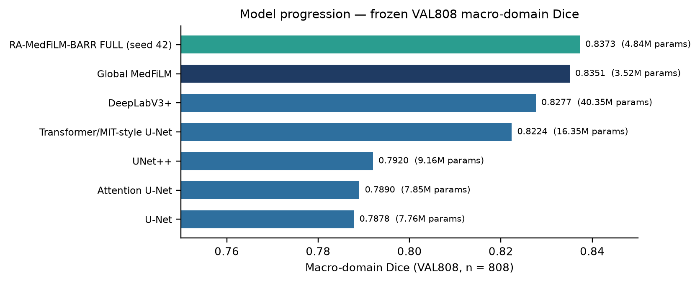
Figure 1.1 — Macro-domain Dice with parameter counts. BARR FULL is the Phase 27 diagnostic evaluation; Lite is excluded because no real-data evaluation exists.

Comparability limits
- Phase 21 inherits 24/24 protocol fields from the Phase 20 shared baseline protocol (phase4_v3 manifests, 512 px RGB, BCE-Dice 0.5/0.5, AdamW 1e-4/1e-4, cosine T_max 100, batch 4/8, AMP, seed 42, early stop 15, selection phase20_macro_domain_mean_dice_v1, threshold 0.5, 2,000-draw bootstrap seed 42). Only architecture and experiment identity differ.
- The five conventional baselines originate from Phase 20A/20B and the shared evaluation contract is the same; the artifacts do not establish that every baseline's training run was byte-identical to Phase 21. Differences are therefore descriptive.
- Macro-domain Dice is the unweighted mean of four per-domain means. ISIC (357) and KUB (280) therefore weigh the same as BUSI (84) and KVASIR (87); pooled Dice is descriptive only and is never the sole summary.
- There is no architecture-matched control (same backbone, FiLM on/off). No causal attribution to FiLM is permitted from this table; that is the purpose of C1, which is not executed.
- VAL808 is a development/validation population. It is not TEST1683 and cannot substitute for it.

2. Thirteen-arm ablation, paired contrasts and confidence intervals
Phase 28 evaluates thirteen arms on ROUTER_DEVELOPMENT (n = 4,957; 875 ROUTER_HOLDOUT rows excluded) at a fixed activation budget K = 1,239 (25%). A0 is global-only and A1 is always-refine; A2–A5 are routing-signal comparators; A6/A7/A8 are the learned router, the router with a resource cost, and the router plus post-safety; R1–R3 and F1 are trained component variants.
Table 2.1 — Thirteen-arm ablation (arm-level point summaries; ROUTER_DEVELOPMENT, n = 4,957)
Arm | Definition | n routed | Mean ΔDice | Harmful | Role
A0 | global only (no routing/refinement) | 0 | +0.0000 | 0.0% | Endpoint Reference
A1 | always refine (full budget) | 4,957 | +0.0017 | 42.7% | Endpoint Reference
A2 | random routing (seeded null) | 1,239 | +0.0014 | 44.4% | Routing Signal Comparator
A3 | entropy routing | 1,239 | +0.0072 | 31.9% | Routing Signal Comparator
A4 | margin routing | 1,239 | +0.0071 | 32.0% | Routing Signal Comparator
A5 | predicted-ROI-size routing | 1,239 | -0.0004 | 46.4% | Routing Signal Comparator
A6 | learned paired-gain routing | 1,239 | +0.0072 | 33.3% | Adjacent Incremental Contrast
A7 | A6 + resource cost U = Δ̂ − λC | 1,239 | +0.0072 | 33.3% | Adjacent Incremental Contrast
A8 | A7 + post-safety S_ω (canonical) | 1,205 | +0.0075 | 32.4% | Mandatory Component Isolation
R1 | router without deep features (width 26) | 1,239 | +0.0033 | 37.4% | Primary Reference Not Pre Registered
R2 | router without task_id (width 202) | 1,239 | +0.0012 | 43.5% | Primary Reference Not Pre Registered
R3 | router, scalar-only features (width 10) | 1,239 | +0.0013 | 42.3% | Primary Reference Not Pre Registered
F1 | refiner without p_global input channel | 1,239 | -0.0326 | 68.8% | Primary Reference Not Pre Registered

Table 2.2 — Paired contrasts with 95% bootstrap CIs (2,000 replicates, seed 42)
Contrast | n | Paired mean Δ | 95% bootstrap CI | Excludes zero?
R1_vs_A6C7 | 4,957 | -0.0010 | [-0.0013, -0.0007] | YES
R2_vs_A6C7 | 4,957 | -0.0015 | [-0.0018, -0.0012] | YES
R3_vs_A6C7 | 4,957 | -0.0015 | [-0.0018, -0.0012] | YES
A8_vs_A7 | 4,957 | +1.57e-05 | [-1.43e-05, +5.10e-05] | NO (includes 0)
F1_integrated_vs_A8 | 4,957 | -0.0100 | [-0.0108, -0.0092] | YES

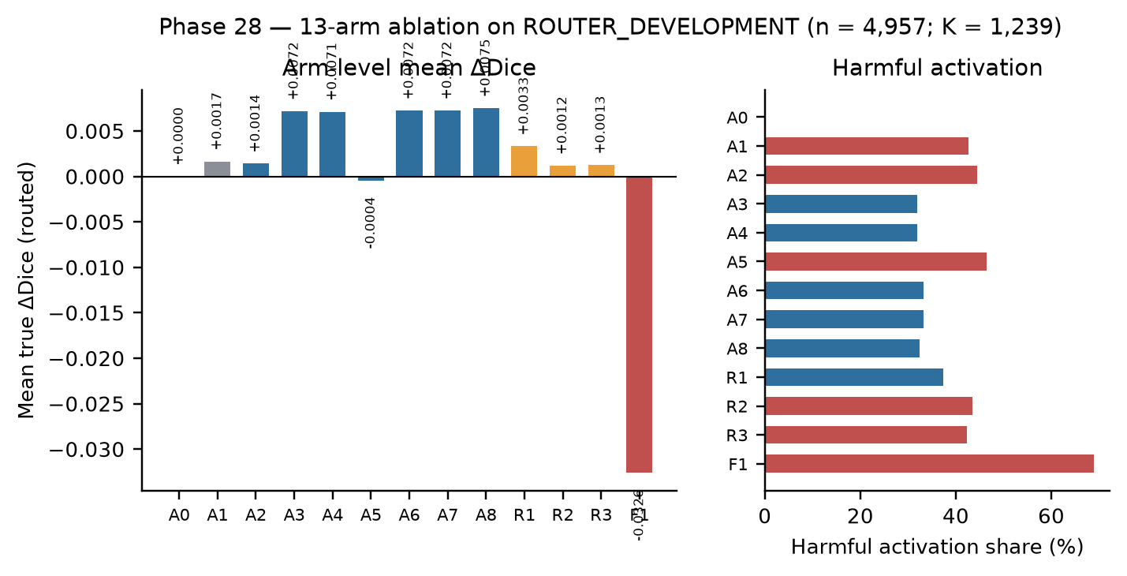
Figure 2.1 — Arm-level mean ΔDice and harmful activation share. F1 (refiner without p_global) is catastrophic and compresses the linear scale; its exact value is −0.03259.
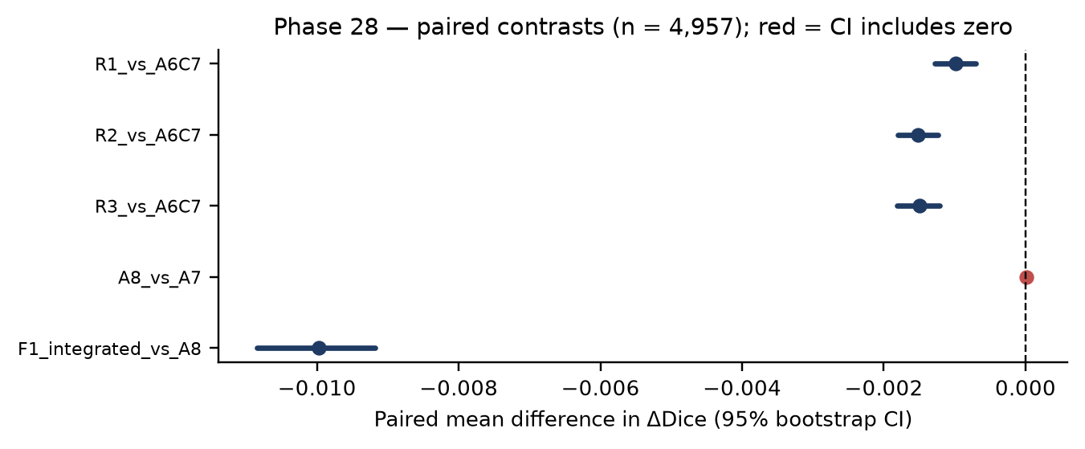
Figure 2.2 — Paired contrast forest plot. A8 vs A7 is the only frozen matched contrast; its CI includes zero.

What the contrasts do and do not establish
- Removing deep global features (R1), task conditioning (R2) or all deep taps (R3) significantly reduces routed ΔDice relative to A6: −0.00098 [−0.00128, −0.00070], −0.00151 [−0.00181, −0.00123] and −0.00150 [−0.00181, −0.00121]. These are descriptive component-isolation contrasts, not a causal claim about the deployed system.
- A7 and A6 have identical arm-level summaries because at λ = 0.25 the resource term did not change membership. A8 differs from A7 only through the safety fallback (1,239 executed, 1,205 accepted, 34 fallbacks). The paired A8 vs A7 difference is +1.6×10⁻⁵ [−1.4×10⁻⁵, +5.1×10⁻⁵] — no detectable mean gain.
- F1 (refiner without the p_global input channel) collapses to −0.03259 mean routed ΔDice with 68.85% harmful activations; the p_global channel is functionally necessary in this design.
- Only A7 vs A8 is a frozen, pre-registered matched contrast. R1–R3 and F1 are explicitly PRIMARY_REFERENCE_NOT_PRE_REGISTERED descriptive rows. Multiplicity: descriptive, no post-hoc correction.
- The population is ROUTER_DEVELOPMENT, a subset of TRAIN5832. These are in-sample results relative to the global backbone and must not be read as held-out generalisation.

3. Six-model evaluation matrix
All six checkpoints are frozen and evaluated on VAL808 (n = 808) with the same evaluation contract (threshold 0.5, src.metrics.evaluation_metrics, 2,000-draw domain-stratified bootstrap, seed 42). Dice and IoU are the published macro-domain values. Precision, Recall and HD95 are the unweighted mean of the four per-domain means computed from the per-image table; this derivation reproduces the published macro Dice exactly for all six models, which validates it.
Table 3.1 — Six-model VAL808 evaluation matrix (macro-domain)
Model | Params | Dice | IoU | Precision | Recall | HD95 px (valid n)
Global MedFiLM | 3,523,001 | 0.8351 | 0.7448 | 0.8495 | 0.8543 | 44.22 (808)
DeepLabV3+ | 40,347,041 | 0.8277 | 0.7412 | 0.8613 | 0.8449 | 39.55 (796)
Transformer/MiT-style U-Net | 16,347,777 | 0.8224 | 0.7366 | 0.8478 | 0.8487 | 40.92 (799)
U-Net++ | 9,159,681 | 0.7920 | 0.6910 | 0.8100 | 0.8403 | 63.12 (796)
Attention U-Net | 7,851,285 | 0.7890 | 0.6927 | 0.8501 | 0.7974 | 54.97 (789)
U-Net | 7,763,041 | 0.7878 | 0.6881 | 0.8331 | 0.8071 | 58.93 (800)

Table 3.2 — Per-domain Dice on VAL808
Model | ISIC | BUSI | KVASIR | KUB
Global MedFiLM | 0.8972 | 0.8588 | 0.8202 | 0.7641
DeepLabV3+ | 0.8853 | 0.8669 | 0.8197 | 0.7387
Transformer/MiT-style U-Net | 0.8871 | 0.8640 | 0.8133 | 0.7252
U-Net++ | 0.8601 | 0.8163 | 0.7710 | 0.7207
Attention U-Net | 0.8617 | 0.8277 | 0.7710 | 0.6958
U-Net | 0.8553 | 0.8198 | 0.7552 | 0.7211

Table 3.3 — Global MedFiLM per-domain metrics with Dice confidence intervals
Domain | n | Dice | IoU | Precision | Recall | HD95 | Dice 95% CI
ISIC | 357 | 0.8972 | 0.8298 | 0.9143 | 0.9069 | 26.01 | [0.8840, 0.9090]
BUSI | 84 | 0.8588 | 0.7636 | 0.8601 | 0.8806 | 31.95 | [0.8367, 0.8788]
KVASIR | 87 | 0.8202 | 0.7355 | 0.8627 | 0.8262 | 67.05 | [0.7752, 0.8627]
KUB | 280 | 0.7641 | 0.6504 | 0.7608 | 0.8037 | 51.88 | [0.7393, 0.7878]
MACRO_DOMAIN | 808 | 0.8351 | 0.7448 | 0.8495 | 0.8543 | 44.22 | [0.7877, 0.8780]

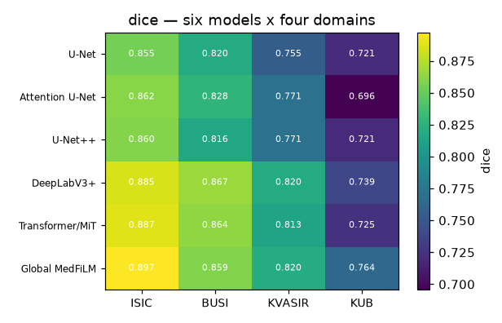
Figure 3.1 — Published Dice matrix: six models × four domains (VAL808). Reused unchanged.
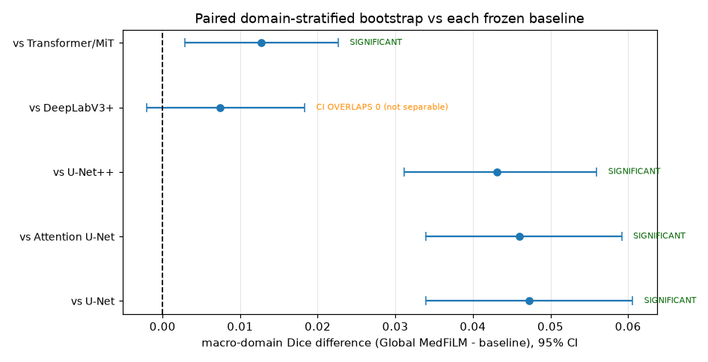
Figure 3.2 — Published paired-bootstrap forest plot for the six-model comparison.

Reading the matrix
- Global MedFiLM has the highest Dice (0.8351) and IoU (0.7448). DeepLabV3+ is second on Dice (0.8277) and IoU (0.7412), and it has higher precision (0.8613 vs 0.8495) and a lower HD95 (39.55 vs 44.22 px). Dice and boundary accuracy therefore rank the models differently; neither alone is the whole picture.
- The paired bootstrap separates Global MedFiLM from U-Net, Attention U-Net, U-Net++ and Transformer/MiT (all CIs exclude zero) but not from DeepLabV3+ (+0.0074 [−0.0020, 0.0183]).
- HD95 is reported with its valid n (789–808). Images with empty predictions have undefined HD95 and precision; those cells are excluded from the mean and the valid count is shown, not silently imputed.
- KUB is the hardest domain for every model (0.764 for Global MedFiLM); ISIC is the easiest (0.897).
- No architecture-matched control exists, so these differences are not a causal FiLM effect.

4. Three-seed historical reproducibility and limitations
Phase 29 re-runs the BARR pipeline under seeds 42, 123 and 3,407 on VAL808. The table is descriptive: the phase explicitly records that no numeric reproducibility pass/fail gate exists and that no best seed was selected or ranked.
Table 4.1 — Three-seed descriptive summary on VAL808
Metric | Seed 42 | Seed 123 | Seed 3407 | Mean | SD (ddof=1) | Range
macro_final_dice | 0.8373 | 0.8385 | 0.8379 | 0.8379 | 0.0006 | 0.0012
macro_global_dice | 0.8351 | 0.8351 | 0.8351 | 0.8351 | 0.0000 | 0.0000
macro_delta_dice | 0.0022 | 0.0034 | 0.0029 | 0.0028 | 0.0006 | 0.0012
n_selected | 279.0000 | 255.0000 | 262.0000 | 265.3333 | 12.3423 | 24.0000
selected_fraction | 0.3453 | 0.3156 | 0.3243 | 0.3284 | 0.0153 | 0.0297
n_accepted | 266.0000 | 230.0000 | 256.0000 | 250.6667 | 18.5831 | 36.0000
safety_accept_fraction | 0.9534 | 0.9020 | 0.9771 | 0.9442 | 0.0384 | 0.0751
n_final_refined | 266.0000 | 230.0000 | 256.0000 | 250.6667 | 18.5831 | 36.0000

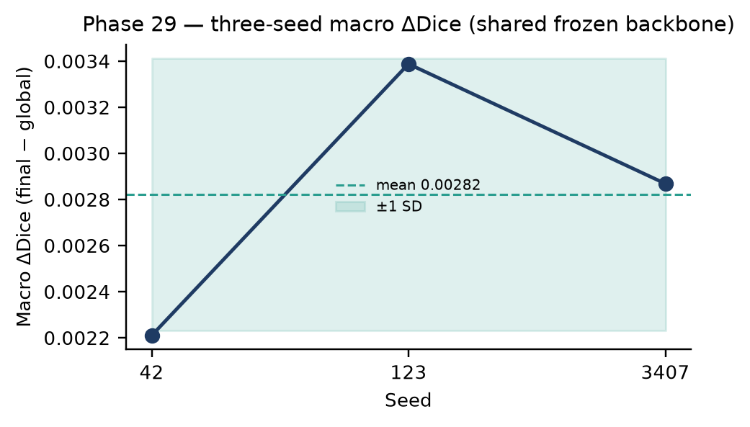
Figure 4.1 — Macro ΔDice by seed with mean and ±1 SD. All three seeds are positive.

Limitations that must travel with these numbers
- The three seeds share one frozen global backbone: macro_global_dice is identical across seeds to 1.4×10⁻¹⁶ (0.8350789601074979). Seed-to-seed variation therefore covers only the downstream components, not backbone initialisation. They are not independent replications of the full pipeline.
- The spread is tiny (SD 0.00059 on ΔDice) and all three seeds are positive, but three seeds cannot support a meaningful variance estimate or a significance claim.
- No numeric reproducibility gate was applied; the phase records 'NO_NUMERIC_REPRODUCIBILITY_PASS_FAIL_GATE'. Reporting a pass/fail verdict here would invent a criterion that does not exist.
- No best-seed selection, ranking or seed cherry-picking was performed (best_seed = null, ranking_performed = false).

5. Accuracy versus compute, parameters and latency
Accuracy is real (VAL808). Parameters and GMACs are architectural properties of the frozen models. Latency and memory are SYNTHETIC_BENCHMARK measurements on fixture weights from Phase D. The three are shown together but never merged into a single scientific claim.
Table 5.1 — Real accuracy beside architectural cost and synthetic latency (*SYNTHETIC_BENCHMARK)
Model | Params | GMACs | Macro Dice (real) | Fwd p50 ms* | Peak MiB*
Global MedFiLM | 3,523,001 | 31.55 | 0.8351 | 15.14 | 322.5
DeepLabV3+ | 40,347,041 | 69.14 | 0.8277 | 16.08 | 308.2
Transformer/MiT-style U-Net | 16,347,777 | 99.10 | 0.8224 | 11.83 | 208.6
U-Net++ | 9,159,681 | 137.94 | 0.7920 | 35.05 | 712.2
Attention U-Net | 7,851,285 | 47.22 | 0.7890 | 14.06 | 343.1
U-Net | 7,763,041 | 46.14 | 0.7878 | 12.41 | 282.8

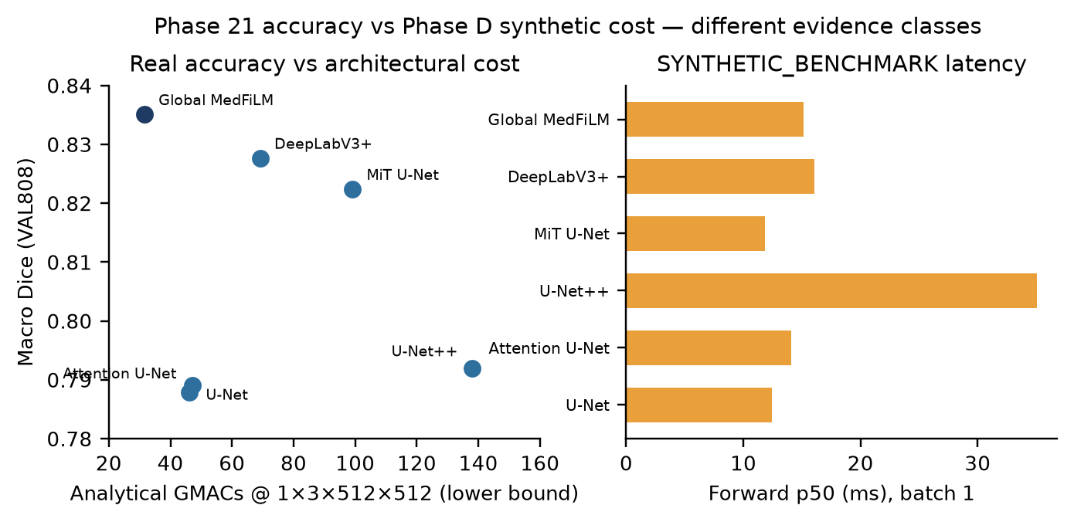
Figure 5.1 — Left: real VAL808 accuracy versus analytical GMACs. Right: synthetic forward latency (Phase D). The two panels are different evidence classes and are not a single accuracy-cost law.

Cost accounting and definitional cautions
- Analytical MACs are a lower bound over Conv2d and Linear layers at 1×3×512×512; GroupNorm, SiLU, pooling, bilinear interpolation, FiLM modulation and sigmoid are excluded.
- Global MedFiLM is the lightest model in the panel (31.55 G) and still achieves the highest Dice; U-Net++ is the most expensive (137.94 G) and does not. Parameter count and accuracy are not monotonic.
- Phase 30 reports A8's analytical average cost as 32.4379 G at a realised activation fraction of 27.43%; A7 is 32.4379 G. S_ω does not save compute — it trades a small number of fallbacks for safety, not for speed.
- Phase D latency is measured on randomly initialised fixture weights (forward p50 11.8–35.1 ms; full pipeline p50 15.1–101.0 ms; peak allocation 208.6–712.2 MiB). It is not a trained-model latency claim.
- The manuscript source fig10_accuracy_vs_cost_source.csv reports 'FULL execute path' at 18.89 ms (n = 1000), which corresponds to a forward-only definition, while Phase D's pipeline p50 is ~88 ms. This is a definitional difference, not a contradiction; the atlas uses Phase D for latency and states the definition.

6. Per-domain and per-sample performance distributions
Aggregate Dice hides the shape of the distribution. The table and figure below use the per-image VAL808 scores of Global MedFiLM (n = 808) and the Phase 27 per-domain preservation deltas.
Table 6.1 — Per-image Dice distribution by domain (Global MedFiLM, VAL808)
Domain | n | Mean | SD | p05 | Median | p95
ISIC | 357 | 0.8972 | 0.1187 | 0.6563 | 0.9337 | 0.9805
BUSI | 84 | 0.8588 | 0.0963 | 0.6694 | 0.8969 | 0.9498
KVASIR | 87 | 0.8202 | 0.2132 | 0.3737 | 0.8919 | 0.9757
KUB | 280 | 0.7641 | 0.2014 | 0.3159 | 0.8329 | 0.9188

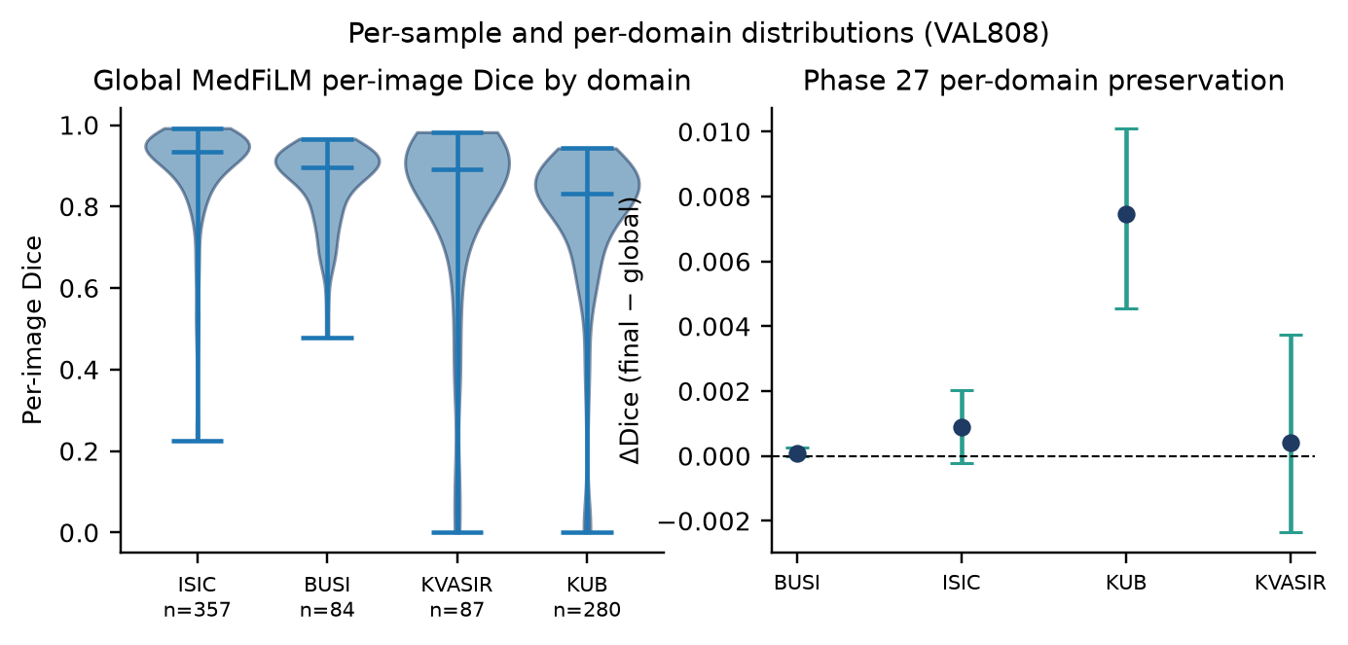
Figure 6.1 — Left: per-image Dice violins by domain. Right: Phase 27 per-domain ΔDice with 95% bootstrap CIs (2,000 replicates).
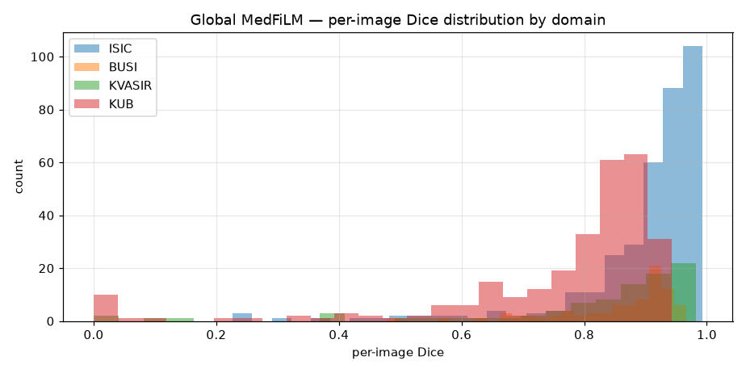
Figure 6.2 — Published per-model Dice distribution and failure panel (VAL808). Reused unchanged.

Distributional findings
- KUB has the lowest mean (0.764) and the widest lower tail; ISIC has the highest mean (0.897). The macro-domain mean is therefore dominated by KUB's behaviour despite equal domain weighting.
- Phase 27 per-domain preservation deltas: KUB +0.00745 [0.00455, 0.01011] (CI excludes zero), ISIC +0.00089 [−0.00021, 0.00203], KVASIR +0.00040 [−0.00236, 0.00374], BUSI +0.00009 [0.00000, 0.00027]. Only KUB shows a clearly positive preservation effect.
- No per-sample TEST distribution is available: the historical Phase 39 result artifact contains only per-domain mean and median Dice, not the per-sample table.

7. Interpretability and robustness visualisations
Phase 35 provides descriptive model-mechanism evidence on VAL808 across four evidence families that are explicitly never merged (I1 FiLM parameters, I2 gradient saliency, I3 ROI/regional behaviour, I4 router feature attribution). Phase 36 provides development-set synthetic-perturbation robustness evidence on the same 808 images.
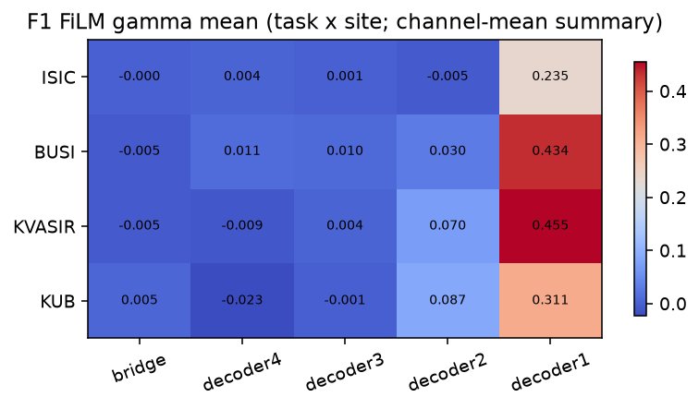
Figure 7.1 — Phase 35: FiLM γ heatmap across the five sites and four tasks (descriptive).
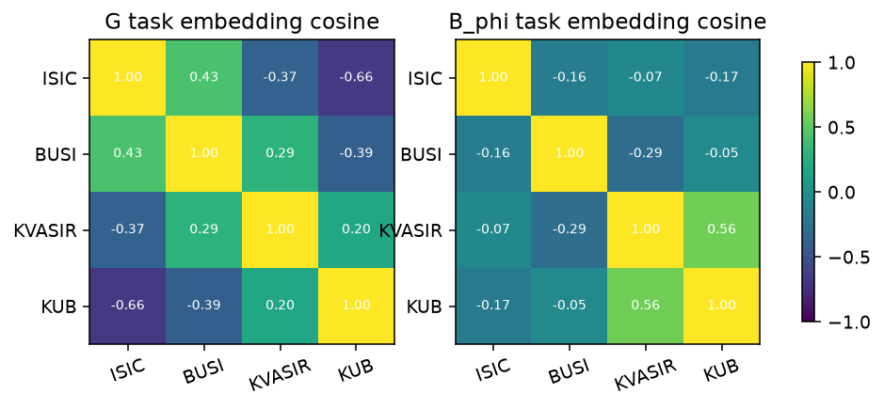
Figure 7.2 — Phase 35: task-embedding geometry. Task identity is separable in embedding space.
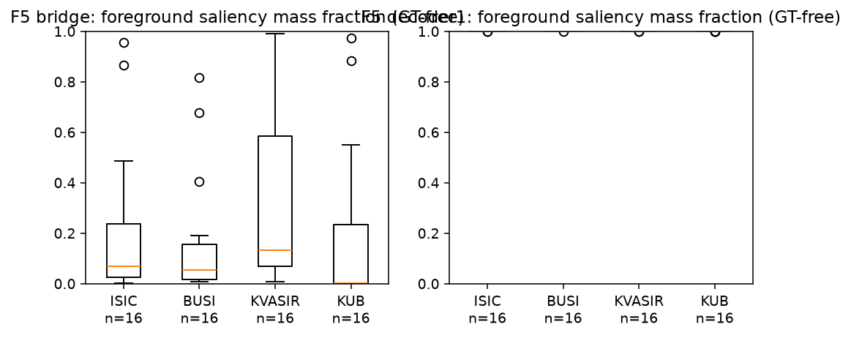
Figure 7.3 — Phase 35: gradient-saliency self-consistency (descriptive mechanism evidence).
Table 7.1 — Phase 36 worst-case per-sample ΔDice by domain (VAL808, synthetic perturbations)
Domain | n | Worst-sample ΔDice (min) | Worst-sample ΔDice (mean)
BUSI | 84 | -0.8731 | -0.1422
ISIC | 357 | -0.8750 | -0.0637
KUB | 280 | -0.9211 | -0.4137
KVASIR | 87 | -0.4900 | -0.1027

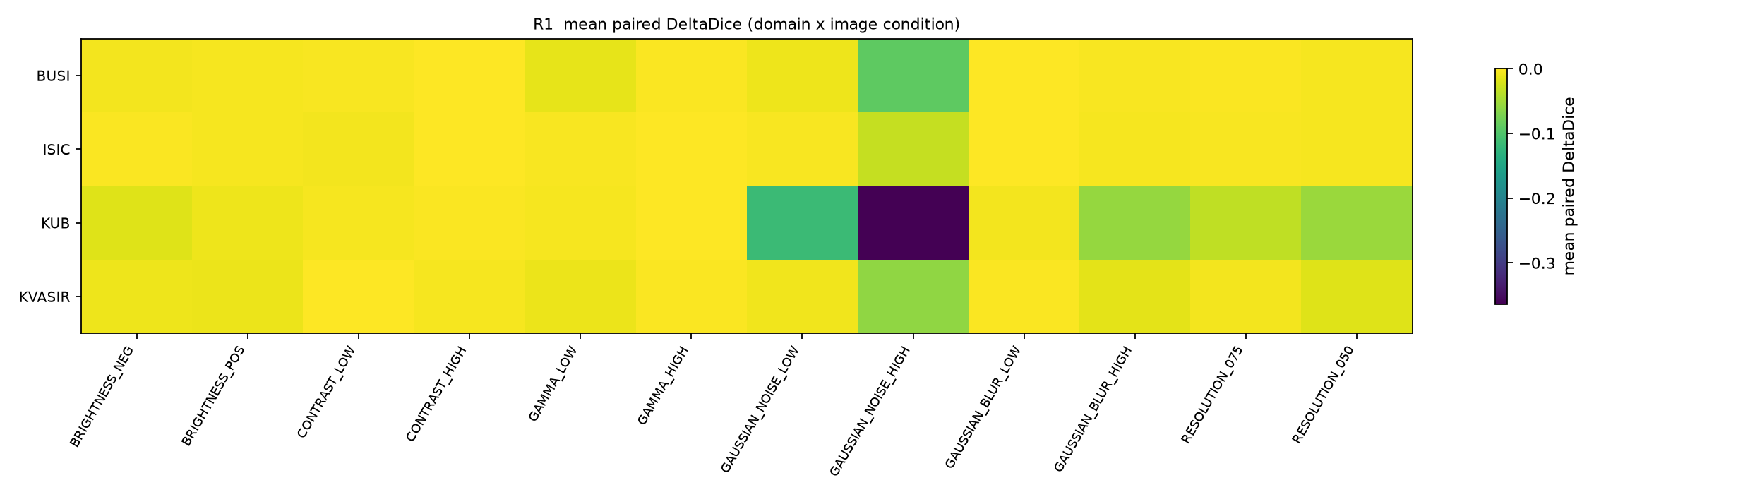
Figure 7.4 — Phase 36: mean paired ΔDice heatmap over image perturbations (16 conditions × domains).
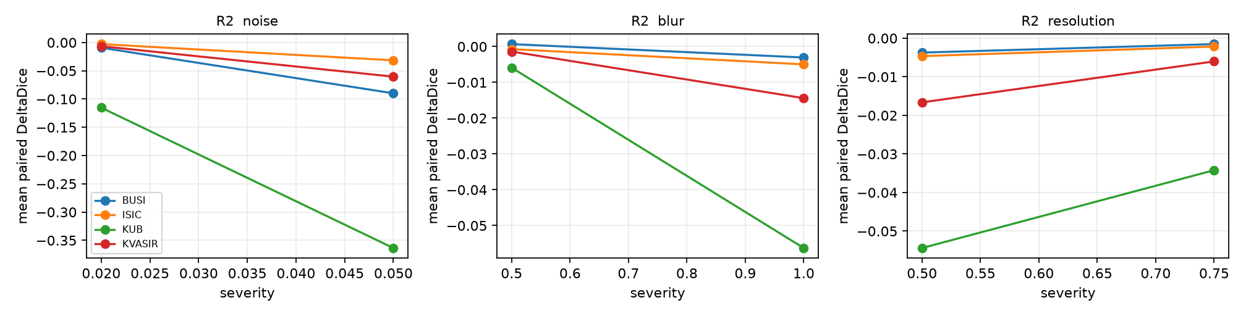
Figure 7.5 — Phase 36: severity curves for noise, blur and resolution.
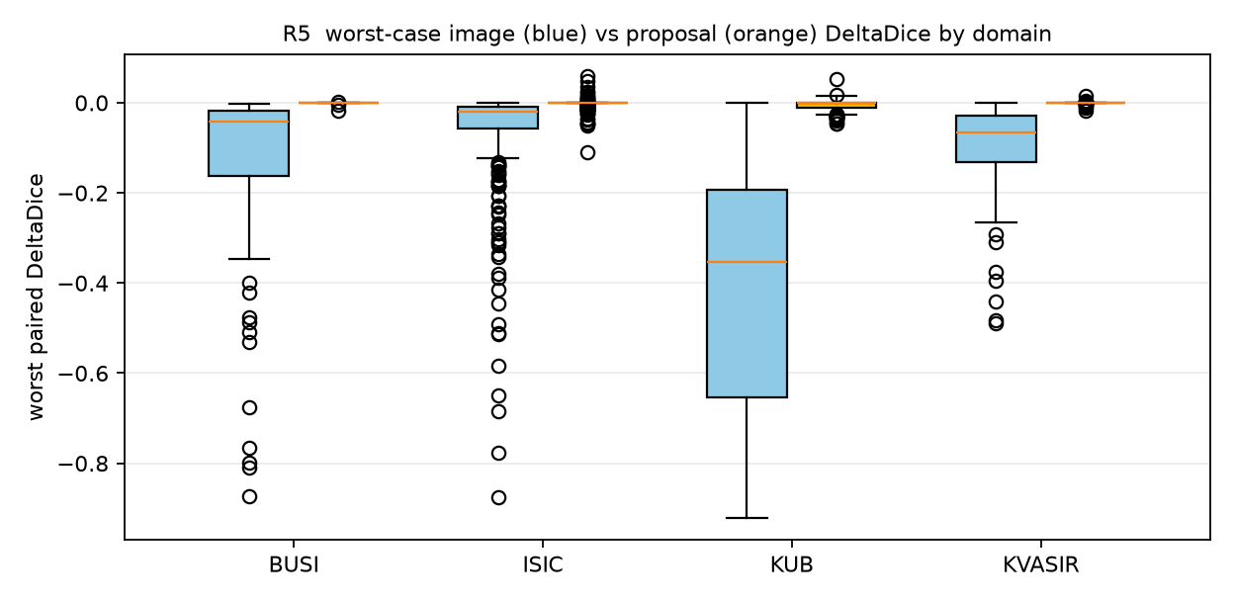
Figure 7.6 — Phase 36: worst-case ΔDice distribution by domain.
Phase 36 scope: 808 clean VAL images, 12,928 perturbed forwards, 0 TEST reads, 0 ROUTER_HOLDOUT reads, 0 training runs, 0 optimizer steps. Clean-equivalence gate: PASS (max |ΔDice| = 0.0).

8. Qualitative segmentation examples and failure cases
Two distinct qualitative sources exist and must not be merged. The internal gallery is drawn from VAL808 and compares six models on the same images. The external panel is drawn from the EXTERNAL 884 cohort (CVC 612 / BrEaST 252 / Stones 20) and illustrates BARR refinement outcomes. They are different populations with different acquisition characteristics.
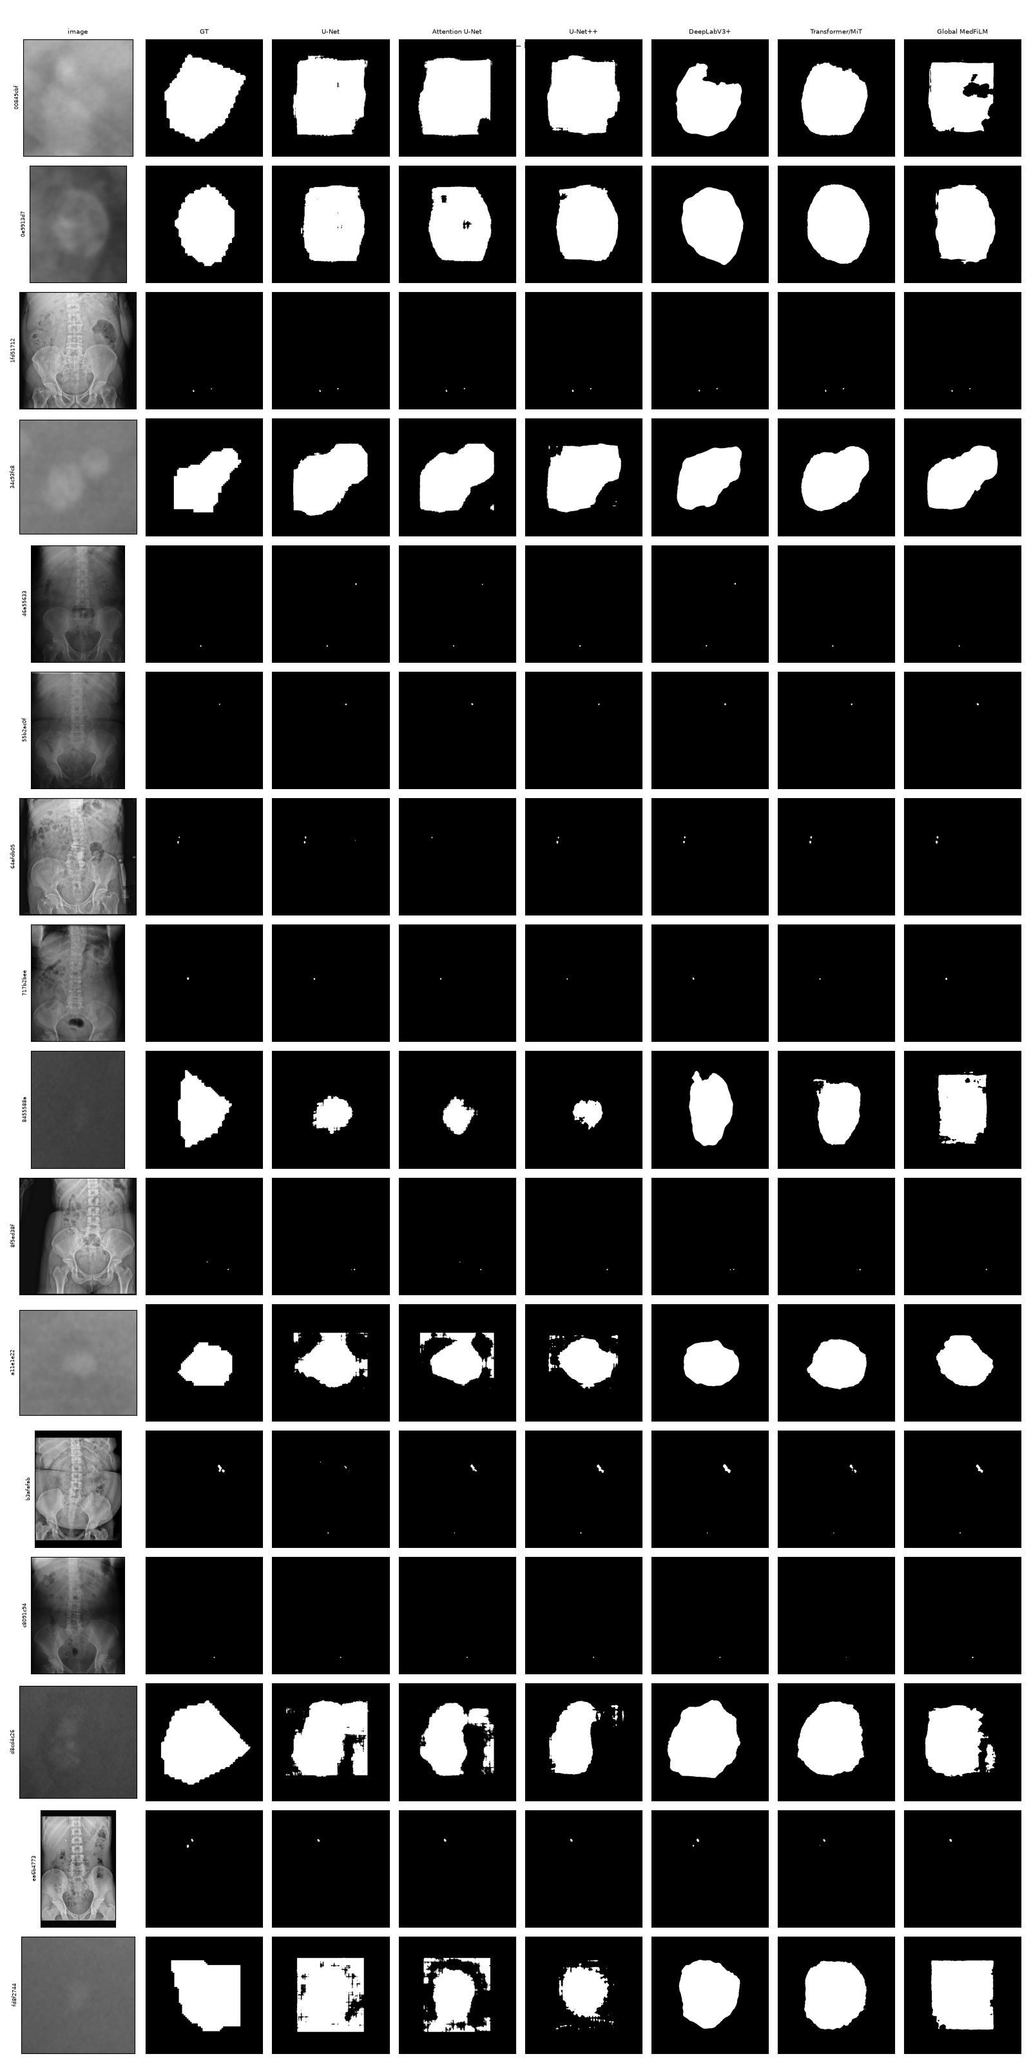
Figure 8.1 — Internal VAL808 gallery (KUB): rows are samples; columns are image, ground truth, U-Net, Attention U-Net, U-Net++, DeepLabV3+, Transformer/MiT and Global MedFiLM.
Table 8.1 — External qualitative case selection (CVC-ClinicDB; EXTERNAL 884)
Case | Sample | Global Dice | BARR Dice | Δ
Accepted beneficial refinement | CVC::160 | 0.806 | 0.921 | +11.5 pp
Accepted harmful refinement | CVC::135 | 0.182 | 0.134 | -4.8 pp
Safety-rejected refinement | CVC::358 | 0.247 | 0.247 | +0.0 pp
Representative non-selected case | CVC::551 | 0.834 | 0.834 | +0.0 pp
Stone-free false-positive failure | STONES::test::c00025_f025-002-9780702042959_jpg.rf.fb280e4f9417dc43e2e7e543aabd904d.jpg | 0.000 | 0.000 | +0.0 pp

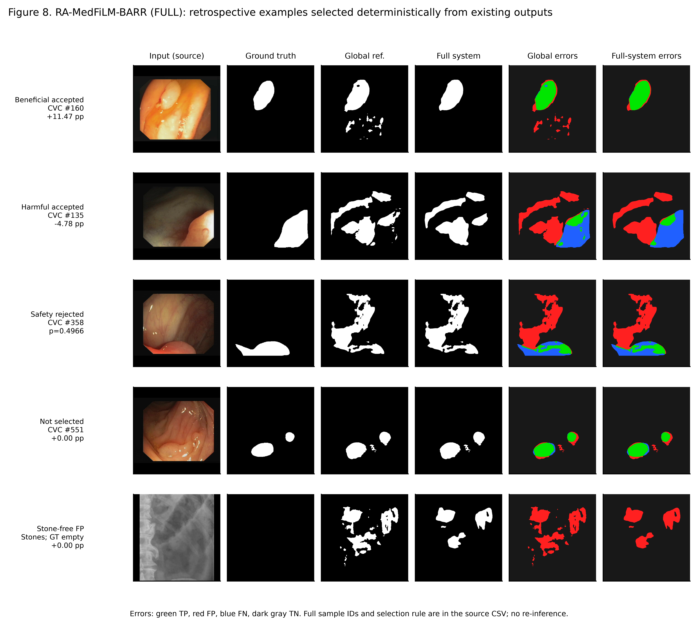
Figure 8.2 — External qualitative refinement examples: accepted beneficial, accepted harmful, rejected, non-selected and stone-free false-positive cases (EXTERNAL 884).
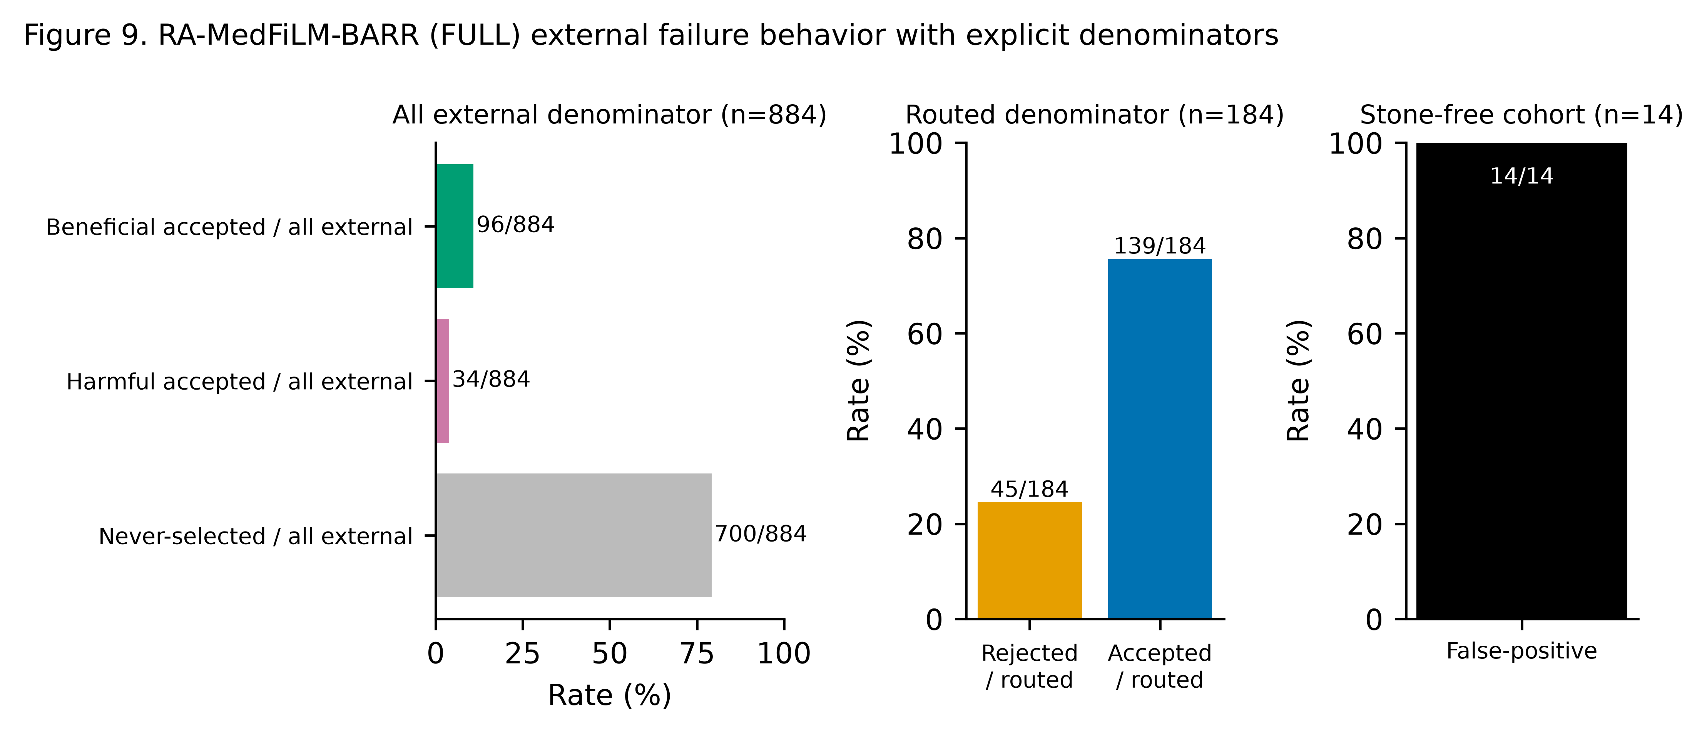
Figure 8.3 — External failure taxonomy counts (EXTERNAL 884).

Internal failure analysis (Phase 33, ROUTER_HOLDOUT)
- Low overlap: 88/875 = 10.06% (cutoff A8 Dice ≤ 0.82553, the global 10th percentile).
- Harmful router activation: 31/240 = 12.92% of EXECUTE rows. Missed benefit: 0/635 SKIP rows. Execute-then-reject: 4/240 = 1.67%.
- Concentration: KUB contributes 73/88 low-overlap cases and 26/31 harmful activations; ISIC contributes 15 low-overlap, 5 harmful and all 4 execute-then-reject; BUSI and KVASIR contribute none.
- Phase 33 marks BOUNDARY_ERROR, COMPONENT_ANALYSIS and QUALITATIVE_GALLERY as INELIGIBLE, so no internal failure image panel exists. The external panel above is the only available qualitative failure evidence, and it belongs to a different population.

9. Historical TEST evaluation and its missing comparative endpoint
Phase 39 opened TEST1683 once. The v1.2 run completed and produced a descriptive result for the single BARR pipeline. The result is one-shot, post-protocol technical recovery evidence with two disclosed pre-outcome failures, and it has no comparative endpoint.
Table 9.1 — Historical Phase 39 TEST1683 descriptive result (one-shot, v1.2)
Domain | n | Dice mean | Dice median
ISIC | 735 | 0.8869 | 0.9349
BUSI | 174 | 0.8504 | 0.8899
KVASIR | 216 | 0.8507 | 0.9096
KUB | 558 | 0.7377 | 0.8421
MACRO (unweighted mean of domains) | 1,683 | 0.8314 | —

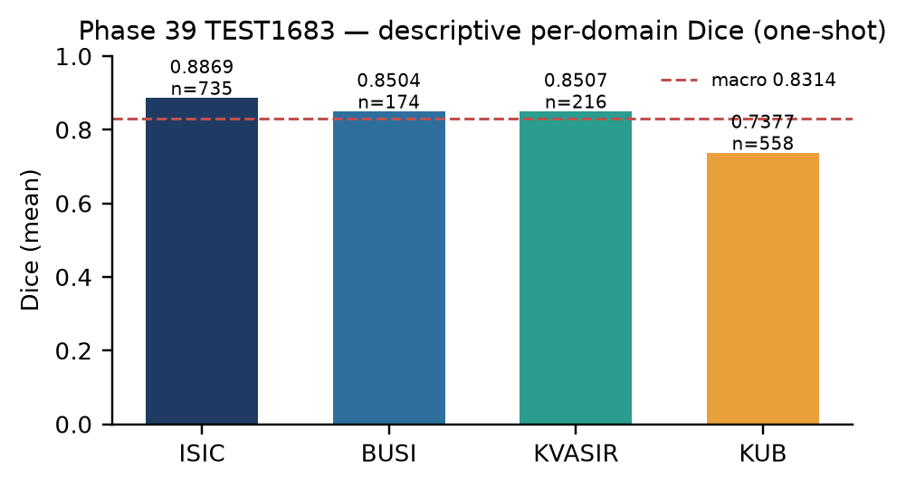
Figure 9.1 — TEST1683 per-domain mean Dice with sample counts. Macro 0.8314.
Table 9.2 — Phase 39 v1.2 execution counters
Counter | Value
test_image_reads | 1,683
test_gt_reads | 1,683
clean_g_forwards | 1,683
b_phi_forwards | 1,681
r_psi_forwards | 501
s_omega_forwards | 501
metric_evaluations | 1,683

What TEST does not contain
- No IoU, Precision, Recall, HD95 or per-sample table is present in the result artifact. Only per-domain mean and median Dice exist. Those metrics are reported here as unavailable, not estimated.
- No comparative endpoint exists: there is no C1-T/C1-C arm, no C2 router/safety ablation and no C3 protocol-faithful baseline on TEST. The result describes one pipeline; it cannot rank models on TEST.
- The result is descriptive and must not be presented as a significance test or a model comparison.

Access reconciliation: historical record versus recent zero-read claims
Table 9.3 — Phase 39 access chain
Revision | Terminal stage | Inference started | TEST reads | Result
v1.0 | MODEL_LOAD | NO | 0 (failed before manifest open) | NONE
v1.1 | SCIENCE_LOOP | YES | partial (inference started; failed) | NONE
v1.2 | COMPLETE | YES | 1683 images + 1683 GT | SCIENTIFIC_RESULT

Reconciliation. The recent coding-verification work made zero TEST reads, and that statement is true for that work: it used synthetic fixtures and redirected temporary roots only. It is not a statement about the whole project. Historically, v1.0 failed at model load before any TEST access; v1.1 started TEST inference and failed in the science loop; v1.2 read all 1,683 images and 1,683 ground-truth masks and produced the result above. The one-shot attempt is consumed. TEST must not be reopened, and the historical v1.2 result stands as the only TEST evidence.

10. Missing-evidence matrix for C1, C2 and C3
The programme's three central causal claims are not established. The matrix below names the required evidence, what exists, and the exact blocker. No synthetic chain test is counted as evidence for a scientific claim.
Table 10.1 — Missing-evidence matrix for C1, C2 and C3
Claim | Required evidence | Available | Blocker | Status
C1 FiLM attribution (C1-T vs C1-C) | 6 matched runs, seeds 42/123/3407, VAL808 paired endpoint | 0/6 runs; design + synthetic chain only | Institutional authorization pending (RC4 trust root absent); no licence/ethics record | NOT_ESTABLISHED
C2 BARR router/safety causal ablation | pre-registered matched ablation with approval | BARR-M1 design ready; policy comparison only; no causal ablation | approval NOT APPROVED; in-sample; zero GPU | NOT_ESTABLISHED
C3 protocol-faithful baseline comparison | full-protocol baseline matrix | EXT-03 15/15 reduced protocol only | no protocol-faithful runs | NOT_ESTABLISHED

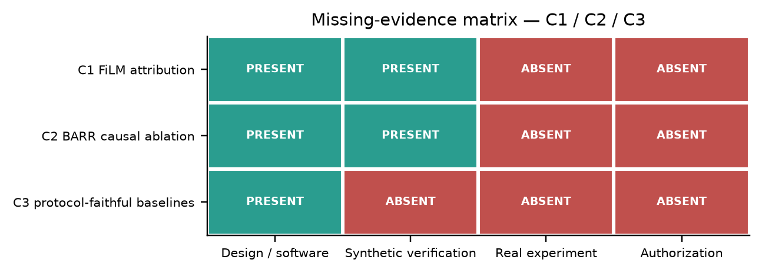
Figure 10.1 — Missing-evidence matrix. Teal = present, red = absent.

C1 — FiLM attribution
Required: six matched C1-T/C1-C runs (seeds 42, 123, 3,407) with identical initial backbone weights, the frozen optimizer/scheduler/selection protocol, TRAIN5832 for optimisation and VAL808 for selection. Available: the matched-arm constructor and a synthetic three-epoch chain test (CHAIN_SOUND). Zero real runs exist. The RC4 institutional trust root is absent, institutional approval is PENDING, no signatory is identified and key custody is not established. There is also no licence or ethics record in the repository. C1 is therefore blocked by authorization, not by software.

C2 — BARR router/safety causal ablation
Required: a pre-registered matched ablation of the router and safety components with approval. Available: BARR-M1 is design-ready but not approved; the executed analysis is a policy comparison, not a causal ablation, and it is in-sample with zero GPU. C2 is NOT_ESTABLISHED.

C3 — Protocol-faithful baselines
Required: a baseline matrix trained under the full frozen protocol. Available: EXT-03, 15/15 complete, but every run used a reduced protocol (Adam 1e-3, BCE-only, no augmentation) and must never be cited as protocol-faithful. C3 is NOT_ESTABLISHED.

Appendix A — Table and figure provenance index
Every table and figure in this atlas is listed below with its source artifact(s), population, sample count and evidence status. The same index is provided in machine-readable form (atlas_table_figure_index.json / .csv).
Table A.1 — Table index
ID | § | Table | Population | n | Status
T1.1 | 1 | Model progression and frozen VAL808 performance | VAL808 | 808 | REAL
T2.1 | 2 | 13-arm ablation matrix (arm-level point summaries) | ROUTER_DEVELOPMENT | 4957 | REAL
T2.2 | 2 | Pre-registered and descriptive paired contrasts with 95% bootstrap CIs | ROUTER_DEVELOPMENT | 4957 | REAL
T3.1 | 3 | Six-model evaluation matrix (VAL808): Dice, IoU, Precision, Recall, HD95 | VAL808 | 808 | REAL
T3.2 | 3 | Global MedFiLM per-domain metrics with Dice 95% CI | VAL808 | 808 | REAL
T4.1 | 4 | Three-seed descriptive summary (VAL808) | VAL808 | 808 | REAL
T5.1 | 5 | Accuracy (real, VAL808) beside architectural cost and synthetic latency | VAL808 accuracy; SYNTHETIC_BENCHMARK latency | 808 | MIXED_LABELLED
T6.1 | 6 | Per-domain per-image Dice distribution (Global MedFiLM, VAL808) | VAL808 | 808 | REAL
T7.1 | 7 | Phase 36 worst-case per-sample ΔDice by domain | VAL808 | 808 | REAL
T8.1 | 8 | External qualitative case selection (CVC-ClinicDB examples) | EXTERNAL 884 | 884 | REAL
T9.1 | 9 | Historical Phase 39 TEST1683 descriptive result | TEST1683 | 1683 | REAL
T9.2 | 9 | Phase 39 access reconciliation (v1.0 / v1.1 / v1.2) | TEST1683 | 1683 | REAL
T10.1 | 10 | Missing-evidence matrix for C1, C2 and C3 | n/a | — | MISSING_EVIDENCE

Table A.2 — Figure index
ID | § | Figure | Population | Status
F1.1 | 1 | Model progression: macro-domain Dice with parameter counts | VAL808 | REAL
F2.1 | 2 | 13-arm ablation: mean ΔDice and harmful activation share | ROUTER_DEVELOPMENT | REAL
F2.2 | 2 | Paired contrast forest plot with 95% bootstrap CIs | ROUTER_DEVELOPMENT | REAL
F4.1 | 4 | Three-seed macro ΔDice with mean and ±1 SD | VAL808 | REAL
F5.1 | 5 | Accuracy vs compute: real VAL808 accuracy and synthetic latency shown separately | MIXED (labelled) | MIXED_LABELLED
F6.1 | 6 | Per-image Dice distributions and per-domain ΔDice with 95% CI | VAL808 | REAL
F7.1 | 7 | Phase 35 — phase35_f1_film_gamma_heatmap | VAL808 | REAL
F7.2 | 7 | Phase 35 — phase35_f3_task_embedding_geometry | VAL808 | REAL
F7.3 | 7 | Phase 35 — phase35_f5_saliency_self_consistency | VAL808 | REAL
F7.4 | 7 | Phase 35 — phase35_f6_router_group_attribution | VAL808 | REAL
F7.5 | 7 | Phase 36 — R1 | VAL808 | REAL
F7.6 | 7 | Phase 36 — R2 | VAL808 | REAL
F7.7 | 7 | Phase 36 — R5 | VAL808 | REAL
F8.1 | 8 | Six-model qualitative gallery (KUB, VAL808) | VAL808 | REAL
F8.2 | 8 | External qualitative refinement examples (CVC-ClinicDB) | EXTERNAL 884 | REAL
F8.3 | 8 | External failure taxonomy counts | EXTERNAL 884 | REAL
F9.1 | 9 | TEST1683 per-domain mean Dice (historical one-shot result) | TEST1683 | REAL
F10.1 | 10 | Missing-evidence matrix for C1, C2 and C3 | n/a | MISSING_EVIDENCE

Appendix B — Unavailable sources and metrics
The following items were searched for and are not available. They are reported explicitly rather than invented or proxied from another population.
- Lite (depthwise) real-data VAL808 Dice/IoU: no real training or evaluation was ever executed; only a synthetic chain test exists.
- TEST1683 IoU, Precision, Recall, HD95 and per-sample records: absent from the Phase 39 result artifact.
- TEST1683 comparative endpoint (C1, C2, C3): never run; TEST is one-shot and consumed.
- Internal qualitative failure gallery: Phase 33 marks QUALITATIVE_GALLERY INELIGIBLE.
- C1 matched runs (0/6), C2 causal ablation, C3 protocol-faithful baselines: not established.
- Licence/ethics record and institutional authorization: no record exists in the repository.
- A single consistent latency definition across the manuscript and Phase D: the manuscript source uses a forward-only definition; Phase D reports pipeline latency. Both are reported with their definitions.

Appendix C — Evidence classes, populations and known discrepancies
Table C.1 — Populations and their roles
Population | n | Role | Used in
TRAIN | 5,832 | Optimisation | Phases 20/21/27/29 (training)
VAL | 808 | Checkpoint selection + development evaluation | Phases 21/27/29/30/35/36
TEST | 1,683 | Protected one-shot evaluation | Phase 39 v1.2 only
ROUTER_DEVELOPMENT | 4,957 | Router/ablation development | Phase 28
ROUTER_HOLDOUT | 875 | Held-out router evaluation | Phase 30/33
EXTERNAL | 884 | External domain-shift stress test | CVC 612 / BrEaST 252 / Stones 20

- Known discrepancy 1: the manuscript fig10 latency (FULL execute 18.89 ms, n = 1000) is forward-only; Phase D pipeline p50 is ~88 ms. Both are reported; neither replaces the other.
- Known discrepancy 2: earlier summaries described TEST as never opened. The correct statement is that the recent coding-verification work made zero reads, while the historical one-shot v1.2 evaluation did open TEST1683 and produced the descriptive result in §9.
- Known discrepancy 3: Phase 36's own release attestation sets requires_v1_23_smoke=false and binds the v1.14 smoke as historical runtime evidence. That is a governance fact about the robustness run, not a scientific result, and it is recorded here for transparency.
- No claim in this atlas is a statistical significance claim from seed 42 alone, and no scientific phase is declared passed.

