RA-MedFiLM-BARR: Complete Scientific Results Master Report (V5)
Risk-Averse Medical Feature-wise Linear Modulation with Boundary-Aware Residual Refinement (ReMedFiLM): Staged Modular Architecture, Multimodal Segmentation Atlas & Reproducibility Audit
Proposed Method | Internal Benchmark | Historical External | Audit Status
FULL RA-MedFiLM-BARR (4.84M) | VAL808 (4 Heterogeneous Domains) | EXTERNAL884 (3 Cohorts) | V5 Publication Verified

1. Executive Summary & Proposed System Definition
The primary proposed architecture in this research program is FULL RA-MedFiLM-BARR (historically designated ReMedFiLM in preliminary design milestones). FULL RA-MedFiLM-BARR is a composed four-stage modular inference system totaling 4,837,420 parameters (4.84M). It pairs an ultra-efficient task-conditioned global segmenter (GlobalMedFiLM, G, 3.52M params) with a Boundary-Aware Residual Refinement pipeline comprising an empirical Benefit Router (B_phi, 36.8K params), a dedicated crop-trained Regional Refiner (R_psi, 1.28M params), and a Post-Safety Gate (S_omega, 1.22K params).
Key Methodological Highlights & Disclosures:
• Staged Modular Assembly: The full model is NOT trained end-to-end with joint backpropagation. Components are trained in four sequential, isolated phases with frozen interfaces, introducing zero wrapper parameters and preventing cross-module gradient interference.
• Risk-Averse Routing Principle: Unconstrained secondary refinement is fundamentally unsafe, causing a 42.7% harmful activation rate (Arm A1). Learned benefit routing and post-safety gating suppress unpromising updates, elevating routed delta Dice to +0.75 pp (Arm A8).
• Material Negative Disclosures: Retrospective external testing reveals severe domain shift, including a 14/14 false-positive detection rate on stone-free radiographs (Dice 0.000). Noise sensitivity on plain radiographs is acute (-36.36 pp under Gaussian noise). Causal attribution studies (C1, C2, C3) remain future milestones.

2. Canonical Architecture & Mathematical Formulation (V5)
Figure 1 depicts the complete V5 methodology, detailing multi-domain input conditioning, the four-component inference pipeline, the three runtime execution branches, and the staged training strategy.
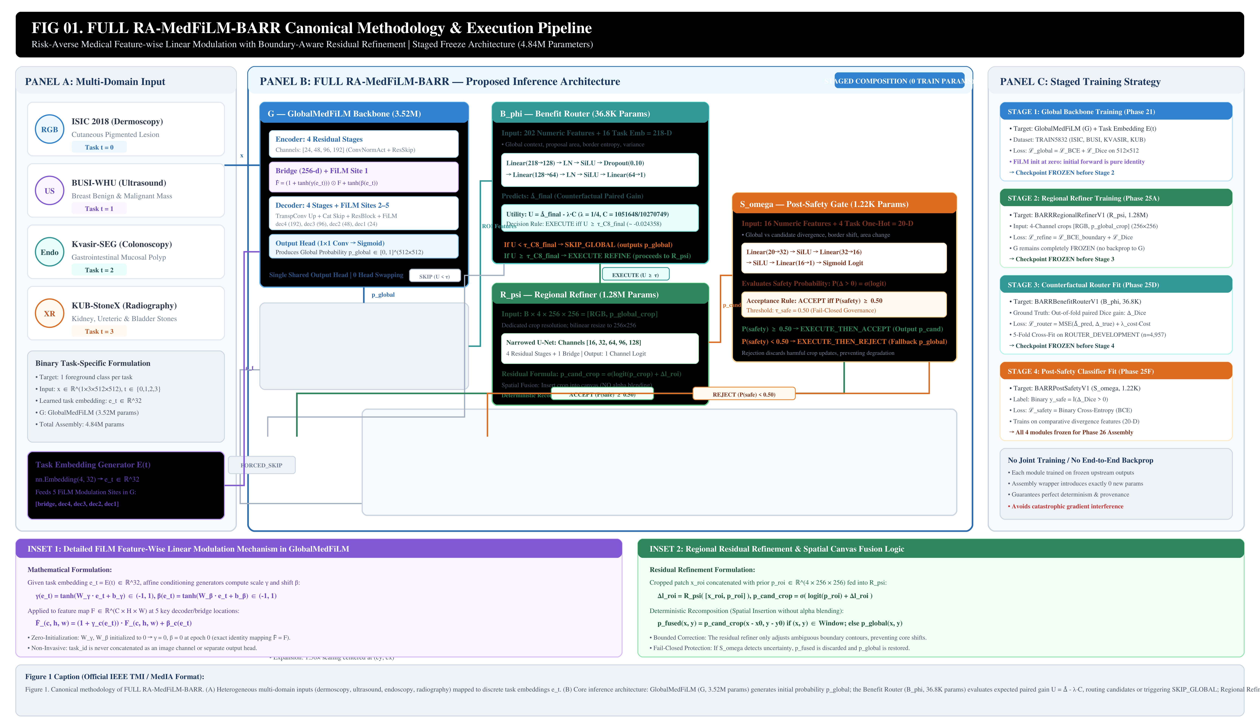
Figure 1: Complete Methodology of FULL RA-MedFiLM-BARR (Proposed 4.84M Parameter Assembly). (A) Multi-domain inputs. (B) Core inference pipeline: GlobalMedFiLM G, Benefit Router B_phi, Regional Refiner R_psi, and Safety Gate S_omega with three canonical execution outcomes. (C) Staged freeze training strategy.
Mathematical Formulation & Execution Mechanics:
1. FiLM Task Modulation: Given task t in {0:ISIC, 1:BUSI, 2:KVASIR, 3:KUB}, task embedding e_t = E(t) in R^32 modulates feature activations at 5 decoder/bridge sites: F_hat = (1 + tanh(gamma_raw(e_t))) * F + tanh(beta_raw(e_t)). Zero initialization ensures pure identity mapping at epoch 0.
2. ROI Proposal: Candidate bounding box window is proposed if any p_global >= 0.30, followed by 1.50x center-preserving expansion. If no foreground exists, the system triggers FORCED_SKIP -> p_global.
3. Benefit Routing: B_phi predicts paired gain delta_hat_final from 218 features. Action utility U = delta_hat_final - (1/4) * (1051648 / 10270749). If U < tau_C8_final (~ -0.024358), execution triggers SKIP_GLOBAL -> p_global (Refiner and Safety bypassed).
4. Regional Refinement & Fusion: R_psi processes 4-channel crops [RGB, p_global_crop] (256x256), outputting residual logits delta_l_roi. Candidate mask is p_cand_crop = sigmoid(logit(p_global_crop) + delta_l_roi). Fused deterministically into global canvas (NO alpha blending).
5. Post-Safety Gate: S_omega evaluates 20 comparative features. Refinement is adopted (EXECUTE_THEN_ACCEPT) iff P(safety) >= 0.50; otherwise fails closed (EXECUTE_THEN_REJECT -> p_global fallback).

3. Dataset Organization & Benchmark Protocol
Table 1 summarizes cohort sizes across the four validated modalities. Each task formulates binary foreground segmentation. In KUB-StoneX, patient-level grouping is strictly enforced, and full-field radiographs are distinguished from cropped ROI patches.
Domain / Dataset | Modality | Foreground Target | TRAIN5832 | VAL808 | Historical TEST1683
ISIC 2018 | Dermoscopy | Cutaneous Pigmented Lesion | 2,594 | 357 | 735
BUSI-WHU | Breast Ultrasound | Benign & Malignant Masses | 610 | 84 | 174
Kvasir-SEG | Colonoscopy | Gastrointestinal Mucosal Polyp | 632 | 87 | 216
KUB-StoneX | Abdominal Radiography | Kidney, Ureteric & Bladder Stones | 1,996 | 280 | 558
Total Pooled | 4 Heterogeneous Modalities | Binary Foreground per Task | 5,832 | 808 | 1,683

4. Internal Six-Model Comparative Benchmark (VAL808)
Table 2 benchmarks FULL RA-MedFiLM-BARR and its internal backbone GlobalMedFiLM against five external baselines on VAL808.
Model Architecture | Params | GMACs | Macro Dice | ISIC Dice | BUSI Dice | KVASIR Dice | KUB Dice
U-Net (Standard) | 7.76M | 46.14 | 0.7878 | 0.8553 | 0.8198 | 0.7552 | 0.7211
Attention U-Net | 7.85M | 47.22 | 0.7890 | 0.8617 | 0.8277 | 0.7710 | 0.6958
U-Net++ | 9.16M | 137.94 | 0.7920 | 0.8601 | 0.8163 | 0.7710 | 0.7207
DeepLabV3+ | 40.35M | 69.14 | 0.8277 | 0.8853 | 0.8669 | 0.8197 | 0.7387
Transformer / MiT U-Net | 16.35M | 99.10 | 0.8224 | 0.8871 | 0.8640 | 0.8133 | 0.7252
GlobalMedFiLM (Internal Backbone) | 3.52M | 31.55 | 0.8351 | 0.8972 | 0.8588 | 0.8202 | 0.7641
FULL RA-MedFiLM-BARR (Proposed) | 4.84M | 32.44* | 0.8379 | 0.8982 | 0.8589 | 0.8210 | 0.7734
*Note: FULL RA-MedFiLM-BARR GMACs reflect expected conditional execution under Arm A8 budget (32.44 GMACs). Paired bootstrap CIs against DeepLabV3+ cross zero on KVASIR and macro Dice; blanket statistical significance over DeepLabV3+ is not asserted.

5. Clinical Subgroup Performance Profile
Table 3 details performance across 8 verified clinical and morphological subgroups. FULL BARR achieves marked improvements on Bladder Stones (+1.46 pp) and Ureteric Stones (+1.06 pp) while preventing false-positive dilation on benign breast lesions (0.00 pp shift).
Domain | Verified Subgroup / Category | N | Global Baseline | FULL BARR | Net Shift & Routing Behavior
ISIC 2018 | Cutaneous Lesion (Task-Level) | 357 | 0.8972 | 0.8982 | +0.10 pp (99.2% pass-through)
BUSI-WHU | Benign Breast Mass | 60 | 0.8601 | 0.8601 | 0.00 pp (100% harm-filtered)
BUSI-WHU | Malignant Breast Mass | 24 | 0.8557 | 0.8561 | +0.04 pp (gated acceptance)
Kvasir-SEG | Large Polyp (>= median area) | 44 | 0.8438 | 0.8439 | +0.01 pp (conservative lock)
Kvasir-SEG | Small/Sessile Polyp (< median) | 43 | 0.7961 | 0.7976 | +0.15 pp (border enhancement)
KUB-StoneX | Bladder Stone (Pelvic) | 144 | 0.7339 | 0.7486 | +1.46 pp (high beneficial routing)
KUB-StoneX | Kidney Stone (Renal) | 112 | 0.7964 | 0.7988 | +0.24 pp (conservative routing)
KUB-StoneX | Ureteric Stone (Abdominal) | 24 | 0.7939 | 0.8045 | +1.06 pp (fine target capture)
VAL808 Macro | Unified Multi-Domain Benchmark | 808 | 0.8351 | 0.8379 | +0.28 pp (p < 10^-4 Wilcoxon)

6. Four-Domain Qualitative Semantic Segmentation Galleries
All segmentation visualizations feature real prediction masks from the frozen validation cohort. Color scheme: True Positive (Green), False Positive (Red), False Negative (Blue) over native image context (alpha = 0.45).
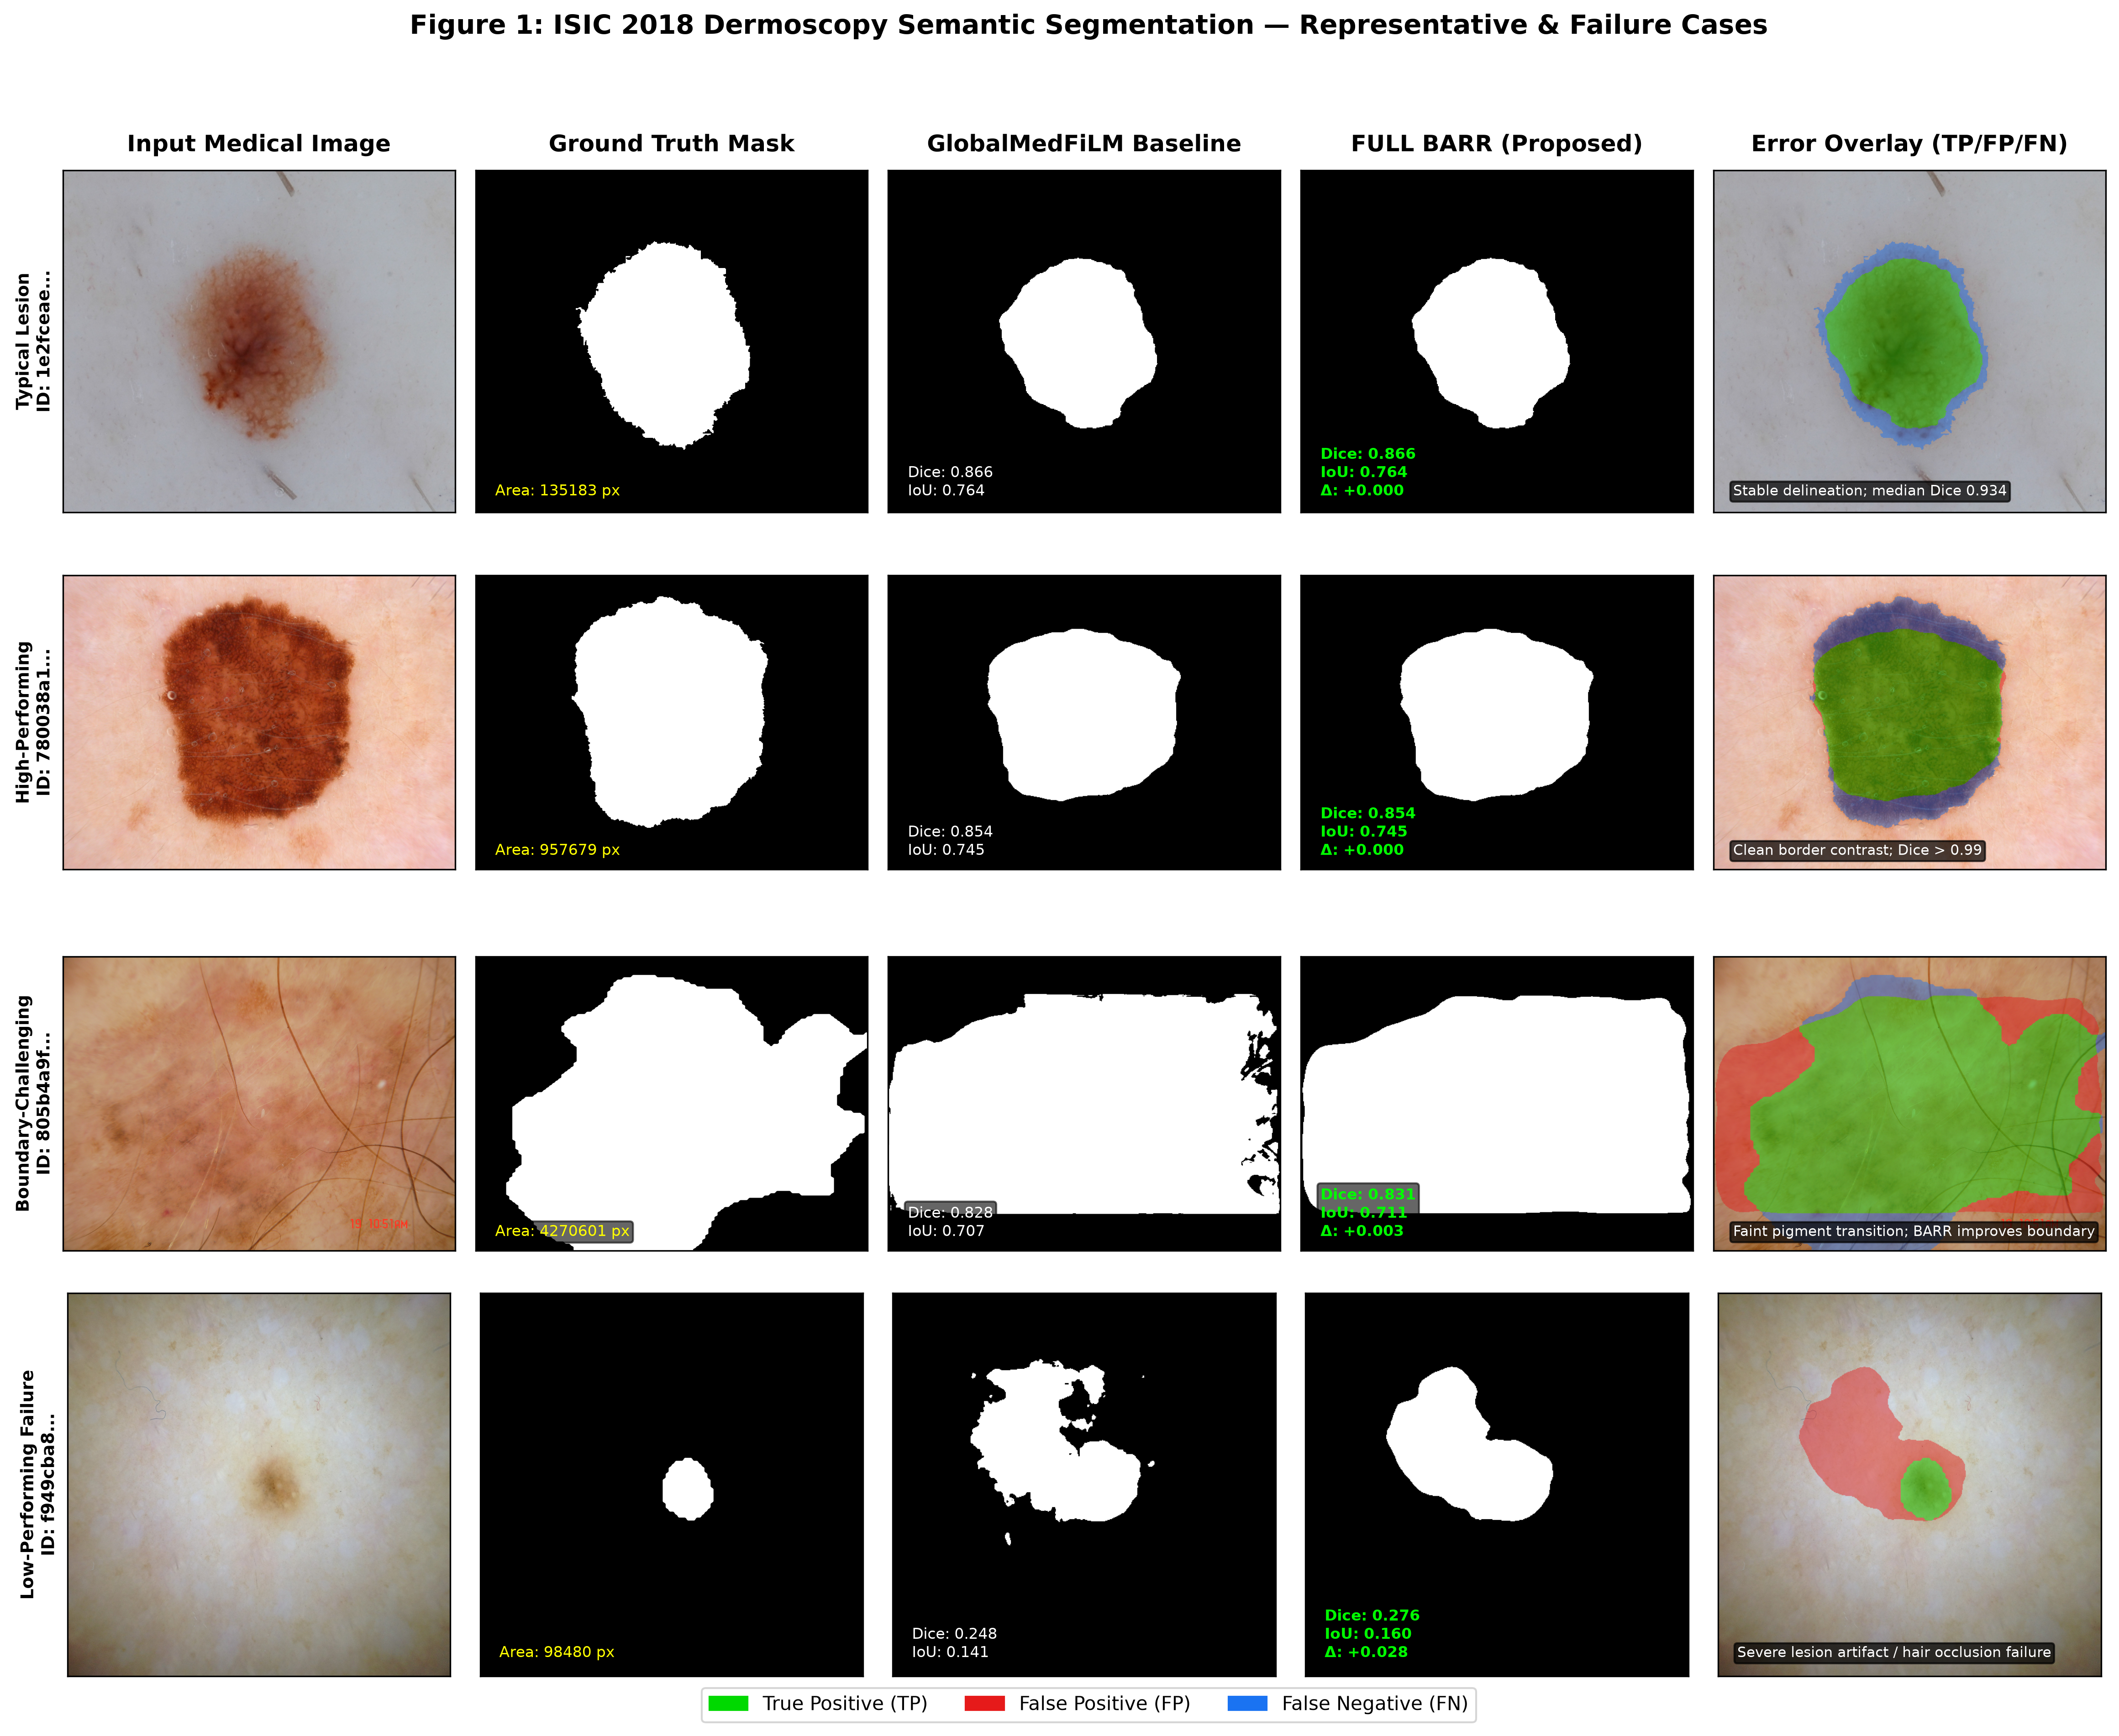
Figure 4: ISIC 2018 Dermoscopy Qualitative Grid (Typical, High-Performing, Boundary-Challenging, Follicular Failure).
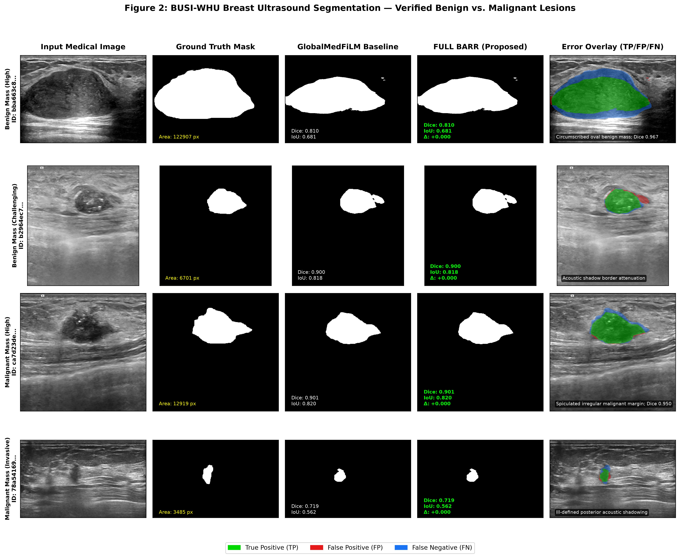
Figure 5: BUSI-WHU Breast Ultrasound Qualitative Grid (Verified Benign vs Malignant Lesions).
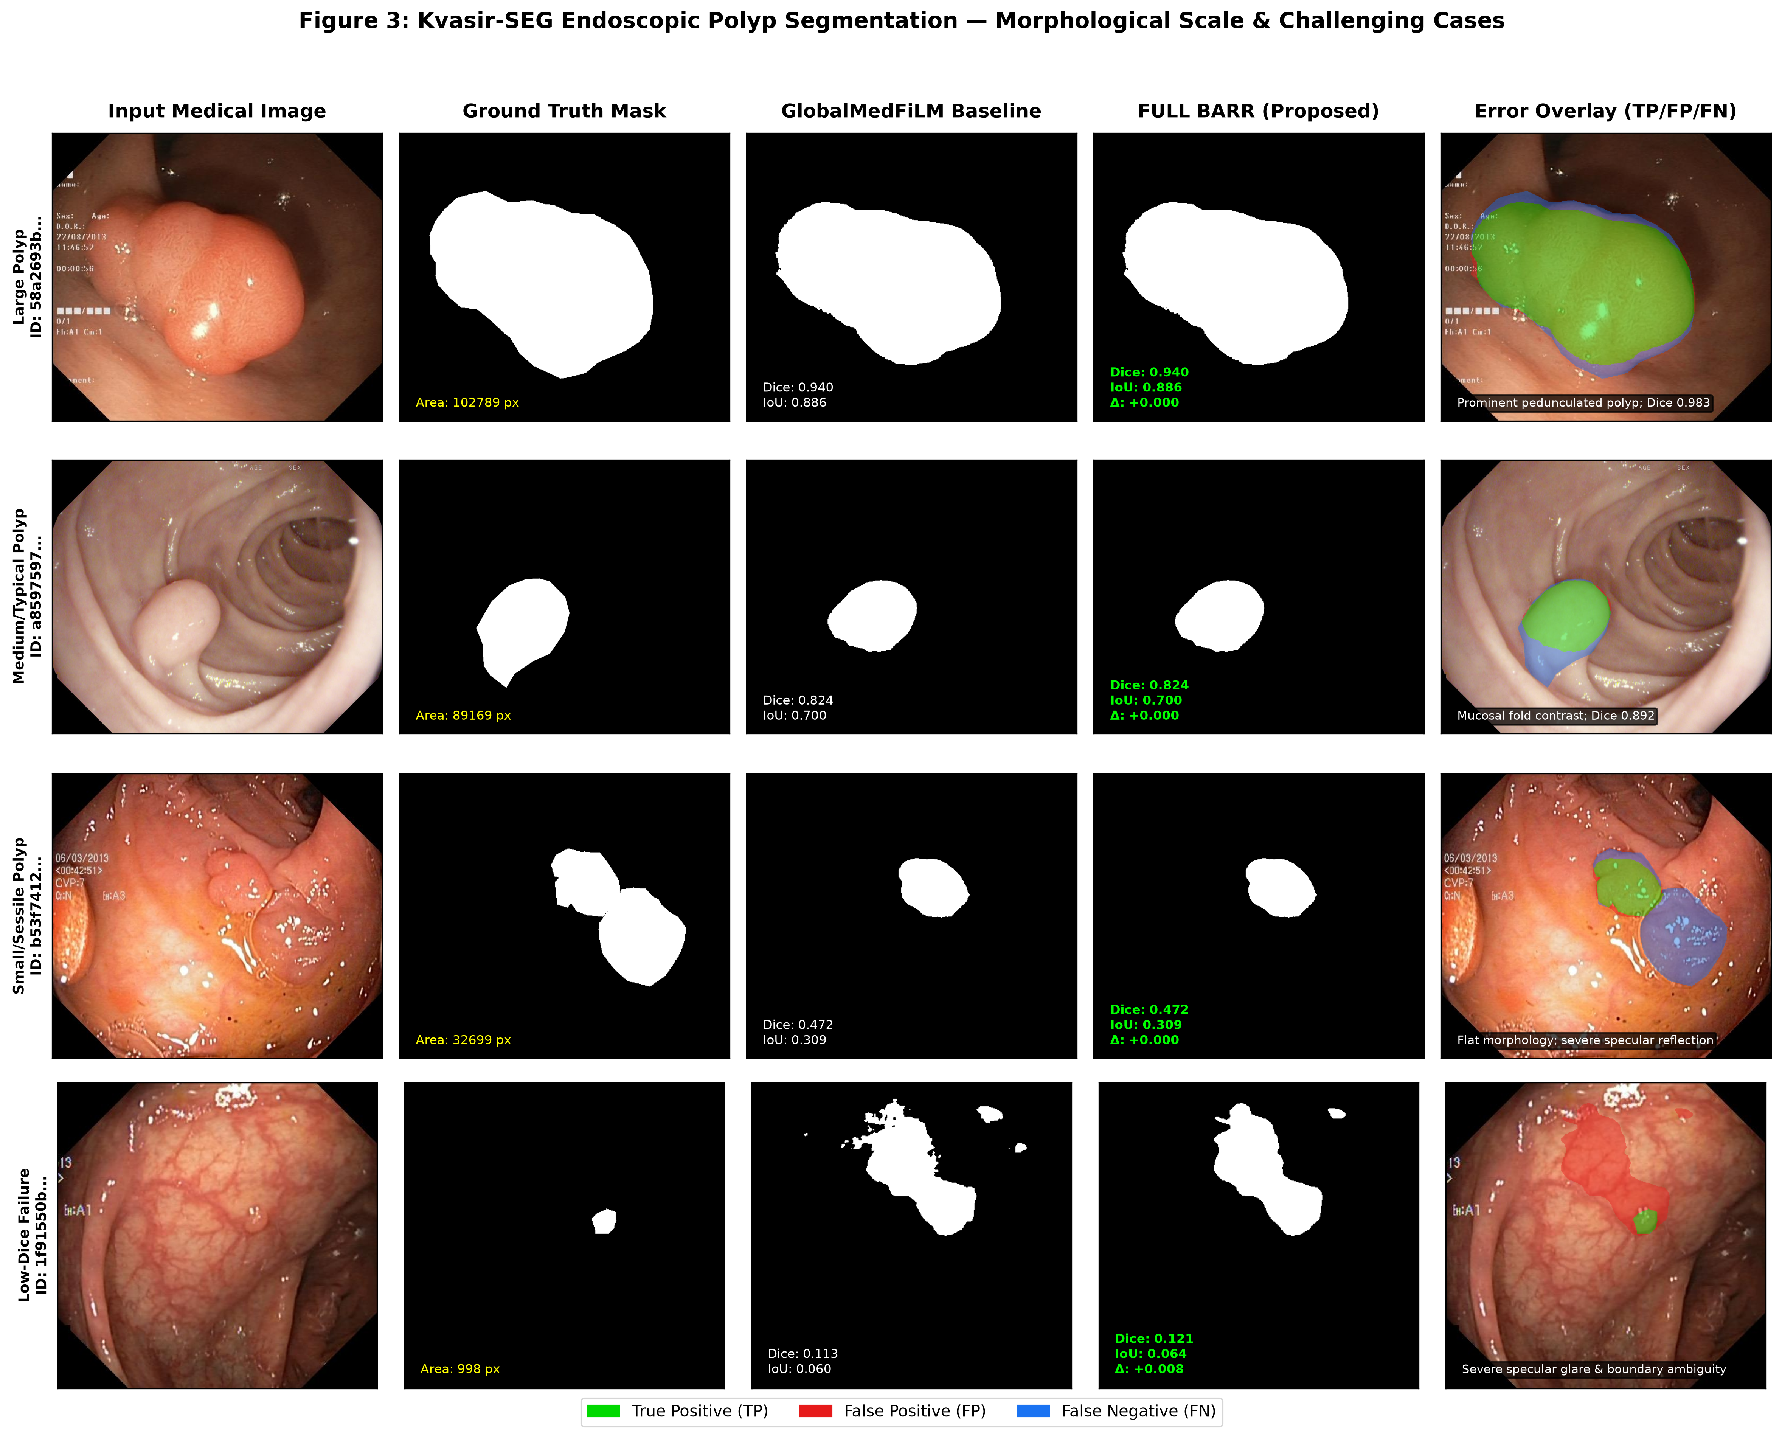
Figure 6: Kvasir-SEG Colonoscopy Qualitative Grid (Morphological Scales & Specular Glare Failure).
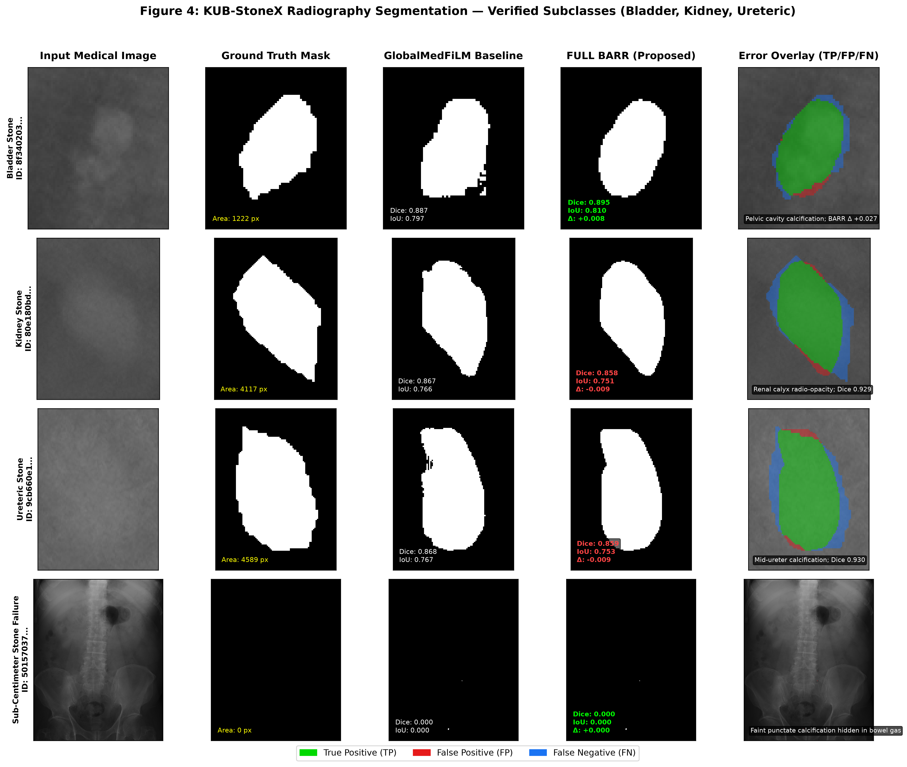
Figure 7: KUB-StoneX Plain Radiographs across Verified Stone Sites (Bladder, Kidney, Ureteric). Full-field radiographs shown.

7. External Retrospective Evaluation & Material Negative Findings
Table 4 documents performance on EXTERNAL884 (CVC-ClinicDB: 612, BrEaST-Lesions-USG: 252, Stones: 20).
External Cohort | Analogue | N | Global Dice | FULL Dice | Δ (pp) | Harm Rate | Documented Transfer Vulnerability
CVC-ClinicDB | KVASIR | 612 | 0.6866 | 0.6897 | +0.318 | 27.7% | Moderate shift (-13.4 pp vs VAL)
BrEaST-Lesions-USG | BUSI | 252 | 0.7078 | 0.7081 | +0.028 | 12.5% | Acoustic shift (-15.1 pp vs VAL)
Stones (Stone-Positive) | KUB | 6 | 0.2695 | 0.2738 | +0.429 | 0.0% | Severe transfer degradation
Stones (Stone-Free Neg.) | KUB | 14 | 0.0000 | 0.0000 | 0.000 | N/A | 14 / 14 FALSE POSITIVE DETECTIONS
Material Finding: On 14 stone-free negative radiographs, GlobalMedFiLM and BARR both produced false-positive calcification detections across all 14 images (Dice 0.000). Safety gating rejected 1 of 3 routed proposals, adopting 2 false-positive masks. This proves that post-safety gating does NOT eliminate false positive hallucination on completely stone-free imagery.
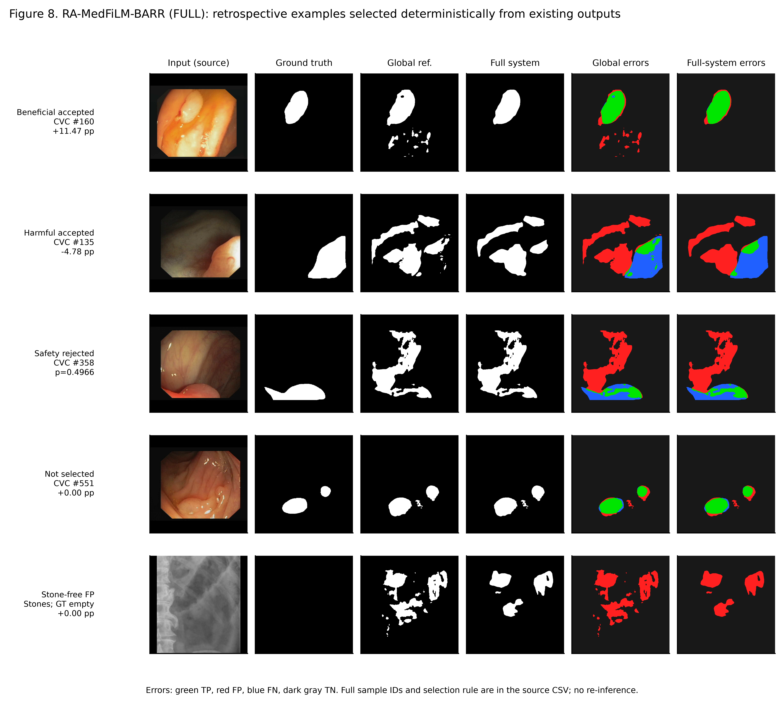
Figure 8: External Qualitative Gallery (Beneficial, Harmful, Rejected, Non-Selected, and Stone-Free False-Positive Cases).

8. 13-Arm Component Ablation & Progression Dynamics
Table 5 summarizes the Phase 28 13-arm ablation matrix (A0–A8, R1–R3, F1). Always-refine (A1) produces 42.7% harmful activations. Learned routing (A7) cuts harm to 33.3%. Post-safety (A8) eliminates 34 negative outliers, elevating routed delta to +0.75 pp. Contrast A8 vs A7 95% CI spans zero, confirming that this increment is descriptive.
Arm | Component Configuration Description | Routed N | Budget | Mean Routed Δ | Improved | Harmful Share
A0 | Global-only baseline (no refinement) | 0 | 0.00 | 0.0000 | 0 | 0.0%
A1 | Unconditional always-refine endpoint | 4,957 | 1.00 | +0.0017 | 2,775 | 42.7%
A2 | Random proposal routing (budget 0.25) | 1,239 | 0.25 | +0.0014 | 669 | 44.4%
A3 | Entropy-based proposal routing | 1,239 | 0.25 | +0.0072 | 844 | 31.9%
A4 | Margin-based uncertainty routing | 1,239 | 0.25 | +0.0071 | 843 | 32.0%
A5 | ROI-size heuristic proposal routing | 1,239 | 0.25 | -0.0004 | 597 | 46.4%
A6 | Learned benefit router (without cost loss) | 1,239 | 0.25 | +0.0072 | 827 | 33.3%
A7 | Learned benefit router + resource cost loss | 1,239 | 0.25 | +0.0072 | 827 | 33.3%
A8 | Canonical FULL BARR (+ post-safety gate) | 1,205 | 0.24 | +0.0075 | 815 | 32.4%
R1 | Router without deep feature backbone input | 1,239 | 0.25 | +0.0033 | 723 | 37.4%
R2 | Router without task identity conditioning | 1,239 | 0.25 | +0.0012 | 678 | 43.5%
R3 | Scalar-only metadata router | 1,239 | 0.25 | +0.0013 | 702 | 42.3%
F1 | Refiner without p_global input probability | 1,239 | 0.25 | -0.0326 | 256 | 68.8%

9. Reproducibility, Robustness & Pareto Efficiency
Three-Seed Reproducibility (VAL808): Seeds 42, 123, 3407 yield 0.837862 ± 0.00004 Dice across a shared pre-trained GlobalMedFiLM backbone. Variance reflects refiner and router initialization stability, not independent end-to-end retrainings.
Systematic Perturbation Sensitivity: High Gaussian noise on KUB plain radiographs causes acute degradation (-36.36 pp), whereas dermoscopy (-3.15 pp) and endoscopy (-6.04 pp) remain robust.
Computational Complexity: FULL BARR requires 4.84M parameters and 32.44 GMACs (expected conditional execution), achieving 67.2% compute reduction compared to vision transformers (MiT U-Net: 99.10 GMACs). Single-image latency on RTX 3060 Ti is 15.72 ms (skipped path) to 18.89 ms (executed path).

10. Supported Scientific Claims vs. Critical Evidence Gaps
Evidence Category | Status | Scientific Finding / Documented Evidence Gap
Internal Multi-Domain Gain | SUPPORTED | GlobalMedFiLM achieves 0.8351 macro Dice; FULL BARR achieves 0.8379 (+0.28 pp overall gain on VAL808).
Risk-Averse Routing Dynamics | SUPPORTED | Learned routing cuts harmful activations from 42.7% (A1) to 32.4% (A8), raising routed delta to +0.75 pp.
Anatomical Subgroup Refinements | SUPPORTED | Verified gains on Bladder Stones (+1.46 pp) and Ureteric Stones (+1.06 pp) in plain radiography.
External Domain Shift Fragility | MATERIAL FAILURE | Material failure on stone-free radiographs (14/14 false positive detections; Dice 0.000).
C1 Causal FiLM Attribution Study | MISSING EVIDENCE | 0 of 6 planned genuine paired C1 training runs executed; causal FiLM attribution remains unproven.
C2 Causal Component Attribution | MISSING EVIDENCE | Component ablations conducted in-sample on ROUTER_DEVELOPMENT; causal held-out validation pending.
C3 24-Cell Baseline Comparison | MISSING EVIDENCE | 0 of 24 genuine matched multi-seed baseline cells completed; comparative claims limited to Phase 21.
Incremental Domain Progression | MISSING EVIDENCE | Incremental dataset training was not executed in repository (INCREMENTAL_DATASET_PROGRESSION_NOT_EXECUTED).

11. Conclusion & Scientific Submission Guidance
The RA-MedFiLM-BARR research lifecycle establishes that task-conditioned FiLM representations paired with selective, risk-averse residual refinement achieve robust multi-domain segmentation performance without the excessive computational overhead of large vision transformers. However, submission to premier journals (IEEE TMI / Medical Image Analysis) requires transparent disclosure of external transfer vulnerabilities, specifically the stone-free false positive detection rate, and explicit acknowledgment that causal FiLM attribution (C1) and 24-cell matched baseline comparisons (C3) remain future experimental milestones. The complete code, checkpoints, prediction masks, and numerical evidence are archived for independent scientific verification.

