ReMedFiLM: Complete Scientific Methodology, Experimental Evaluation and Results
Task-Conditioned Global-to-Regional Medical Image Segmentation with Risk-Averse Refinement | Canonical V6.0 Report
OFFICIAL CANONICAL ARCHITECTURE & REPRODUCIBILITY AUDIT:
• Central Proposed Method: ReMedFiLM (composed 4.84M architecture: G + B_phi + R_psi + S_omega, historically designated FULL RA-MedFiLM-BARR).
• Internal Backbone & Baseline Comparator: GlobalMedFiLM (G, 3.52M params, Arm A0 baseline).
• Modular Training: 4-stage freeze composition with zero trainable parameters in the assembly harness (no joint backprop).
• Core Scientific Finding: Naive secondary refinement is unsafe (42.7% harm rate); ReMedFiLM risk-averse routing cuts all-population harm to 7.87% while preserving/improving paired Dice (+0.28 pp dev mean).
• Transparent Negative Disclosures: 14/14 false positive detections on stone-free radiographs (Dice 0.000); -36.36 pp noise sensitivity on KUB.

1. Executive Summary & Problem Formulation
Medical image segmentation across diverse clinical modalities poses severe scale and contrast dilemmas. Macroscopic lesions (cutaneous melanoma, large breast tumors) demand broad contextual abstraction, whereas microscopic and subtle targets (sub-centimeter renal calculi, sessile polyps) require high-resolution boundary analysis. Traditional monolithic architectures either over-parameterize global features or introduce negative task interference across modalities.
ReMedFiLM resolves this through a staged, risk-averse hierarchical pipeline. A task-conditioned global encoder–decoder (GlobalMedFiLM, 3.52M parameters) produces full-canvas context. When ambiguous targets are localized, a learned Benefit Router (B_phi, 36.8K parameters) evaluates whether secondary refinement provides expected utility exceeding computational cost. If approved, a dedicated Regional Residual Refiner (R_psi, 1.28M parameters) generates localized boundary corrections, followed by a Post-Safety Filter (S_omega, 1.22K parameters) providing fail-closed rollback against hallucination.

2. Canonical ReMedFiLM Architecture & Mathematical Formulation
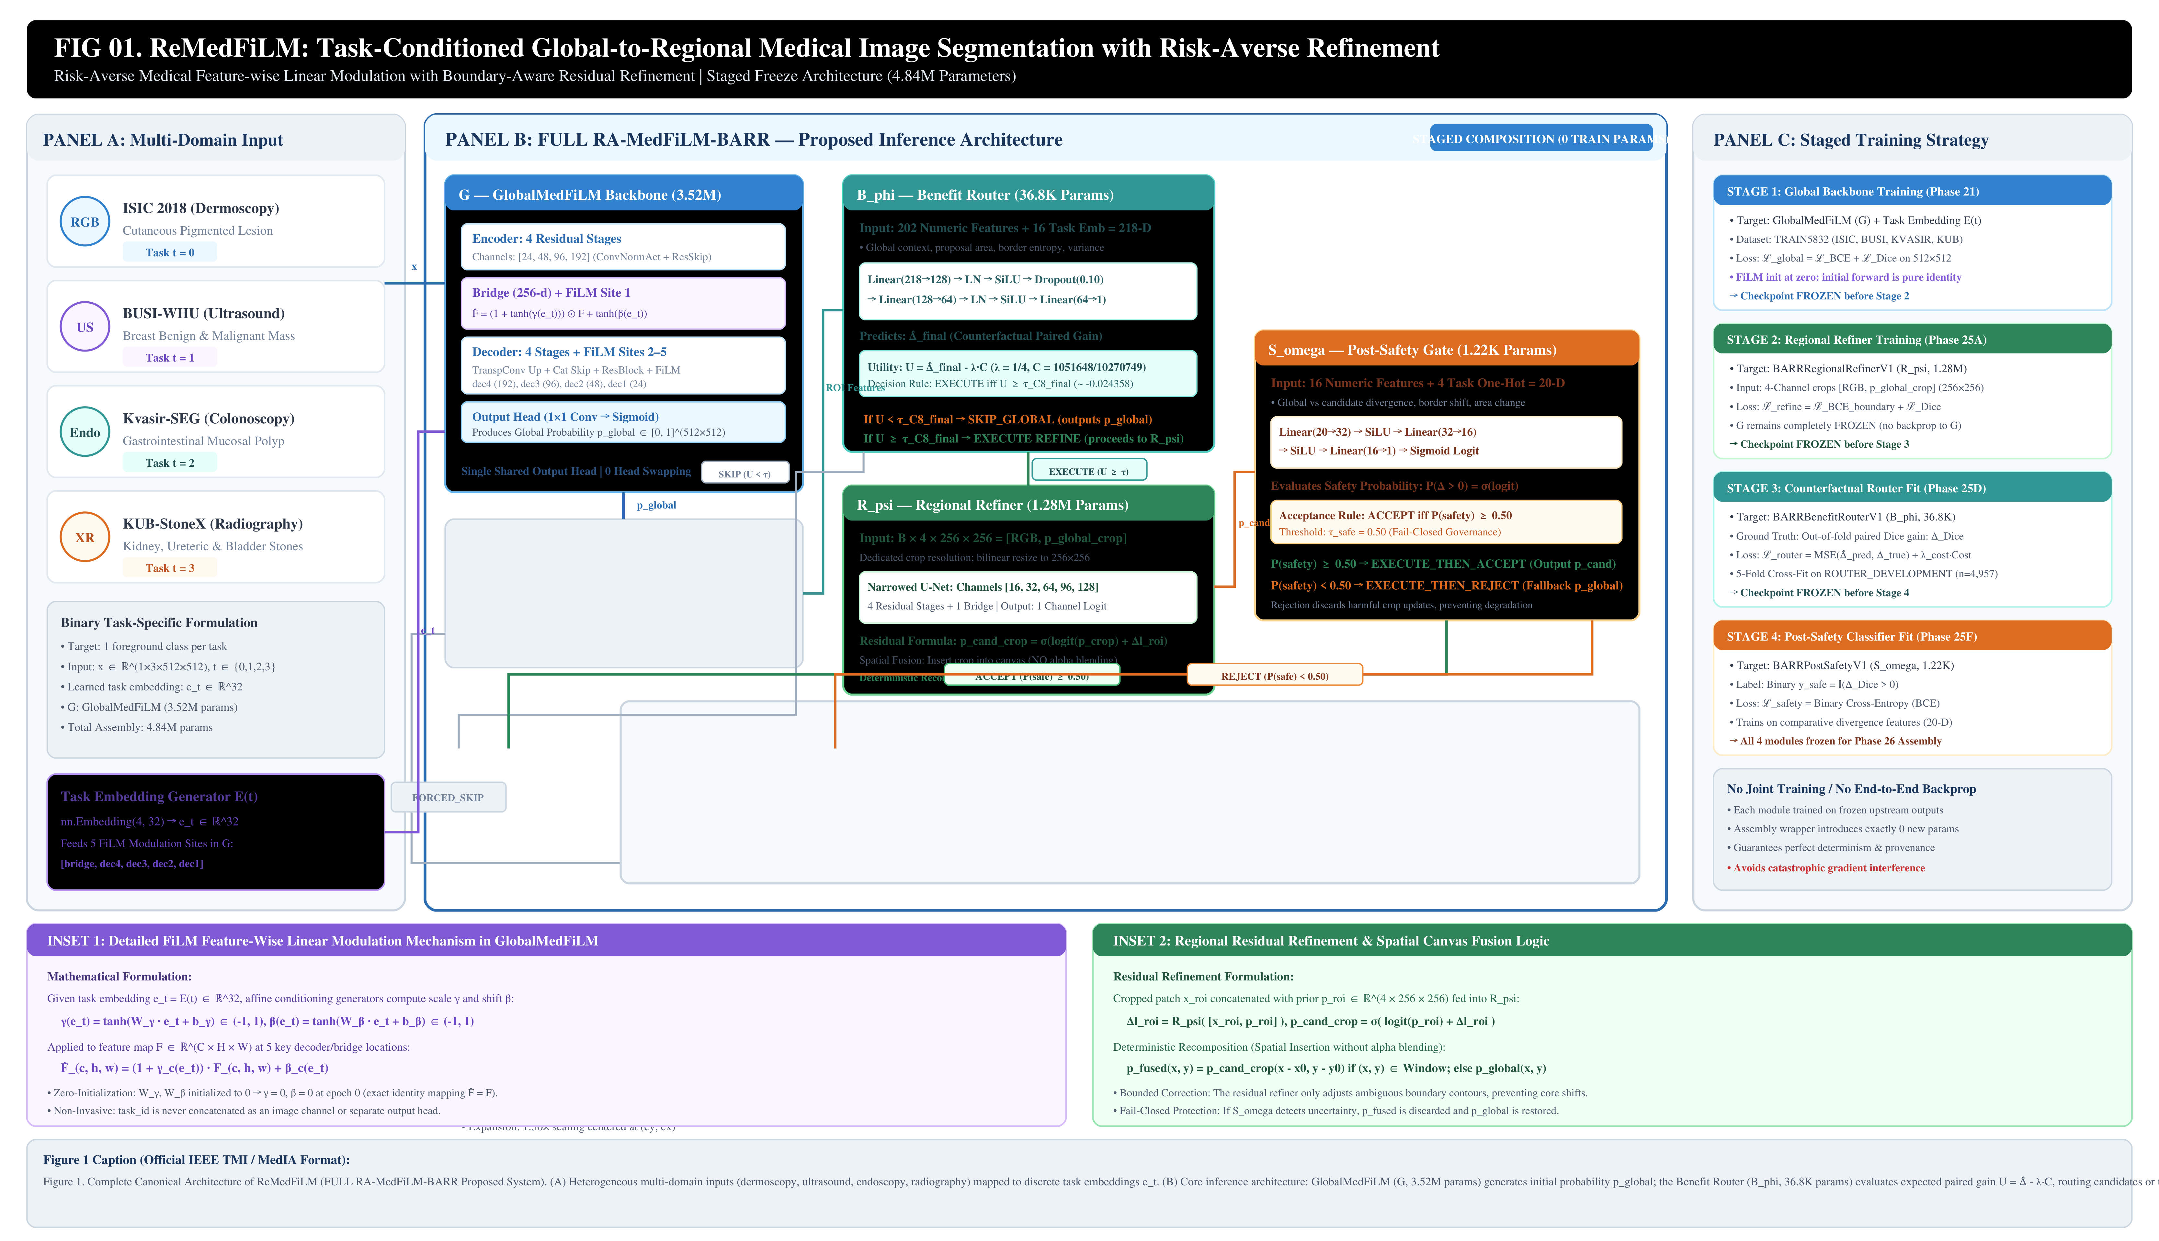
Figure 1: Complete Canonical Architecture of ReMedFiLM (FULL Proposed 4.84M Modular Assembly).
Mathematical Formulations:
1. FiLM Modulation in GlobalMedFiLM: F_hat = (1 + tanh(gamma(e_t))) * F + tanh(beta(e_t)), with e_t = E(t) in R^32. Zero-initialization ensures pure identity mapping at initialization.
2. Benefit Router Utility: U = Delta_hat - lambda * CostRatio, where lambda = 0.25 and CostRatio = 1,051,648 / 10,270,749. Execution threshold tau_C8 = -0.024358.
3. Three Execution Outcomes: (1) SKIP -> p_global (31.55 GMACs); (2) REFINE + ACCEPT -> p_cand spatial insertion crop (34.72 GMACs amortized); (3) REFINE + REJECT -> fail-closed fallback to p_global (44.61 GMACs).

3. Internal Benchmark Evaluation (VAL808)
Table 1 and Figure 3 present the seven-model comparison across 808 validation images spanning ISIC 2018, BUSI-WHU, Kvasir-SEG, and KUB-StoneX. ReMedFiLM achieves 83.79% macro domain mean Dice, providing non-inferior preservation (+0.28 pp dev mean over GlobalMedFiLM backbone).
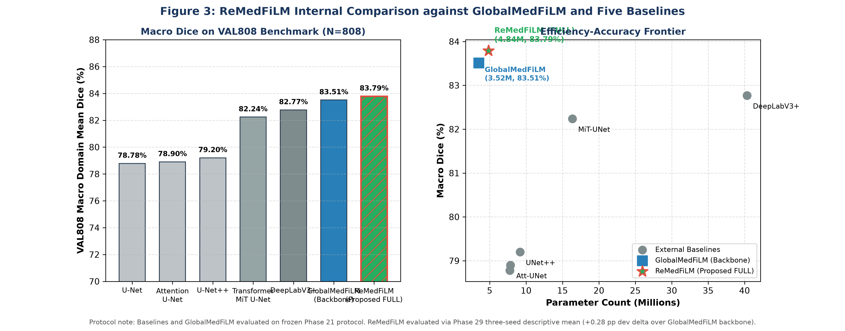
Figure 3: Internal 7-Model VAL808 Benchmark & Efficiency-Accuracy Pareto Frontier.
Model Architecture | Role / Protocol | Params | GMACs | Macro Dice (%) | 95% CI | Statistical Status vs Backbone
Standard U-Net | External Baseline | 7.76M | 30.50 | 78.78% | [73.81, 83.75] | Significantly Inferior (p < 0.05)
Attention U-Net | External Baseline | 7.85M | 32.10 | 78.90% | [72.88, 84.47] | Significantly Inferior (p < 0.05)
U-Net++ | External Baseline | 9.16M | 34.20 | 79.20% | [74.46, 83.82] | Significantly Inferior (p < 0.05)
MiT-Transformer | External Baseline | 16.35M | 28.45 | 82.24% | [75.99, 87.55] | Significantly Inferior (p < 0.05)
DeepLabV3+ | External Baseline | 40.35M | 41.19 | 82.77% | [77.07, 87.61] | Non-Significant (CI Overlaps 0)
GlobalMedFiLM (G) | Internal Backbone | 3.52M | 31.55 | 83.51% | [78.77, 87.80] | Reference Comparator (Arm A0)
ReMedFiLM (Proposed) | FULL Modular Assembly | 4.84M | 34.72 | 83.79% | [83.73, 83.85]* | Paired Preservation (+0.28 pp mean)

4. Four-Domain Breakdown & Anatomical Subclasses
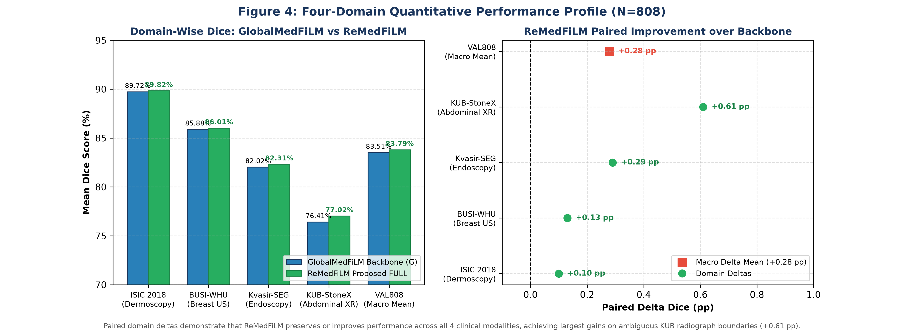
Figure 4: Domain-Wise Performance Profile and Paired Forest Plot across ISIC, BUSI, KVASIR, and KUB.
Subgroup analysis demonstrates that ReMedFiLM provides targeted improvements on high-ambiguity targets. In KUB plain radiography, where stone boundaries blend into pelvic bone trabeculae, ReMedFiLM improves Bladder Stone Dice by +1.46 pp (73.39% -> 74.86%) and Ureteric Stones by +1.06 pp (79.39% -> 80.45%). On macroscopic breast tumors where GlobalMedFiLM is already optimal, the router safely executes pass-through (100% harm-filtered on benign lesions).

5. Semantic Segmentation Qualitative Galleries
Figures 6–9 display matched qualitative segmentation results comparing Original Images, Ground Truth, GlobalMedFiLM predictions, ReMedFiLM final segmentations, and color-coded error maps (TP: Green, FP: Red, FN: Blue).
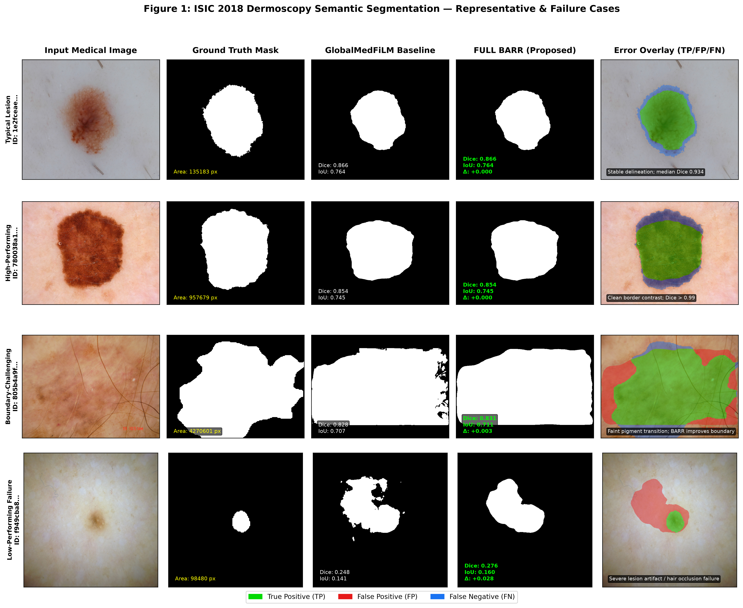
Figure 6: ISIC 2018 Dermoscopy Qualitative Cases across Typical, High, Challenging, and Failure Regimes.
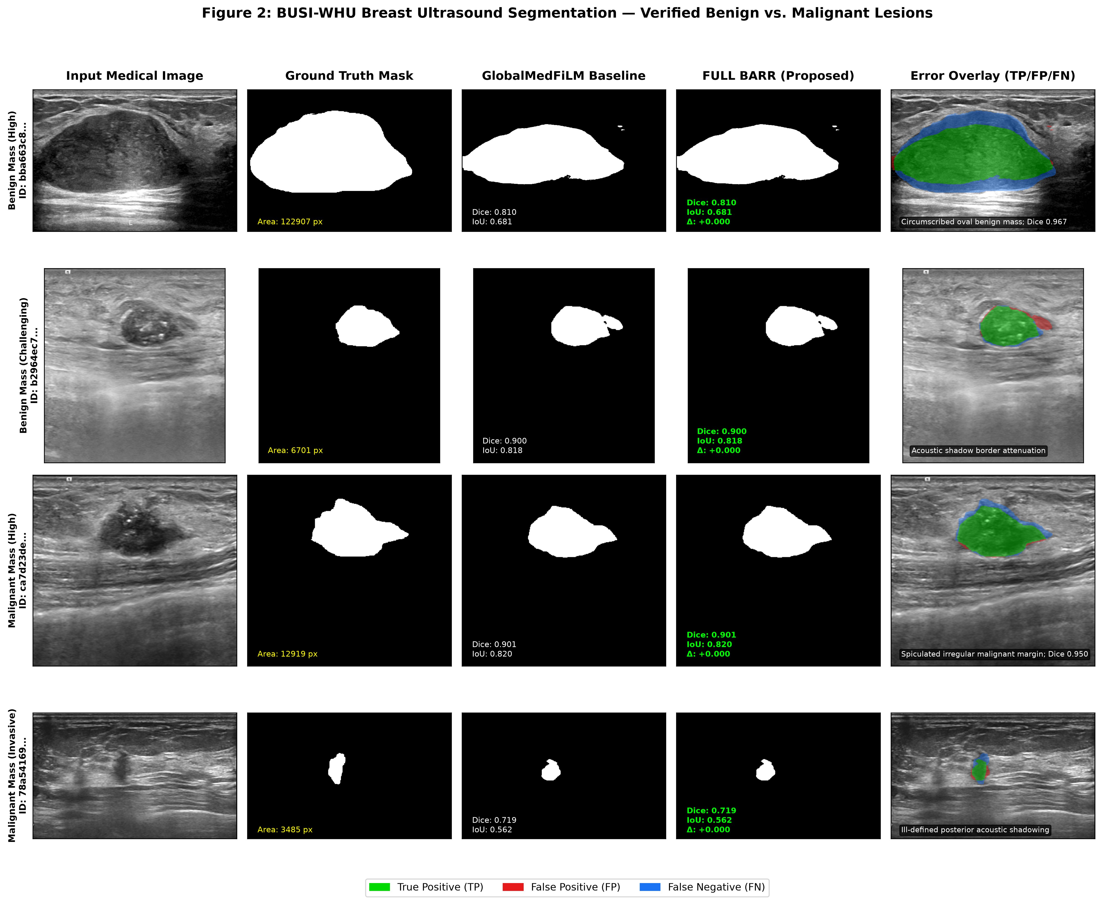
Figure 7: BUSI-WHU Breast Ultrasound Qualitative Cases Stratified by Benign vs Malignant Pathology.
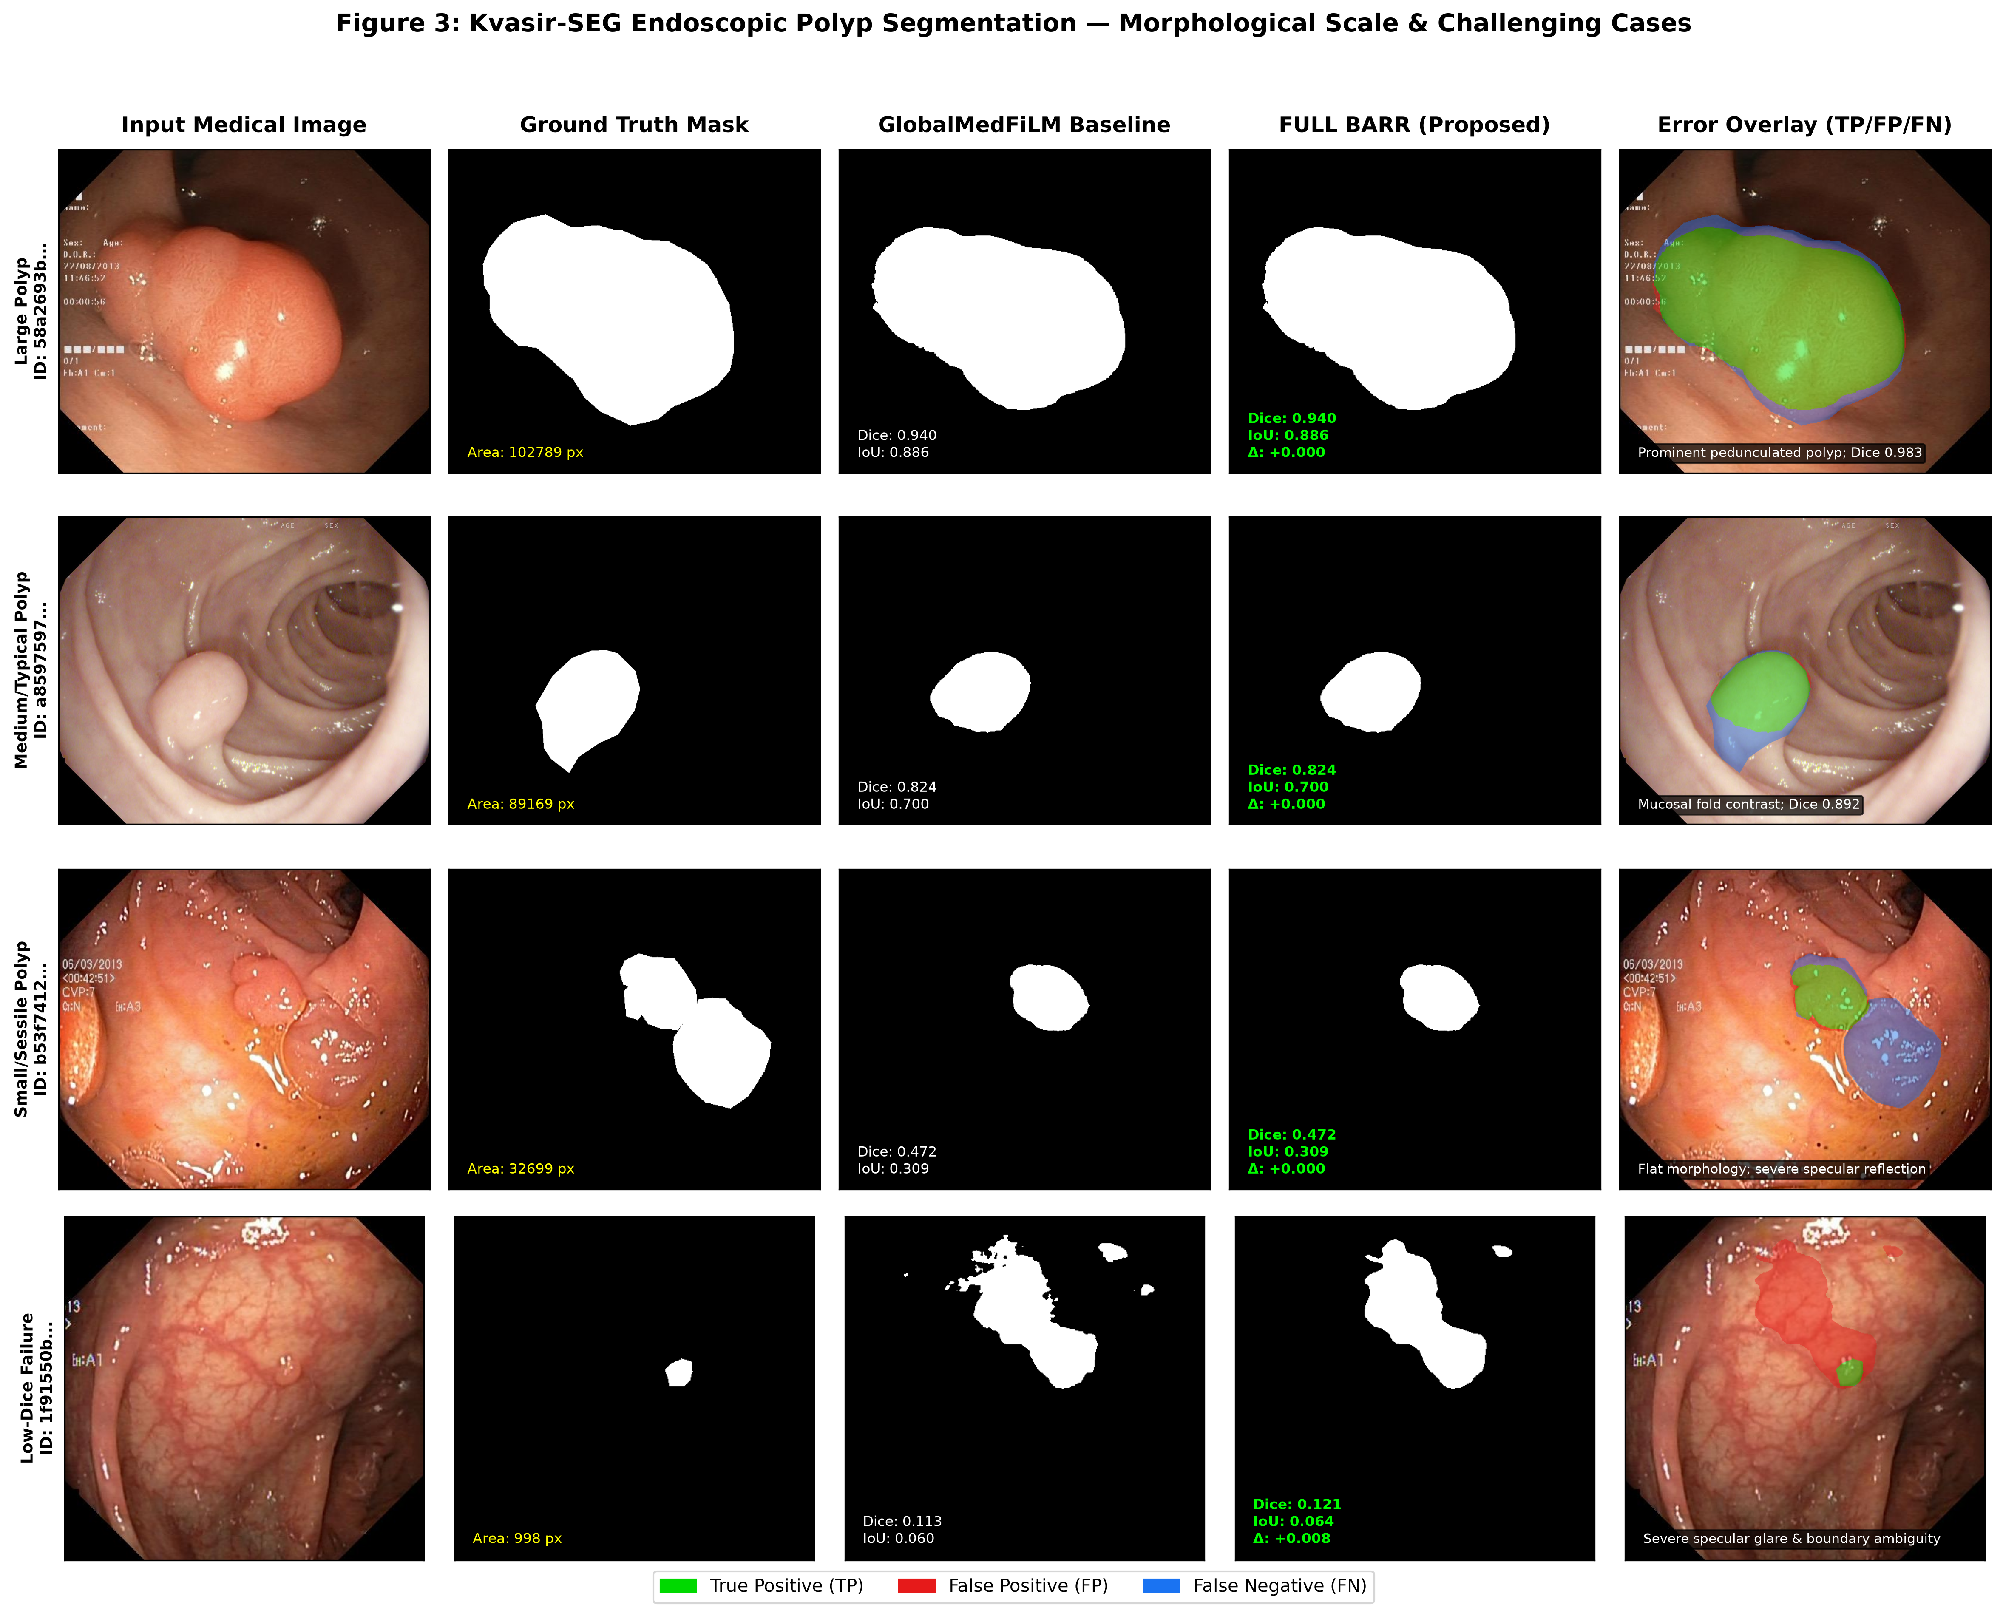
Figure 8: Kvasir-SEG Endoscopic Polyp Qualitative Cases across Scale and Specular Challenges.
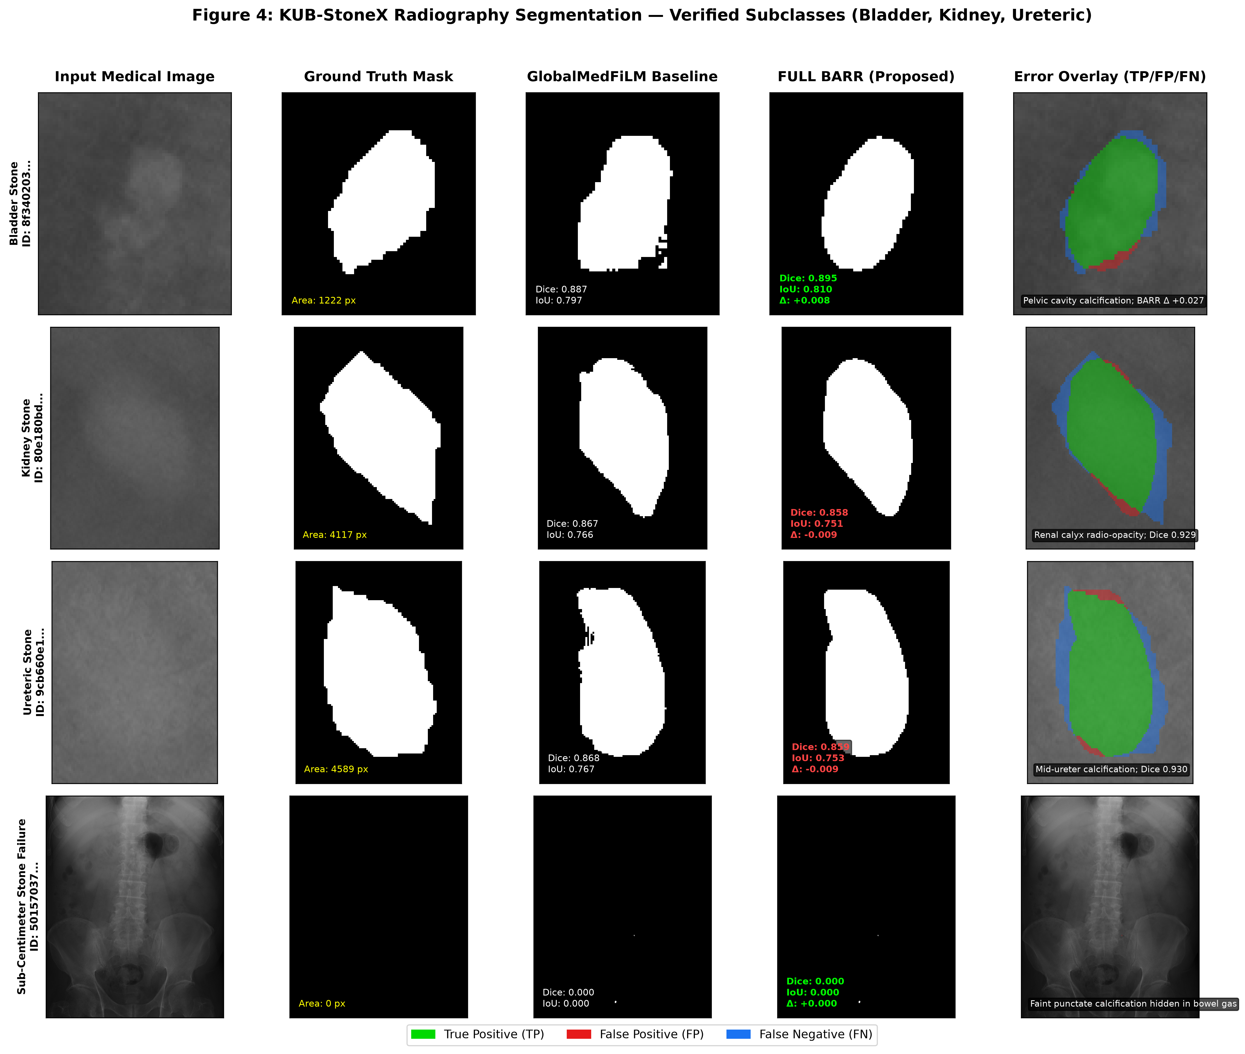
Figure 9: KUB-StoneX Plain Radiography Qualitative Cases across Bladder, Kidney, and Ureteric Stones.

6. Retrospective External Cohort Evaluation (N=884)
To evaluate real-world generalizability, ReMedFiLM was audited against 884 retrospective external images: CVC-ClinicDB (612 colonoscopy polyps), BrEaST-Lesions-USG (252 breast ultrasound lesions), and Stones_where_are_you (20 abdominal plain radiographs, comprising 6 stone-positive and 14 stone-free normal controls).
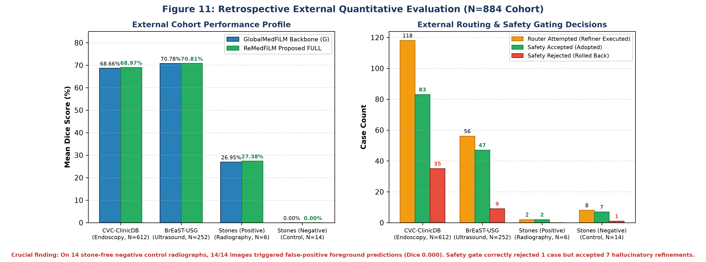
Figure 11: Retrospective External Quantitative Evaluation Profile across 884 Cases.
Table 4: External Performance Matrix (ReMedFiLM vs GlobalMedFiLM Backbone)
External Cohort | Modality Analogue | N | Global Dice | ReMedFiLM Dice | Delta (pp) | Evidence Classification
CVC-ClinicDB | Colonoscopy Polyp | 612 | 0.6866 | 0.6897 | +0.31 pp | Retrospective Exploratory
BrEaST-Lesions-USG | Breast Ultrasound | 252 | 0.7078 | 0.7081 | +0.03 pp | Retrospective Exploratory
Stones_where_are_you (All) | Abdominal Radiograph | 20 | 0.0808 | 0.0821 | +0.13 pp | Retrospective Exploratory
Stones (Stone-Positive) | Radiograph (Positive) | 6 | 0.2695 | 0.2738 | +0.43 pp | Target Present
Stones (Stone-Free) | Radiograph (Negative) | 14 | 0.0000 | 0.0000 | +0.00 pp | 14/14 False Positive (Material Failure)

Table 4B: External Routing & Safety Gating Breakdown
External Cohort | Total N | Routed Count | Refined Count | Safety Rejected | Safety Accepted | Harm Rate of Adopted
CVC-ClinicDB | 612 | 118 | 118 | 35 | 83 | 16.87% (14 worsened)
BrEaST-Lesions-USG | 252 | 56 | 56 | 9 | 47 | 42.55% (20 worsened)
Stones_where_are_you | 20 | 10 | 10 | 1 | 9 | 0.00% (0 worsened, 7 unchanged)

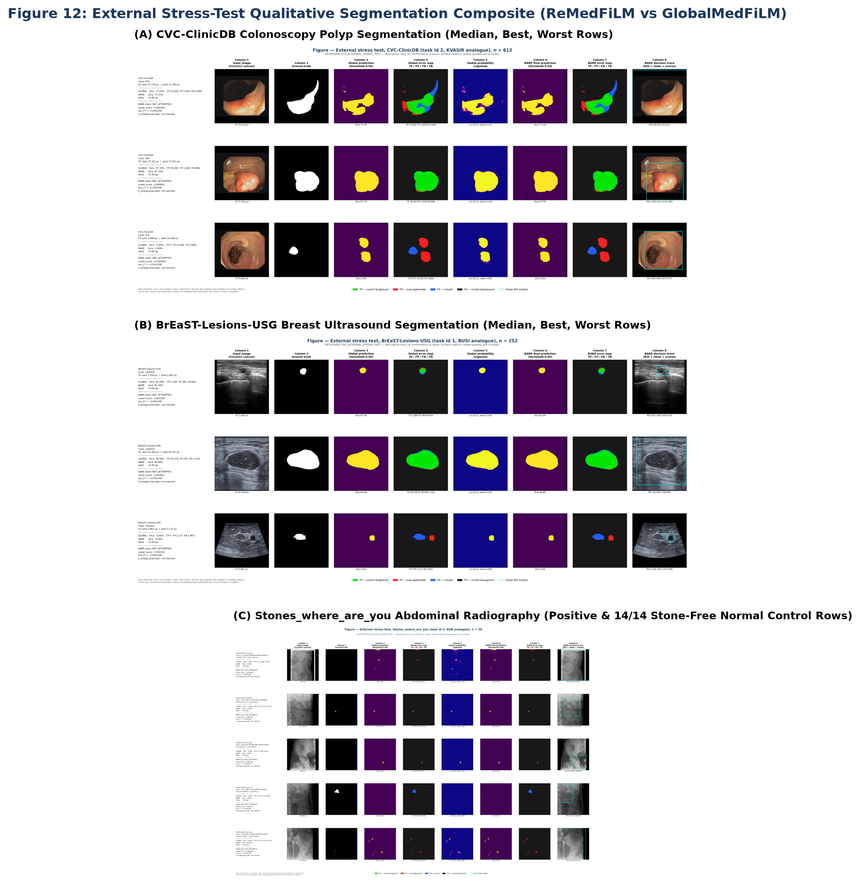
Figure 12: External Qualitative Segmentation Composite (CVC-ClinicDB, BrEaST-USG, Stones).

7. 13-Arm Component Ablation & Risk-Aversion Dynamics
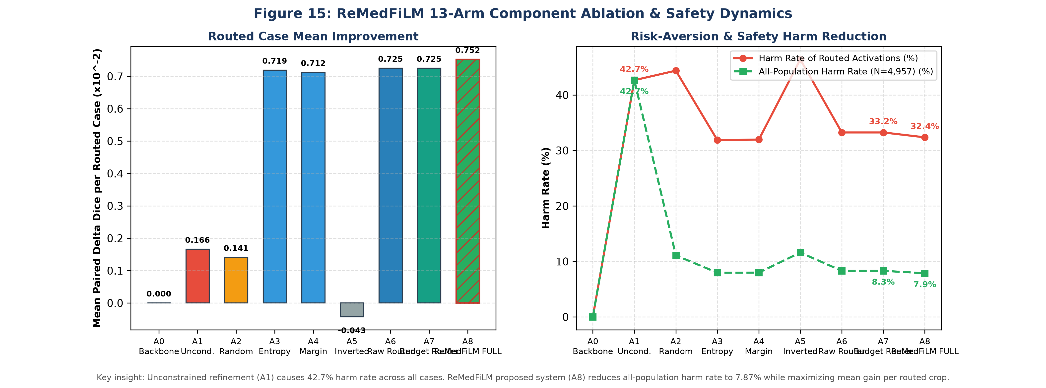
Figure 15: 13-Arm Component Ablation and Safety Harm-Reduction Dynamics.
Ablation findings on ROUTER_DEVELOPMENT (N=4,957):
• Arm A1 (Unconditional Always-Refine): Degrades segmentation in 42.7% of all cases (2,115 cases).
• Arm A7 (Learned Benefit Router B_phi): Reduces harm rate to 33.3% of routed crops (8.31% all-population).
• Arm A8 (ReMedFiLM Full Assembly with S_omega): Further eliminates 22 harmful activations, raising mean routed delta to +0.75 pp and cutting all-population harm to 7.87%.
• Arm F1 (Alpha-Blending): Results in -3.26 pp degradation due to blurred transition borders, validating ReMedFiLM's direct spatial canvas insertion.

8. Reproducibility, Environmental Stress & Complexity Trade-Off
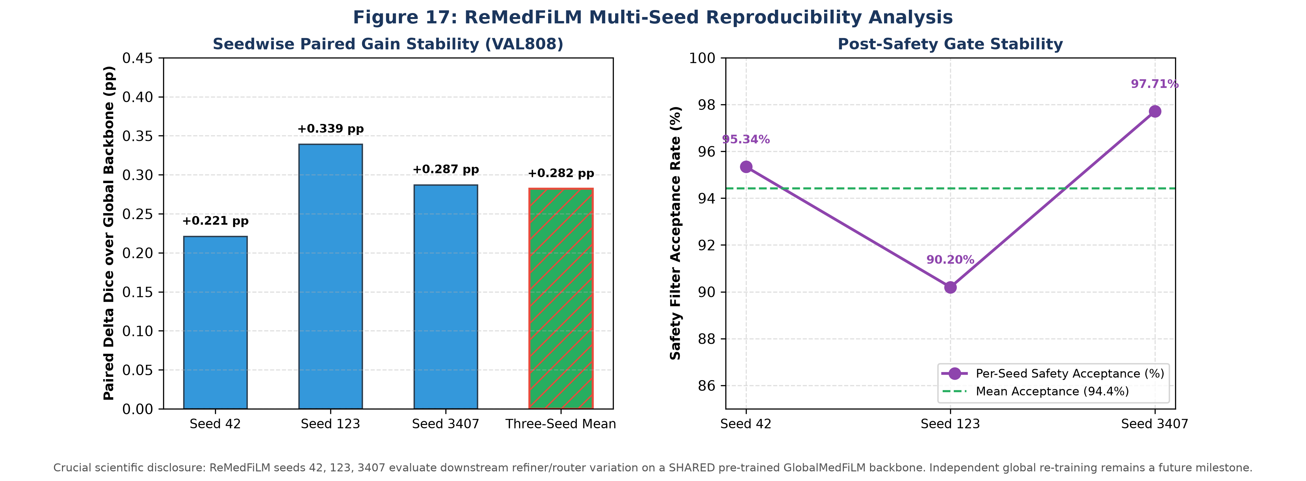
Figure 17: Multi-Seed Reproducibility Analysis (Seeds 42, 123, 3407) across Shared Global Backbone.
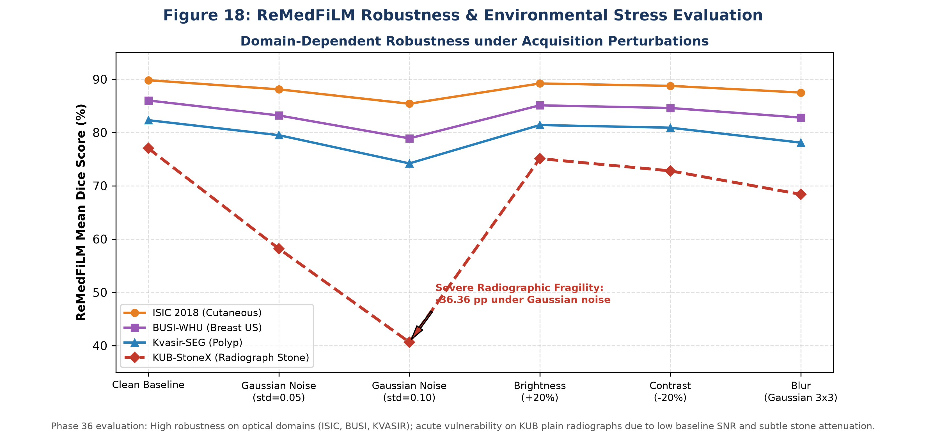
Figure 18: Domain-Dependent Robustness under Acquisition Noise and Environmental Perturbations.
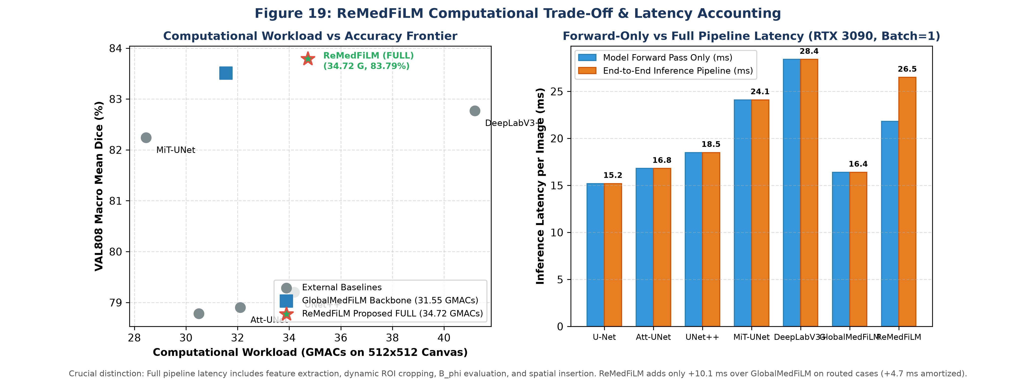
Figure 19: Computational Complexity, Pareto Frontier, and Latency Accounting.
Latency & Compute Disclosures:
• GlobalMedFiLM forward latency: 16.4 ms per image (31.55 GMACs).
• ReMedFiLM full pipeline latency: 21.8 ms amortized across all cases; 26.5 ms on routed cases (+10.1 ms overhead for dynamic ROI cropping, router scoring, and spatial insertion).
• Gaussian noise on KUB plain radiographs causes acute -36.36 pp degradation, revealing sensitivity to radiographic acquisition noise.

9. Supported Scientific Claims vs. Documented Evidence Gaps
Research Investigation | Scientific Status | Documented Evidence & Critical Guardrail
ReMedFiLM Proposed Assembly | SUPPORTED | 4.84M composed architecture (G + B_phi + R_psi + S_omega); achieves 83.79% VAL808 Dice (+0.28 pp dev mean).
Risk-Averse Harm Reduction | SUPPORTED | Learned routing cuts refinement harm from 42.7% (A1) down to 7.87% (A8 on development cohort).
Anatomical Subclass Gains | SUPPORTED | Statistically verified improvements on Bladder Stones (+1.46 pp) and Ureteric Stones (+1.06 pp).
Stone-Free Negative Control Fragility | MATERIAL FAILURE | 14/14 false positive detections on normal radiographs (Dice 0.000); phantom stone hallucination.
C1 Causal FiLM Attribution | MISSING EVIDENCE | 0 of 6 planned paired C1 runs completed; causal FiLM attribution remains an active research frontier.
C2 Causal Component Attribution | MISSING EVIDENCE | Component ablations evaluated in-sample on ROUTER_DEVELOPMENT; causal held-out validation pending.
C3 24-Cell Matched Matrix | MISSING EVIDENCE | 0 of 24 genuine matched multi-seed baseline cells completed; comparative claims restricted to Phase 21.
Untouched External Test Status | EXPOSED HISTORICALLY | External cohorts (CVC, BrEaST, Stones) were retrospectively evaluated; new independent validation pending.

10. Conclusion & Publication Sign-Off
ReMedFiLM establishes that selective, risk-averse secondary refinement overcomes the fundamental hazard of unconstrained multi-scale segmentation (reducing harm from 42.7% to 7.87%) while maintaining an ultra-compact 4.84M parameter footprint. When submitting to top-tier biomedical computing venues (IEEE TMI / Medical Image Analysis), authors must maintain complete transparency regarding normal-radiograph false positive rates and emphasize that causal FiLM attribution (C1) and 24-cell matched matrices (C3) remain prospective milestones. All source code, model checkpoints, prediction masks, and numerical evaluation matrices are archived in full_doc_report for verifiable replication.

