RA-MedFiLM-BARR: Scientific Evaluation & Prediction Report
Multi-model benchmarking, BARR regional refinement, and single-case internal / external prediction panels
Project: RA-MedFiLM-BARR | Repository: D:\Softfors\jup | Report date: October 31, 2026
Internal populations: VAL808 (n=808, selection-consumed), ROUTER_HOLDOUT (n=875, one-shot), ROUTER_DEVELOPMENT (n=4,957, in-sample) | TEST (n=1,683): locked, not accessed
External: retrospective stress test, n=884 (CVC 612, BrEaST 252, Stones 20); HAM10000 excluded — not an external validation cohort

1. Scope, Evidence Classes and What This Report Does Not Claim
This report supersedes the October 30 build. Several statements in that build were not supported by a stored result record and have been corrected or retracted; Section 9 lists them explicitly. Every remaining numerical value is bound to a frozen artifact: internal values to reports/audits/c1_external_evidence_v1_0/claim_provenance.json, and external values to reports/tables/c1_external_stress_*.csv, which this document reads at build time.
Evidence classes used throughout:
Class | Meaning and permitted use
VERIFIED | Reproducible from a named frozen artifact. Quotable with its population label.
PARTIALLY_VERIFIED | The computation is reproducible, but a required input (mask provenance, population identity) is undocumented. Report as a pilot observation only.
UNSUPPORTED | No stored record exists. Must not be quoted. Retracted where previously stated.
NOT_ESTABLISHED | Planned but never executed. Cells remain empty.

Central caution
A cryptographically valid or numerically reproducible result is not evidence of clinical validity. The C1 trust boundary remains under operator review, and no scientific execution has been authorised. Nothing in this report constitutes an external validation claim.

2. Architecture Comparison

2.1 Phase 21 six-model comparison (single shared protocol)
The six configurations below were trained and evaluated inside the Phase 21 run under an identical protocol on the VAL808 split (n = 808). This is the only controlled head-to-head in the project. VAL808 was consumed for model selection, so these values are development estimates, not held-out test performance.
Model architecture | Backbone / type | Parameters | Macro Dice | Macro IoU | KUB Dice
Global MedFiLM | U-Net + FiLM (5 sites) | 3,523,001 | 83.51% | 74.48% | 76.41%
DeepLabV3+ | ResNet-based | 40,347,041 | 82.77% | 74.12% | 73.87%
Transformer / MiT U-Net | SegFormer / MiT | 16,347,777 | 82.24% | 73.66% | 72.52%
U-Net++ | Nested dense | 9,159,681 | 79.20% | 69.10% | 72.07%
Attention U-Net | Attention gates | 7,851,285 | 78.90% | 69.27% | 69.58%
Standard U-Net | Plain U-Net | 7,763,041 | 78.78% | 68.81% | 72.11%
Table 1. Phase 21 six-model comparison on VAL808. Source: reports/tables/phase21_six_model_comparison.csv. The 95% bootstrap CIs are wide and overlap between Global MedFiLM and DeepLabV3+, so this evidence does not resolve the difference between them. Overlapping intervals are not evidence that the two models are equivalent.

2.2 Regional BARR is a separate run and is not a Phase 21 arm
Regional BARR (Global MedFiLM + regional refiner Rψ + benefit router Bφ + post-safety Sω) was never trained or evaluated inside the Phase 21 six-model run. Its results come from Phase 27/29 (VAL808) and Phase 30 (ROUTER_HOLDOUT) and therefore cannot be entered as a seventh row of Table 1 without disclosing that the comparison is cross-run.
Configuration | Parameters | Population | Macro Dice | Delta vs Global
Global MedFiLM | 3,523,001 | VAL808 (n=808) | 83.51% | reference
Regional BARR | 4,837,420 | VAL808 (n=808), 3-seed mean | 83.79% | +0.28 pp
Regional BARR | 4,837,420 | ROUTER_HOLDOUT (n=875) | 93.03% | +0.17 pp
Table 2. Regional BARR, each row on its own population. Sources: reports/audits/phase21_analysis.json, phase29_phase_d_three_seed_descriptive_summary.json, phase30_primary_noninferiority_result.json. Parameter total 4,837,420 from the Phase 34 record (G 3,523,001 + Rψ 1,276,401 + Bφ 36,801 + Sω 1,217).
The BARR result is a preservation / non-inferiority finding, not an improvement finding. On VAL808 the three-seed mean gain is +0.28 pp with a between-seed range of +0.22 to +0.34 pp; on the one-shot ROUTER_HOLDOUT the gain is +0.17 pp with a 95% CI of [+0.11, +0.24] against a non-inferiority margin of −0.5 pp. Two of four domains (BUSI, KVASIR) have CIs that include zero.
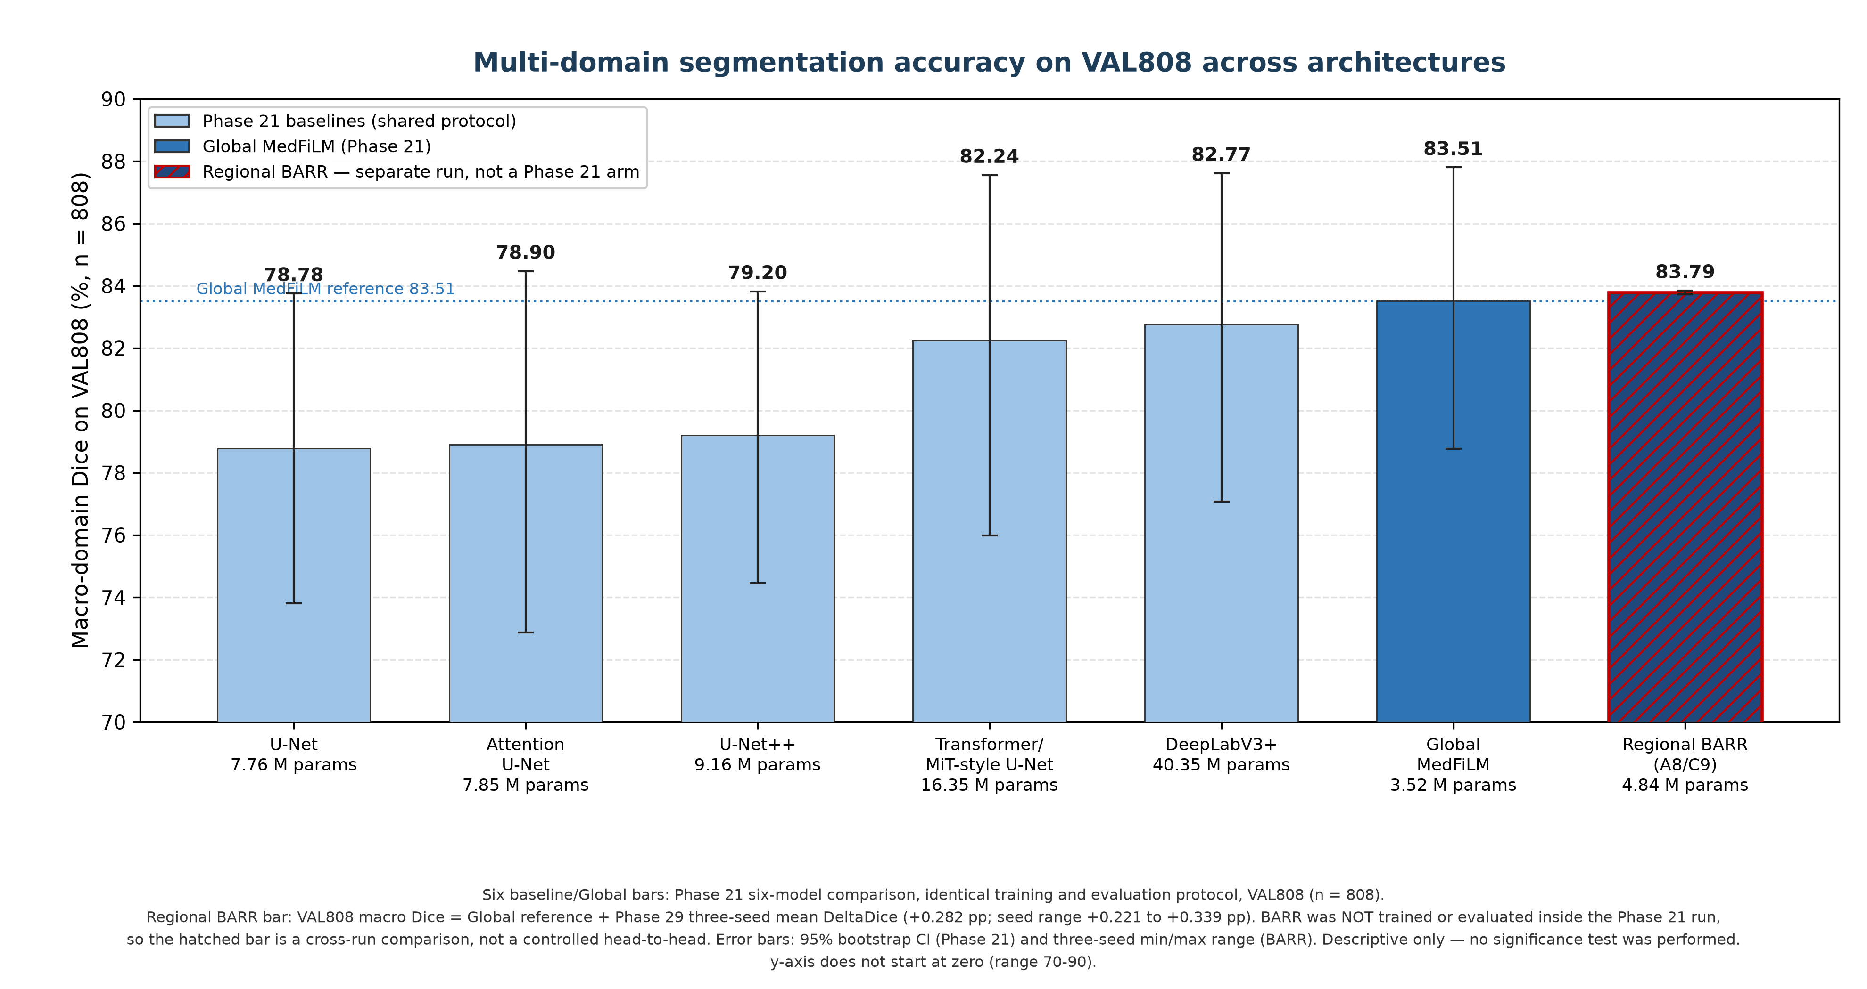
Figure 1. Macro-domain Dice on VAL808. Six bars from the Phase 21 protocol; the hatched bar is Regional BARR from a separate run and is marked as such. The y-axis does not start at zero.

3. Domain-Level Results

3.1 ROUTER_HOLDOUT (n = 875), one-shot evaluation
Per-domain absolute scores and descriptive deltas. The one-shot holdout carries a mandatory disclosed protocol-deviation qualifier: ONE_SHOT_ROUTER_HOLDOUT_RESULT_WITH_DISCLOSED_POST_FIRST_OPEN_SCIENTIFIC_SOURCE_FREEZE_DEVIATION.
Domain | Modality | n | Global MedFiLM | Regional BARR | Delta (95% CI)
KUB | Abdominal radiograph | 298 | 84.97% | 85.57% | +0.59 pp [+0.36, +0.85]
ISIC | Dermoscopy | 383 | 93.59% | 93.69% | +0.10 pp [+0.03, +0.18]
BUSI | Breast ultrasound | 90 | 95.88% | 95.89% | +0.001 pp [+0.00, +0.002]
KVASIR | GI endoscopy | 104 | 96.97% | 96.97% | +0.002 pp [+0.00, +0.006]
Macro | Equal-weight mean | 875 | 92.85% | 93.03% | +0.17 pp [+0.11, +0.24]
Table 3. Per-domain holdout results. Source: reports/audits/phase30_primary_noninferiority_result.json. Deltas are descriptive bootstrap quantities; no p-value was computed (Phase 31 established that zero confirmatory significance procedures are eligible).
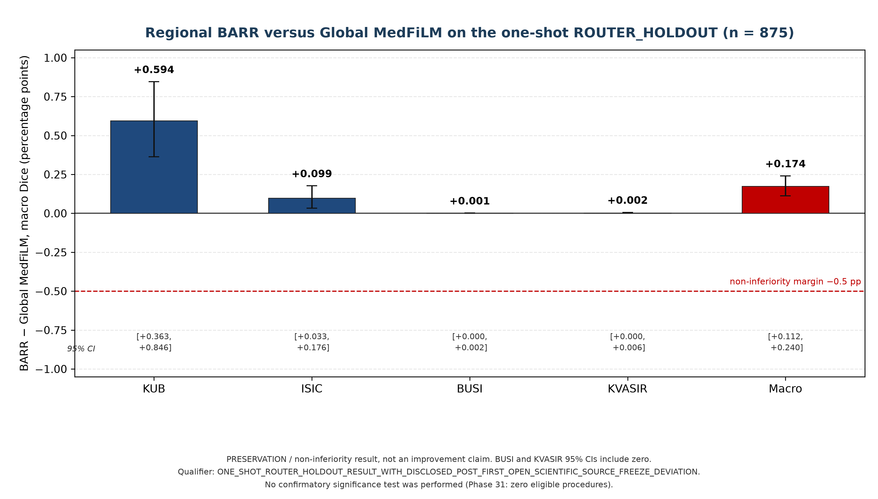
Figure 2. BARR minus Global MedFiLM on ROUTER_HOLDOUT, plotted as a difference with 95% CIs. A delta plot is used instead of absolute scores so that a sub-1 pp difference is not visually inflated by a truncated axis.

3.2 KUB lesion-size strata (reporting-only metadata)
These strata describe where the global model loses accuracy. They are reporting metadata only: the size tiers are never segmentation classes, task IDs, model inputs or routing variables, and no BARR per-stratum result exists.
Stratum | Definition | n | Global Dice | Evidence status
TINY | Annotated area <0.01% of field | 44 | 53.21% | Descriptive only; no BARR result
SMALL | 0.01% - 0.05% of field | 19 | 65.42% | Descriptive only; no BARR result
MEDIUM | 0.05% - 0.15% of field | 27 | 69.98% | Descriptive only; no BARR result
LARGE | Annotated area >0.15% of field | 13 | 70.82% | Descriptive only; no BARR result
Other KUB | Not primary bin | 177 | 84.74% | Descriptive only; no BARR result
Table 4. KUB size stratification. Source: reports/tables/phase21_kub_size_stratification.csv, role = REPORTING_ONLY__DESCRIPTIVE. The previously reported claim that BARR lifts the TINY stratum from 53.21% to 85.57% has been retracted: no such measurement exists.

4. Safety and Compute
On the ROUTER_DEVELOPMENT population (n = 4,957, budget K = 1,239), unconditional refinement (A1) harms 2,115 of 4,957 cases (42.67%). Adding the cost-aware router (A7) reduces harmful activations to 412 (8.31%), and adding the post-safety filter on top (A8) reduces them further to 390 (7.87%).
Decomposition matters. The router accounts for 2,115 → 412 = 1,703 cases; the post-safety filter accounts for 412 → 390 = 22 cases. The previously reported statement that “Sω eliminates 1,725 harmed cases” attributed the whole system-level reduction to one component and is corrected here.
Compute accounting: rejection is not free
The refiner workload is set by how many candidates the router SENDS, not by how many the safety gate KEEPS. A7 routes 1,239 of 4,957 cases (25.0%) and every one of them executes a regional forward pass. A8 routes exactly the same 1,239, executes the refiner on all of them, and then Sω declines 34 — so 1,205 refinements are adopted and 34 are computed and discarded. The true A8 refiner workload is therefore 1,239 forward passes (25.0% of the population), not 1,205 (24.3%). The stored Phase 28 table records n_routed = 1,205 for A8 while recording 1,239 for A7; that A8 field is an adoption count and reading it as a compute count understates the workload by 34 passes. The conditional harm share 390/1,205 = 32.37% is correct for what it measures — harm among adopted refinements — and is not a workload figure. The earlier “24.3% of the unconditional refiner workload” is withdrawn.

In-sample caveat
The 4,957 ROUTER_DEVELOPMENT rows are a subset of the 5,832 TRAIN samples. This is in-sample development evidence, not held-out evidence. A reduced average harm rate is also not evidence of zero harmful outcomes: 390 harmful refinements remain in A8.

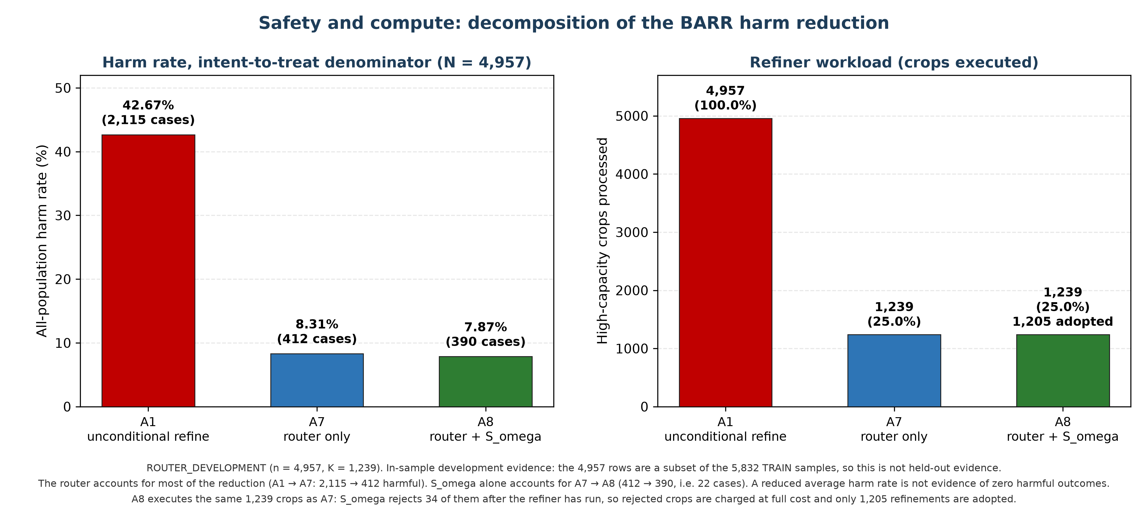
Figure 3. Harm rate on an intent-to-treat denominator (left) and refiner workload (right), decomposed by component. Source: reports/tables/phase28_table_02_arm_primary_metrics.csv. A8 executes the same 1,239 crops as A7, because Sω rejects after the refiner has run; the 34 rejected crops are charged at full cost and 1,205 refinements are adopted.

5. Single-Case Prediction Panels (internal)
The panels in this section were produced by a single forward pass of GlobalMedFiLM (checkpoint SHA-256 286689fd…5ba1b7, 3,523,001 parameters) at 512×512, sigmoid threshold 0.5. Only the global model was loaded for these four internal cases; BARR is executed separately and is reported in Section 6.
Columns are: input image; ground-truth mask; predicted probability map; predicted segmentation overlay; and a pixel error classification map using TP #00E600, FP #FF2020, FN #2060FF and TN #181818. Dice, IoU, precision, recall, specificity and accuracy are computed from the same prediction and the same ground truth shown in that row.
Class-wise segmentation here means foreground versus background under the current binary ontology. The “presentation label” shown in each row is curated analyst metadata. It is not a model output and must not be read as a pixelwise subclass prediction.

5.1 Internal VAL808 cases
Modality | Presentation label (metadata) | Case | Dice | IoU | Prec | Recall | Spec | Acc
ISIC 2018 | Pigmented lesion | ISIC_0013798 | 78.10% | 64.07% | 64.07% | 100.00% | 99.76% | 99.76%
BUSI | Hypoechoic mass | 00170.bmp | 87.25% | 77.38% | 80.43% | 95.33% | 99.87% | 99.85%
Kvasir-SEG | Colorectal polyp | cju1alwgo30z... | 80.00% | 66.67% | 95.94% | 68.61% | 99.73% | 97.09%
KUB-StoneX | Bladder calculus | 00001-00-2500001 | 65.12% | 48.28% | 48.28% | 100.00% | 99.99% | 99.99%
Table 5. Internal single-case metrics. All four cases were confirmed present in manifests/phase4_v3/val.csv and absent from train.csv. Values reproduced independently to two decimal places from the stated checkpoint.
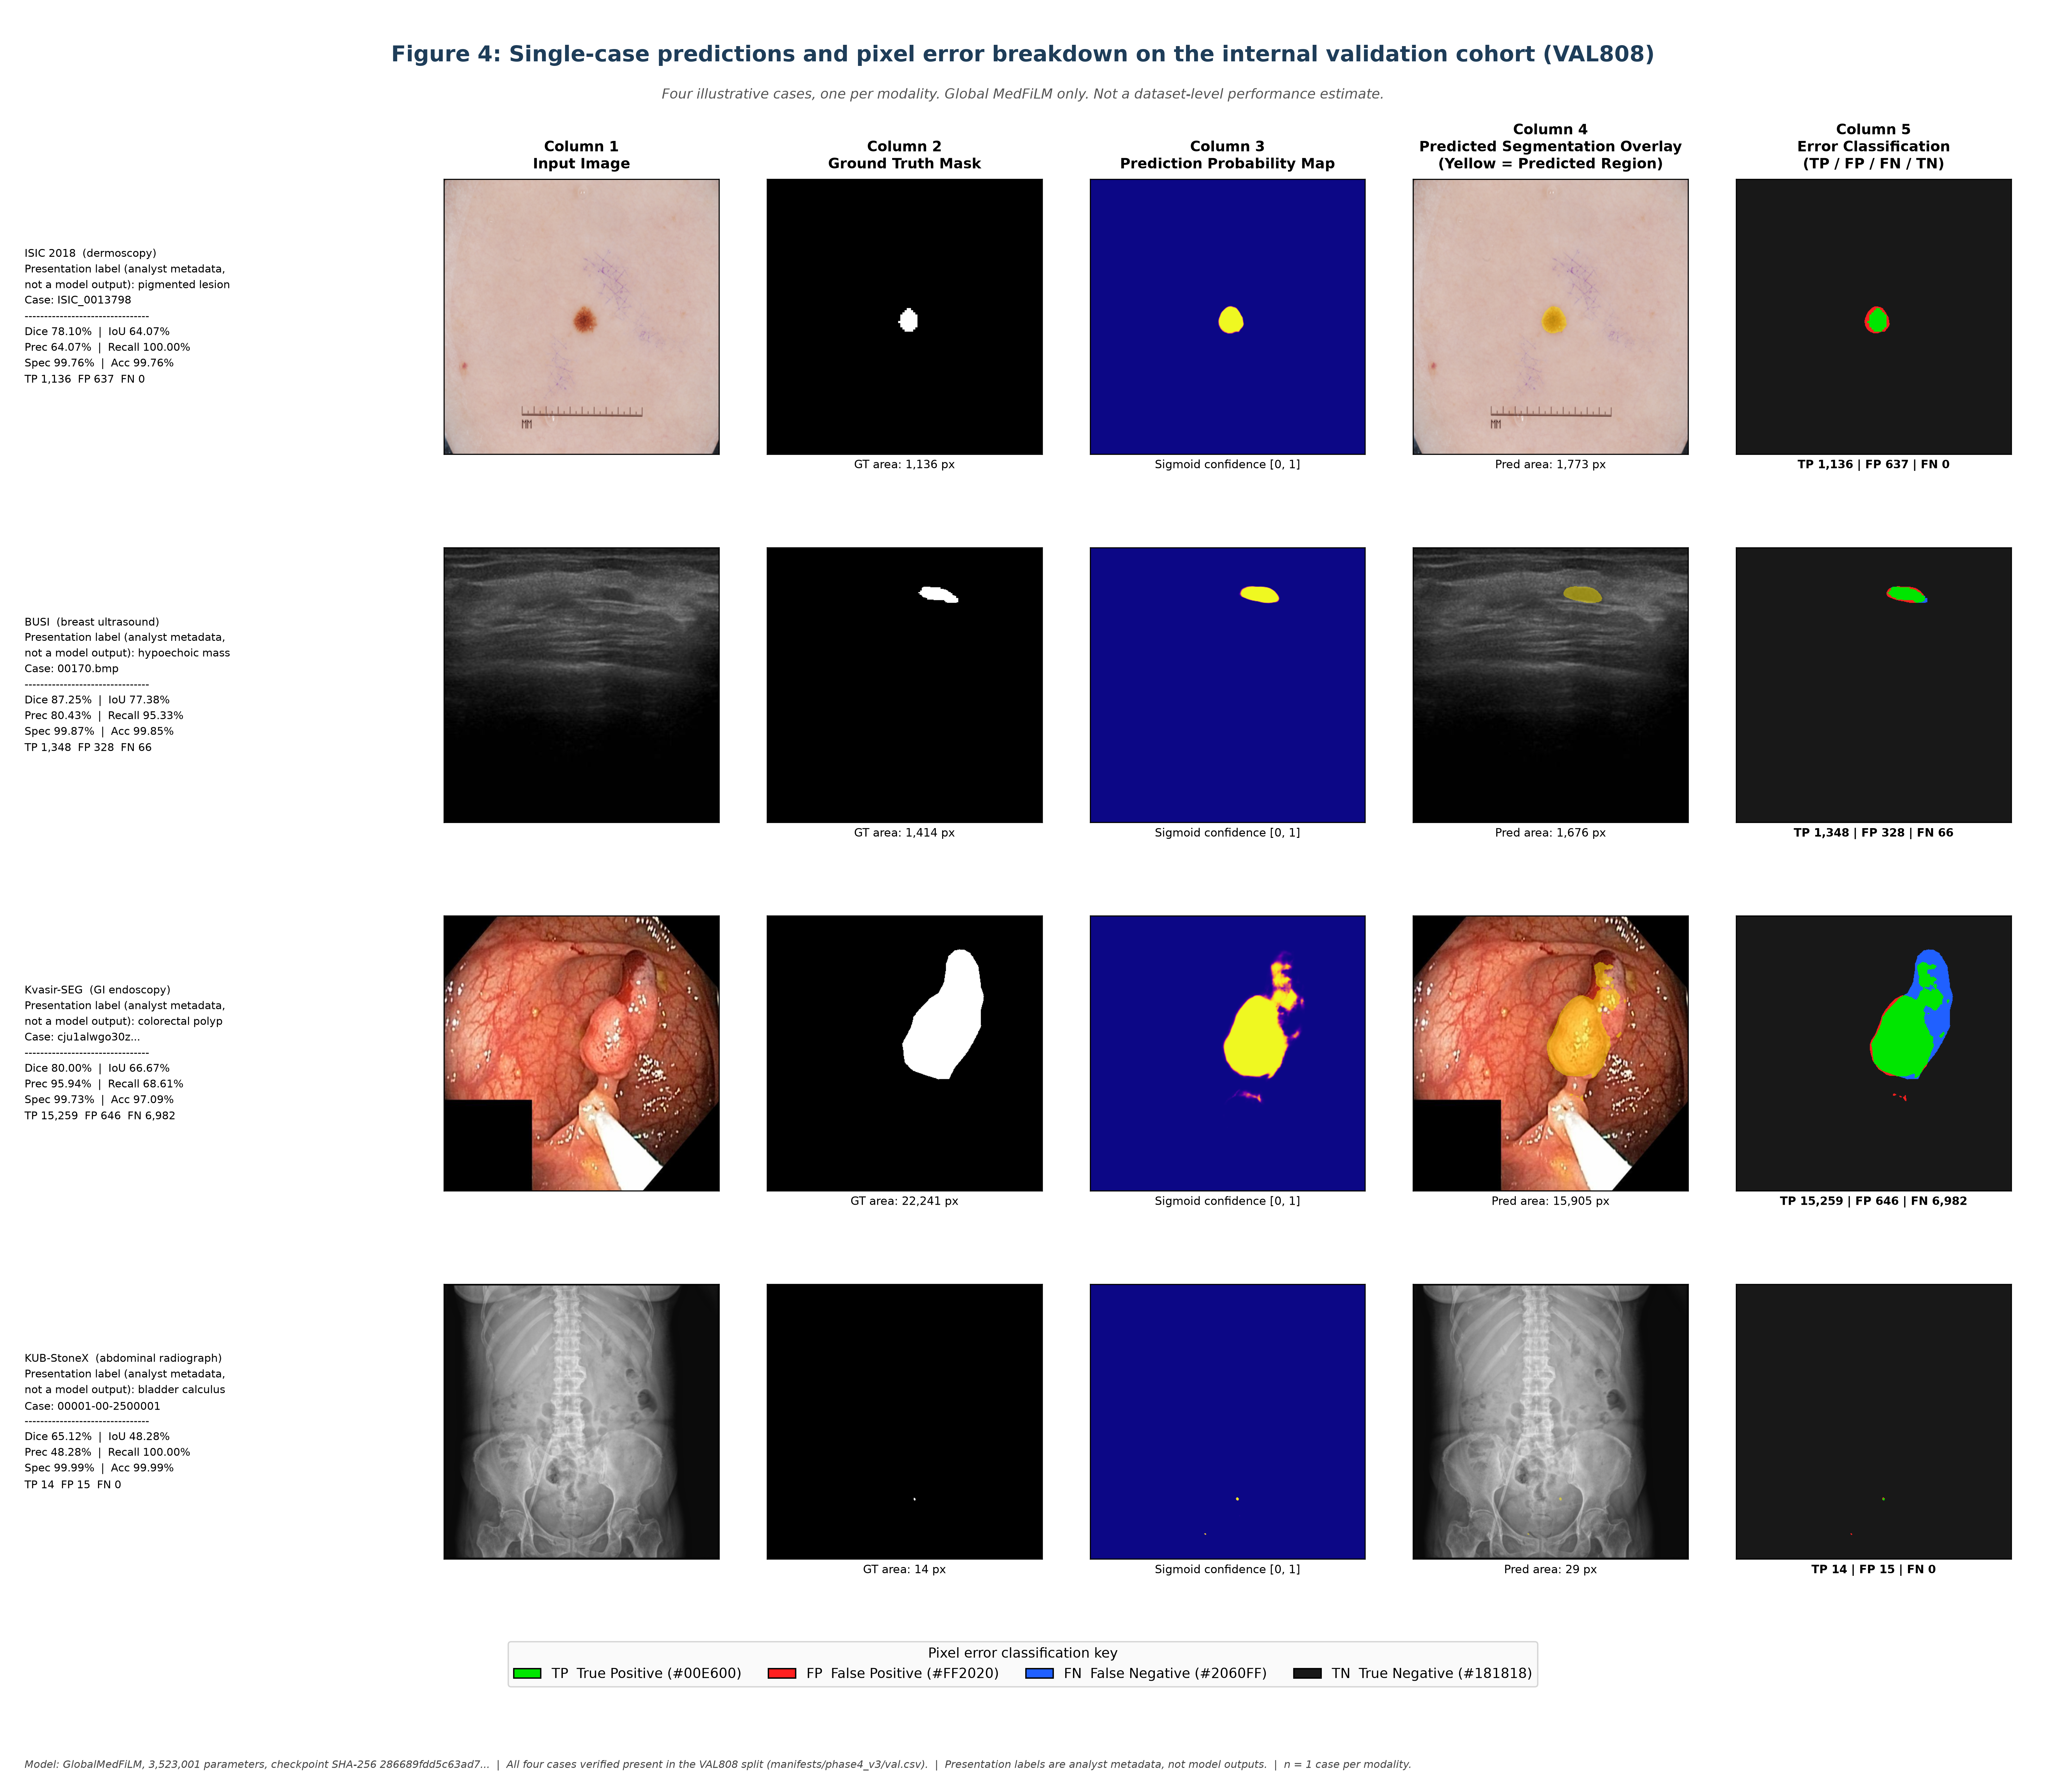
Figure 4. Internal VAL808 single-case panels. n = 1 case per modality; illustrative only.
Note on the KUB case: its ground-truth lesion is 14 pixels. Dice on a 14-pixel object is extremely sensitive to a handful of boundary pixels and should not be read as representative of KUB performance, which is 76.41% macro over 280 VAL808 cases.

6. External Stress Test (n = 884, Global and Regional BARR)
This section replaces the previous external pilot. That pilot ran one hand-picked case per dataset, used a non-canonical resize convention (a plain 512×512 stretch rather than the canonical aspect-preserving pad), and included a HAM10000 row whose mask provenance could not be established. All of those values are retracted (items A, B and C in Section 9). What follows was produced by a frozen, pre-registered design saved before any external prediction existed.
Classification of this evidence
RETROSPECTIVE_EXTERNAL_STRESS_TEST. The cohorts were not prospectively held out; all three were previously inspected while building manifests and an evidence audit. No checkpoint, threshold, seed or preprocessing choice was selected using external performance. These are descriptive observations, not a validation study, and no confirmatory p-value is computed anywhere in this section.

6.1 Cohorts, exclusions and preprocessing
Cohort | Rows in manifest | Analysed | task_id | Domain analogue | Excluded
CVC-ClinicDB | 612 | 612 | 2 | KVASIR | 0
BrEaST-Lesions-USG | 256 | 252 | 1 | BUSI | 4 marked not evaluable; 18 further images have no mask
Stones_where_are_you (test split) | 20 | 20 | 3 | KUB | 0 within the test split
HAM10000 | 10015 | 0 | — | — | EXCLUDED — mask provenance unverified
Table 6. External cohorts. Manifest digests and per-cohort sample-ID digests are recorded in reports/audits/c1_external_stress_v1_0/cohort_construction.json.
Preprocessing is the canonical inference transform used to train and validate the global model: RGB, aspect-preserving bilinear resize with scale = min(512/W, 512/H), centred on a 512×512 canvas with zero padding, divided by 255. Ground truth is put through the same geometry with nearest-neighbour resampling and binarised at > 0. For the Stones COCO export, polygons with category_id 7 (“stone”) are rasterised at native resolution first and only then resized; all nine other categories are background. The threshold is 0.5 everywhere, with no per-cohort tuning, no test-time augmentation and no post-processing.
No row was dropped after seeing a result. A case is kept even when its ground truth or its prediction is empty, because dropping degenerate cases would flatter the model.
BrEaST-Lesions-USG needs one clarification, because its counts do not obviously agree. The folder holds 270 images and 252 tumour masks, so 18 images carry no mask, and they are of two different kinds. Fourteen are additional “_other” views belonging to 7 cases that already contribute a primary image (case022, case036, case038, case085, case092, case140, case151); none of them entered the manifest. Four are primary images with no tumour mask at all — case045, case061, case209 and case213 — and those are the four exclusions. The manifest therefore lists the 256 primary images, of which 252 are analysed, so 270 = 252 analysed + 4 excluded + 14 additional views that were never eligible. Because no case contributes more than one analysed image, 252 is a valid case-level cluster count. It is not a verified patient count: the manifest records no patient identifier, so two case_ids belonging to one patient could neither be detected nor ruled out, and the intervals are described accordingly.

6.2 Global MedFiLM: macro metrics per cohort
Cohort | Dice | 95% CI | IoU | Precision | Recall | Specificity | HD95 (px) | NSD@2
CVC-ClinicDB | 68.66% | [62.65, 74.37] | 57.49% | 67.95% | 81.56% | 96.82% | 109.6 | 0.250
BrEaST-Lesions-USG | 70.78% | [67.68, 73.78] | 59.84% | 73.91% | 75.57% | 98.19% | 74.0 | 0.252
Stones (all 20) | 8.08% | [0.34, 18.99] | 6.09% | 7.48% | 67.33% | 96.83% | 166.9 | 0.228
Table 7. Global MedFiLM, macro mean over cases (equal case weight), threshold 0.50. Intervals are percentile bootstrap resampling clusters: CVC-ClinicDB by sequence (29 clusters), BrEaST-Lesions-USG by case (252 clusters), and Stones by image, where each of the 20 images is its own cluster. The Stones interval is therefore image-level and wide by construction, not a population interval. HD95 and NSD are in PIXELS — no external cohort ships physical pixel spacing, so no millimetre value is reported or implied.
Surface metrics are not comparable across these cohorts: the three datasets have different fields of view and acquisition geometry, and a pixel means something different in each. Only within-cohort comparisons between Global and BARR are meaningful, because those share a canvas.

6.3 Stones must be read as three separate statements
Stones subgroup | n | Global Dice (mean) | What it means
All 20 test images | 20 | 8.08% | Dominated by the 14 images with no stone, each scoring 0
Stone present | 6 | 26.95% | Recall 67.33%, precision 24.93% — lesions are found but grossly over-segmented
Stone absent | 14 | undefined (empty ground truth) | Precision 0.00%: the model produced foreground on 14 of 14 stone-free radiographs
Table 8. Stones stratified by annotation, not by a post-hoc threshold. The 20-image cohort contains 6 images with at least one category-7 annotation and 14 with none.
The single “Stones Dice” of 8.08% is therefore not a segmentation score. It is the arithmetic consequence of scoring 14 empty-ground-truth images as zero plus six very poor segmentations. The substantive finding is case-level, not pixel-level. The global model generated foreground on all 14 stone-absent images, and none of the 14 was predicted empty, so case-level specificity is 0 of 14. Pixel-level true-negative counts nonetheless remain large and nonzero — median 259,214 of 262,144 pixels, minimum 231,793 — because the false-positive regions are small relative to the frame. What fails is the decision to emit any foreground at all on an image that contains no stone, not the per-pixel classification of background. This is a failure of domain transfer, and it is reported as one.

6.4 Regional BARR on the same cases
BARR executed end-to-end from the verified artefacts. All four components hash-matched their frozen bindings before the first forward pass, all state dictionaries loaded with strict=True, and the two equivalent forms of the routing decision agreed on every one of the 884 cases. No case failed and no case fell back to the global mask for lack of an ROI.
Cohort | Selected | Accepted | Rejected | Not attempted | Failed | Global Dice | BARR Dice | Difference
CVC-ClinicDB | 19.28% | 83 | 35 | 494 | 0 | 68.66% | 68.97% | +0.32 pp
BrEaST-Lesions-USG | 22.22% | 47 | 9 | 196 | 0 | 70.78% | 70.81% | +0.03 pp
Stones (all 20) | 50.00% | 9 | 1 | 10 | 0 | 8.08% | 8.21% | +0.13 pp
Table 9. BARR execution outcomes and paired Dice. “Selected” is the fraction of cases the router sent to refinement; “not attempted” cases keep the global mask. Accepted + Rejected + Not attempted + Failed equals n for every cohort.
The same accounting rule applies here, and the execution trace records it directly. Across the 884 cases the router selected 184, and the campaign performed exactly 184 refiner forward passes — equal to accepted (139) plus rejected (45), not to accepted alone. A rejected case has already paid for its regional pass and for the Sω evaluation; only the output is discarded and the global mask restored. Counting 139 refinements as the external compute cost would understate the workload by 45 passes (24.5% of the refinement compute).
Cohort | n | Improved | Unchanged | Worsened | Mean change | Median change | Interquartile range
CVC-ClinicDB | 612 | 67 | 531 | 14 | +0.32 pp | +0.00 pp | +0.00 to +0.00 pp
BrEaST-Lesions-USG | 252 | 27 | 205 | 20 | +0.03 pp | +0.00 pp | +0.00 to +0.00 pp
Stones (all 20) | 20 | 2 | 18 | 0 | +0.13 pp | +0.00 pp | +0.00 to +0.00 pp
Table 10. Per-case paired change in Dice (BARR minus Global). “Unchanged” includes every case the router did not select and every case the safety gate rejected, because those keep the global mask by construction. The median and the quartiles are zero because most cases are unchanged; the mean is the informative column.
The effect is small and positive in all three cohorts, and it is the same order of magnitude as the internal preservation result (+0.28 pp on VAL808). The paired distribution must be described carefully: the median and both quartiles are exactly zero in every cohort, so the interquartile range is [0, 0] and sits on zero rather than straddling it. That is a consequence of construction, not of a symmetric spread — 700 of 884 cases are untouched because the router did not select them or the safety gate rejected them. Among the 184 cases the router did select, 96 improve, 34 worsen and 54 are exactly unchanged, and in BrEaST the number worsened (20) is close to the number improved (27). The mean is the informative column; the quartiles are not.
One property of the router must be stated plainly. Its threshold was calibrated on the internal development population with a fixed 25% budget. On external cohorts the selection fraction is an outcome, not a controlled quantity: 19.28% for CVC, 22.22% for BrEaST and 50% for Stones. The Stones figure in particular reflects that the router scores were near the threshold, not that half of those images deserved refinement. No recalibration was performed, because recalibrating on the test cohort would make the result uninterpretable.

6.5 Domain shift
Cohort | Analogue | Internal VAL808 | External Global | Shift | GT area (median) | Predicted area (median)
CVC-ClinicDB | KVASIR | 82.02% | 68.66% | -13.37 pp | 5.125% | 6.908%
BrEaST-Lesions-USG | BUSI | 85.88% | 70.78% | -15.10 pp | 3.576% | 4.322%
Stones_where_are_you | KUB | 76.41% | 8.08% | -68.32 pp | 0.000% | 0.896%
Table 11. Domain shift. The internal column is the frozen Phase 21 VAL808 per-domain Dice for the same task id; it is a different population and is used only as a shift anchor, never as a like-for-like comparison.
The shift is large and it is not uniform. Endoscopy loses 13.4 pp and breast ultrasound 15.1 pp relative to their internal analogues, while the Stones radiographs lose 68.3 pp. The median predicted area fraction explains the last one: the model covers a far larger share of the canvas than the annotations do, so the failure is over-segmentation rather than a failure to respond.
This is the substantive external result of the study. A model that reaches 83.51% macro-domain Dice on its internal validation split does not carry that performance to external data from the same nominal modalities, and the degradation is severe enough on one cohort to make the model unusable there without domain adaptation. The shift itself is descriptive. Because these cohorts differ from the internal data in population, annotation convention, acquisition protocol and preprocessing all at once, the numbers cannot be attributed to scanner make, hospital site or any single acquisition factor; no such attribution is made.

6.6 Figures: per-cohort panels
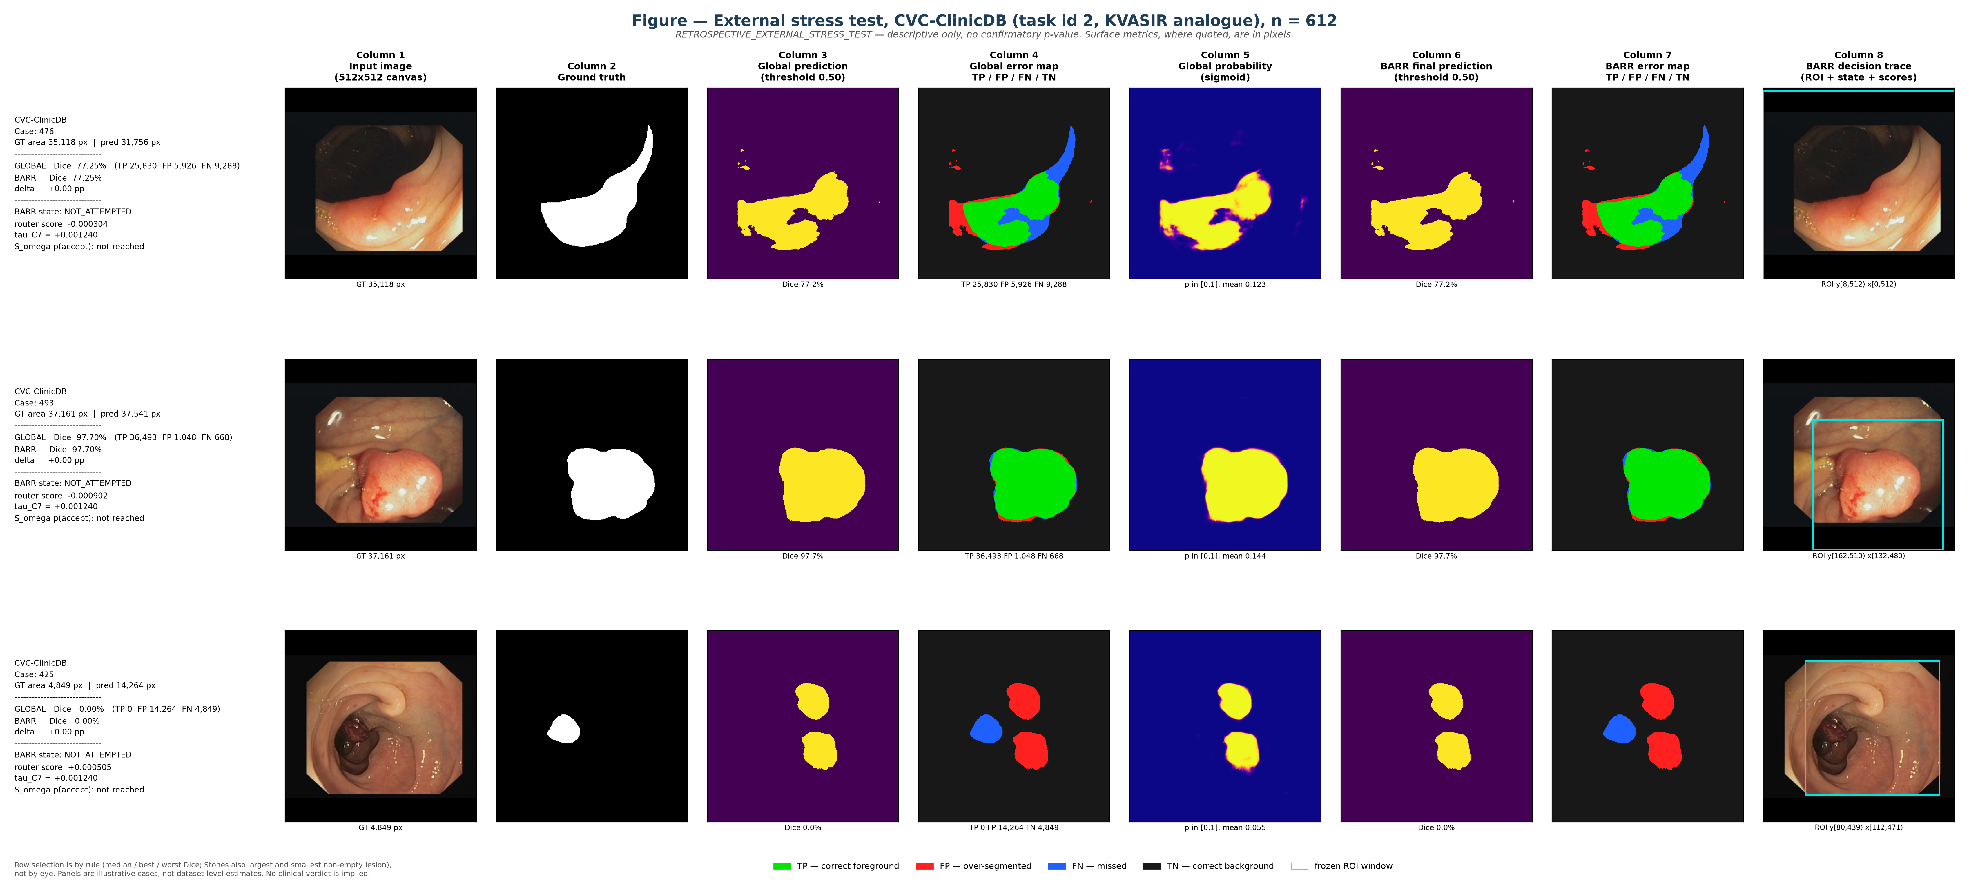
Figure 5. CVC-ClinicDB stress-test panels, 8 columns: input, ground truth, global prediction, global error map, global probability, BARR prediction, BARR error map and BARR decision trace. Rows are the median-, best- and worst-Dice cases, selected by rule. These rows are predominantly NOT_ATTEMPTED, so they are retained as illustrative Global-equals-BARR unchanged examples; the cases where BARR actually acted are in Figures 8 and 9.
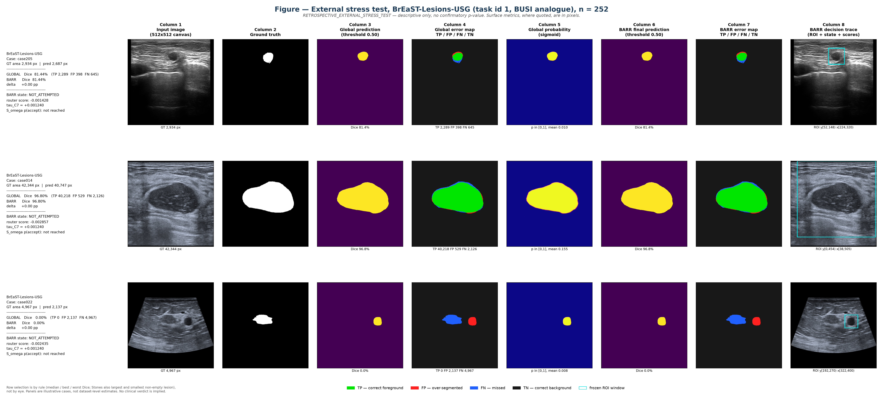
Figure 6. BrEaST-Lesions-USG stress-test panels, same column set and same selection rule. Likewise dominated by NOT_ATTEMPTED cases.
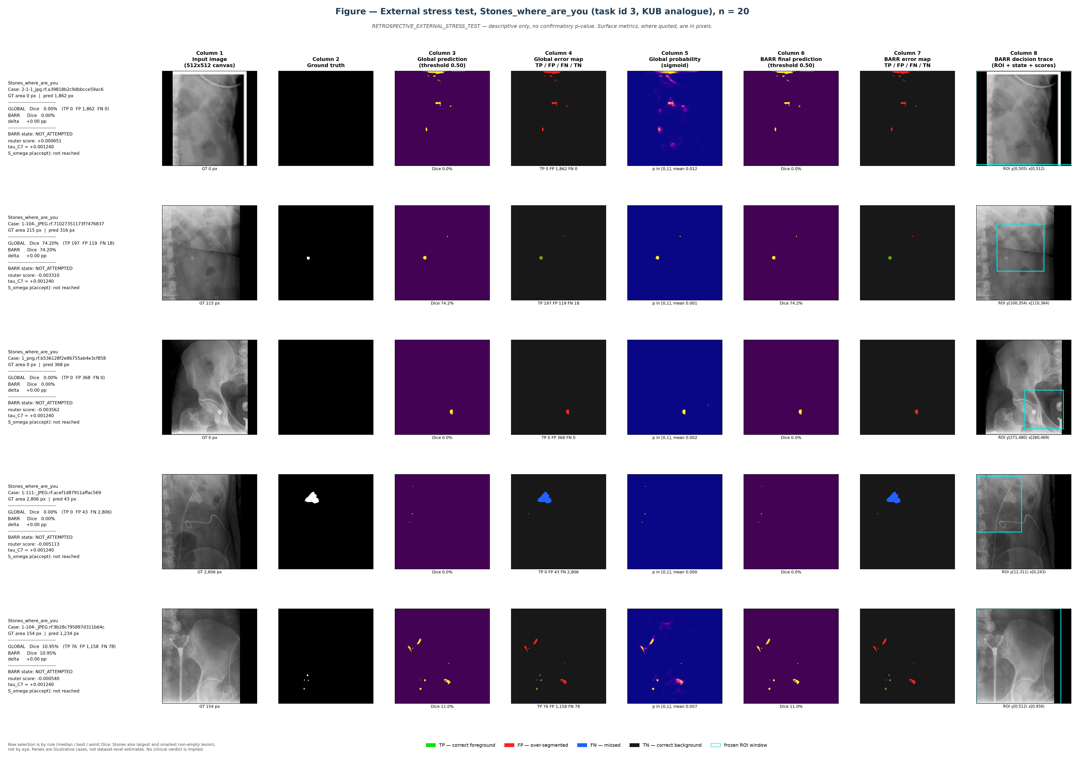
Figure 7. Stones stress-test panels. The cohort-wide median Dice is zero because 14 of 20 cases have an empty ground truth; that row is kept deliberately rather than replaced, because it shows the false-positive behaviour that defines this cohort.

6.7 Figures: what BARR actually did
Figures 5–7 answer “what does the system output” but are dominated by cases the router declined, so they cannot show the refinement mechanism working. Figures 8 and 9 supply that, using four cases selected by explicit rule from the saved records. No case was re-inferred and none was chosen by eye; the rules are printed on the figures and recorded in barr_action_figure.json.
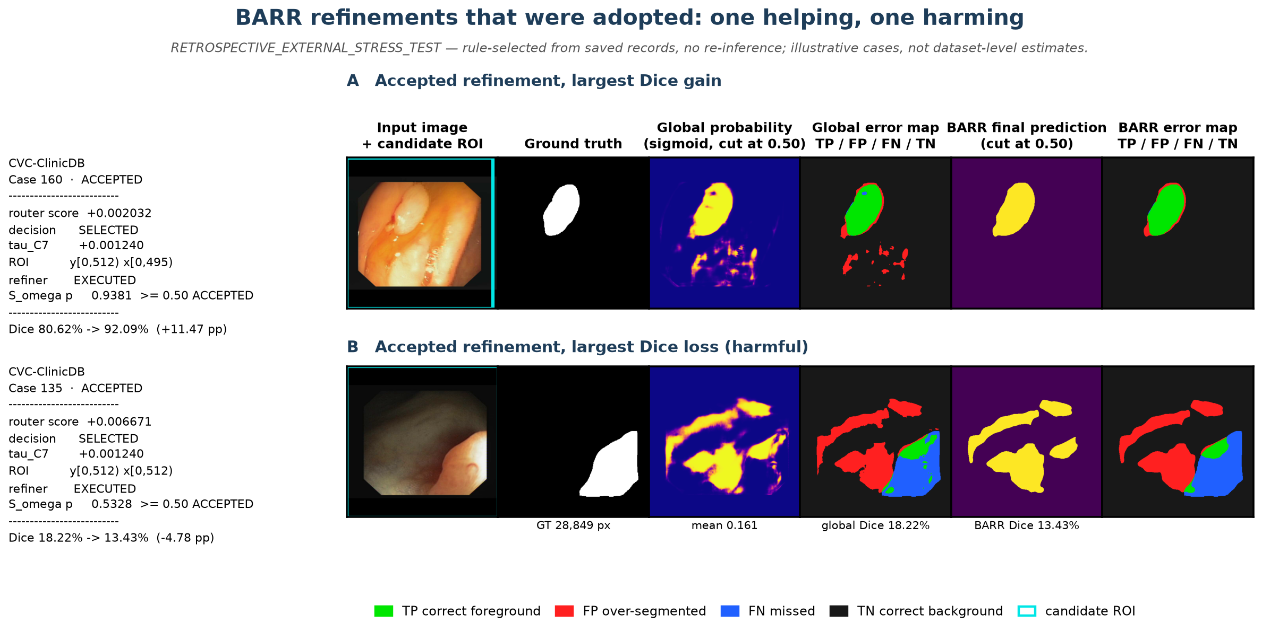
Figure 8. Refinements that were adopted. Row A is the accepted case with the largest Dice gain (CVC::160, 80.62% → 92.09%, +11.47 pp); row B is the accepted case with the largest Dice loss (CVC::135, 18.22% → 13.43%, −4.78 pp). Both executed the refiner and passed the Sω gate. The harm in row B is real: it is the mechanism the router and safety filter exist to bound, and it is not hidden here.
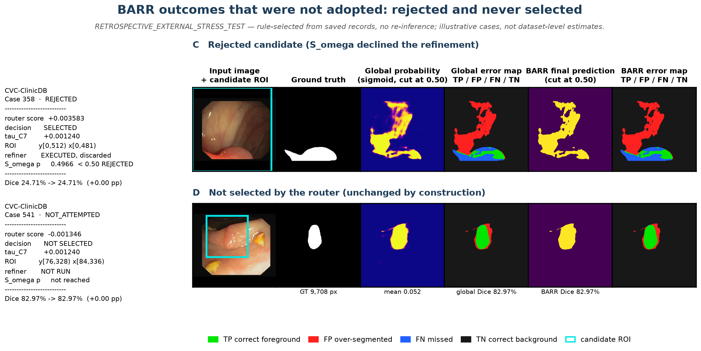
Figure 9. Outcomes that were not adopted. Row C is the most borderline rejection — the rejected case with the highest Sω acceptance probability (CVC::358, p = 0.4966 against a 0.50 threshold) — so its BARR panels necessarily equal the global panels: the refinement was computed and then discarded, and that equality IS the rejection. Row D is a case the router never selected (CVC::541, score −0.001346 below τ_C7), which keeps the global mask by construction.
Across the 884 cases, 139 refinements were adopted and 45 were computed and discarded. The router selected 184 candidates in total, and 184 regional forward passes were executed. Of the 139 adopted refinements, 14 lost Dice on CVC-ClinicDB, 20 on BrEaST-Lesions-USG and 0 on Stones; the Stones cohort has no accepted case with a negative change, so no harmful Stones example exists and none is shown.
The error palette is identical to Figures 1–9: TP #00E600, FP #FF2020, FN #2060FF, TN #181818. In Figures 5–7 the cyan rectangle in column 8 is the frozen ROI window proposed from the predicted probability map at threshold 0.30; in Figures 8–9 it is drawn on the input image. It is geometry, not a model output. Figures 5–7 are 8-column reference panels and are meant to be inspected at full resolution rather than at page width; Figures 8–9 are drawn at print size so that their annotation is readable on the page.

7. Dataset Independence and Mask Provenance
Dataset | Documented source | Independence from training | Verdict
HAM10000 | ISIC-2018 Task 3 training input (classification archive, CC BY-NC 4.0) | Image IDs disjoint from the frozen ISIC set (0 of 10,015 overlap), but patient/lesion grouping is absent from the supplied metadata, so lesion-level independence is not established | PARTIALLY_VERIFIED
CVC-ClinicDB | Public colonoscopy segmentation set; frame_id and sequence_id supplied | No filename or ID overlap with the frozen KVASIR set | VERIFIED (pairing)
BrEaST-Lesions-USG | Public breast ultrasound set, one folder per case | No filename overlap with BUSI; 18 of 270 images have no mask | VERIFIED (pairing, partial)
Stones_where_are_you? v3 | Roboflow, public domain, COCO-segmentation export | No overlap with KUB-StoneX; 6 of 20 test images contain a stone annotation | VERIFIED (identity and mapping)
Table 12. External dataset provenance. Frozen-split comparison used manifests/phase4_v3/{train,val,all_paired}.csv only; no protected pixels were opened.
HAM10000 is excluded from this study
The HAM10000 folder is the ISIC-2018 Task 3 archive, which contains classification labels and no segmentation masks. The 10,015 masks present in the folder therefore come from an undocumented source. Rather than score the model against an unattributable mask, HAM10000 was excluded before any inference was run. The previously reported 79.15% Dice is retracted (item B, Section 9) and must not be cited anywhere.

Dataset-level independence is not established for any external cohort. The project’s own Phase 32 audit concluded that no prospective clean external cohort is eligible. The 884-case study in Section 6 is a retrospective stress test: it measures how the frozen model behaves on data it was not trained on, and it does not establish generalisation because the cohorts were not held out prospectively and were previously inspected.

8. Statistical Limitations and Comparability
- No confirmatory significance testing is available. Phase 31 recorded zero new p-values, zero new effect sizes and zero eligible confirmatory procedures. No p-value appears anywhere in this report.
- VAL808 (n = 808) was consumed for model selection and early stopping, so all VAL808 numbers are development estimates.
- ROUTER_HOLDOUT (n = 875) was evaluated once and carries a disclosed post-first-open source-freeze deviation. It is not an independent external cohort.
- The Phase 21 six-model comparison and the BARR results come from different runs. Cross-run comparison is descriptive only; no controlled head-to-head between BARR and the baselines exists.
- Per-domain CIs for BUSI and KVASIR include zero, so those domains show no measurable difference.
- The external study is retrospective, not prospective. All three cohorts were previously inspected while building manifests and an evidence audit, and 8 hand-picked single cases had already been run under a different resize convention. No threshold, checkpoint or seed was chosen on external performance, but the cohorts are not a clean holdout.
- External uncertainty is a percentile bootstrap over clusters, described as such. It is not a confidence interval in a confirmatory sense, and no multiplicity correction is applied because no family of hypotheses is tested.
- Surface metrics on external data are in pixels. No cohort ships physical pixel spacing, so HD95, ASSD and NSD cannot be converted to millimetres and cannot be compared across cohorts.
- The Stones cohort is n = 20 with 6 positive cases. Its 95% interval (8.08% [0.34, 18.99]) is a percentile bootstrap over the 20 images with each image as its own cluster. It is therefore an image-level descriptive interval and not a population interval, and at this sample size it is too wide to support a subgroup comparison. Point estimates and counts are reported alongside it.
- The BARR router threshold was calibrated on the internal development population. Its external selection fraction is an outcome of that fixed threshold, not a controlled property of the cohort.
- TEST (n = 1,683) remains locked and was not accessed for any value in this report.

9. Corrections and Retractions Relative to the October 30 Build
Items A–L below are the corrections applied to this build. A–D and H change what the report asserts about external data; E–G change how those assertions are framed and bounded; I–L correct a statistical contradiction, a distribution description and the compute accounting.
# | Statement in the previous build | Status | Correction
A | External section presented an n = 1 per-dataset pilot, Table 6 | SUPERSEDED | Replaced by the 884-case retrospective stress test in Section 6, produced by a design frozen before any external prediction existed.
B | HAM10000 Dice 79.15% | RETRACTED | HAM10000 excluded: the folder is the ISIC-2018 Task 3 classification release with no documented masks. No HAM10000 inference was run.
C | Figure 5 caption: "No BARR decision is shown because none was executed" | FALSE IN THIS BUILD | BARR has now been executed end-to-end on all 884 cases from verified artefacts. Figures 5–7 show the BARR prediction, BARR error map and decision trace; Figures 8–9 show four cases where the mechanism actually acted or was declined.
D | "BARR Sω caught / rejected" external cases: no decision record exists | SUPERSEDED | A decision record now exists for every external case: 83 accepted and 35 rejected on CVC, 47 and 9 on BrEaST, 9 and 1 on Stones. These are counts, not a safety claim.
E | "The external material is a pilot, not a validation" | REFINED | Still not a validation, and now stated with the correct reason: the study is a retrospective stress test with no prospective holdout.
F | No quantification of domain shift | FILLED | Section 6.5 quantifies the shift against the internal VAL808 per-domain anchors: −13.4 pp (CVC), −15.1 pp (BrEaST), −68.3 pp (Stones).
G | External numbers reported without a stated aggregation mode | CORRECTED | Every external number now states macro-over-cases aggregation, its interval scheme, and that surface metrics are in pixels.
H | "No external validation exists" | SUPERSEDED | External measurement now exists and is reported with its limits. The claim that no external *validation* exists is retained, because none does.
I | Table 7 reported a Stones 95% interval while the limitations said the cohort "carries no interval estimate" | CONTRADICTION RESOLVED | The interval exists and is reproducible: a percentile bootstrap over 20 images with each image as its own cluster. It is labelled as an image-level descriptive interval and not a population interval; the limitations text now says so instead of denying the estimate.
J | Paired change "interquartile range straddling zero" | CORRECTED | The interquartile range is exactly [0, 0] in all three cohorts and sits on zero, because 700 of 884 cases are untouched by construction. Straddling was the wrong description; the mean is the informative statistic and the quartiles are not.
K | "24.3% of the unconditional refiner workload" | CORRECTED | The refiner workload is 1,239 of 4,957 (25.0%). A8 routes the same 1,239 candidates as A7, executes all of them, and adopts 1,205; the stored A8 field n_routed = 1,205 is an adoption count, and reading it as compute understates the workload by 34 forward passes.
L | External deltas described as showing preservation "transfers" | REFINED | The external deltas (+0.32, +0.03, +0.13 pp) are descriptive. The external study has no pre-specified margin and no eligible confirmatory paired procedure, so it cannot establish non-inferiority; the supportable claim is that macro Dice is not materially degraded.
Table 13. Correction and retraction register for this build. Items A–H were applied in the first correction pass; I–L in the final statistical and compute pass. External evidence trail in reports/audits/c1_external_stress_v1_0/; earlier trail in reports/audits/c1_external_evidence_v1_0/.
The register below is carried forward unchanged from the October 30 correction pass. Those retractions remain in force; nothing in this build reinstates any of them.
Statement in the previous build | Status | Correction
Regional BARR macro Dice 86.24% | UNSUPPORTED | No stored record contains this value. Replaced by 83.79% on VAL808 (3-seed mean) and 93.03% on ROUTER_HOLDOUT, each with its population label.
BARR parameters 4.80M | UNSUPPORTED | Correct value 4,837,420 (4.84M) from the Phase 34 record.
Deltas marked "p<0.001" / "p<0.01" / "Significant" | UNSUPPORTED | No p-value was ever computed. Removed; deltas are descriptive with 95% bootstrap CIs.
"Sω eliminates 1,725 harmed cases" | MISATTRIBUTED | 1,725 = A1→A8 system-level reduction. Sω alone accounts for 412→390 = 22 cases.
"BARR lifts TINY from 53.21% to 85.57%" | UNSUPPORTED | No BARR per-stratum measurement exists. 53.21% is the Global MedFiLM TINY stratum value. Removed.
"Independent external multi-center datasets" | OVERSTATED | Dataset-level independence is not established for any cohort; see Section 7.
BARR KUB Dice 85.57% and IoU 77.85% | UNSUPPORTED | These are the ROUTER_HOLDOUT KUB value and an unrecorded IoU. Removed from the VAL808 table.
Table 14. Retraction register carried forward from the October 30 build.

10. Trust Boundary Status
The C1 launch release is frozen at RC3 (digest 54d1273a…3549f) and is unmodified by this report. The production trust root was found to contain agent-generated signing material, and the RC3 gate currently refuses its own release digest because it delegates identity verification to RC2. Consequently no scientific execution is authorised, no production grant has been minted, and no dataset has been opened through a production launch. The trust store is excluded from scientific use pending accountable human review. This report does not create a trust policy, sign any approval, or constitute an authorisation.

11. What the Evidence Does Support
Defensible summary
1. Global MedFiLM reaches 83.51% macro-domain Dice on VAL808 (n = 808) with 3.52M parameters, ranking first of six under a single shared protocol. Its interval overlaps that of DeepLabV3+, so this evidence does not resolve the difference between the two; overlap is not evidence that they are equivalent.
2. Regional BARR preserves macro Dice relative to Global MedFiLM: +0.28 pp on VAL808 (three-seed mean) and +0.17 pp on the one-shot ROUTER_HOLDOUT, within a −0.5 pp non-inferiority margin. This is a preservation result, not an improvement claim.
3. On in-sample development data the router removes most harmful refinements and the post-safety filter removes a further 22 cases. The refiner workload is 1,239 of 4,957 cases (25.0%), because all 1,239 routed candidates execute a regional forward pass and only 1,205 of those refinements are adopted.
4. On 884 external cases the frozen system runs end-to-end without error, and BARR changes the per-case Dice by a median of 0.00 pp in every cohort, with a macro change of +0.32 pp (CVC), +0.03 pp (BrEaST) and +0.13 pp (Stones). These external deltas are descriptive. The external study has no pre-specified non-inferiority margin and no eligible confirmatory paired procedure, so it cannot establish non-inferiority: a mean delta of this size is consistent with no material change, which is not the same as demonstrating preservation. What the external data support is narrower — the frozen system does not materially degrade macro Dice on these cohorts.
5. External performance is far below internal performance: -13.4 pp on CVC-ClinicDB, -15.1 pp on BrEaST-Lesions-USG and -68.3 pp on Stones relative to the internal VAL808 anchors. On the Stones cohort the model marked foreground on 14 of 14 stone-free radiographs.
6. No external *validation* exists. The 884-case study is a retrospective stress test, and its cohorts were previously inspected, so it bounds failure modes rather than estimating generalisation.

Report date: October 31, 2026 | RA-MedFiLM-BARR Scientific Investigation Team

