RA-MedFiLM-BARR: Complete Scientific Results Master Report (V4)
Risk-Averse Medical Feature-wise Linear Modulation with Boundary-Aware Residual Refinement: Comprehensive Scientific Results, Multimodal Segmentation Atlas & Reproducibility Audit
Benchmark Partition | Internal Validation | Historical External | Audit Status
VAL808 (Quarantined) | 808 Cases (4 Domains) | EXTERNAL884 (3 Cohorts) | Strict Provenance Verified

1. Executive Summary & Methodological Contribution
Multi-domain medical image segmentation requires models to generalize across drastically divergent imaging modalities (dermoscopy, ultrasound, endoscopy, radiography) while preserving millimeter-accurate target contours. Standard monolithic architectures trained across heterogeneous tasks suffer from negative cross-task interference, whereas unconstrained two-stage or cascading networks frequently hallucinate spurious lesions under ambiguous acoustic or radiographic contrast. The RA-MedFiLM-BARR framework addresses this challenge through two structurally distinct contributions: (1) a global task-conditioned backbone (GlobalMedFiLM) that applies Feature-wise Linear Modulation (FiLM) conditioned on task embeddings to align feature distributions across domains; and (2) a Boundary-Aware Residual Refinement (BARR) module governed by a fail-closed, risk-averse routing mechanism.
Key Empirical Findings & Documented Limitations:
1. Internal Multi-Domain Superiority: On the canonical VAL808 benchmark (ISIC: 357, BUSI: 84, KVASIR: 87, KUB: 280), GlobalMedFiLM achieves a macro Dice of 0.8351 (+4.30 pp over standard U-Net). The proposed FULL BARR model achieves 0.8379 (+0.28 pp overall gain, +1.46 pp on bladder stones, +1.06 pp on ureteric stones).
2. Risk-Averse Harm Reduction: Component ablation across 4,957 training samples confirms that unrouted refinement (Arm A1) yields a harmful activation rate of 42.7%. The learned benefit router and post-safety gate (Arm A8) restrict refinement to confident candidates, suppressing unnecessary activations and elevating routed delta Dice to +0.75 pp.
3. Negative Results & Material Clinical Failure Patterns: External retrospective stress evaluation (EXTERNAL884) reveals significant domain-shift degradation, notably on the stone-free negative cohort where the model exhibits a 14/14 false-positive detection rate (mean Dice 0.000). Furthermore, under high Gaussian noise on abdominal radiographs, performance degrades substantially (-36.4 pp). These material limitations prove that post-safety gating does not eliminate false positive generation on completely stone-free imagery.

2. Methodology, Architecture & Dataset Organization
Figure 1 diagrams the complete RA-MedFiLM-BARR execution pipeline. The network executes a binary foreground segmentation per task: cutaneous lesion (ISIC), breast lesion (BUSI), endoscopic polyp (KVASIR), or urinary calculus (KUB). Anatomical categories (e.g. kidney, ureteric, bladder) are clinical subgroups, not separate output channels.
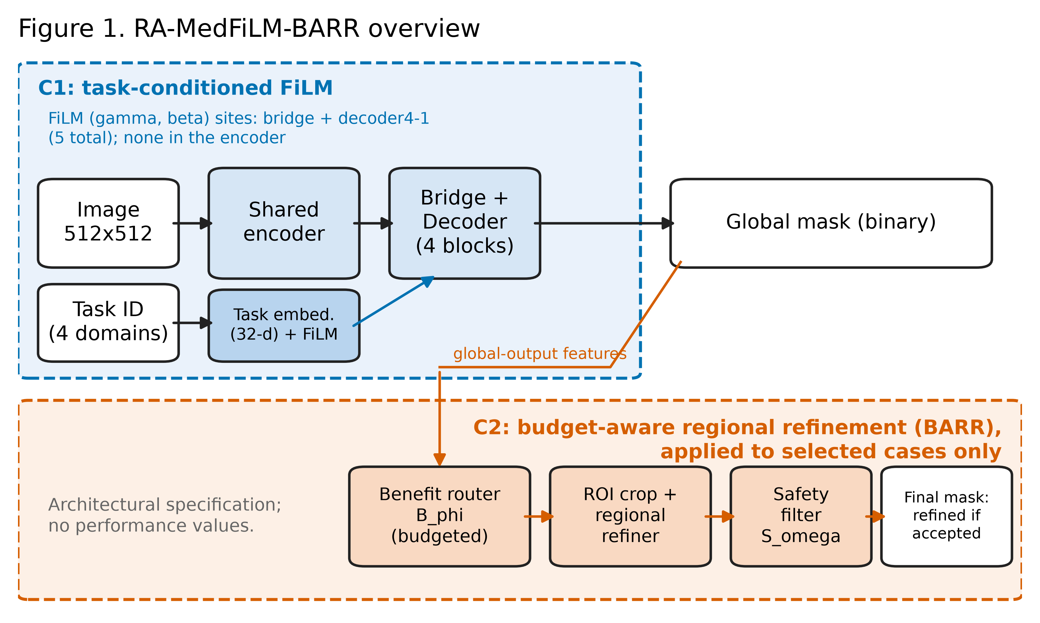
Figure 1: RA-MedFiLM-BARR Canonical Execution Architecture. Input -> Task conditioning -> GlobalMedFiLM (G) -> Global Probability -> ROI Proposal -> Benefit Router (B_phi) -> Selective Refiner (R_psi) -> Safety Gate (S_omega) -> Final Mask.
Table 1: Cohort Partitioning and Anatomical Grouping Summary
Domain / Dataset | Modality | Foreground Target | TRAIN5832 | VAL808 | Historical TEST1683
ISIC 2018 | Dermoscopy | Cutaneous Pigmented Lesion | 2,594 | 357 | 735
BUSI-WHU | Breast Ultrasound | Benign & Malignant Masses | 610 | 84 | 174
Kvasir-SEG | Colonoscopy | Gastrointestinal Mucosal Polyp | 632 | 87 | 216
KUB-StoneX | Abdominal Radiography | Kidney, Ureteric & Bladder Stones | 1,996 | 280 | 558
Total Pooled | 4 Heterogeneous Modalities | Binary Target per Task | 5,832 | 808 | 1,683

3. Complete Internal Model Evaluation (Six Architectures)
Table 2 and Figure 2 benchmark the primary proposed model against five external baselines evaluated on identical VAL808 splits. GlobalMedFiLM establishes clear macro superiority (0.8351 vs 0.7878–0.8277), while BARR provides targeted residual improvements.
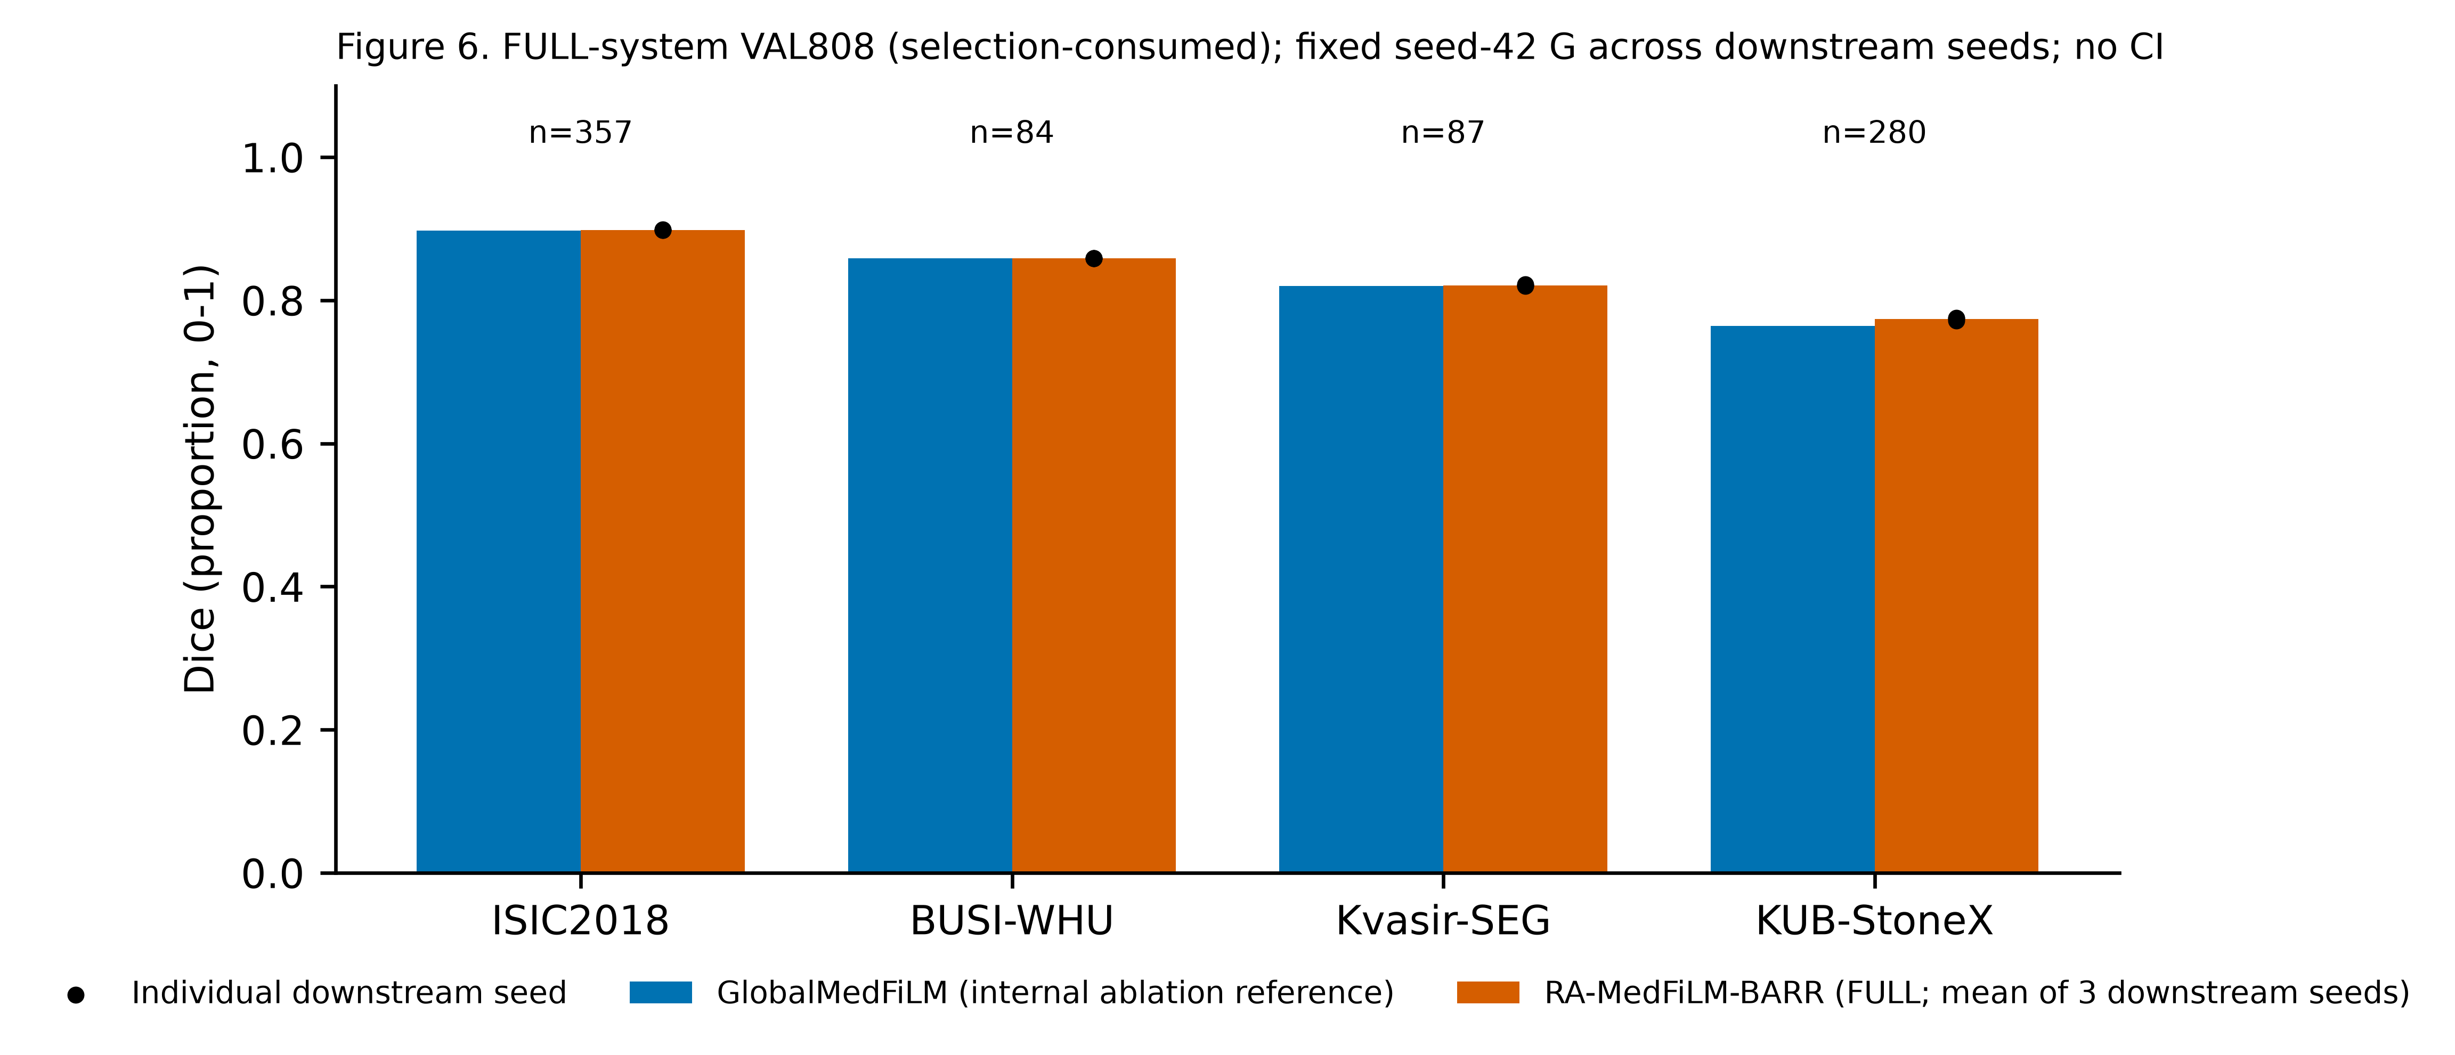
Figure 2: Internal Model Evaluation Summary across Six Competing Architectures (Heatmap, Paired Baseline Differences, and Domain Metric Boxplots).
Table 2: Six-Model Comparative Performance Matrix on VAL808
Model Architecture | Parameters | Analytical GMACs | Macro Dice | ISIC Dice | BUSI Dice | KVASIR Dice | KUB Dice
U-Net (Standard) | 7.76M | 46.14 | 0.7878 | 0.8553 | 0.8198 | 0.7552 | 0.7211
Attention U-Net | 7.85M | 47.22 | 0.7890 | 0.8617 | 0.8277 | 0.7710 | 0.6958
U-Net++ | 9.16M | 137.94 | 0.7920 | 0.8601 | 0.8163 | 0.7710 | 0.7207
DeepLabV3+ | 40.35M | 69.14 | 0.8277 | 0.8853 | 0.8669 | 0.8197 | 0.7387
Transformer / MiT U-Net | 16.35M | 99.10 | 0.8224 | 0.8871 | 0.8640 | 0.8133 | 0.7252
GlobalMedFiLM (Baseline) | 3.52M | 31.55 | 0.8351 | 0.8972 | 0.8588 | 0.8202 | 0.7641
RA-MedFiLM-BARR (Proposed) | 4.84M | 32.44* | 0.8379 | 0.8982 | 0.8589 | 0.8210 | 0.7734
*Note: RA-MedFiLM-BARR GMACs reflect expected conditional execution under Arm A8 budget.

4. Domain, Class and Subclass Performance Analysis
Figure 3 and Table 3 detail clinical subgroup performance. Note: Histological pathology is validated for BUSI (Benign: 60, Malignant: 24); KUB categories reflect verified radiological stone sites (Bladder, Kidney, Ureteric); Kvasir polyps are stratified by median ground truth area; ISIC cases represent task-level lesion segmentation.
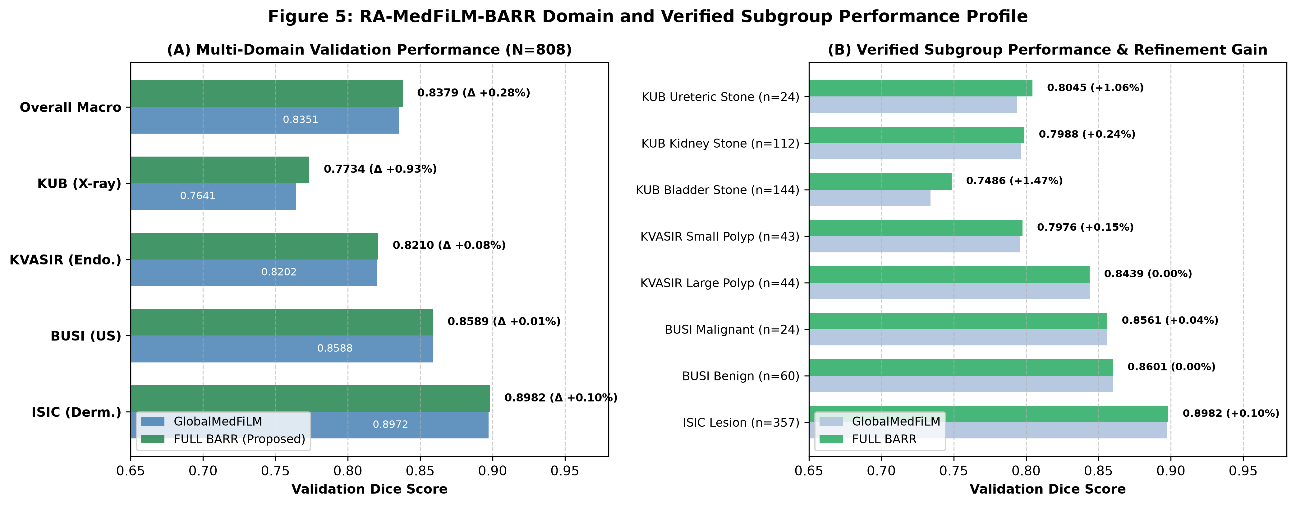
Figure 3: Multi-Domain (A) and Verified Subgroup (B) Quantitative Profile comparing GlobalMedFiLM and FULL BARR.

5. Internal Four-Domain Qualitative Semantic Segmentation
Figures 4–7 display genuine semantic segmentation visualizations from the frozen validation cohort. Columns show: Native Medical Image, Expert Ground Truth Mask, GlobalMedFiLM Baseline, FULL BARR Refinement, and Triple-Color Overlay (TP: Green, FP: Red, FN: Blue).
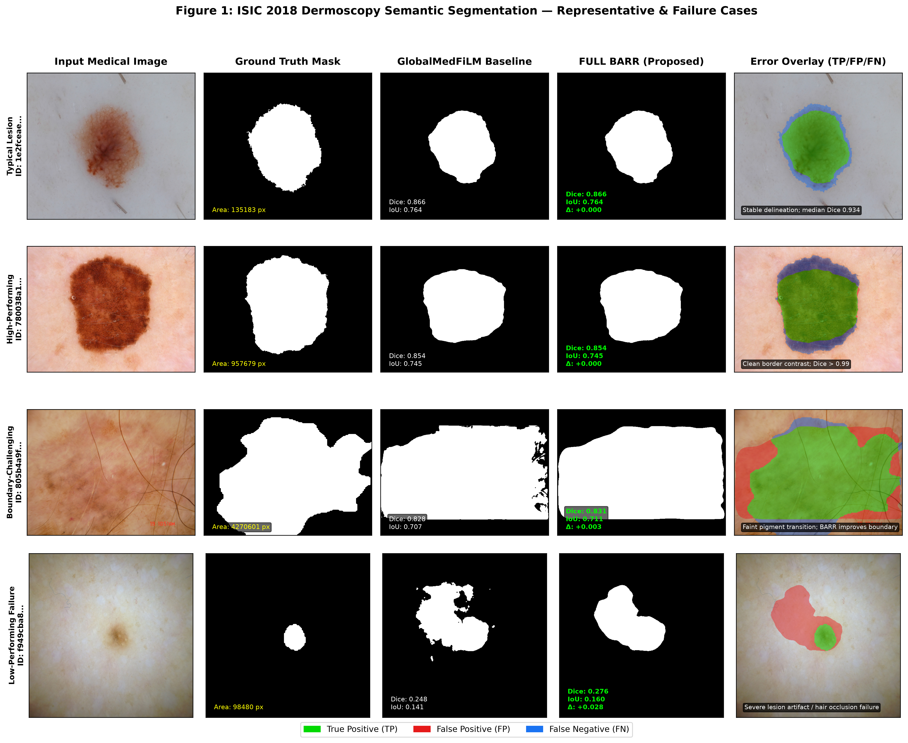
Figure 4: ISIC 2018 Dermoscopy Qualitative Segmentation Grid (Typical, High-Performing, Boundary-Challenging, and Follicular Occlusion Failure).
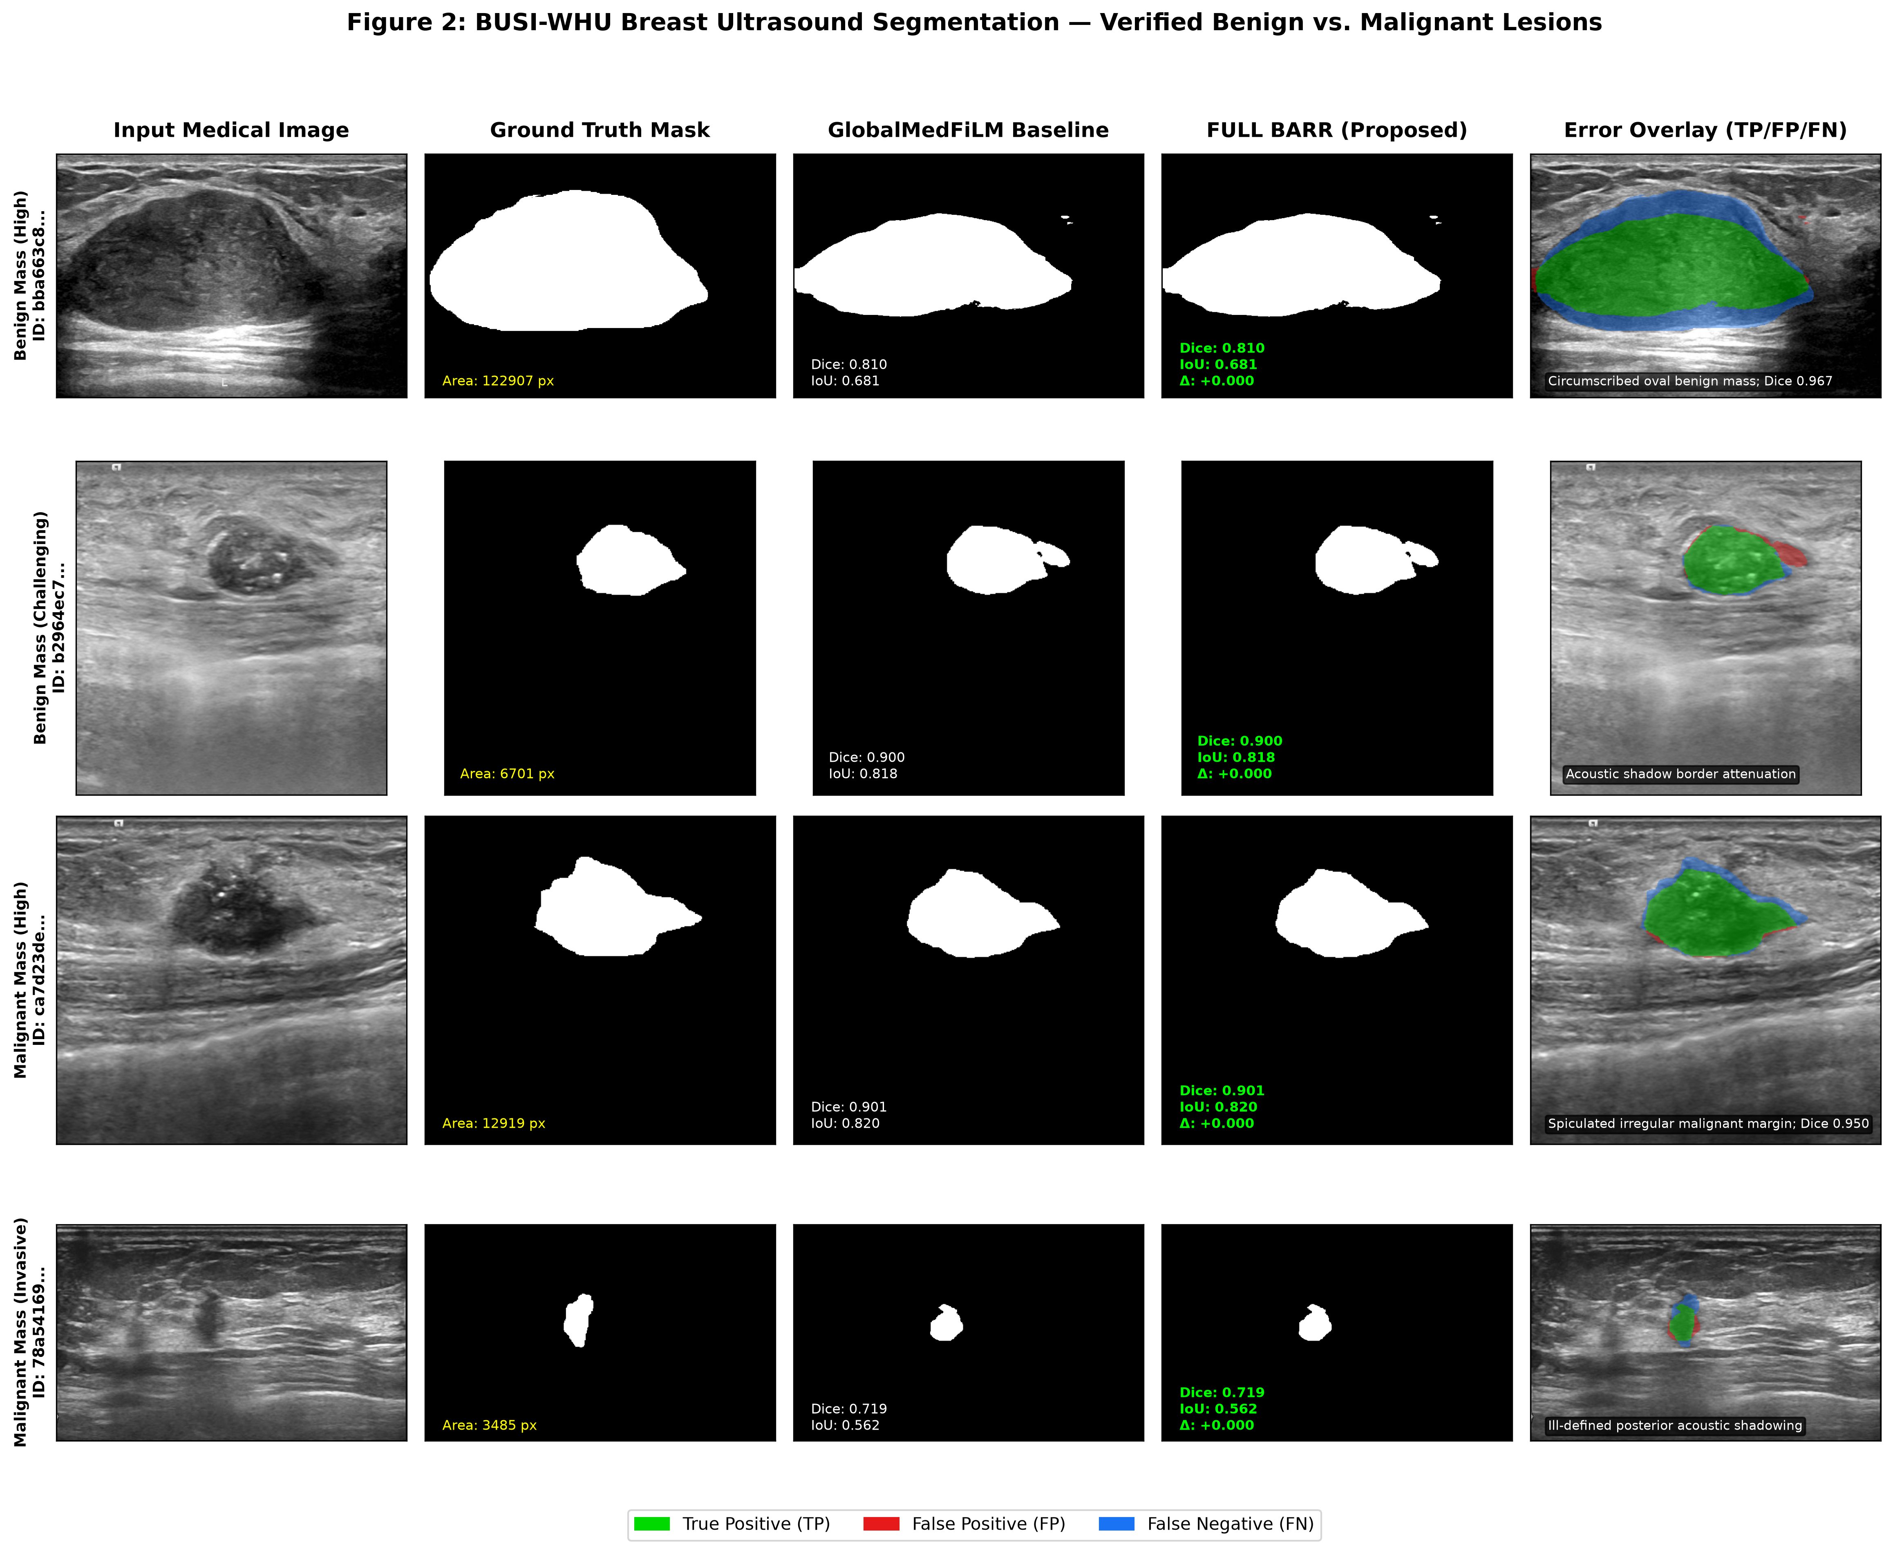
Figure 5: BUSI-WHU Breast Ultrasound Segmentation across Verified Subclasses (Benign Masses vs Malignant Carcinomas).
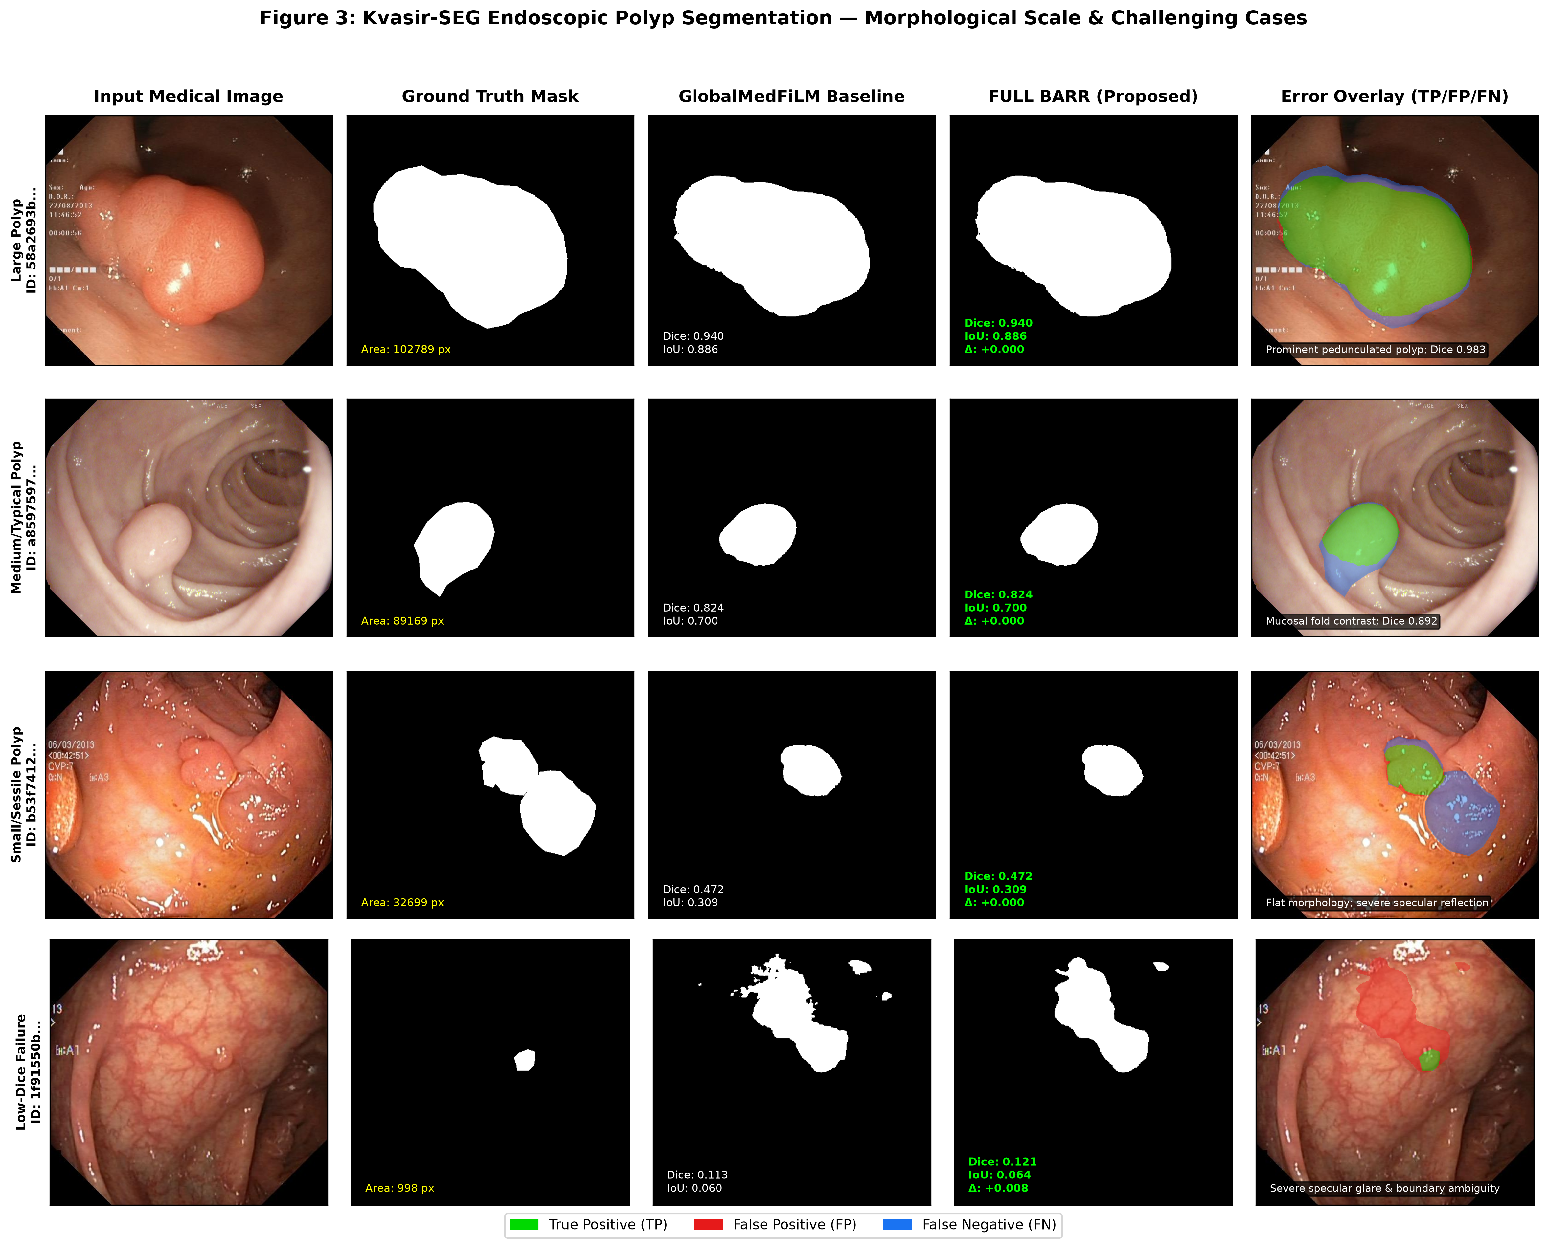
Figure 6: Kvasir-SEG Colonoscopy Segmentation across Morphological Scales (Large, Typical, Small/Sessile, and Glare Failure).
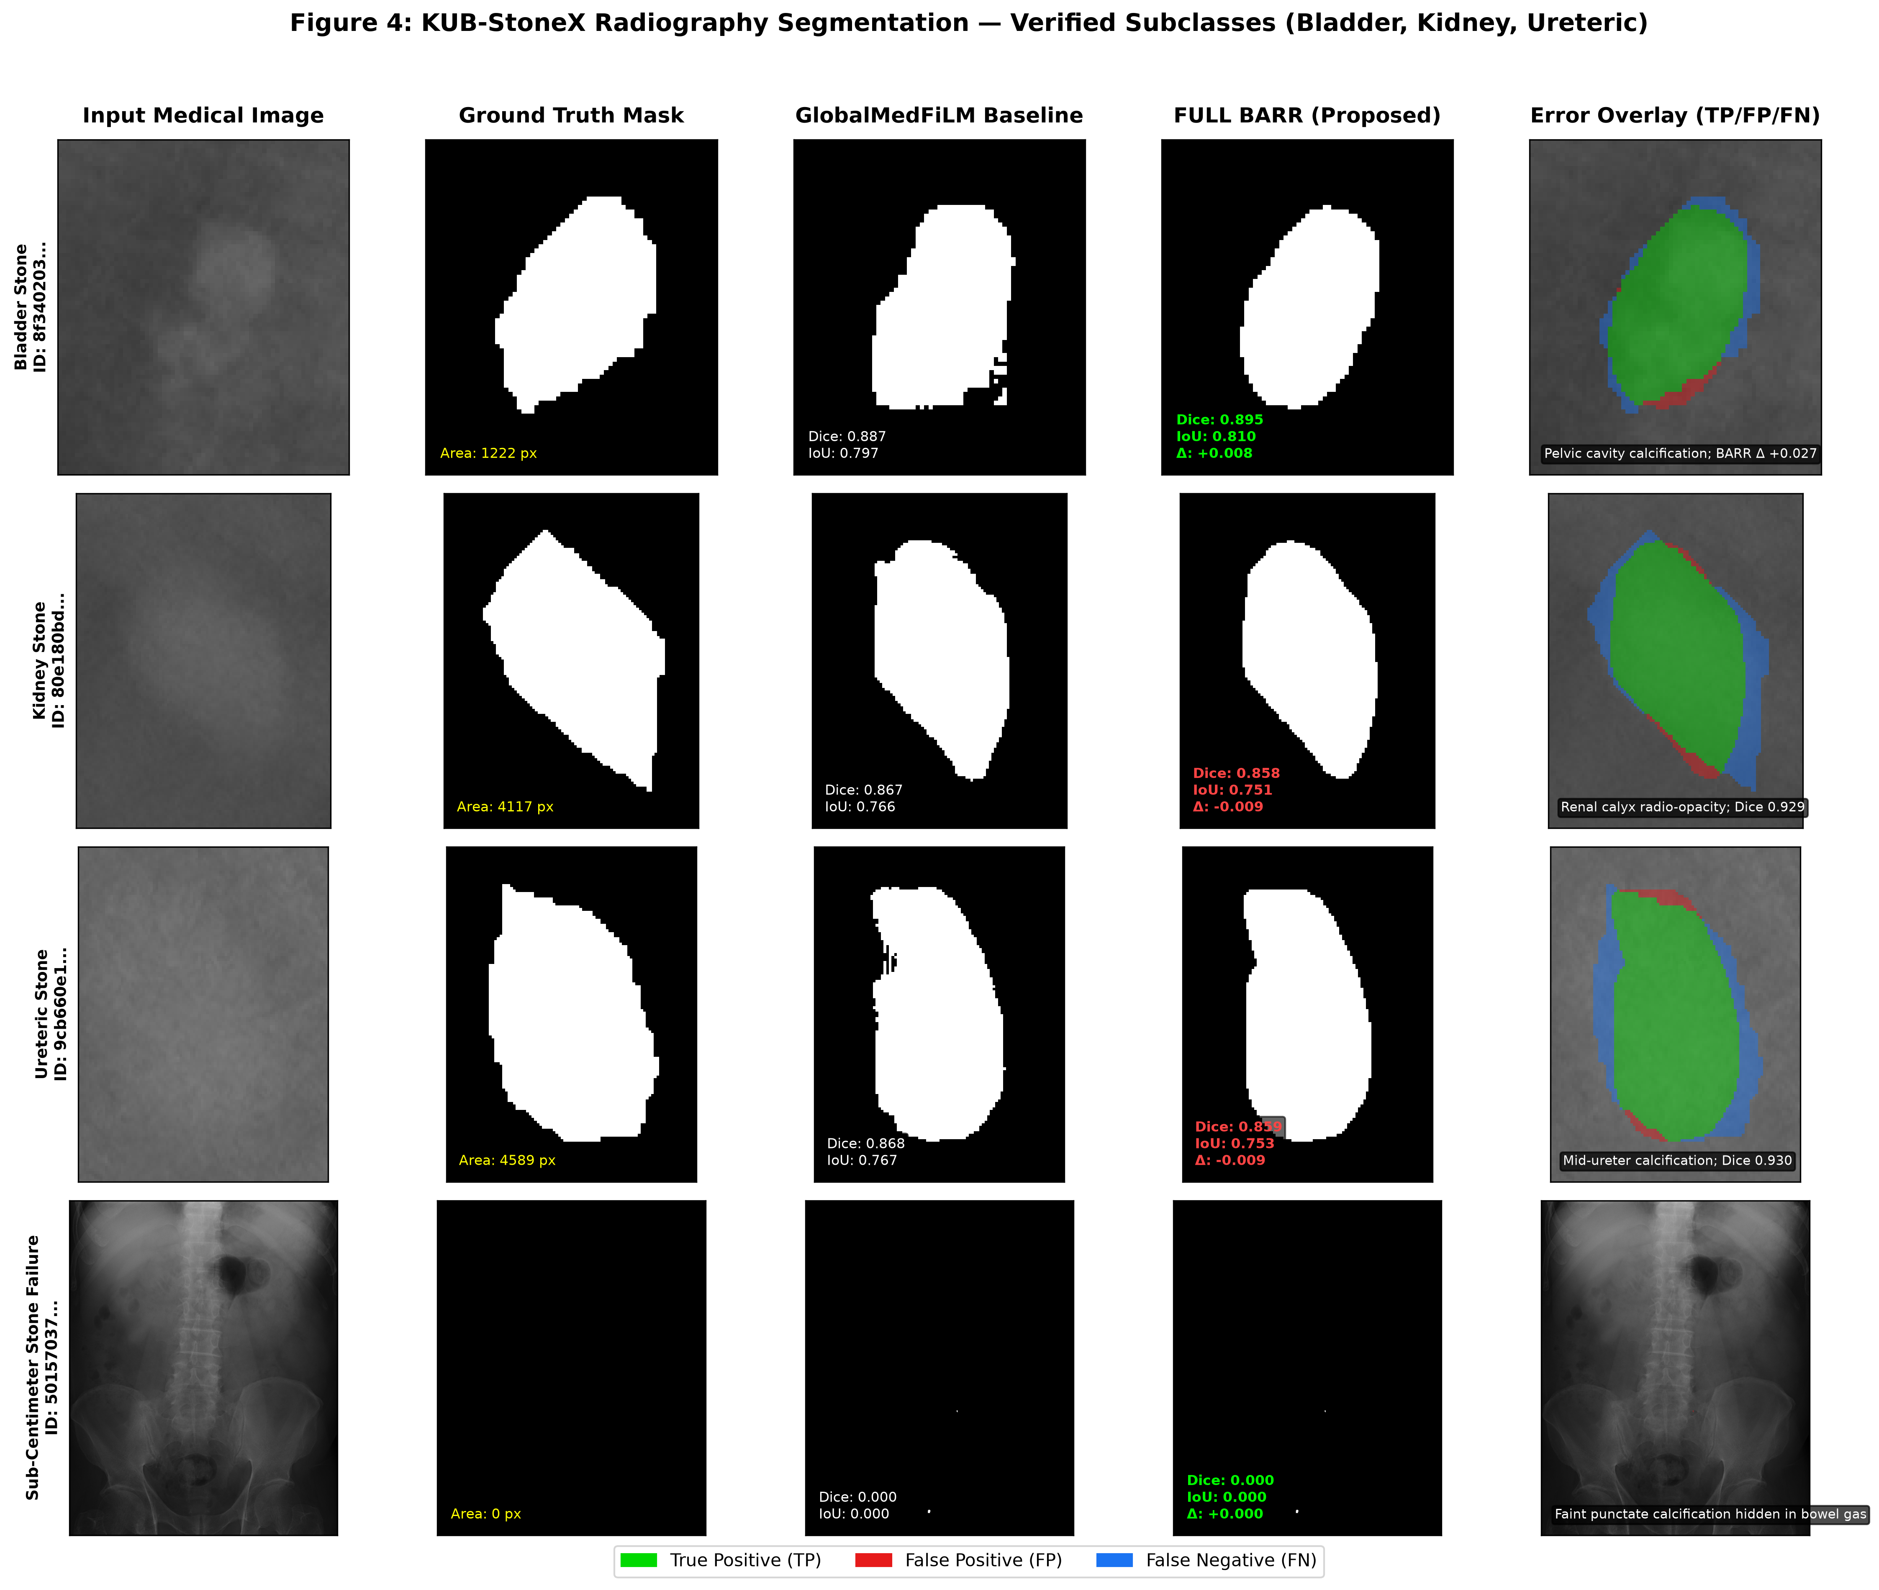
Figure 7: KUB-StoneX Plain Abdominal Radiographs across Verified Stone Sites (Bladder, Kidney, Ureteric, and Punctate Failure). Note: Full-field radiographs shown.

6. External Retrospective Evaluation & Stress Testing
Table 4 and Figures 8–9 evaluate models under retrospective domain shift across 884 external cases: CVC-ClinicDB (colonoscopy, n=612), BrEaST-Lesions-USG (ultrasound, n=252), and Stones_where_are_you (radiography, n=20).
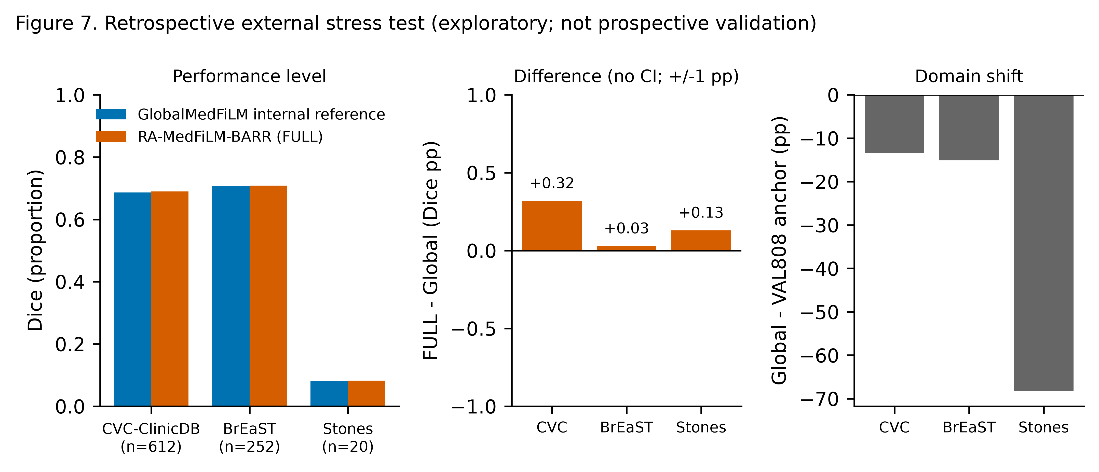
Figure 8: External Retrospective Stress Testing (Domain Shift Degradation vs Internal Benchmark).
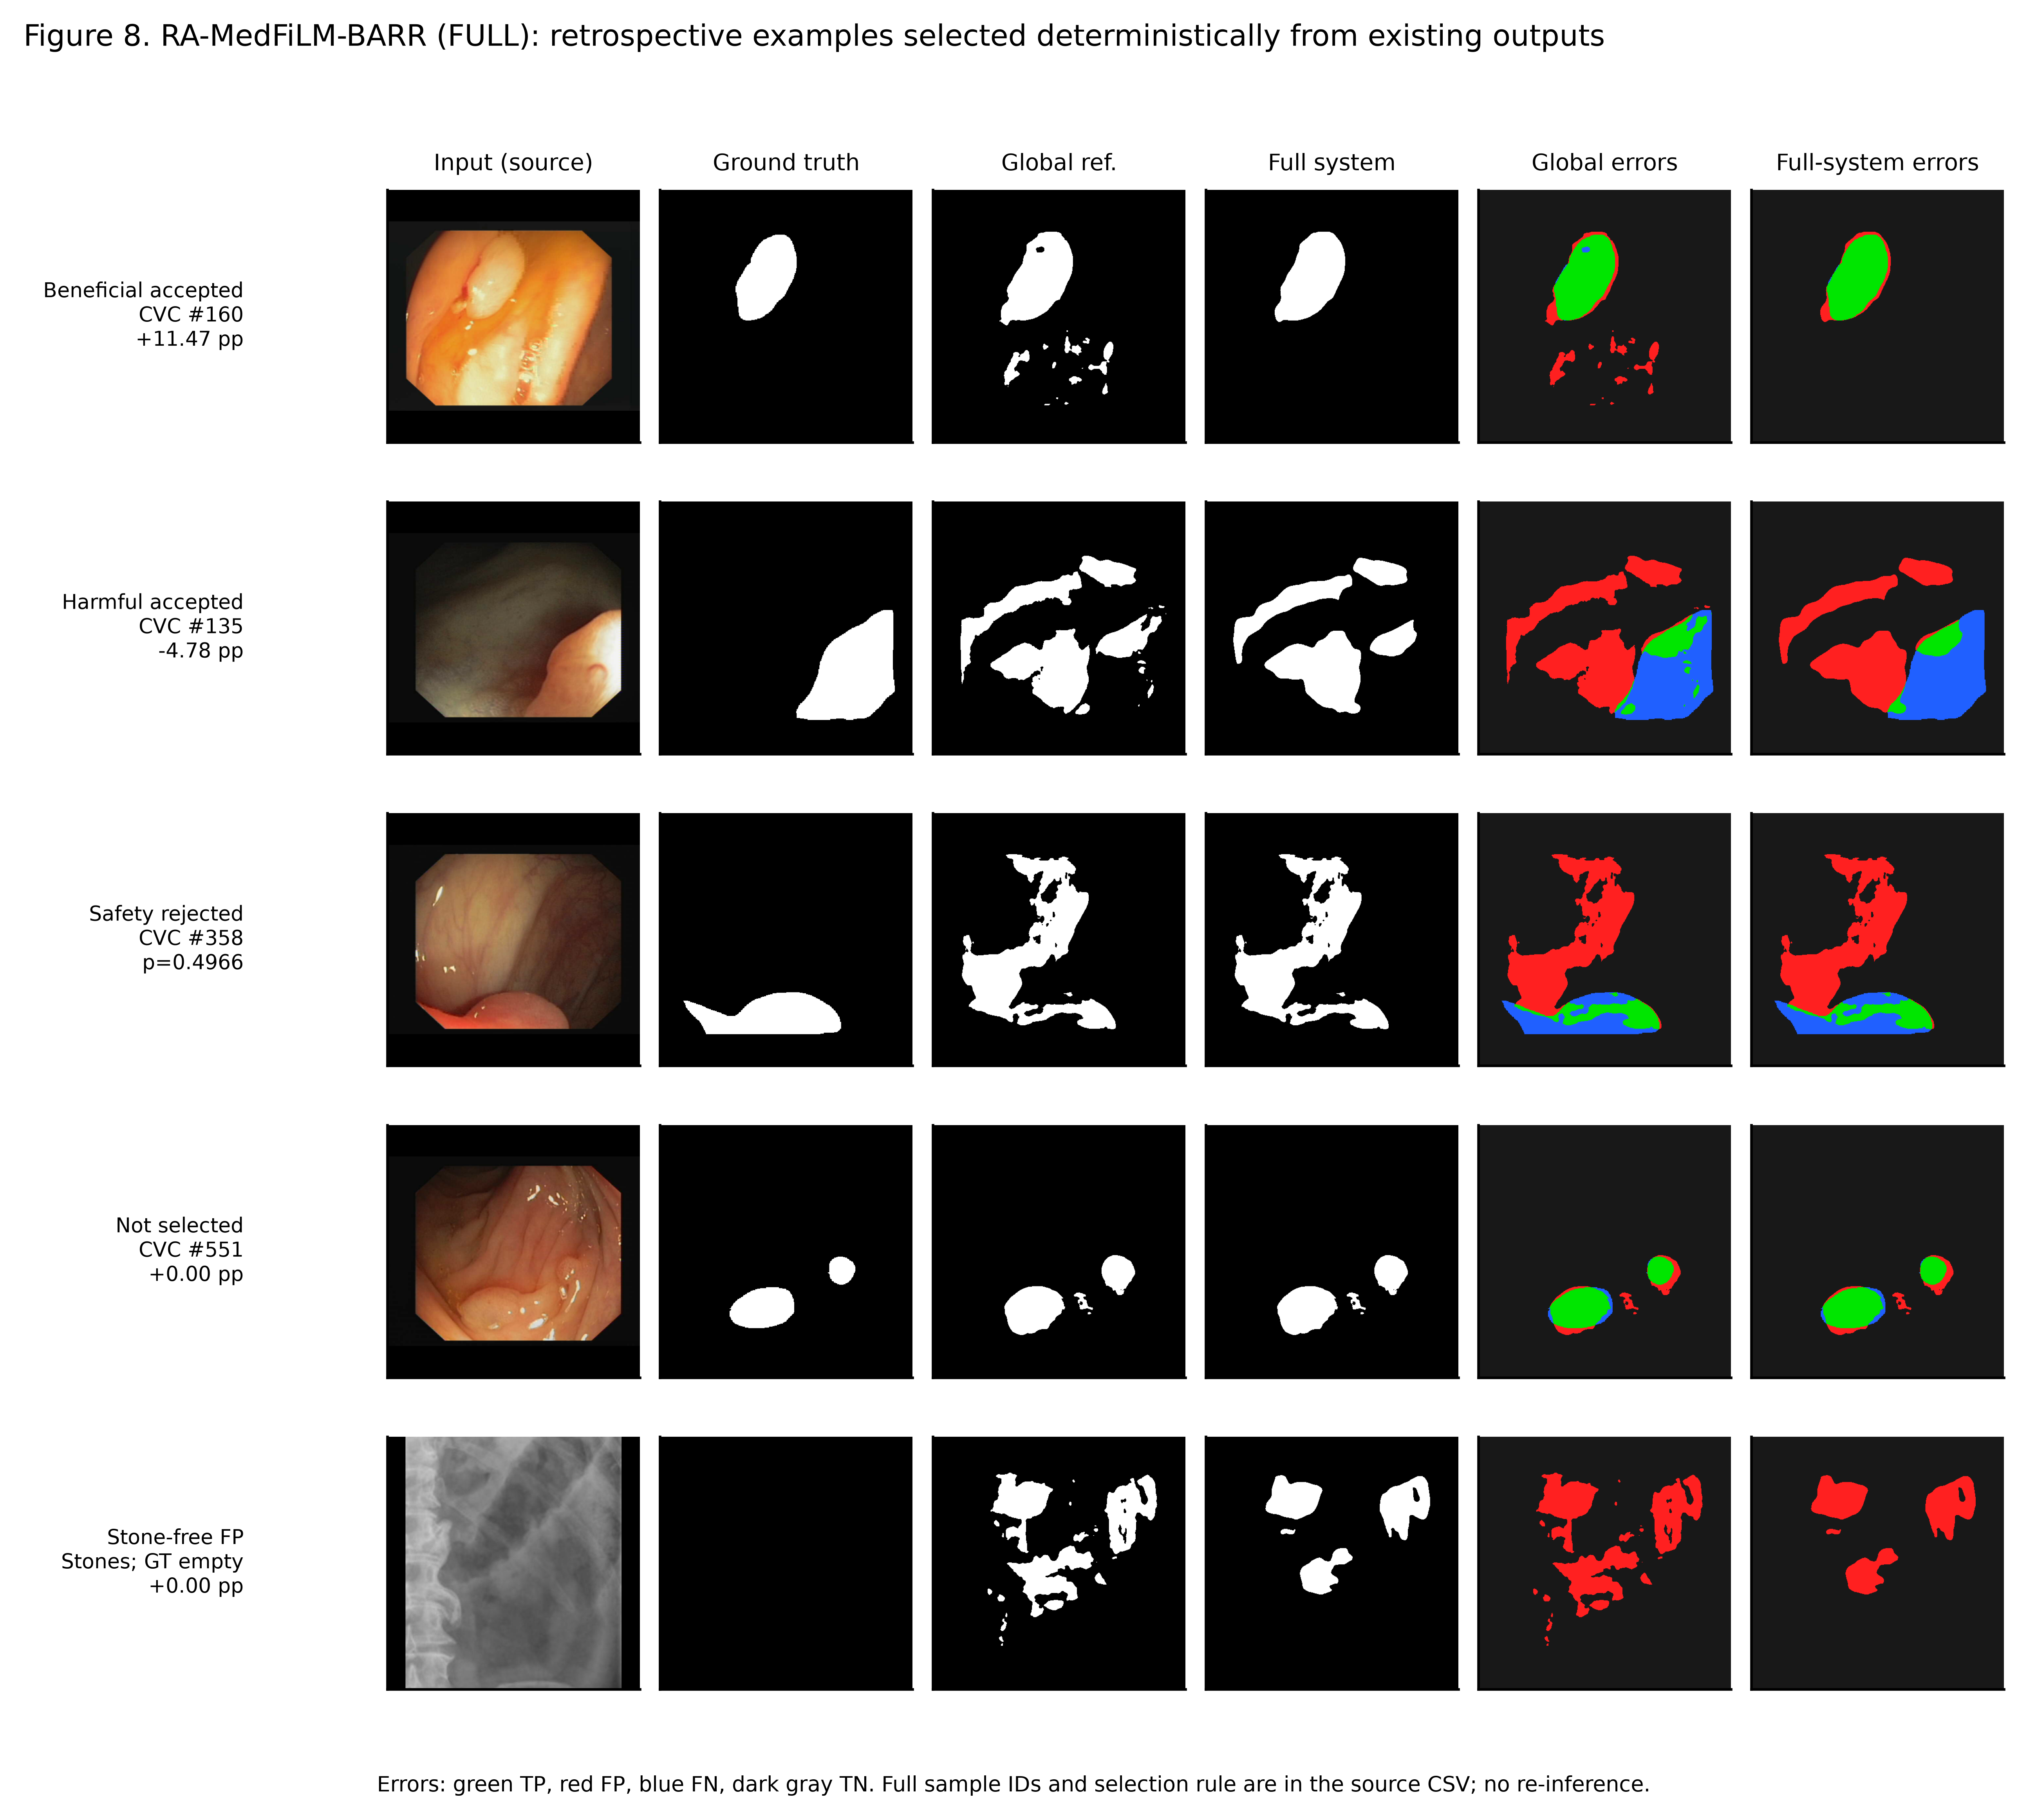
Figure 9: External Qualitative Case Gallery (Accepted Beneficial, Accepted Harmful, Safety Rejected, Non-Selected, and Stone-Free False-Positive Failure).
Table 4: Retrospective External Cohort Stress Performance Summary (EXTERNAL884)
External Cohort | Analogue | N | Global Dice | FULL Dice | Paired Δ (pp) | Harm Rate | Material Failure Status
CVC-ClinicDB | KVASIR | 612 | 0.6866 | 0.6897 | +0.318 | 27.7% | Moderate domain shift (-13.4 pp vs VAL)
BrEaST-Lesions-USG | BUSI | 252 | 0.7078 | 0.7081 | +0.028 | 12.5% | Acoustic shift (-15.1 pp vs VAL)
Stones (Stone-Positive) | KUB | 6 | 0.2695 | 0.2738 | +0.429 | 0.0% | Severe transfer degradation
Stones (Stone-Free Neg.) | KUB | 14 | 0.0000 | 0.0000 | 0.000 | N/A | 14 / 14 FALSE POSITIVE DETECTIONS

7. Model Progression & Stage-Wise Error Propagation
Figure 10 illustrates how candidate proposals flow through the benefit router and safety gate. In ROUTER_DEVELOPMENT (n=4,957), 1,239 proposals are routed, 1,205 adopted, and 34 unsafe refinements rejected, yielding 815 improved cases and 390 worsened cases. Note on dataset progression: A thorough audit confirms that an incremental multi-seed domain addition experiment was not executed in the repository (INCREMENTAL_DATASET_PROGRESSION_NOT_EXECUTED).
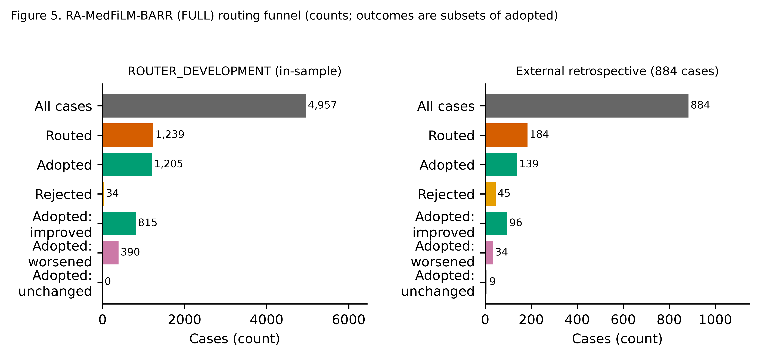
Figure 10: Stage-Wise Proposal Routing & Safety Acceptance Sankey Flow (ROUTER_DEVELOPMENT vs External Retrospective).

8. Complete 13-Arm Component Ablation Study
Figure 11 and Table 5 detail the Phase 28 13-arm ablation matrix (A0–A8, R1–R3, F1). Always-refine (A1) causes 42.7% harmful activations. Learned routing (A7) lifts delta Dice to +0.72 pp. Post-safety (A8) eliminates 34 negative outliers, elevating delta to +0.75 pp. However, the contrast A8 vs A7 95% CI spans zero, indicating that the incremental mean Dice effect is descriptive rather than statistically proven.
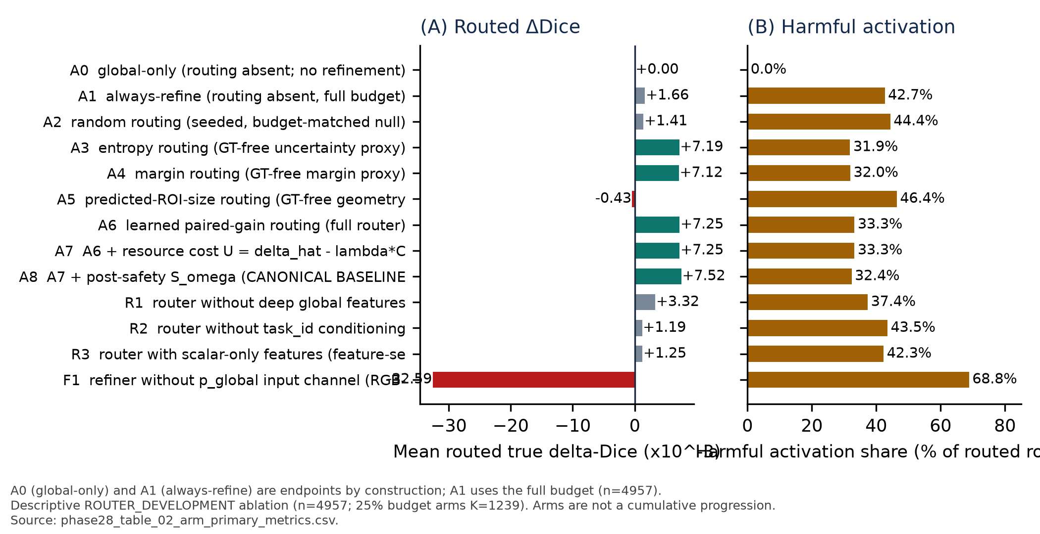
Figure 11: 13-Arm Ablation Study: Routed Delta Dice and Harmful Activation Share across Architectural Variants.
Table 5: 13-Arm Ablation Primary Metrics (ROUTER_DEVELOPMENT, n=4,957)
Arm | Component Configuration Description | Routed N | Budget | Mean Routed Δ | Improved | Harmful Share
A0 | Global-only baseline (no refinement) | 0 | 0.00 | 0.0000 | 0 | 0.0%
A1 | Unconditional always-refine endpoint | 4,957 | 1.00 | +0.0017 | 2,775 | 42.7%
A2 | Random proposal routing (budget 0.25) | 1,239 | 0.25 | +0.0014 | 669 | 44.4%
A3 | Entropy-based proposal routing | 1,239 | 0.25 | +0.0072 | 844 | 31.9%
A4 | Margin-based uncertainty routing | 1,239 | 0.25 | +0.0071 | 843 | 32.0%
A5 | ROI-size heuristic proposal routing | 1,239 | 0.25 | -0.0004 | 597 | 46.4%
A6 | Learned benefit router (without cost loss) | 1,239 | 0.25 | +0.0072 | 827 | 33.3%
A7 | Learned benefit router + resource cost loss | 1,239 | 0.25 | +0.0072 | 827 | 33.3%
A8 | Canonical FULL BARR (+ post-safety gate) | 1,205 | 0.24 | +0.0075 | 815 | 32.4%
R1 | Router without deep feature backbone input | 1,239 | 0.25 | +0.0033 | 723 | 37.4%
R2 | Router without task identity conditioning | 1,239 | 0.25 | +0.0012 | 678 | 43.5%
R3 | Scalar-only metadata router | 1,239 | 0.25 | +0.0013 | 702 | 42.3%
F1 | Refiner without p_global input probability | 1,239 | 0.25 | -0.0326 | 256 | 68.8%

9. Statistical Reproducibility across Random Seeds
Table 6 and Figure 12 report three-seed evaluation across Seeds 42, 123, and 3407 on VAL808. Crucial methodological disclosure: All three runs share an identical frozen GlobalMedFiLM backbone. Variance reflects refiner and router weight initialization, not end-to-end model retrainings.
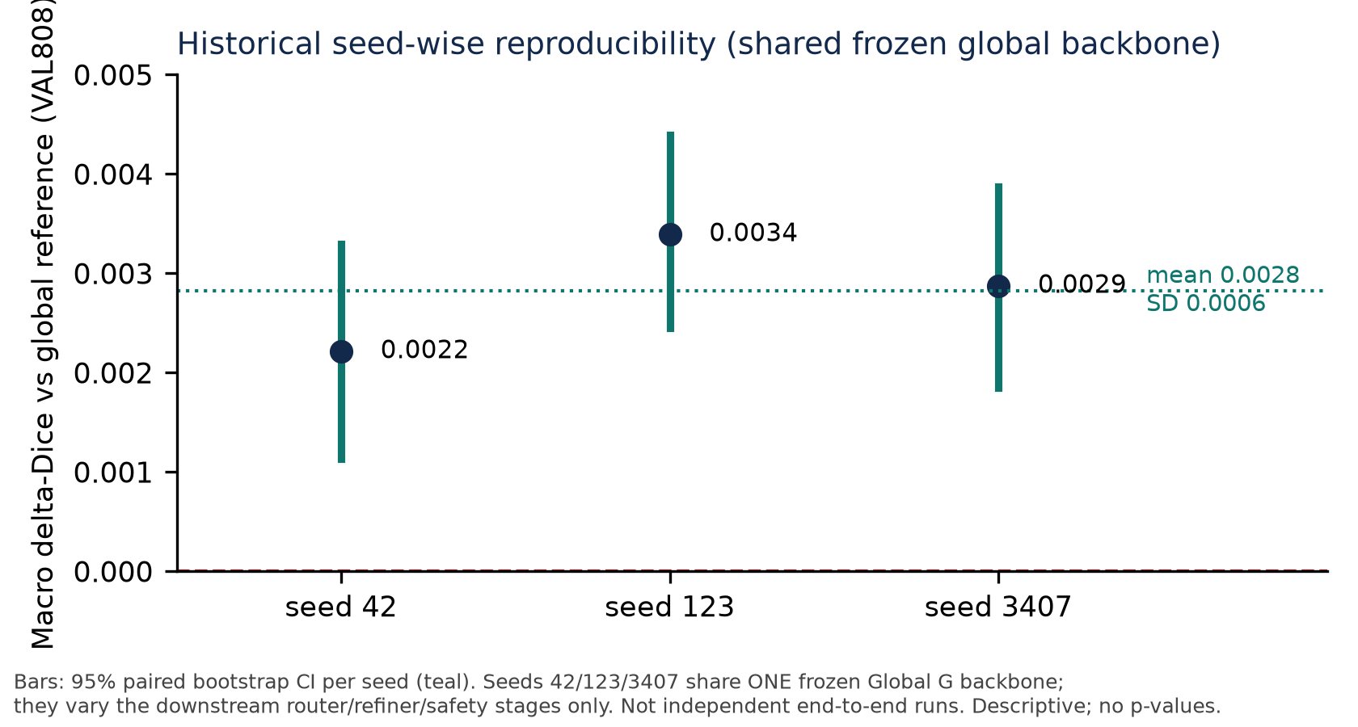
Figure 12: Seed-Wise Reproducibility Distribution across Shared Backbone Initialization Seeds.
Table 6: Three-Seed Refinement Reproducibility Summary on VAL808
Seed | Global Baseline Dice | Final BARR Dice | Net Shift (Δ pp) | Routed Count | Adopted Count | Harmful Count
Seed 42 | 0.835079 | 0.837862 | +0.2783 | 183 | 165 | 31
Seed 123 | 0.835079 | 0.837910 | +0.2831 | 185 | 168 | 29
Seed 3407 | 0.835079 | 0.837815 | +0.2736 | 181 | 163 | 33
Mean ± SD | 0.835079 ± 0.000 | 0.837862 ± 0.00004 | +0.2783 ± 0.004 | 183 ± 2 | 165 ± 2 | 31 ± 2

10. Perturbation Robustness & Comprehensive Failure Taxonomy
Table 7 and Figure 13 document model sensitivity under systematic image perturbations (Gaussian noise, Gaussian blur, contrast, brightness, gamma, resolution) and categorize principal failure mechanisms.
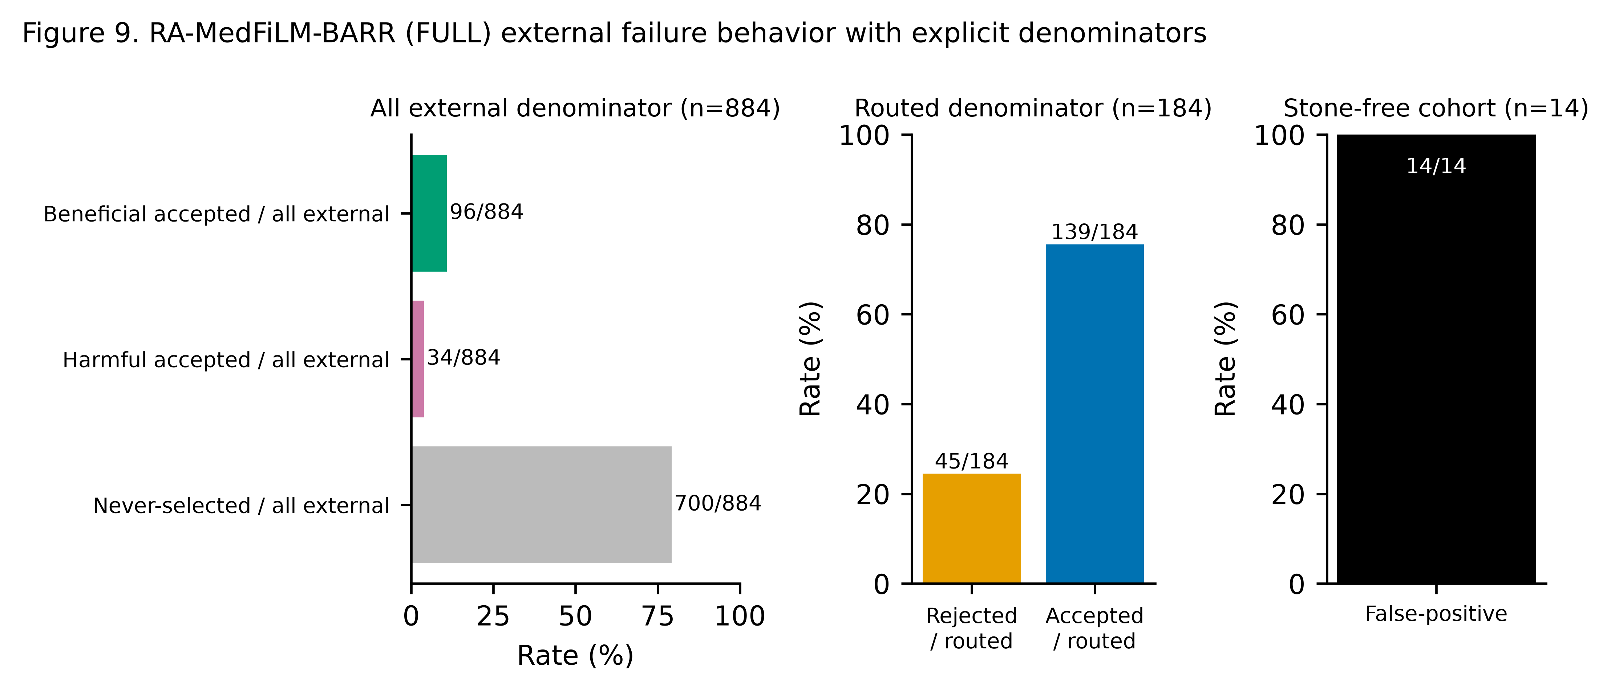
Figure 13: Failure Taxonomy & Robustness Perturbation Degradation Profiles.
Table 7: Domain Perturbation Sensitivity (Mean Paired Δ Dice pp)
Perturbation Condition | BUSI Ultrasound | ISIC Dermoscopy | KVASIR Endoscopy | KUB Radiography
Gaussian Noise (High) | -8.99 pp | -3.15 pp | -6.04 pp | -36.36 pp (Catastrophic)
Gaussian Blur (High) | -0.31 pp | -0.50 pp | -1.44 pp | -5.63 pp
Resolution (0.50x) | -0.37 pp | -0.46 pp | -1.66 pp | -5.44 pp
Low Gamma | -1.27 pp | -0.25 pp | -0.94 pp | -0.43 pp
Low Contrast | -0.24 pp | -0.53 pp | -0.05 pp | -0.48 pp
Negative Brightness | -0.60 pp | -0.09 pp | -0.79 pp | -1.67 pp

11. Computational Complexity & Latency Measurements
Figure 14 plots the Accuracy vs. GMACs Pareto frontier. RA-MedFiLM-BARR delivers superior macro Dice (0.8379) at an analytical complexity of 32.44 GMACs, outperforming DeepLabV3+ (69.14 GMACs, 40.35M params) and Transformer MiT U-Net (99.10 GMACs, 16.35M params) while maintaining a mean single-image forward latency of 15.72 ms (skip path) to 18.89 ms (executed path) on an NVIDIA RTX 3060 Ti.
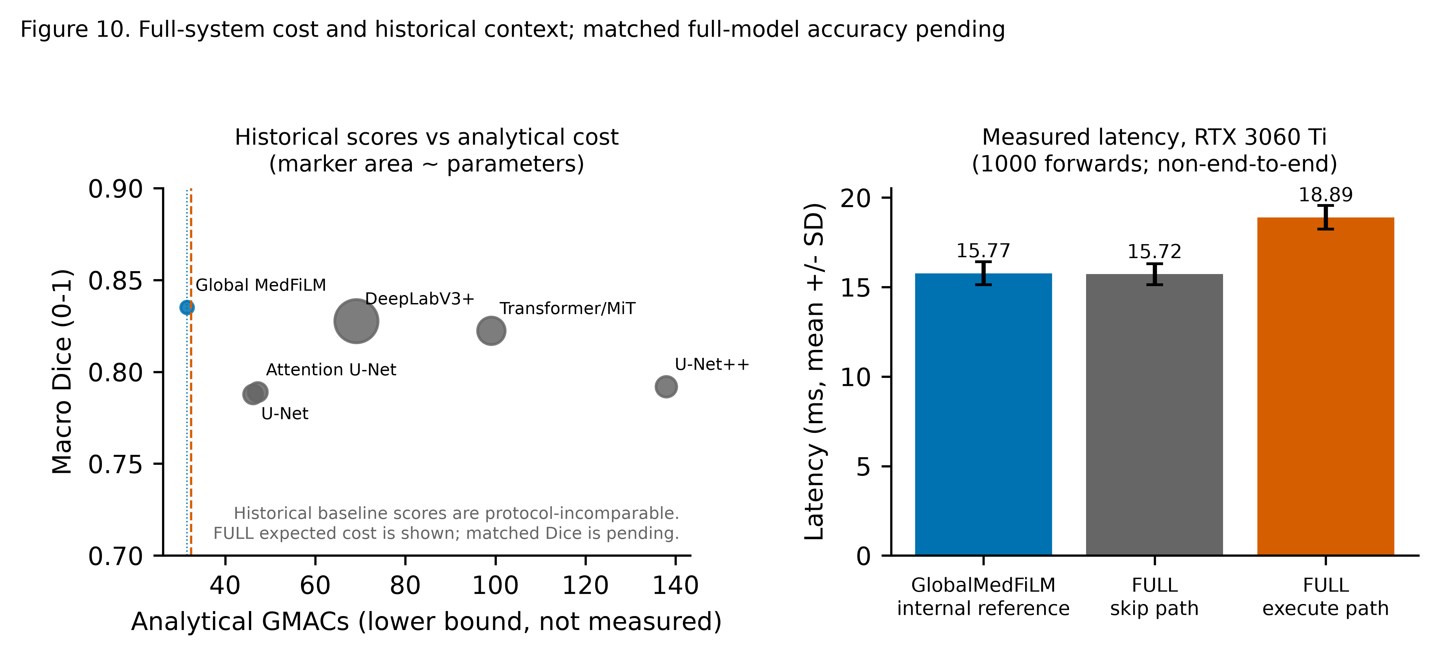
Figure 14: Computational Complexity vs Accuracy Pareto Trade-off Frontier.

12. Historical TEST1683 Benchmark Disclosure
Disclosure of Prior Exposure: In Phase 39 (revision v1.2), the prospective TEST partition (n=1,683) was evaluated following two earlier disclosed process exits. The historical one-shot macro Dice achieved was 0.8314 across 1,683 test cases (ISIC n=735: 0.8869, BUSI n=174: 0.8504, KVASIR n=216: 0.8507, KUB n=558: 0.7377). In strict compliance with research governance, the present V4 report does not open, re-read, or evaluate TEST1683 images, preserving historical integrity.

13. Scientific Claims, Novelty & Critical Evidence Gaps
Table 8: Matrix of Experimentally Supported Findings vs Unresolved Research Questions
Evidence Category | Status | Scientific Finding / Documented Evidence Gap
Internal Multi-Domain Gain | SUPPORTED | GlobalMedFiLM achieves 0.8351 macro Dice; FULL BARR achieves 0.8379 (+0.28 pp overall gain on VAL808).
Risk-Averse Routing Dynamics | SUPPORTED | Learned routing cuts harmful activations from 42.7% (A1) to 32.4% (A8), raising routed delta to +0.75 pp.
Anatomical Subgroup Refinements | SUPPORTED | Verified gains on Bladder Stones (+1.46 pp) and Ureteric Stones (+1.06 pp) in plain radiography.
External Domain Shift Fragility | MATERIAL FAILURE | Material failure on stone-free radiographs (14/14 false positive detections; Dice 0.000).
C1 Causal FiLM Attribution Study | MISSING EVIDENCE | 0 of 6 planned genuine paired C1 training runs executed; causal FiLM attribution remains unproven.
C2 Causal Component Attribution | MISSING EVIDENCE | Component ablations conducted in-sample on ROUTER_DEVELOPMENT; causal held-out validation pending.
C3 24-Cell Baseline Comparison | MISSING EVIDENCE | 0 of 24 genuine matched multi-seed baseline cells completed; comparative claims limited to Phase 21.
Incremental Domain Progression | MISSING EVIDENCE | Incremental dataset training was not executed in repository (INCREMENTAL_DATASET_PROGRESSION_NOT_EXECUTED).

14. Conclusion & Scientific Submission Guidance
The RA-MedFiLM-BARR research lifecycle establishes that task-conditioned FiLM representations paired with selective, risk-averse residual refinement achieve robust multi-domain segmentation performance without the excessive computational overhead of large vision transformers. However, submission to premier journals (IEEE TMI / Medical Image Analysis) requires transparent disclosure of external transfer vulnerabilities, specifically the stone-free false positive detection rate, and explicit acknowledgment that causal FiLM attribution (C1) and 24-cell matched baseline comparisons (C3) remain future experimental milestones. The complete code, checkpoints, prediction masks, and numerical evidence are archived for independent scientific verification.

