Bangla-English Code-Mixed Sentiment Classification
A Comparative Study of BoW and TF-IDF
with Traditional Machine Learning Models
MD. Saiful Islam Shanto  Department of Computer Science and Engineering American International University-Bangladesh Dhaka, Bangladesh  247582-2@student.aiub.edu | Tahmid Yousuf Prince  Department of Computer Science and Engineering American International University-Bangladesh Dhaka, Bangladesh  22-49637-3@student.aiub.edu
Sadia Ahmed  Department of Computer Science and Engineering American International University-Bangladesh Dhaka, Bangladesh  23-55053-3@student.aiub.edu | Samiul Hasan  Department of Computer Science and Engineering American International University-Bangladesh Dhaka, Bangladesh  23-55331-3@student.aiub.edu

Abstract- Bangla–English code-mixed restaurant reviews combine English vocabulary with Bangla expressions, including informal Romanized spellings. This study compares sparse text representations and traditional classifiers on a lexically filtered subset of BDFoodSent. The original multilingual dataset contains 334,119 reviews; normalization, duplicate and conflicting-label handling, and strict lexical filtering yield 18,957 reviews. Sentiment labels are derived from ratings: 1–2 indicate negative, 3 neutral, and 4–5 positive. The subset contains 12,591 negative, 2,176 neutral, and 4,190 positive reviews. A stratified 80/20 split with seed 42 produces 15,166 training and 3,791 test instances. Bag of Words (BoW) and term frequency–inverse document frequency (TF-IDF) are paired with Logistic Regression (LR), linear Support Vector Machine (SVM), and Multinomial Naive Bayes (NB). BoW+LR achieves the highest accuracy, 78.7655%, whereas BoW+NB achieves the highest macro F1, 60.53858%. BoW exceeds TF-IDF in both measures for each classifier on this split. However, BoW+LR identifies only 16 of 435 neutral test reviews, giving 3.678161% neutral recall. These findings support metric-specific model selection and show that aggregate accuracy obscures weak minority-class recognition. Lexical selection, rating-derived supervision, spelling variability, and incomplete implementation metadata limit interpretation and reproducibility.
Index Terms- Bangla–English code mixing, sentiment classification, Romanized Bangla, Bag of Words, TF-IDF, class imbalance.

I. INTRODUCTION
Sentiment classification assigns an evaluative label to text and can summarize opinions expressed in customer reviews. For Bangla–English communication, the task involves both the underlying sentiment and variation in how language is written. Romanized Bangla uses Latin letters to express Bangla words; code mixing additionally involves material from more than one language. These concepts overlap but are not interchangeable: a review written entirely in Romanized Bangla is not necessarily Bangla–English code-mixed. Recent corpus work explicitly treats Bengali–English code mixing as a distinct resource and modeling problem [1].
Restaurant feedback provides a practical setting for studying this distinction. BDFoodSent contains Bangla, English, and Banglish reviews collected from Foodpanda Bangladesh, together with ratings and other fields [2]. Its multilingual coverage does not imply that every review mixes languages. Consequently, using all source records as a code-mixed benchmark would misstate the population under study. This project instead constructs a subset using normalization, consistent duplicate handling, and a lexical requirement for both Romanized Bangla and English indicators.
A second issue concerns the relationship between representation and classifier. Count-based BoW and TF-IDF are accessible baselines, yet frequency weighting can change which lexical signals dominate classification. Classical sentiment research demonstrates that feature choices and classifier variants affect the ranking of simple models [3], [4]. It is therefore useful to compare representations within each classifier, rather than attributing performance to the algorithm alone.
The present study evaluates six combinations formed from BoW and TF-IDF with LR, linear SVM, and Multinomial NB. Its contribution is an empirical comparison on a clearly delimited, rating-labeled subset, supported by complete aggregate results and a class-wise analysis of the highest-accuracy model. It does not introduce a new classification algorithm or claim superiority over published benchmarks. The central questions are whether BoW or TF-IDF performs better under the recorded setup, whether accuracy and macro F1 select the same model, and which errors remain hidden by the aggregate score.
The results show that model selection depends on the evaluation objective. BoW+LR maximizes accuracy, while BoW+NB maximizes macro F1. The LR confusion matrix reveals that neutral reviews are rarely recovered despite strong negative-class recall. Section II relates the experiment to prior work; Section III describes the data and methods; Section IV analyzes the results and limitations; Section V concludes with future directions.

II. RELATED WORK

A. Sparse Representations and Traditional Sentiment Models
Pang et al. [3] compared Naive Bayes, maximum entropy, and SVM for movie-review sentiment classification. Their study established the relevance of supervised text classifiers while showing that sentiment prediction presents challenges beyond topic classification. Wang and Manning [4] subsequently demonstrated that NB and SVM performance depends on the feature design, model variant, and document setting. Their analysis of bag-of-features models cautions against treating a classifier name as sufficient evidence of expected performance. Together, these studies motivate a controlled representation–classifier comparison, but they do not determine the best combination for Bangla–English reviews.
For Bangla news, Maisha et al. [5] combined Count Vectorizer and TF-IDF processing with six classifiers, including LR, linear SVM, and Multinomial NB. Their binary document-level setting confirms the applicability of sparse feature pipelines to Bangla text. However, the writing style, document length, and binary labels differ from informal, three-class restaurant feedback. Shanto et al. [6] provide a closer domain comparison through Bangla e-commerce reviews, examining count and TF-IDF features with n-grams in binary and multiclass experiments. Their study makes label configuration and vectorization explicit experimental choices. These findings justify comparing BoW against TF-IDF here without assuming that a result from Bangla-script news or product reviews transfers to a filtered code-mixed population.

B. Bangla Sentiment and Restaurant Review Classification
Hassan et al. [7] investigated Bangla conversational sentiment using several supervised methods, including SVM, Multinomial NB, and LR, with positive and negative labels. That work supports the use of traditional classifiers for Bangla sentiment, but its binary conversational task cannot assess neutral-class recovery. Sharif et al. [8] studied Bengali restaurant-review sentiment with Multinomial Naive Bayes. The common review domain makes NB particularly relevant as a baseline in this project. Nevertheless, their positive/negative task differs from the rating-derived negative/neutral/positive outcome studied here. A neutral category changes both the decision boundaries and the interpretation of an overall accuracy score.
These distinctions matter when reading published results. Differences in annotation, class balance, review source, and test design can change difficulty independently of the classifier. This paper therefore uses prior work to motivate the experiment and identify methodological contrasts, rather than placing its accuracy beside unrelated scores as evidence of an advance. In particular, a rating of 3 is an operational label in the present study; it should not be equated automatically with a human judgment that the review text expresses no positive or negative sentiment.

C. Code Mixing and Romanized Bangla Processing
Mandal and Das [9] studied English–Bengali movie reviews in which both languages use Roman script. Their reported experiments found substantial differences between models relying on English features and models incorporating code-mixed evidence. This directly motivates retaining evidence from both languages when defining the present subset. The study suggests that the language composition of the training evidence matters alongside the classifier choice. Its binary movie-review setting remains different from the restaurant-rating task considered here.
Language identification is a related but separate problem. Mandal et al. [10] explored character- and phonetic-based LSTM models for word-level Bengali–English language identification. Their work addresses inconsistent phonetic transliteration and ambiguous language membership in Roman-script text. It explains why a fixed lexical indicator list can be an economical screening method while remaining an imperfect measure of actual code mixing. The present filter does not reproduce that language identification system and has no reported token-level language accuracy. A lexical match should therefore be interpreted as a selection condition, not as verified linguistic annotation.

D. Code Mixed Corpora and Contextual Modeling
Tareq et al. [11] constructed a Bangla–English code-mixed review corpus and investigated augmentation to strengthen cross-lingual relationships in word embeddings. Their approach targets information that sparse word counts do not explicitly encode: connections between expressions across languages. This provides a useful future direction, while the present comparison isolates accessible sparse baselines without introducing synthetic training data or embedding-based features. Their weighted F1 results are not directly comparable to the macro F1 reported here because the averaging rules and datasets differ.

E. Position of the Present Study
Across these studies, three connected issues motivate the experiment: sparse representations remain relevant baselines; code-mixed text requires an explicit treatment of language variation; and label definitions affect what performance means. The present work brings these issues together by comparing two representations across three classifiers and examining macro as well as class-wise outcomes. Its scope is descriptive: the results characterize the supplied split and processing protocol, while lexical validity, implementation completeness, and generalization beyond that split remain open questions.

III. METHODOLOGY

A. Dataset and Rating Derived Sentiment Labels
The source is BDFoodSent: A Large-Scale Sentiment-Labeled Restaurant Review Dataset from Bangladesh, created by Ehsanur Rahman Rhythm and Md Humaion Kabir Mehedi [2]. Mendeley Data version 2 was published on December 2, 2024, with DOI 10.17632/532fxhnwbb.2 and a Creative Commons Attribution 4.0 International (CC BY 4.0) license. The exact repository page is https://data.mendeley.com/datasets/532fxhnwbb/2. This version documents 334,119 reviews. The source includes multilingual content and English translations; the project concerns the original-language review content rather than translated English as a code-mixing signal.
The project maps ratings 1–2 to negative, rating 3 to neutral, and ratings 4–5 to positive. These are rating-derived targets, not manually annotated textual sentiment. Fig. 1 shows the retained distribution: 12,591 negative reviews (66.4%), 2,176 neutral reviews (11.5%), and 4,190 positive reviews (22.1%). Table I summarizes the dataset and experiment. The retained 18,957 reviews represent approximately 5.67% of the source; this percentage describes selection, not a measured prevalence of code mixing in BDFoodSent.
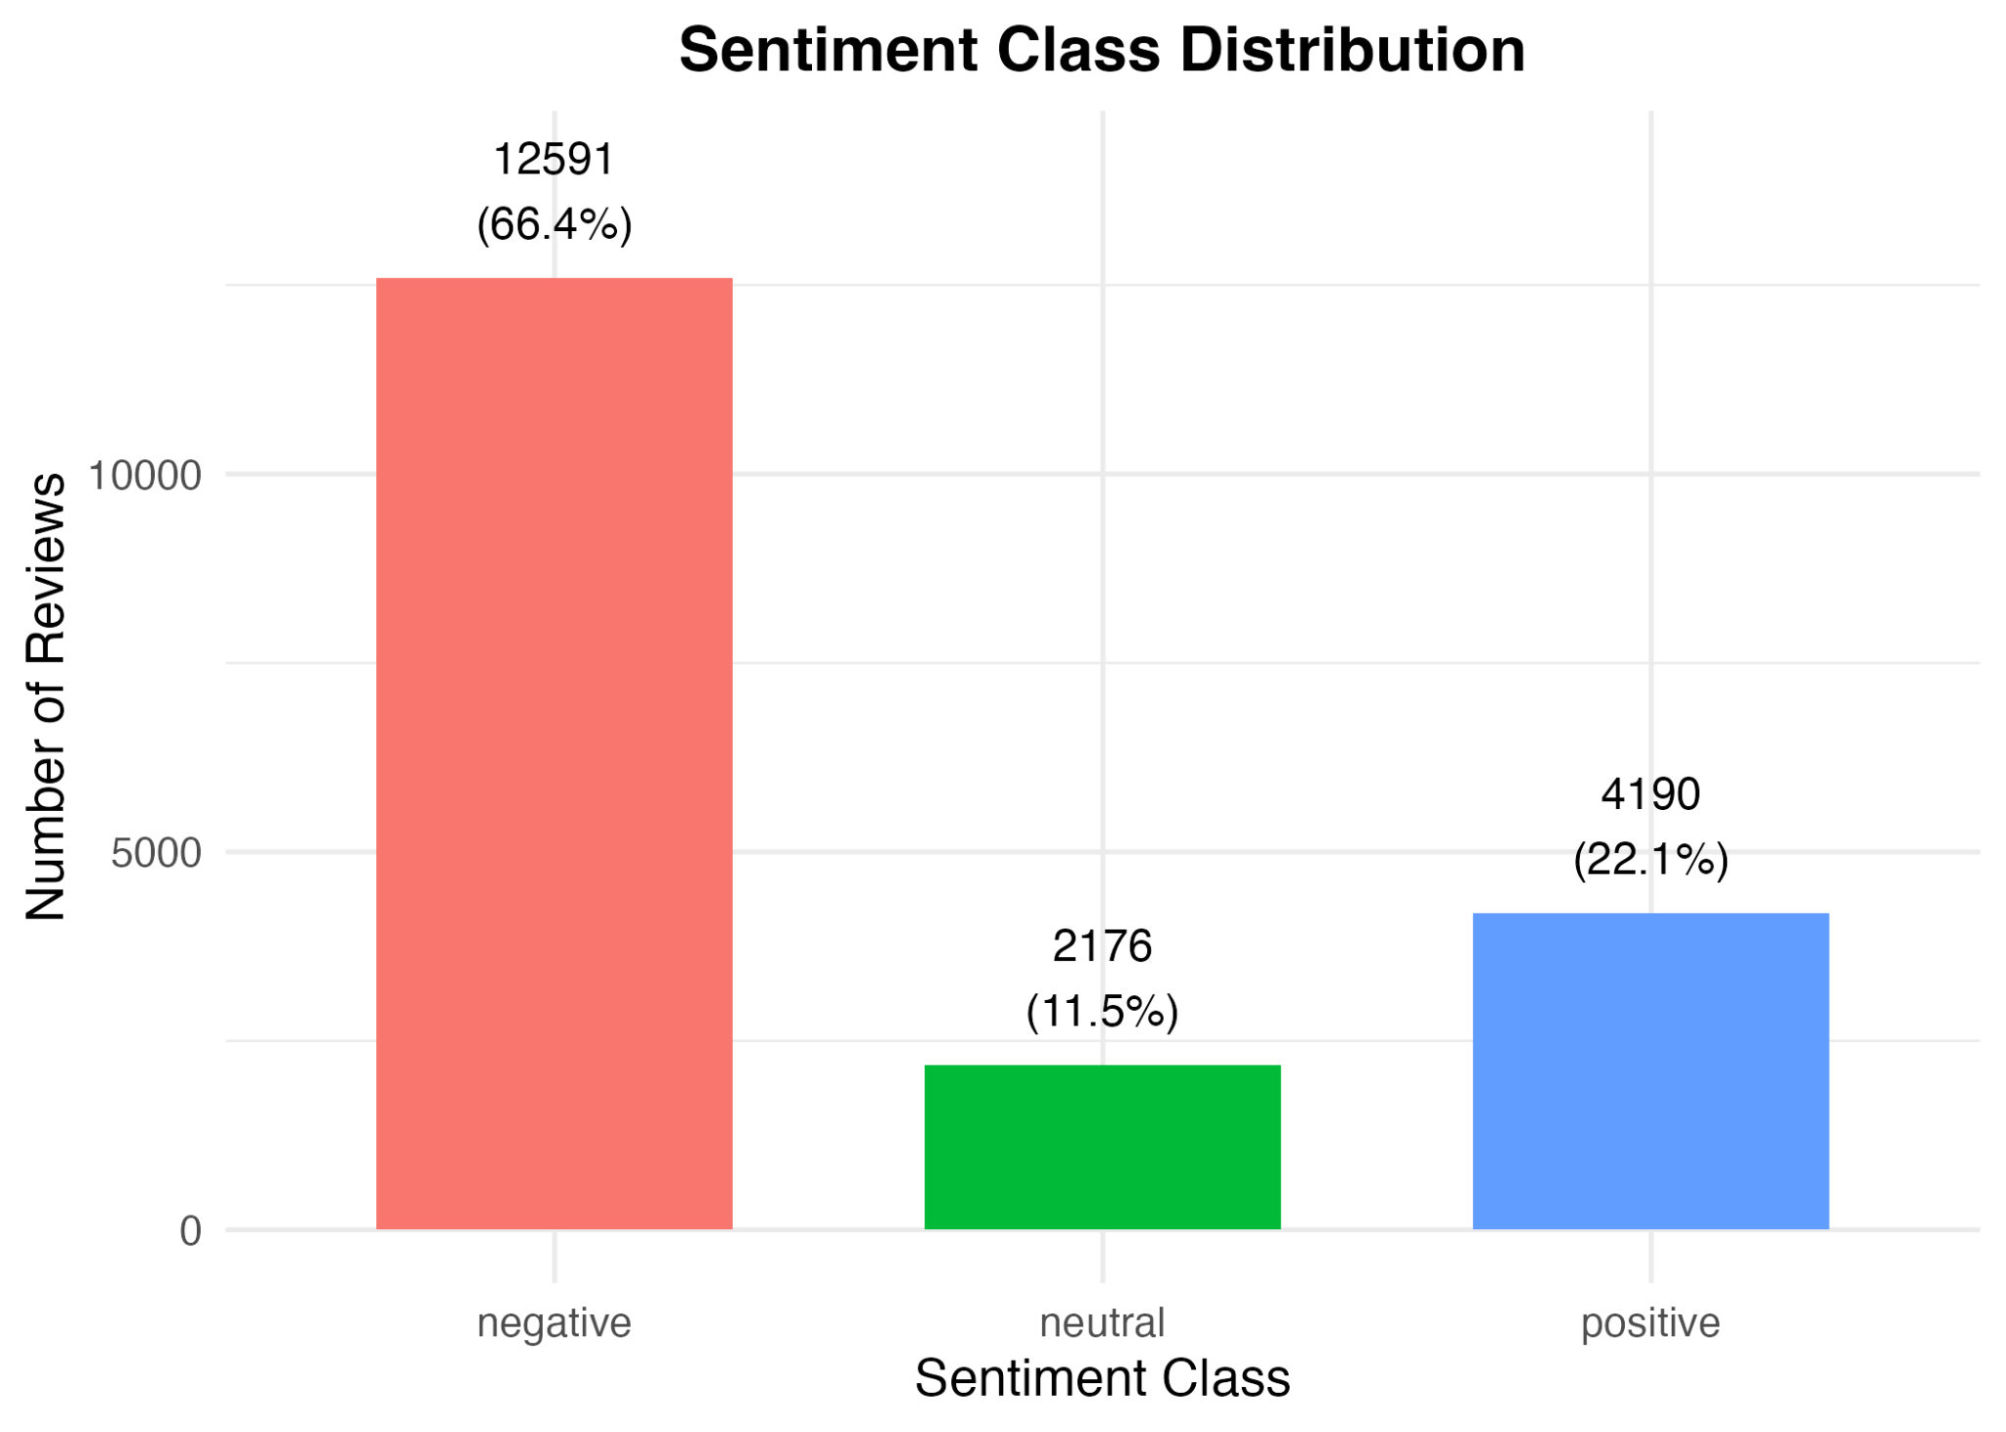
Fig. 1. Sentiment distribution of the filtered 18,957-review subset.
TABLE I
DATASET AND EXPERIMENTAL STATISTICS
Item | Value
Original BDFoodSent reviews | 334,119
Filtered reviews | 18,957
Negative | 12,591 (66.4%)
Neutral | 2,176 (11.5%)
Positive | 4,190 (22.1%)
Training set | 15,166
Test set | 3,791
Split and seed | Stratified 80/20; 42
BoW minimum document frequency | 5
Final BoW features | 3,615
Representations and classifiers | 2 × 3 = 6 experiments

B. Code Mixed Subset Construction
The subset is defined by a strict lexical condition: a retained review must match Romanized Bangla indicators and English indicators. The conjunction is important because the presence of Latin characters alone does not distinguish English from Romanized Bangla. Reviews failing either part of the lexical condition are excluded. The filter operationalizes a Bangla–English/Romanized-Bangla code-mixed subset, but it is not a linguistic guarantee that each retained instance contains an unambiguous switch between languages.
The selection process follows normalization and duplicate handling, as summarized in Fig. 2. This ordering ensures that eligibility is evaluated consistently on cleaned text. Because indicator-based selection can favor familiar words and spellings, the resulting subset should be understood as a lexically selected population. No manual audit of code-mixing precision, language-tagging evaluation, or estimate of excluded valid examples is available for this experiment.
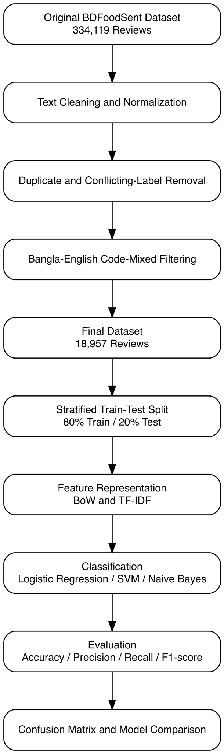
Fig. 2. Project workflow from the multilingual source to six sentiment-classification experiments.

C. Preprocessing and Duplicate Handling
Preprocessing converts text to lowercase, removes URLs, punctuation, and numeric content, and normalizes whitespace. Records are then grouped by normalized review text. If a normalized group contains conflicting sentiment labels, the entire group is removed. For repeated instances with the same normalized text and label, one copy is retained. This policy avoids assigning contradictory targets to identical normalized inputs and prevents repeated normalized text from being counted multiple times.
The operations also change the available signal. Punctuation and numeric removal may discard emphasis or information relevant to a review, while normalization may collapse superficially different strings. The experiment does not establish how much each step contributes because no preprocessing ablation is supplied. Likewise, spelling normalization, translation, stemming, and language-model preprocessing are not claimed as implemented steps.

D. Train and Test Split and Reproducibility
The final subset is divided using a stratified 80/20 split with random seed 42, yielding 15,166 training and 3,791 test reviews. Stratification preserves the class proportions approximately; it does not balance the classes. The BoW+LR confusion matrix implies test supports of 2,518 negative, 435 neutral, and 838 positive reviews, consistent with the total test size. All six reported results belong to this experimental comparison.
Exact rerunning requires the normalization rules, both lexical indicator lists, retained record identifiers, software versions, and full estimator/vectorizer settings. The available experiment record specifies the split, BoW minimum document frequency, and BoW feature count but does not preserve all of those implementation details. A complete reproduction must also verify that vocabulary and inverse document frequencies were fitted using training text only; this cannot be independently confirmed from aggregate metrics. Accordingly, the paper reports the documented protocol without inventing missing settings or asserting independently verified leakage control.

E. Bag of Words Representation
BoW represents a review by its term counts over a vocabulary. If V is the vocabulary, the feature for term t in review d is x(d,t) = count(t,d). The recorded BoW minimum document frequency is 5, and the final representation has 3,615 features. This threshold removes sufficiently rare vocabulary items, reducing the sparse feature space, but may also exclude uncommon Romanized spellings. BoW preserves frequency evidence while omitting explicit word order and cross-lingual semantic relationships.

F. TF IDF Representation
TF-IDF reweights a term according to its occurrence within a review and its prevalence across documents. A general form is w(t,d) = tf(t,d) × idf(t), where inverse document frequency decreases as the number of documents containing t increases. This can reduce the influence of ubiquitous terms and increase the relative weight of more selective terms. The precise smoothing, normalization, n-gram settings, and feature count of the recorded TF-IDF configuration are not supplied, so no specific implementation formula or shared BoW vocabulary is asserted.

G. Logistic Regression
LR learns linear relationships between sparse features and class membership. The model associates feature weights with sentiment decisions, making it a useful discriminative baseline. In multiclass use, probabilities or class scores determine the predicted label according to the implementation. The supplied record does not identify the solver, regularization strength, or multiclass strategy. Both BoW+LR and TF-IDF+LR are evaluated as recorded, without attributing their results to an unverified parameter choice.

H. Linear Support Vector Machine
A linear SVM learns separating decision surfaces in the sparse feature space using a margin-based objective. Its relevance to sentiment classification follows the traditional comparisons in [3], [4]. The linear qualifier specifies the kernel type for this project; it does not establish the exact multiclass implementation or regularization value. Evaluating SVM with each representation tests whether frequency counts and corpus-based term weighting produce different outcomes under the reported setup.

I. Multinomial Naive Bayes
Multinomial NB estimates class-dependent feature likelihoods under a conditional-independence assumption. Its decision can be expressed as the class maximizing log P(c) + Σt x(d,t) log P(t|c). BoW supplies count features, while TF-IDF supplies nonnegative weighted features in the corresponding experiment. The model is included because NB is a well-established text baseline [4] and has been studied for Bengali restaurant reviews [8]. Smoothing and prior settings are not available in the supplied record.

J. Evaluation Metrics
Accuracy is the number of correct predictions divided by the total number of test reviews. For class c, precision is TPc/(TPc + FPc), recall is TPc/(TPc + FNc), and F1 is 2PcRc/(Pc + Rc). Macro precision, macro recall, and macro F1 average the respective class metrics equally across the three classes. In particular, macro F1 is the mean of the three class F1 values, not the harmonic mean of macro precision and macro recall.
Equal class weighting makes macro F1 useful here because negative reviews dominate the subset. It complements rather than replaces accuracy: the two measures answer different questions about total correctness and performance across labels. The reported percentages retain the supplied precision in tables, while prose and figures use rounded values where appropriate. The confusion matrix is interpreted with predicted labels in rows and actual labels in columns; this orientation determines the correct precision and recall denominators.

IV. RESULTS AND ANALYSIS

A. Overall Model Comparison
Table II reports all six experiments, including accuracy, macro precision, macro recall, and macro F1. BoW+LR gives the highest accuracy of 78.7655%; TF-IDF+LR follows at 78.42258%. Fig. 3 shows the accuracy ranking. The 0.34292-percentage-point LR difference corresponds to 13 additional correct predictions on the 3,791-review test set, as derived from the supplied rounded accuracies. This is an observed difference on one split, not evidence of statistical significance.

TABLE II
SIX MODEL PERFORMANCE COMPARISON IN PERCENT
Model | Accuracy | Macro  precision | Macro  recall | Macro F1
BoW+LR | 78.7655 | 60.42916 | 56.14804 | 54.86088
TF-IDF+LR | 78.42258 | 59.62756 | 55.20782 | 53.78184
BoW+SVM | 75.67924 | 58.40195 | 58.00012 | 57.91521
TF-IDF+SVM | 73.67449 | 57.7801 | 57.81947 | 57.76619
BoW+NB | 70.7465 | 60.28112 | 63.69166 | 60.53858
TF-IDF+NB | 69.19019 | 59.10375 | 62.40924 | 59.11344
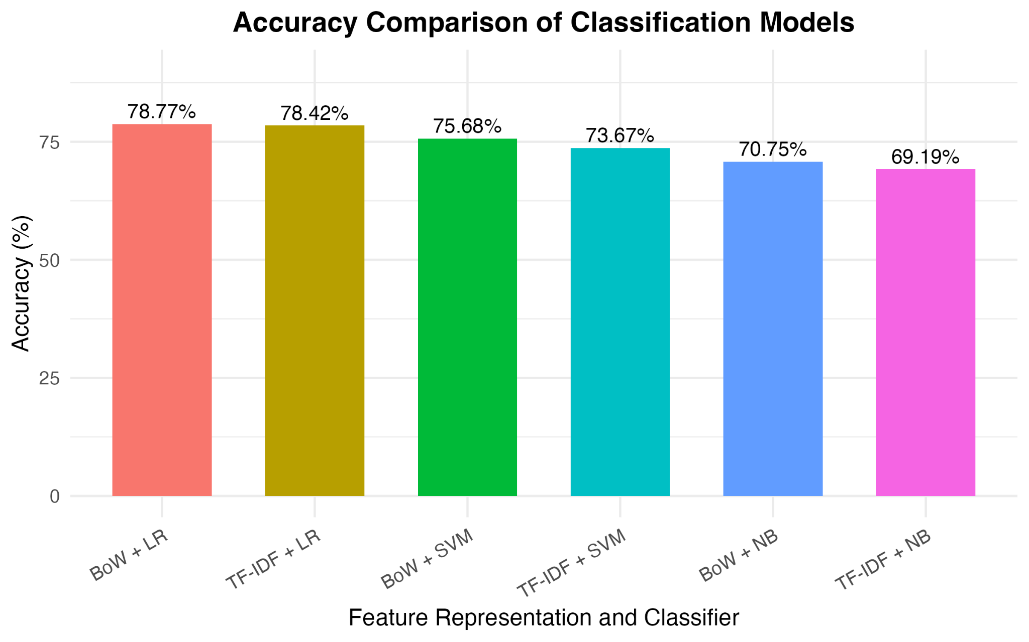
Fig. 3. Accuracy of the six representation–classifier combinations.

The ordering changes when each class contributes equally. BoW+NB obtains the highest macro F1 of 60.53858%, followed by TF-IDF+NB at 59.11344%, as shown in Fig. 4. Both SVM configurations exceed the LR configurations in macro F1 despite lower accuracy. BoW+NB also has the highest macro recall, 63.69166%, whereas BoW+LR has the highest macro precision, 60.42916%. Thus, the table supports several metric-specific observations rather than a single universally best classifier.
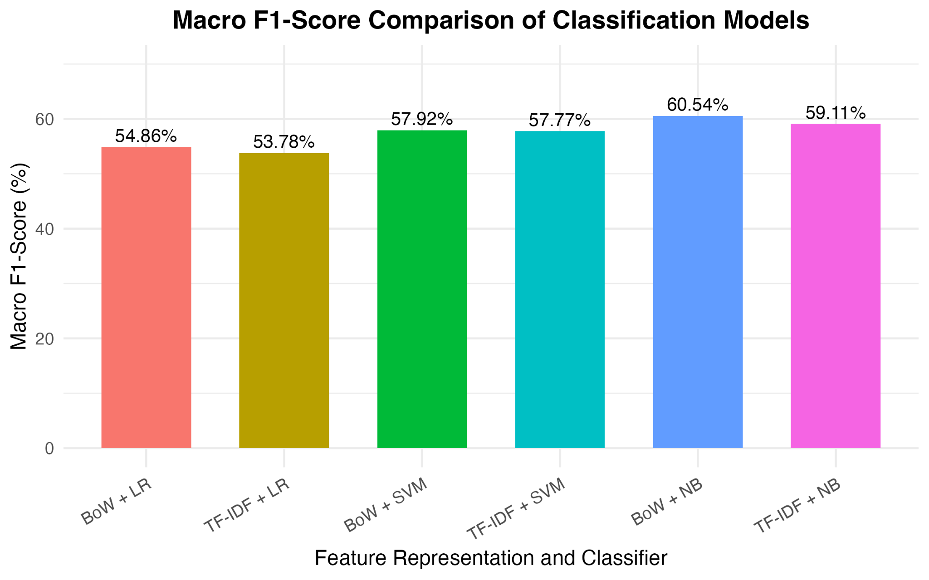
Fig. 4. Macro F1 ranking differs from the accuracy ranking.

B. BoW Versus TF IDF
BoW exceeds TF-IDF in accuracy and macro F1 for each of the three classifiers. The accuracy advantages are 0.34292 percentage points for LR, 2.00475 for SVM, and 1.55631 for NB. The corresponding macro F1 advantages are 1.07904, 0.14902, and 1.42514 percentage points. Fig. 5 pairs the representations by classifier for macro F1, making the relatively small SVM difference visible.
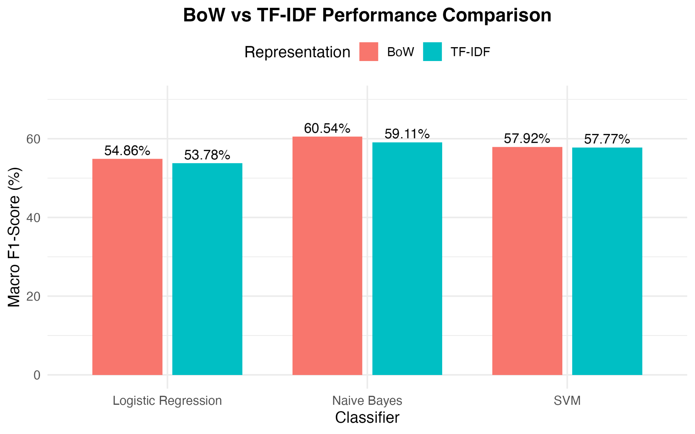
Fig. 5. Paired BoW and TF-IDF macro F1 comparison for each classifier.
One possible explanation is that frequently occurring words carry useful sentiment evidence in this selected review population, so downweighting them does not help the recorded models. This remains a hypothesis: the experiment includes no feature-weight inspection, vocabulary-matched ablation, or review-length analysis that would isolate the mechanism. Unknown TF-IDF settings further limit causal interpretation. The supported conclusion is that the recorded BoW configurations performed better on these two metrics for this split, not that count weighting is intrinsically superior for all Bangla–English text.

C. Accuracy and Macro F1 Trade Off
Choosing BoW+NB instead of BoW+LR reduces accuracy by 8.019 percentage points and increases macro F1 by 5.67770 percentage points. LR therefore better serves the narrow objective of maximizing total correct labels in this test population, while NB better serves the reported equal-class F1 objective. Neither result establishes that all classes improve under NB, because its class-wise metrics and confusion matrix are not supplied. In particular, improved NB neutral recall must not be inferred solely from its higher macro recall.
As a derived reference, always predicting negative would classify 2,518 of 3,791 test cases correctly, giving approximately 66.42% accuracy. Every reported model exceeds that majority-class reference, but exceeding it does not establish reliable three-class performance. The large difference between the accuracy and macro F1 of LR warrants inspecting which classes account for the correct predictions and which errors remain frequent.

D. Confusion Matrix and Class Wise Performance
Fig. 6 presents the BoW+LR confusion matrix. Its vertical axis is predicted sentiment and its horizontal axis is actual sentiment; the figure displays positive at the top and negative at the bottom. In negative, neutral, positive row order, the counts are [2382, 280, 233], [22, 16, 17], and [114, 139, 588]. The diagonal sums to 2,986 correct predictions, reproducing the reported 78.7655% accuracy after rounding.
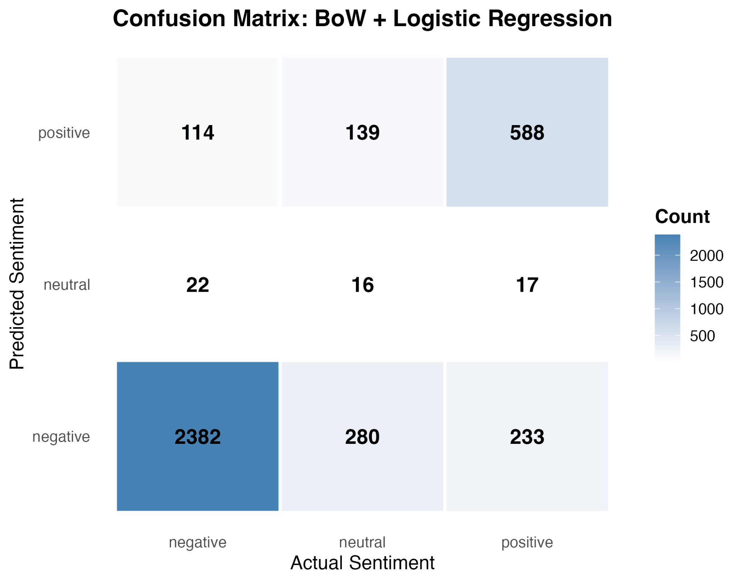
Fig. 6. BoW+LR confusion matrix. Rows are predictions; columns are actual labels.
Negative-class recall is 2,382/2,518 = 94.598888%. However, the model predicts negative for 2,895 reviews, including 280 actual neutral and 233 actual positive cases. Its negative precision is consequently lower, at 82.27979%. Positive performance is more balanced: 588 of 838 positive reviews are correctly identified, yielding 70.167064% recall and 69.91677% precision. Table III preserves all supplied class-wise scores, and Fig. 7 visualizes their contrast.
TABLE III
BOW AND LR CLASS WISE PERFORMANCE IN PERCENT
Class | Precision | Recall | F1
Negative | 82.27979 | 94.598888 | 88.010345
Neutral | 29.09091 | 3.678161 | 6.530612
Positive | 69.91677 | 70.167064 | 70.041691
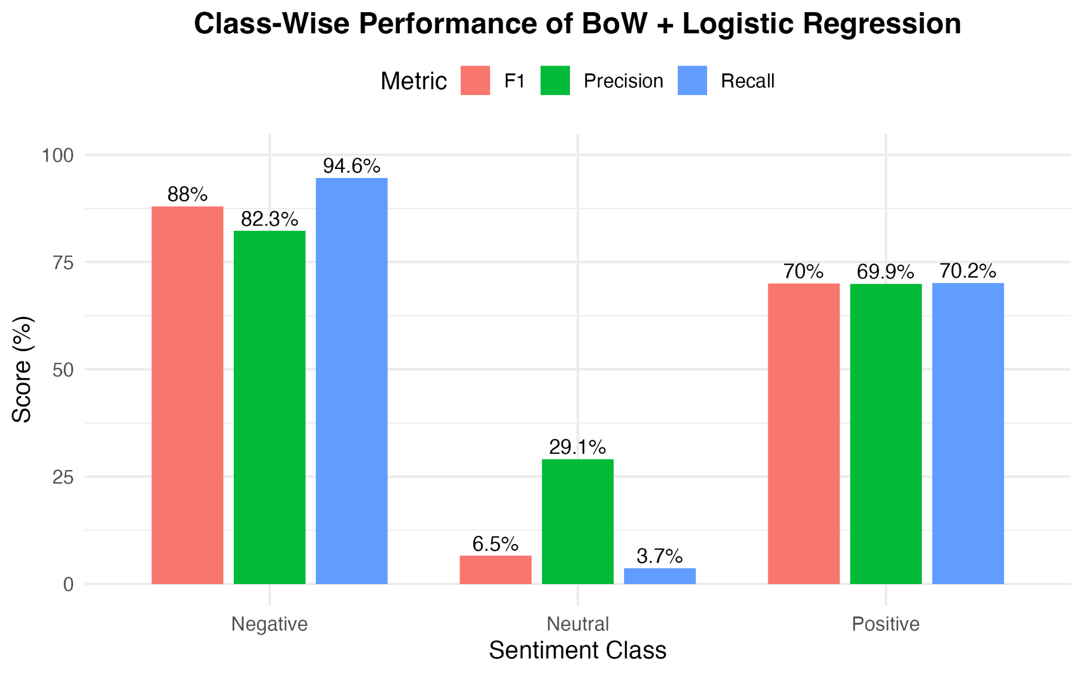
Fig. 7. BoW+LR precision, recall, and F1 for each sentiment class.
Neutral sentiment is the principal failure. Only 16 of 435 neutral test reviews are correctly recognized; 280 are assigned negative and 139 positive. The model emits only 55 neutral predictions in total, of which 39 are incorrect. This produces 29.09091% precision, 3.678161% recall, and 6.530612% F1 for neutral. A user relying on neutral labels would therefore miss almost all actual rating-3 reviews even though overall accuracy is nearly 79%.
The confusion matrix demonstrates the failure but does not establish its cause. Class imbalance is consistent with strong majority-class recovery, and rating-3 reviews may contain evaluative language that overlaps with other classes. However, verifying those explanations requires review-level inspection and label auditing. The present evidence supports an error-pattern description, not a confirmed account of linguistic ambiguity or model behavior at the token level.

E. Limitations and Threats to Validity
First, lexical filtering is a heuristic. It can exclude valid code-mixed reviews with unseen Romanized spellings and retain ambiguous strings that match both lists. Since no language-level audit is reported, filter precision and coverage remain unknown. The subset therefore cannot represent all code-mixed BDFoodSent content or all Bangla–English online communication. Second, rating-derived labels measure a customer rating category and may disagree with the sentiment expressed in the text. Removing conflicting normalized groups resolves a specific consistency problem but does not validate the remaining labels.
Third, class imbalance remains pronounced after stratification, and the LR results expose poor neutral recovery. The study does not report a controlled comparison of class weighting, resampling, or decision-threshold adjustments. Fourth, sparse representations do not explicitly model contextual meaning, cross-lingual equivalence, or Romanized spelling variation. No experiment quantifies whether these limitations explain individual errors. Fifth, a single held-out split provides no estimate of variability across seeds, restaurants, or time periods; no significance test or external validation is supplied.
Finally, the exact lexical lists, some feature settings, estimator parameters, and implementation versions are unavailable. These gaps prevent independent exact reproduction from the manuscript alone. The supplied aggregate results are reported as experiment outcomes, not as newly rerun measurements. Conclusions about weighting effects and classifier rankings should remain tied to this recorded setup until the complete pipeline and retained split are archived and independently checked.

V. CONCLUSION AND FUTURE WORKS
This study compared BoW and TF-IDF with LR, linear SVM, and Multinomial NB on 18,957 lexically selected Bangla–English/Romanized-Bangla restaurant reviews from BDFoodSent. The labels were derived from ratings, and evaluation used a stratified 80/20 split with seed 42. BoW+LR achieved the highest accuracy, 78.7655%, while BoW+NB achieved the highest macro F1, 60.53858%. BoW exceeded TF-IDF on both metrics for each classifier within the recorded comparison. These results support choosing a model according to the evaluation objective rather than describing one model as universally best.
The class-wise analysis is central to that conclusion. BoW+LR recovered only 16 of 435 neutral reviews, despite high negative recall. Aggregate accuracy is consequently insufficient for assessing the usefulness of the three-class system. Future work should first archive the exact preprocessing code, lexical dictionaries, retained identifiers, and complete model settings, and verify training-only feature fitting. A manually reviewed sample can then evaluate both code-mixing selection and disagreement between ratings and textual sentiment.
Further experiments should use repeated stratified evaluation and examine class weighting or resampling within training data, selecting models with attention to neutral recall and macro F1. Character n-grams and spelling normalization offer testable ways to address Romanized variation. Cross-lingual augmentation [11] and code-mixed language-model baselines [1] can extend the comparison once the sparse pipeline is reproducible. External-domain evaluation would be needed before generalizing these findings beyond the selected restaurant reviews.

REFERENCES
[1] S. Alam, M. F. Ishmam, N. H. Alvee, M. S. Siddique, M. A. Hossain, and A. R. M. Kamal, “BnSentMix: A diverse Bengali-English code-mixed dataset for sentiment analysis,” in Proc. First Workshop on Language Models for Low-Resource Languages, Abu Dhabi, United Arab Emirates, 2025, pp. 68–77. [Online]. Available: https://aclanthology.org/2025.loreslm-1.4/
[2] E. R. Rhythm and M. H. K. Mehedi, “BDFoodSent: A large-scale sentiment-labeled restaurant review dataset from Bangladesh,” Mendeley Data, ver. 2, Dec. 2, 2024, doi: 10.17632/532fxhnwbb.2. [Dataset]. License: CC BY 4.0. [Online]. Available: https://data.mendeley.com/datasets/532fxhnwbb/2
[3] B. Pang, L. Lee, and S. Vaithyanathan, “Thumbs up? Sentiment classification using machine learning techniques,” in Proc. Conf. Empirical Methods in Natural Language Processing (EMNLP), 2002, pp. 79–86, doi: 10.3115/1118693.1118704.
[4] S. Wang and C. D. Manning, “Baselines and bigrams: Simple, good sentiment and topic classification,” in Proc. 50th Annu. Meeting of the Association for Computational Linguistics, vol. 2: Short Papers, 2012, pp. 90–94. [Online]. Available: https://aclanthology.org/P12-2018/
[5] S. J. Maisha, N. Nafisa, and A. K. M. Masum, “Supervised machine learning algorithms for sentiment analysis of Bangla newspaper,” Int. J. Innovative Computing, vol. 11, no. 2, pp. 15–23, 2021, doi: 10.11113/ijic.v11n2.321.
[6] S. S. Shanto, Z. Ahmed, N. Hossain, A. Roy, and A. I. Jony, “Binary vs. multiclass sentiment classification for Bangla e-commerce product reviews: A comparative analysis of machine learning models,” Int. J. Information Engineering and Electronic Business, vol. 15, no. 6, pp. 48–63, 2023, doi: 10.5815/ijieeb.2023.06.04.
[7] M. Hassan et al., “Sentiment analysis on Bangla conversation using machine learning approach,” Int. J. Electrical and Computer Engineering, vol. 12, no. 5, pp. 5562–5572, Oct. 2022, doi: 10.11591/ijece.v12i5.pp5562-5572.
[8] O. Sharif, M. M. Hoque, and E. Hossain, “Sentiment analysis of Bengali texts on online restaurant reviews using multinomial Naïve Bayes,” in Proc. 1st Int. Conf. Advances in Science, Engineering and Robotics Technology (ICASERT), 2019, pp. 1–6, doi: 10.1109/ICASERT.2019.8934655.
[9] S. Mandal and D. Das, “Analyzing roles of classifiers and code-mixed factors for sentiment identification,” arXiv preprint arXiv:1801.02581, 2018, doi: 10.48550/arXiv.1801.02581.
[10] S. Mandal, S. D. Das, and D. Das, “Language identification of Bengali-English code-mixed data using character & phonetic based LSTM models,” arXiv preprint arXiv:1803.03859, 2018, doi: 10.48550/arXiv.1803.03859.
[11] M. Tareq, M. F. Islam, S. Deb, S. Rahman, and A. Al Mahmud, “Data-augmentation for Bangla-English code-mixed sentiment analysis: Enhancing cross linguistic contextual understanding,” IEEE Access, vol. 11, pp. 51657–51671, 2023, doi: 10.1109/ACCESS.2023.3277787.

