### ****Comsats University Islamabad, Lahore Campus****

  
**OOP Lab Assignment**

**Submitted to:**

**Sir Shahid Bhatti**

**Submitted by:**

Samiullah Ashfaq  
SP24-BSE-107  
Section A

### ****JFX Extended Form Code****

**package example.demo1;**

**import javafx.animation.PauseTransition;**

**import javafx.application.Application;**

**import javafx.event.ActionEvent;**

**import javafx.geometry.Insets;**

**import javafx.geometry.Pos;**

**import javafx.scene.Scene;**

**import javafx.scene.control.*;**

**import javafx.scene.image.Image;**

**import javafx.scene.image.ImageView;**

**import javafx.scene.layout.*;**

**import javafx.scene.paint.Color;**

**import javafx.scene.text.Font;**

**import javafx.scene.text.Text;**

**import javafx.stage.FileChooser;**

**import javafx.stage.Stage;**

**import javafx.util.Duration;**

**import java.io.File;**

**public class App extends Application {**

**private String submittedName;**

**private String submittedFatherName;**

**private String submittedPhone;**

**private String submittedCity;**

**private String submittedImagePath;**

**private Label createStyledLabel(String text) {**

**Label label = new Label(text);**

**label.setStyle("-fx-font-size: 16px; -fx-font-weight: bold; -fx-text-fill: white;");**

**return label;**

**}**

**private Text createStyledText(String text) {**

**Text styledText = new Text(text);**

**styledText.setStyle("-fx-font-size: 16px; -fx-fill: white;");**

**return styledText;**

**}**

**public static void main(String[] args) {**

**launch(args);**

**}**

**@Override**

**public void start(Stage primaryStage) {**

**primaryStage.setTitle("JavaFX Extended Form");**

**// Create the main layout**

**GridPane grid = new GridPane();**

**grid.setAlignment(Pos.CENTER);**

**grid.setHgap(10);**

**grid.setVgap(10);**

**grid.setPadding(new Insets(25, 25, 25, 25));**

**grid.setStyle("-fx-background-color: #284b63;"); // Dark blue background**

**// Add font**

**Font.loadFont(getClass().getResourceAsStream("/fonts/Roboto-Regular.ttf"), 16);**

**Text scenetitle = new Text("Welcome to JFX App");**

**scenetitle.setStyle("-fx-font-size: 30px; -fx-font-weight: bold; -fx-fill: white;");**

**grid.add(scenetitle, 0, 0, 2, 1);**

**// Name field**

**Label nameLabel = new Label("Name:");**

**nameLabel.setStyle("-fx-font-size: 14px; -fx-font-weight: bold; -fx-text-fill: white;");**

**grid.add(nameLabel, 0, 1);**

**TextField nameField = new TextField();**

**grid.add(nameField, 1, 1);**

**// Father Name field**

**Label fatherNameLabel = new Label("Father Name:");**

**fatherNameLabel.setStyle("-fx-font-size: 14px; -fx-font-weight: bold; -fx-text-fill: white;");**

**grid.add(fatherNameLabel, 0, 2);**

**TextField fatherNameField = new TextField();**

**grid.add(fatherNameField, 1, 2);**

**// Phone Number field**

**Label phoneLabel = new Label("Phone Number:");**

**phoneLabel.setStyle("-fx-font-size: 14px; -fx-font-weight: bold; -fx-text-fill: white;");**

**grid.add(phoneLabel, 0, 3);**

**TextField phoneField = new TextField();**

**grid.add(phoneField, 1, 3);**

**// City Address field**

**Label cityLabel = new Label("City Address:");**

**cityLabel.setStyle("-fx-font-size: 14px; -fx-font-weight: bold; -fx-text-fill: white;");**

**grid.add(cityLabel, 0, 4);**

**TextField cityField = new TextField();**

**grid.add(cityField, 1, 4);**

**// Image Upload Button**

**Label imageLabel = new Label("Upload Image:");**

**imageLabel.setStyle("-fx-font-size: 14px; -fx-font-weight: bold; -fx-text-fill: white;");**

**grid.add(imageLabel, 0, 5);**

**Button uploadButton = new Button("Browse");**

**uploadButton.setStyle("-fx-background-color: #ffa500; -fx-text-fill: white; -fx-font-size: 14px; -fx-font-weight: bold;");**

**final Text imagePath = new Text();**

**uploadButton.setOnAction(e -> {**

**FileChooser fileChooser = new FileChooser();**

**fileChooser.getExtensionFilters().addAll(**

**new FileChooser.ExtensionFilter("Image Files", "*.png", "*.jpg", "*.jpeg")**

**);**

**File selectedFile = fileChooser.showOpenDialog(primaryStage);**

**if (selectedFile != null) {**

**imagePath.setText(selectedFile.getAbsolutePath());**

**}**

**});**

**HBox uploadBox = new HBox(10);**

**uploadBox.getChildren().addAll(uploadButton, imagePath);**

**grid.add(uploadBox, 1, 5);**

**// Password field**

**Label pw = new Label("Password:");**

**pw.setStyle("-fx-font-size: 14px; -fx-font-weight: bold; -fx-text-fill: white;");**

**grid.add(pw, 0, 6);**

**PasswordField pwBox = new PasswordField();**

**grid.add(pwBox, 1, 6);**

**// Submit button with loading effect**

**Button btn = new Button("Submit");**

**btn.setStyle("-fx-background-color: #4682b4; -fx-text-fill: white; -fx-font-size: 14px; -fx-font-weight: bold;");**

**final ProgressIndicator loadingSpinner = new ProgressIndicator();**

**loadingSpinner.setVisible(false);**

**HBox hbBtn = new HBox(10);**

**hbBtn.setAlignment(Pos.BOTTOM_RIGHT);**

**hbBtn.getChildren().addAll(btn, loadingSpinner);**

**grid.add(hbBtn, 1, 8);**

**// View Info button**

**Button viewBtn = new Button("View Info");**

**viewBtn.setStyle("-fx-background-color: #32cd32; -fx-text-fill: white; -fx-font-size: 14px; -fx-font-weight: bold;");**

**viewBtn.setDisable(true);**

**HBox hbViewBtn = new HBox(10);**

**hbViewBtn.setAlignment(Pos.BOTTOM_RIGHT);**

**hbViewBtn.getChildren().add(viewBtn);**

**grid.add(hbViewBtn, 1, 9);**

**final Text actiontarget = new Text();**

**actiontarget.setStyle("-fx-font-size: 12px; -fx-font-style: italic;");**

**grid.add(actiontarget, 1, 10);**

**// Handle Submit Button**

**btn.setOnAction(e -> {**

**StringBuilder errors = new StringBuilder();**

**// Validation**

**if (nameField.getText().isEmpty()) errors.append("Name is required.\n");**

**if (fatherNameField.getText().isEmpty()) errors.append("Father Name is required.\n");**

**if (phoneField.getText().isEmpty() || !phoneField.getText().matches("\\d{11}"))**

**errors.append("Valid Phone Number (11 digits) is required.\n");**

**if (cityField.getText().isEmpty()) errors.append("City Address is required.\n");**

**if (pwBox.getText().isEmpty()) errors.append("Password is required.\n");**

**if (imagePath.getText().isEmpty()) errors.append("Image upload is required.\n");**

**if (errors.length() > 0) {**

**// Display errors in an alert dialog**

**Alert alert = new Alert(Alert.AlertType.ERROR);**

**alert.setTitle("Validation Errors");**

**alert.setHeaderText("Please correct the following errors:");**

**alert.setContentText(errors.toString());**

**alert.showAndWait();**

**viewBtn.setDisable(true); // Disable view button on errors**

**loadingSpinner.setVisible(false); // Hide loading spinner if error occurs**

**} else {**

**// Show loading spinner**

**loadingSpinner.setVisible(true);**

**// Simulate loading time**

**PauseTransition pause = new PauseTransition(Duration.seconds(2));**

**pause.setOnFinished(event -> {**

**// Save submitted data**

**submittedName = nameField.getText();**

**submittedFatherName = fatherNameField.getText();**

**submittedPhone = phoneField.getText();**

**submittedCity = cityField.getText();**

**submittedImagePath = imagePath.getText();**

**actiontarget.setFill(Color.WHITESMOKE);**

**actiontarget.setText("Form submitted successfully!");**

**viewBtn.setDisable(false); // Enable view button**

**loadingSpinner.setVisible(false); // Hide loading spinner**

**});**

**pause.play();**

**}**

**});**

**// Handle View Info Button**

**viewBtn.setOnAction(e -> {**

**// Create a new VBox for the submitted info page**

**VBox infoView = new VBox(20);**

**infoView.setAlignment(Pos.CENTER);**

**infoView.setPadding(new Insets(30));**

**infoView.setStyle("-fx-background-color: linear-gradient(to bottom, #2c3e50, #bdc3c7);"); // Gradient background**

**// Title**

**Text title = new Text("Submitted Information");**

**title.setStyle("-fx-font-size: 24px; -fx-font-weight: bold; -fx-fill: white;");**

**infoView.getChildren().add(title);**

**// Name**

**HBox nameBox = new HBox(10);**

**nameBox.setAlignment(Pos.CENTER_LEFT);**

**nameBox.getChildren().addAll(**

**createStyledLabel("Name:"),**

**createStyledText(submittedName)**

**);**

**infoView.getChildren().add(nameBox);**

**// Father Name**

**HBox fatherNameBox = new HBox(10);**

**fatherNameBox.setAlignment(Pos.CENTER_LEFT);**

**fatherNameBox.getChildren().addAll(**

**createStyledLabel("Father Name:"),**

**createStyledText(submittedFatherName)**

**);**

**infoView.getChildren().add(fatherNameBox);**

**// Phone Number**

**HBox phoneBox = new HBox(10);**

**phoneBox.setAlignment(Pos.CENTER_LEFT);**

**phoneBox.getChildren().addAll(**

**createStyledLabel("Phone Number:"),**

**createStyledText(submittedPhone)**

**);**

**infoView.getChildren().add(phoneBox);**

**// City Address**

**HBox cityBox = new HBox(10);**

**cityBox.setAlignment(Pos.CENTER_LEFT);**

**cityBox.getChildren().addAll(**

**createStyledLabel("City Address:"),**

**createStyledText(submittedCity)**

**);**

**infoView.getChildren().add(cityBox);**

**// Uploaded Image**

**if (submittedImagePath != null) {**

**HBox imageBox = new HBox(10);**

**imageBox.setAlignment(Pos.CENTER_LEFT);**

**imageBox.getChildren().add(createStyledLabel("Uploaded Image:"));**

**ImageView imageView = new ImageView(new Image("file:" + submittedImagePath));**

**imageView.setFitWidth(100);**

**imageView.setFitHeight(100);**

**imageView.setStyle("-fx-effect: dropshadow(gaussian, rgba(0, 0, 0, 0.5), 10, 0.5, 0, 0); -fx-border-color: white; -fx-border-radius: 50; -fx-border-width: 3;");**

**imageBox.getChildren().add(imageView);**

**infoView.getChildren().add(imageBox);**

**}**

**// Back Button**

**Button backButton = new Button("Back");**

**backButton.setStyle("-fx-background-color: #3498db; -fx-text-fill: white; -fx-font-size: 14px; -fx-font-weight: bold;");**

**backButton.setOnAction(event -> {**

**// Return to the form view**

**primaryStage.getScene().setRoot(grid);**

**});**

**infoView.getChildren().add(backButton);**

**// Set the new scene content**

**primaryStage.getScene().setRoot(infoView);**

**});**

**// Set the scene and show the window**

**Scene scene = new Scene(grid, 800, 500);**

**primaryStage.setScene(scene);**

**primaryStage.show();**

**}**

**}**

****Explanation for the Code****

This JavaFX application provides a GUI-based form for collecting user data, including personal details and an image upload. Here's an explanation of its components and functionality:

### ****1. Application Overview****

The application uses the JavaFX framework and follows the Application class structure. It creates a graphical interface where users can input their information, validate the form, and view the submitted data in a formatted layout.

### ****2. Features and Layout****

1. **Main Layout:**
   * A GridPane is used for the main form layout, styled with a dark blue background and proper spacing.
   * The form is centered using alignment properties and Insets for padding.
2. **Fields and Labels:**
   * Input fields include text fields for Name, Father Name, Phone Number, and City.
   * Labels are styled for visual consistency using CSS properties.
   * A PasswordField is included for password input.
3. **Image Upload:**
   * A FileChooser allows the user to select an image file. The file path is displayed once selected.
4. **Buttons:**
   * **Submit Button:**
     + Validates all input fields and shows errors in an alert dialog if inputs are invalid.
     + Displays a loading spinner during the submission process.
   * **View Info Button:**
     + Initially disabled and enabled only after successful form submission.
     + Opens a new view displaying the submitted information.
5. **Dynamic Info View:**
   * Displays the collected user data, including the uploaded image preview.
   * A "Back" button allows returning to the form view.

### ****3. Form Validation****

* The Submit button checks:
  + Fields are non-empty.
  + Phone numbers contain exactly 11 digits.
  + An image is uploaded.
* If validation fails, errors are displayed in an Alert.

### ****4. Loading Spinner****

* A ProgressIndicator simulates processing after form submission using a PauseTransition. This ensures a smooth user experience.

### ****5. Viewing Submitted Data****

* The View Info button transitions to a new scene (VBox) showing the formatted user details:
  + Each data field is displayed with styled text.
  + If an image is uploaded, it is displayed as a rounded preview using an ImageView.

### ****6. Back Navigation****

* A "Back" button in the view info page returns the user to the main form.

### ****7. Styling****

* Inline CSS styles are used for labels, text, and buttons.
* **Custom fonts are loaded to enhance visual aesthetics.**

### ****8. Program Entry****

* The application launches with the main method, which calls the start method to initialize and display the primary stage.

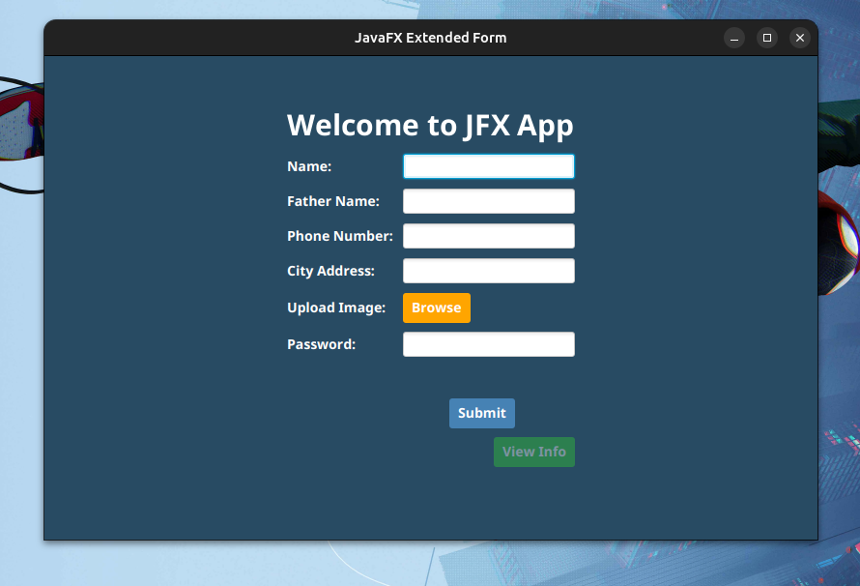**Attached ScreenShots**

