COMSATS University Islamabad, Lahore Campus


OS Lab Exam Mid Term

Submitted to: Ma’am Zeenat Afzal
Submitted by: Afrasayyab Munawar
Roll: SP24-BSE-007-A

Question #01:

a.

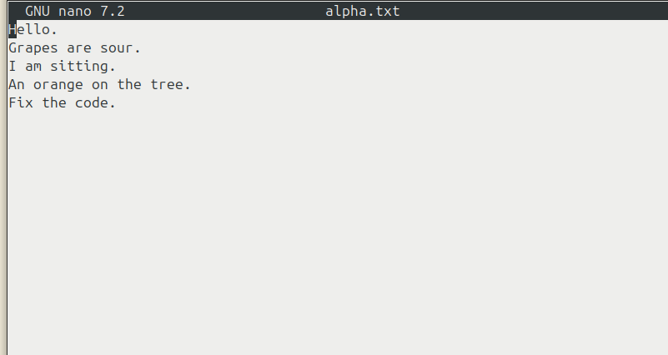

b.
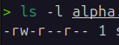

c.
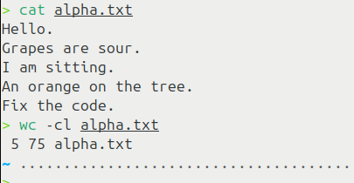

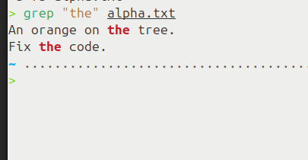
d.

Question #02:

#include <stdio.h>
#include <stdlib.h>
#include <unistd.h>
#include <sys/types.h>
#include <sys/wait.h>
#include <sys/stat.h>

int main() {
pid_t pid1, pid2;
int a, b, sum;
char dir[50];

printf("Parent PID: %d\n", getpid());

// Child 1 - arithmetic
pid1 = fork();
if (pid1 == 0) {
printf("\nChild 1 PID: %d - Arithmetic\n", getpid());
printf("Enter 2 numbers: ");
scanf("%d %d", &a, &b);
sum = a + b;
printf("Sum = %d\n", sum);
exit(0);
}

wait(NULL); // Wait for child1 to complete before child2

// Child 2 - mkdir
pid2 = fork();
if (pid2 == 0) {
printf("\nChild 2 PID: %d - Directory\n", getpid());
printf("Enter dir name: ");
scanf("%s", dir);
mkdir(dir, 0755);
printf("Created: %s\n", dir);
exit(0);
}

wait(NULL); // Wait for child2

printf("\nParent summary:\n");
printf("Child1 PID %d: addition\n", pid1);
printf("Child2 PID %d: mkdir\n", pid2);

return 0;
}

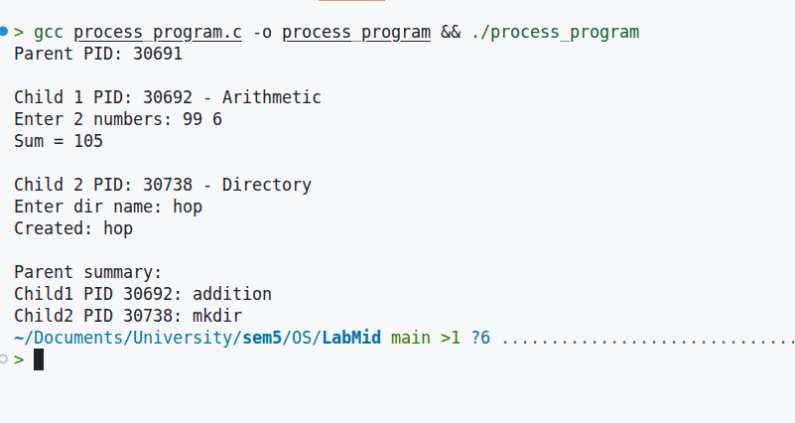

Question #03:

#include <stdio.h>
#include <stdlib.h>
#include <unistd.h>
#include <sys/types.h>
#include <sys/ipc.h>
#include <sys/msg.h>
#include <string.h>

// Message structure for System V message queue
struct msgbuf {
long mtype; // Message type (must be > 0)
char mtext[100]; // Word data
};

#define MSG_KEY 1234 // Key for message queue

int main() {
int msgid;
struct msgbuf msg;

// Create or get message queue
msgid = msgget(MSG_KEY, 0666 | IPC_CREAT);
if (msgid == -1) {
perror("msgget sender");
exit(1);
}

printf("Sender: Sending 5 words (starting with A or S)...\n");

// Send 5 words
char *words[] = {"Apple", "Sky", "Ant", "Sun", "Arrow"};
for (int i = 0; i < 5; i++) {
msg.mtype = 1; // Same type for all messages
strcpy(msg.mtext, words[i]);

if (msgsnd(msgid, &msg, strlen(msg.mtext) + 1, 0) == -1) {
perror("msgsnd");
exit(1);
}
printf("Sent: %s\n", msg.mtext);
sleep(1); // Delay between sends
}

printf("Sender: All 5 words sent.\n");

// Optional: remove queue after sending (but let receiver read first)
// msgctl(msgid, IPC_RMID, NULL);

return 0;
}
#include <stdio.h>
#include <stdlib.h>
#include <unistd.h>
#include <sys/types.h>
#include <sys/ipc.h>
#include <sys/msg.h>
#include <string.h>

// Same message structure
struct msgbuf {
long mtype;
char mtext[100];
};

#define MSG_KEY 1234

int main() {
int msgid;
struct msgbuf msg;

// Get existing message queue
msgid = msgget(MSG_KEY, 0666);
if (msgid == -1) {
perror("msgget receiver");
exit(1);
}

printf("Receiver: Waiting for 5 messages...\n");

// Receive all 5 messages
for (int i = 0; i < 5; i++) {
if (msgrcv(msgid, &msg, sizeof(msg.mtext), 1, 0) == -1) {
perror("msgrcv");
exit(1);
}

printf("Received: %s", msg.mtext);
// Print only if starts with 'S'
if (msg.mtext[0] == 'S') {
printf(" (PRINTED - starts with S)\n");
} else {
printf(" (ignored - starts with A)\n");
}
}

// Clean up queue
msgctl(msgid, IPC_RMID, NULL);
printf("Receiver: All messages processed. Queue removed.\n");

return 0;
}

